**Problem Statement：**

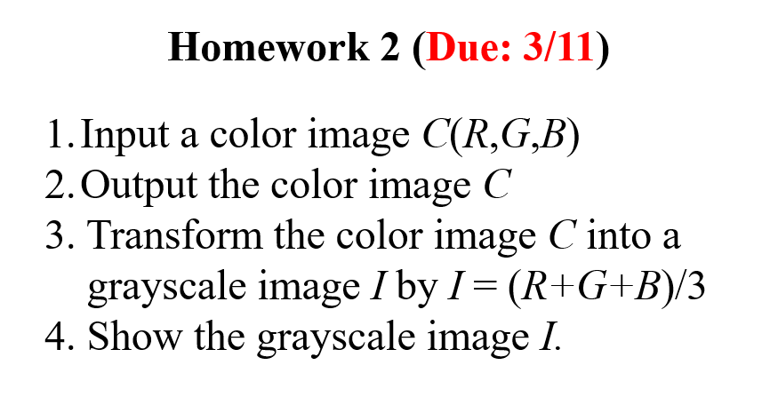

**Input：**

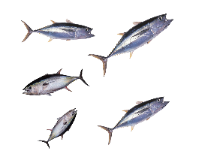

**Output：**

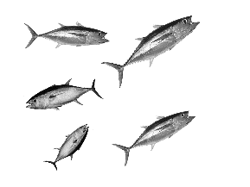

**Source Code：**

# Load libraries

import sys

import numpy as np

import matplotlib.pyplot as plt

import matplotlib.image as mpimg

#Define RGB to grayscale function

#I=(R+G+B)/3

def rgb2gray(rgb):

return np.dot(rgb[..., :3],[0.2,0.5,0.3])

# Standard input image file name

img=mpimg.imread(sys.argv[1])

#Call RGB to grayscale function

gray=rgb2gray(img)

#Save output image file

#原圖

plt.imsave(sys.argv[1].split('.')[-2]+"_1"+sys.argv[1].split('.')[-1],img)

#灰階

plt.imsave(sys.argv[1].split('.')[-2]+"_gray."+sys.argv[1].split('.')[-],gray,cmap='gray')

#Plot input and output images

figure,ax=plt.subplots(1,2)

ax[0].imshow(img)

ax[1].imshow(gray,cmap='gray')

plt.show()

**Comments：**

**以前就已經裝好anaconda,用過opencv,只是用的方式不太一樣而已,沒遇到什麼太大的困難。**