**Problem Statement：**

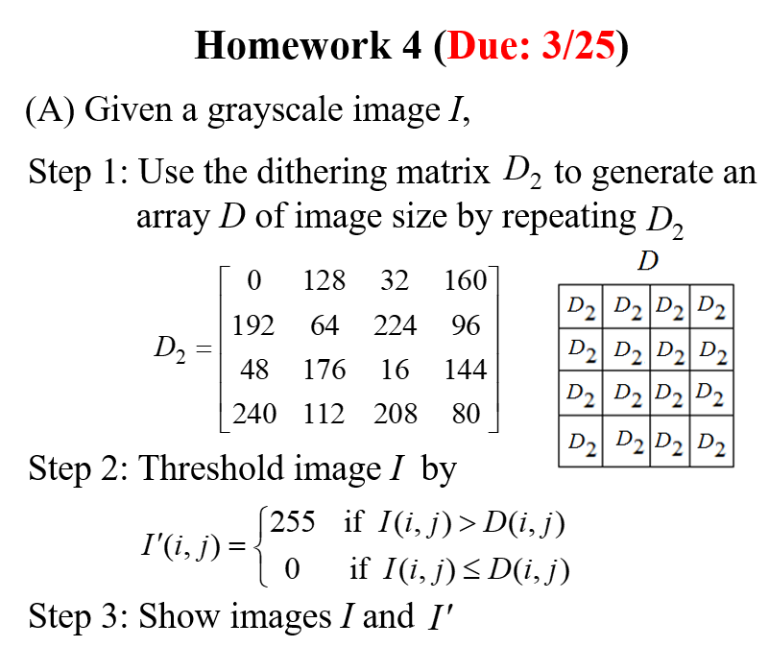

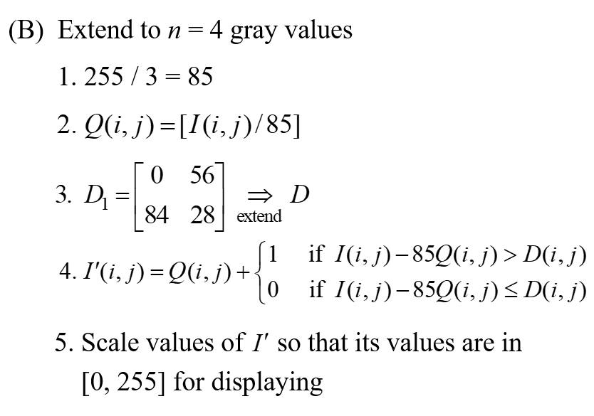

**Input：**



**Output：**

(A)

(B) 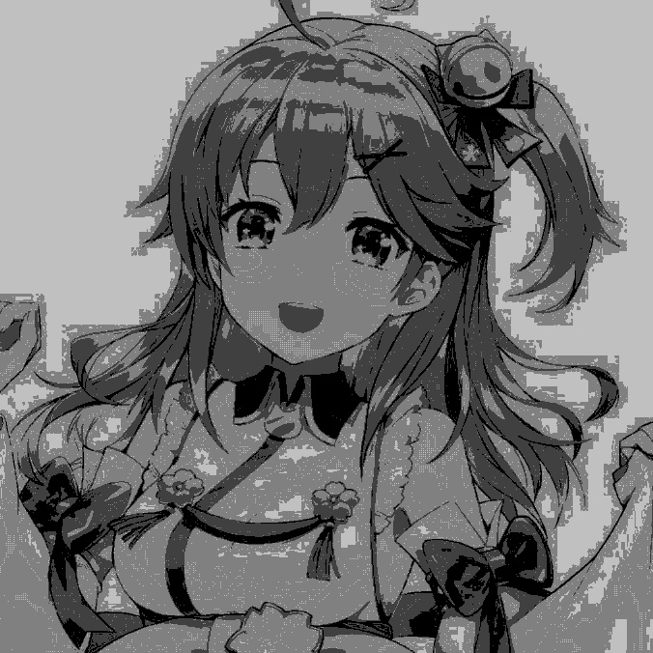

**Source Code：**

**import cv2**

**import numpy as np**

**#讀圖片<class 'numpy.ndarray'>**

**img = cv2.imread('C:\\Users\\paul\\Desktop\\miko_gray.jpg',cv2.IMREAD_GRAYSCALE)**

**# resize image**

**width = 676**

**height = 676**

**dim = (width, height)**

**img= cv2.resize(img, dim, interpolation = cv2.INTER_AREA)**

**d_1= [[0,128,32,160],**

**[192,64,224,96],**

**[48,176,16,144],**

**[240,112,208,80]]**

**d_2=[[0,56],[84,28]]**

**d1=[[0]*676 for i in range(676)]**

**d2=[[0]*676 for i in range(676)]**

**#產生D1**

**for i in range(int(height)):**

**for j in range(int(width)):**

**if i%4==0 and j%4==0:**

**d1[i][j]=0**

**if i%4==0 and j%4==1:**

**d1[i][j]=128**

**if i%4==0 and j%4==2:**

**d1[i][j]=32**

**if i%4==0 and j%4==3:**

**d1[i][j]=160**

**if i%4==1 and j%4==0:**

**d1[i][j]=192**

**if i%4==1 and j%4==1:**

**d1[i][j]=64**

**if i%4==1 and j%4==2:**

**d1[i][j]=224**

**if i%4==1 and j%4==3:**

**d1[i][j]=96**

**if i%4==2 and j%4==0:**

**d1[i][j]=48**

**if i%4==2 and j%4==1:**

**d1[i][j]=176**

**if i%4==2 and j%4==2:**

**d1[i][j]=16**

**if i%4==2 and j%4==3:**

**d1[i][j]=144**

**if i%4==3 and j%4==0:**

**d1[i][j]=240**

**if i%4==3 and j%4==1:**

**d1[i][j]=112**

**if i%4==3 and j%4==2:**

**d1[i][j]=208**

**if i%4==3 and j%4==3:**

**d1[i][j]=80**

**#產生D2**

**for i in range(int(height)):**

**for j in range(int(width)):**

**if i%2==0 and j%2==0:**

**d2[i][j]=0**

**if i%2==0 and j%2==1:**

**d2[i][j]=56**

**if i%2==1 and j%2==0:**

**d2[i][j]=84**

**if i%2==1 and j%2==1:**

**d2[i][j]=28**

**#Threshold image I**

**I1=[[0]*width for i in range(height)]**

**I2=[[0]*width for i in range(height)]**

**Q=[[0]*width for i in range(height)]**

**for i in range(height):**

**for j in range(width):**

**Q[i][j]=img[i,j]/85**

**for i in range(height):**

**for j in range(width):**

**if img[i,j]>d1[i][j]:**

**I1[i][j]=255**

**else:**

**I1[i][j]=0**

**for i in range(height):**

**for j in range(width):**

**if (img[i,j]-85*Q[i][j])>d2[i][j]:**

**I2[i][j]=Q[i][j]+1**

**else:**

**I2[i][j]=Q[i][j]+0**

**I1=np.array(I1,dtype=np.uint8)**

**I2=np.array(I2,dtype=np.uint8)**

**#print("I1=",I1)**

**print("I2=",I2*51)**

**cv2.imshow('img',img)**

**cv2.imshow('I1',I1)**

**cv2.imshow('I2',I2*51)**

**retval1=cv2.imwrite('C:\\Users\\paul\\Desktop\\I1.jpg',I1)**

**retval2=cv2.imwrite('C:\\Users\\paul\\Desktop\\I2.jpg',I2*51)**

**cv2.waitKey(0)**

**cv2.destroyAllWindows()**

**Comments：**

**這份作業在一開始在上課時,以為要dithering array 是由dithering matrix行列式值組成,無論怎麼弄都無法正確執行,後來才了解原來是真的把矩陣拿下去組合,花了很多時間想。第二題一開始怎麼嘗試都是黑色的,後來跟同學討論後才知道，原來要讓它散佈在0-255中才行。我看他的值域是0-5,所以把每個值乘上51,不曉得這個做法是否是正確的?**