**Problem Statement：**

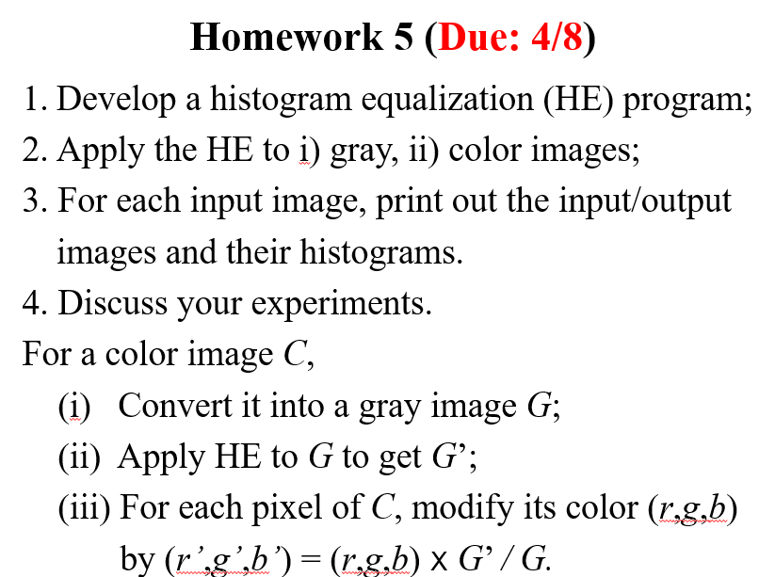

**Input：**

1. **gray:**



1. **color:**



**Output：**

1. **gray:**

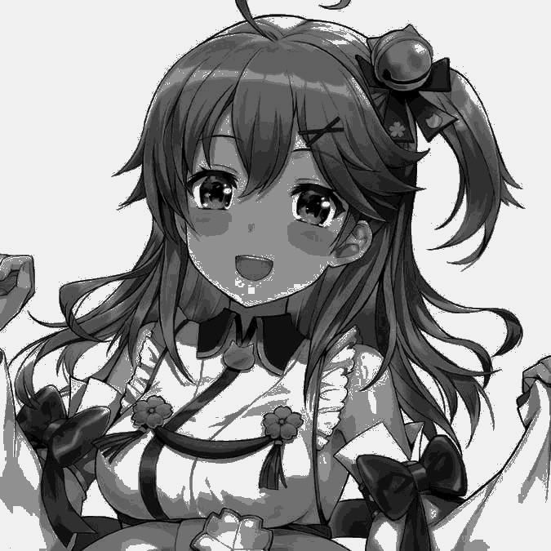

1. **color**



**Histogram：**

1. **input:**
2. **gray:**

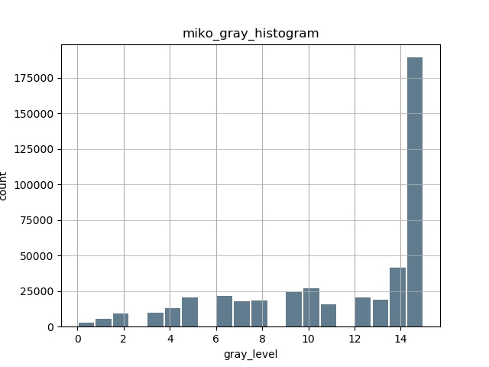

1. **color:**

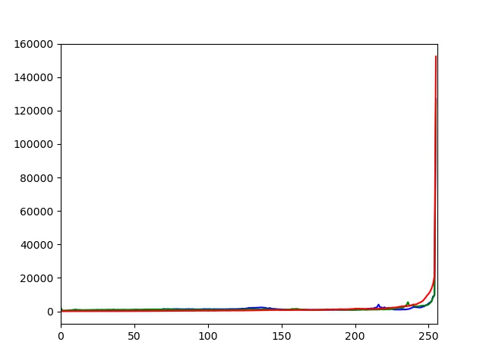

1. **output:**
2. **gray:**

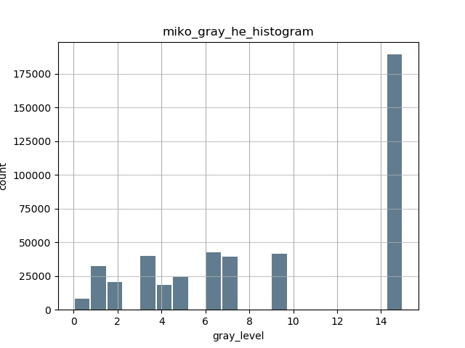

1. **color:**

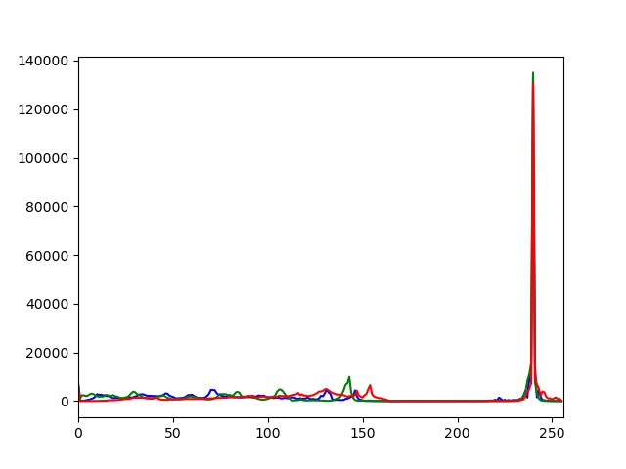

**Source Code：**

**import cv2**

**import numpy as np**

**import pandas as pd**

**import matplotlib.pyplot as plt**

**def plot_he_gray(img,name):**

**imgo=img**

**img=(img/16).astype(int)**

**for i in range(675):**

**for j in range(675):**

**if img[i,j]==0:**

**img[i,j]=round((15/455625)*sumn[0])**

**elif img[i,j]==1:**

**img[i,j]=round((15/455625)*sumn[1])**

**elif img[i,j]==2:**

**img[i,j]=round((15/455625)*sumn[2])**

**elif img[i,j]==3:**

**img[i,j]=round((15/455625)*sumn[3])**

**elif img[i,j]==4:**

**img[i,j]=round((15/455625)*sumn[4])**

**elif img[i,j]==5:**

**img[i,j]=round((15/455625)*sumn[5])**

**elif img[i,j]==6:**

**img[i,j]=round((15/455625)*sumn[6])**

**elif img[i,j]==7:**

**img[i,j]=round((15/455625)*sumn[7])**

**elif img[i,j]==8:**

**img[i,j]=round((15/455625)*sumn[8])**

**elif img[i,j]==9:**

**img[i,j]=round((15/455625)*sumn[9])**

**elif img[i,j]==10:**

**img[i,j]=round((15/455625)*sumn[10])**

**elif img[i,j]==11:**

**img[i,j]=round((15/455625)*sumn[11])**

**elif img[i,j]==12:**

**img[i,j]=round((15/455625)*sumn[12])**

**elif img[i,j]==13:**

**img[i,j]=round((15/455625)*sumn[13])**

**elif img[i,j]==14:**

**img[i,j]=round((15/455625)*sumn[14])**

**elif img[i,j]==15:**

**img[i,j]=round((15/455625)*sumn[15])**

**else:**

**break**

**img = img.astype(np.uint8)**

**cv2.imshow(name,img*16)**

**cv2.waitKey(0)**

**retval=cv2.imwrite(name,img*16)**

**def plot_he_color(gray,img,name):**

**o=gray**

**gray=(gray/16).astype(int)**

**for i in range(675):**

**for j in range(675):**

**if gray[i,j]==0:**

**gray[i,j]=round((15/455625)*sumn[0])**

**elif gray[i,j]==1:**

**gray[i,j]=round((15/455625)*sumn[1])**

**elif gray[i,j]==2:**

**gray[i,j]=round((15/455625)*sumn[2])**

**elif gray[i,j]==3:**

**gray[i,j]=round((15/455625)*sumn[3])**

**elif gray[i,j]==4:**

**gray[i,j]=round((15/455625)*sumn[4])**

**elif gray[i,j]==5:**

**gray[i,j]=round((15/455625)*sumn[5])**

**elif gray[i,j]==6:**

**gray[i,j]=round((15/455625)*sumn[6])**

**elif gray[i,j]==7:**

**gray[i,j]=round((15/455625)*sumn[7])**

**elif gray[i,j]==8:**

**gray[i,j]=round((15/455625)*sumn[8])**

**elif gray[i,j]==9:**

**gray[i,j]=round((15/455625)*sumn[9])**

**elif gray[i,j]==10:**

**gray[i,j]=round((15/455625)*sumn[10])**

**elif gray[i,j]==11:**

**gray[i,j]=round((15/455625)*sumn[11])**

**elif gray[i,j]==12:**

**gray[i,j]=round((15/455625)*sumn[12])**

**elif gray[i,j]==13:**

**gray[i,j]=round((15/455625)*sumn[13])**

**elif gray[i,j]==14:**

**gray[i,j]=round((15/455625)*sumn[14])**

**elif gray[i,j]==15:**

**gray[i,j]=round((15/455625)*sumn[15])**

**else:**

**break**

**r=(gray*16)/(o+0.0000000000000001)**

**for k in range(3):**

**img[:,:,k]=img[:,:,k]*r**

**img = img.astype(np.uint8)**

**#miko.jpg HE後之Histogram**

**color = ('b','g','r')**

**for i,col in enumerate(color):**

**histr = cv2.calcHist([img],[i],None,[256],[0,256])**

**plt.plot(histr,color = col)**

**plt.xlim([0,256])**

**plt.savefig("miko_color_he_histogram.jpg")**

**plt.show()**

**retval=cv2.imwrite(name,img)**

**cv2.imshow(name,img)**

**cv2.waitKey(0)**

**#照片轉成grayscale**

**def rgb2gray(rgb):**

**return np.dot(rgb[..., :3],[0.2,0.5,0.3])**

**img1 = cv2.imread('miko.jpg')**

**img2 = cv2.imread('miko_gray.jpg',cv2.IMREAD_GRAYSCALE)**

**img1_plot=img1**

**img2_plot=img2**

**gray=rgb2gray(img1_plot)**

**#miko_gray.jpg HE前Histogram**

**L=16**

**T=455625**

**n=[]**

**rv=[0]*16**

**sumn=[0]*16**

**he2=[]**

**img2=(img2/16).astype(int)**

**img2=pd.Series(img2.flatten())**

**img2.plot.hist(grid=True, bins=20, rwidth=0.9,**

**color='#607c8e')**

**plt.title('miko_gray_histogram')**

**plt.xlabel('gray_level')**

**plt.ylabel('count')**

**plt.grid(axis='y', alpha=0.75)**

**plt.savefig("miko_gray_histogram.jpg")**

**plt.show()**

**#miko_gray.jpg HE後之Histogram**

**for i in img2.value_counts().sort_index():**

**n.append(i)**

**for i in range(16):**

**for j in range(i+1):**

**sumn[i]+=n[j]**

**for i in range(16):**

**rv[i]=round((15/455625)*sumn[i])**

**he2.extend([rv[i]]*n[i])**

**#print(plot2)**

**he2=pd.Series(np.array(he2))**

**he2.plot.hist(grid=True, bins=20, rwidth=0.9,**

**color='#607c8e')**

**plt.title('miko_gray_he_histogram')**

**plt.xlabel('gray_level')**

**plt.ylabel('count')**

**plt.grid(axis='y', alpha=0.75)**

**plt.savefig("miko_gray_he_histogram.jpg")**

**plt.show()**

**#miko_gray.jpg HE後之output**

**plot_he_gray(img2_plot,"miko_gray_he.jpg")**

**#miko.jpg HE前之Histogram**

**color = ('b','g','r')**

**for i,col in enumerate(color):**

**histr = cv2.calcHist([img1],[i],None,[256],[0,256])**

**plt.plot(histr,color = col)**

**plt.xlim([0,256])**

**plt.savefig("miko_color_histogram.jpg")**

**plt.show()**

**#miko.jpg HE後之histogram和output**

**plot_he_color(gray,img1_plot,"miko_he.jpg")**

**Comments：**

**這次的作業相比之前的難很多,有兩大問題,1是histogram繪圖,2是histogram equalization實現。histogram繪圖還好,並沒有花太久時間,用pandas和matplotlib可以很快速解決。主要是難在histogram equalization實現。要知道opencv 怎麼存資料以及numpy的用法才有辦法對他進行操作,花了蠻久的時間,收穫非常多。**