ConV → BN → ReLU → ConV → BN → Add → ReLU
Weight → BN → ReLU → Weight → BN → Add → ReLU
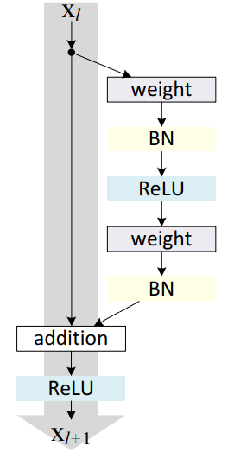
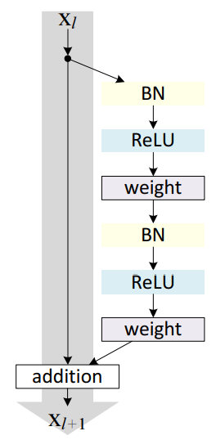
structure : BN → ReLU → Conv → BN → ReLU → Conv → ADD

Structure in paper

7 x 7 64 stride 2
3×3 max pool, stride 2

x 3
1 x 1, 64
3 x 3, 64
1 x 1, 256

x 4
1 x 1, 128
3 x 3, 128
1 x 1, 512

x 6
1 x 1, 256
3 x 3, 256
1 x 1, 1024

x3
1 x 1, 512
3 x 3, 512
1 x 1, 2048

global avg pool, 1000-d fc, softmax
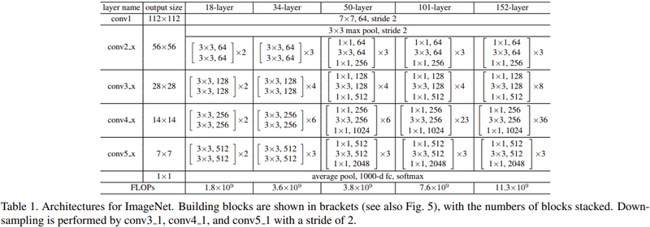
example

input
conv1_conv
conv1_bn
conv1_relu
pool1
conv2_block1_1_conv
conv2_block1_1_bn
conv2_block1_1_relu
conv2_block1_2_conv
conv2_block1_2_bn
conv2_block1_2_relu
conv2_block1_0_conv : pool channel size x 4
conv2_block1_3_conv
conv2_block1_0_bn
conv2_block1_3_bn
conv2_block1_add : 1_0_bn + 1_3_bn
conv2_block1_out

conv2_block2

structure : BN → ReLU → Conv → BN → ReLU → Conv → ADD

