Visual Programming Enviroments - Project

PONG Game

Paul stefan berbec

2015

PONG Game in Java using JavaFX

Contents

2 Short history of early gaming industry 3

3 About Pong 4

4 Mission Statement 5

5 Use Case scenarios 5

6 Application architecture overview 6

6.1 Class diagram 6

6.2 Class dependency diagram 7

# Short history of early gaming industry

Although it wasn't the first, Atari's *Pong*was the first video game to get the **ball** rolling -- or bouncing, as it were. Humble even by contemporary standards, *Pong*was an effort to introduce a video game so intuitive that even a child (or inebriated bar patron) could grasp it instantly.

It was in many ways a reaction to the first commercial arcade video game, *Computer Space*,from 1971, an overly ambitious effort based on *Spacewar!*,a pioneering mainframe computer-based space combat simulation from the 1960s developed by and for engineers (which will be covered in an upcoming article, "*Spacewar!* (1962): The Best Waste of Time in the History of the Universe").

Unfortunately, *Computer Space*proved too complex for the first wave of would-be gamers to handle. Whereas *Computer Space*had boldly gone where no coin-op had gone before, *Pong*merely asked players to "avoid missing ball for high score." The banal but intuitive gameplay made it the right game at the right time.

In 1972, most Americans were just getting used to color television; the idea of playing an actual game on a TV screen was revolutionary. What *Pong*really achieved, then, was demonstrating to the masses that computers were far more than esoteric tools for engineers and rocket scientists. It was the TV game of the future -- a future they were now part of.

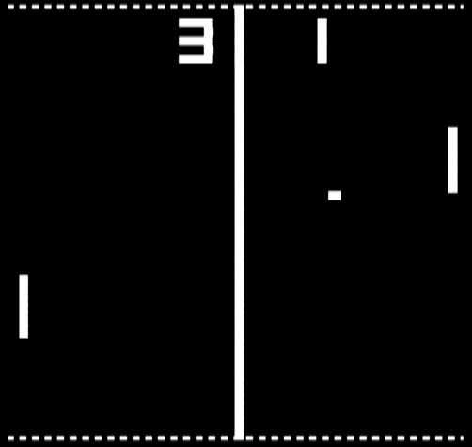  
**A classic image of *Pong* as displayed by the Coleco Telstar Alpha home system.**

The modern video game industry was born on November 29, 1972, in Andy Capp's Tavern in Sunnyvale, California. The game was *Pong*,a machine recently constructed by Al Alcorn, an engineer working for gaming entrepreneurs Nolan Bushnell and Ted Dabney, who had recently incorporated under the name "Atari*.*"

# About Pong

**Pong** is a two-dimensional sports game that simulates table tennis. The player controls an in-game paddle by moving it vertically across the left side of the screen, and can compete against either a computer-controlled opponent or another player controlling a second paddle on the opposing side. Players use the paddles to hit a ball back and forth. The aim is for each player to reach eleven points before the opponent; points are earned when one fails to return the ball to the other.

# Mission Statement

Design a simple PONG game with multiplayer and single player support using Java language. The application will be implemented with JavaFX components.

# Use Case scenarios

# Application architecture overview

## Class diagram

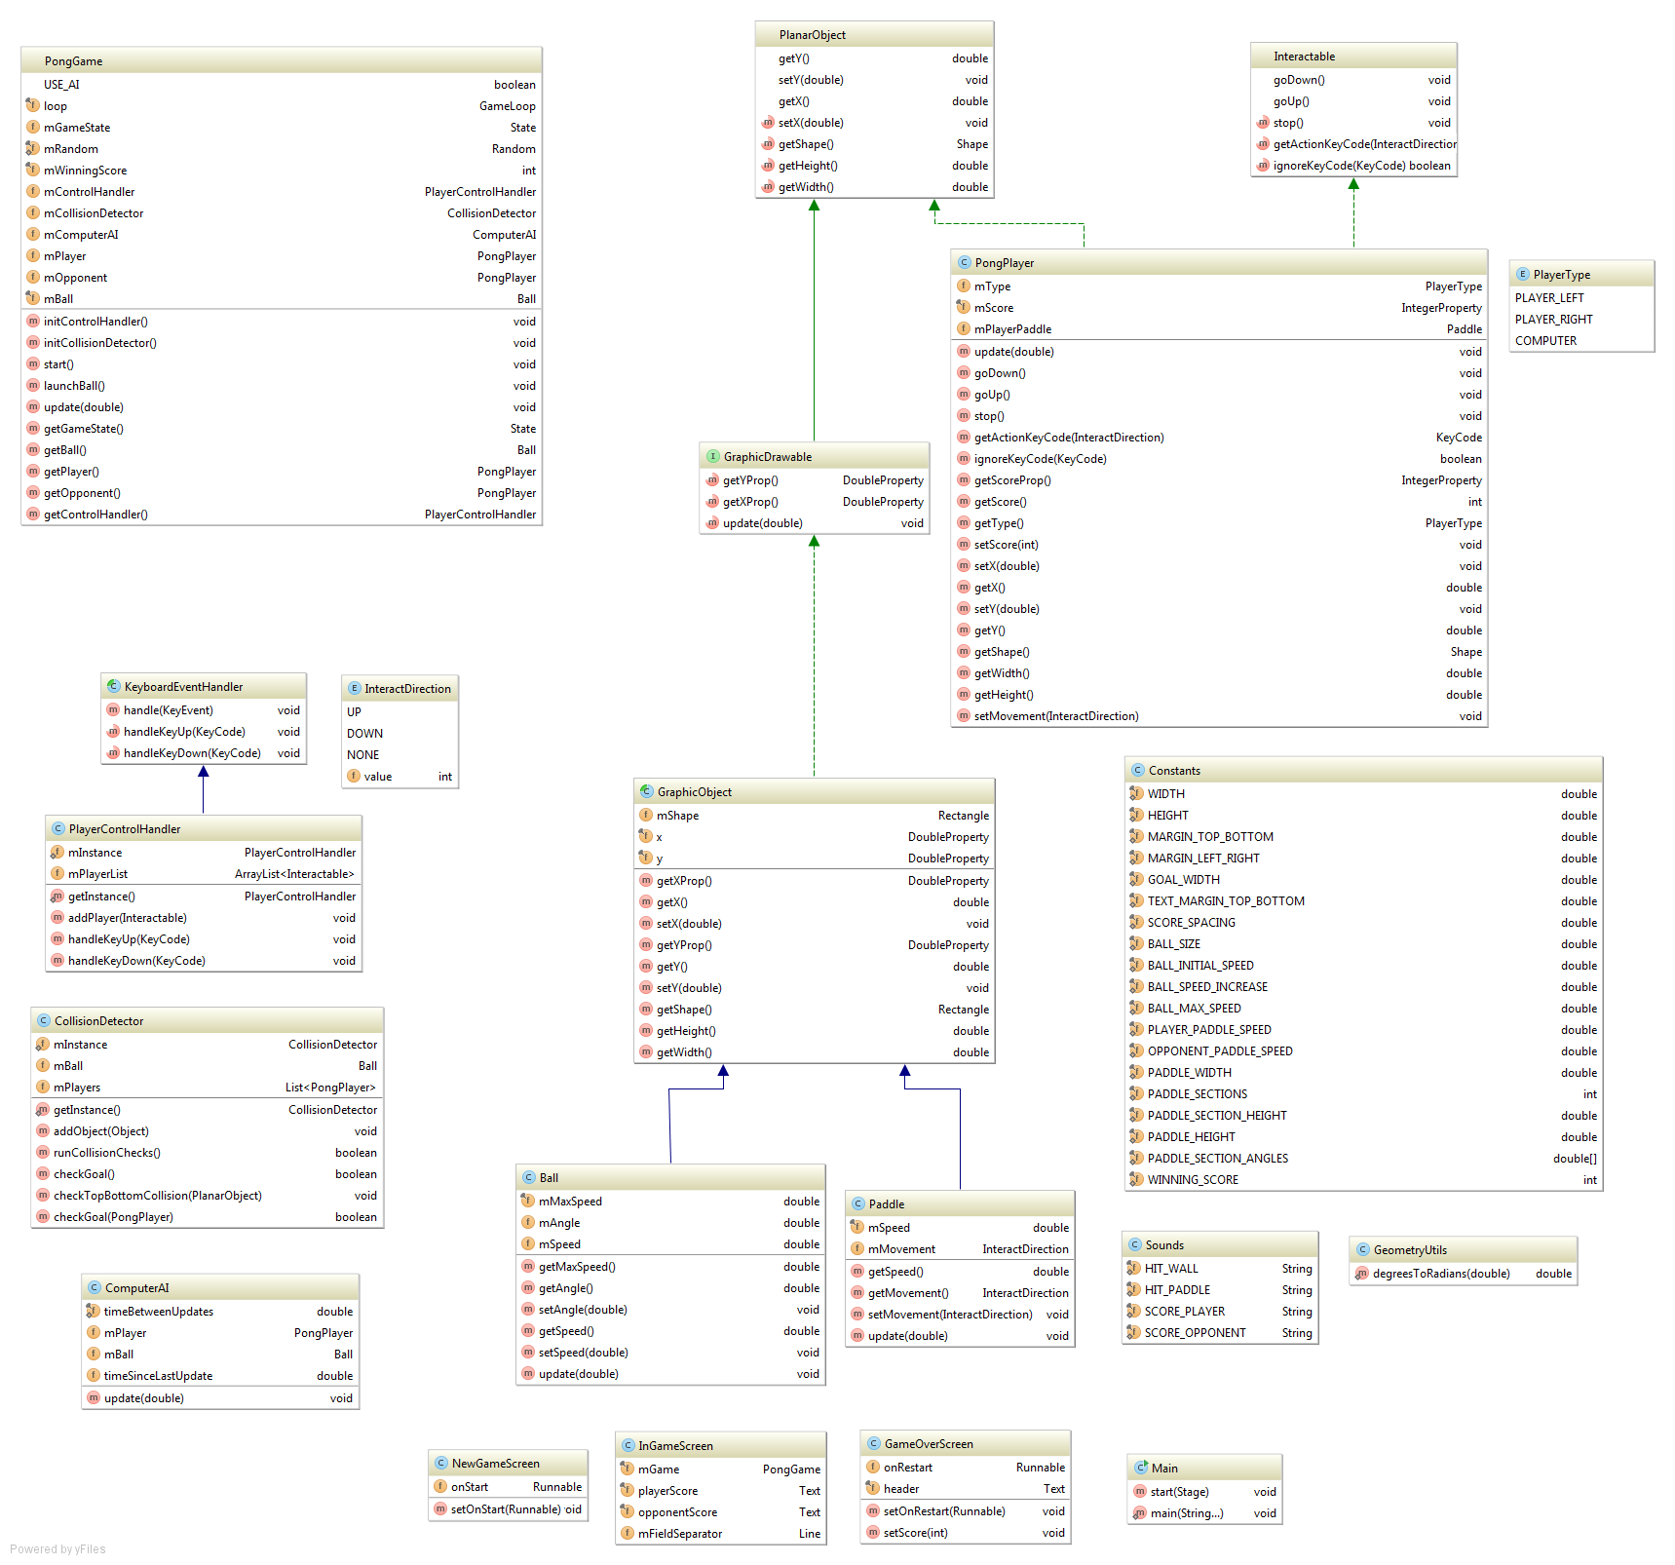

The application is modularly implemented si it can be easily changed. For example we can easily achieve a 4 player version of this game just by adding 2 new players and 2 new control schemas (or apply the ComputerAI for them) in the main game class. Also we could in the future implement a 2 player version but with multiple balls and so on.

## Class dependency diagram

