logo.png

Topic: Horse Club

Quick Intro:

Horse Club is application for Horse management club that will save record of Breeds, Horses, Events and both Logins Credentials i.e. Admin and User Login and Registration.



**Analysis:**  This application is built in ASP.NET. The major feature is about keeping a record of breeds and horses in a single application and much more things like that Keeping record of events to.

**Systems design** – This is a high-level description of how a computer-based system would satisfy the requirements; it is expected to be a single-user system that does not rely on data connection for the primary facility.

**Systems Specifications**

OS -Windows 10

IDE- Visual Studio

**Programming** – ASP.NET and C# was used for functionality completed as a working system in an MVC model.

# Project Goal:

Project Goal to Create a record keeping application for horse Club that enables CRUD operation

# Project Objective:

The main objectives of the project was to enable that admin can login into the project and add the details for record keeping

Resources

|  |  |
| --- | --- |
| Processor | 1 GHz |
| RAM | 512 MB |
| Disk space (minimum) |  |
| 32-bit | 4.5 GB |
| 64-bit | 4.5 GB |

ProjectMilestones

|  |  |  |
| --- | --- | --- |
| **Milestone** | **Time taken** | **Finalized** |
| Designing | 2 Days | Yes |
| Programming | 2 Days | Yes |
| Documentation | 2 days | Yes |

ProjectSchedule

1. The conclusion of the preliminary inquiry

2. Drafted design

3. Approval of the design

4. The prototype programme has been finished.

5. Signed-off stages of programme refinement

6. The programme has been completed.

7. The programme was put to the test

8. Completed system documentation

# Index Page :



# Admin Page

Admin Username : [HorseClub@admin.com](mailto:HorseClub@admin.com)

Admin Passowrd: [HorseClub@admin.com](mailto:HorseClub@admin.com)

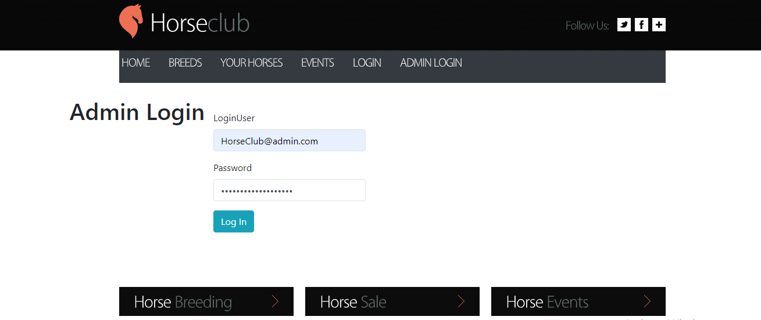

With the Successful admin login admin can add new Breeds in the website and can also Edit, Delete that Breeds



# Add new Event

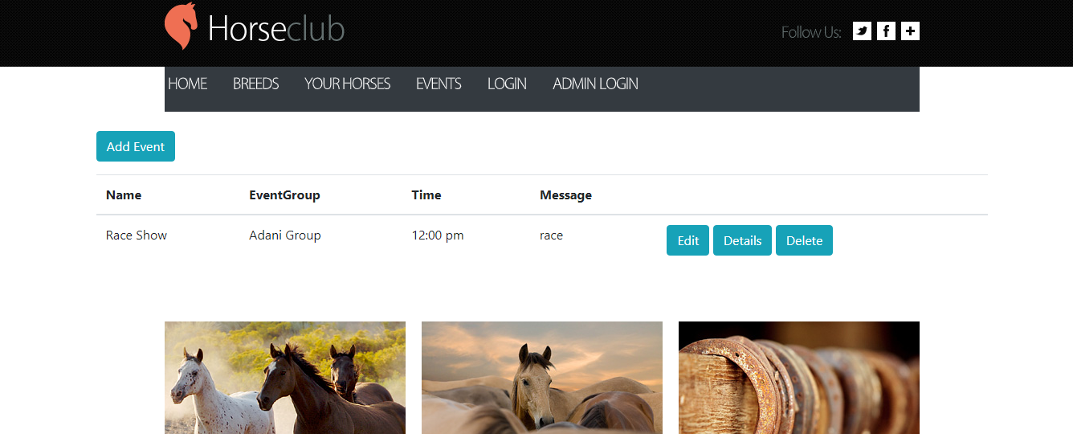

# Create new Account

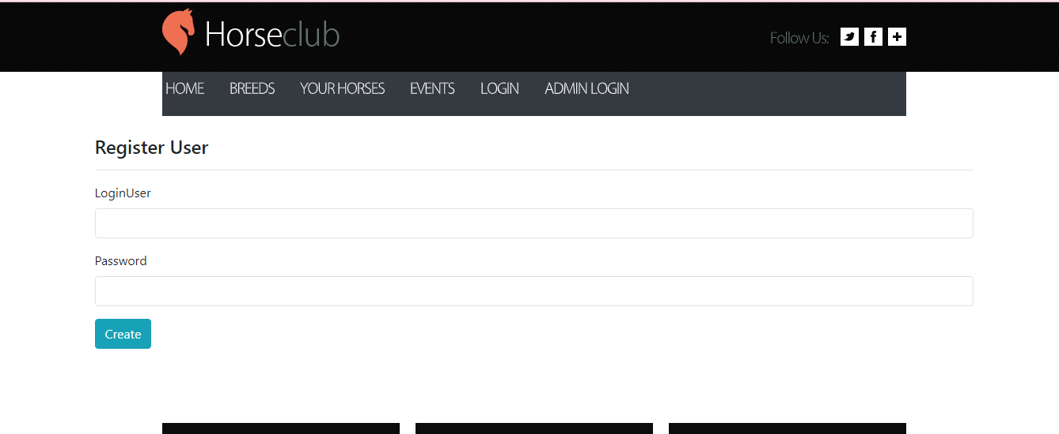

# Add Horses



Hourses can be added by logging user