電通二乙微處理器實驗 實驗結報

實驗名稱 | 期末考
組別 | 67 | 組員 | 游竣傑

- 實驗目的

- 實驗步驟
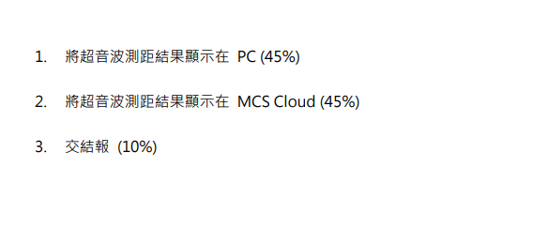
- 程式碼
#include <LWiFi.h>
#include <WiFiClient.h>
#include "MCS.h"
#include <Ultrasonic.h>
#define TRIGGER_PIN 16
#define ECHO_PIN 17
Ultrasonic ultrasonic(TRIGGER_PIN, ECHO_PIN);
// Assign AP ssid / password here
#define _SSID "游竣傑的iPhone"
#define _KEY "12345678"
// Assign device id / key of your test device
MCSDevice mcs("D88c4CM0", "Wp3N6P5ty5jdblQX");
// Assign channel id
// The test device should have 2 channel
// the first channel should be "Controller" - "On/Off"
// the secord channel should be "Display" - "On/Off"
MCSDisplayFloat ulcm("Ultrasonic");
MCSDisplayFloat ulin("ulin");
void setup() {
// setup Serial output at 9600
Serial.begin(9600);
// setup LED/Button pin
// setup Wifi connection
while (WL_CONNECTED != WiFi.status())
{
Serial.print("WiFi.begin(");
Serial.print(_SSID);
Serial.print(",");
Serial.print(_KEY);
Serial.println(")...");
WiFi.begin(_SSID, _KEY);
}
Serial.println("WiFi connected !!");
// setup MCS connection
mcs.addChannel(ulcm);
mcs.addChannel(ulin);
while (!mcs.connected())
{
Serial.println("MCS.connect()...");
mcs.connect();
}
Serial.println("MCS connected !!");
// read LED value from MCS server
}
void loop() {
// call process() to allow background processing, add timeout to avoid high cpu usage
Serial.print("process(");
Serial.print(millis());
Serial.println(")");
mcs.process(100);
// updated flag will be cleared in process(), user must check it after process() call.
float cmMsec, inMsec;
long microsec = ultrasonic.timing();
cmMsec = ultrasonic.convert(microsec, Ultrasonic::CM);
inMsec = ultrasonic.convert(microsec, Ultrasonic::IN);
Serial.print("MS: ");
Serial.print(microsec);
Serial.print(", CM: ");
Serial.print(cmMsec);
Serial.print(", IN: ");
Serial.println(inMsec);
delay(1000);
if (!ulcm.set(cmMsec))
{
Serial.print("Failed to update humidity");
Serial.println(ulcm.value());
}
if (!ulin.set(inMsec))
{
Serial.print("Failed to update temperature");
Serial.println(ulin.value());
}
delay(500);
// check if need to re-connect
while (!mcs.connected())
{
Serial.println("re-connect to MCS...");
mcs.connect();
if (mcs.connected())
Serial.println("MCS connected !!");
}
}

- 實驗電路圖
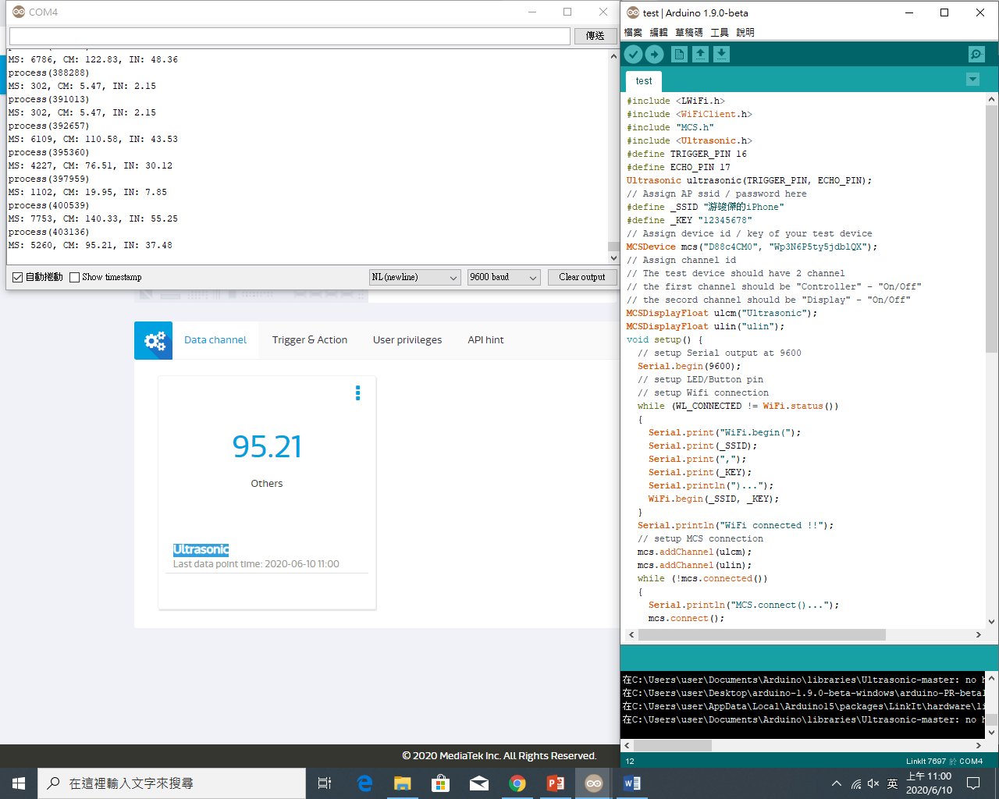
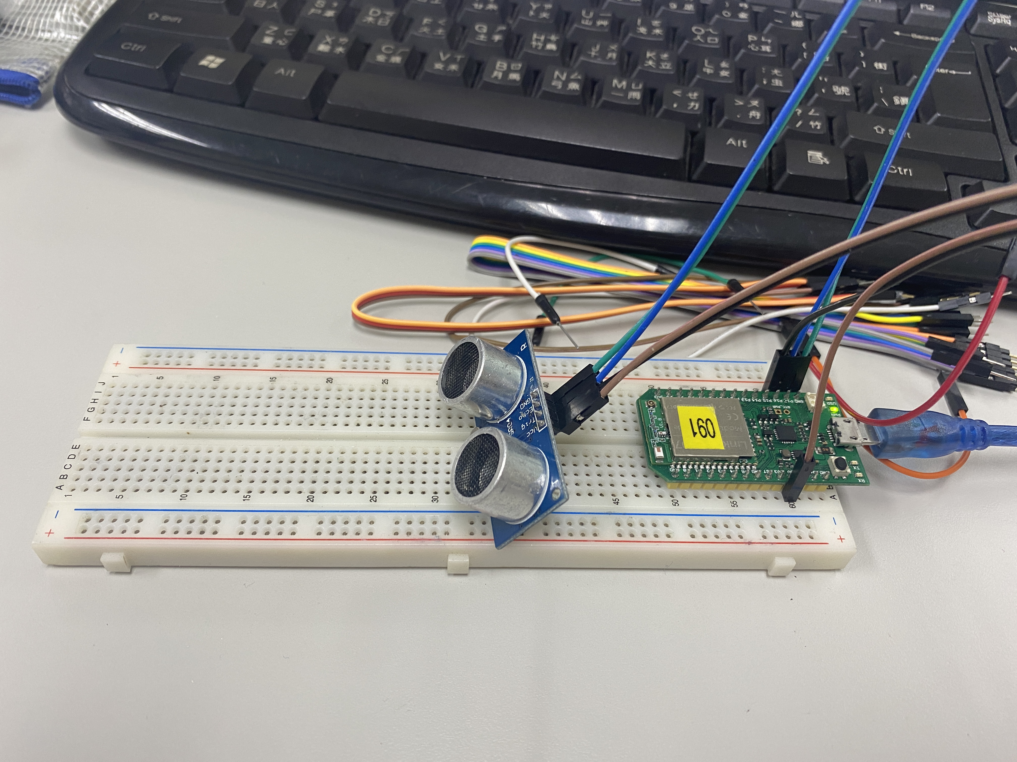

- 心得討論
期末考很有意思，綜合前面實驗，很有趣。

