**Daffodil International University**

Department of Software Engineering (SWE)

Project/Thesis Committee

February 16, 2022

**NOTICE**

This is to notify that student who have registered for the course SWE 431/SE-431/DS 431/RE 431/ CS 431: Final Year Project/Thesis are asked to submit their Project/Thesis proposal by 28/02/2022. In order to submit the Project/Thesis proposal, students are asked to fill up the proposal form. Instruction mention below,

Before go through the instruction please join google class using Code: **oyyojz4**

**Eligibility for Thesis/Project/Internship**

* A student must be completed at least 125 Credits to Enrolled SE-431/DS 431/RE 431/ CS 431: Final Year Project/Thesis
* **Thesis:** Students must have **3.5** CGPA to apply for Thesis. For less CGPA Dept. and Thesis/Project Committee will decide later by their fixed criteria.
* **Project:** Any student can take the project but you must be followed **SDLC** to complete the project. We highly discourage the so-called old management system project. Students must have knowledge in both Back end and front end development for the project.
* Internship: Students must have **3.25** CGPA. Students must work on **renowned software companies** for internships and must work on **SDLC Steps**. Internship time minimum of **4 months** and you must submit **appointment latter** to the Thesis/Project Committee. After filling all the criteria the Thesis/Project Committee will inform you about the result. If the result is negative then you have to take the project to complete your degree.
* **No group allowed, Individual Task .**

1. **Go to website (**[**http://swe.application.daffodilvarsity.edu.bd/final_project/public/register**](http://swe.application.daffodilvarsity.edu.bd/final_project/public/register)**)**
2. **Complete Registration (Fill up Name, Valid email address, Password)**

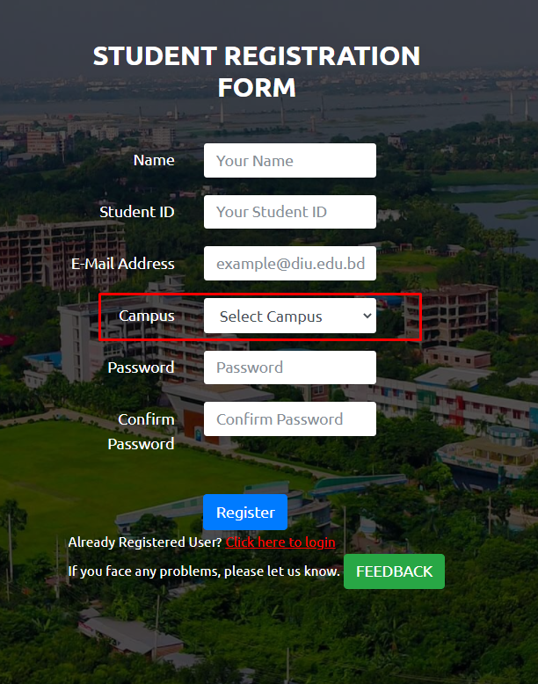

.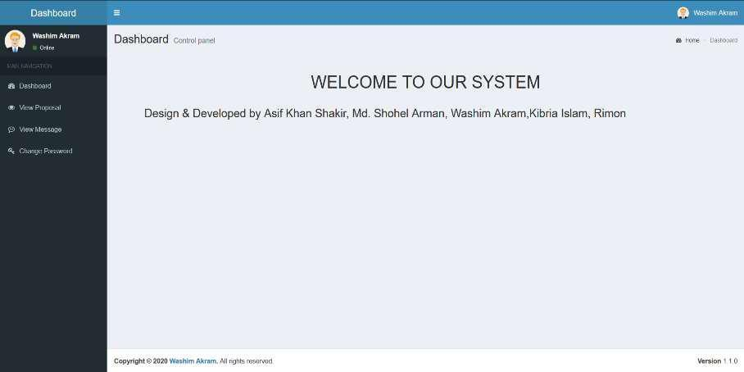

1. **If you are already registered you can be logged in using your student email id and your password.**

**Url:** [**http://swe.application.daffodilvarsity.edu.bd/final_project/public/login**](http://swe.application.daffodilvarsity.edu.bd/final_project/public/login)

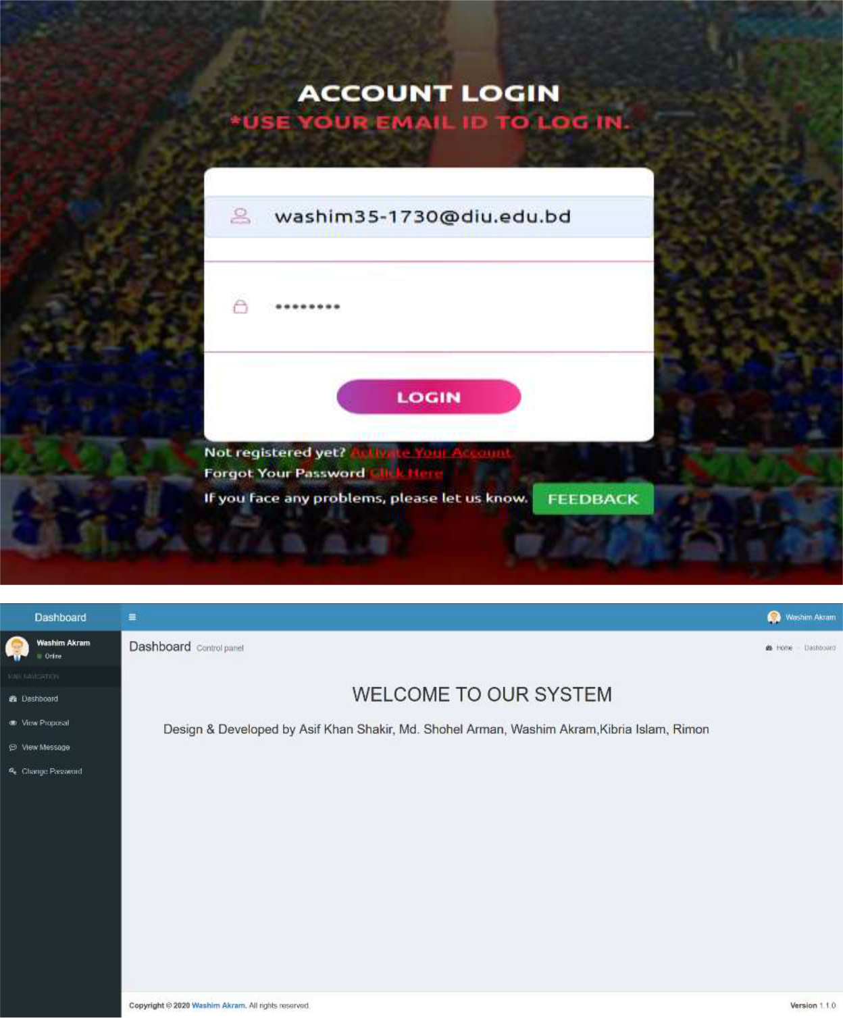

1. **Submit your Proposal Click Here:**

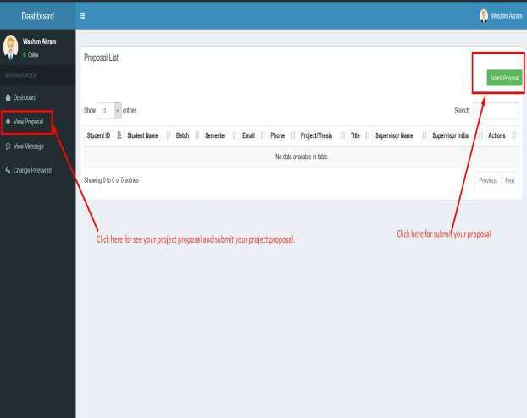

1. **Fill up the proposal form and click submit button. (Fill up Student ID, Batch, Semester, Phone Number, Study, CGPA, Project/Thesis/Internship, Title, Description, * If you want then you can change your name.)**

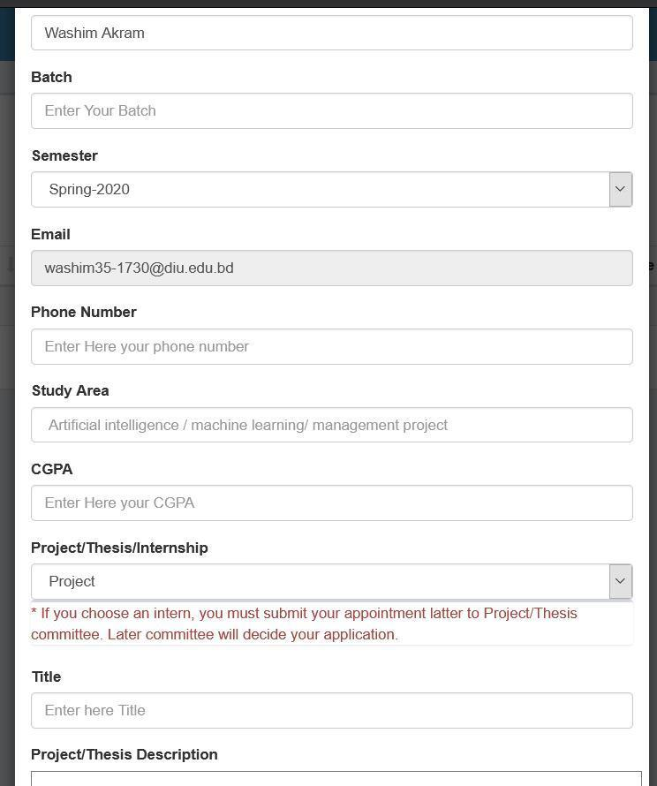

**6. Click View proposal button and see your proposal accepted or pending.**

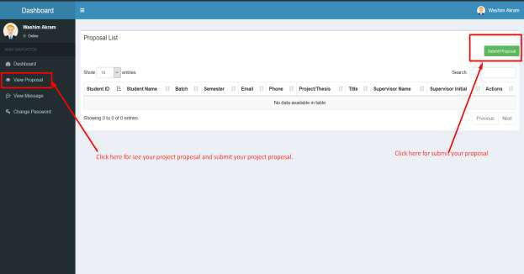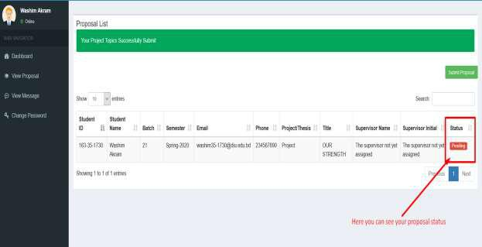

**7. Click view message button and you can see your task.**

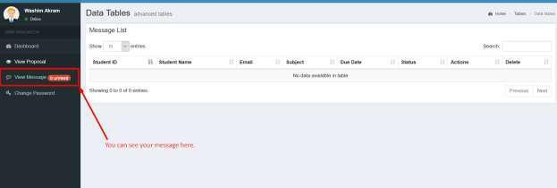

**8. Click view details button then you can see details task.**

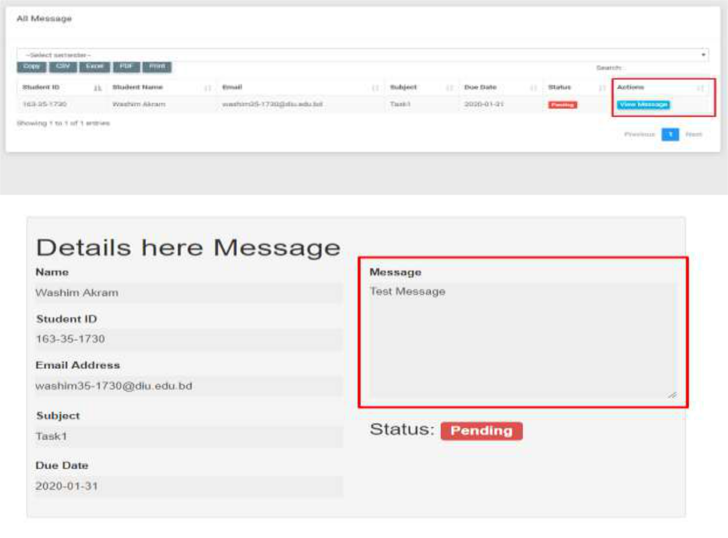

**9. Here you can see notice.**

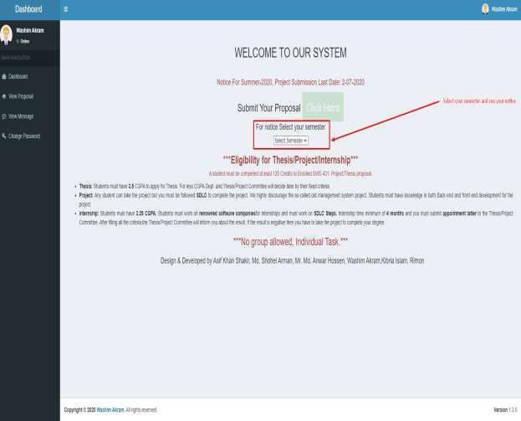

*** Join Google classroom for all the update: **oyyojz4**

**NB: After 28th February 2022 no proposal will be accepted,

**NB: For further queries contact with this number:

01673383289, 01673290848 & 01618401100

Syeda Sumbul Hossain, Md. Shohel Arman, Khalid Been Badruzzaman Biplob

Senior Lecturer & Member, Project/Thesis Committee Department of Software Engineering