# System Requirements for Electoral Runs Web- site

|  |  |  |
| --- | --- | --- |
| **UTCN**  Name of the Student  Group: 30434 | **System requirements for *<*Project Title*>***  *Code: T SWDP System Requirements* | **Page**  **1/5** |

1. **Introduction**

The project presented in this document is a website for managing and pre- senting electoral runs. The platform will:

* Display the list of candidates along with their photos, descriptions, projects, party affiliation, and policies.
* Show information about regions, including the majority political party voted in each region.
* Provide comprehensive information about each candidate, their vision, and potential contributions if elected.

# General View of Actors and Use Cases

**Actors Table**

|  |  |  |
| --- | --- | --- |
| **Actor** | **Type** | **Description** |
| Administrator | Human | The person managing the system, including  adding candidates, updating region details, and managing party information. |
| Visitor | Human | General users visiting the site to view in-  formation about candidates, parties, and re- gional voting patterns. |
| Candidate | Human | Individuals participating in the electoral  run, providing their profiles, policies, and projects. |

# Detailed Description of Actors and Use Cases

## Actors

### Administrator Type: Human

**Detailed description:** The administrator manages the system by adding

or updating candidate information, regional details, and party-related data. They are also responsible for maintaining the accuracy of the information displayed on the website.

### Where used:

* + - * Manage Candidates
      * Manage Regions
      * Manage Parties

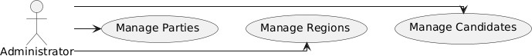

* + 1. **Visitor Type:** Human

**Detailed description:** Visitors interact with the website to browse and explore electoral information, including candidates, their projects, parties, and regional voting data.

### Where used:

* + - * View Candidates
      * View Regions
      * View Party Details

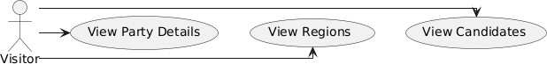

* + 1. **Candidate Type:** Human

**Detailed description:** Candidates are users whose profiles are presented on the website. Their data includes photos, descriptions, project visions, party affiliation, and policies.

### Where used:

* + - * Provide Profile Details

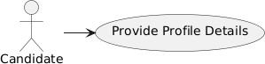

## Use Cases

### Manage Candidates

**Actor:** Administrator **Precondition:** Administrator is authenticated and logged in. **Postcondition:** Candidate details are added or updated in the system. **Behavior:** Administrator adds new candidates, updates their pro- files, or removes candidates.

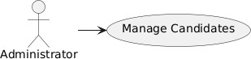

### View Candidates

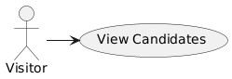**Actor:** Visitor **Precondition:** None. **Postcondition:** Visitor sees the list of candidates with their details. **Behavior:** Visitor selects the candidates section to browse the information.

### View Regions

**Actor:** Visitor **Precondition:** None. **Postcondition:** Visitor views re- gional voting patterns and political party distributions. **Behavior:** Visitor navigates to the regions section for relevant details.

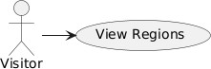

### Manage Regions

**Actor:** Administrator **Precondition:** Administrator is authenticated and logged in. **Postcondition:** Regional details are added or updated in the system. **Behavior:** Administrator adds or modifies data for regions.

