Chicago 311 Data Engineering Project
End-to-End Data Engineering Pipeline
for Chicago 311 Service Requests
Project Documentation

Author: Giorgiana-Paula Crihan
Year: 2026

1. Project Overview
The Chicago 311 Data Engineering Project implements an end-to-end data pipeline for processing and analyzing service requests published by the City of Chicago.
The project uses the Socrata API as its primary data source and combines Python, Apache Airflow, Parquet, DuckDB, and dbt to create a reproducible data engineering workflow.
Service request data is extracted incrementally from the API, stored temporarily in Parquet format, loaded into DuckDB, transformed and validated using dbt, and orchestrated through Apache Airflow. A historical backfill covering 2022–2025 is also included to provide sufficient historical data for year-over-year and ward redistricting analyses.
The pipeline preserves both the current state of service requests and relevant historical changes using dbt snapshots. Data quality tests are included to validate uniqueness, relationships, dates, geographic information, and ward assignments.
The resulting data warehouse is used to answer three analytical questions concerning service request resolution times, repeated or duplicate complaints, and the impact of Chicago's 2023 ward redistricting on request volumes.

2. Architecture
The project is designed as an end-to-end data engineering pipeline that integrates data extraction, storage, transformation, validation, historical tracking, and orchestration.
Chicago 311 Socrata API → Parquet → DuckDB → dbt → Analytical Queries

2.1 Data Extraction
Chicago 311 Service Request data is retrieved from the City of Chicago Socrata API using Python. The regular pipeline uses incremental extraction based on a watermark stored in the pipeline_control table in DuckDB. The last_run_date watermark represents the point from which the next extraction should continue, preventing the pipeline from downloading the complete dataset during every execution. The API extraction also includes pagination and retry logic. Data is retrieved in batches, while temporary server errors (500 and 503) are retried before the pipeline fails.

2.2 Raw Data Storage
The records returned by the API are stored in Apache Parquet format in the raw/ directory. Parquet provides an intermediate storage layer between extraction and warehouse loading and allows the extracted data to be stored in a structured and efficient columnar format.

2.3 Data Warehouse
DuckDB is used as the local analytical data warehouse. Extracted Parquet data is loaded into the warehouse before being transformed by dbt. The warehouse contains the raw service request data, pipeline control information, transformed models, and historical snapshot data.

2.4 Data Transformation and Historical Tracking
dbt is responsible for transforming the raw data into structured, query-ready datasets. The project uses a staging layer for data cleaning, standardization, and type conversion, followed by mart models used for analytical queries. dbt snapshots are used to preserve historical changes in the data, allowing the project to maintain historical information instead of storing only the latest state of a record.

2.5 Historical Backfill
In addition to the regular incremental pipeline, a historical backfill was performed for the period 2022–2025. Because the Chicago 311 dataset contains several million records, the backfill was divided into approximately six-month intervals. This reduces the amount of data processed during a single execution and makes the process easier to manage and restart if necessary.

2.6 Pipeline Orchestration
Apache Airflow orchestrates the regular pipeline through four main tasks: extract, load, transform, and validate. The extract task retrieves new service request records from the Socrata API and stores them as Parquet; load writes the extracted records into DuckDB; transform executes the dbt models; and validate executes the dbt data quality tests. The DAG is scheduled to run daily and includes retry logic to improve pipeline reliability.

2.7 Architecture Diagram
Chicago 311 Socrata API
↓
Extraction (Python)
↓
Parquet
↓
DuckDB
↓
dbt
↓
Models + Snapshots
↓
Analytical Queries
Apache Airflow orchestration:
extract → load → transform → validate
Figure 1. Architecture of the Chicago 311 data engineering pipeline.

3. Implementation Details
The implementation is divided into Python modules, dbt models, and Airflow orchestration components. Each component has a separate responsibility, making the pipeline easier to maintain and test.
Data ingestion. Python modules communicate with the Chicago 311 Socrata API and retrieve records using pagination. Regular executions use the last_run_date watermark for incremental extraction, while historical data from 2022–2025 is processed separately through the backfill procedure in approximately six-month intervals.
Storage and loading. Extracted records are first written to Parquet files and then loaded into DuckDB. The loading process is designed to avoid duplicate service requests, using sr_number as the unique identifier.
Data modeling. dbt transforms the raw records into staging and mart models. The main analytical model, fct_service_requests, contains the service request information required by the three analytical questions, while dim_ward provides ward-related information.
Historical data. dbt snapshots are used to preserve changes over time. Historical ward information is maintained using a Slowly Changing Dimension Type 2 (SCD Type 2) approach, allowing requests to be analyzed according to the ward boundaries applicable at different points in time.
Spatial processing. For the ward redistricting analysis, current ward boundary geometries are retrieved and processed using the DuckDB Spatial Extension. Service request coordinates can therefore be spatially reassigned to the current ward map and compared with their historical ward assignments.
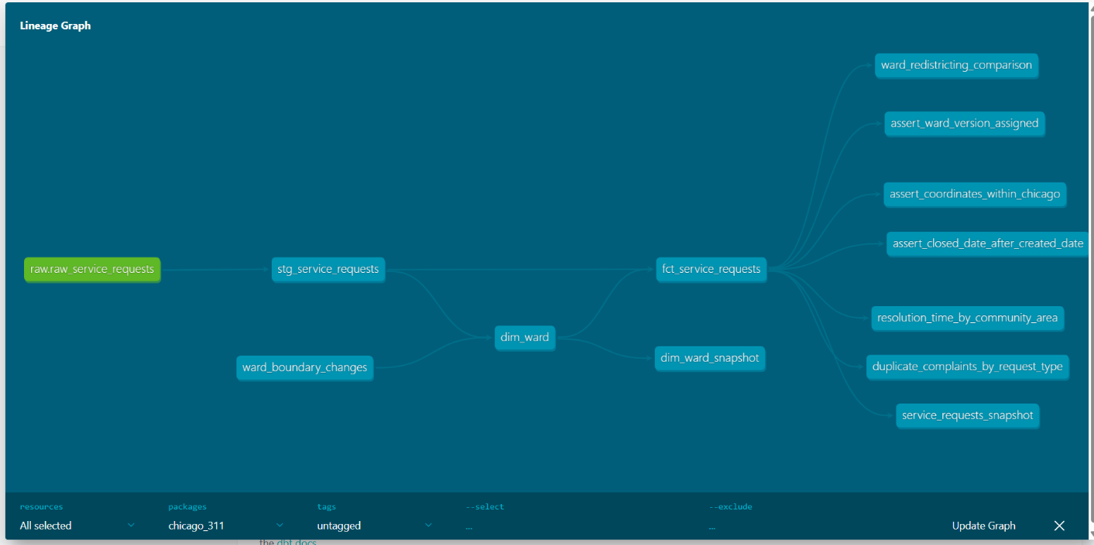Figure 2. dbt lineage graph showing the relationships between the source, staging, and mart models.

4. Airflow Orchestration and Data Quality
Apache Airflow is used to automate and coordinate the regular execution of the pipeline. The chicago_311_pipeline DAG is scheduled to run daily and contains four sequential tasks:
extract → load → transform → validate
The extract task retrieves new records from the Socrata API, load stores them in DuckDB, transform executes the dbt models, and validate runs the dbt data quality tests. The DAG is configured with one retry and a five-minute retry delay. max_active_runs=1 prevents multiple instances of the pipeline from running simultaneously.
The pipeline was also tested for idempotency. After triggering the DAG multiple times, the uniqueness test on sr_number continued to pass, confirming that rerunning the pipeline does not introduce duplicate service requests.

4.1 Data Quality
Seven dbt tests are used to validate the transformed data. They cover:
- uniqueness and non-null validation for sr_number;
- relationships between service requests and the ward dimension;
- validation that closed_date is not earlier than created_date;
- validation of geographic coordinates;
- validation of ward version assignment;
- validation of community_area.
The community_area test uses severity: warn because some source records legitimately contain missing values. These records are retained rather than causing the complete pipeline to fail.
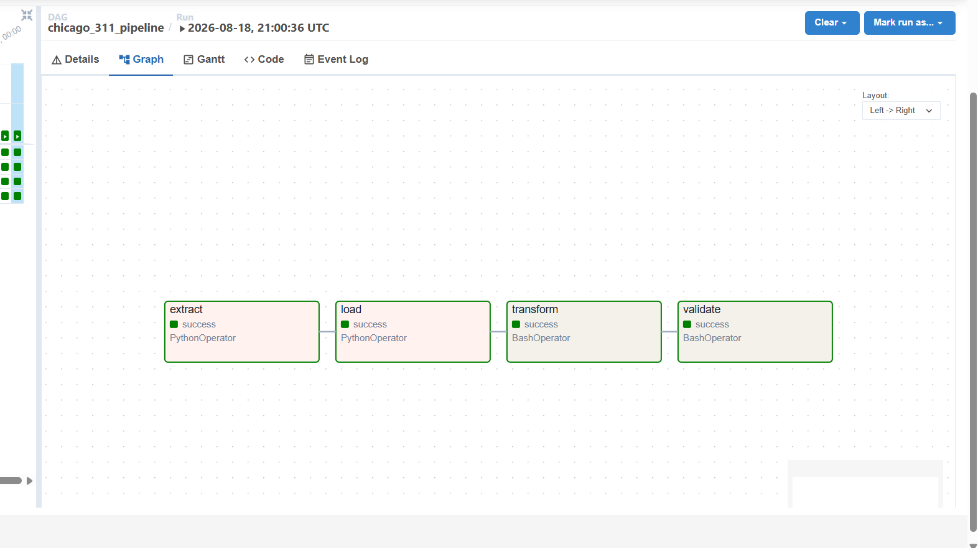
Figure 3. Successful execution of the Chicago 311 pipeline in Apache Airflow Graph View.

5. Analytical Results
The transformed Chicago 311 dataset was used to answer three analytical questions concerning service request resolution times, repeated complaints, and ward redistricting.

5.1 Question 1 – Resolution Time by Community Area
Deliverable question:
Which community areas have the slowest median resolution time for pothole/graffiti requests, and has it improved or worsened year-over-year?

Approach:
The analysis calculates the median resolution time for pothole and graffiti requests by community area and year. The results are ranked to identify the five slowest community areas for each request type, while the previous year's median is used to determine whether resolution performance improved or worsened.
Results:
The results show a significant difference between the two request types. Graffiti removal requests generally maintain short median resolution times of approximately 1–3 days, while pothole complaints show considerably higher variability.
In 2025, Community Area 29 recorded a median pothole resolution time of 51 days, compared with 22.5 days in the previous year. One of the most significant values was observed in Community Area 20 in 2024, where the median reached 81 days, compared with 12 days in 2023.
Conclusion:
Pothole resolution deteriorated in several community areas, particularly during 2024–2025, while graffiti resolution remained comparatively fast and stable.

5.2 Question 2 – Reopened/Duplicate Complaints
Deliverable question:
Which request types have the highest ratio of reopened/duplicate complaints (same location, same type, within a short window)?

Approach:
Requests were grouped by service request type and location and ordered by creation date. A request was considered a possible short-window repeat when another request of the same type had been submitted at the same address within the previous three days. These results were also compared with the official duplicate indicator available in the source data. Request types with fewer than 1,000 records were excluded from the comparison.

Results:
Open Fire Hydrant Complaint had the highest short-window repeat ratio at 37.66%, with 10,281 repeated requests out of 27,297 total requests. It also had a high official duplicate ratio of 41.64%.

Traffic Signal Out Complaint followed with a short-window repeat ratio of 32.36% (33,235 out of 102,700 requests), compared with an official duplicate ratio of 18.12%. Sign Repair Request - One Way Sign had the third-highest short-window repeat ratio at 29.50%, despite only 0.65% of its requests being officially marked as duplicates.
Conclusion:
The results show that short-window repeated complaints and officially identified duplicates do not always correspond. Some request types have a high frequency of repeated reports at the same location even when relatively few records are officially classified as duplicates. This suggests that the short-window analysis can reveal repeated reporting patterns that are not fully represented by the source system's duplicate flag.

5.3 Question 3 – Ward Redistricting Impact
Deliverable question:
Do ward-level request volumes look different when requests are attributed to the ward in effect at the time versus the current ward map, for the years spanning the 2023 redistricting?

Approach:
Service requests from 2022–2024 with valid geographic coordinates were analyzed. The recorded ward represents the historical assignment available in the service request data, while each request was also spatially reassigned using its latitude and longitude and the current ward boundaries. Request volumes were then aggregated by year and ward and compared between the two assignments.

Results:
The comparison shows substantial differences, particularly for requests from 2022, before the 2023 redistricting. For example, Ward 34 decreases from 22,365 requests under the historical assignment to 8,941 using the current ward map, a difference of −60.02%. Ward 2 decreases from 11,290 to 7,548 requests (−33.14%).
The effect is not limited to decreases. Ward 21 increases from 21,956 to 28,078 requests (+27.88%), while Ward 35 increases from 15,010 to 18,468 (+23.04%) when the current boundaries are applied.
Conclusion:
Yes, ward-level request volumes can differ substantially depending on which ward boundaries are used. The largest differences are visible in the pre-redistricting data, demonstrating that applying the current ward map retrospectively can significantly change ward-level statistics. Historical ward assignments should therefore be preserved when analyzing trends across the 2023 redistricting.

6. Challenges and Design Decisions
Several technical challenges influenced the design of the pipeline. One of the main challenges was the large size of the Chicago 311 dataset, which contains millions of service request records. To avoid repeatedly downloading the entire dataset, the regular pipeline uses incremental extraction based on a watermark (last_run_date) stored in DuckDB.
Historical data required a different approach. The 2022–2025 backfill was divided into approximately six-month intervals, reducing the amount of data processed during each execution and making failed runs easier to restart.
To improve reliability when communicating with the Socrata API, the extraction process includes pagination and retry logic for temporary server errors. Extracted data is first stored in Parquet format before being loaded into DuckDB, providing an intermediate raw data layer.
Data quality was another consideration. Some fields, such as community_area, contain legitimate missing values in the source dataset. Therefore, the corresponding dbt test was configured as a warning rather than an error, allowing the pipeline to preserve these records without failing the complete execution.
Finally, the ward redistricting analysis required spatial processing. Request coordinates were combined with current ward boundary geometries using the DuckDB Spatial Extension, allowing historical ward assignments to be compared with assignments based on the current map.

7. Conclusion
The Chicago 311 project demonstrates the implementation of an end-to-end data engineering pipeline for processing and analyzing large-scale public service request data. The solution integrates the Chicago Socrata API, Python, Parquet, DuckDB, dbt, and Apache Airflow to provide automated data extraction, storage, transformation, validation, and orchestration.
The pipeline supports both incremental daily processing and historical backfilling, while dbt models, tests, and snapshots provide structured analytical data, data quality validation, and historical tracking.
The three analytical questions demonstrate how the resulting data can be used to identify differences in service request resolution times, detect repeated complaint patterns, and evaluate the impact of ward redistricting on request volumes.
Overall, the project provides a reproducible and maintainable pipeline that transforms raw Chicago 311 data into validated datasets suitable for analysis.

