Arab Academy for Science and Technology
College of Computing and Information Technology
Department of Computer Science

Grainola
AI-Powered Meeting Intelligence Platform
Web Engineering Course Project Report

Submitted By
Paula Akram Samir
Student ID: 221017681

1. Project Description

1.1 Overview
Grainola is a full-stack, AI-powered meeting intelligence platform inspired by tools like Grain.co and Otter.ai. The platform allows users to upload audio or video recordings of meetings, automatically transcribes them using Groq's Whisper model, generates structured AI summaries using Llama 3, and extracts key highlights. Users can organise meetings into folders, connect their Google Calendar for seamless scheduling, and search across all transcripts and summaries.
The application targets professionals, teams, and students who regularly attend meetings and need an efficient way to capture, review, and act on meeting content without manually reviewing hours of recordings.

1.2 Core Features
- Audio/video upload with direct-to-S3 presigned URL flow
- Automatic speech-to-text transcription via Groq Whisper API
- AI-generated meeting summaries (short + long-form) using Llama 3
- Highlight creation and management for key moments
- Folder-based meeting organisation with colour coding
- Global search across titles, transcripts, and summaries
- Google Calendar OAuth2 integration for importing scheduled meetings
- Tiered subscription system: Free, Basic ($9.99/mo), and Premium ($29.99/mo)
- Responsive, modern UI built with Next.js 14 and Tailwind CSS
- JWT authentication with secure refresh token rotation

1.3 Technology Stack
Layer | Technology | Purpose
Frontend | Next.js 14 (App Router) | React framework with SSR/CSR
Styling | Tailwind CSS + shadcn/ui | Utility-first responsive design
State | TanStack React Query v5 | Server state & cache management
Auth State | Zustand (persisted) | Client auth store with localStorage
Backend | Node.js + Express + TypeScript | REST API server
Database | MongoDB Atlas (M0 Free) | Document database
ODM | Mongoose | MongoDB schema & query layer
Auth | JWT (15 min) + Refresh Tokens | Secure token-based authentication
Transcription | Groq Whisper | Fast speech-to-text
Summarisation | Groq Llama 3 | AI text generation
File Storage | AWS S3 + Presigned URLs | Secure media uploads
Calendar | Google Calendar API v3 | OAuth2 calendar integration
Validation | Zod | Runtime schema validation

2. System Architecture

2.1 High-Level Architecture
Grainola follows a decoupled, three-tier architecture separating the presentation layer (Next.js frontend), the application logic layer (Express API), and the data persistence layer (MongoDB Atlas). Third-party services are integrated at the application layer.

2.2 Component Diagram
FRONTEND (Next.js 14)  React Query • Zustand • Tailwind  Pages: Landing | Auth | Dashboard | Meetings | Pricing  Axios HTTP client with JWT interceptor | BACKEND (Express + TypeScript)  REST API • Zod Validation • JWT Auth  Routes: Auth | Meetings | Folders | Subscription | Calendar  Fire-and-forget processing pipeline
DATA LAYER (MongoDB Atlas)  Collections: Users • Meetings • Recordings • Transcripts • Summaries • Highlights • Folders | THIRD-PARTY SERVICES  Groq Whisper (transcription)  Groq Llama 3 (summarisation)  AWS S3 (media storage)  Google Calendar API (integration)

2.3 Request Flow
- User authenticates via JWT; access token (15 min) stored in memory, refresh token (7 days) stored in MongoDB
- Frontend requests a presigned S3 URL from the backend
- Browser uploads the media file directly to AWS S3 (no server buffering)
- Frontend notifies backend of the completed upload
- Backend creates a Meeting document with status PENDING and returns immediately
- A background processor.service picks up the job: downloads from S3 → sends to Groq Whisper → stores transcript → sends to Groq Llama 3 → stores summary → updates status to COMPLETED
- Frontend polls (React Query refetch) until status changes to COMPLETED

2.4 Authentication & Security
- Short-lived JWT access tokens (15 minutes) minimise exposure window
- Refresh tokens are UUID v4, stored hashed in MongoDB with expiry
- Axios interceptor automatically refreshes expired access tokens transparently
- All sensitive routes are protected by auth middleware verifying the JWT signature
- Plan limits enforced server-side via requirePlan / attachPlanLimits middleware
- Zod schemas validate all incoming request bodies and query parameters

3. Database Schema

Grainola uses MongoDB Atlas (M0 free tier) as its primary datastore, accessed via Mongoose ODM. All collections use MongoDB ObjectIds as primary keys. The schema is designed for document-oriented storage with embedded subdocuments for closely related data and references for normalised relationships.

3.1 Users Collection
Field | Type | Required | Description
_id | ObjectId | Auto | Primary key
email | String | Yes | Unique email address
password | String | Yes | bcrypt hashed password
name | String | Yes | Full display name
googleId | String | No | Google OAuth ID for calendar
googleTokens | Object | No | OAuth access/refresh tokens
subscription | Object | Yes | Embedded subscription subdoc (plan, startedAt, expiresAt)
refreshTokens | Array | No | Active refresh token hashes
createdAt | Date | Auto | Mongoose timestamp

3.2 Meetings Collection
Field | Type | Required | Description
_id | ObjectId | Auto | Primary key
userId | ObjectId ref | Yes | Owner (ref: User)
folderId | ObjectId ref | No | Parent folder (ref: Folder)
title | String | Yes | Meeting title (max 200 chars)
description | String | No | Optional description
meetingDate | Date | Yes | When the meeting occurred
durationSeconds | Number | No | Duration from audio metadata
status | Enum | Yes | PENDING | PROCESSING | COMPLETED | FAILED
calendarEventId | String | No | Google Calendar event ID
createdAt | Date | Auto | Mongoose timestamp

3.3 Additional Collections
- Recordings — s3Key, s3Url, mimeType, fileSize, duration; belongs to one Meeting
- Transcripts — fullText, segments (array of {start, end, text, speaker}), language; belongs to one Meeting
- Summaries — shortText (300 chars), longText (2000 chars), keyPoints (array), actionItems (array), topics (array); belongs to one Meeting
- Highlights — text, startTime, endTime, note, tags; belongs to one Meeting
- Folders — userId, name, color (hex), description, position (display order); belongs to one User

3.4 Subscription Subdocument
- plan: Enum ("free" | "basic" | "premium"), default "free"
- startedAt: Date — when the current plan began
- expiresAt: Date — null for free tier, set on paid plans
Plan limits enforced at the API layer: Free (5 meetings/month, 30 min max), Basic (50 meetings/month, 2 hours max), Premium (unlimited).

4. API Endpoints

All endpoints are prefixed with /api/v1. Protected routes require a valid JWT access token in the Authorization: Bearer header.

4.1 Authentication Endpoints
Method | Endpoint | Auth | Description
POST | /auth/register | Public | Register new user (name, email, password)
POST | /auth/login | Public | Login, returns access + refresh tokens
POST | /auth/refresh | Public | Exchange refresh token for new access token
POST | /auth/logout | JWT | Invalidate refresh token
GET | /auth/me | JWT | Get current authenticated user profile

4.2 Meetings Endpoints
Method | Endpoint | Auth | Description
GET | /meetings | JWT | List meetings (page, limit, folderId, search, status filters)
POST | /meetings | JWT | Create new meeting (title, folderId, meetingDate)
GET | /meetings/:id | JWT | Get single meeting with recordings, transcript, summary, highlights
PUT | /meetings/:id | JWT | Update meeting title, description, folder, date
DELETE | /meetings/:id | JWT | Delete meeting and all related data
PATCH | /meetings/:id/move | JWT | Move meeting to different folder
POST | /meetings/:id/highlights | JWT | Add a highlight to a meeting
DELETE | /meetings/:id/highlights/:hId | JWT | Remove a highlight

4.3 Recordings / Upload Endpoints
Method | Endpoint | Auth | Description
POST | /upload/presigned-url | JWT | Get S3 presigned PUT URL for direct browser upload
POST | /upload/complete | JWT | Notify backend upload is done; triggers async processing

4.4 Folders Endpoints
Method | Endpoint | Auth | Description
GET | /folders | JWT | List all folders for current user
POST | /folders | JWT | Create folder (name, color, description)
PUT | /folders/:id | JWT | Update folder name, color, or description
DELETE | /folders/:id | JWT | Delete folder (meetings moved to root)

4.5 Subscription Endpoints
Method | Endpoint | Auth | Description
GET | /subscription/plans | Public | Get all available plans (Free, Basic, Premium)
GET | /subscription/my-plan | JWT | Get current user subscription details
POST | /subscription/subscribe | JWT | Subscribe to a plan by planId
POST | /subscription/change-plan | JWT | Switch to a different plan

4.6 Google Calendar Endpoints
Method | Endpoint | Auth | Description
GET | /calendar/auth-url | JWT | Get Google OAuth2 authorisation URL
GET | /calendar/oauth/callback | Public | OAuth2 callback; stores tokens
GET | /calendar/events | JWT | Fetch upcoming calendar events
POST | /calendar/import/:eventId | JWT | Import calendar event as a meeting
DELETE | /calendar/disconnect | JWT | Revoke Google Calendar access

5. UI Screenshots

The following screenshots were taken from the live running application, demonstrating the core user interface flows.

5.1 Main Dashboard
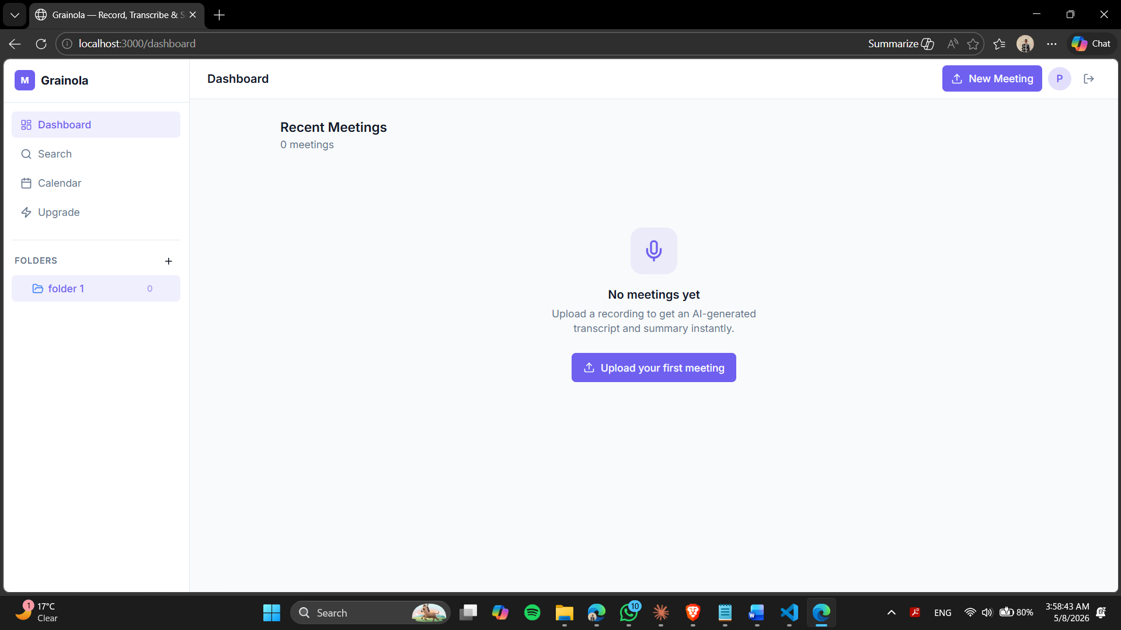
Figure 1: Main dashboard showing meeting list with status indicators and folder navigation

5.2 Authentication — Login 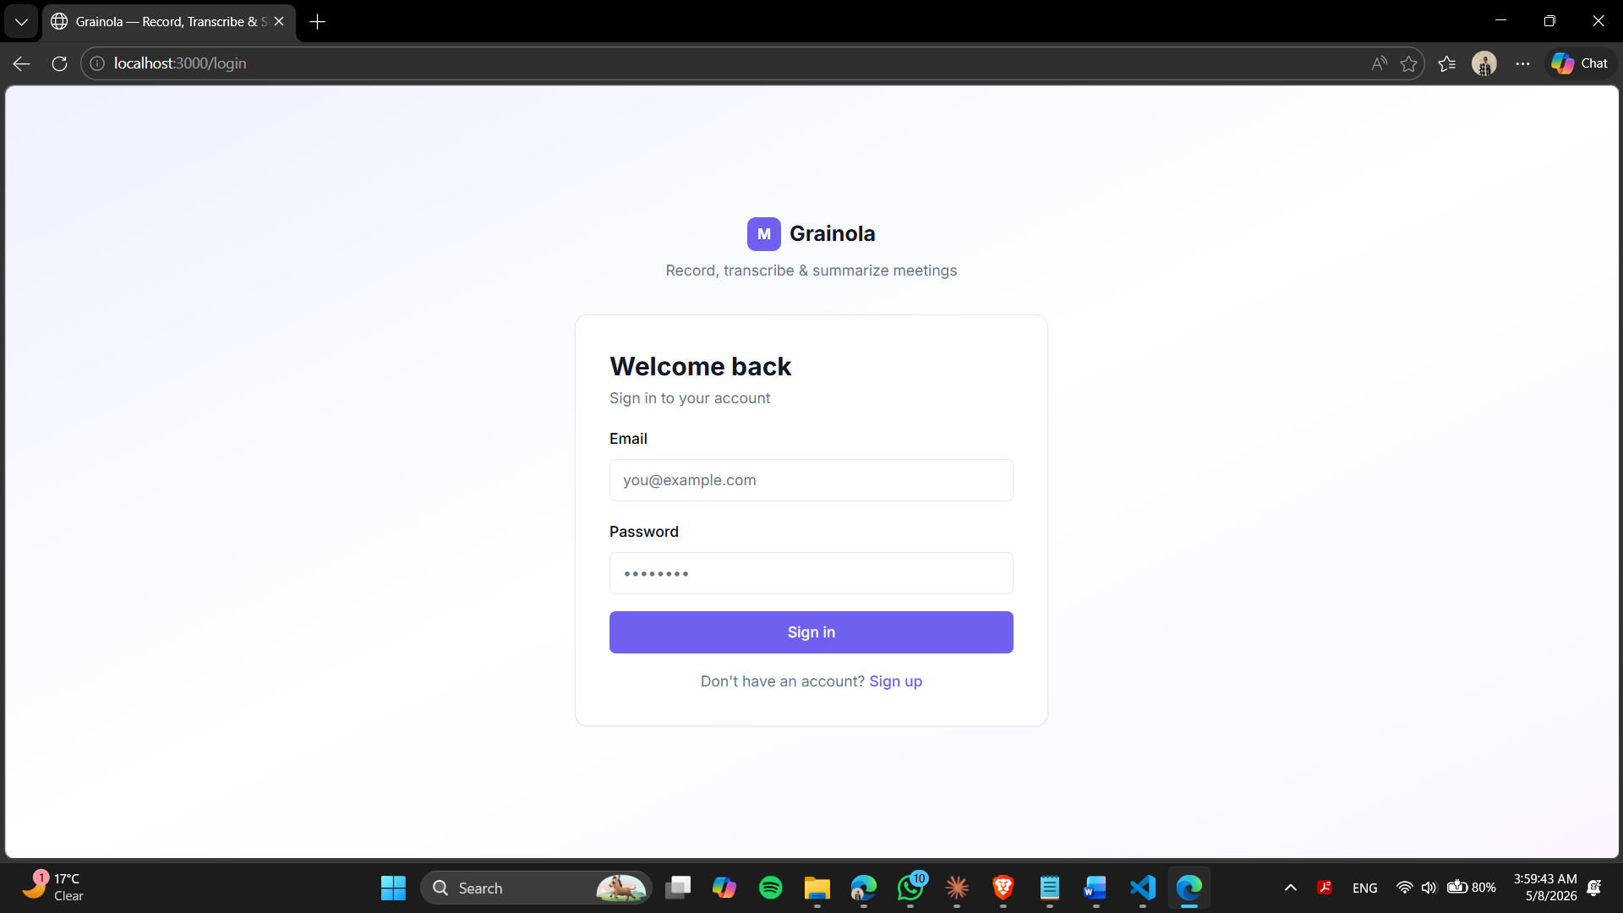
Figure 2: Login page with email/password form and link to registration

5.3 Authentication — Registration
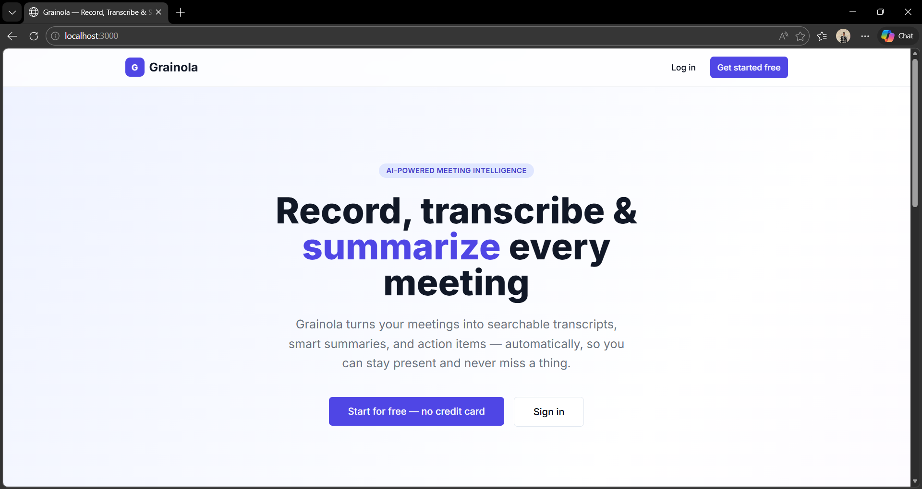
Figure 3: Registration page for new user sign-up

5.4 Meeting Detail View
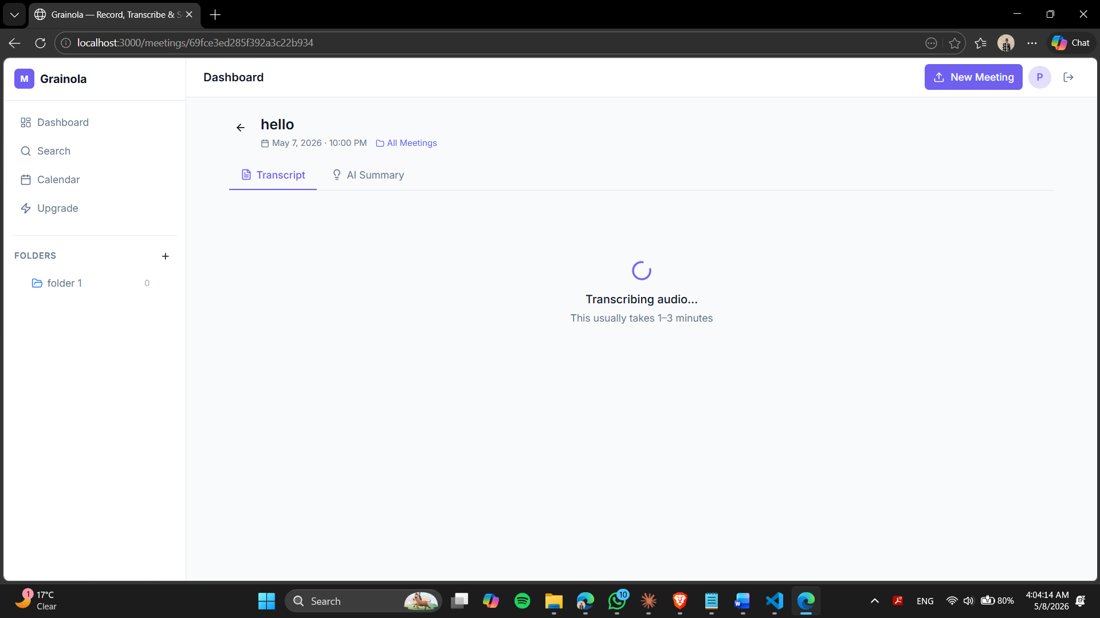
Figure 4: Meeting detail page showing Transcript and AI Summary tabs with processing state

5.5 Search Functionality
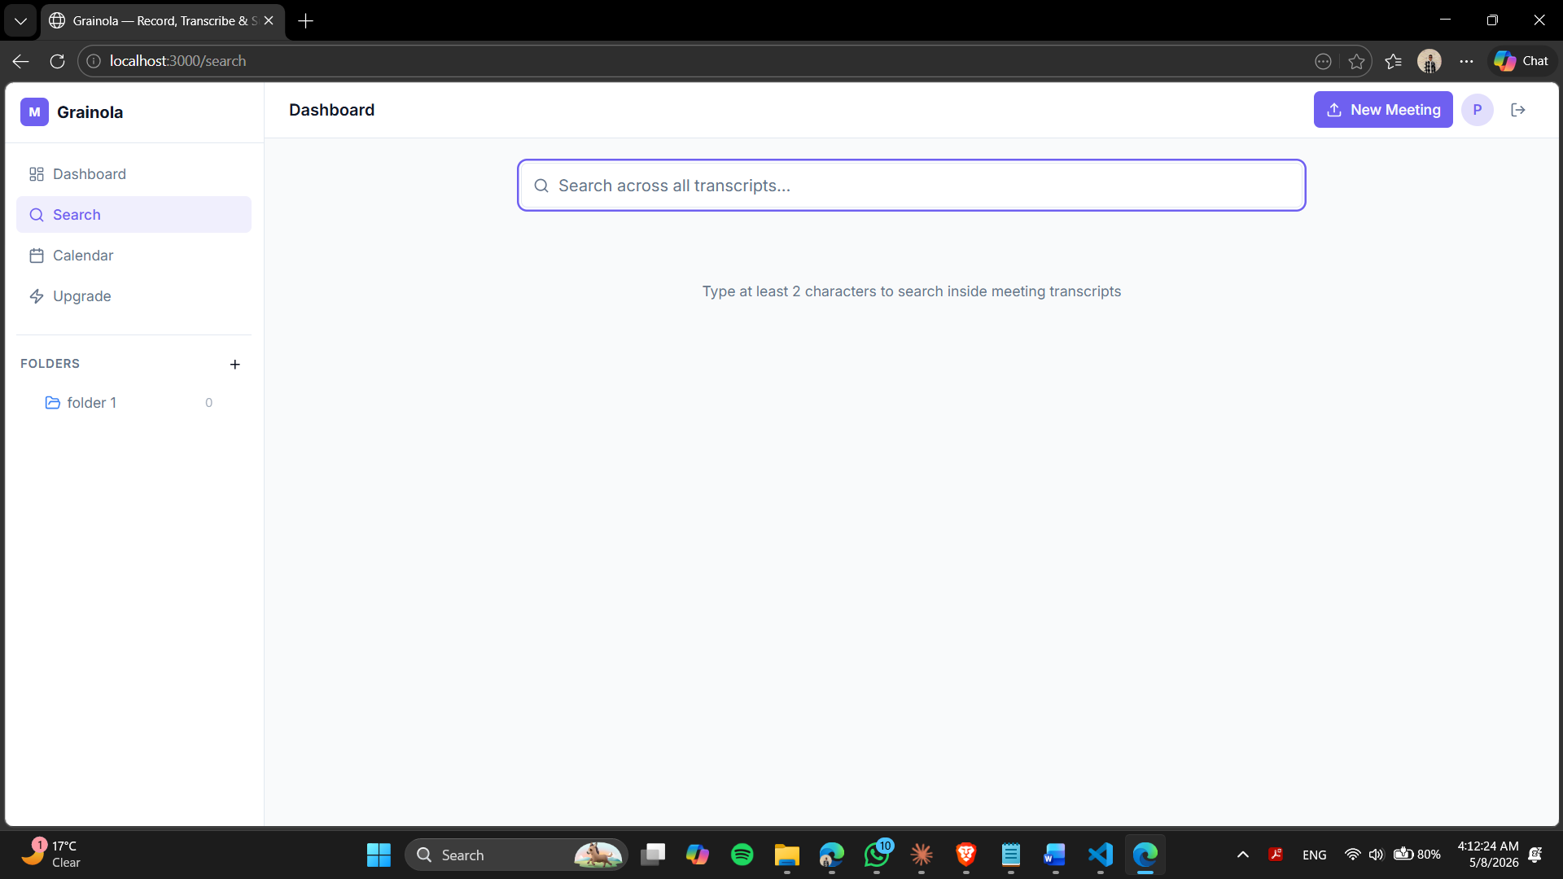
Figure 5: Global search across meeting transcripts and summaries

5.6 Google Calendar Integration
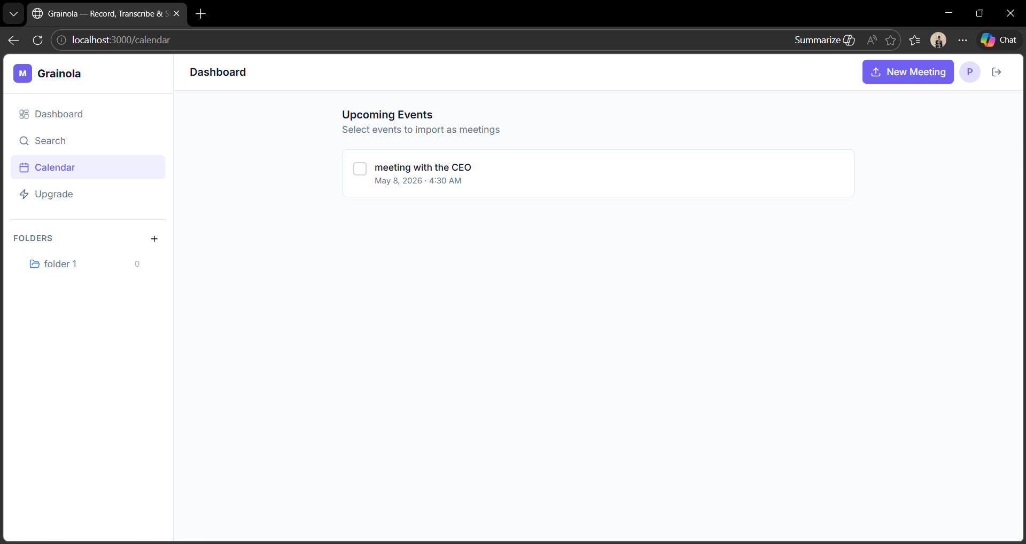
Figure 6: Google Calendar integration page for connecting and importing meetings

5.7 Pricing & Subscription Plans
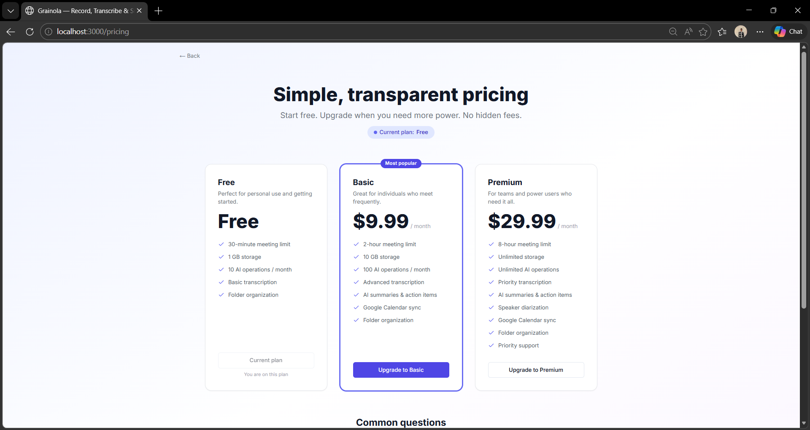
Figure 7: Pricing page with Free, Basic ($9.99/mo), and Premium ($29.99/mo) plan cards

6. Conclusion

Grainola successfully demonstrates a complete, production-grade web application built with modern technologies. The project integrates a Next.js 14 frontend with a Node.js/Express backend, MongoDB Atlas database, and multiple third-party APIs (Groq, AWS S3, Google Calendar) into a cohesive platform.
Key engineering challenges solved during development include: JWT token rotation with transparent refresh, MongoDB Atlas direct connection (bypassing SRV DNS resolution issues in Node.js), a fire-and-forget async processing pipeline for AI transcription and summarisation, MongoDB ObjectId validation (replacing incorrect UUID validators), and null-safe rendering for meetings without folder assignments.
The subscription system demonstrates plan-based access control implemented cleanly as Express middleware, keeping business logic separate from route handlers. The platform is designed to be extensible — adding new AI models, storage providers, or subscription tiers requires minimal changes.
All requirements specified in the Web Engineering course project brief have been fulfilled, including a responsive multi-page application, authenticated REST API, external service integration, and database persistence.

