Paula Bishop WEB 289 Capstone Project Spring 2015

**Media Sources**

*Note—this starts out with original unedited artwork and moves into artwork I created*

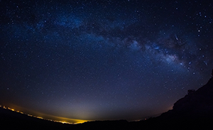

Title: cel-estrellat.jpg

Usage: used in masthead design

Source: <https://eltraductorcatala.wordpress.com/2015/02/16/abendlied-unterm-gestirnten-himmel-canco-de-capvespre-sota-un-cel-estrellat-woo-150-ludwig-van-beethoven/>

 

(original) (altered by me)

Title: whisk_silhouette.png

Usage: used in logo design

Source: <http://sweetclipart.com/whisk-silhouette-859>



Title: magnifying_glass.jpg

Usage: Search partial

Source: <http://www.freevectors.net/details/Free+Vector+Of+The+Day+231133A+Magnifying+Glass>



Title: parchment on roll.jpg

Usage: Sidebar partial

Source: <http://minecraftfanfictions.wikia.com/wiki/File:Scroll_template.jpg>

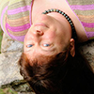

Title: Paula -- Sep 25-2011 -- 22.jpg

Usage: About page

Source: Photoshoot by Paul Howey on September 25, 2011 at Botanical Gardens near UNCA

 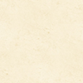

(original) (altered by me)

Title: concrete_seamless.png

Usage: Background

Source: <http://subtlepatterns.com/?s=concrete_seamless>

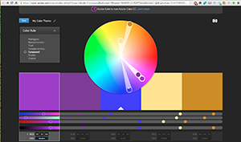 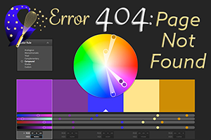

(original) (altered by me)

Title: Screenshot of my Alchemy color theme from Adobe Kuler

Usage: 404 page

Source: <https://color.adobe.com/Alchemy-color-theme-5561054/>

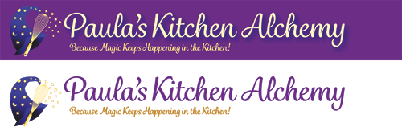

Title: hat and logo_paths.eps

Usage: Original design for masthead, then logo separate from background

Source: Created in Adobe Illustrator CC by me, using Bezier tool to create the hat, with gradient fills, and tracing the whisk, and creating stars using the star tool. Typeface: Grafolita Script medium from Adobe TypeKit



Title: alchemy_mast.jpg

Usage: Masthead for desktop version

Source: Created in Adobe Photoshop CC by me, using the Illustrator file above and the cel-estrellat.jpg and filters on the type layers



Title: alchemy_mobilemast.jpg

Usage: Masthead for mobile version

Source: Created in Adobe Photoshop CC by me, basically cropping down and resizing tagline to be readable at smaller sizes



Title: no_img.jpg

Usage: Default thumbnail photo

Source: Created in Adobe Photoshop CC by me using image from logo

All food pictures (not all shown here, as I keep uploading them when adding recipes) are taken by me with a Panasonic Lumix 12 Megapixel camera over the past several years as I started conceiving the idea of creating a cookbook.

