Video Lessons PoC — status, how it works, questions
Meeting 30 Oct 2026 · end of week 3 · demo planned ~13 Nov

1. Where we are
Area | Status | Note
Lesson from the recordings (topic, length, level → script written by Claude) | Works | Sources cited for every part
Video: narrated slides and animation; highlights follow the voice | Works | Free engine, runs on the laptop
Remotion Pro: motion design and 6 presenter options (robot, cat, 3D and 2D people) | Fixing setup on client laptop | Works in the test environment
Voices: Kokoro (free, local) and ElevenLabs (Starter plan) | In progress | Kokoro sounded more natural in the first test; ElevenLabs improved, retest Monday
Run card for every result (inputs, models, cost) and a comparison page of all versions | Works | Client requirement

2. How it works
The picture and the editable blocks below show the same flow. Edit the blocks directly (type in any box).
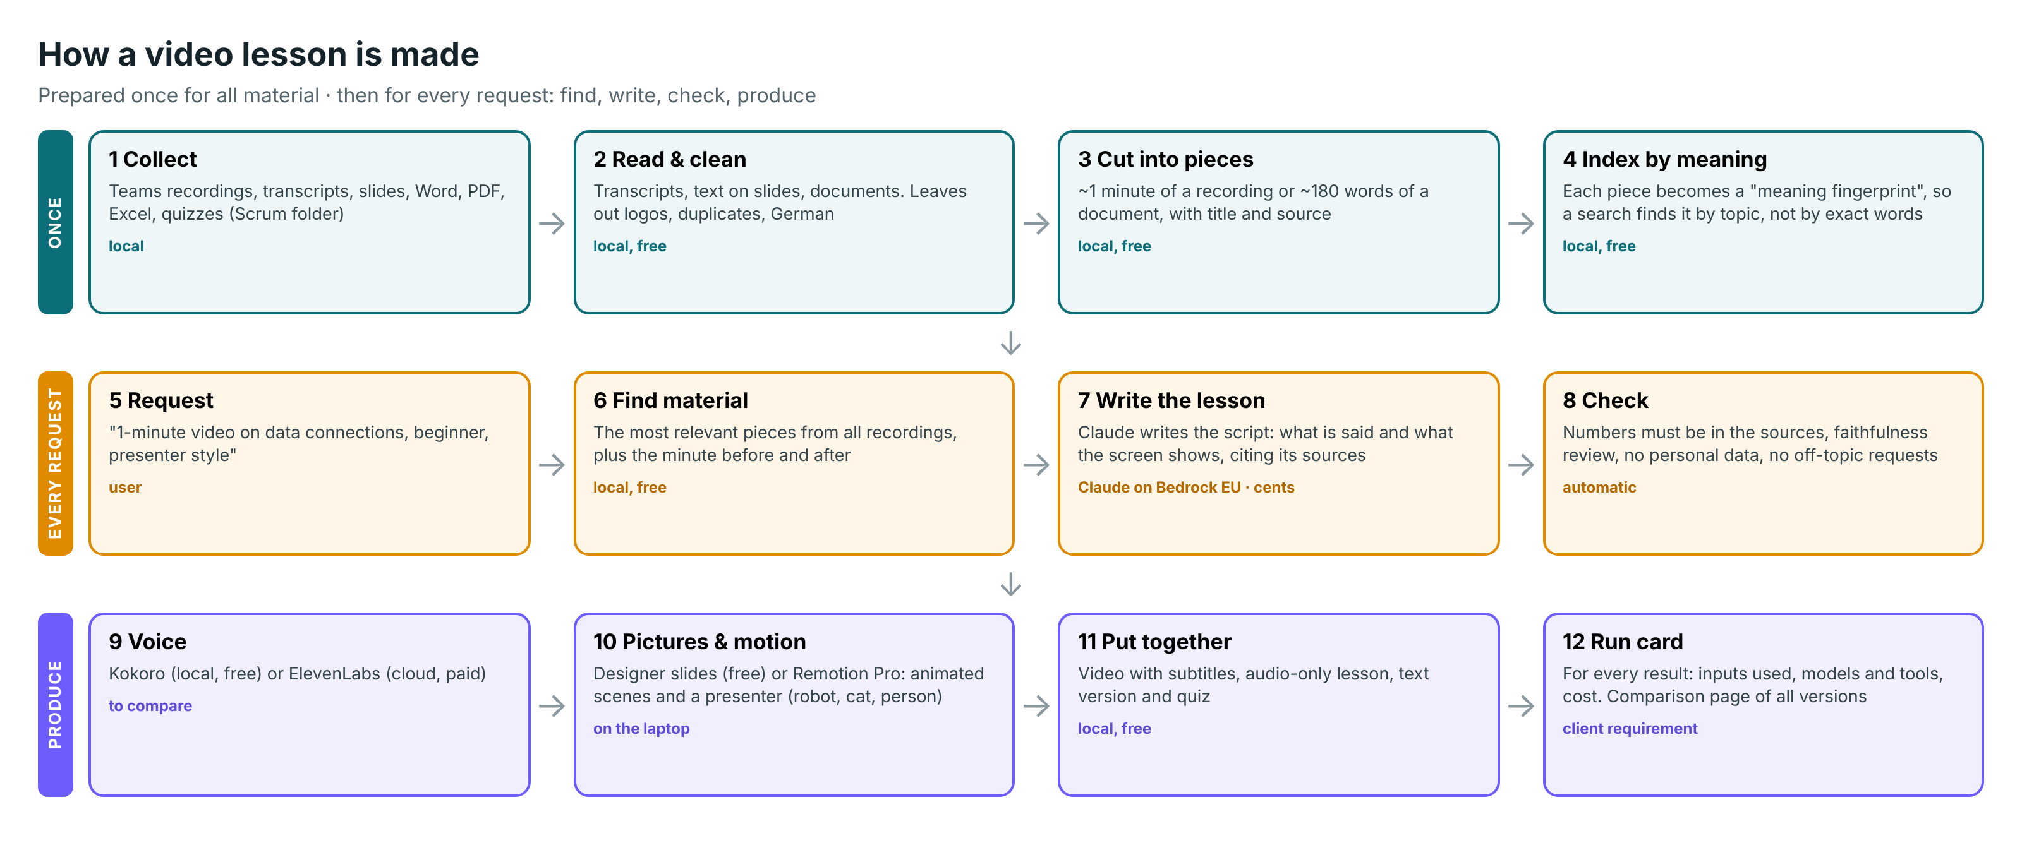

Editable version
ONCE | 1 Collect  Teams recordings, transcripts, slides, Word, PDF, Excel, quizzes (Scrum folder)  local | → | 2 Read & clean  Transcripts, text on slides, documents. Leaves out logos, duplicates, German  local, free | → | 3 Cut into pieces  ~1 minute of a recording or ~180 words of a document, with title and source  local, free | → | 4 Index by meaning  Each piece gets a "meaning fingerprint", so a search finds it by topic, not exact words  local, free
 |  |  |  | ↓
EVERY  REQUEST | 5 Request  "1-minute video on data connections, beginner, presenter style"  user | → | 6 Find material  The most relevant pieces from all recordings, plus the minute before and after  local, free | → | 7 Write the lesson  Claude writes the script: what is said and what the screen shows, citing its sources  Claude on Bedrock EU · cents | → | 8 Check  Numbers must be in the sources, faithfulness review, no personal data, no off-topic requests  automatic
 |  |  |  | ↓
PRODUCE | 9 Voice  Kokoro (local, free) or ElevenLabs (cloud, paid)  to compare | → | 10 Pictures & motion  Designer slides (free) or Remotion Pro: animated scenes and a presenter  on the laptop | → | 11 Put together  Video with subtitles, audio-only lesson, text version and quiz  local, free | → | 12 Run card  For every result: inputs used, models and tools, cost. Comparison page of all versions  client requirement

3. Why it is built this way
Choice | Why | Alternative considered
Search by meaning over all material (steps 4 and 6) | Finds the topic even when people word it differently. Only the relevant parts go to the AI: cheaper, more accurate, works when the library grows | Give the AI everything (breaks with more material); keyword search (misses synonyms)
Claude through the company gateway, EU region | Best writing quality, cents per lesson, the approved route, data stays in the EU | Local open models: free but weaker and slow on the laptop (tested)
Everything else on the laptop (reading, search, voice, video) | Free and no data leaves the laptop | Cloud services: cost and approvals
Every excerpt labelled and cited | Each statement can be traced to a recording and minute, and checked | Free text that cannot be verified
Automatic checks before anything is produced | Catch invented numbers, personal data and requests that try to steer the AI | Manual review only
Several tools side by side, same content | The PoC goal: choose on quality and cost with evidence | Pick one tool up front

4. How it knows which recording to use (example: 3 videos on data connections)
Step | What happens
1. Pieces, not whole videos | Every recording was cut into ~1-minute pieces, each with the recording title, its description and the text on the slides.
2. Compare by meaning | The request ("data connections") is compared with every piece of every recording, not with whole videos.
3. Best matches | The 12 best-matching pieces are taken, each with the minute before and after, so an explanation is not cut mid-thought.
4. Not covered = says so | If nothing matches well enough, it answers that the material does not cover the topic. It does not invent.
5. How much material | If everything relevant fits (~9,000 words) Claude gets all of it; otherwise the best matches up to that limit. A longer lesson gets more material.
6. Result for 3 videos | It uses the best parts of all three, the most relevant recording first, each in the order it was said.
7. Traceable | Each excerpt has a label (S1, S2…). Claude must cite the labels; we map them back to recording + minute in the script and the run card.
8. One recording only | Possible on request: a lesson from one chosen recording.
Not decided yet (needs your input): if two recordings say different things, which one wins (the newest, the official owner)? Do recordings have a date, owner or version we can use?

5. Tested so far
What | Result | Status
Local open-source route (models on the laptop) | Works; writing slower and weaker | Done
Claude Sonnet / Opus through the gateway (EU) | Best quality; cents per lesson | Done
Designer slides with motion (free engine) | Good look, free | Done
Remotion: templates, scenes written by Claude, Pro | Pro looks best; 9–20 min to render one video minute on the laptop; company licence for production | Done
Presenters: robot, cat, 3D people, 2D illustrated people | 6 options; 2D renders 2.4× faster than 3D | Done
Highlights follow the voice | Fixed | Done
ElevenLabs video by code | Only on the Pro plan ($99/month); Starter: web app only | Done
Safety checks: personal data, off-topic requests, invented numbers | Working | Done
Voices: Kokoro vs ElevenLabs | First test: Kokoro more natural. ElevenLabs now gets the surrounding sentences; retest | In progress

6. Still to test before the demo
What | Why | When
ElevenLabs improved voice and better voices (Voice Library) vs Kokoro | Decide whether a paid voice is worth it | Mon 2 Nov
Remotion Pro on the client laptop | Show the animated version on real hardware | Mon 2 Nov
Full comparison: voices × presenters × looks, rated by business | Choose with evidence | Mon–Tue
Music and sound effects on / off | Requested option, with costs | Tue 3 Nov
Realistic AI video: Veo clips, lip-synced presenter (ElevenLabs web app) | Is real-looking video worth the cost? | Wed 4 Nov
NotebookLM, Synthesia, Colossyan with the same topic | Compare with ready-made tools | Wed 4 Nov
Cost per video minute and per month (20 / 100 / 500 videos) | Business decision | Thu 5 Nov
Claude through MCP, Higgsfield (from the last meeting) | To confirm scope | To confirm
Other voices: Azure Speech, Google | Free tiers exist; text goes to these companies | If approved

7. Questions for today
# | Question | Why it matters | Answer / notes
Expectations
1 | What do you expect from me by the end of the PoC? Which deliverables, in what form? | Focus of the last 2 weeks
2 | Demo: date, audience, length, what must be shown (text / audio / slides / animation)? | Plan the demo
3 | How will you judge success (quality, cost, speed)? Who rates the comparison? | Clear decision criteria
4 | Do you have any questions for me, or is anything unclear so far? | Close gaps early
Your target picture
5 | You have a picture of how it should work. Can you share it, so I map our 12 steps onto it? | Build towards your target, not a guess
6 | Where should the material library live on the platform, and who adds new material? | Steps 1–4 after the PoC
7 | Which parts become agent skills (find material, write lesson, make video)? Who is my developer contact and from when? | Step after the PoC
8 | Where are videos made after the PoC (server, GPU), and where are they published (e-learning platform, format)? | A laptop needs 9–20 min per video minute
Content rules
9 | If recordings on one topic differ, which wins (newest, official owner)? Do they have a date / owner / version? | See section 4
10 | Material to exclude or always prefer? Do users see only material they have access to? | Correct and allowed content
11 | Must a person review a lesson before it is published? | Process and effort
Decisions and budget
12 | Which look and presenter (see the options sheet)? | Narrow the tests to 1–2
13 | Is the free local voice enough, or a paid ElevenLabs voice? Monthly budget? | Starter $6 → Creator $22 → Pro $99
14 | Remotion for production needs a company licence (from $100/month). Buy it, or keep the free engine? | Licence
15 | Realistic AI video in the PoC (ElevenLabs Pro, $99/month) or later? | Budget approval
16 | May I trial Azure Speech, Google voices, Synthesia, Colossyan? The lesson text goes to these companies | Approvals
17 | The cat and one 2D style need an author credit (CC BY). Is that acceptable? | Licences

8. Next two weeks
When | What
Mon 2 Nov | Remotion on the client laptop; full comparison of voices and presenters
Tue 3 Nov | Voice decision; version with music
Wed 4 Nov | Realistic AI video, NotebookLM, Synthesia, Colossyan → comparison
Thu 5 Nov | Cost model; update the solution design
Fri 6 Nov | Demo dry run with you
9–12 Nov | Fixes, demo material, how to move it onto the platform
~13 Nov | Demo

