Standard DEB equations for H. tuberculata
L. Pecquerie – 2013/03/14
Paulo F. Lagos 2023/04/18

Table of Contents
1 Stylized facts and empirical effects of ocean acidification on the European Abalone 2
2 Stylized facts and empirical effects of ocean acidification on marine invertebrates. 3
General Hypothesis: 3
3 Forcing variables 4
4 State variables – Initial conditions 4
5 Primary parameters (rates are at reference temperature $T1=20$°C) 4
6 Auxiliary and Compounds parameters 5
7 Ocean acidification specific parameters 5
8 Shell growth parameters 5
9 Scaled functional response 6
10 Temperature correction 6
10.1 List of temperature corrected parameters 6
11 DEB model fluxes (J.d⁻¹) 7
12 Differential equations 8
13 Observable variables 9
14 Summary of data for model calibration 9
15 Possible plots options 9

Stylized facts and empirical effects of ocean acidification on the European Abalone
 | Facts |  | Empirical evidence
Feeding | F1 | Feeding rate slightly increase at higher pCO₂ | Guo et al., (2022)
Shell | S1 | Shell weight decrease | Azoux-Bordenave et al., (2022)
 | S1 | Spherulitic layer thickness decrease
 | S3 | Shell length decreases in juveniles exposed to low pH | Azoux-Bordenave et al., (2020); Azoux-Bordenave et al., (2022)
 | S3 | After 48hpf calcification is reduced | Kavousi et al., (2022); Wessel et al., (2018)
Mortality | M1 | Larval survival decreases | Weesel et al., (2018); Azoux-Bordenave et al., (2022)
 | M2 | Larval viability decreases only in pre-metamorphic larvae (96hpf) | Weesel et al., (2018)
Physiology | P1 | No effects on swimming activity | Kavousi et al., (2022)
 | P2 | No effects on respiration rates in larva or adults | Kavousi et al., (2022); Avignon et al., (2020)
 |  | No effects on excretion rates on adults | Avignon et al., (2020)
 | P2 | Lower hemolymph pH | Avignon et al., (2020)
 | P3 | Genetic expression reduced | Azoux-Bordenave et al., (2022)
Growth | G1 | Reduction in length at 96 hpf in larvae | Azoux-Bordenave et al., (2022)
 | G2 | growth continues and do not slow down after reproductive events.
 | G3 | Shell is roughly 1/3 of the total weight.
 | G4 | France Haliotis abalone growth faster and to a larger size compared to wild abalone thanks to genetic selection. | Sabine personal observations
 | G5 | Farm abalone are moved from a nursery area to sea pens after 32 months where a following shift in diet and temperature occurs, this shift is generally observable and related to an abrupt change in the coloration of the shell. Does this color change translate into observable differences in growth rates before and after the transition from nursery to sea pens? | Sabine personal observations
Reproduction | R1 | No effect on fertilization success | Azoux-Bordenave et al., (2022)
 | R2 | No effect on number of eggs releases | Azoux-Bordenave et al., (2022)

Stylized facts and empirical effects of ocean acidification on marine invertebrates.
 | Facts |  | Empirical evidence
Feeding | F1 | Clearance and ingestion rates tend to decrease with increased pCO₂ but this trend is more representative for larval stages and at pCO₂ levels higher than current atmospheric levels. | Parker et al., (2013); Vargas et al., (2022);  Clements and Darrow (2018)
 | F2 | Typically warming and acidification tend to alter behavior by decreasing activity level or movements and increase grazing rates | Bass & Falkenberg, (2023);
Shell | S1 | Shell density and weight decrease in juveniles and adults | Azoux-Bordenave et al., (2020); Vargas et al., (2022)
 |  | More acidic environment of the extrapallial fluid which is in direct contact with newly formed nacre layers, negatively impacts the energetics of CaCO₃ deposition and/or organic matrix formation, or even the interaction between organic and mineral phase construction | Pörtner et al., (2004)
 | S2 | Calcification rates can decrease up to 60% in young larval stages. | Kavousi et al., (2022); Frieder et al., (2017)
 | S3 | Decreases in shell growth could be partly explained by higher maintenance requirements for cellular homoeostasis and a shift towards unfavorable nitrogen cycling causing reduced protein accretion rates. As a consequence, calcification may not necessarily be affected exclusively by lowered [CO₂⁻³] in body fluids and ambient seawater but also in a secondary fashion by lowered net protein deposition. | Pörtner et al., (2004)
Mortality | M2 | Survival is among the traits most impacted by ocean acidification across taxa but most representative on larval stages. | Vargas et al., (2022) ; Pansch et al., (2013); Kimura et al., (2011);  Griffith and Glober, (2017)
Physiology | P1 | Sensitivities and vulnerabilities to ocean acidification increase when facing an increase in temperature or other environmental stressor and can affect energy balance via disrupting acid-base homeostasis. An energy demanding process that elevates energy costs of biomineralization. | Sokolova, (2021); Clark (2020); Vargas et al., (2022)
 | P2 | Shell formation is a metabolically expensive process influenced by ion availability, temperature and nutritional state. Estimates of the amount of energy required to produce a unit of shell vary largely between studies but may be as large as ~60% of the available assimilated energy. | Mayk et al., (2022); Sanders et al., (2018)  Figuerola et al., (2021)
 | P3 | Effects of ocean acidification on respiration rates are minimal across taxa. However, younger life stages more susceptible than adult so present higher respiration rates with increasing pCO₂. However, at high pCO₂ treatments. | Vargas et al., (2022);  Lim and Harley, (2018)
 | P4 | Maintained or increased rates of calcification under hypercapnia may be crelated to partial or full extracellular pH compensation, as the extracellular pH regulatory response results in an accumulation of extracellular bicarbonate. This might alter the transport kinetics of HCO⁻³ across calcifying epithelia or directly increase carbonate saturation states (Ω) at the site of calcification. Increased calcification has so far only been observed in species that perform strong pHe regulatory responses (cephalopods, decapod crustaceans and fish). | Ries et al., (2009); Checkley et al., (2009) ; Comeau et al., (2010)
 | P5 | Hypercapnia elicits a reduction in aerobic metabolism in marine organisms (metabolic depression) as a result of acid–base disturbances. | Pörtner et al., (2004)
 | P6 | Lower O:N ratios, resulting from increased NH⁺⁴ excretion as a consequence of osmoregulatory demands, can explain reduced growth rates due to enhanced unfavorable protein metabolism. Higher amino acid metabolism is energetically less efficient compared to turnover of carbohydrate and lipid as it implies a continuous energy loss by enhanced excretion. | Tenderger & Kautsky, (1986); Tendergen et al., (1987)
Growth | G1 | Increased acidification reduces growth rates specially in younger developmental stages and overall decrease growth | Zhao et al., (2023), Vargas et al., (2022)
 | G2 | Increased acidification can delay development in larval stages | Frieder et al., (2017);  Figuerola et al., (2021)
 | G3 | somatic growth is not necessarily strongly affected by elevated pCO2 as the calcification process. | Pörtner et al., (2004)
Reproduction | R1 | Reduced or impaired reproduction, but impact on reproduction is less or minor compared to other fitness related traits. | Vargas et al., (2022), Glass et al., (2023)
Overall | O1 | Sensitivity indicators such as the standard metabolic rate, aerobic scope, growth, morphology, calcification, maintenance of acid–base balance, immune response, fertilization, sperm motility, developmental time, changes in gene expression patterns, behavioral changes and abundance in response to ocean acidification exposure show that for mollusks there are almost no positive effects associated with ocean acidification even at low partial pressures of pCO₂ of 500 – 650 μatm. | Wittman and Pörtner, (2013); Sokolova (2021); Scherer at al., (2022); Parker et al., (2013)
 | O2 | Species sensitivities and vulnerabilities to ocean acidification increase when facing a increase in temperature or other environmental stressor and can affect energy balance via disrupting acid-base homeostasis. An energy demanding process that elevates energy costs of biomineralization | Sokolova, (2013); Sokolova, (2021); Scherer at al., (2022)
 | O3 | Elevated metabolic rates due to ocean warming will probably challenge the energy budgets even more, leaving less energy for growth of calcified structures. | Pörtner et al., (2004)
 | O4 | At current levels of pCO2 a general response is that metabolism rises and shell growth rates decrease while somatic growth is preserved under elevated seawater pCO2 | Pörtner et al., (2004)

General Hypothesis: Animals with higher metabolic rates or levels of activity, a higher capacity to adjust body fluids pH, and less expressed calcified structures e.g., Crustaceans and fish, tend to cope better than more inactive, sessile groups with heavier skeletons and a lower capacity to regulate pH e.g., Corals, Echinoderms and Mollusks. (Wittman & Pörtner, 2013).

Forcing variables
- $T$ Temperature (K)
- pCO2 partial pressure of CO2
- $X$ Food density (dimension depends on application)

State variables – Initial conditions
Symbol | Value | Units | Definition
$$E$$ | $$E_{0}$$ | J | Reserve
$$V$$ | $$≈0$$ | cm³ | Structure
$$E_{H}$$ | $$0$$ | J | Cumulated energy invested into development
$$E_{R}$$ | $$0$$ | J | Reproduction buffer
S | 0 | cm³ | Shell volume

Primary parameters (rates are at reference temperature $T_{1}=20$°C)
Symbol | Value | Unit | Definition
$$T_{A}$$ | 8000 | K | Arrhenius temperature
$$T_{L}$$ | 277 | K | lower boundary tolerance range
$$T_{H}$$ | 296 | K | Upper boundary tolerance range
$$T_{AL}$$ | 23434 | K | Arrhenius temperature for lower boundary
$$T_{AH}$$ | 92422 | K | Arrhenius temperature foe upper boundary
$$\left\{{\dot{F}}_{m}\right\}$$ | 6.5 | m³.cm⁻².d⁻¹ | Surface-area specific searching rate
$$z$$ | 3.0392 | - | Zoom factor
$$κ_{X}$$ |  | - | Fraction of food energy  fixed in reserve
$$\left\{{\dot{p}}_{Am}\right\}$$ |  | J.cm⁻².d⁻¹ | Surface-area-speci  fic maximum assimilation rate
$$\dot{v}$$ |  | cm.d⁻¹ | Energy conductance
$$κ$$ |  | - | fraction of mobilized reserve allocated to soma
$$κ_{R}$$ |  | - | fraction of reproduction energy  fixed in eggs
$$\left[{\dot{p}}_{M}\right]$$ |  | J.cm⁻³.d⁻¹ | Specific Volume-linked somatic maintenance rate
$$\left\{{\dot{p}}_{T}\right\}$$ |  | J.cm⁻³.d⁻¹ | Specific surface-area-linked somatic maintenance rate
$${\dot{k}}_{J}$$ |  | d⁻¹ | Maturity maintenance rate coefficient
$$\left[E_{G}\right]$$ |  | J.cm⁻³ | Volume-specific costs of structure
$$E_{H}^{b}$$ |  | J | Maturity threshold at birth
$$E_{j}^{b}$$ |  | J | Maturity threshold at metamorphosis
$$E_{H}^{p}$$ |  | J | Maturity threshold at puberty
$$h_{a}$$ |  | 1.d⁻¹ | Weibull aging acceleration
$$s_{G}$$ |  | - | Gompertz stress coefficient

Auxiliary and Compounds parameters
Symbol | Value | Unit | Definition
$$K$$ | $$= \frac{\left\{{\dot{p}}_{Am}\right\}}{κ_{X}\left\{{\dot{F}}_{m}\right\}}$$ | mol.m⁻³ | Half saturation constant
$$δ_{M}$$ |  | - | Shape coefficient after metamorphosis
$$δ_{L}$$ |  | - | Shape coefficient before metamorphosis
$$d_{V}$$ |  | g.cm⁻³ | Specific density of structure
$$μ_{V}$$ |  | J.mol⁻¹ | Chemical potential of structure
$$μ_{E}$$ |  | J.mol⁻¹ | Chemical potential of reserve
$$w_{V}$$ |  | g.mol⁻¹ | Specific weight of structure
$$w_{E}$$ |  | g.mol⁻¹ | Specific weight of reserve
$$c_{w}$$ |  | - | Total water fraction of the organism
$$ρ_{V}$$ |  | J.g⁻¹ | Energy content of one gram of structure

Ocean acidification specific parameters
Symbol | Value | Unit | Definition
$$C_{XL}$$ |  | 𝜇atm | Lower boundary for ingestion
$$C_{XH}$$ |  | 𝜇atm | Upper boundary for ingestion
$$C_{MH}$$ |  | 𝜇atm | higher pCO₂ boundary for maintenance costs
$$C_{ML}$$ |  | 𝜇atm | Lower boundary for maintenance costs
$$q$$ |  | J.cm². 𝜇atm⁻¹.d⁻¹ | Maintenance coefficient related to pCO₂
$$κ_{LR}$$ |  | - | Yield of reproduction tissue lysis
$$κ_{LV}$$ |  | - | Yield of structural tissue lysis

Shell growth parameters
Symbol | Value | Unit | Definition
$$v_{A}$$ |  | cm.d | Coupling coefficient to assimilation
$$v_{D}$$ |  | cm.d | Coupling coefficient to dissipation
$$v_{G}$$ |  | cm.d | Coupling coefficient to growth
$$a_{A}$$ |  | cm.d | Opacity function for assimilation
$$a_{D}$$ |  | cm.d | Opacity function for growth
$$a_{G}$$ |  | cm.d | Opacity function for dissipation

Scaled functional response
$$f= \frac{X}{(X+K)}$$

pH-related correction functions

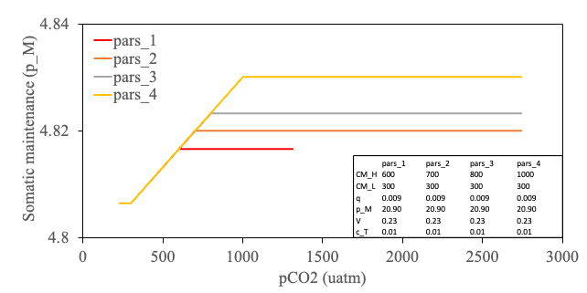
Fixed CM_L
Fixed CM_H
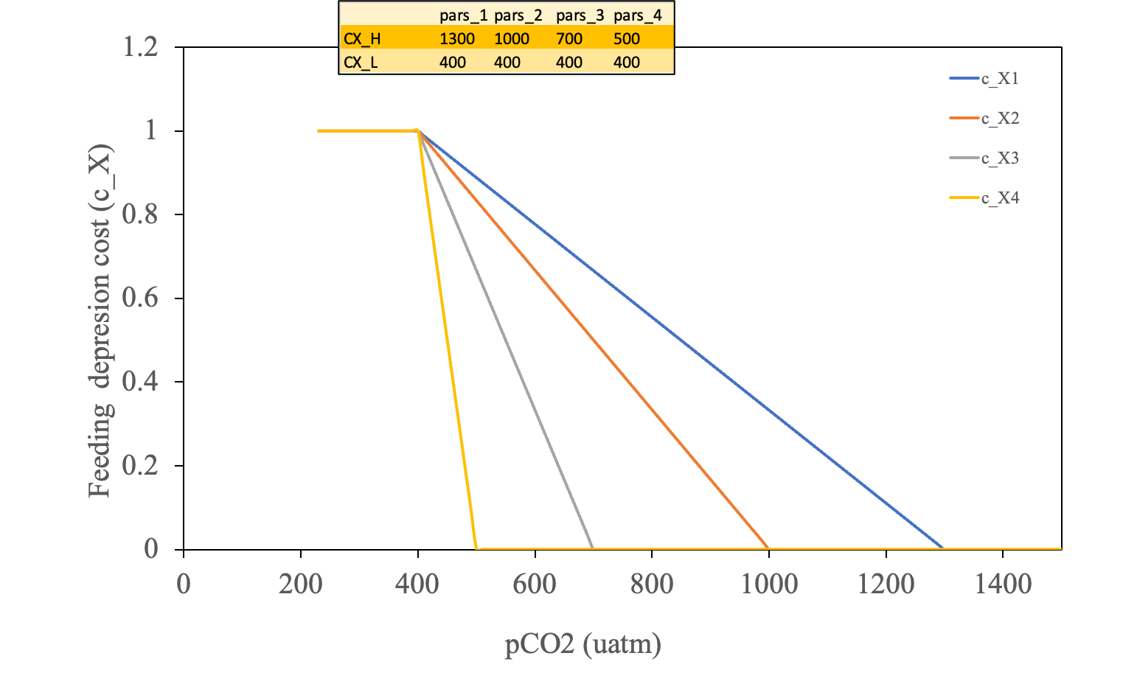

Temperature correction
$c_{T}=exp\left(⁡\frac{T_{A}}{T_{1}}-\frac{T_{A}}{T}\right)$ (Simple version)
Or with an optimal range version (see Kooijman 2010, Section 1.3.7 p. 21)
$$c_{T}=exp\left(⁡\frac{T_{A}}{T_{1}}-\frac{T_{A}}{T}\right)\left(\frac{1+exp\left(⁡\frac{T_{AL}}{T_{1}}-\frac{T_{AL}}{T_{L}}\right)+exp\left(⁡\frac{T_{AH}}{T_{H}}-\frac{T_{AH}}{T_{1}}\right)}{1+exp\left(⁡\frac{T_{AL}}{T}-\frac{T_{AL}}{T_{L}}\right)+exp\left(⁡\frac{T_{AH}}{T_{H}}-\frac{T_{AH}}{T}\right)}\right)$$

with $T_{L}$ and $T_{H}$ the critical lower and upper boundaries of the thermal tolerance range respectively (in K) and $T_{AL}$ and $T_{AH}$, the Arrhenius temperatures for these boundaries
$$\left\{{\dot{p}}_{Am}\right\}=c_{T}\left\{{\dot{p}}_{Am}\right\}$$

pCO2 effects on assimilation and maintenance
$$if: {pC0}_{2}≤ -→C_{X}=1.$$
$$if: {C_{XL}<pC0}_{2} \& {pC0}_{2}<{CX}_{H}-→ C_{X}=\frac{{CX}_{H}-{pCO}_{2}}{{CX}_{H}- {CX}_{L}}$$
$$if: {pC0}_{2}≥ {CX}_{H}-→ C_{X}=1$$

$${\dot{p}}_{A}=κ_{X} {\dot{p}}_{X }C_{X}$$
$${\dot{p}}_{M}= \left[{\dot{p}}_{M}\right] V+q\min\left(max\left( \left({pCO}_{2}{ - C}_{ML}, 0 \right), C_{MH}-C_{ML} V^{2/3}\right) \right)c_{T}$$

List of temperature corrected parameters

- $\left\{{\dot{p}}_{Am}\right\}= c_{T} \left\{{\dot{p}}_{Am}\right\}$
- $\dot{v}=c_{T} \dot{v}$
- $k_{M}= c_{T }k_{M}$
- $\left\{p_{Xm}\right\}= p_{Xm} c_{T}$
- $\left[{\dot{p}}_{M}\right]=c_{T} \left[{\dot{p}}_{M}\right]$
- $\left\{{\dot{p}}_{T}\right\}=c_{T} \left\{{\dot{p}}_{T}\right\}$
- ${\dot{k}}_{J}=c_{T}{\dot{ k}}_{J}$

DEB model fluxes (J.d⁻¹)
If $E_{H}<E_{H}^{b}$
- ${\dot{p}}_{X}=0$
- ${\dot{p}}_{A}=0$, Assimilation
- ${\dot{p}}_{M}= \left[{\dot{p}}_{M}\right] V+q\min\left(max\left( \left({pCO}_{2}{ - C}_{ML}, 0 \right), C_{MH}-C_{ML} \right) \right) {V^{2/3} c}_{T}$
- ${\dot{p}}_{J}=min\left(V, V_{b}\right) \left(\frac{1-κ}{κ}\right) \left[{\dot{p}}_{M}\right] c_{T}$, Maturity maintenance
- ${\dot{p}}_{C}= \left(\frac{E}{V}\right)\frac{E_{G }v V^{2/3} + \left[{\dot{p}}_{M}\right] V }{κ \frac{E}{V} { E}_{G}}$ $c_{T}$, Reserves mobilization
- ${\dot{p}}_{G}=κ {\dot{p}}_{C}- {\dot{p}}_{M}$, Growth
- ${\dot{p}}_{R}=\left(1-κ\right){\dot{p}}_{C}- {\dot{p}}_{J}$, Reproduction
- ${\dot{p}}_{D}= {\dot{p}}_{M}+ {\dot{p}}_{J}+ \left(1-κ_{R}\right) {\dot{p}}_{R}$ Dissipation

Else
- ${\dot{p}}_{X}=f \left\{{\dot{p}}_{Xm}\right\} V^{2/3}$
- ${\dot{p}}_{A}=κ_{X} {\dot{p}}_{X }C_{X}$, Assimilation
- ${\dot{p}}_{M}= \left[{\dot{p}}_{M}\right] V+q\min\left(max\left( \left({pCO}_{2}{ - C}_{ML}, 0 \right), C_{MH}-C_{ML} \right) \right) V^{2/3} c_{T}$, Somatic maintenance
- ${\dot{p}}_{J}=min\left(V, V_{p}\right) \left(\frac{1-κ}{κ}\right) \left[{\dot{p}}_{M}\right] c_{T}$, Maturity maintenance
- ${\dot{p}}_{C}= \left(\frac{E}{V}\right)\frac{E_{G }v V^{2/3} + \left[{\dot{p}}_{M}\right] V }{κ \frac{E}{V} { E}_{G}}$ $c_{T}$, Reserves mobilization
- ${\dot{p}}_{G}=κ {\dot{p}}_{C}- {\dot{p}}_{M}$, Growth
- ${\dot{p}}_{R}=\left(1-κ\right) {\dot{p}}_{C}- {\dot{p}}_{J}$, Reproduction
- ${\dot{p}}_{D}= {\dot{p}}_{M}+ {\dot{p}}_{J}+ \left(1-κ_{R}\right) {\dot{p}}_{R}$, Dissipation
- ${\dot{p}}_{LR}= \frac{1}{κ_{LR}} \left({\dot{p}}_{M}-κ {\dot{p}}_{C}-\left(\left(1-κ\right) {\dot{p}}_{C}- {\dot{p}}_{J}\right)\right)$
- ${\dot{p}}_{LR}= \frac{1}{κ_{LV}} \left({\dot{p}}_{M}-κ {\dot{p}}_{C}-\left(\left(1-κ\right) {\dot{p}}_{C}- {\dot{p}}_{J}\right)\right)$

Differential equations
$$\frac{dE}{dt}={\dot{p}}_{A}-{\dot{p}}_{C}$$
If: $κ {\dot{p}}_{C}< {\dot{p}}_{M}$, in starvation conditions fraction from mobilization does not cover maintenance costs
$$\frac{dE_{H}}{dt}=0$$
$\frac{dS}{dt}=\left(\frac{1}{\left\{{\dot{p}}_{Am}\right\}}\right)\left(v_{G }{\dot{p}}_{G}+ v_{D}{\dot{p}}_{D}\right)$
If: $V≥ V_{p }\& E_{R }≥ {\dot{p}}_{LR}$
$$\frac{dV}{dt}=0$$
$$\frac{dR}{dt}= {-\dot{p}}_{LR}$$
Else:
$$\frac{dV}{dt}=\frac{-{\dot{p}}_{LV}}{\left(ρ_{V} d_{V}\right)}$$
$$\frac{dR}{dt}= 0$$
Else:
$$\frac{dV}{dt}=\frac{{\dot{P}}_{G}}{E_{G}}$$
$$\frac{dS}{dt}=\left(\frac{1}{\left\{{\dot{p}}_{Am}\right\}}\right)\left({ v_{A }{\dot{p}}_{A}+ v}_{G }{\dot{p}}_{G}+ v_{D}{\dot{p}}_{D}\right)$$
If $E_{H}<E_{H}^{p}$
$$\frac{dE_{H}}{dt}= {\dot{p}}_{R}; \frac{dE_{R}}{dt}=0$$
Else:
$$\frac{dE_{H}}{dt}=0$$
$$\frac{dE_{R}}{dt}={\dot{p}}_{R}; \frac{dE_{R}}{dt}={(1-κ)\dot{p}}_{C}-{\dot{p}}_{J}$$

Observable variables
- $L_{w}=\frac{V^{1/3}}{δ_{M}}$, Physical length (cm)
- $W_{V}=d_{V} V$, Dry weight of structure (g)
- $W_{E}=\frac{w_{E}}{μ_{E}}E$, Dry weight of reserve (g)
- $W_{ER}=\frac{w_{E}}{μ_{E}}E_{R}$, Dry weight of reproduction buffer (g)
- $W=W_{V}+W_{E}{ + W}_{ER}$, Total dry weight (g)
- $W_{w}= \frac{W}{1-c_{w}}$, Wet weight (g)
- $F=\frac{κ_{R}E_{R}}{E_{0}}$, Fecundity (# eggs)
- $S_{L}= \frac{S^{\left(1/3\right)}}{δ_{M}}$, Shell physical length (cm)

Summary of data for model calibration
- Around 2 to 5mm there is a non-mandatory shift in the dietary components from biofilm to Ulva or other macroalgae.
- Animals that don’t shift to Ulva soon don’t growth the same as adults that do change diet and they don’t catch up in growth with the ones that do change diet.
- Differentiate between farm and wild animal on DEB code.

Possible plots options (pH ~ Temperature data)

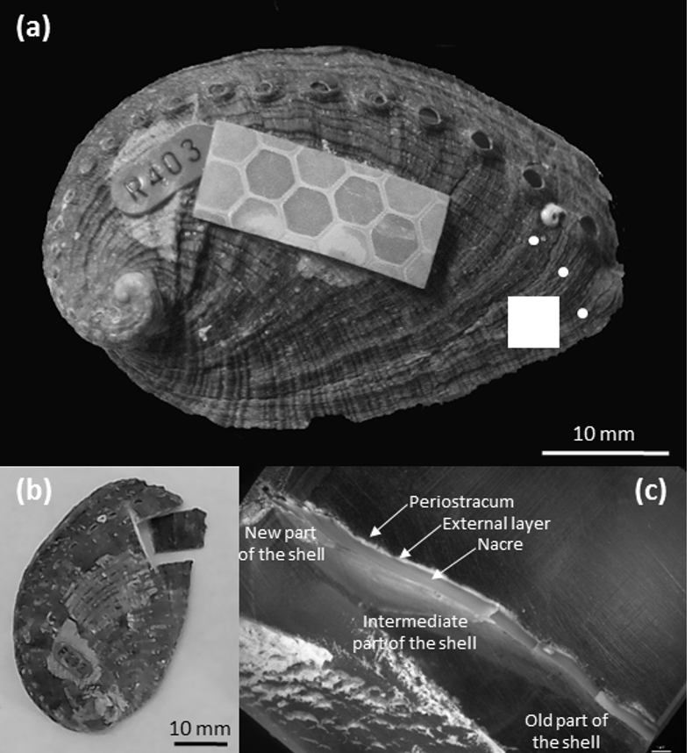
Thickness 3
Thickness 2
Thickness 1

data: Avignon et al., (2020)

data: Avignon et al., (2020)

Possible plots options (Standard data)

data: Roussel et al., (2019)

UPCOMING DATASETS
- Respiration and excretion rates for adults and early juveniles at several temperatures

