Laboratory 11: Sequential Multiplier

11.1 Objective
- Design a sequential multiplier circuit that takes two 4-bit numbers as inputs (multiplicand and multiplier) and produces an 8-bit product as output.
- Display the result on the 7-segment displays of the FPGA board.
- To familiarize with the design of large digital systems using a data path and a control path.

11.2 Introduction
Large and medium size digital systems are mostly sequential systems with a large number of registers and counters. It is impractical to design such systems using FSM design techniques, because those FSMs will have a huge number of states. Generally, large digital systems are partitioned into two units:

- Data Path: This is the data processing unit. It includes both combinational and sequential modules of well-defined functions, e.g. registers, counters, adders, multiplexers, decoders, etc.
- Control Path: This is the control unit or simply “controller,” which controls the operations performed by the data path and the proper sequencing of these operations. The controller is implemented as an FSM that may be designed in the conventional manner.

This lab involves the design, simulation and prototyping of a sequential multiplier. Unlike in Lab 9, the multiplication process needs to be done by the shift-and-add sequential multiplication procedure. The multiplier will be partitioned into a data path and a controller, and each part will be designed separately. The completed design will be simulated in Verilog and tested by programming the Spartan 3E FPGA device of the Nexys2 board. The design can be easily extended to an n-bit multiplier that uses the same controller and the same data path configuration, with the sizes of the data path components (e.g., registers, adder) adjusted accordingly.

Multiplication begins with the reset pulse. After accepting the data inputs, the multiplier begins its multiplication process and when it is completed, it displays the result on the leftmost two display segments.

11.3 Shift-and-Add Multiplication

The shift-and-add multiplication method uses a small amount of hardware repeatedly to perform multiplication. It is slower than the combinational multiplier we saw in Lab 9, but is more efficient in the use of hardware. In this method, depending on bit i of the multiplier, either the multiplicand is added to the collected partial result and then shifted to the right (when bit i is 1), or (when bit i is 0) the collected partial result is just shifted one place to the right without being added to the multiplicand. Figure 11.1 shows a flowchart of a 4-bit sequential multiplier.

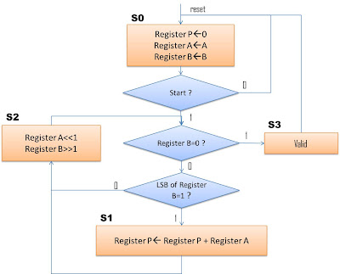

Figure 11.1: A Flowchart of a Sequential 4-Bit Multiplier

In order to carry out a hardware implementation of this procedure we make certain modifications to this procedure. First, instead of having to move our observation point from one bit of the multiplier to the left bit, we place the multiplier in a shift register, always observe its right-most bit, and after every calculation, we move it one place to the right, making its next bit accessible. Second, for the partial products, instead of writing one and the next one to its left, when writing a partial product, we move it to the right as we are writing it, and the next one will not have to be shifted.

Finally, instead of calculating all partial products and at the end adding them up, when a partial product is calculated, we add it to the previous partial result and write the newly calculated value as the new partial result. Therefore, if the multiplier bit that is being observed is 0, 00000000 is to be added to the previously calculated partial result, and the new value should be shifted one place to the right. In this case, since the value being added to the partial result is 00000000, adding is not necessary, and only shifting the partial result is sufficient. This process is called shift. However, if the multiplier LSB is 1, the multiplicand is to be added to the previously calculated partial result, and the calculated new sum must be shifted one place to the right. This is called add-and-shift.

Repeating the above procedure, when all bits of the multiplier are shifted out, the partial result becomes the final multiplication result.

11.4 Sequential Multiplier Design

11.4.1 Control / Data Path Partitioning

The sequential multiplier can be partitioned into a data path and a controller. The data path consists of registers, logic units and their interconnecting busses. The controller is a finite state machine that issues control signals for control of what gets clocked into the data registers. Both the data path and the controller are triggered with the same clock signal. On the rising edge of a clock the controller goes into a new state. In this state, several control signals are issued, and as a result the components of the data path start reacting to these signals. The time given for all activities of the data path to stabilize is from one edge of the clock to another. Values that are propagated to the inputs of the data path registers are clocked into these register with every clock edge.

11.4.2 Multiplier Data Path

The multiplier data path uses two 8-bit registers, Product and Multiplicand and a 4-bit shift register Multiplier. An adder and a multiplexer constitute the other components of the data path. The bus assignments and logic unit output selections in the data path are controlled by the control signals generated by the controller.

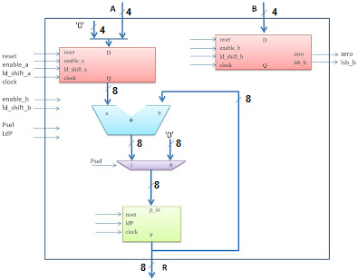

Figure 11.2: Sequential 4-Bit Multiplier Data Path

11.4.3 Multiplier Controller

The multiplier controller is a finite state machine that has a starting state, an ending state, and some intermediate states. In Lab 10, you had built a finite state machine. In this lab, you have to coordinate the outputs of the finite state machine with the actions to be performed in the data path.

11.5 Experiments
Pre-lab:
- Understand the difference between the combinational multiplier and the sequential multiplier. What is the advantage of using a sequential multiplier? What is a disadvantage?
- Develop Verilog codes for a 4-bit sequential multiplier.
- Simulate and verify your design.

Procedure:
- Show your codes and circuit of your sequential multiplier to your TA.
- Demonstrate the operation of your multiplier on 7-segment LED displays.
- Use a function generator and a logic analyzer to obtain the worst case propagation delay for the implemented circuit.

