Laboratory 9: Combinational Multipliers

9.1 Objective
- Design combinational multiplier circuits that take two 4-bit numbers as inputs (multiplicand and multiplier) and produce an 8-bit product as output.
- Display the result on the 7-segment displays of the FPGA board.

9.2 Introduction
Multiplication is a common operation in digital systems. For that reason, custom designed multipliers are often used. The goal of this lab is to make you familiar with the design and implementation of such a multiplier. A combinational multiplier is another example of how simple logic blocks (gates, half adders and full adders) can be combined to construct a much more complex block. In particular, it is possible to construct a 4x4 combinational multiplier from an array of AND gates, half-adders and full-adders, taking what you have learned recently and extending it to a more complex circuit. The purpose of this lab is to implement a relatively complex arithmetic function, such as binary multiplication, using simple logic building blocks.

Let us look at how binary multiplication is performed by hand. Figure 9.1 shows the multiplication of two 4-bit binary unsigned numbers.

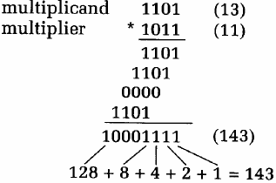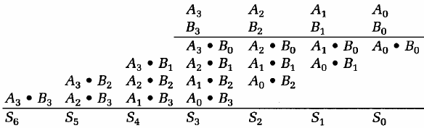
Fig. 9.1: The multiplication operation for 4-bit unsigned numbers
Just as in decimal multiplication, the multiplicand is multiplied by each bit in the multiplier. Each of the four partial products is aligned (shifted left) according to the position of the multiplier bit involved in forming that partial product. The four resulting partial products are added to form the final product.
As we are dealing with binary numbers, forming the partial products is particularly easy. If the multiplier bit is a 1, then the corresponding product is simply an appropriately shifted copy of the multiplicand. If the multiplier bit is a zero, then the product is zero. 1-bit binary multiplication is thus just an AND operation. This is illustrated in the right hand side of Figure 9.1.

A k-bit multiplicand and an m-bit multiplier produce a (k+m)-bit product. Typically, the operands in a multiplication operation are of the same length, so two n-bit operands form a 2n-bit product.

9.3 Combinational Multiplier
This lab involves designing a combinational circuit that can be used to form the necessary partial products and the final sum. The method described here is sometimes referred to as partial product accumulation and is described in detail in many digital logic textbooks. Because we are dealing with binary numbers, the partial products reduce to simple AND operations between the corresponding bits in the multiplier and multiplicand. Each bit of the multiplier is AND’ed with the multiplicand to form partial products, which are summed to form the product.
Figure 9.2 shows a combinational circuit for performing this 4-bit multiplication. The top layer of 16 AND gates generates the 16 partial product bits that result from ANDing all combinations of the 4 multiplicand bits with the 4 multiplier bits. The column sums are formed using a collection of half adders and full adders.

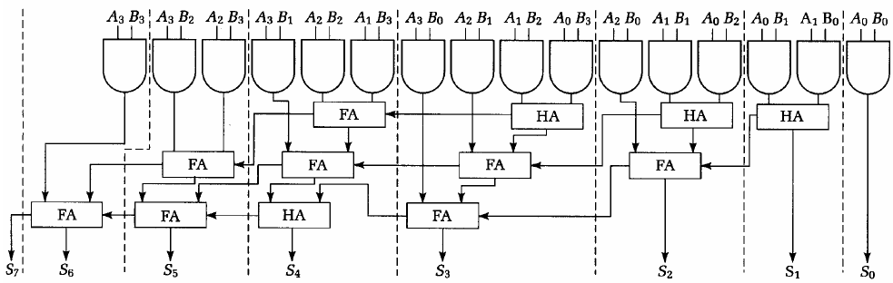
Figure 9.2: A Combinational Circuit for Performing 4-bit Binary Multiplication

The speed of this combinational multiplier is a function of how long it takes the carries from the less significant bits on the right to propagate through to the left. This scheme is often referred to as ripple carry as each column in the sum must wait for the carries to be computed in the less significant columns before its corresponding sum bit can be computed. It is possible to include lookahead carry circuitry (as in Lab 8) to compute the carries in parallel, thus greatly speeding up the computation at an increase in gate count. We won’t consider this aspect in this lab.

9.4 Combinational Array Multiplier

The combinational multiplier in Figure 9.2 used a variety of building blocks such as AND gates, half adders, and full adders. It is possible to build a combinational multiplier using a 2-dimensional array of a single block type. Figure 9.3 shows this basic building block. It consists of an AND gate for computing locally the corresponding partial product (XY), an input passed into the block from above (Sum In), and a carry (Cin) passed from a block diagonally above. It generates a carry out bit (COUT) and a new sum out bit (Sum Out). An implementation of a multiplier that uses this basic building block is shown in Figure 9.4. This is called a combinational array multiplier. The A_{i} values are distributed along block diagonals, and the B_{i} values are passed along the rows.

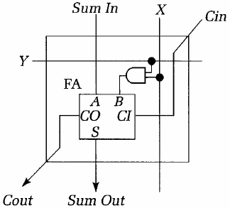
Figure 9.3: Basic Block in a Combinational Array Multiplier

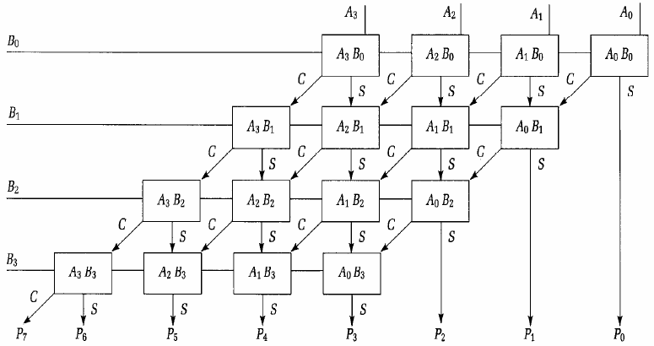
Figure 9.4: A 4-bit Combinational Array Multiplier

9.5 Booth Multiplier

You can speed up the multiplication process described above by a constant factor, based on the fact that shifting is quicker than adding (or subtracting). The key observation is the following. A run of consecutive 1s in a binary number

m n 210 binary weight
00000000000011111110000000 binary number

is equal to (2^{m} ─ 2^{n}).

You can use this to construct a Booth encoding of the multiplier, considering one or more bits at a time. In this lab you will be using a 2-bit encoding, but we shall first consider the simple case of 1-bit encoding. Whenever we consider a bit we also look at the bit to its right. The encoding then is as follows:

The_bit Adj_bit Contribution Comments
0 0 0 Zero on its own
0 1 1 High end of a run of ones
1 0 ─1 Low end of a run of ones
1 1 0 Middle of a run of ones

The actual contribution to the value is of course the value shown times 2^{n}, where n is its bit-position.

The 2-bit encoding version is as follows (here the value will be multiplied by 2^{n} where n is the position of the less significant bit):

The_bits Adj_bit Contribution Comments
00 0 0 Zero on its own
00 1 1 High end of a run of ones
01 0 1 An isolated one
01 1 2 High end of a run of ones
10 0 ─2 Low end of a run of ones
10 1 ─1 End of a run, start of another
11 0 ─1 Low end of a run of ones
11 1 0 Middle of a run of ones

When each pair of bits is encoded in this way, its contribution to the partial product may be found by multiplying and adding the multiplicand by the appropriate factor (i.e. shifting and adding/subtracting).

9.6 Pre-Lab
- Understand the difference between the regular multipliers and the Booth multiplier. What is the advantage of using a Booth multiplier? What is the disadvantage of using a Booth multiplier?
- Develop Verilog codes for the two 4-bit regular multipliers and a 4-bit Booth multiplier.
- Simulate and verify your designs.

9.7 In-Lab Procedure
- Show your codes and circuits to your TA.
- Demonstrate the operation of your 3 multiplier circuits on 7-segment LEDs.
- Use a function generator and a logic analyzer to obtain the worst case propagation delay for the implemented multiplier circuits.

9.8 Post-Lab
- What were the major problems you encountered in the lab, and how did you fix them? Simply saying “the TA fixed it” is not sufficient!
- The multiplier is an excellent example of how hierarchical design can be beneficial to designing large circuits. How did you use hierarchy in the multiplier circuits, and how did it help you to build it?

