Google- Coding Challenge- Java

Paul Aldea

SHOW_ALL_VIDEOS

The method, showAllVideos(), sorts the videos lexicographically and prints the list of the videos.

I created another method, getVideoStrings(), that separates the tags of the videos and returns the title, id and the tags of the videos.

PLAY<video_id>

The method, playVideo(), have the variable “currentvideo” which keeps the current video. The ArrayList “array” keeps the title of the video every time a video is played and when the video stops, the video title is removed from the array.

The method still has a problem when we try to play a video and stop a previous video.

STOP

The method, stopVideo(), checks if a video is playing, stops the video and make the “currentvideo” variable null. if no video’s playing the method returns “No video is currently playing”.

I helped the other students form the group chat to get the “currentvideo”.

PLAY_RANDOM

The method, playRandomVideo(), has a list with all the videos and another one for the video’s id. The method adds all the video’s IDs to the list. I implemented the function Random to get a random video from the playlist and after I played the random video.

I used the help of the other students from Java group chat to complete this method.

PAUSE

The method, pauseVideo(), has the variable “ok”, which check if the video is or not paused, the variable “currentvideo”, which check if a video is playing.

CONTINUE

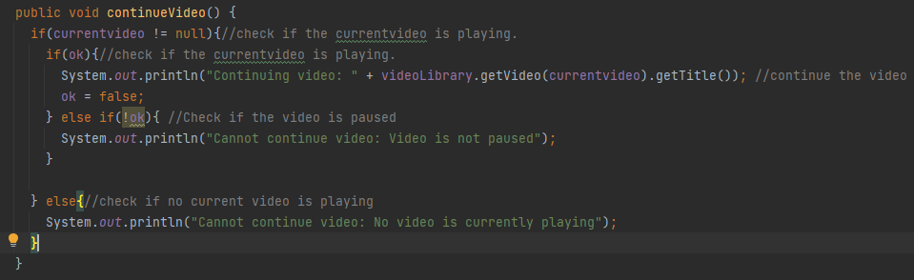

The method, continueVideo(), check if the video is currently paused. The method uses the variable ok to check if the video is playing. If the video is playing the method displays “Cannot continue video: Video is not paused”, else it displays “Continuing video + current video title”.

SHOW_PLAYING

The method, showPlaying(), displays the title, video_id video tags and paused video of the video that’s currently playing. The method uses the variable “ok” to check if the variable is paused and the variable “okStatus” to display the status of the video.