PageDesigner
for Broker
User Guide
Version 3.0a
March 2000

Copyright © Centrereed Ltd 2000

TABLE OF CONTENTS
1 Introduction 4
2 Live, Test and Demo versions 4
3 What can and cannot be changed 5
3.1 Page layouts 5
3.2 Letter layouts 5
4 Terminology 6
4.1 Addressee 6
4.2 Contact 6
4.3 Date 6
4.4 Heading 6
4.5 To Whom 6
4.6 Preamble 6
4.6.1 Enquiry Preamble 6
4.6.2 Quotation and Quotation Summary Preamble 7
4.6.3 Purchase Order Preamble 7
4.6.4 Acknowledgement Preamble 7
4.7 Description 7
4.8 Parts Information 7
4.9 No of Plates 7
4.10 Artwork 7
4.11 Quantities / Price 7
4.12 Boxed In 8
4.13 Questions and Answers 8
4.14 Additional Details 8
4.15 Quote / Required Date 8
4.16 Notes 8
4.17 Postamble 8
4.17.1 Enquiry Postamble 8
4.17.2 Quotation and Quotation Summary Postamble 8
4.17.3 Purchase Order Postamble 8
4.17.4 Acknowledgement Postamble 9
4.18 Signatory 9
4.19 Continuation 9
5 Logging On 10
6 The Main Menu 11
7 Page Layouts 12
7.1 Adding a new page layout 13
7.2 Amending an existing page layout 15
7.3 Viewing a page layout 15
7.4 Deleting a page layout 16
8 Letter Layouts 18
8.1 Letter Layout Tab Stops 19
8.2 Enquiry Letters 20
8.3 Quotation Letters 24
8.4 Quotation Summary Letters 25
8.5 Purchase Orders 26
8.6 Order Acknowledgements 27
9 The Layout Previewer 28
10 Generating database scripts 31

Introduction
Established in 1980, Centrereed have built an enviable reputation for supplying high quality reliable software to the printing industry. Through practical experience and listening to our customers, Centrereed have developed BROKER, the Windows based software solution for any company that outsources all or some print.
An important part of Broker’s functionality is the production of letters or faxes to customers and suppliers. The content of these letters is derived from the data entered during enquiry, quotation, raising of purchase orders and so on. However, the user is able to customise these letters to use pre-printed or blank stationery with company logos and address details being added automatically for faxed output. In addition, the wording of certain sections of letters can be altered, as can the order in which items appear in the letter.
PageDesigner is the utility that allows these page and letter layouts to be customised. It is simple to use but offers a high degree of flexibility to enable the user to format Broker output to specific requirements.

Live, Test and Demo versions
Broker and PageDesigner are designed to run in three different modes: live, test and demo. The default mode is live, accessing the live database. For training purposes, the user can opt to log onto the test database. In addition, demonstration versions of the software are available which allow prospective users to evaluate the rich functionality of Broker for a thirty day period.
The PageDesigner features of the Broker system are only available from version 2.1a onwards. Should you try to run PageDesigner and receive the following error message:

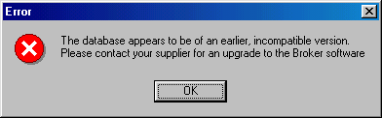
then you need to have an upgrade applied to your database.

What can and cannot be changed
While every effort has been made to allow letter layouts to be as flexible as possible, it should be borne in mind that normal conventions of letter writing dictate that certain elements of a letter fall in a particular order. The PageDesigner software will allow you to start with the signature, “Yours faithfully” and so on, ending with “Dear Sir or Madam” at the bottom but the letter’s recipient may not be too impressed. You should also try to avoid use of too many different fonts and font sizes as this can give the end result a cluttered look.

Page layouts
For each page layout that you define, the following attributes of the page can be defined and changed:
- Paper size (e.g. A4 or Letter)
- Orientation (portrait or landscape)
- Top, left, bottom and right margins
- The position of any pre-printed items on the page
- The location and size of a logo and/or address information to print on blank stationery
- Whether this is the default format to use when printing
- Whether this is the default format to use when sending faxes electronically

Letter layouts
Three are five defined letter layout categories:
- Enquiry
- Quotation
- Quotation Summary
- Purchase Order
- Order Acknowledgement

For letter layouts, the following items can be specified:
- Up to five fonts for use within the letter
- Two tab stop settings
- Whether this is the default format to use for the letter category
- For each element of a letter (see Terminology below), one of the five possible fonts can be specified with changed size and style.
- For each element of a letter, attributes such as left margin and alignment can be changed.
- For each element of a letter, the order in which the item is printed, whether it is printed at all, and whether it has blank lines before and after.
- For non-database related items in a letter, you can change the text of the item and the item’s alignment.
- For database related items in a letter, you can specify an alternate font for the database portion of the item.

Terminology
The five letters which can be customised are enquiry, quotation, quotation summary, purchase order and acknowledgement. All of these contain common elements of data which are referred to in the software and this document by the following terminology:

Addressee
The person to whom the letter or fax is being sent, either a supplier (in the case of enquiries and purchase orders) or a customer (in the case of quotations and acknowledgements). This is normally printed at the top left hand corner of the first page but its position can be altered. The data (name, address, etc) is obtained from the Broker database and cannot be altered.

Contact
The contact within your organisation to whom queries should be addressed. This is normally printed at the top of the first page, to the right of the addressee (see above). The text “Contact: “ can be changed. The data (contact name) is obtained from the Broker database and cannot be altered.

Date
The date on which the letter or fax is produced. This is normally printed underneath the contact (see above). The text “Date: “ can be changed or deleted. The date is taken from the current system date at the time of printing.

Heading
The heading is the enquiry or purchase order reference number printed at the start of the letter. The enquiry reference number is generated by the Broker system when a new enquiry is created and is used to reference enquiries and quotations. The purchase order reference number is generated by the Broker system when a new purchase order is created and is used to reference purchase orders and order acknowledgements. The text preceding the reference number can be changed. The data is obtained from the Broker database and cannot be altered.

To Whom
This is the first user-amendable element of a letter. For any letter other than enquiries, it would normally be “Dear”, the standard English letter salutation. For enquiries, a more general “To whom it may concern” or “For the attention of the Estimating Department” might be more appropriate. Both the text and position of this element can be changed.

Preamble
The preamble is that part of the letter that normally comes after the “Dear Mr Brown” or “To whom it may concern”. The default versions supplied with the software are as follows:

Enquiry Preamble
“We would be pleased to receive your Quotation and best delivery date for the following item:- ”

Quotation and Quotation Summary Preamble
“We thank you for your recent enquiry and are pleased to offer the following price(s) for your consideration:- “

Purchase Order Preamble
“We are pleased to confirm our Order for your Quotation referred to above. Please proceed as specified below and acknowledge our order by return.”

Acknowledgement Preamble
“Please check the above information carefully and advise us immediately if it does not meet with your exact requirements. Unless discrepancies or changes are notified by return in writing we cannot accept responsibility for any errors which may be incurred.”
In each case, both the text and order of printing may be changed.

Description
The description is taken from the database and is what was entered when an enquiry was first created (or a new purchase order created without a preceding enquiry). The text “Description: “ can be changed. The data from the database cannot be altered but the order of printing can be.

Parts Information
Information about parts (colour, weight, paper type, inks and so on) is taken from the database and is as entered when an enquiry was first created (or a new purchase order created without a preceding enquiry). The text “Part N” can be changed. The data cannot be altered but the order of printing can be.

No of Plates
The number of plates needed is taken from the database and is as entered when an enquiry was first created (or a new purchase order created without a preceding enquiry). The text “No of Plates: “ can be changed. The data cannot be altered but the order of printing can be.

Artwork
Any information about artwork is taken from the database and is as entered when an enquiry was first created (or a new purchase order created without a preceding enquiry). The text “Artwork: “ can be changed. The data cannot be altered but the order of printing can be.

Quantities / Price
Information about quantities and quoted prices is taken from the database and is as entered when an enquiry was first created (or a new purchase order created without a preceding enquiry). The text “Quantity: “ or “Price: “ can be changed. The data cannot be altered but the order of printing can be.

Boxed In
Information about the quantity in a box is taken from the database and is as entered when an enquiry was first created (or a new purchase order created without a preceding enquiry). The text “Boxed In: “ can be changed. The data cannot be altered but the order of printing can be.

Questions and Answers
Any questions and answers applicable to the product type are taken from the database and are as entered when an enquiry was first created (or a new purchase order created without a preceding enquiry). The text cannot be altered but the order of printing can be. Different fonts can be specified for the question text and the answer text.

Additional Details
Any additional details are taken from the database and are as entered when an enquiry was first created (or a new purchase order created without a preceding enquiry). The text “Additional Details: “ can be changed. The data cannot be altered but the order of printing can be.

Quote / Required Date
For enquiries, the date by which a quote is needed. For purchase orders, the date by which delivery is needed. The text “Required by: “ can be changed. The data cannot be altered but the order of printing can be.

Notes
Any additional information is taken from the database and is as entered when an enquiry was first created (or a new purchase order created without a preceding enquiry). The text “Notes: “ can be changed. The data cannot be altered but the order of printing can be.

Postamble
The postamble is that part of the letter that normally comes before the signoff. The default versions supplied with the software are as follows:

Enquiry Postamble
“Thank you for your assistance, if you have any queries or suggestions please do not hesitate to contact my sales administration team.”

Quotation and Quotation Summary Postamble
“Our quoted prices are subject to final copy and are firm for 30 days unless otherwise agreed in writing. We trust this price meets your approval and look forward to receiving your instructions.
“All prices are exclusive of VAT at the ruling rate at date of invoice.“

Purchase Order Postamble
“Should you have any problems interpreting this order or have a query with this specification, please contact us immediately.”

Acknowledgement Postamble
“Please check the above information carefully and advise us immediately if it does not meet with your exact requirements. Unless discrepancies or changes are notified by return in writing we cannot accept responsibility for any errors which may be incurred.”
In each case, the text may be changed.

Signatory
The signatory is taken from the database. This letter element allows the user to specify the text preceding the signatory’s name. The standard text is “Yours sincerely,” but could be “Yours faithfully,”, “Best Wishes,” and so on.

Continuation
The text that is printed at the head of the second and each subsequent page. The text “Continuation….” Can be changed as can the font.

Logging On
PageDesigner uses the same log-on and security mechanisms as Broker. When the program is run, the user is presented with the standard Broker log-on screen:
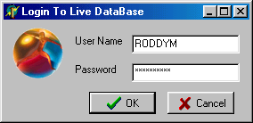
Double click here to switch modes

By double clicking on the icon on the left of the log-in screen, it is possible to switch from live to test mode and vice-versa.
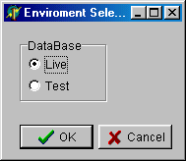
After logging on successfully, the program checks the database version. If it comes from an earlier version of broker, you will receive the following error message and the program will terminate:

The Main Menu
Once logged on, the user is presented with the main program menu. The screen looks like this:
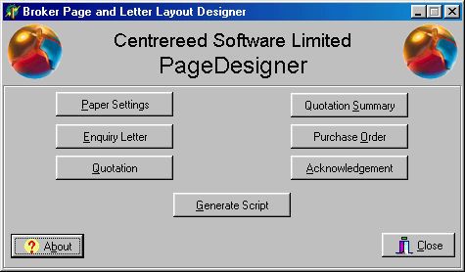
Clicking on the “About” button will display information about the program and its version. Should you experience problems with the software, the version number will help Centrereed support staff in their investigations.
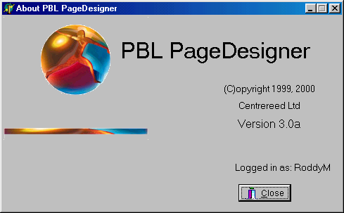
The seven buttons on the main menu are the available functions for this utility:
- “Paper Settings” will take you to the forms for setting up page layouts.
- “Enquiry Letter” allows you to customise the contents and layout of enquiry letters to suppliers.
- “Quotation” allows you to customise the content and layout of quotation letters to customers.
- “Quotation Summary” allows you to customise the content and layout of abbreviated quotation letters to customers.
- “Purchase Order” allows you to customise the content and layout of purchase orders to suppliers.
- “Acknowledgement” allows you to customise the content and laoyout of order acknowledgements to customers.
- The last button “Generate Scripts” is used to generate database set-up scripts for the five default letters. This would normally be done by a member of Centrereed’s support staff.

Page Layouts
Clicking on “Page Layouts” will cause the main menu to shrink and a toolbar to appear as shown:
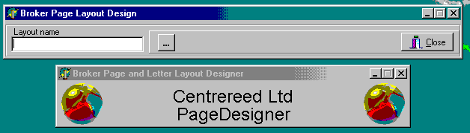
If an existing layout name is known, it can be typed into the edit box. Otherwise, click on the button with three dots to get a list of layout names to select from:
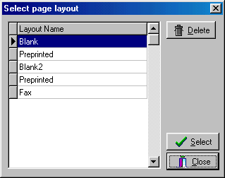
Once an existing layout has been selected, the toolbar changes as shown below:
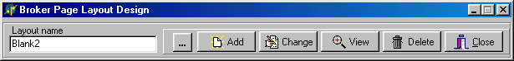
By clicking on the appropriate button, the following actions can be undertaken:
- Add: Add a new page layout
- Change: Amend an existing page layout
- View: View an existing page layout
- Delete: Delete an existing page layout
- Close: Return to the main menu

Adding a new page layout
When adding a new page layout, you will be presented with a form looking like this:
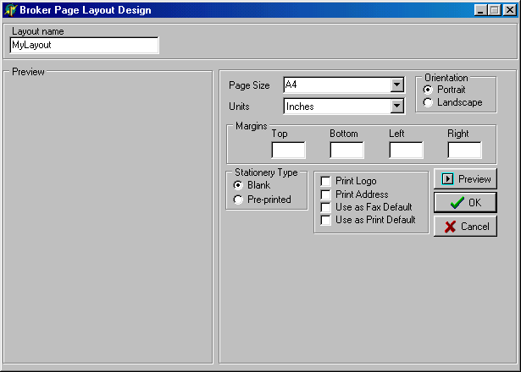
You should give your new layout a unique layout name that does not already exist within the Broker database. You should then assign attributes to the layout as follows:
- Page size
This can be A4 (210 x 297mm) or US Letter (8.5” x 11”)
- Orientation
Portrait or Landscape
- Units
Inches, centimetres or pixels
- Margins
The top, left, bottom and right margins expressed in units as selected above
- Stationery Type
Blank or Pre-printed

If stationery type is selected as “blank” then you have three options: print a bitmap logo; print company address details; and set this to be the default layout for sending faxes electronically. Additional data entry boxes appear on the form when one or more of these options is selected:
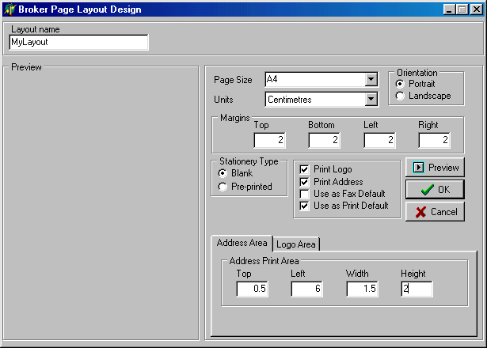
If stationery type is selected as “pre-printed” then you can specify an area on the page where pre-printed information already exists.
You can get an idea of what the layout looks like by clicking the “Preview” button:
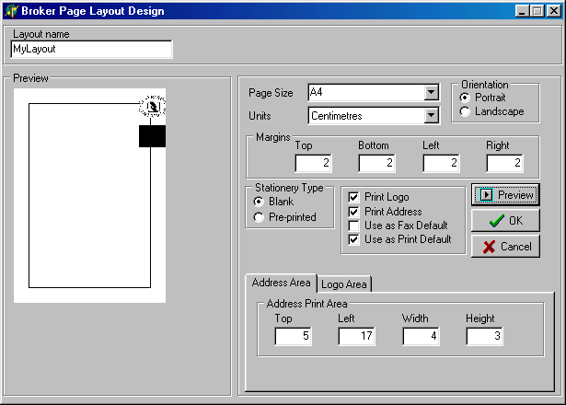

Amending an existing page layout
After selecting a layout to edit, click the “change” button on the toolbar. All fields can be amended in the same way as adding a new record. Use preview to view the result of your changes.

Viewing a page layout
After selecting a layout from the list (or typing in its name), click view to see the settings for the layout as well as a preview. No data can be changed in this mode.

Deleting a page layout
You may either delete a layout when in the select box or from the toolbar. You should be aware that deleting the default layouts “Blank” and “Pre-printed” which come with the software can lead to unpredictable results. It is strongly advised that these layouts are never deleted.
When selecting from the select box, there is only a simple confirmation:
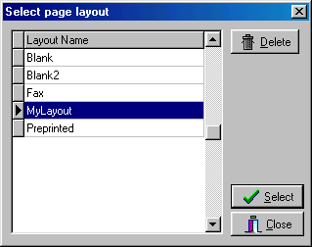
Clicking here will pop up the box shown below
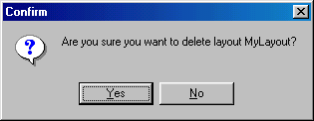
When delete is selected from the toolbar, the layout data is displayed along with a preview and instructions to click OK or Cancel:
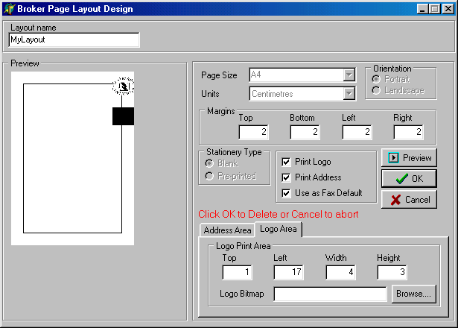

Letter Layouts
The five basic letter layouts contain common elements such as addressee, date, preamble and so on. See the section above “Terminology” for an explanation of the various elements used in printing letters.
The elements that comprise a letter are displayed as buttons on a form. By clicking a button corresponding to a letter element, you can set the font attributes. You may also be able to change the text and/or the printing order of the element.
The first button shown for all letters is the “Letter Settings” button. This allows you to choose up to five fonts to be used in the letter. Font one is used as the default throughout the letter and must be specified. All other fonts are optional but must be set if you use them in letter elements later on.
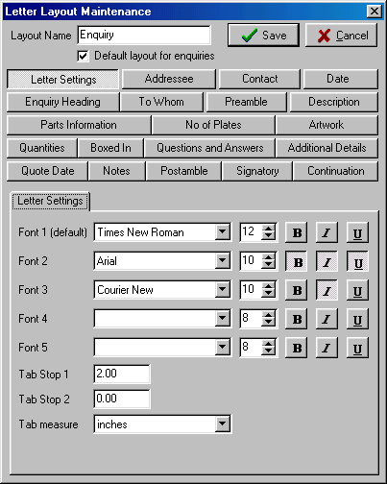

Letter Layout Tab Stops
The tab stop values (Tab Stop 1 and Tab Stop 2) in the Letter Layout are used at printing time to divide the page into three logical columns for the printing of certain elements of the letter. The values of the tab stops can be specified either in inches or centimetres. The default values when the software and database are first loaded are Tab Stop 1 = 1.33 inches and Tab Stop 2 = 3.43 inches. If the values are set to zero, these default values are still used where applicable within the printing routines.
In the example printout shown below, Tab Stop 1 for this layout has been set to two inches.
All text in “split lines” is lined up to tab stop 1.

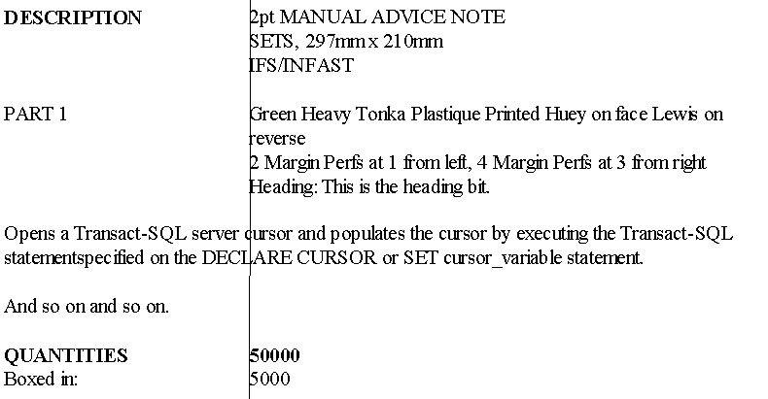
The printing items which are normally “split” in this way are as follows:
- Description
- Parts Information
- Number of Plates
- Artwork
- Quantities and/or Prices
- Boxed In
- Questions and Answers

Enquiry Letters
An enquiry letter consists of the elements shown on the example screen below:
By clicking on an element button, the screen will change as shown below. There are several possibilities as to what can be done with an element:
- You can always specify a font, font size and font style (bold, italic, underline) for the text portion (if there is one)
- You can always specify a font, font size and font style (bold, italic, underline) for the data portion (if there is one) You may be able to change the text associated with the element
- You may be able to change the alignment associated with the element
- You may be able to change the order in which the element is printed
- You may be able to suppress printing of the element
- You may be able to specify blank lines before and/or after the element

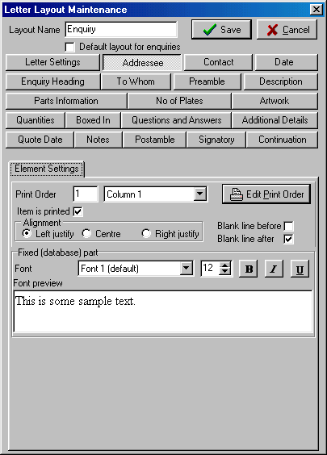
Above is an example of an element which can have a different font specified for the data taken from the database. It has no user-definable text. The text shown is merely a preview to help you see what the font looks like.
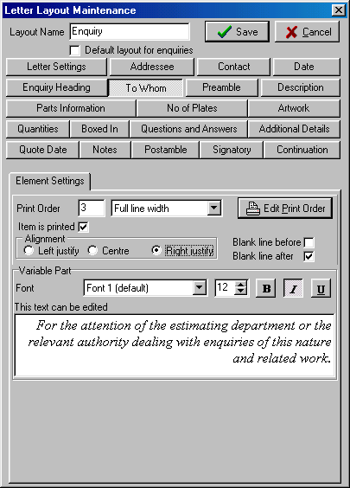
Above is an example of a text element which can have all its attributes edited. You can change the font, the text, say whether or not this is printed, and ask for blank lines before and after the element is printed. You can also change the justification of the text but, as shown in the example, it looks odd.

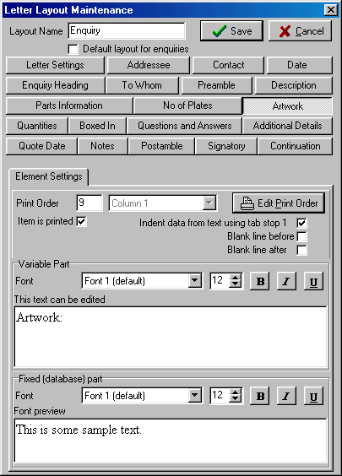
The example shown above has a text part (“Artwork:”) which can be amended as well as a database part. Each part can have a different font as long as the option “Indent data from text using tab stop 1” has been selected.

Quotation Letters
A quotation letter’s elements are as shown by the buttons on the snapshot below:
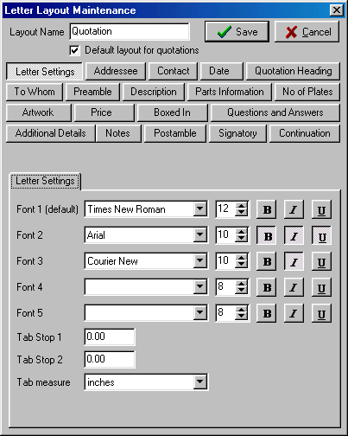

Quotation Summary Letters
Quotation Summary letters are very similar to quotation letters except that, instead of one quotation letter per line of enquiry, the summary prints one letter with abbreviated details for all lines in the enquiry. This is essentially done by disabling the print of most of the letter elements. You can turn back on the printing of all of the elements should you wish.
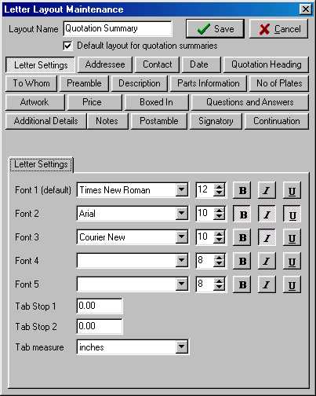

Purchase Orders
A purchase order’s elements are as shown by the buttons on the snapshot below:
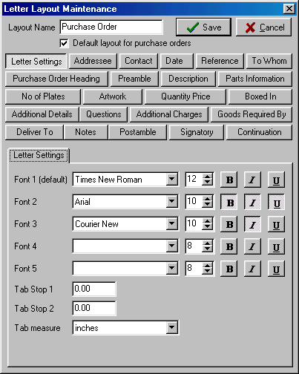

Order Acknowledgements
An order acknowledgement’s elements are as shown by the buttons on the snapshot below:
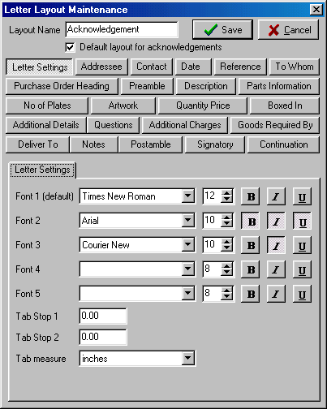

The Layout Previewer
When you are editing a letter element, you have the option to see a mini preview of the layout. This is not accurate as to font and exact column size but it does allow you to get a general impression of the final layout.
Click in this button to invoke the preview screen.
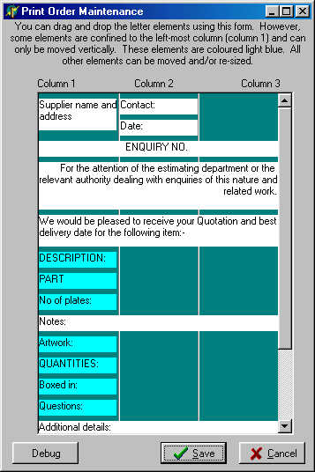
Items can be moved using standard Windows drag and drop with the mouse. Or right-click on an item to get a pop-up menu of functions:

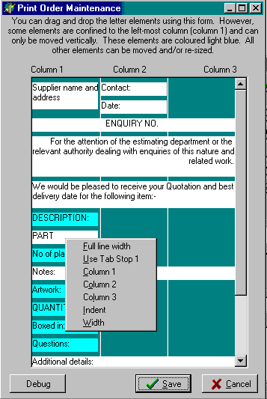
The left margin and width of an item can be specified, overriding the margins created by the tab stop values.
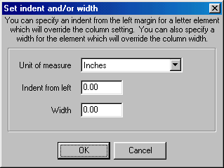

Generating database scripts
Should you make amendments to the four original letter layouts and at a later stage wish to re-create them, this is possible by generating a database script. This should only be used under the guidance of CentreReed Software support staff.
When you click the Generate button, the following screen appears:
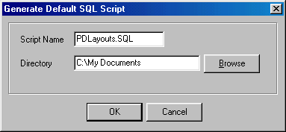
You may give the output file a different name from the default (PDLayouts.SQL) and specify a directory for output.
The script that is produced can be edited if necessary prior to submission to the database server.

