NAME : AMARTYA PAUL

JOB ROLE: INTERN ASSIGNMENT

**REPORT**

This screenshot shows the successful placement of a Limit Buy Order for BTCUSDT. The bot UI confirms success with a green flash message, and the USDT balance is updated accordingly to reflect the locked margin or fee.

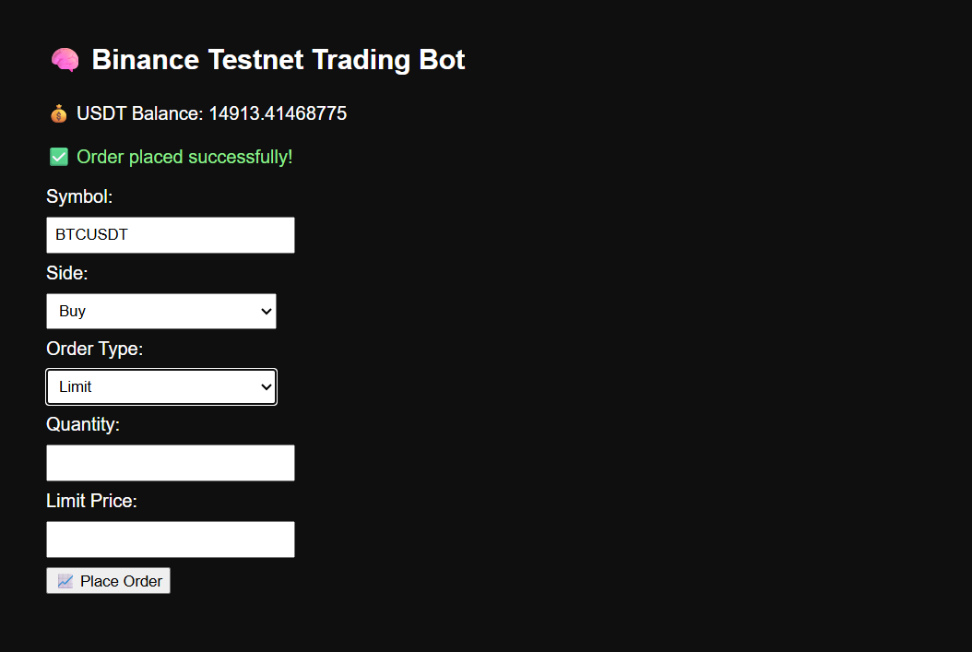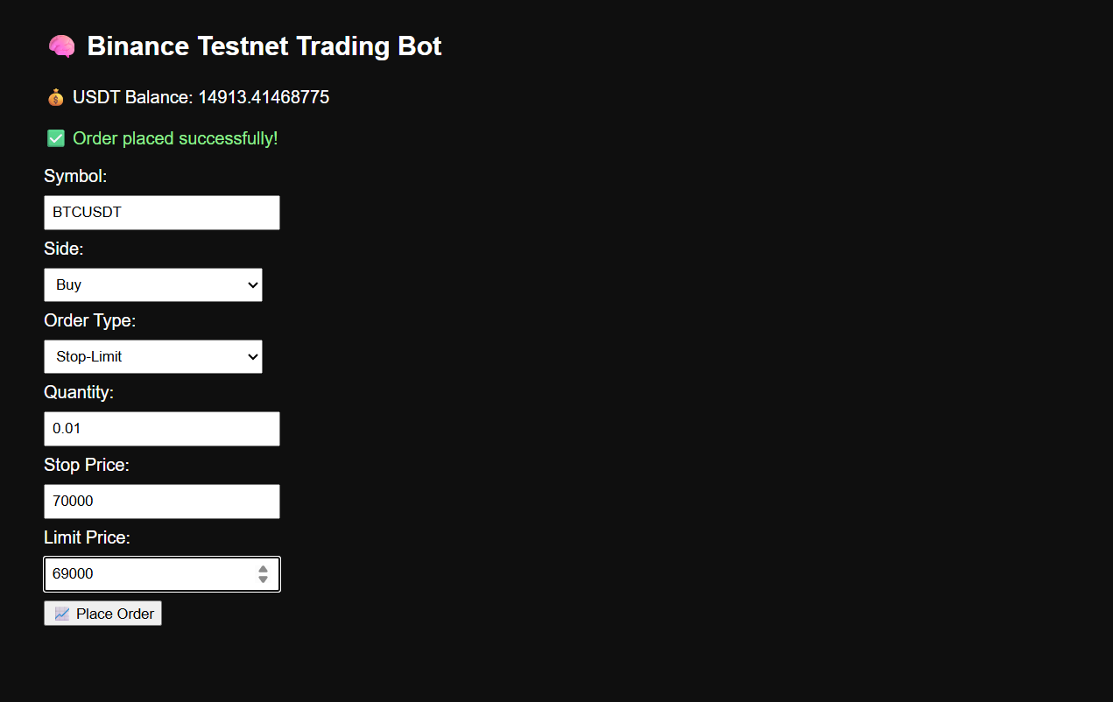

This screenshot demonstrates the execution of a Market Sell Order. The balance shows a decrease post-order, confirming live API execution through Binance Testnet.

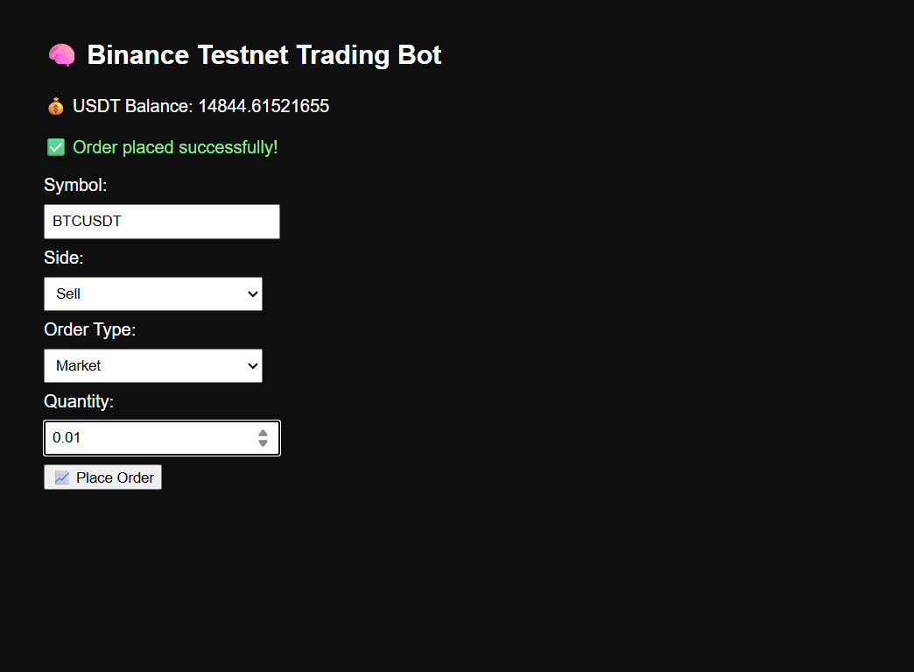

This screenshot shows the execution of a Market Sell Order for the trading pair BTCUSDT.

* The user has selected Sell as the side, Market as the order type, and entered a quantity of 0.01.
* Upon clicking "Place Order", the bot interacted with the Binance Testnet via API and successfully placed the order.
* The success is visually confirmed by a green flash message — “Order placed successfully!”
* The USDT balance displayed at the top (14844.61521655) reflects the updated available balance after order execution.

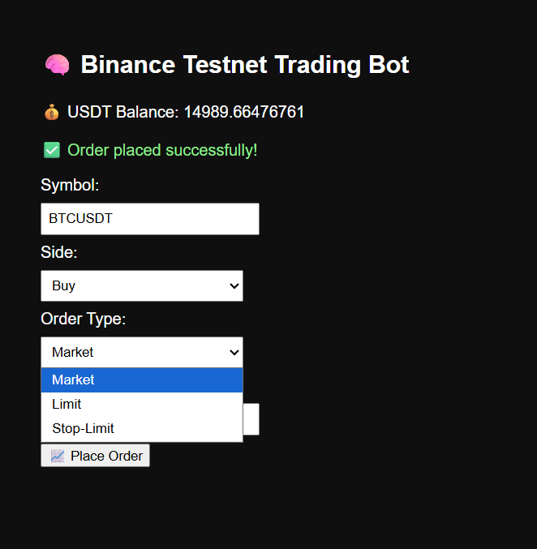

This screenshot highlights the Order Type selection feature in the Binance Testnet Trading Bot interface.  
 The user is shown selecting from the dropdown with 3 supported order types:

* Market
* Limit
* Stop-Limit

This confirms that the bot supports the required order types as per the project specification, and offers a dynamic UI for user-friendly selection.  
 The interface also displays the current USDT balance and confirms successful previous order execution.

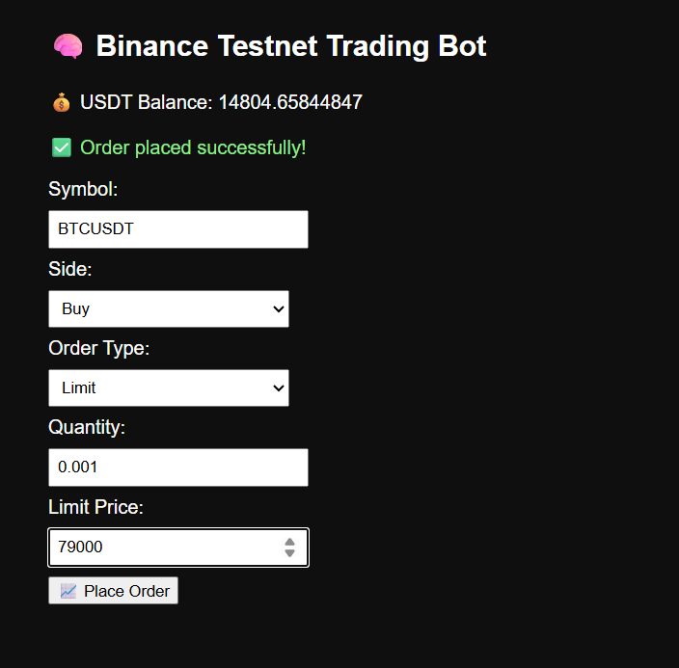

This snapshot shows the working frontend of a Binance Testnet Trading Bot. The user interface displays the current USDT balance, order confirmation message, and input fields to place a limit order. In this example, a buy limit order for 0.001 BTC at a price of 79000 USDT has been successfully placed. The bot is integrated with the Binance Futures Testnet API and provides real-time balance fetching and order execution.