Data Business
2026
Assessment 2
23708 Studio 1: Foundation
Paula Moreno Mappe
Student Id: 26177980
- Data Overview and Summary Statistics
  - Summary Statistics Table: This section provides a summary of the key variables in the dataset, to understand the general characteristics of the Udemy courses under analysis.
Table 1: Descriptive Statistics for Udemy Course Variables
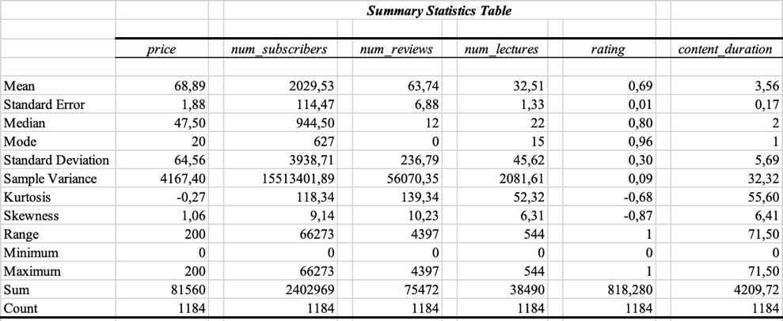
1.2 Price Distribution: To better understand how course prices are distributed across the dataset, a histogram was constructed for the price variable.
Chart 1: Price Histogram
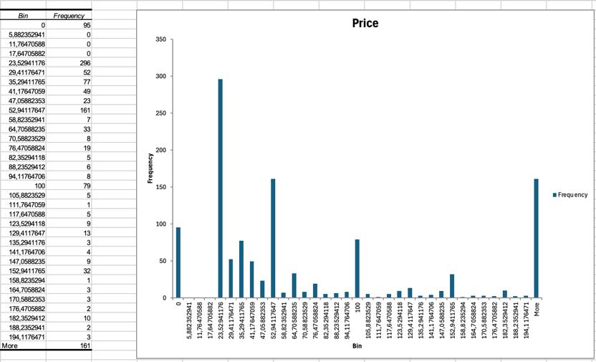
The price distribution is right-skewed, the skewness is 1.06, indicating that most courses are priced at the lower end of the scale, while a small number of premium courses pull the mean upward. The average price is $68.89, which's a lot higher than the median price of $47.50, this means the average price does not really show what most courses cost. The median price is a way to know what most courses cost and the mode price is $20, which tell us that the most repetitive price in the market is very low. Regarding the variability, the standard deviation of $64.56 is large relative to the mean, showing that the prices of courses are over the place from $0 to $200. This means the company can charge different prices for courses, they can give away some courses for free or charge little or they can charge a lot for premium courses. Overall, the company has a lot of choices when it comes to pricing, however according to the data, we can say that the best prices are usually lower than the average price.
1.3 Number of Subscribers Distribution: A histogram was similarly constructed for the number of subscribers variable to examine how demand is distributed across courses in the dataset.
Chart 2: Number of Subscribers Histogram
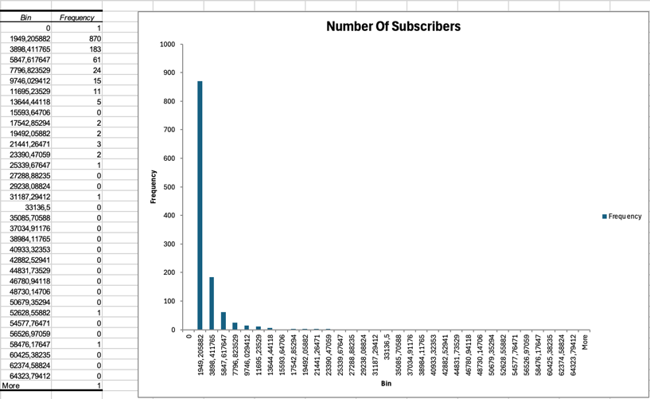
The distribution of the number of subscribers is strongly right-skewed, with a skewness value of 9.14, this shows that there is a very high concentration of demand in a small number of courses. The mean of numbers of subscribers is 2,029 which is more than double the median, which is 944, and the mode is 627 being very lower, indicating that the average of subscribers is heavily skewed by a small group of popular courses. Following with the standard deviation of 3,938 is almost double the mean, which further confirms this extreme dispersion, showing a market in which the popularity of courses is highly uneven. As shown in the histogram, almost 870 courses fall within the first interval, and we can observe that the frequency drops off from there, remaining close to zero across the rest of the distribution. In conclusion, we can analyze that the company will need to think carefully about differentiation, marketing, and course quality to compete for number of subscribers.
- Course Distribution by Level and Year
The following shows how web development courses are spread out across difficulty levels and the years they were published.
2.1 Course Level Category Distribution
Figure 1: Bar Chart and Pie Chart of Course Level Category
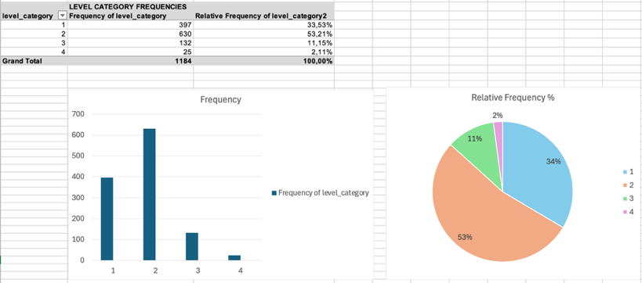
The frequency bar chart and pie chart for course level category shows how web development courses on Udemy are structured in stages of difficulty. We can observe that the “All levels” which is level 2, is the most common category, since it has over 630 courses, 53.21% of the data, telling us that more than half of all courses in the dataset are not targeted at a specific skill level. The second largest group is the “Beginner Level”, level 1, with 397 courses and 33.53% of the data. These two categories together account 87% of all courses, meaning that web development education market is highly focus on the entry-level and broad audiences. The “Intermediate Level” courses is a much smaller share of the market, being only 132 courses, 11.15%, and the “Expert Level” courses is the lowest of the dataset, with only 25 courses, 2.11%. The lack of expert-level content could indicate, that either there’s a gap in the market for advanced learners, or that experienced costumers tend to seek more specialized resources outside of structured online platforms.
2.2 Year Distribution
Figure 2: Bar Chart and Pie Chart of Year
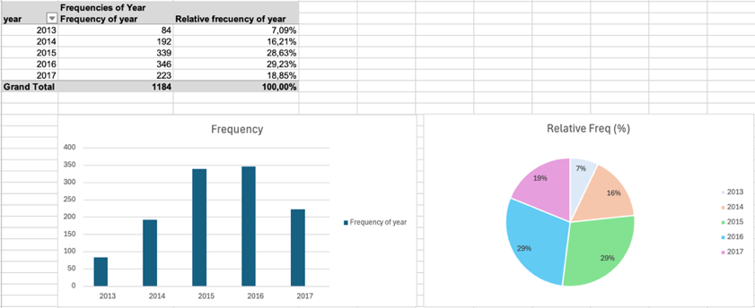
When we look at how courses were published over the years the numbers show that more courses were published from 2013 to 2016 but then the number of courses went down in 2017. In 2013, 84 courses were published, which is a small part of the total and this is because online learning was still getting popular at that time. By 2014 the number of courses had more than doubled to 192 which means more people were getting interested in education, the online education market was at its best in 2015 and 2016 with 339 and 346 courses published which's almost 58% of all the courses. In 2017 the number of courses published went down to 223, but it may be possible that the data for 2017 is not complete which would mean the number of courses is lower than in previous years. Overall, the online education market was growing strongly through time, which is a good sign for the company that wants to get into this market.
- Hypothesis Testing: Differences in Course Ratings Across Publication Years 2014 – 2027.
The following investigates whether the average course rating differs between courses published in 2014 and 2017, using a two-sample t-test assuming equal variances at a 5% significance level.
3.1 Hypotheses
The null and alternative hypotheses are stated as follows:
- H0: μ2014 = μ2017 (the average course rating is the same in both years)
- H1: μ2014 ≠ μ2017 (the average course rating differs between the two years)
This is a two-tailed test, as we are testing whether the ratings differ in either direction, rather than predicting which year would have a higher rating.
3.2 Results of The Hypothesis.
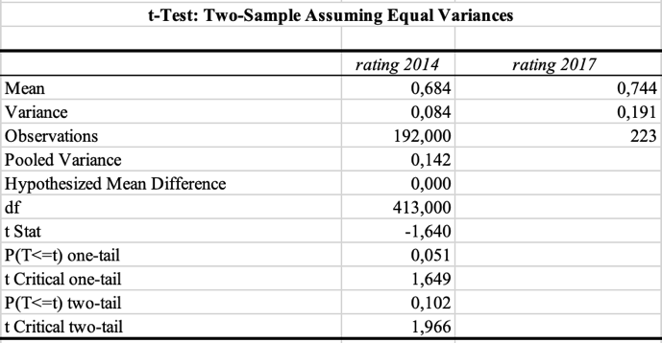
The two-sample t-test gave us a t-statistic of -1.640 and a p-value of 0.102, we need to compare the p-value to the significance level of 0.05 to see if the difference in ratings is statistically significant. In this case 0.102 is greater than 0.05 so we do not reject the null hypothesis. The 2017 courses had an average rating of 0.744 compared to 0.684 for 2014 courses, however the difference in rating of the 2017 courses and the 2014 courses is not big enough to say it is a change, it could be a normal variation in the data. From a business point of view course ratings have been consistent over time, this means the course rating trends should not be the reason, for the company’s decision to enter the online education market.
- Correlation Analysis: Price vs. Number of Subscribers
This part looks at how the price of a course affects the number of people who subscribe to it. We make a prediction, about what we think will happen.
4.1 Predicted Direction
When we think about the Law of Demand, we can expect that the price of a course and the number of subscribers will have a negative correlation. The Law of Demand says that as the price of a course goes up it will be less appealing to people who might want to buy it, because the course becomes too expensive for some people. Therefore, it is predicted that higher-priced courses will tend to have fewer subscribers, producing a negative correlation coefficient.
4.2 Result of correlation between the price and the number of subscribers.
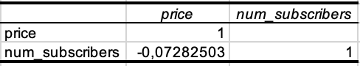
The correlation between the price of a course and the number of subscribers is negative which is what we predict would happen. The correlation is -0.073, this number is very small, which means that the price of a course and the number of subscribers is not really related in a way. This is important because it means that the price of a course does not tell us much, about the number of subscribers it will attract.
4.3 Why the Sign Might Differ from the Prediction
While the result is what we predict it would be, we should think about why the relationship between price and subscribers might be different in other situations or with different data. There are a few situations for this, first the price of a course may tell subscribers the quality of a course, in markets where people cannot easily know if a course is good before they buy it, a higher price might show a high quality, attracting more subscribers, meaning that price and subscribers are related positive. Second case can be instructors who are popular and have a good reputation, may be able to charge more money for their courses, which is another scenario of a positive relationship. The third situation can be the fact that there are some free courses in the data which might make the relationship between price and subscribers look different than it really is, because a lot of free courses do not get many subscribers since they are not very good or people do not know about them which makes the relationship between price and subscribers look weaker than it should be. Finally, things like how good a course's, how well known the instructor is, and how much the course is advertised can affect both the price and the number of subscribers at the same time which can hide what is going on with the relationship between price and demand.
- Regression Modelling and Results
This section tries to find out how price affects the number of subscribers. We use two models, one model looks at price and subscribers, the other model considers other variables that might affect the number of subscribers. By comparing these models, we can see how price affects subscribers while keeping factors in mind.
Model 1: Simple Linear Regression (Without Controls)
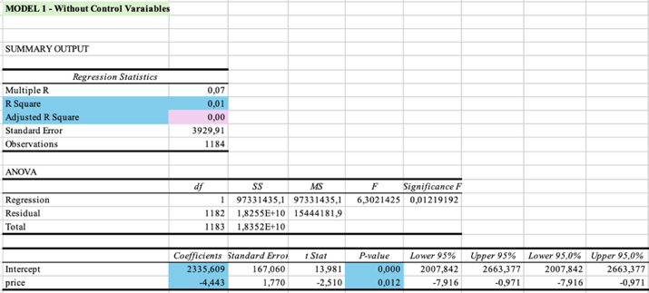
Model 2: Multiple Linear Regression (With Controls)
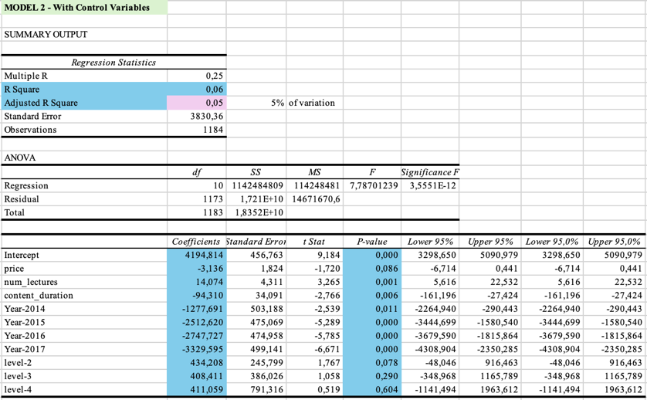
- Coefficient, size and statistical significance analysis.
6.1. Model 1: Simple Linear Regression – without control variables
The first model examines the relationship between price and the number of subscribers without any additional explanatory variables. The estimated regression equation is:
- num_subscribers = 2335.61 − 4.44 × price
The intercept of 2335.61 is the starting point, it shows how many subscribers a course would have if it were free, this number is reliable because it is statistically significant (p <0.001) providing a reliable baseline for the model. The price coefficient is -4.44, this means that for every dollar a course costs the number of subscribers goes down by 4; this coefficient is statistically significant at the 5%, since the p level is 0.012, confirming that price does have a measurable negative effect on demand, which is consistent with the Law of Demand. The difference price is not big, because if a course costs 10 dollars more it would have 44 fewer subscribers, which is not a lot especially since some courses have tens of thousands of subscribers. The R² is 0.0053, showing that the price of a course only explains a small part of 0.5% of the variation in subscriber numbers, meaning the vast majority of what drives course popularity is not captured by price alone.
  - Model 2: Multiple Linear Regression - with controls variables
The second model is with control variables: number of lectures, content duration, year dummies, and level category dummies. This was made with the purpose to isolate the true effect of price while holding other factors constant. The estimated regression equation is:
- num_subscribers = 4194.81 − 3.14 × price + 14.07 × num_lectures − 94.31 × content_duration + year dummies + level dummies
The intercept of 4194.81 shows the expected number of subscribers for a beginner course, that was published in 2013 with no price, no lectures and no content duration; this result is very reliable on (p < 0.001). We can observe that in this model the price coefficient decreases to -3.14, meaning that for each dollar increase in price is now associated with approximately 3 fewer subscribers, meaning that this coefficient is no longer statistically significant at the 5% , because the p level is (p = 0.086), which suggests that the effect of price seen in Model 1 was driven by its correlation with other variables, once these factors have been taken into account, price alone cannot be regarded as a direct determinant of demand.
Consequently, the number of lectures coefficient is 14.07, revealing that each additional lecture is associated with approximately 14 more subscribers. In contrast, the content duration coefficient is -94.31 is also significant (p = 0.006) but negative, which in this case means that each additional hour of content is associated with approximately 94 fewer subscribers. This may suggest that learners prefer courses structured and concise lectures rather than courses that are long in total duration.
The courses that were published from 2014 until 2017 show a drop in the number of subscribers. The year 2014 courses have -1,278 subscribers; 2015 courses have fewer subscribers with about -2,513 fewer subscribers; in 2016 courses have around -2,748 subscribers and finally for 2017 courses have the fewest subscribers, with about -3,330 fewer subscribers. This is probably because the courses that were published earlier like the year 2013 courses have had time to get noticed and get students. These year effects have a big impact in our model, because the time subscribers stay on the platform is very important, helping the company to have subscribers on the platform for long as possible. Finally, we can analyze that none of the course level categories are significant, at a 5 percent level, level 2 has a p value of 0.078; level 3 has a p value of 0.290; level 4 has a p value of 0.604, meaning that we cannot say that course difficulty affects the number of subscribers when other factors are considered.
- Model Comparison and Predictive Power
When we look at both models the R² goes up from 0.53 percent in Model 1 to 6.23 percent in Model 2. The Adjusted R² also goes up from 0.45 percent to 5.43 percent. The Adjusted R² goes up telling us that the extra variables we added really did make the model better; however, even the better model only explains about 6 percent of the differences in the number of subscribers, this shows that there are a lot of things that affect how popular a course is, like how well people think of the instructor, marketing and how relevant the topic is, these are things that are not included in our data. The biggest difference between the two models is the price, in Model 1 the price coefficient is -4.44, in Model 2 it is -3.14 and loses statistical significance entirely when controls are added. This tells us that in Model 1, price was capturing the influence of other correlated variables, and that the true effect of price on demand is economically very small. Overall, while Model 2 is clearly superior to Model 1, both models should be interpreted as tools for understanding general associations between variables rather than instruments for predicting demand.
- Regression and Causation: Causality and Price Effects on Demand
The results from point 5 do not really show that the price of web development courses affects the demand. The price is linked to demand according to the law of demand; however, it does not mean that the price is the reason for the demand, there are some other factors for this. First the model is missing some other variables, for example, the reputation of the instructor, who are well known and usually charge more for their courses, they also get a lot of students because people trust them; since we do not have information about the instructor’s reputation it affects the link between the price and the demand for web development courses. Second it is possible that the popularity of a course affects its price, of the price affecting how many people want to take the course the people who create the courses might change the price based on how popular the course is, they might charge more for courses that are doing well or charge less for courses that are not doing well. For these reasons when we look at the results from point 5 we should think of the link between the price and the demand as a statistical connection, not a cause-and-effect relationship, because the link between the price and demand, for web development courses is probably affected by variables we don’t have in the data.
- Course Recommendations for Maximizing Subscribers
From Model 2 we can see that there are three things to recommend. First to publish courses early, the variable that affects the results the most is the year published; for example courses that were published in 2013 are likely to have up to 3,330 subscribers than courses published in 2017. So if we analyse this data we can say that courses that have been out for longer have time to get noticed and get reviews from subscribers.The second recommendation would be to have lectures that are shorter rather than fewer lectures that are longer; since the number of lectures has a significant positive effect on subscribers (+14.07 per lecture, p = 0.001), while total content duration has a significant negative effect (−94.31 per hour, p = 0.006). This tells us that people taking the courses prefer courses in many short segments rather than long content. Finally the third recommendation is that, as we could see in model 2 the price of a course and level category is therefore unlikely to meaningfully increase subscriber numbers. So trying to compete with courses by lowering the price or making the course easier or harder is probably not going to make a big difference in the number of subscribers.
- Log-log regression Model
Model 3: Log_price and Log_number of subscribers regression
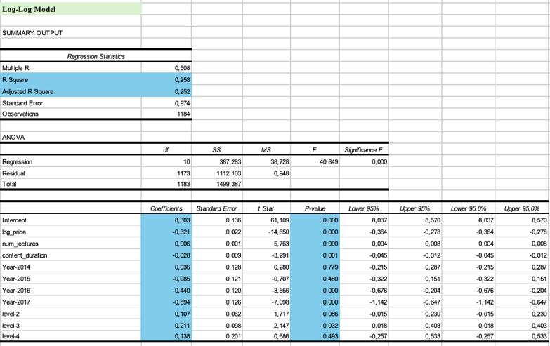
The log-log regression uses the natural logarithms of price and num_subscribers (log_price and log_num) instead of the raw values, it keeps the same control variables as Model 2. In this case, the coefficient on log_price shows how much the number of subscribers changes when the price changes by 1%.
10.1 Does the conclusion about price change?
The Model 2 price coefficient is -3.14, and statistically significant, p value is 0.086, meaning we do not know if the price influences the demand. The log_price coefficient in the log-log model is -0.321, with a high statistically significant, p < 0.001, showing that if the price goes up by 1 percent the number of subscribers goes down by 0.3 percent. The log-log model shows that there is a negative relationship between the price and the demand that the linear model did not show. The demand for the log-log model is not very elastic because the elasticity is -0.32, that subscribers are not very sensitive to changes in the price, if the price goes up by 1 percent the demand will go down.
10.2 How does the model fit change?
The fit of the model gets a lot better. The R² goes up from 0.0623 in Model 2 to 0.2583 in the log-log model. The Adjusted R² goes up from 5.43% to 25.20%. This means that the log-log model explains more than four times as much change in the number of subscribers, which is a big improvement.
10.3 Is this a better set of requirements?
Yes, for three different reasons. The first thing to note is that the big jump in Adjusted R² shows that the log-log model does a much better job of capturing the underlying demand relationship. Second, since both price and num_subscribers are heavily right-skewed, as seen in point 1, using a log transformation makes extreme values less extreme and creates more symmetric distributions. Third, the elasticity interpretation is more useful for business because it tells you that a 1% price increase will lower demand by 0.32%. This is much more useful than a raw coefficient in absolute units; the log-log specification is the best model overall because it fits the data better, gives more accurate estimates, and gives results that are easier to understand.
- Linear Demand Curves
Figure 3: Demand Curve course published in 2013 and 2017

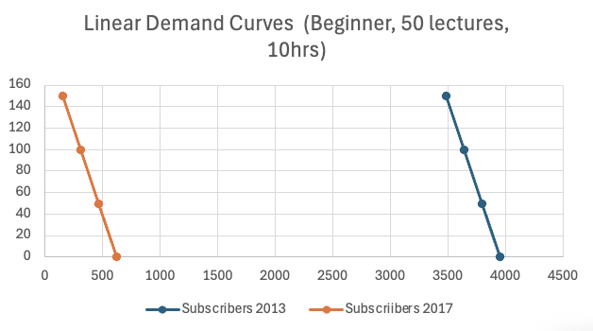
We used the coefficient estimates from Model 2 to make two linear demand curves for a course with 50 lectures, 10 hours of content, and taught at a beginner level. One curve was for a course that came out in 2013 and the other for a course that came out in 2017. The equations for demand are:
- D(2013): num_subscribers = 3,955 − 3.14 × price
- D(2017): num_subscribers = 626 − 3.14 × price
The two demand curves are parallel, which means they have the same slope (−3.14) but different starting point, because the price sensitivity of demand is the same for both courses, but the baseline level of demand is very different, at any given price. The 2013 course is expected to get about 3,329 more subscribers than the same course in 2017, which tells us that the demand is affected in both curves by the year it was published, the demand curve for 2013 is a lot farther to the right than the demand curve for 2017, from which we can analyse that older courses get better with time, they can get reviews from subscribers and have great platform visibility.
- Conclusion
This report looked at 1,184 Udemy web development courses to identify what makes people want to take these courses. What the report found out is that the price of a course does not really affect how many people sign up for it. What is more important is how the course is set up and how long it has been on the website, courses that have lectures that're easy to follow and were put up on the website a long time ago tend to get more people signing up. The log-log model, with an Adjusted R² of 25.20%, provides the most appropriate specification for capturing this relationship. The company should use this information to its advantage, hey should get into the market soon as possible and focus on making courses that are well organised and have a lot of lectures.

