6/10/2026
Paula Moreno Mappe
student id: 26177980
Private Hospital Insurance in Australia: Long-Term Trends and Individual Determinants of Uptake
23708 Studio 1: Foundation - Autumn 2026
Table of Contents
Introduction 3
Task 1: Long-term trends in Private Hospital Insurance (PHI) uptake and the sustainability of the PHI market 4
Section 1: Data Exploration and Quality Assessment 4
Section 2: Descriptive and Exploratory Analysis of PHI Trends 6
2.1 Long-Term Trend in Total PHI Membership: Has total PHI membership grown, declined, or stayed flat over time? 6
2.2 Long-Term Trend in PHI Coverage Rate: How has the PHI coverage rate evolved once population growth is accounted for? 7
2.3 Coverage Rate by Age Group: Did younger people drop out at a different rate from middle-aged and older people? 8
2.4 Period Comparison: Pre-COVID, During COVID, and Post-COVID, How did the COVID-19 pandemic affect these trends? 9
Section 3: Discussion and Sustainability Outlook 11
Task 2: Statistical model to analyse PHI uptake and assess the influence of relevant factors. 13
Section 2.1: Regression Model, Determinants of PHI Uptake. 13
Linear Probability Model (LPM) 13
Linear Probability Model Result Table 14
Summary of reasoning for variable selection and interpretation of the estimated coefficients, for all explanatory variables included in our model: 15
Section 2.2 : Missing Variables 25
Section 2.3 Omitted Variable Bias and Reverse Causality 25
Section 2.4: Creation of synthetic individual with average characteristics of the variables included your LPM. 27
Section 2.5 Estimating the Effect of the Medicare Levy Surcharge 29

Introduction

Australia runs a mixed health system, whereby the universal health care is provided through Medicare for the basic services offered by hospitals and doctors, whereas the PHI provides benefits such as reduced wait-times, choice of doctor, and improved facilities. This paper will analyze the trends of PHI enrollment and coverage in Australia to determine the extent to which the market was shrinking prior to the emergence of the pandemic and the dynamics that occurred in its operation after the outbreak. Data used in the report were obtained from the Quarterly Enrollment Report compiled by the APRA and population estimates from the Australian Bureau of Statistics covering the time frame of September 1997 and September 2025. The paper consists of two tasks, namely, task 1 which analyzes the trend and sustainability of the market and task 2 that formulates a regression model for the factors influencing an individual to enroll for PHI.

Task 1: Long-term trends in Private Hospital Insurance (PHI) uptake and the sustainability of the PHI market

The present study aims to investigate whether there has been any reduction in the number of PHI memberships and coverage ratios before the outbreak of the pandemic; see the different trends between age groups; analyze the behavior of the market during and post-pandemic; and determine the sustainability of the market.

Section 1: Data Exploration and Quality Assessment
This analysis draws on two primary data sources, the first is the "HT by Age" sheet from the APRA, PHI Membership Trends data, which records the number of individuals holding private hospital treatment insurance, broken down by five-year age group, for each quarter from September 1997 to September 2025. The second source is the ABS quarterly estimates of the Australian resident population by age group, covering the same time, these population figures were used alongside the APRA membership data to calculate the PHI coverage rate.
Figure 1: PHI Coverage rate per quarter (first 10 rows)
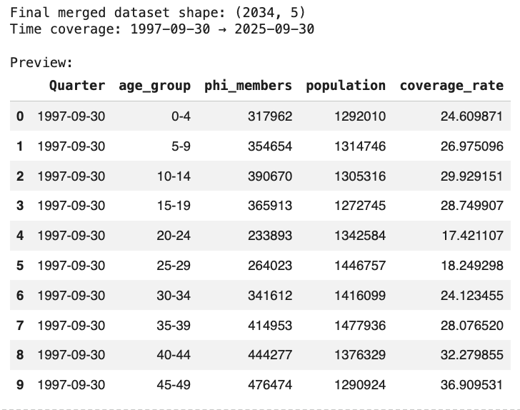

Figure 2: Average coverage rate by age group (across all quarters)
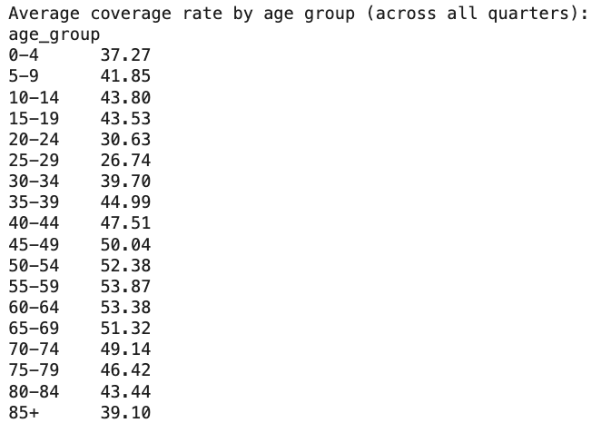
The two data sets have been checked for any missing values, duplicates, or other discrepancies in the structure. Age groups have been standardized by putting together both data sets and categorizing them into five groups, that is: children (0-19), young adults (20-34), middle-age group (35-54), older but pre-retirement age group (55-69), and elderly group (70+). On the other hand, timelines were created for this analysis based on the information provided by WHO regarding their response to this pandemic (Timeline: WHO'S COVID-19 Response, n.d.). Pre-COVID (2015-2019), COVID (2020, mid 2023), post-COVID (mid 2023, 2025)

Section 2: Descriptive and Exploratory Analysis of PHI Trends

2.1 Long-Term Trend in Total PHI Membership: Has total PHI membership grown, declined, or stayed flat over time?

Figure 1: Trend in total PHI membership (September 1997 to September 2025)
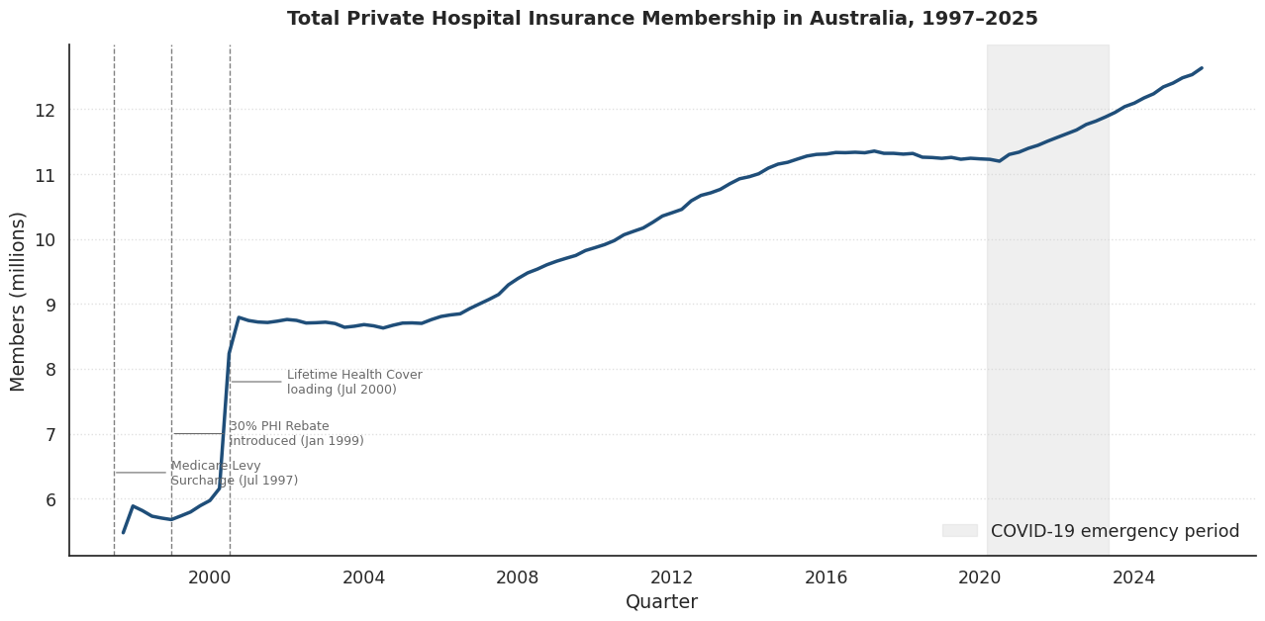

According to Figure 1, total PHI membership rose steadily from about 5.5 million in September 1997 to 12.6 million in September 2025. The growth was uneven, however, with three sharp inflection points concentrated between 1997 and 2000, when three major policy reforms were introduced to lift PHI uptake (Palangkaraya & Yong, 2005). The Medicare Levy Surcharge (MLS), introduced on 1 July 1997, imposed an additional tax on higher-income earners without PHI. The 30% PHI Rebate, introduced on 1 January 1999, subsidized premium payments for all Australians. The Lifetime Health Cover (LHC) loading, introduced on 1 July 2000, penalized individuals who delayed purchasing PHI beyond age 30. Within three years, membership rose from approximately 6 million to 8.8 million a 45% increase.

From 2015 to 2019, years leading up to the COVID 19, memberships grew steadily but more slowly, reaching approximately 11.3 million for 2019. During the initial phase of the pandemic (2020 to mid-2021), membership growth temporarily stalled, however contrary to pre-pandemic concerns about a potential market collapse, the enrollment accelerated significantly from 2022 onward, reaching 12.6 million by the end of the period 2025.

There are two important insights from the following graph. First, the government policies had a huge impact on PHI memberships, incentivising private cover reduces pressure and waiting times on the public system. Second This post-pandemic rebound reflects deferred demand, people who postponed purchasing PHI during the uncertainty of the pandemic re-enrolled once hospital services resumed.

2.2 Long-Term Trend in PHI Coverage Rate: How has the PHI coverage rate evolved once population growth is accounted for?

Figure 2: Coverage Rate (September 1997 to September 2025)
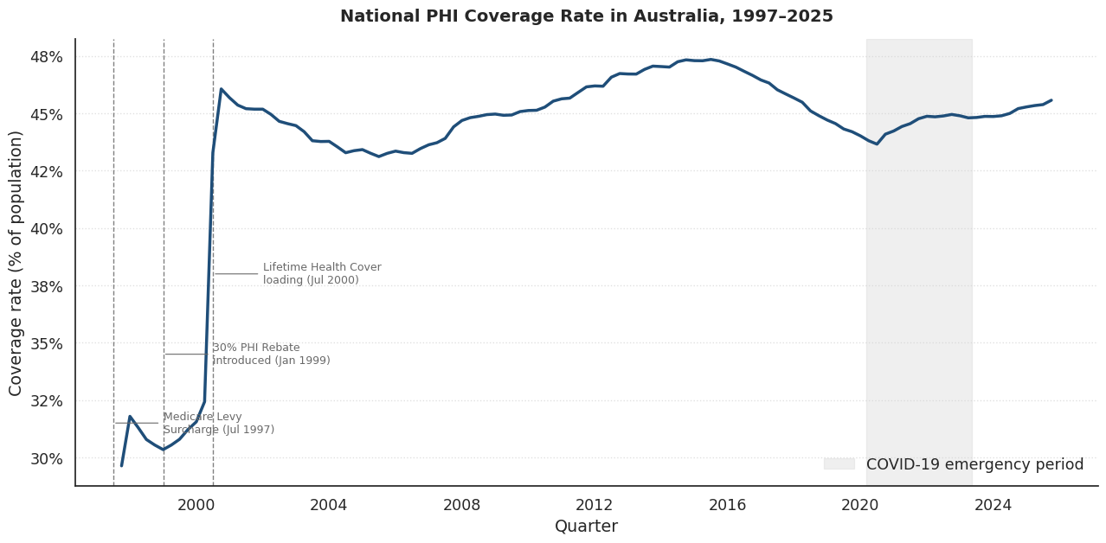

Figure 2 presents the national PHI coverage rate, the proportion of the Australian population holding private hospital treatment cover, which is a meaningful indicator of market health as it controls for population growth.
Between 1997 and 1999, the coverage rate was declining around 30%, but after the two government policy interventions of 1999–2000, the coverage rate reached a peak of 45.7%, a gain of nearly 15 percentage points in just three years, which shows us how impactful are government policies. From 2001 onwards, coverage declined and rise along time, falling to 44.0% by December 2019, confirming that concerns about a weakening PHI market before the pandemic were true (Duckett & Moran, 2021). During 2020 and 2021, the rate fell further before recovering strongly from 2022 onwards, returning to 45.6% by September 2025. Table 1 summarizes these key movements.

Table 1: National PHI Coverage Rate at Key Points in Time (1999–2025)
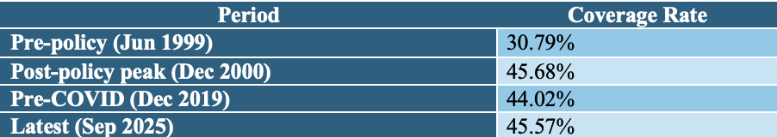

2.3 Coverage Rate by Age Group: Did younger people drop out at a different rate from middle-aged and older people?
Figure 3: PHI Coverage Rate by Age Group (September 1997 to September 2025)
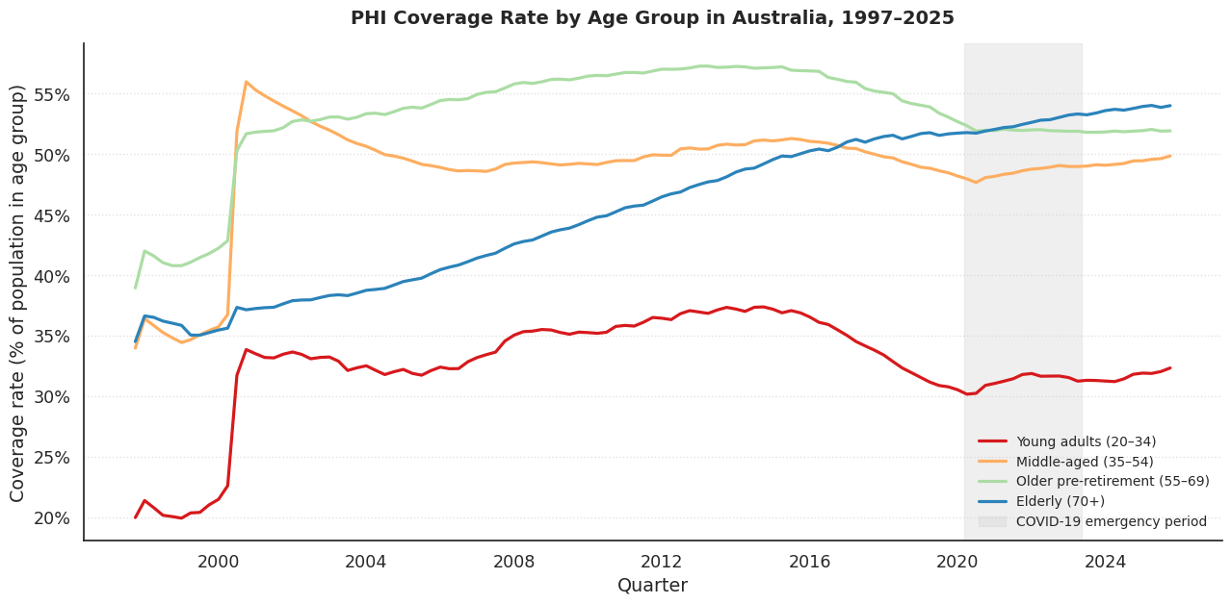
The 0–19 age group is excluded from this analysis, since PHI coverage for children and teenagers is typically determined by their parents, the analysis therefore focuses on the four adult age groups.

Figure 3 illustrates the disaggregation of the overall coverage rate for PHI by four different adult age. The most noticeable pattern is that observed in the young adult population aged 20-34 years; there was a significant improvement, their coverage rising from 20% to 33% after the policy reforms implemented in 1999-2000, oscillating between 33% and 35% throughout the decade 2000s, reaching its peak around 37% in 2015, and subsequently dropping down to 30% by the end of 2019, before the pandemic outbreak.

The middle-aged (35–54) show long, gradual decay; their coverage has been slipping for over two decades, from 56% after the 2000 reforms to under 50% by 2025. There is no single turning point, just a long, steady drift away from private cover.

The older pre-retirement group (55–69) was the most stable, holding above 55% throughout the 2010s before a decline became visible after 2015, suggesting this was least sensitive to rising premiums given their anticipate need in hospital treatment and therefore more willing to pay rising premiums.

Only the elderly (70+) have shown an increase in coverage throughout the entire 28-year period, from about 35% in 1997 to more than 54% by 2025. In 2020, the graph of the elderly became higher than that of the older pre-retirement age group, meaning that currently, the group that is most insured is above the age of 70. The comparison of these two lines, reflects a significant change in the demographic structure of the insured population, with the aging of the insured population, the cost of claims becomes higher, leading to increased premiums.

2.4 Period Comparison: Pre-COVID, During COVID, and Post-COVID, How did the COVID-19 pandemic affect these trends?
Figure 4 : Average PHI coverage rate across three periods
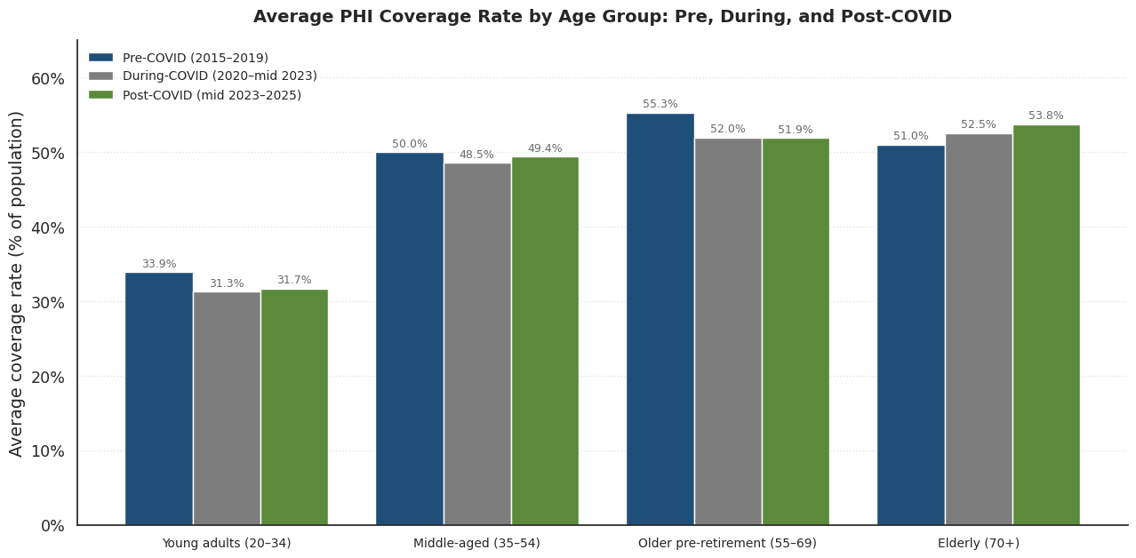
Table 2: Average PHI Coverage Rate by Age Group and Period
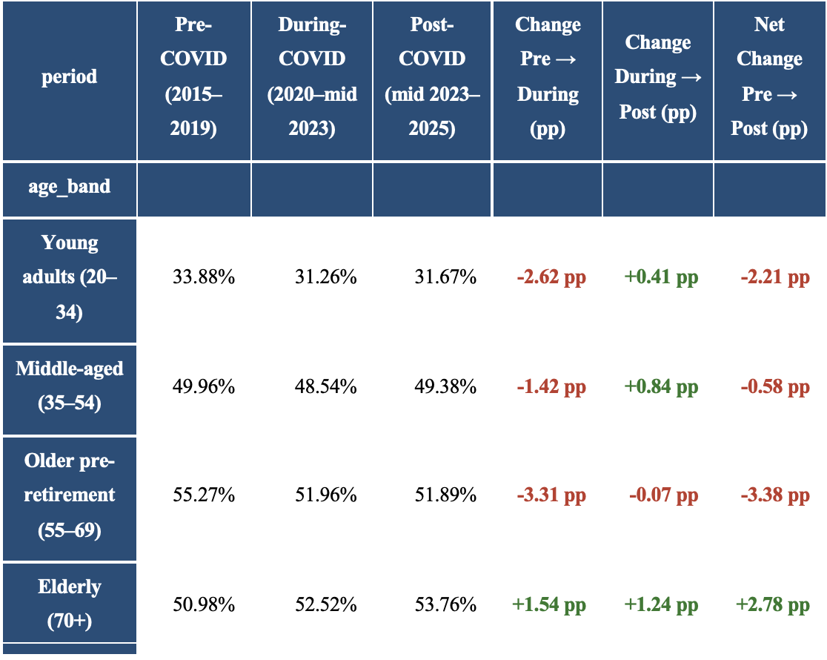
Figure 4 and Table 2 break down the average PHI coverage rate by age group across three discrete periods bounded by the WHO's official COVID-19 emergency window (March 2020 to May 2023).
Before COVID (2015–2019), coverage levels varied significantly across age groups, older pre-retirement Australians (55–69) were the most insured at 55.27%, followed by the elderly (70+) at 50.98%, middle-aged (35–54) at 49.96%, and young adults (20–34) at the bottom with just 33.88%.
When COVID hit (2020–mid 2023), coverage fell across all groups except the elderly. The older pre-retirement group took the biggest hit, losing 3.31 percentage points, while young adults dropped 2.62 percentage points to 31.26%. The middle-aged group held up relatively well, declining by just 1.42 percentage points.
During the post-COVID period (middle of 2023 – 2025), all categories showed improvement, although not by much, in order to be able to achieve pre-pandemic numbers. Young adults managed to improve only by 0.41 percentage points, having ended up at 31.67%, far from where they began. Pre-retirees barely improved, increasing by just 0.07 percentage points, the only group to break away from this pattern and keep growing throughout the whole time frame is the elderly, whose number went up to 53.76%.
In terms of net change, the final number tells us the main story, with all categories ending up with worse results compared to the pre-COVID state, except for the elderly, who were able to increase by 2.78 percentage points.

Section 3: Discussion and Sustainability Outlook
The overall picture of the PHI trend is one of fragile stability. The market looks resilient, membership is at a record high, and the national coverage rate has nearly returned to its post-2000 peak, but beneath that headline figure, three structural concerns remain unresolved.
First, young adult coverage has not recovered to pre-COVID levels and remains on a long-term downward trend, as this group pays more in premiums than it claims; their continued exit weakens the financial foundation of the entire system. Building on this, the insured pool is steadily ageing, with the elderly now the most insured age group for the first time in the dataset. This shift is consistent with the death spiral mechanism, where higher average claims push premiums up, driving further exits among younger members (Duckett & Moran, 2021). Finally, government policy incentives have weakened in real terms, reducing the financial motivation to insure for many households (Bilgrami et al., 2021).
Without targeted policy action to improve affordability and strengthen the value proposition for younger Australians, the PHI market risks entering a slow but sustained decline, placing growing pressure on the public healthcare system over the long term.

Task 2: Statistical model to analyse PHI uptake and assess the influence of relevant factors.
This section uses individual-level survey data collected from a nationally representative sample of 1,705 Australians in 2025 to identify the factors that influence the decision to hold private hospital insurance. The analysis then uses the LPM to generate predictions, assess its limitations, and discuss how the Medicare Levy Surcharge affects demand for PHI.

Section 2.1: Regression Model, Determinants of PHI Uptake.
This section estimates the linear regression model for explaining PHI uptake at the individual level. The dependent variable is PHI, which is binary (1 if the individual holds PHI, 0 otherwise), so the model (LPM) will estimate coefficients that are interpreted as changes in the probability of holding PHI.

Linear Probability Model (LPM)
Equation of the population regression model:
$$PHI_{i}=β_{0}+β_{1}HHincome_{i}+β_{2}age_{i}+β_{3}age_{i}^{2}+β_{4}bachelor_{i}+β_{5}employed_{i}+β_{6}health_{i}+β_{7}couple_{i}+β_{8}depchildren_{i}+β_{9}female_{i}+β_{10}city_{i}+u_{i}$$

The 10 explanatory variables
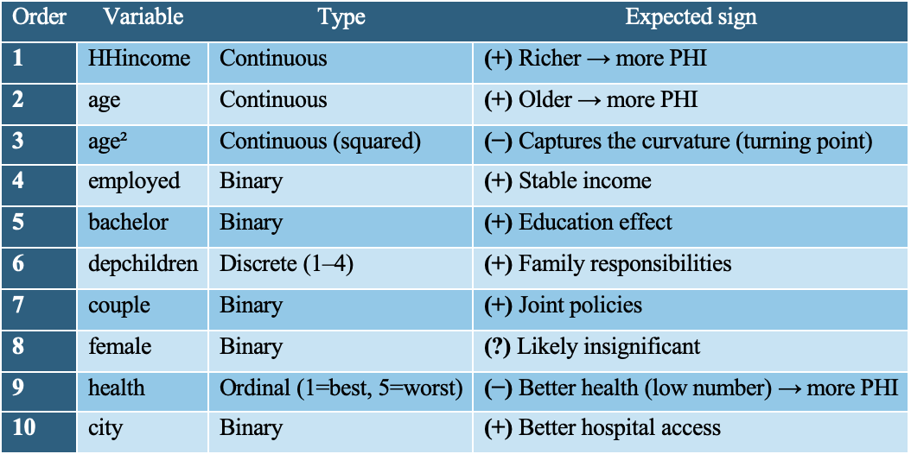

Linear Probability Model Result Table
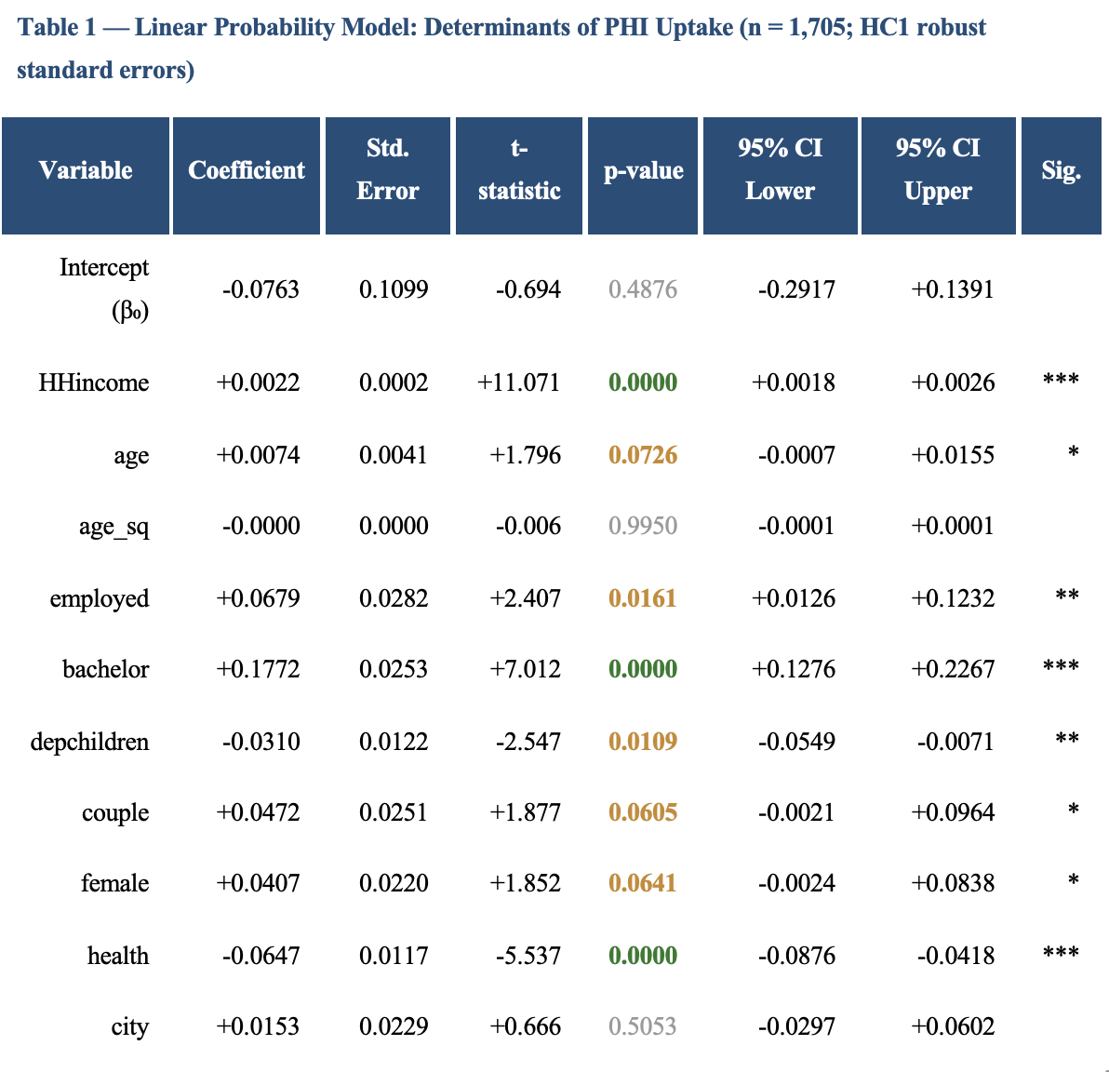
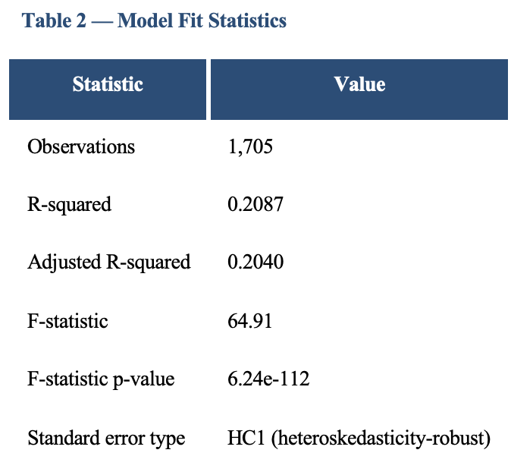

Summary of reasoning for variable selection and interpretation of the estimated coefficients, for all explanatory variables included in our model:

Table 1 : HHincome
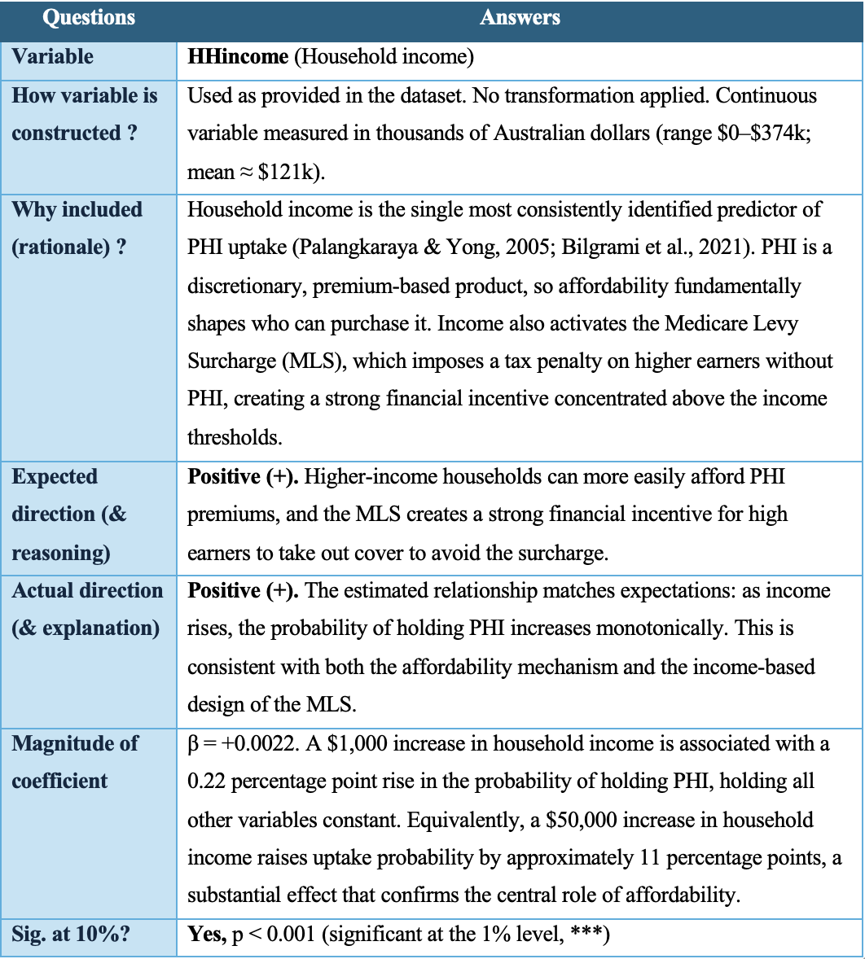

Table 2 : Age
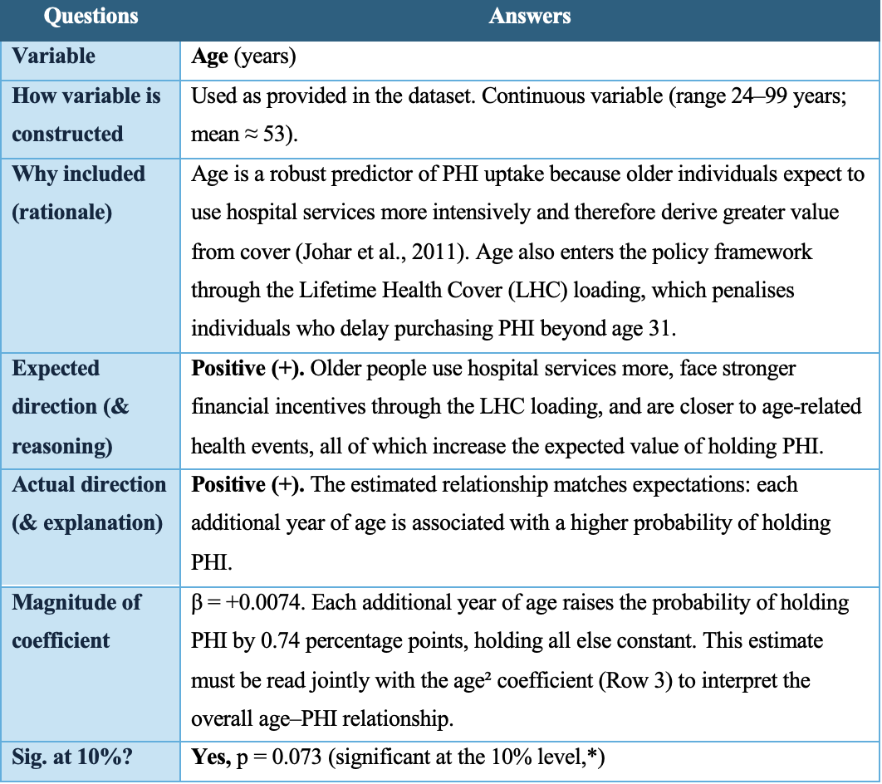

Table 3: Age² (age_sq)
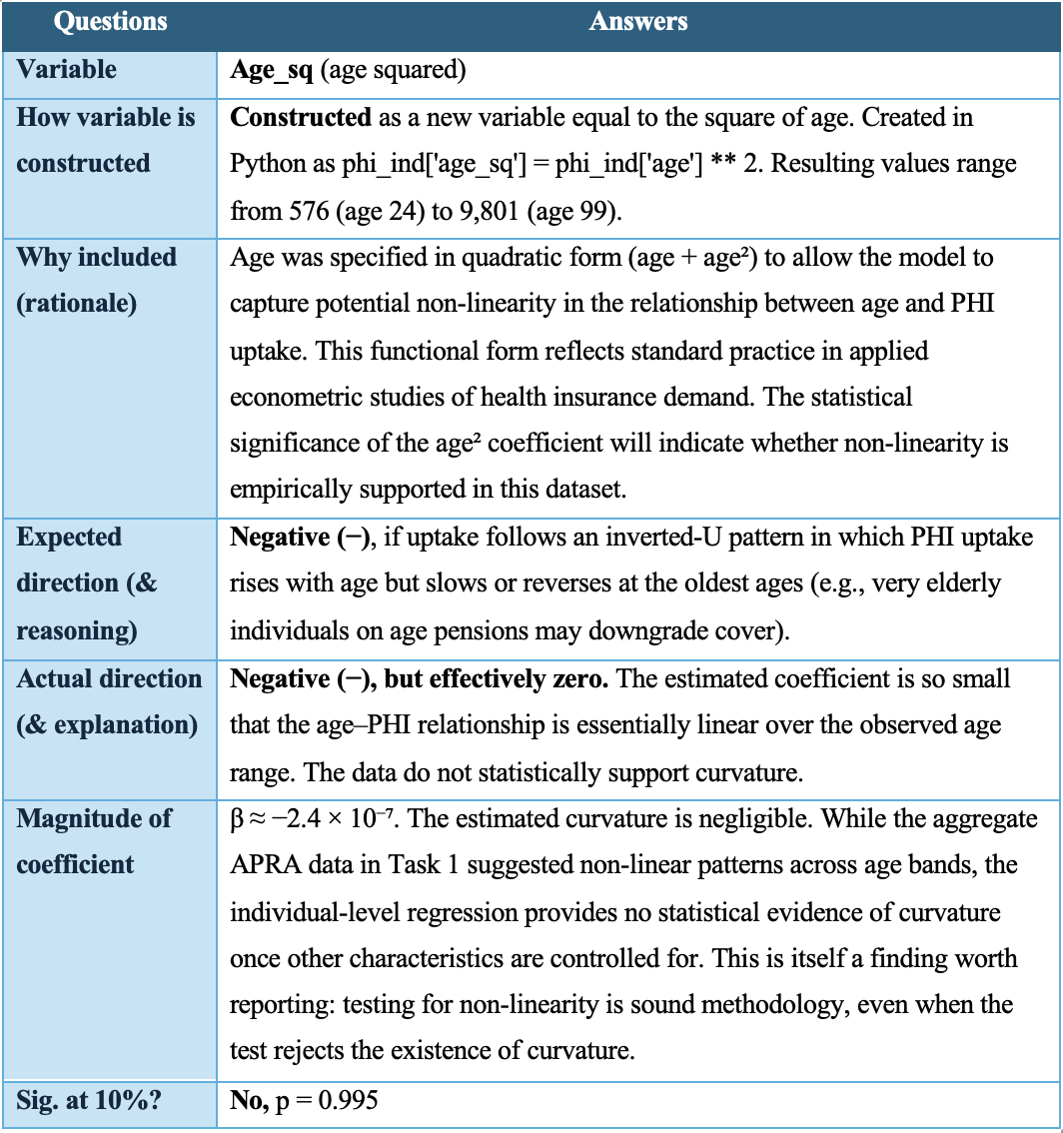

Table 4: Employed
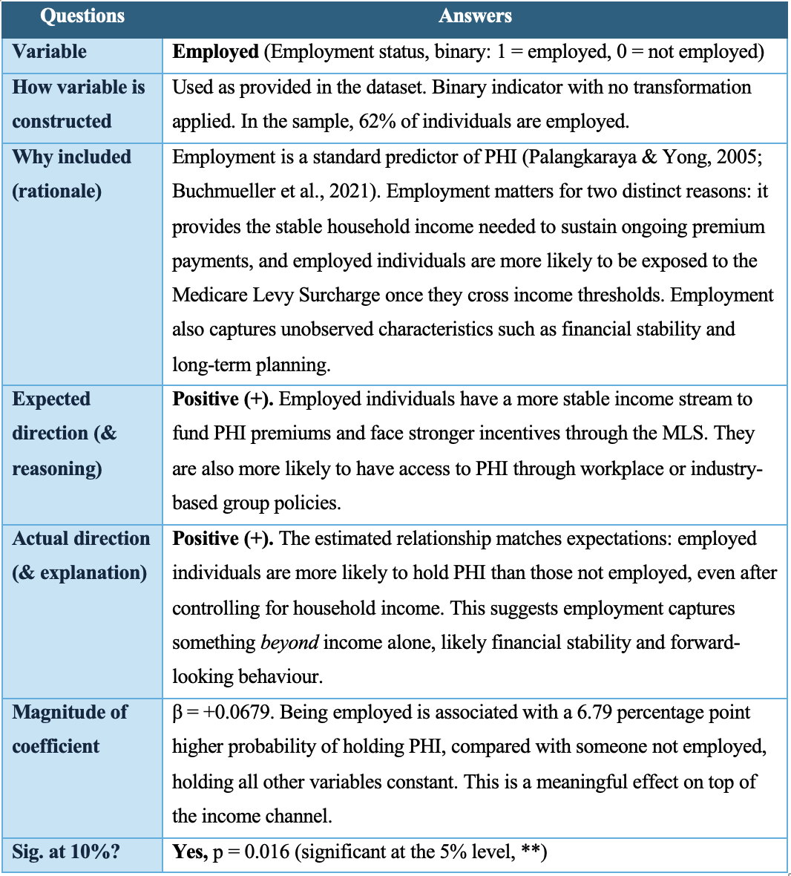

Table 5: Bachelor
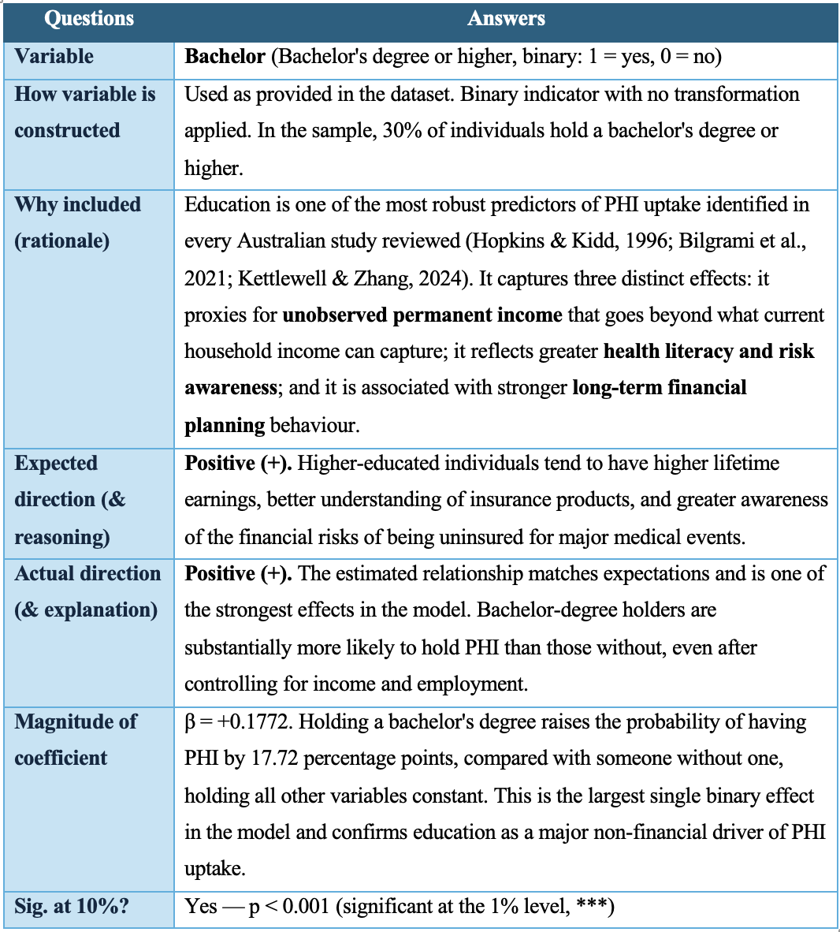

Table 6 : Depchildren
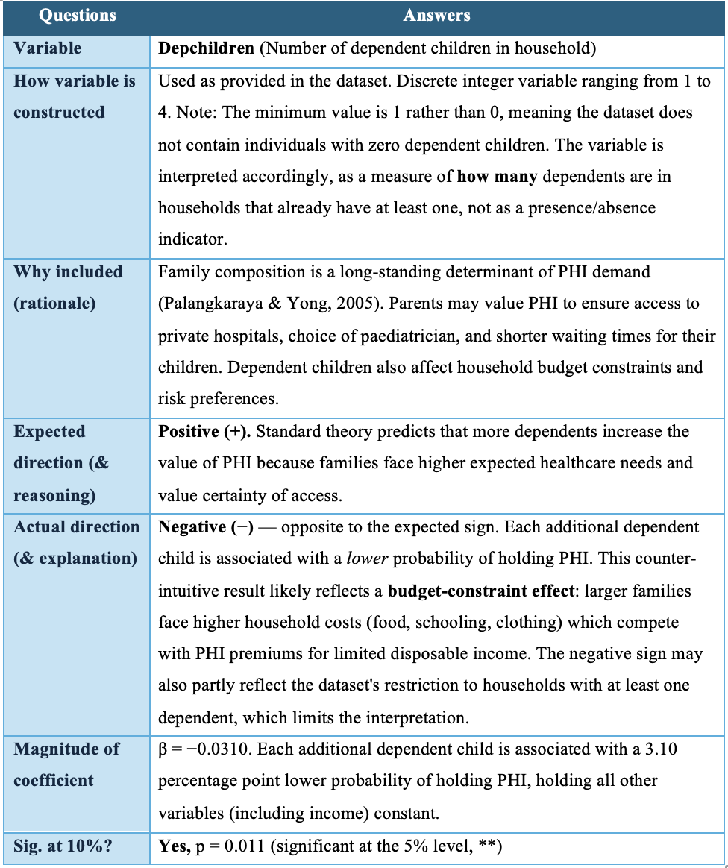

Row 7: Couple
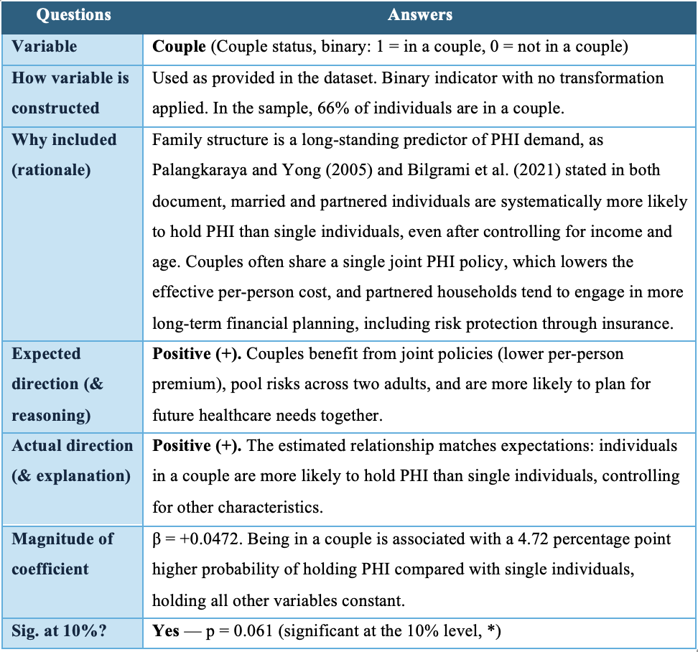

Table 8: Female

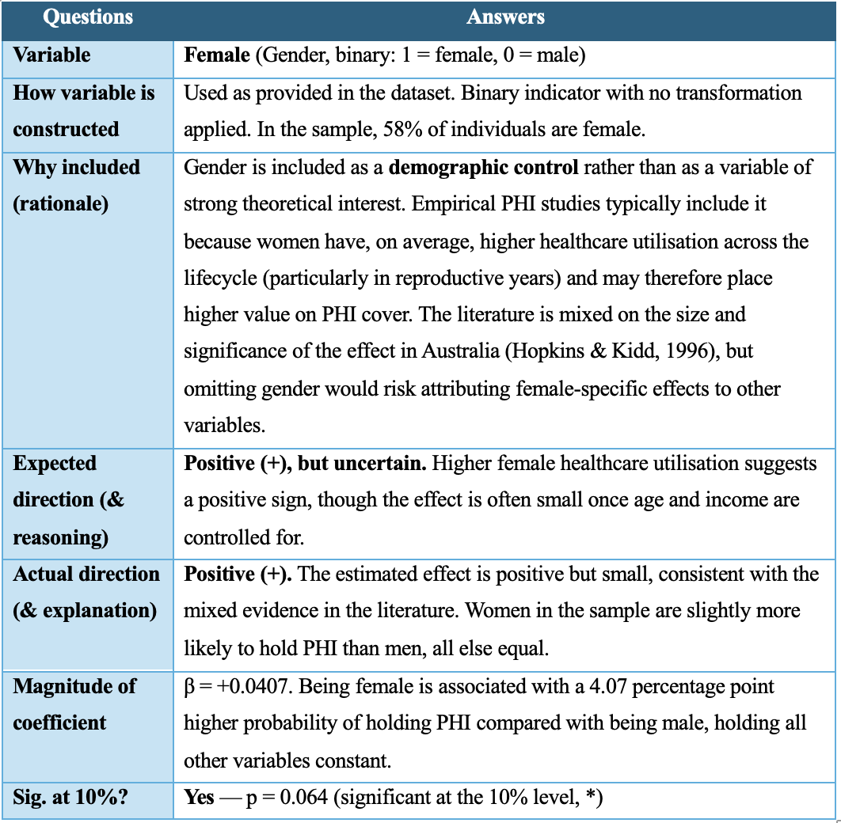

Table 9: Health (the most interesting variable in the model)

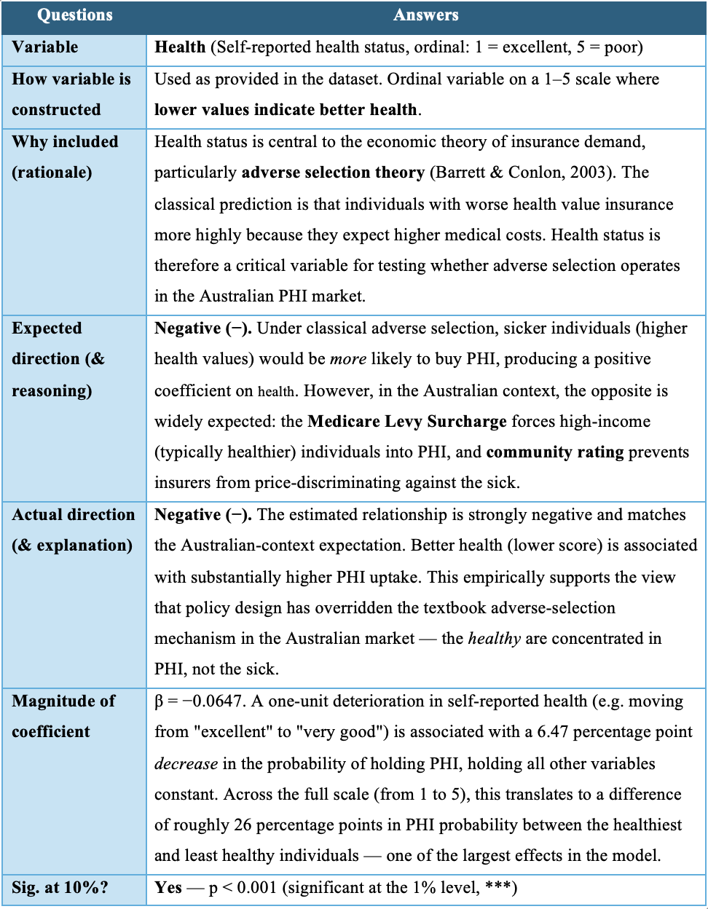

Table 10: City
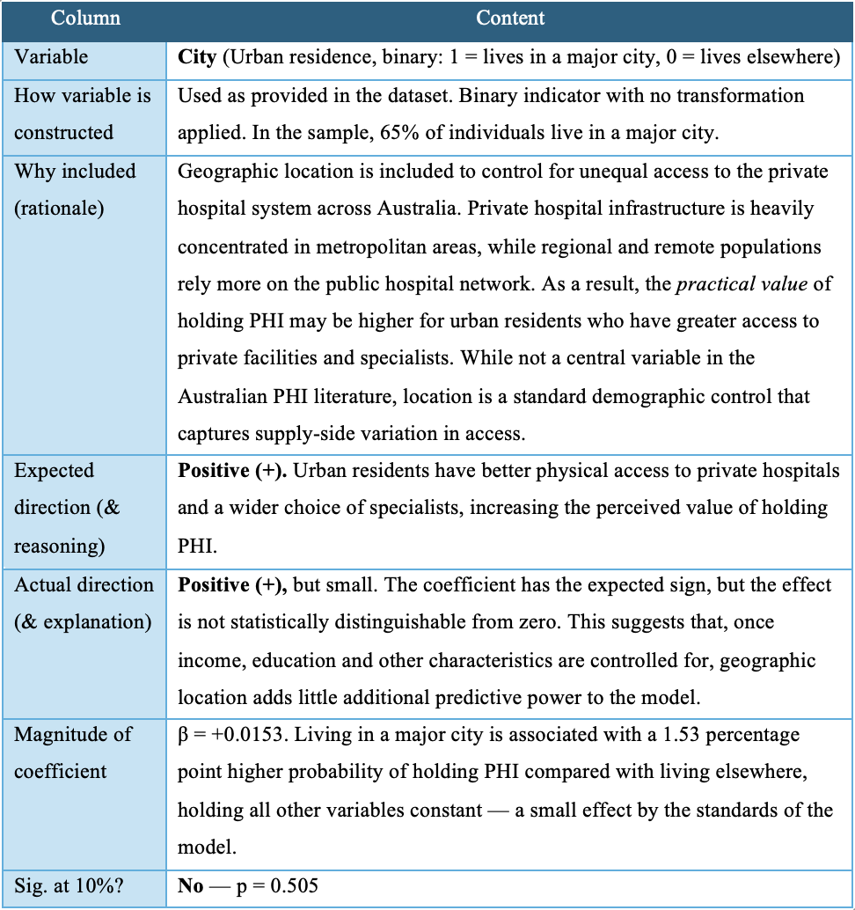

Section 2.2 : Missing Variables

While the PHI_2026 dataset contains a strong set of personal and household characteristics, several determinants of PHI uptake are not directly observed, four omissions stand out.

First, the dataset contains no information on the price of PHI faced by each individual, premium level, level of cover (basic, mid, top), or chosen excess. Price is one of the strongest determinants of insurance demand (Kettlewell & Zhang, 2024; Bilgrami et al., 2021), and its absence prevents the model from separating willingness to pay from ability to pay.

Second, there is no measure of Medicare Levy Surcharge (MLS) liability, the MLS depends on individual taxable income and family thresholds rather than on household income, yet it is a key driver of PHI uptake at the top of the income distribution (Buchmueller et al., 2021). Its absence means the income coefficient mixes affordability and tax incentive effects.

Third, the dataset omits measures of family medical history, expected healthcare needs, and risk aversion. These are theoretically central to insurance demand and their absence likely contributes to omitted variable bias on the health coefficient.

Finally, the dataset does not capture employer-provided PHI benefits or workplace group schemes, which lower the effective price of cover for many Australian employees and shift the take-up decision.

Section 2.3 Omitted Variable Bias and Reverse Causality

The estimated coefficients describe statistical associations rather than causal effects, since causal interpretation requires both no omitted determinants of PHI uptake and one-way causality from the explanatory variables to PHI, three variables are particularly vulnerable.

Health is affected by both problems. The model does not capture risk aversion, family medical history, or expected healthcare needs, traits that may produce both worse self-reported health and stronger demand for PHI, biasing the coefficient. Reverse causality also applies, holding PHI itself can improve reported health through faster specialist access and preventive screening (Johar et al., 2011).

Bachelor's degree is primarily exposed to omitted variable bias. Education correlates with unobserved traits such as financial literacy, long-term planning, family background, and risk aversion, which independently influence PHI uptake. Part of the estimated +17.7 pp effect therefore likely reflects these traits rather than education itself.

Employment is exposed to both problems. It correlates with unobserved health (sicker individuals are less likely to work) and with workplace PHI subsidies not captured in the dataset. It is also subject to mild reverse causality, the financial commitment of holding PHI may motivate individuals, articularly at older ages, to remain employed.

The estimated coefficients should therefore be interpreted as associations rather than causal effects. Establishing causality would require richer data capturing risk aversion, family history, and workplace benefits.

Section 2.4: Creation of synthetic individual with average characteristics of the variables included your LPM.
Using the estimated Linear Probability Model, this section predicts the probability of holding PHI for a synthetic average individual, a hypothetical person whose characteristics equal the sample mean of each explanatory variable. The probability is then recomputed under three counterfactual scenarios.
Build the synthetic average individual:
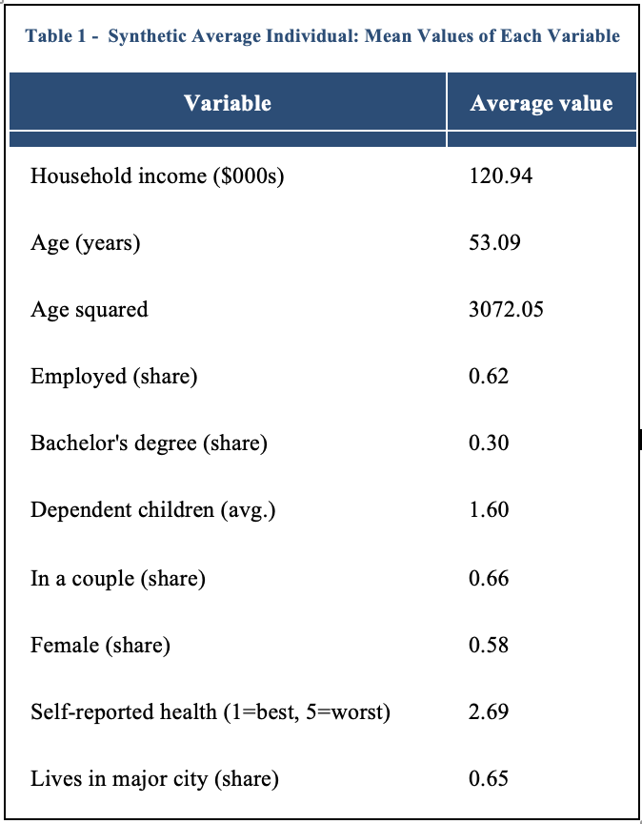
Description of the synthetic individual
The average individual in the sample is approximately 53 years old, with a household income of $121,000, in moderately good self-reported health (2.69 on the 1–5 scale, where 1 is best), and with 1.6 dependent children on average. They are 62% likely to be employed, 66% likely to be in a couple, 58% likely to be female, 65% likely to live in a major city, and 30% likely to hold a bachelor's degree.
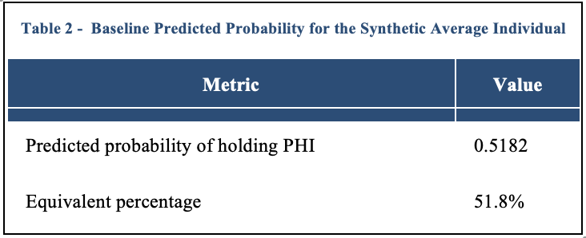
Plugging these values into the estimated regression equation yields a predicted probability of holding PHI of 0.518 (51.8%). As expected, this baseline figure is very close to the overall PHI uptake rate observed in the sample (52%), which confirms that the model is internally consistent at the means.
Results
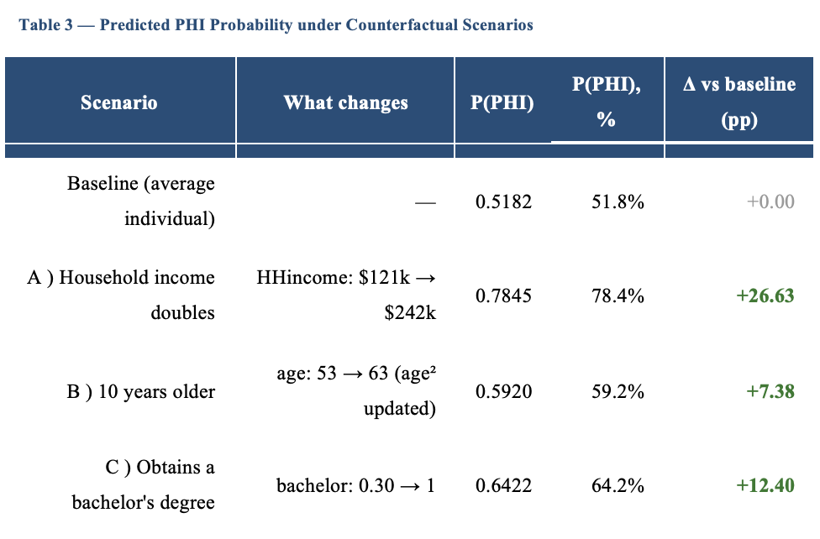

Doubling household income from $121k to $242k raises the predicted probability of PHI by 26.6 percentage points, from 51.8% to 78.4%, by far the largest effect, confirming income as the dominant driver of PHI uptake through both affordability and MLS exposure. Becoming ten years older (53 to 63) raises the probability by 7.4 percentage points (51.8% to 59.2%), a meaningful but smaller effect, consistent with the modest age coefficient and the absence of significant curvature. Obtaining a bachelor's degree raises the probability by 12.4 percentage points (51.8% to 64.2%), the second-largest effect, confirming education as a major non-financial determinant of PHI uptake.
Together, these scenarios show that the strongest predicted changes in PHI uptake come from income and education, with age playing a more limited role for an already middle-aged individual.

Section 2.5 Estimating the Effect of the Medicare Levy Surcharge
The Medicare Levy Surcharge (MLS) is a tax penalty applied to higher-income individuals without PHI, activated at specific income thresholds. Estimating its causal effect requires a design that separates the tax-incentive effect from other factors varying with income.
A regression-discontinuity (RDD) approach is the most natural strategy. Comparing PHI uptake just above and just below the threshold isolates the MLS effect, since individuals on either side are similar in underlying characteristics but differ sharply in MLS exposure. Stavrunova and Yerokhin (2014) apply an RDD to 2008 Australian tax return data and find that PHI coverage rises by approximately 6.5 percentage points at the threshold, with the effect strongest among young taxpayers.
An alternative is a panel-data approach exploiting within-individual variation over time. Buchmueller et al. (2021) use the HILDA longitudinal survey, leveraging year-to-year income fluctuations and a 2008 reform that raised the MLS thresholds, a design closer in to difference in differences.
Three assumptions must hold, for a valid causal interpretation.First, there must be no precise manipulation of income around the threshold; Stavrunova and Yerokhin (2014) themselves document "bunching" of reported income just below the cutoff, complicating identification. Second, all other determinants of PHI uptake must vary smoothly across the threshold (for RDD) or be appropriately controlled for (for the panel-data approach). Third, the estimated effect must be isolated from concurrent policy changes (such as the PHI Rebate or LHC) that also influence uptake.
If these assumptions hold, the estimate captures the causal effect of the MLS on PHI demand. If they fail, the estimate mixes MLS exposure with underlying income-related preferences, and should be interpreted as an association rather than a causal impact.

Reference:
- Australian Bureau of Statistics. (2025). Australian quarterly population by age [Data set]. Retrieved from Canvas.
- Australian Prudential Regulation Authority. (2025). Quarterly Private Health Insurance Membership Trends, December 2025 [Data set]. https://www.apra.gov.au/quarterly-private-health-insurance-statistics
- Barrett, G. F., & Conlon, R. (2003). Adverse selection and the decline in private health insurance coverage in Australia: 1989–95. Economic Record, 79(246), 279–296.
- Bilgrami, A., Cutler, H., Sinha, K., & Cheng, Z. (2021). The impact of means-tested premium rebates and tax penalties on the demand for private hospital cover in Australia. The Economic Record, 97(317), 170–211.
- Buchmueller, T. C., Cheng, T. C., Pham, N. T. A., & Staub, K. E. (2021). The effect of income-based mandates on the demand for private hospital insurance and its dynamics. Journal of Health Economics, 75, 102403.
- Duckett, S., & Cowgill, M. (2019). Saving Private Health 2: Making private health insurance viable. Grattan Institute.
- Duckett, S., & Moran, G. (2021). Stopping the death spiral: Creating a future for private health (Report No. 2021-05). Grattan Institute.
- Hopkins, S., & Kidd, M. P. (1996). The determinants of the demand for private health insurance under Medicare. Applied Economics, 28(12), 1623–1632.
- Johar, M., Jones, G., Keane, M., Savage, E., & Stavrunova, O. (2011). Waiting times for elective surgery and the decision to buy private health insurance. Health Economics, 20(S1), 68–86.
- Kettlewell, N., & Zhang, Y. (2024). Financial incentives and private health insurance demand on the extensive and intensive margins. Journal of Health Economics, 94.
- Palangkaraya, A., & Yong, J. (2005). Effects of recent carrot-and-stick policy initiatives on private health insurance coverage in Australia. The Economic Record, 81(254), 262–272.
- Stavrunova, O., & Yerokhin, O. (2014). Tax incentives and the demand for private health insurance. Journal of Health Economics, 34, 121–130.

