Prepared by: Paula Moreno

Student ID: 26177980
Subject: 22804 Business Analytics Foundations
Strategic Focus: Discount Strategy
Dataset: Assessment 2 Retail — Monday 3pm
Submission Date: 15/05/2026
Discount Strategy Analysis: A Preliminary Business Analytics Study for a Premium Direct-to-Consumer Apparel Retailer
2026
Executive Summary
This report examines how a premium direct-to-consumer apparel retailer uses discounts, based on 7,629 orders placed between October 2023 and June 2024.
The data shows that discounts are working in the short term, discounted orders have a 28% larger basket size and a higher average order value $39.12 vs $36.44 for full-price orders. However, they are not turning customers into loyal buyers. Only 10% of customers return for a second purchase, and the predictive model confirms that receiving a discount on a first order makes no meaningful difference to whether a customer comes back.
What drives retention is how much a customer spends, not whether they were given a discount. More concerning, 27.3% of customers have never once paid full price. This level of discount dependency risks damaging the brand's premium image over time.
Based on these findings, four recommendations are proposed: using the predictive model to target retention discounts more precisely; restructuring discounts around customer spending tiers; taking steps to reduce discount dependency; and setting a cap on discount depth for core products. A/B testing and a more advanced predictive model are suggested as next steps for Assessment 3.

Table of Contents
Introduction 3
Section 1: Business Problem Framing & Data Quality Assessment 4
1.1 Business Context and Analytical Objective 4
1.2 Dataset Description and Suitability 5
1.3 Data Quality Assessment 5
1.3.1 Missing Values 5
1.3.2 Duplicate Records 5
1.3.3 Outliers 5
1.4 Key Variables Created 6
1.5 Initial Findings 6
1.6 Limitations 7
Section 2: Descriptive & Exploratory Analysis 8
2.1 Order value and basket size: Are discounts driving more spend ? 8
2.2 Discount Depth: What discount sizes are most commonly applied? 8
2.3 Discount Frecuency: How often do customers use discounts? 9
2.4 Discount Dependancy: Are customers discount-dependent? 9
2.5 Discounts Targeting: Are the right customers receiving discounts? 10
2.6 Customer Retention: Do discounts bring customers back ? 10
2.7 Revenue Impact: Is discounting generating more revenue? 12
2.8 Product Category Analysis: Where are discounts concentrated ? 13
2.9 Section summary 14
Section 3: Basic Predictive Modelling 16
3.2 Data Preparation and Variable Selection 16
3.3 Model Comparison and Selection 16
3.4 Model Performance 17
3.5 Feature Importance and Business Interpretation 18
3.6 Identifying High-Risk Customers 19
3.7 Limitations 19
Section 4: Insights, Recommendations & Next steps 20
4.1 Key Insights 20
4.2 Recommendations 20
4.3 Proposal 21

Introduction
Discounts are one of the most common tools in retail but offering them without a clear strategy can do more harm than good. This report takes a close look at how a premium direct-to-consumer apparel retailer is currently using discounts, and whether that approach is genuinely working for the business.
The starting point for this analysis came from three concerns raised by management, customers not coming back after their first purchase, uncertainty around pricing decisions, and a lack of data to guide those decisions. These are not small issues for a growing retailer, and they all point back to the same question: is the discount strategy helping or hurting?
To answer that, this report analyses 7,629 orders placed between October 2023 and June 2024, using data from four sources — orders, orderlines, customers, and products. The analysis was done in Python and Jupyter Notebook, with Tableau used to build the visualizations.
The report works through four areas: first checking the quality of the data, then exploring what the numbers show about discount behavior, followed by a predictive model to identify which customers are at risk of not returning, and finally a set of practical recommendations the business can act on.

Section 1: Business Problem Framing & Data Quality Assessment

1.1 Business Context and Analytical Objective
This report analyses the discount strategy of direct‑to‑consumer (DTC) online retail company operating in the premium apparel segment. Discount strategies that are not well carried out can erode profit margins, train customers to wait for promotions, and sub estimate the brand's premium positioning. The goal of this analysis is to determine if the discounts offered by the retailer are encouraging profitable behavior from customers or unnecessarily reducing revenue from purchases that would have been made anyway.

1.2 Dataset Description and Suitability
The dataset provided contains four related tables, each with different information.
Table 1: Retail dataset content
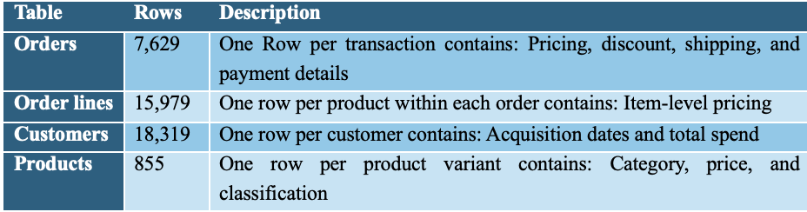
The orders table is the source, containing key discount variables, like discount_amount, cart_discount, and order_subtotal, and th he customer table was also used to assess retention and profitability

1.3 Data Quality Assessment
The dataset was examined for missing values, duplicate records, and outliers.

1.3.1 Missing Values
Missing values in discount columns reflected the absence of a promotion and were filled with zero. All other relevant columns were complete

1.3.2 Duplicate Records
No duplicate order IDs were found, confirming each row represents a unique transaction.

1.3.3 Outliers
A small number of orders were identified but assessed as bulk transactions consistent with the retailer's multi item incentive strategy. No negative or implausible values were found.
Boxplot: Order Totals
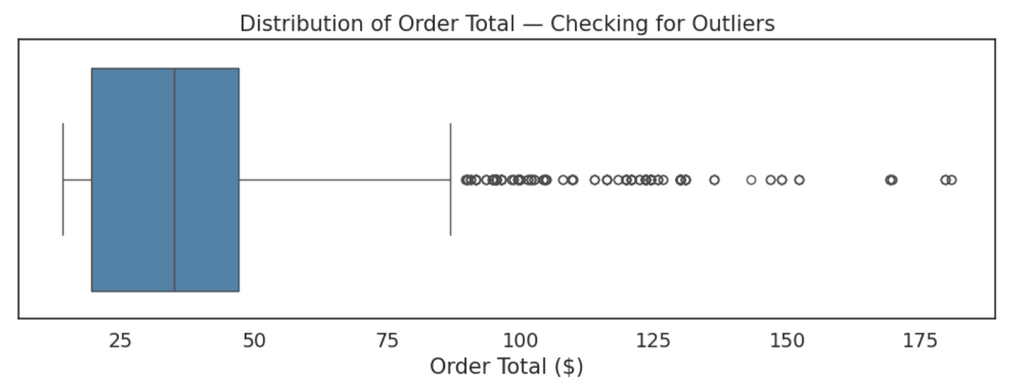

1.4 Key Variables Created
Two variables were engineered: a Discount Flag (1/0) to flag discounted orders, and a Discount Rate to measure the discount as a percentage of the order total.

1.5 Initial Findings
The initial exploration revealed the following key metrics.
Table 2
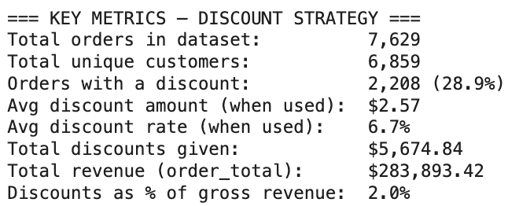
FIGURE 1
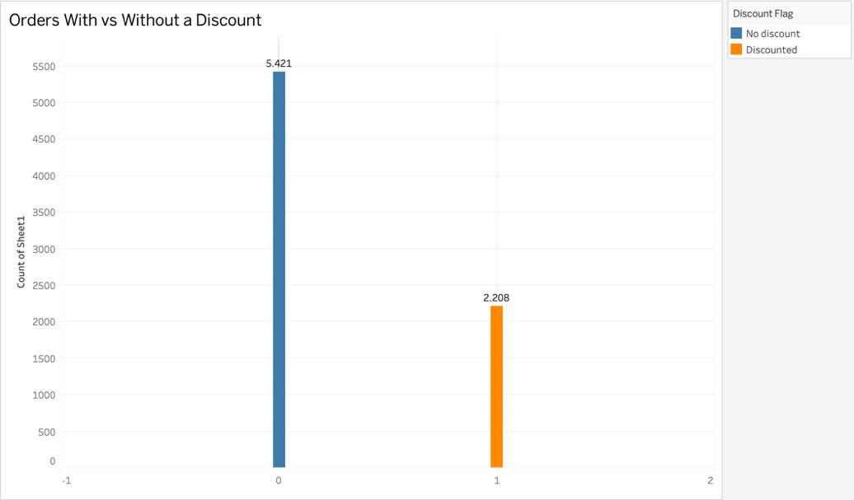

FIGURE 2
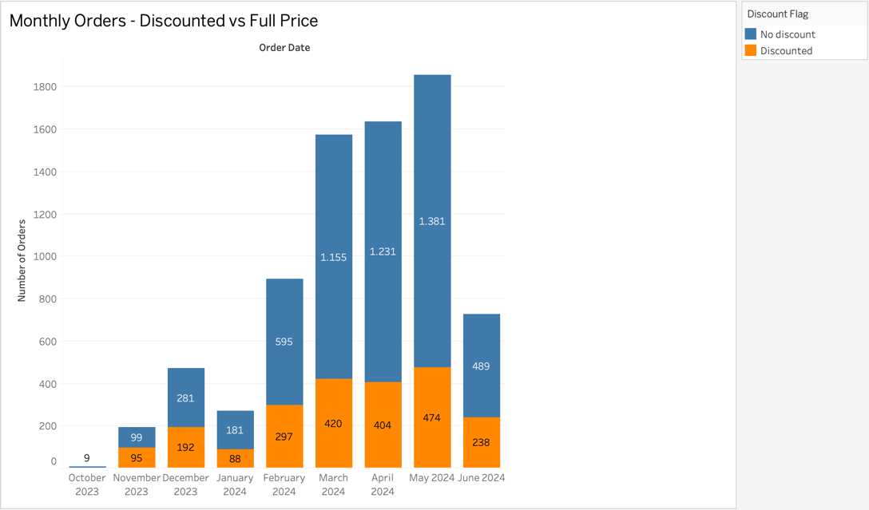
71.1% of oders were placed at full price, with 28.9% discounted. Order volumes grew substantially, peaking in May 2024, with the discount proportion remaining consistent month-to-month, suggesting a systematic rather than seasonal approach.

1.6 Limitations
The dataset lacks coupon or promotional code data, limiting attribution to specific campaigns. The observation window of eight months is also relatively short.

Section 2: Descriptive & Exploratory Analysis
This section examines discount patterns across eight business questions to assess how discounts are applied, who receives them, and whether they generate measurable business value.

2.1 Order value and basket size: Are discounts driving more spend ?
FIGURE 2.1
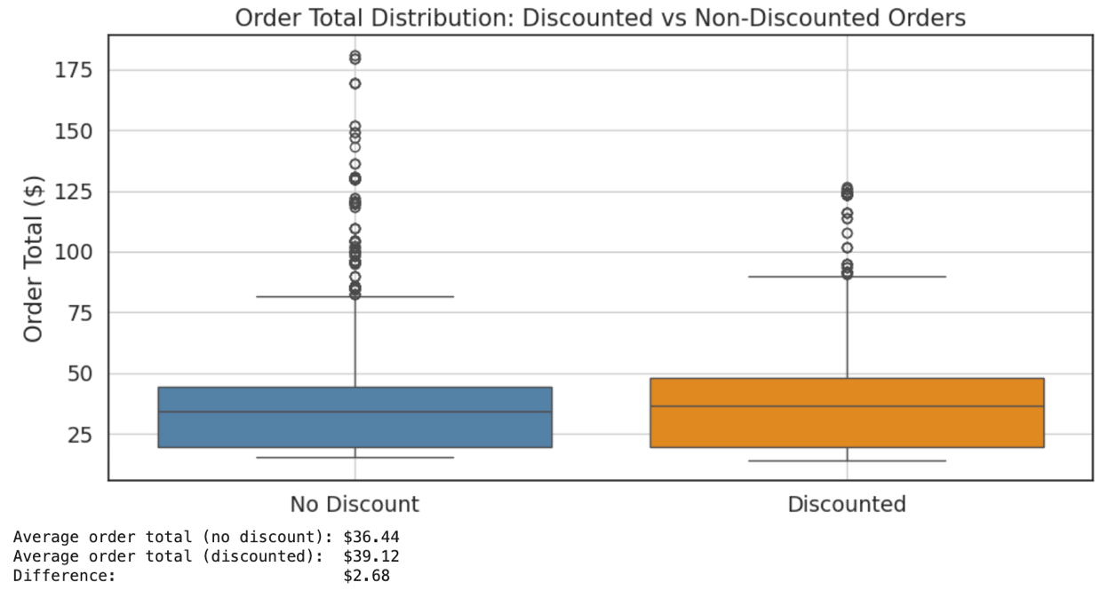
FIGURE 2.2
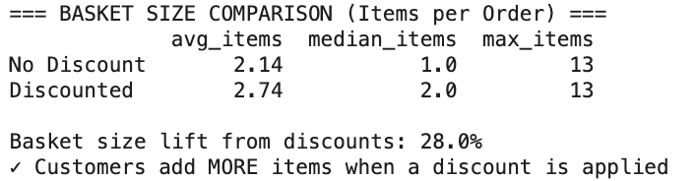
Discounted orders average $39.12 versus $36.44 for full price orders, meaning discounted customers spend slightly more even after the promotion is applied. Basket size shows a 28% lift, 2.74 items for discounted orders versus 2.14 for full price, with the median rising from 1 to 2 items, confirming this effect is consistent across most transactions.

2.2 Discount Depth: What discount sizes are most commonly applied?
FIGURE 2.3
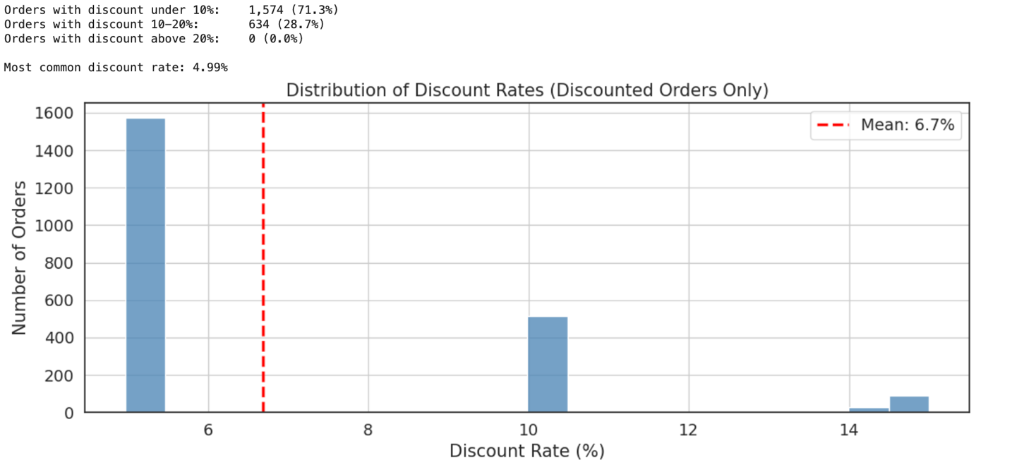
The most common discount rate is 4.99% average 6.7% . In total, 71.3% of discounted orders fall below 10%, with 28.7% in the 10–20% range and none above 20%. The data suggests the retailer use two fixed tiers around 5% and 10% rather than a personalised approach.

2.3 Discount Frecuency: How often do customers use discounts?
FIGURE 2.4
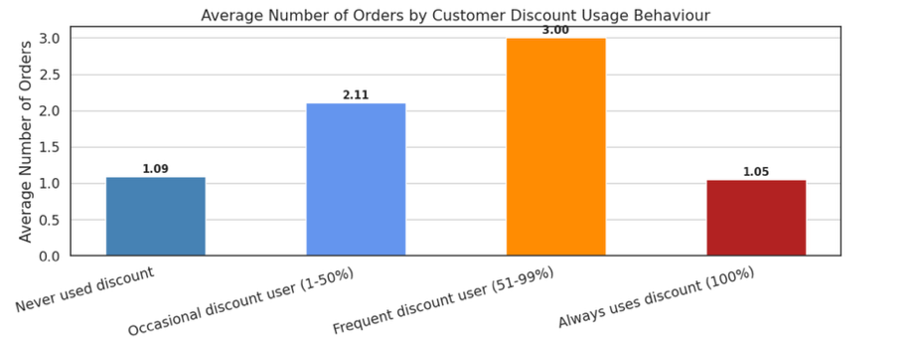
Frecuent discount users (51–99%) have a discount average of 3.00 orders, being the most engaged segment. Customers who always use a discount the order average is 1.05 orders, nearly all one time buyers, mirroring those who never discount has a 1.09 of orders. Loyalty is concentrated in frecuent discount users, however we suggest to drive attention to costumer who never or always use discount.

2.4 Discount Dependancy: Are customers discount-dependent?
FIGURE 2.5:
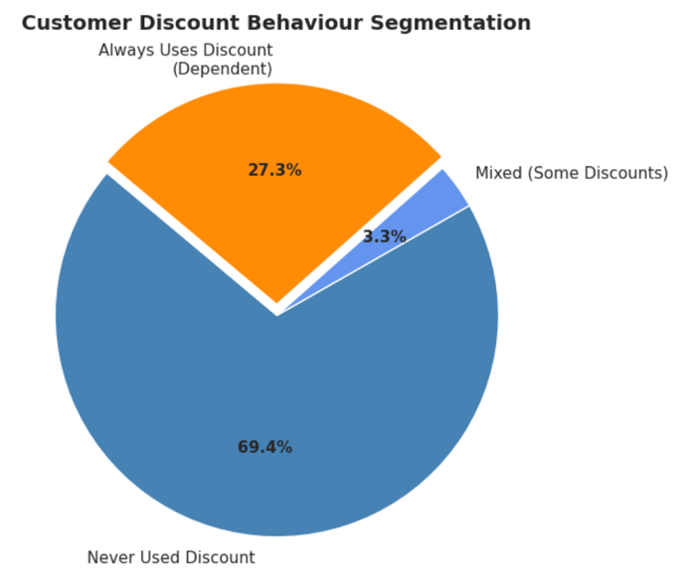
The majority of customers 69.4% purchase at full price, a strong indicator for premium positioning. However, 27.3% are entirely discount dependent, a concern for a premium brand, because removing discounts would likely cause this segment to stop purchasing. The remaining 3.3% show mixed behaviour and the highest order frequency, making them the most valuable loyalty segment.

2.5 Discounts Targeting: Are the right customers receiving discounts?
FIGURE 2.6:
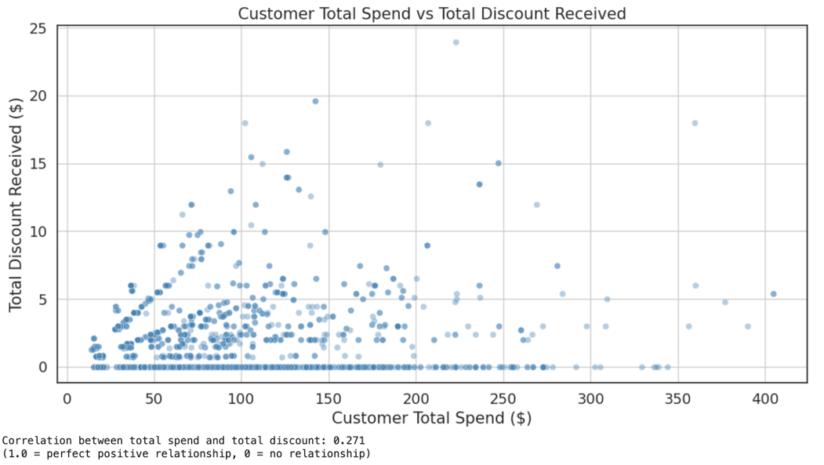
The correlation between customer lifetime spend and total discount received is 0.271 weak. Many high-spending customers receive little discount, while some low-spending customers receive disproportionately large discounts, indicating poor targeting.

2.6 Customer Retention: Do discounts bring customers back ?
FIGURE 2.7
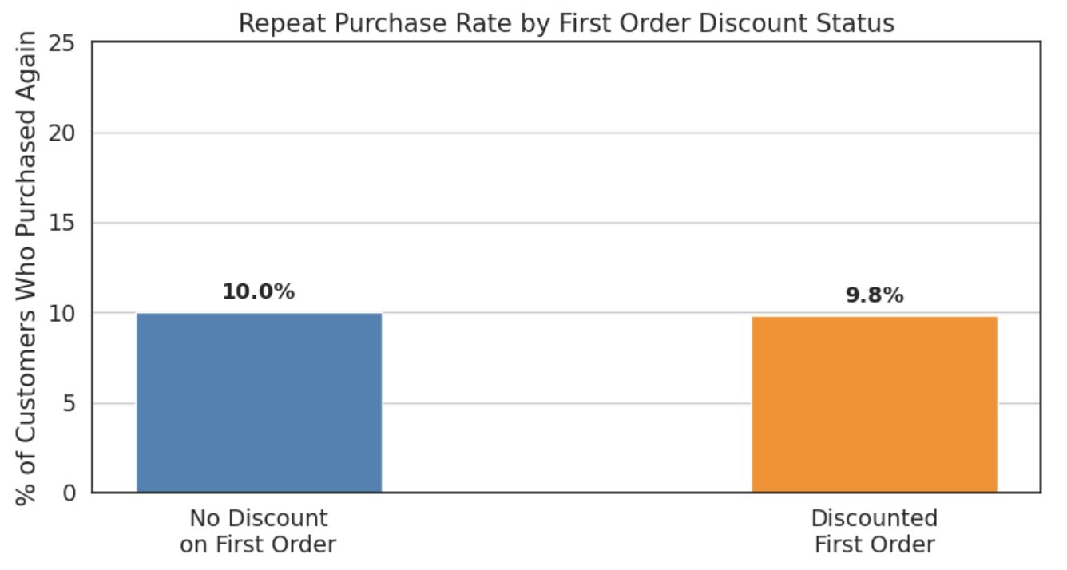
The most concerning finding in this analysis is a 10% overall retention rate, meaning 90% of customers made a single purchase and never returned. Critically, discounts have no meaningful impact on this outcome customers whose first order was discounted returned at a rate of 9.8%, compared to 10.0% for full-price first-time buyers. Discounts are not converting first-time buyers into loyal customers, any more effectively than full-price purchases.
FIGURE 2.8
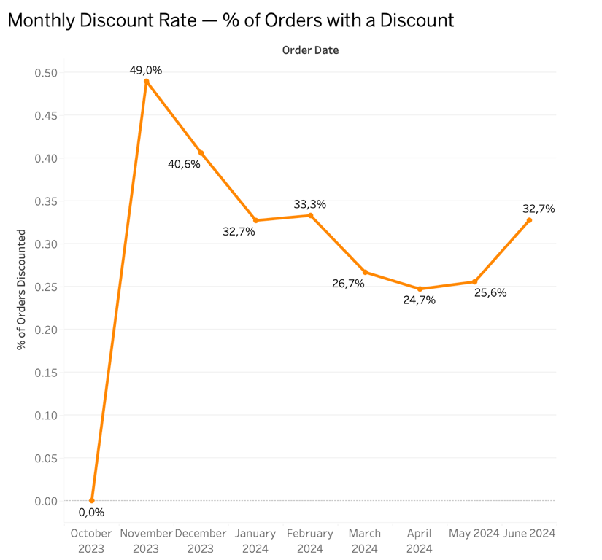
The Tableau line chart shown above provides important context by illustrating how the discount rate has evolved over time. Discounts peaked at 49% in November 2023 likely due to promotion or the run-up to Christmas, then it falls to 25% in April 2024; a slight rebound to 32.7% in June 2024 could indicate a new campaign; although this normalisation is encouraging, the persistently low retention rate suggests that discounts have not been replaced by significant investment in retention.
For a business with high acquisition costs, a 10% retention rate means most of that spend goes unrecovered. Discounts given to customers who never return are pure margin loss with no long-term return.

2.7 Revenue Impact: Is discounting generating more revenue?
FIGURE 2.9

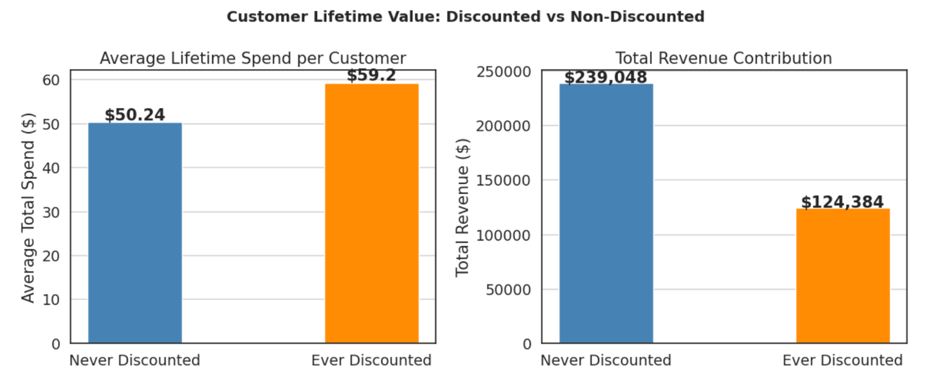
FIGURE 2.10
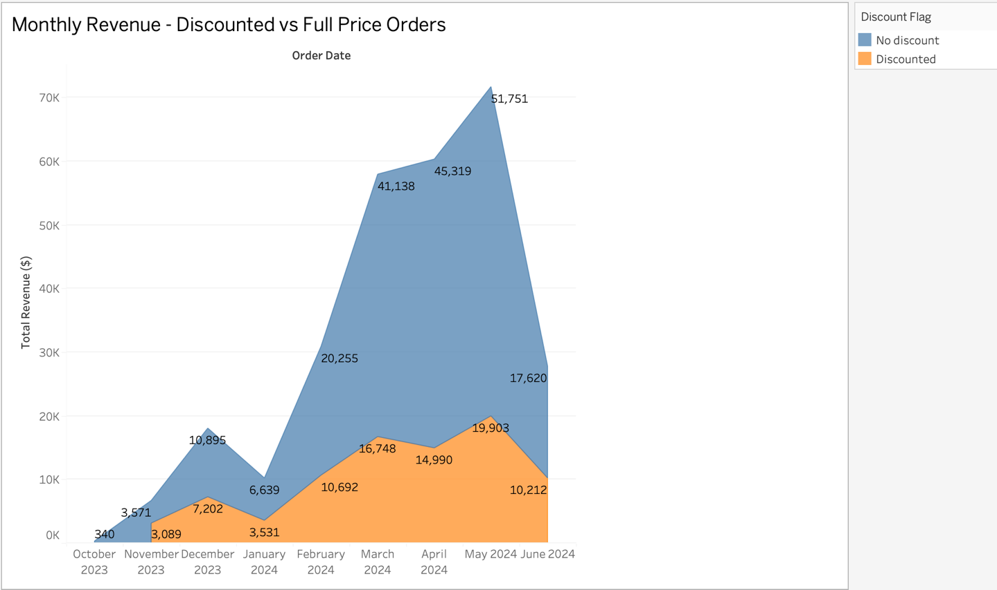

Individually, discounted customers have a higher average lifetime spend $59.20 vs. $50.24, suggesting promotion engaged customers are higher value. Yet non discounted customers drive 65.8% of total revenue $239K vs. $124K due to their greater volume.
The area chart reinforces this, full price orders dominate monthly revenue, with growth driven by volume and organic demand rather than discounting. Discounts hold a stable share of monthly revenue throughout, suggesting they function as a permanent fixture rather than a targeted growth lever.

2.8 Product Category Analysis: Where are discounts concentrated ?
FIGURE 2.11
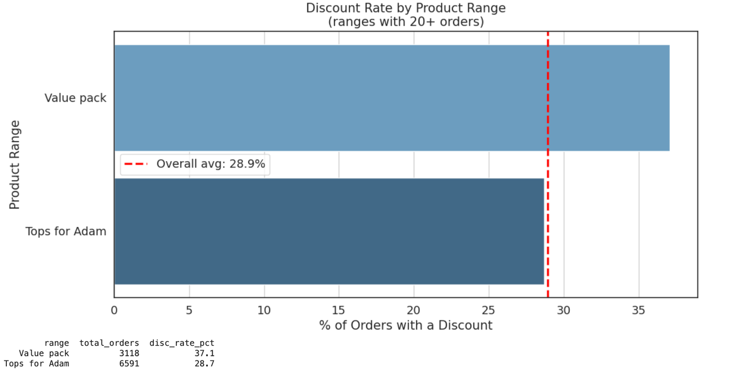
FIGURE 2.12
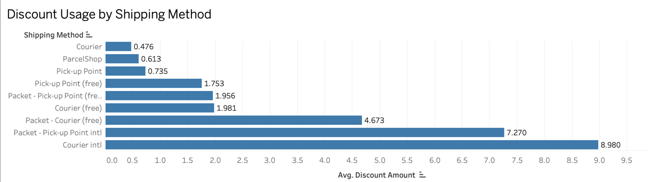
Among product ranges with sufficient volume, Value Pack 3,118 orders carries the highest discount rate at 37.1% well above the 28.9% overall average consistent with a strategy of using bundle incentives to drive higher order values. Tops for Adam 6,591 orders sits just below average at 28.7%, suggesting no deliberate targeting or protection of this core range.
Discount amounts also vary significantly by shipping method. International methods attract substantially higher average discounts Courier intl at $8.98 and Packet Pick-up Point intl at $7.27 compared to just $0.48 for domestic Courier. This points to a deliberate strategy of using deeper discounts to offset the perceived cost barrier of cross-border purchasing.

2.9 Section summary
The analysis reveals a discount strategy with clear short-term benefits but structural weaknesses that limit its long-term effectiveness. Discounts are positively influencing purchasing behaviour generating a 28% basket size lift and a slightly higher average order value $39.12 vs $36.44. The conservative discount depth 71.3% under 10% protects margins while still driving incremental spend.
However, three findings raise significant concerns against management's objective of optimising discounts to drive profitable behaviour and supporting data driven decision making. The overall retention rate is just 10%, and discounts make no measurable difference to whether customers return, over a quarter of customers 27.3% are discount dependent, having never paid full price. And discounts show weak alignment with customer loyalty correlation of 0.271, suggesting promotional spend is not being directed where it matters most.

Section 3: Basic Predictive Modelling
After doing a deep analysis we identified that customer retention is the most critical challenge that the business is facing. The predictive model in this section directly address that challenge with the following business question : Can we predict which customers are at risk of not returning, so the business knows exactly who to target with a retention discount?
This question helps us to identify high risk customers that are likely to churn, so the company can deploy a retention discount, supporting managements core objectives, by optimising discount strategies to drive profitable behaviour, and identifying opportunities for more proactive, data-driven decision-making.

3.2 Data Preparation and Variable Selection
The model was built at the customer level using variables available after a customer's first purchase, a realistic point at which a retention discount decision would be made. Variables that would cause data leakage were excluded as it is total_orders, which directly determines the target.
Ten features were included as inputs: first_order_discounted, first_order_value, first_order_subtotal, first_order_shipping, first_order_seq, basket_size, shipping_method, payment_method, customer_total_spent, active_day.
The target variable is is_repeat 1 = returned, 0 = did not return, the dataset contains 6,859 customers, which 685 (10%) returned and 6,174 (90%) did not.

3.3 Model Comparison and Selection
Six classification models were trained and evaluated using 10-fold cross-validation, ranked by AUC.
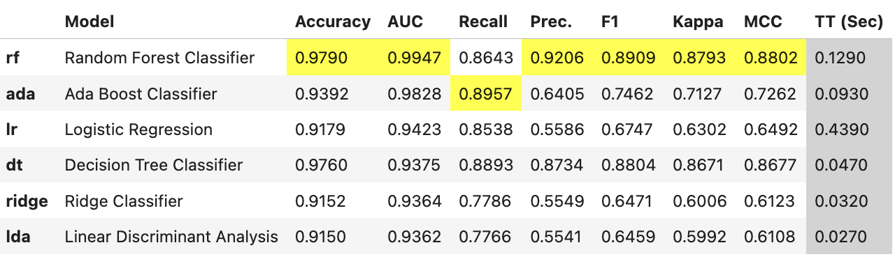
Random Forest achieved the highest AUC of 0.9947, followed by AdaBoost (0.9828) and Logistic Regression (0.9423). Logistic Regression was selected as the primary model due to its interpretability, producing clear feature importance scores that explain which variables drive predictions, which is essential for translating model outputs into business decisions.

3.4 Model Performance
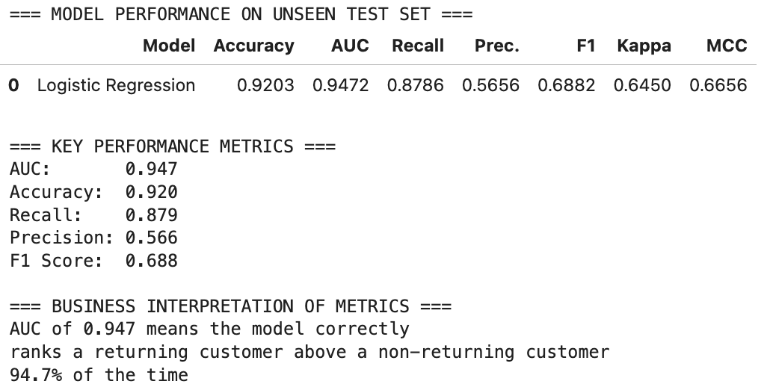
An AUC of 0.947 indicates excellent discriminatory ability. Recall was prioritised as the secondary metric because missing a churning customer is more costly to the business than incorrectly targeting a loyal one with a discount.
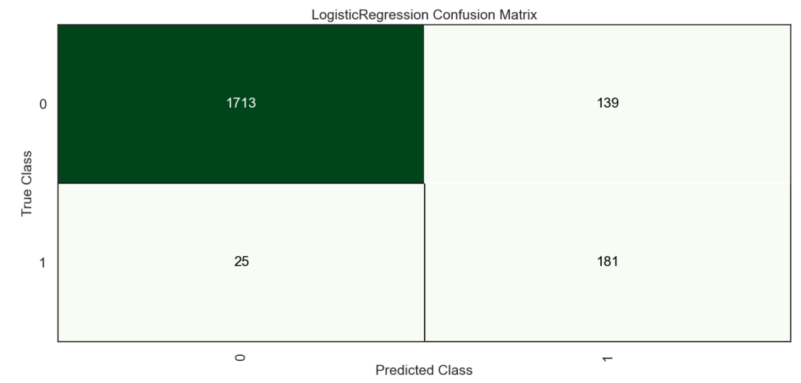
The confusion matrix confirms strong performance 1,713 non-returning customers correctly identified and 181 actual returners correctly flagged, with only 25 missed.
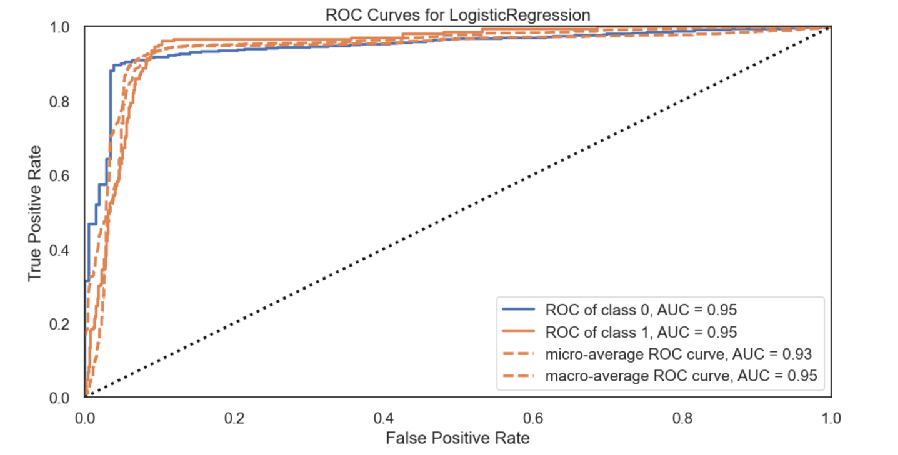
The ROC curve shows an AUC of 0.95 for both classes, with the curve bowing strongly toward the top-left corner confirming the model discriminates well above random chance.

3.5 Feature Importance and Business Interpretation
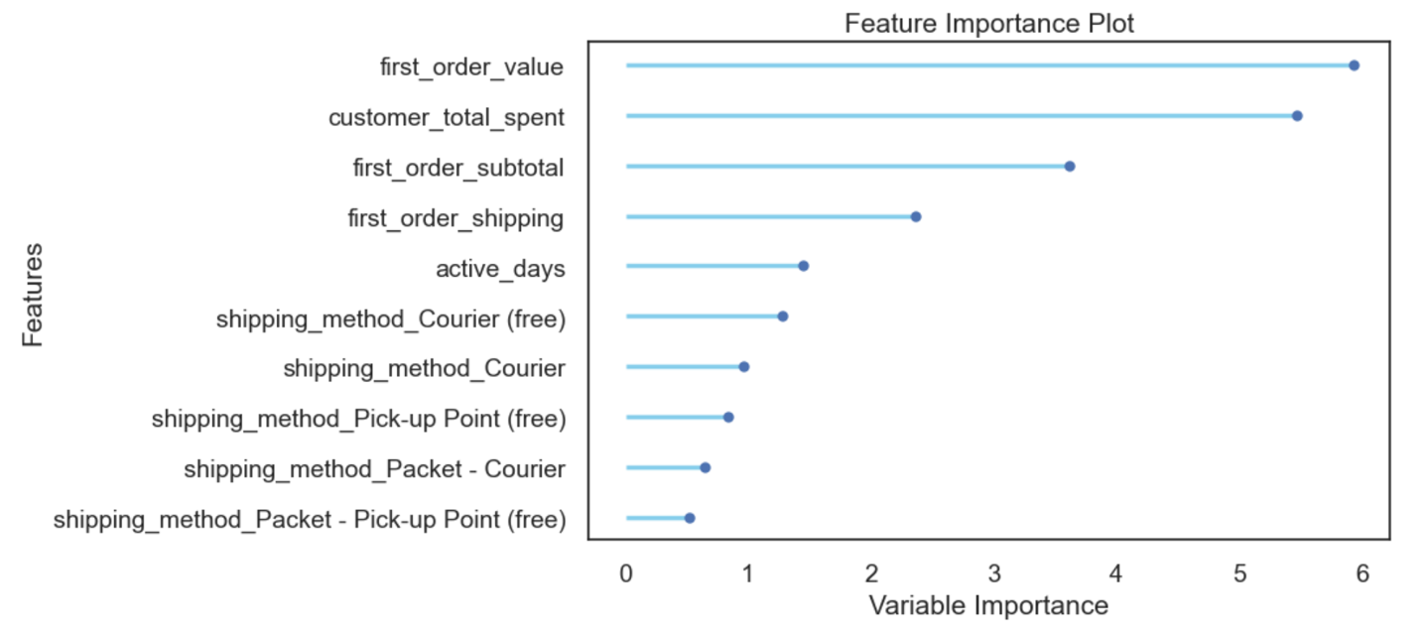
The five strongest predictors of customer return are:
1. first_order_value: customers who spend more on their first order are significantly more likely to return, suggesting initial spend is a strong signal of engagement.
2. customer_total_spent: higher lifetime spend is associated with greater loyalty.
3. first_order_subtotal: confirms that basket size on the first visit is a reliable retention indicator.
4. first_order_shipping: customers choosing premium shipping show higher return probability.
5. active_days: Longer customer tenure predicts return.
Most critically, first_order_discounted does not appear among the top predictors. This directly confirms the Section 2 finding that discounts have negligible influence on whether customers return. The predictive model reinforces this with quantitative evidence, the strongest drivers of retention are transaction value and customer spend, not promotional pricing.

3.6 Identifying High-Risk Customers
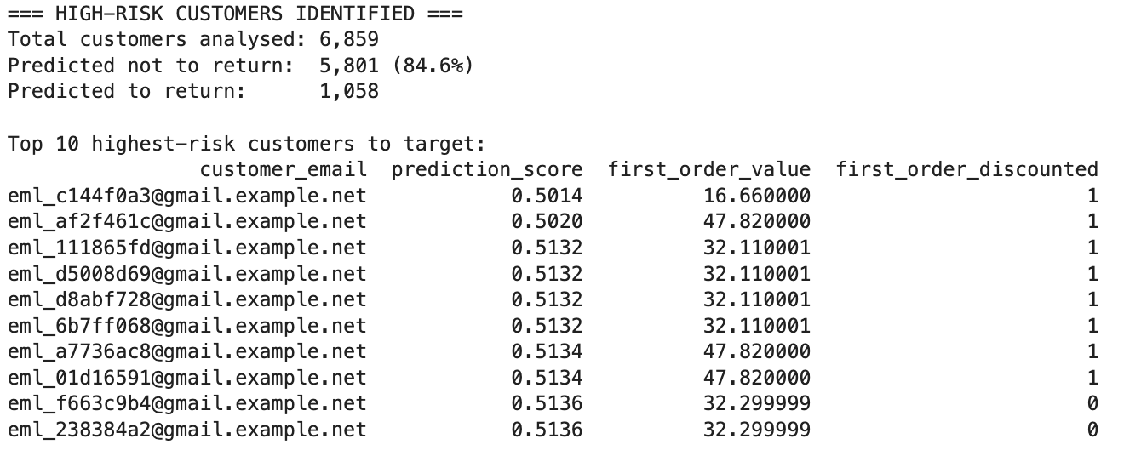
Applying the model to all 6,859 customers identified 5,801 (84.6%) as predicted not to return. These customers represent the priority targets for retention discount interventions. The model assigns each a prediction score customers with scores closest to 0.5 are the highest-uncertainty cases where a well-timed discount is most likely to change behaviour, while customers near 0.0 are unlikely to return regardless of any intervention. This output enables the business to shift from applying discounts broadly across 28.9% of all orders to a precision retention strategy targeting the specific customers where discount investment is most likely to generate return.

3.7 Limitations
The model predicts correlation, not causation it cannot confirm that a discount will cause a high-risk customer to return. The short observation window of 8.1 months may not capture full seasonal patterns, and without A/B testing data, the optimal discount amount for the identified high-risk segment cannot be determined.

Section 4: Insights, Recommendations & Next steps

4.1 Key Insights
The analysis across Sections 2 and 3 produces three overarching insights that directly inform the recommendations below:
First, discounts are generating short-term behavioural benefits a 28% basket size lift and a slightly higher average order value $39.12 vs $36.44, but are not building customer loyalty. The predictive model confirmed that whether a customer received a discount on their first order has influence on whether they return.
Second, the business has a critical retention problem that discounting alone cannot solve. With 90% of customers making only one purchase, the cost of customer acquisition is not being recovered through repeat revenue regardless of whether a discount was used.
Third, discounts are not being directed at the right customers. The weak correlation of 0.271 between customer spend and discounts received, combined with 27.3% of customers being discount dependent, suggests the current strategy is rewarding price sensitive buyers rather than building a loyal customer base.

4.2 Recommendations
Recommendation 1
Introduce targeted retention discounts and replace broad discounting with precision targeting. Using the predictive model from Section 3, the business can identify the 5,801 high-risk customers and deploy retention discounts specifically to this group after their first purchase. Customers predicted as likely to return should be left to purchase at full price, protecting an estimated $239,048 in non discounted revenue.
Recommendation 2
Introduce a value based discount structure, redirect discount investment toward high-value customers. Given that first order value and total spend are the strongest predictors of retention, the business should introduce spend tiered discounts; for example, offering loyalty rewards only to customers who spend above a defined threshold. This directly addresses the misalignment identified in the spend-discount correlation analysis.
Recommendation 3
Reduce discount dependency gradually, the 27.3% of customers who have only purchased on discount represent a structural risk. The business should gradually reduce discount frequency for this segment while introducing alternative retention mechanisms, such as personalised product recommendations, loyalty points, or exclusive early access to new collections to shift the value proposition away from price.
Recommendation 4
Protect premium positioning on core products, Value Pack products are discounted at 37.1% significantly above the 28.9% average. While bundle discounts can drive basket size, excessive discounting of core product ranges risks undermining the brand's premium positioning. A maximum discount threshold of 10% on full-price items is recommended, consistent with the shallow discount depthalready observed across 71.3% of discounted orders.

4.3 Proposal
The most valuable extension of this analysis is replacing the Logistic Regression model with the Random Forest classifier (AUC 0.9947) would improve prediction accuracy and allow more customers to be correctly identified before they churn. This, combined with A/B testing results, would create a fully data-driven retention discount engine transforming the current reactive approach into a proactive, profitable strategy.

