

**American International University- Bangladesh**

**Computer Graphics**

**Project Report**

**Spring 2020-2021**

**Project Title:** A Busy City

**Section: L**

**Group: J**

|  |  |
| --- | --- |
| Student Name | Student Id |
| HASAN, MD. JAHID | **19-39899-1** |
| PAUL, ANIK KUMAR | **19-39880-1** |
| AFENDI, MD. YOUSUF | **19-39887-1** |

Introduction:

This is a computer graphics project to display a busy city with visual roads and cars, roadside house, tree and a scenery. Code-blocks IDE, OpenGL and C++ programming language are used to build this project.

Problem Statement:

Traffic jam is a part of a busy city and due to all type of vehicles on the roads, accident is also a common scenario.

Objective:

As heavy vehicle is the main cause of traffic, it is kept on the different lanes. There is a divider (black line on the project) in the middle of small vehicle and heavy vehicle lanes.

Methodology:

This system can be developed by adding the proper divider and changing the all types of vehicle in a single road to another side road of the divider.

Significant of the project:

Referring to the problem statement, public can use the roads without having traffic jam or vehicle collision.

Conclusion:

Living in a busy city with problems are common and all the problems have solution. In this project a particular problem of traffic jam and accident is focused. It is tried to solve by adding lane divider and moving the high and small vehicle to different lanes.

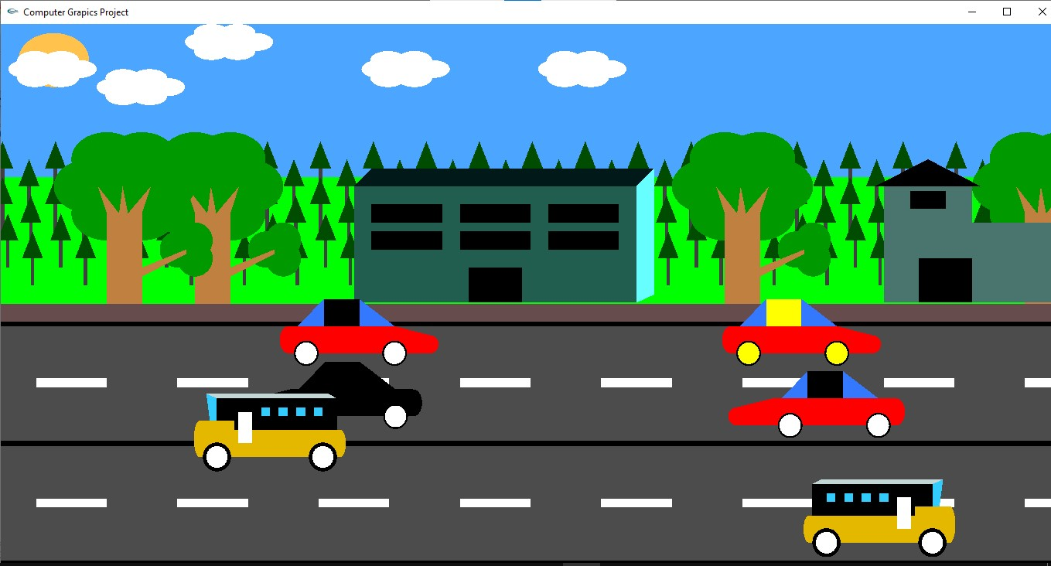

Figure: A Busy City