Customer Injeq Oy
Project Pnr
Device QUADRA™
Type Medical Device
Revision | Issued by | Date | Changes after last revision
1.0 | Marko Reidla | 15.10.2013 | Initial revision
References
Ref. | Title, author, source, date, status
[1] | Device Requirement Specification, Marko Reidla, -, 15.10.2013, Draft

Table of Contents
ABBREVIATIONS 3
INTRODUCTION 5
1 OVERVIEW OF THE WIDEBAND MULTIFREQUENCY IMPEDANCE SPECTROSCOPY DEVICE QUADRA™ 5
2 QUADRA™ MULTIFREQUENCY IMPEDANCE SPECROSCOPY DEVICE (MISD) 6
2.1 Features of QUADRA™ Impedance Spectroscopy Device 7
2.2 External Entities and Interfaces of Impedance Spectroscopy Device 8
2.3 External Power Supply 8
2.4 Computing Device 8
2.5 BIP Needle 8
2.6 JTAG Debugger 9
2.7 Programmer 9
3 QUADRA LOGICAL EXTERNAL INTERFACES 9
3.1 Power Supply 9
3.2 Control Command Messages 9
3.2.1 Control Command Message Structure 10
3.2.1.1 Excitation And Measurement Sampling rate Configuring Command 10
3.2.1.2 DFT End-Result Scaling Value Configuring Command 11
3.2.1.3 Analog Inputs Gain Amplifiers Gain Configuring Command 11
3.2.1.4 Analog Output Potentiometer Output Level Configuring Command 12
3.2.1.5 Excitation Table Upload Command 12
3.2.1.6 Frequency Bins Table Upload Command 12
3.2.1.7 Start Data Acquisition Control Command 13
3.2.1.8 Stop Data Acquisition Control Command 13
3.3 Output Data Packages 13
3.3.1 Notification Package Structure 14
3.3.1.1 Notification Output Message 14
3.3.2 Data Package structure 14
3.3.2.1 Output Data Package 15
3.4 Excitation Signal Input And Output 15

ABBREVIATIONS
ADC Analog to Digital Converter
ASCII American Standard Code for Information Interchange character-encoding scheme
BIP Bioimpedance
CPU Central Processing Unit
DAC Digital to Analog Converter
DFT Discrete Fourier transform
DLL Dynamic Linked Library
DMA Direct Memory Access controller
DMAC Dual Multiply and ACcumulate
DPOT Digital potentiometer
DSP Digital Signal Processor
ePWM Enhanced Pulse Width Modulator
FIFO First In, First Out, a method for organizing and manipulating a data buffer
GPIO General Porpous Input Output
I²C Inter-Integrated Circuit. Standard of bi-directional 2-wire bus for efficient inter-IC control originally developed by Philips Semiconductors
JTAG Joint Test Action Group is the name for the IEEE standard 1149.1 used for testing printed circuit boards using boundary scan
MISD Multifrequency Impedance Spectroscopy Device
PGA Programmable Gain Amplifier
RAM Random Access Memory
RISC Reduced Instruction Set Computing type CPU
QUADRA™ Registred trademar of the Multifrequency Impedance Spectroscopy Device, abbreviation from noun „quadrature“
SAR Successive Approximation type analog to digital converter
SCI Serial Communications Interface
SPI Serial Peripheral Interface
TB Time Base ePWM counter
UART Universal asynchronous receiver-transmitter
USB Universal Serial Bus

INTRODUCTION
Eliko with Injeq Oy and Mariachi Oy is developing Real-Time Multifrequency Impedance Spectroscopy Device (MISD) for medical application like real time identification of tissue with BIP needle. The current prototype device with main board hardware version 2.0 is modified for required medical standards. In this document the QUADRA main board version 2.0 with its corresponding firmware is disserted.
The device is used in application where the measurement time is limited due to the biological objects rapid impedance variations in time. Therefore the device must enable to capture the maximum number of spectrograms in time. In addition the spectrograms themselves must contain enough number of frequency points required to describe biological objects impedance spectra.
For that reason a novel pre-synthesized spectrally sparse multi-frequency binary waveform (customized binary sequence of pulses) with known spectral frequency points is used to excite biological object under test. At same time the device measures response from the biological object under test and calculates real and imaginary values for every known frequency points used in excitation signal. Calculated real and imaginary values are forward to user interface for further result interpretation.

OVERVIEW OF THE WIDEBAND MULTIFREQUENCY IMPEDANCE SPECTROSCOPY DEVICE QUADRA™
The Impedance Spectroscopy Device called QUADRA™ (from noun quadrature), can be described as flow-through streaming device which on normal operation continuously converts excited impedance response to frequency represented complex values. The device uses computer based user interface on which measurement data-packages are received for translation and control messages are sent to control the device. For interface with measured impedance object the bioimpedance needle is used.
The typical application is shown in Figure 1
Computing device
Excitation Response

Power Supply
Control messages Data packages

QUADRA ™
BIP needle
Impedance spectroscopy device
Biological object
Figure 1 Identification of tissue with BIP needle typical application

In typical application QUADRA™ Impedance Spectroscopy Device is used as continuous feedback device for needle user to verify that the needle is in contact of correct tissue or organ. An example of usage of the devise is in Figure 2. Black colored box on right side of the table is QUADRA™ Impedance Spectroscopy Device. The device is shown in Error: Reference source not found.
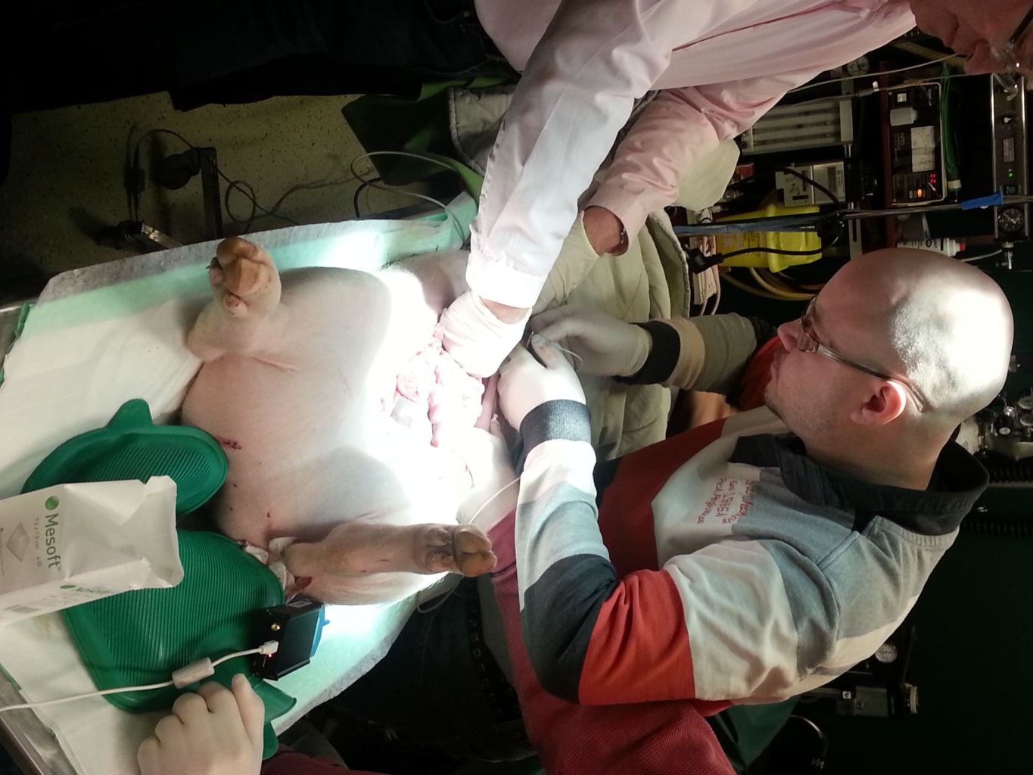
Figure 2 Needle experiment with QUADRA™ Impedance Spectroscopy Device

QUADRA™ MULTIFREQUENCY IMPEDANCE SPECROSCOPY DEVICE (MISD)
The QUADRA™ Impedance Spectroscopy Device main board and enclosure in Error: Reference source not found consists of Texas Instruments Digital Signal Processor, FTDI™ USB Interface controller, switching power supply units, analog input-output amplifiers and buffers with protection circuits. The power supply input and USB data lines are isolated.
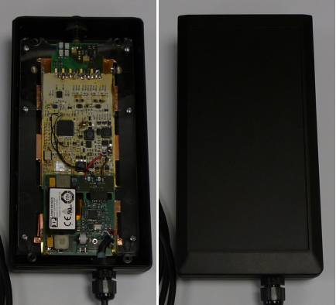
USB Connector
BIP Needle connector
Figure 3 QUADRA prototype internals and enclosure

Features of QUADRA™ Impedance Spectroscopy Device
The Multifrequency Impedance Spectroscopy Device can be used for tissue identification based on measured impedance values at the tip of the needle. In real-time the device user can establish the tissue type on which the needle is in contact with. In this way the user can know how to move the needle. For that the device has the required features:
- Real-Time
  - Up to 1ms interval of update rate.
- Wide Frequency-point selection
  - Up to 16 frequency point spectrograms
- To meet the medical grade standards
  - Device input power supply and data lines are isolated and needle output has current limiting protecting circuit
- Different frequency ranges
  - Selectable operating frequency ranges by modifying internal frequency dividers

External Entities and Interfaces of Impedance Spectroscopy Device
External entities that are connected to the Multifrequency Impedance Spectroscopy Device (MISD) and corresponding data flows and input-output signal are shown on the context diagram in Figure 4.
Control messages
Data Packages
External power supply
Computing device
MISD
+5V
JTAG Debugger
Programmer
BIP needle
Excitation current output
Excitation current input
Figure 4 Context diagram of the QUADRA™ Multifrequency Impedance Spectroscopy Device

External Power Supply
The MISD is supplied from external user interface devices USB supply bus of 5VDC with maximum allowable current of 500mA.
Interface: USB 2.0 Hi-Speed

Computing Device
The user interface device, like personal computer or laptop, is the computing device for result interpretation, presentation and logging. Also the user interface device controls and configures the MISD with control messages. At the same time the user interface device acts as external power supply also, described in 2.3.
Interface: USB 2.0 Hi-Speed

BIP Needle
BIP needle is the interface device with the biological object. The needle has integrated electrodes to pass the excitation signal to the biological object and capture the excitation signal from the biological object.
Interface: BIP needle connector

JTAG Debugger
A debugger, like the Spectrum Digital XDS510LC with the Texas Instruments Code Composer Studio can be used for on-chip debugging of the Texas Instruments Digital Signal Processor through industry standard JTAG interface. The debugger gives the tester complete control (only if internal Code Security Module CSM is disabled) of the internal resources of the Digital Signal Processor, integrated in the MISD. The JTAG interface of the Digital Signal Processor provides a “back door” into the MISD Digital Signal Processor, enabling to test separately sub-blocks on the MISD board.
Interface: JTAG port (IEEE std. 1149.1 compliant interface)

Programmer
MISD main board has JTAG connector from which FLASH memory can be reprogrammed, verified, locked or unlocked.
Interface: JTAG port (IEEE std. 1149.1 compliant interface)

QUADRA LOGICAL EXTERNAL INTERFACES
QUADRA™
USB Data Bus
Power Supply
Excitation Signal
Response Signal
REDEL 8-p BIP needle connector
USB connector
+5V Supply
Excitation Current Output
Excitation Current Input
Control Command Messages
Measurement Data Packages
Notification Messages
Figure 5 Logical Interfaces of the Device

Power Supply
The power supply for MISD is connected through the physical USB connector, where the standard of USB 2.0 specifies supply range of 4,75VDC to 5,25VDC, with maximum load of 500mA. At the USB interface the 5kV power supply isolation and data line isolation circuits are used to meet the required medical standards.

Control Command Messages
The binary level control command messages are sent by user interface device to the MISD which are used to modify the internal variables and data array values and to control the MISD operating modes. The control command messages with their header and payload are transferred in USB protocol as USB encapsulated payload data.

Control Command Message Structure
Header CtrlMsgHdr
>One byte – Command identification constant where the values 0x01 and 0xFF are for device mode of operation control and the constant values between them are commands for configuring the device.
Payload
>Configuring command arguments where every argument can be in size of one byte or 16-bit word. The number of arguments depends on the actual configuring command. All the leading bytes are the most significant bytes of the 16-bit signed or unsigned words.
NOTE: Control Commands cannot be executed during data acquisition mode, only StopDataAcq command can be executed.

Excitation And Measurement Sampling rate Configuring Command
The SampelratesDividersConfigure command is for reconfiguring the DSP internal clock frequency dividers values for lower or higher operating frequency ranges.
Seq. Nr | Name | Type | Multi-plicity | Element Description | Allowable value
1 | header | CntMsgHdr | 1 | Command identification constant | 0x02
2 | highSpeedClockDivider | Unsigned int16 | 1 | High Speed Time-base Clock Prescale (HSPCLKDIV), where TBCLK = SYSCLKOUT/ (HSPCLKDIV×CLKDIV), used for reconfiguring operating frequency range  0 – divide by 1  1 – divide by 2  2 – divide by 4  3 – divide by 6  4 – divide by 8  5 – divide by 10  6 – divide by 12  7 – divide by 14 | 0 to 7
3 | lowSpeedClockDivider | Unsigned int16 | 1 | Time-base Clock Prescale (CLKDIV), where TBCLK = SYSCLKOUT/ (HSPCLKDIV× CLKDIV), used for reconfiguring operating frequency range  0 – divide by 1  1 – divide by 2  2 – divide by 4  3 – divide by 8  4 – divide by 16  5 – divide by 32  6 – divide by 64  7 – divide by 128 | 0 to 7
4 | samplingPeriod | Unsigned int16 | 1 | ADC sampling rate period value in number of TBCLK | 0 to 65535

DFT End-Result Scaling Value Configuring Command
The DFTScalingConfigure is used to configure DSP internal variable that controls the divider value (divided down by logical shift), which is used to scale down the DFT end result to fit in 16-bit range.
Seq. Nr | Name | Type | Multi-plicity | Element Description | Allowable value
1 | header | CntMsgHdr | 1 | Command identification constant | 0x04
2 | accRShift | Unsigned int16 | 1 | Accumulator right shift value | 0 to 15

Analog Inputs Gain Amplifiers Gain Configuring Command
The PGAGainConfigure command is used to reconfigure the programmable gain amplifier amplification at the input of analog interface. The gains can be configuring to 1, 10, 100, and 1000 times amplification.
Seq. Nr | Name | Type | Multi-plicity | Element Description | Allowable value
1 | header | CntMsgHdr | 1 | Command identification constant | 0x05
2 | gainConf | Unsigned int8 | 1 | Lower Half of the byte represents both PGA gain settings: | 0 to 15
  nr | Bit name | Type | Value Definition
  0 | ADC-A-G0 | Boolean | [G0:G1]  00 – Gain 1x  01 – Gain 10x  10 – Gain 100x  11 – Gain 1000x
  1 | ADC-A-G1 | Boolean
  2 | ADC-B-G0 | Boolean | [G0:G1]  00 – Gain 1x  01 – Gain 10x  10 – Gain 100x  11 – Gain 1000x
  3 | ADC-B-G1 | Boolean
  4 | don’t care | Boolean | X
  5 | don’t care | Boolean | X
  6 | don’t care | Boolean | X
  7 | don’t care | Boolean | X

Analog Output Potentiometer Output Level Configuring Command
The POTLevelConfigure command is to reconfigure excitation output level by lowering the signal amplitude within 256 steps from the maximum amplitude.
Seq. Nr | Name | Type | Multi-plicity | Element Description | Allowable value
1 | header | CntMsgHdr | 1 | Command identification constant | 0x06
2 | potViperConf | Unsigned int16 | 1 | Potentiometer viper value | 0 to 256

Excitation Table Upload Command
The ExctTableLoad command is for uploading the new excitation period values to the DSP internal RAM where the old default table will be overwritten.
Seq. Nr | Name | Type | Multi-plicity | Element Description | Allowable value
1 | header | CntMsgHdr | 1 | Command identification constant | 0x0A
2 | perCountValue | Unsigned int16 | 1 | New Period values table length | 1 to 4000
3 | periodTable | Unsigned int16 | perCountValue | New period values table array | 79 to 2719

Frequency Bins Table Upload Command
The FrqBinLoad command is for uploading new frequency bin values to the bin table, where bin values must be suited with excitation table frequency points. The DFT algorithm calculates complex values for the frequency points according to the bin values in the table bintable.
Seq. Nr | Name | Type | Multi-plicity | Element Description | Allowable value
1 | header | CntMsgHdr | 1 | Command identification constant | 0x0B
2 | binCountValue | Unsigned int16 | 1 | New Bin table length value | 1 to 16
3 | bintable | Unsigned int16 | binCountValue | New Bin table array | 1 to 500

Start Data Acquisition Control Command
The StartDataAcq command is to activate DSP internal data acquisition mechanisms and data processing. During this operating mode the other configuration commands are ignored.
Seq. Nr | Name | Type | Multi-plicity | Element Description | Allowable value
1 | header | CntMsgHdr | 1 | Command identification constant | 0x01

Stop Data Acquisition Control Command
The StopDataAcq command is to disable DSP internal data acquisition mechanisms and data processing instantly.
Seq. Nr | Name | Type | Multi-plicity | Element Description | Allowable value
1 | header | CntMsgHdr | 1 | Command identification constant | 0xFF

Output Data Packages
The output data packages transmitted by the MISD are used to pass text formatted notification messages and to pass complex value measurement end results to the user interface device. The output data packages with their header and payload are transferred in USB protocol as USB encapsulated payload data.

Notification Package Structure
Header NtfHdr
>Two byte of data package identifier is used in user interface device to get the package type and the beginning of package.
Payload
>Number of bytes variating, which represents the ASCII formatted string.

Notification Output Message
The NotificationMessage is sent by the MISD after executing user interface commands with successful or unsuccessful results or the command package reading times out. All the messages are ASCII formatted and can be displayed directly to the user interface.
Seq. Nr | Name | Type | Multi-plicity | Element Description | Value range
1 | header | NtfHdr | 1 | Notification header constant | 0x07; 0x20
2 | text | Unsigned int8 | 1…64 | ASCII symbol bytes | 1 to 127

Data Package structure
Header DataHdr
>Four byte – Data package identifier constants which are used in user interface device to extract the correct package beginning from continues data-stream.
Payload
>Data packages arguments where most of the arguments are 16-bit signed/unsigned and 32-bit unsigned types and the number of arguments depends on data package. All the leading bytes are the most significant bytes of the 16-bit word.
Measurement Data Payload MeasurementPl
Seq. | Name | Type | Description | Value
1 | RealPartChA | Unsigned int16 | Response measurement channel A Real value at frequency point 1 to binCountValue (refer to 3.2.1.6) | -32767 to 32767
2 | ImaginaryPartChA | Unsigned int16 | Response measurement channel A Imaginary value at frequency point 1 to binCountValue (refer to 3.2.1.6) | -32767 to 32767
3 | RealPartChB | Unsigned int16 | Response measurement channel B Real value at frequency point 1 to binCountValue (refer to 3.2.1.6) | -32767 to 32767
4 | ImaginaryPartChB | Unsigned int16 | Response measurement channel B Imaginary value at frequency point 1 to binCountValue (refer to 3.2.1.6) | -32767 to 32767

Output Data Package
When the device is operating in data acquisition mode the output data package with measurement end results of complex values are transmitted to user interface device in every one millisecond if running in full speed mode.
Seq. Nr | Name | Type | Multi-plicity | Element Description | Value range
1 | header | DataHdr | 1 | Data Package header constant | 0xFF; 0xFE; 0xFC; 0xFB
2 | packageLength | Unsigned int16 | 1 | Packet length in number of bytes ¹ | 28 to 148
3 | measurementData | MeasurementPl | binCountValue (refer to 3.2.1.6) | A and B channel complex DFT measurement data | -
4 | maxValueChA | Unsigned int16 | 1 | The maximum value from ADC Channel-A measurement buffer | 0 to 32767
5 | minValueChA | Unsigned int16 | 1 | The minimum value from ADC Channel-A measurement buffer | 0 to 32767
6 | maxValueChB | Unsigned int16 | 1 | The maximum value from ADC Channel-B measurement buffer | 0 to 32767
7 | minValueChB | Unsigned int16 | 1 | The minimum value from ADC Channel-B measurement buffer | 0 to 32767
8 | packetCounter | Unsigned int16 | 1 | Counts the Output Data packages transmitted to user interface device | 0 to 65535
9 | timerValue | Unsigned int32 | 1 | The 32-bit timer timestamp at the moment when Output data packet is transmitted | 0 to 8388607
¹ The packageLength includes the value itself with header bytes and depens on the size of the frequency bin table

Excitation Signal Input And Output
The analog input and output is interfaced with BIP needle through 8-pin REDEL connector, described in Table 1. Device has digital output channel from where the customized binary sequence of pulses with sparse spectra is formed and passed as excitation to the impedance object. The excitation output current is limited by internal protection circuits as described in Figure 6. The excitation current is passed through the shunt circuit to extract the response voltage and current before it reaches the needle.
Table 1 BIP Needle connector pin assignment
Pin Number | Signal Name | Voltage/Current range [V]/[A]
1 | Guard (not connected to patient) | -
2 | Not connected | -
3 | Not connected | -
4 | Not connected | -
5 | Common GND excitation current input return | -
6 | Not connected | -
7 | Not connected | -
8 | Excitation output (at the current output the response voltage and current is measured with internal shunt circuit) | Refer to Figure 6

1mA
10uA
1kHz
100kHz
Frequency
Allowable Current
Figure 6 Current Limitation (RMS) vs. Carrier Frequency

