Report on sales.csv

Total sales in the year were **$ 45,542.00**, with an average sales of $3,795.17 per month. The sales range from a minimum of $1,521.00 per month to a maximum of $7,479.00 per month.

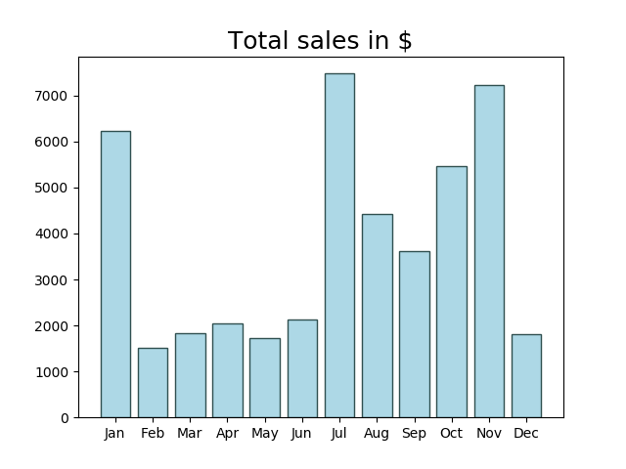

Total costs in the year were **$ 30,159.00**, with an average costs of $2,513.25 per month. The costs range from a minimum of $1,098.00 per month to a maximum of $3,965.00 per month.

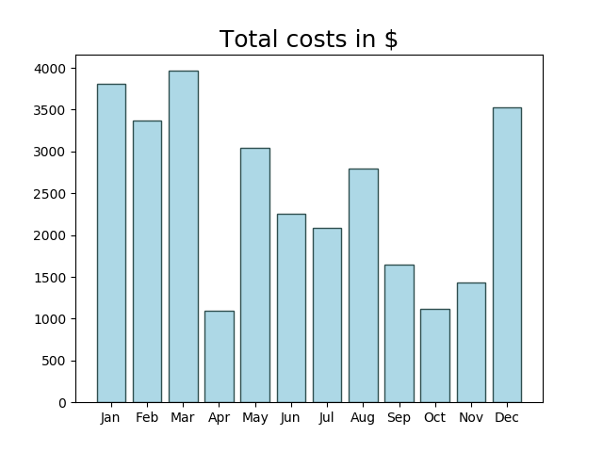

Total profit in the year were **$ 15,383.00**, with an average profit of $1,281.92 per month. The profit range from a minimum of $-2,123.00 per month to a maximum of $5,793.00 per month.

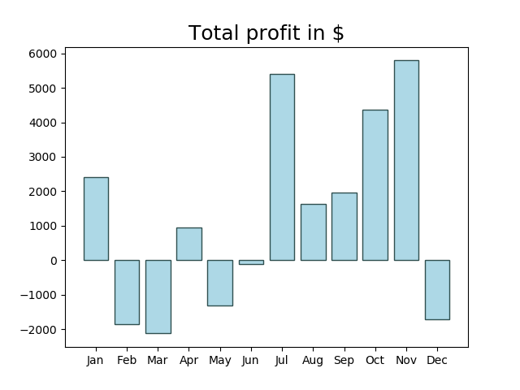

There are 7 profit making months ( January, April, July, August, September, October, November) with an average profit of $3,216.57 per month.

There are 5 loss making months ( February, March, May, June, December) with an average loss of $-1,426.60 per month.