GLM analysis – Count regression (Poisson/NB) - Report
Predicted Eulaema nigrita abundance along forest cover and mean annual precipitation gradients
INTRODUCTION
Bee communities in tropical ecosystems are strongly influenced by climatic factors and habitat structure. For orchid bees (Apidae: Euglossini), variables such as precipitation and forest cover can alter resource availability, nesting suitability, and thermal/microclimatic conditions. In particular, Eulaema nigrita is a widespread species commonly associated with open or disturbed habitats, yet environmental gradients may still shape its local abundance (de Jesus Corrêa-Neto et al., 2024; Opedal, 2020).
In this analysis, we investigated how mean annual precipitation (MAP) and forest cover influence the abundance of E. nigrita across multiple sampling sites. These predictors represent two major ecological axes: climatic water availability and landscape structure. Understanding how E. nigrita responds to these gradients helps clarify habitat preferences and potential vulnerability to land-use change.
ANALYSIS METHODS
To evaluate how mean annual precipitation (MAP) and forest cover influence the abundance of Eulaema nigrita, we modeled the count data using generalized linear models (GLMs). We first fitted a Poisson GLM with a log link, appropriate for count responses with a skewed distribution. However, result showed clear overdispersion, which indicates that the variance exceeds the mean, violating the Poisson assumption and inflating test statistics.
We therefore refitted the model using a Negative Binomial GLM, which includes an additional dispersion parameter allowing the variance to exceed the mean. This model substantially improved the fit.
The final Negative Binomial model included MAP and forest cover as continuous predictors. We report coefficient estimates (β), standard errors, z-values, significance tests,effects on the original scale (exp(β)). The percentage of variance explained by the model (pseudo R²) we get from using the following formula:
$$\% of Variation explained=1-\frac{Residual deviance}{Null deviance}*100$$
Model fit was assessed with residual and observed-versus-predicted plots, as well as with the Akaike Information Criterion (AIC).

RESULTS
Across our 178 sampling sites, Eulaema nigrita abundance varied widely, from very low counts at highly forested and wet sites to high counts at open, drier sites. Mean abundance was 81.14 individuals per site, with a range of 0 - 1.054.
Both predictors, forest cover and men annual precipitation, had negative effects on Eulaema nigrita abundance. Sites with higher forest cover and higher precipitation generally had fewer individuals, while sites with low forest cover and lower precipitation had higher abundance (Fig. 1).
The Poisson GLM initially fit to the data showed an important amount of overdispersion, with a residual deviance of 17.881 on 175 degrees of freedom (expected ≈ 175) and an AIC of 18.811. This indicated that variance substantially exceeded the mean, violating Poisson assumptions.
Refitting with a Negative Binomial GLM substantially improved model fit. The final model had a residual deviance of 211.01 on 175 degrees of freedom, a null deviance of 271.10, and an AIC of 1.843,1 confirming it accounted for overdispersion and provided a better representation of the data.
The Negative Binomial model explained 22.1% of the total deviance, reflecting the proportion of variation in E. nigrita abundance captured by forest cover and MAP. Each unit increase in forest cover reduces expected abundance to 27% of previous and each 1 mm increase in precipitation reduces abundance by 0.14% (Tab. 1).
Table 1. Negative Binomial GLM results for effects of forest cover and mean annual precipitation (MAP) on Eulaema nigrita abundance
Factors | Estimate (β) | SE | z value | p-value | exp(β)
Intercept | 6.679 | 0.330 | 20.265 | < 2e-16 | 795.76
Forest cover | -1.312 | 0.317 | -4.137 | 3.51e-05 | 0.27
MAP | -0.0014 | 0.00022 | -6.242 | 4.32e-10 | 0.99

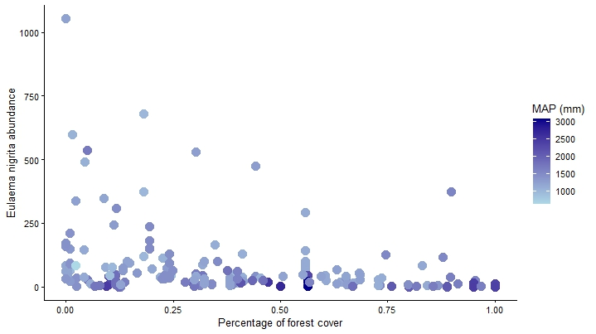
Figure 1. Relationship between forest cover and Eulaema nigrita abundance, colored by mean annual precipitation (MAP)
The scatter plot shows observed abundances of E. nigrita (grey points) across sites with varying forest cover. The colored lines represent predictions from the Negative Binomial GLM: the black line shows the mean predicted abundance, while the dark blue and light blue lines indicate the predicted abundance plus or minus one standard deviation, respectively. This visualization highlights the negative relationship between forest cover and E. nigrita abundance, confirming that individuals are more abundant in open, less-forested sites (Fig. 2).

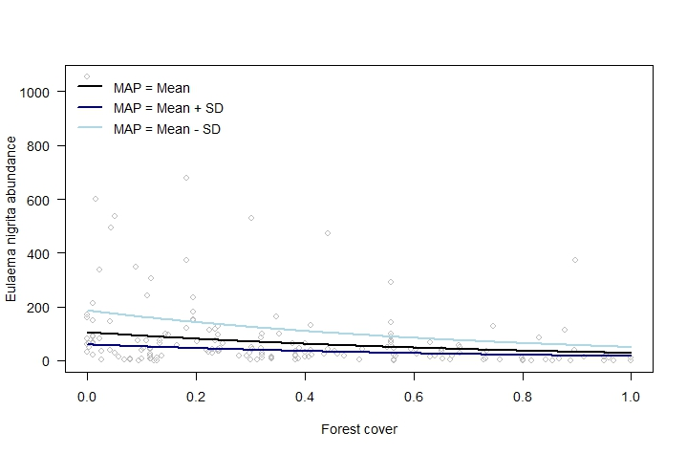Figure 2. Predicted Eulaema nigrita abundance across a gradient of forest cover and mean annual temperature (MAP) at its mean and + and - SD

CONCLUSION
Our analysis demonstrates that both forest cover and mean annual precipitation negatively affect Eulaema nigrita abundance. Sites with higher forest cover and higher precipitation support fewer individuals, whereas open and drier sites harbor higher abundances. The Negative Binomial GLM accounted for overdispersion in the data and explained approximately 22% of the total variation in abundance. These findings suggest that E. nigrita favors more open, less forested habitats, and that climatic and landscape gradients are important determinants of its local distribution. This has implications for predicting responses of orchid bee communities to land-use change and climate variation in tropical ecosystems.
REFERENCES
de Jesus Corrêa-Neto, J., de Oliveira, M. L., & Hipólito, J. (2024). Euglossini bee diversity is driven by forest cover in coastal Amazon. Neotropical Entomology, 53(1), 63-74.
Opedal, Ø. H., Martins, A. A., & Marjakangas, E. L. (2020). A database and synthesis of euglossine bee assemblages collected at fragrance baits. Apidologie, 51(4), 519-530.
R - CODE

