Examples of bug reports for page skleptest.pl

1. **Title: "Shop now" button redirects to an empty page.**

**Description**: After clicking the “shop now” button the client is redirected to an unknown url with a message “Page is unreachable” (http://./product-category/most-wanted/)  
  
**Steps to reproduce:**

1. Page skleptest.pl is already opened.
2. Click on the “shop now” button.

**Actual result:** the client is redirected to an unknown page.

**Expected result:** the client should be redirected to the “most wanted” page (https://skleptest.pl/product-category/most-wanted/ ).

**Attachment:**

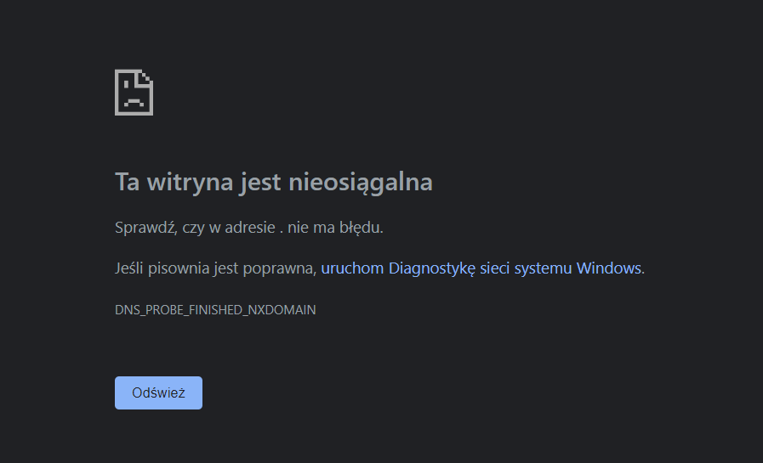

1. **Title: "View cart" button does not work**

**Description:** After clicking “add to cart” button, the “view cart” button appears. After clicking the “view cart” button nothing happens, the client is not redirected to the “cart” page.

**Steps to reproduce:**

1. The skleptest.pl page is already opened.
2. Click on the “most wanted” tab.
3. Click “add to cart” on any product.
4. Click “view cart” button.

**Actual result:** the client is not redirected to the “cart” page.

**Expected result:** clients should be redirected to “cart” page (https://skleptest.pl/cart/ ).

**Attachment:**



1. **Title: Removing products from the cart does not work.**

**Description**: After adding a product to the cart and opening the cart page it is impossible to remove anything from the cart. The “x” icon does not work.

**Steps to reproduce:**

1. Page skleptest.pl is already opened.
2. Click on “most wanted”.
3. Click “add to cart” on any product.
4. Click on “my cart” at the top of the page.
5. Click on the “x” icon on the left side of the product.

**Actual result:** the client cannot remove products from the shopping list.

**Expected result:** the client should be able to remove any product from the shopping list by clicking the “x” icon.

**Attachment:**



1. **Title: After clicking the "send" button on Contact page an empty yellow box appears.**

**Description:** After clicking the "send" button with an empty contact form on the Contact page, an empty yellow box appears. The box does not contain any information for the user and is too small to do so.

**Steps to reproduce:**

1. Page skleptest.pl is already opened.
2. Click on “contact” tab.
3. Click on “send” button without filling in the contact form.

**Actual result:** after clicking the "send" button on Contact page an empty yellow box appears.

**Expected result:** after clicking “Send” button when the contact form is not filled properly there should appear a yellow box with an error message, telling the user that certain information is required, e.g.: “Email is required to send a message”.

**Attachment:**

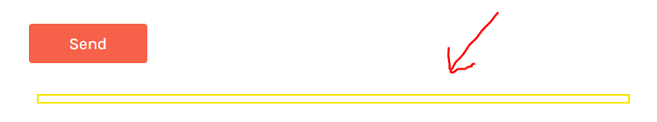

1. **Title: There is a discrepancy between the address written on the page and the Google Maps link.**

**Description:** On the contact page, there is a discrepancy between the provided address and the Google Maps link. On the page there is “Legnicka 12” written in the “Our location” field (without the city name) and the Google Maps link redirects us to “Psia Łączka” in Wroclaw leading to major misinformation.

**Steps to reproduce:**

1. Page skleptest.pl is already opened.
2. Click on the “contact” tab.

**Actual result:** there is a discrepancy between addresses provided on the page.

**Expected result:** the two addresses should provide the same information containing the street name and number, together with the city and postal code. The same information should be visible in the Google Maps address view.

**Attachment:**

