mfStocks60_60shift

# Preprocessing

library(dplyr)  
stocks60$stocks_hourly_diff = stocks60$stocks_hourly %>% diff() %>% append(NA, 0) # Difference for moving averages  
stocks60$stocks_hourly_diff_ln = stocks60$stocks_hourly %>% log() %>% diff() %>% append(NA, 0) # Log then difference for variance stabilization  
  
stocks60$day_count = stocks60$dt_hourly %>% date() %>% as.integer() - stocks60$dt_hourly %>% date() %>% as.integer() %>% min() + 1 # Counting the days

stocks60$morality =   
 stocks60$care_p_hourly*stocks60$care_sent_hourly +   
 stocks60$fairness_p_hourly*stocks60$fairness_sent_hourly +  
 stocks60$loyalty_p_hourly*stocks60$loyalty_sent_hourly +  
 stocks60$authority_p_hourly*stocks60$authority_sent_hourly +  
 stocks60$sanctity_p_hourly*stocks60$sanctity_sent_hourly

stocks60$morality_lag = lag(stocks60$morality) # lag morality index  
  
stocks60$care_p_hourly_lag = lag(stocks60$care_p_hourly) # lag moral probabilities  
stocks60$fairness_p_hourly_lag = (stocks60$fairness_p_hourly)  
stocks60$loyalty_p_hourly_lag = lag(stocks60$loyalty_p_hourly)  
stocks60$authority_p_hourly_lag = lag(stocks60$authority_p_hourly)  
stocks60$sanctity_p_hourly_lag = lag(stocks60$sanctity_p_hourly)  
  
stocks60$care_sent_hourly_lag = lag(stocks60$care_sent_hourly) # lag moral sentiments  
stocks60$fairness_sent_hourly_lag = lag(stocks60$fairness_sent_hourly)  
stocks60$loyalty_sent_hourly_lag = lag(stocks60$loyalty_sent_hourly)  
stocks60$authority_sent_hourly_lag = lag(stocks60$authority_sent_hourly)  
stocks60$sanctity_sent_hourly_lag = lag(stocks60$sanctity_sent_hourly)  
  
stocks60$care_lag = stocks60$care_p_hourly_lag * stocks60$care_sent_hourly_lag # lag probability*sentiments  
stocks60$fairness_lag = stocks60$fairness_p_hourly_lag * stocks60$fairness_sent_hourly_lag  
stocks60$loyalty_lag = stocks60$loyalty_p_hourly_lag * stocks60$loyalty_sent_hourly_lag  
stocks60$authority_lag = stocks60$authority_p_hourly_lag * stocks60$authority_sent_hourly_lag  
stocks60$sanctity_lag = stocks60$sanctity_p_hourly_lag * stocks60$sanctity_sent_hourly_lag

stocks60_ordered = stocks60[, c(1, 24, 2:4, 16:21, 5, 22, 23, 25, 6:15, 27:36, 26, 37:41)] # REORDER COLUMNS  
stocks60_ordered %>% colnames() # DISPLAY COL NAMES

## [1] "dt_hourly" "day_count" "season_intraday_hourly" "season_workday_hourly"   
## [5] "season_month_hourly" "tf1_hourly" "tf2_hourly" "tf3_hourly"   
## [9] "tf4_hourly" "tf5_hourly" "tf6_hourly" "stocks_hourly"   
## [13] "stocks_hourly_diff" "stocks_hourly_diff_ln" "morality" "care_p_hourly"   
## [17] "fairness_p_hourly" "loyalty_p_hourly" "authority_p_hourly" "sanctity_p_hourly"   
## [21] "care_sent_hourly" "fairness_sent_hourly" "loyalty_sent_hourly" "authority_sent_hourly"   
## [25] "sanctity_sent_hourly" "care_p_hourly_lag" "fairness_p_hourly_lag" "loyalty_p_hourly_lag"   
## [29] "authority_p_hourly_lag" "sanctity_p_hourly_lag" "care_sent_hourly_lag" "fairness_sent_hourly_lag"   
## [33] "loyalty_sent_hourly_lag" "authority_sent_hourly_lag" "sanctity_sent_hourly_lag" "morality_lag"   
## [37] "care_lag" "fairness_lag" "loyalty_lag" "authority_lag"   
## [41] "sanctity_lag"

stocks60ts = ts(stocks60_ordered) # MAKE TIME SERIES

plot(stocks60ts[,"stocks_hourly"]) # PLOT INITIAL DATA

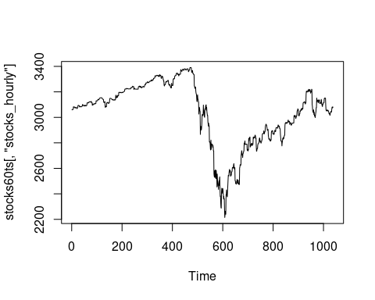

acf(stocks60_ordered$stocks_hourly, lag.max = NULL, type = c("correlation"), plot = TRUE, na.action = na.pass) # ACF FOR NON-TRANSFORMED DATA

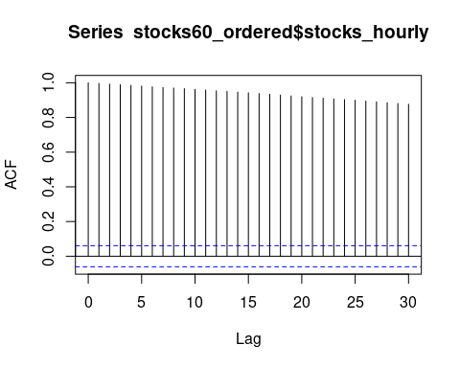

acf(stocks60_ordered$stocks_hourly, lag.max = NULL, type = c("partial"), plot = TRUE, na.action = na.pass) # PACF FOR NON-TRANSFORMED DATA

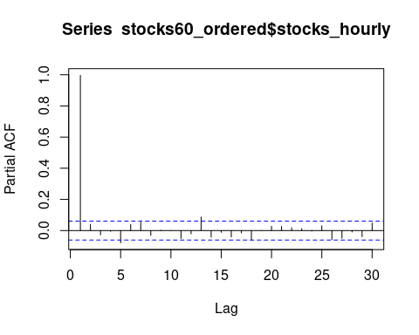

acf(stocks60_ordered$stocks_hourly_diff_ln, lag.max = NULL, type = c("correlation"), plot = TRUE, na.action = na.pass) # ACF FOR TRANSFORMED DATA

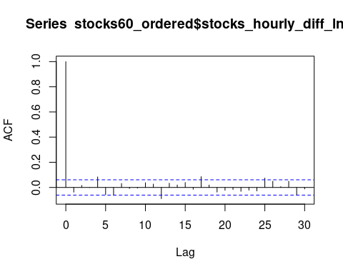

acf(stocks60_ordered$stocks_hourly_diff_ln, lag.max = NULL, type = c("partial"), plot = TRUE, na.action = na.pass) # PACF FOR TRANSFORMED DATA

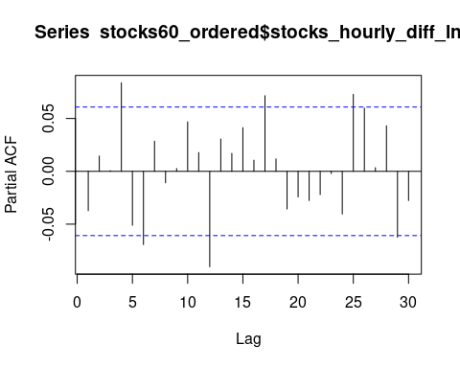

plot(stocks60ts[,"stocks_hourly_diff_ln"]) # UNSTABLE VARIANCE IN CONTRACTION AND RECOVERY PERIOD - NEED GARCH MODEL

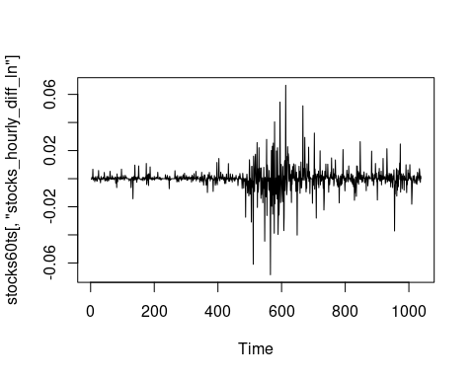 # Data Exploration

hist(stocks60_ordered[16:25]) # PROB & SENT

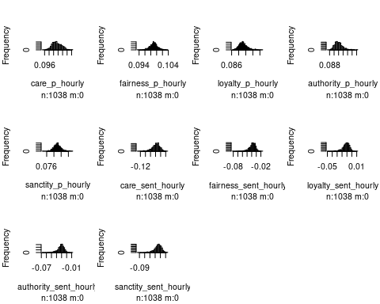

hist(stocks60_ordered[26:35]) # PROB & SENT LAG

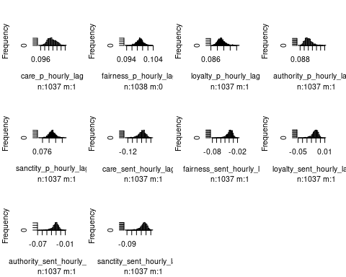

hist(stocks60_ordered[, c(15,36)]) # MORALITY & MORALITY LAG

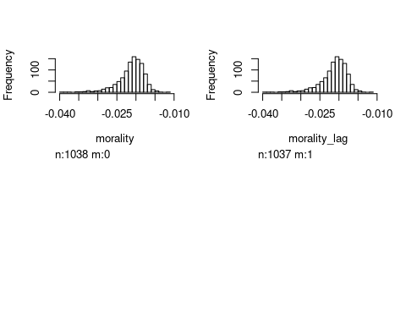

hist(stocks60_ordered[37:41]) # FOUNDATIONS LAG

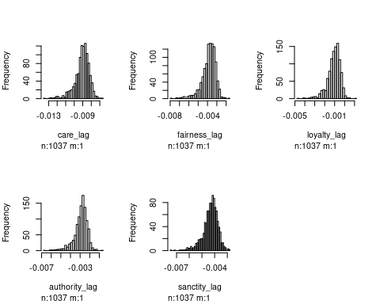

hist(stocks60_ordered[14]) # TRANSFORMED STOCKS

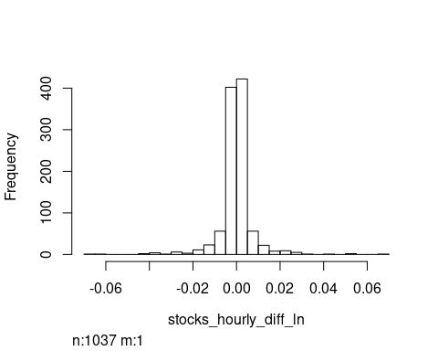

# VIOLIN  
plot_violin <- function(input) {   
 return(input + geom_violin(trim = FALSE) + stat_summary(fun.data = "mean_sdl", fun.args = list(mult = 1), geom = "pointrange", color = "black"))}  
  
# DOUBLE VIOLIN  
plot_violin2 <- function(input) {  
 return(input + geom_violin(aes(color = tf2_hourly), trim = FALSE,position = position_dodge(0.9)) + geom_boxplot(aes(color = tf2_hourly),width = 0.60, position = position_dodge(0.9)) + scale_color_manual(values = c("#00AFBB","#E7B800")))}  
  
# BOXPLOT  
plot_boxplot <- function(input) {  
 return(input + geom_boxplot(notch = TRUE, fill = "lightgray") +stat_summary(fun.y = mean, geom = "point",shape = 18, size = 2.5, color = "#FC4E07"))}  
  
# SCATTERPLOT  
plot_scatter <- function(input) {  
 return(ggplot(stocks60_ordered, aes(input, stocks_hourly_diff_ln, color=tf2_hourly)) + geom_point() + geom_smooth(method=lm) +scale_color_manual(values = c('#999999','#E69F00')) + theme(legend.position=c(0,1), legend.justification=c(0,1)))}  
  
# X DENSITY  
plot_xdensity <- function(input) {  
 return(ggplot(stocks60_ordered, aes(input, fill=tf2_hourly)) +geom_density(alpha=.5) +scale_fill_manual(values = c('#999999','#E69F00')) + theme(legend.position = "none") )}  
  
# Y DENSITY  
plot_ydensity <- function() {return(ggplot(stocks60_ordered, aes(stocks_hourly_diff_ln, fill=tf2_hourly)) +geom_density(alpha=.5) +scale_fill_manual(values = c('#999999','#E69F00')) +theme(legend.position = "none") )}  
  
# BLANK PLOT  
plot_blank <- function() {  
 return(ggplot() + geom_blank(aes(1,1)) +theme(plot.background = element_blank(),panel.grid.major = element_blank(),panel.grid.minor = element_blank(),panel.border = element_blank(), panel.background = element_blank(),axis.title.x = element_blank(),axis.title.y = element_blank(),axis.text.x = element_blank(),axis.text.y = element_blank(),axis.ticks = element_blank()))}

e <- ggplot(stocks60, aes(x = tf2_hourly, y = morality_lag))   
plot_boxplot(e) # MORALITY BOX PLOT

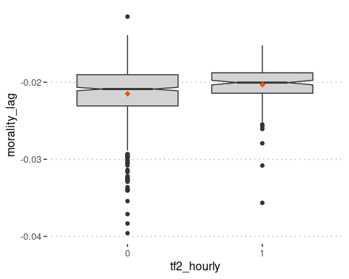

plot_violin(e) # MORALITY VIOLIN PLOT

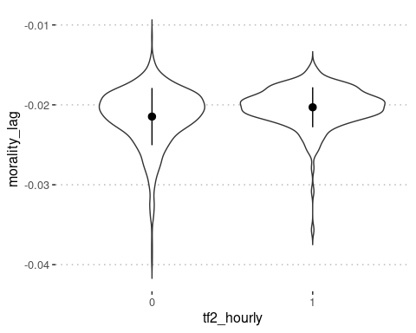

stocks60_foundations_long = melt(stocks60_ordered[, c(7,37:41)])

## Using tf2_hourly as id variables

e1 <- ggplot(stocks60_foundations_long, aes(x = variable, y = value))  
plot_violin(e1) # FOUNDATIONS VIOLIN PLOT

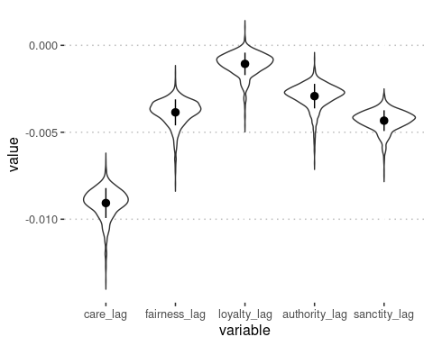

plot_boxplot(e1) # FOUNDATIONS BOX PLOT

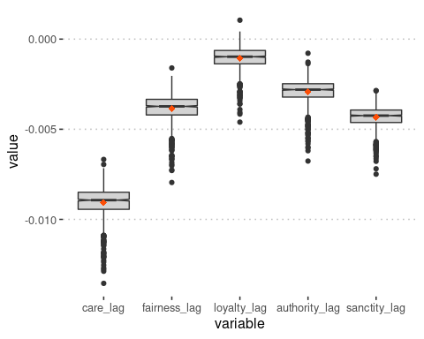

plot_violin2(e1) # FOUNDATIONS BY TF VIOLIN PLOT

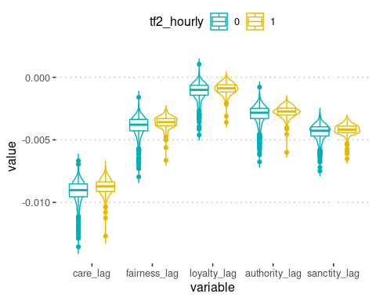

scatterPlot <- plot_scatter(stocks60_ordered$morality_lag)  
xdensity <- plot_xdensity(stocks60_ordered$morality_lag)  
ydensity <- plot_ydensity()  
blankPlot <- plot_blank()  
grid.arrange(xdensity, blankPlot, scatterPlot, ydensity, ncol=2, nrow=2, widths=c(4, 1.4), heights=c(1.4, 4)) # MORALITY PLOT

## `geom_smooth()` using formula 'y ~ x'

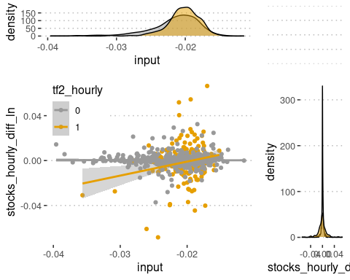

scatterPlot <- plot_scatter(stocks60_ordered$care_lag)  
xdensity <- plot_xdensity(stocks60_ordered$care_lag)  
ydensity <- plot_ydensity()  
blankPlot <- plot_blank()  
grid.arrange(xdensity, blankPlot, scatterPlot, ydensity, ncol=2, nrow=2, widths=c(4, 1.4), heights=c(1.4, 4)) # CARE PLOT

## `geom_smooth()` using formula 'y ~ x'

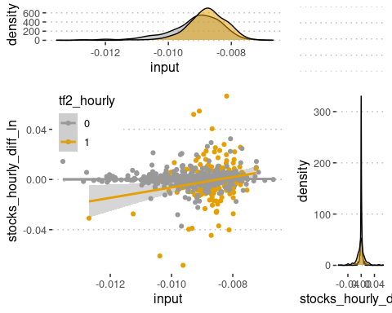

scatterPlot <- plot_scatter(stocks60_ordered$fairness_lag)  
xdensity <- plot_xdensity(stocks60_ordered$fairness_lag)  
ydensity <- plot_ydensity()  
blankPlot <- plot_blank()  
grid.arrange(xdensity, blankPlot, scatterPlot, ydensity, ncol=2, nrow=2, widths=c(4, 1.4), heights=c(1.4, 4)) # FAIRNESS PLOT

## `geom_smooth()` using formula 'y ~ x'

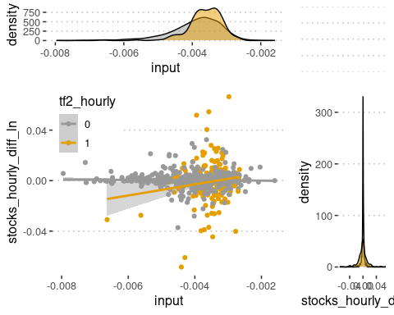

scatterPlot <- plot_scatter(stocks60_ordered$loyalty_lag)  
xdensity <- plot_xdensity(stocks60_ordered$loyalty_lag)  
ydensity <- plot_ydensity()  
blankPlot <- plot_blank()  
grid.arrange(xdensity, blankPlot, scatterPlot, ydensity, ncol=2, nrow=2, widths=c(4, 1.4), heights=c(1.4, 4)) # LOYALTY PLOT

## `geom_smooth()` using formula 'y ~ x'

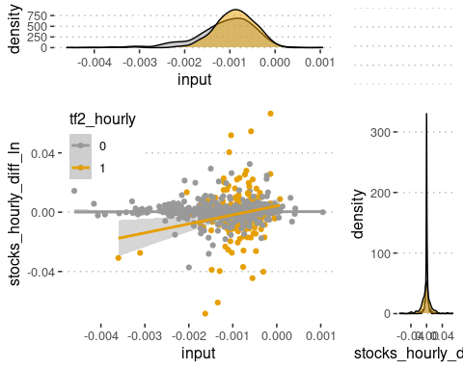

scatterPlot <- plot_scatter(stocks60_ordered$authority_lag)  
xdensity <- plot_xdensity(stocks60_ordered$authority_lag)  
ydensity <- plot_ydensity()  
blankPlot <- plot_blank()  
grid.arrange(xdensity, blankPlot, scatterPlot, ydensity, ncol=2, nrow=2, widths=c(4, 1.4), heights=c(1.4, 4)) # AUTHORITY PLOT

## `geom_smooth()` using formula 'y ~ x'

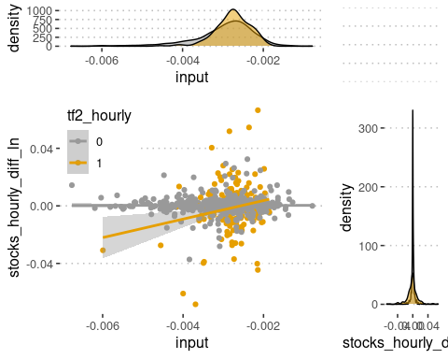

scatterPlot <- plot_scatter(stocks60_ordered$sanctity_lag)  
xdensity <- plot_xdensity(stocks60_ordered$sanctity_lag)  
ydensity <- plot_ydensity()  
blankPlot <- plot_blank()  
grid.arrange(xdensity, blankPlot, scatterPlot, ydensity, ncol=2, nrow=2, widths=c(4, 1.4), heights=c(1.4, 4)) # SANCTITY PLOT

## `geom_smooth()` using formula 'y ~ x'

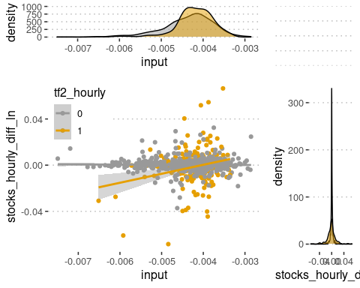

# Removing Outliers

omtted60 <- na.omit(stocks60_ordered)

outlier_rm_IQR <- function(data, df_str, col_str, threshold){  
 Q <- quantile(data, probs=c(.25, .75), na.rm = FALSE) # 25/75 QUANTILES AFTER REMOVING ROW 1 (NA row)  
 iqr <- IQR(data) # IQR AFTER REMOVING ROW 1 (NA row)  
 upper <- Q[2]+threshold*iqr # Upper Range for outliers  
 lower <- Q[1]-threshold*iqr # Lower Range for outliers  
 df <- get(df_str)  
 column <- get(df_str)[col_str]  
 a <- subset.data.frame(df, column > lower)  
 b <- subset.data.frame(df, column < upper)  
 return(intersect(a,b))  
}  
  
a <- outlier_rm_IQR(omtted60$morality_lag[-1], "stocks60_ordered", "morality_lag", 2.5)  
b <- outlier_rm_IQR(omtted60$stocks_hourly_diff_ln[-1], "stocks60_ordered", "stocks_hourly_diff_ln", 2.5)  
  
stocks60_outrm <- intersect(a,b)  
stocks60_outrm_moralityonly <- outlier_rm_IQR(omtted60$morality_lag[-1], "omtted60", "morality_lag", 2.5)

# Fitting and Evaluating Models

stocks60.model.lm <- lm(stocks_hourly_diff_ln ~ tf2_hourly * morality_lag,data = omtted60)  
  
stocks60.model.lm.foundations <- lm(stocks_hourly_diff_ln ~ tf2_hourly * (care_lag +fairness_lag +loyalty_lag +authority_lag +sanctity_lag), data = omtted60)  
  
stocks60.model.lme.null <-lmer(stocks_hourly_diff_ln ~ 1 + (1|day_count), data = omtted60, REML=TRUE)  
  
stocks60.model.lme <- lmer(stocks_hourly_diff_ln ~ (1 + season_intraday_hourly + tf2_hourly*morality_lag + (1 + season_intraday_hourly | day_count)), data = omtted60, REML = TRUE)

## boundary (singular) fit: see ?isSingular

stocks60.model.lme.foundations <- lmer(stocks_hourly_diff_ln ~ (1 + season_intraday_hourly + tf2_hourly*(care_lag + fairness_lag + loyalty_lag + authority_lag + sanctity_lag) + ( 1 + season_intraday_hourly | day_count)), data = omtted60, REML = TRUE)

## boundary (singular) fit: see ?isSingular

stocks60.model.lm.outrm <- lm(stocks_hourly_diff_ln ~ tf2_hourly * morality_lag,data = stocks60_outrm_moralityonly)  
  
stocks60.model.lm.foundations.outrm <- lm(stocks_hourly_diff_ln ~ tf2_hourly * (care_lag +fairness_lag +loyalty_lag +authority_lag +sanctity_lag), data = stocks60_outrm_moralityonly)  
  
stocks60.model.lme.null.outrm <-lmer(stocks_hourly_diff_ln ~ 1 + (1|day_count), data = stocks60_outrm_moralityonly, REML=TRUE)  
  
stocks60.model.lme.outrm <- lmer(stocks_hourly_diff_ln ~ (1 + season_intraday_hourly + tf2_hourly*morality_lag + (1 + season_intraday_hourly | day_count)), data = stocks60_outrm_moralityonly, REML = TRUE)

## boundary (singular) fit: see ?isSingular

stocks60.model.lme.foundations.outrm <- lmer(stocks_hourly_diff_ln ~ (1 + season_intraday_hourly + tf2_hourly*(care_lag + fairness_lag + loyalty_lag + authority_lag + sanctity_lag) + ( 1 + season_intraday_hourly | day_count)), data = stocks60_outrm_moralityonly, REML = TRUE)

## boundary (singular) fit: see ?isSingular

# Anova(stocks60.model.lm, type="III", test="F")  
# Anova(stocks60.model.lm.foundations, type="III", test="F")  
# Anova(stocks60.model.lme.null, type="III", test="F")  
# Anova(stocks60.model.lme, type="III", test="F")  
# Anova(stocks60.model.lme.foundations, type="III", test="F")  
#   
# anova(stocks60.model.lm, stocks60.model.lm.foundations)  
# anova(stocks60.model.lme.null, stocks60.model.lme, stocks60.model.lme.foundations)

anova(stocks60.model.lme.outrm, stocks60.model.lm.outrm, type="Chisq")

## refitting model(s) with ML (instead of REML)

## Data: stocks60_outrm_moralityonly  
## Models:  
## stocks60.model.lm.outrm: stocks_hourly_diff_ln ~ tf2_hourly * morality_lag  
## stocks60.model.lme.outrm: stocks_hourly_diff_ln ~ (1 + season_intraday_hourly + tf2_hourly * morality_lag + (1 + season_intraday_hourly | day_count))  
## npar AIC BIC logLik deviance Chisq Df Pr(>Chisq)   
## stocks60.model.lm.outrm 5 -6974.8 -6950.1 3492.4 -6984.8   
## stocks60.model.lme.outrm 9 -7108.0 -7063.6 3563.0 -7126.0 141.18 4 < 2.2e-16 ***  
## ---  
## Signif. codes: 0 '***' 0.001 '**' 0.01 '*' 0.05 '.' 0.1 ' ' 1

anova(stocks60.model.lme.foundations.outrm, stocks60.model.lm.foundations.outrm, type="Chisq")

## refitting model(s) with ML (instead of REML)

## Data: stocks60_outrm_moralityonly  
## Models:  
## stocks60.model.lm.foundations.outrm: stocks_hourly_diff_ln ~ tf2_hourly * (care_lag + fairness_lag + loyalty_lag + authority_lag + sanctity_lag)  
## stocks60.model.lme.foundations.outrm: stocks_hourly_diff_ln ~ (1 + season_intraday_hourly + tf2_hourly * (care_lag + fairness_lag + loyalty_lag + authority_lag + sanctity_lag) + (1 + season_intraday_hourly | day_count))  
## npar AIC BIC logLik deviance Chisq Df Pr(>Chisq)   
## stocks60.model.lm.foundations.outrm 13 -6995.3 -6931.3 3510.7 -7021.3   
## stocks60.model.lme.foundations.outrm 17 -7122.2 -7038.5 3578.1 -7156.2 134.92 4 < 2.2e-16 ***  
## ---  
## Signif. codes: 0 '***' 0.001 '**' 0.01 '*' 0.05 '.' 0.1 ' ' 1

Anova(stocks60.model.lm.outrm, type="III", test="F")

## Anova Table (Type III tests)  
##   
## Response: stocks_hourly_diff_ln  
## Sum Sq Df F value Pr(>F)   
## (Intercept) 0.000019 1 0.2995 0.5843039   
## tf2_hourly 0.000829 1 13.2848 0.0002811 ***  
## morality_lag 0.000010 1 0.1614 0.6879312   
## tf2_hourly:morality_lag 0.000979 1 15.6930 7.97e-05 ***  
## Residuals 0.063410 1016   
## ---  
## Signif. codes: 0 '***' 0.001 '**' 0.01 '*' 0.05 '.' 0.1 ' ' 1

Anova(stocks60.model.lm.foundations.outrm, type="III", test="F")

## Anova Table (Type III tests)  
##   
## Response: stocks_hourly_diff_ln  
## Sum Sq Df F value Pr(>F)   
## (Intercept) 0.000004 1 0.0683 0.793872   
## tf2_hourly 0.000001 1 0.0198 0.888113   
## care_lag 0.000064 1 1.0560 0.304386   
## fairness_lag 0.000169 1 2.7877 0.095300 .   
## loyalty_lag 0.000050 1 0.8191 0.365664   
## authority_lag 0.000009 1 0.1518 0.696921   
## sanctity_lag 0.000011 1 0.1808 0.670754   
## tf2_hourly:care_lag 0.000150 1 2.4636 0.116823   
## tf2_hourly:fairness_lag 0.000490 1 8.0659 0.004601 **   
## tf2_hourly:loyalty_lag 0.000059 1 0.9702 0.324877   
## tf2_hourly:authority_lag 0.000037 1 0.6027 0.437729   
## tf2_hourly:sanctity_lag 0.001333 1 21.9634 3.16e-06 ***  
## Residuals 0.061178 1008   
## ---  
## Signif. codes: 0 '***' 0.001 '**' 0.01 '*' 0.05 '.' 0.1 ' ' 1

Anova(stocks60.model.lme.null.outrm, type="III", test="F")

## Analysis of Deviance Table (Type III Wald F tests with Kenward-Roger df)  
##   
## Response: stocks_hourly_diff_ln  
## F Df Df.res Pr(>F)  
## (Intercept) 0.0011 1 170.51 0.9737

Anova(stocks60.model.lme.outrm, type="III", test="F")

## Analysis of Deviance Table (Type III Wald F tests with Kenward-Roger df)  
##   
## Response: stocks_hourly_diff_ln  
## F Df Df.res Pr(>F)   
## (Intercept) 0.0176 1 714.94 0.894460   
## season_intraday_hourly 0.2880 1 172.68 0.592197   
## tf2_hourly 5.8463 1 755.69 0.015846 *   
## morality_lag 0.0374 1 655.32 0.846692   
## tf2_hourly:morality_lag 7.2744 1 770.26 0.007147 **  
## ---  
## Signif. codes: 0 '***' 0.001 '**' 0.01 '*' 0.05 '.' 0.1 ' ' 1

Anova(stocks60.model.lme.foundations.outrm, type="III", test="F")

## Analysis of Deviance Table (Type III Wald F tests with Kenward-Roger df)  
##   
## Response: stocks_hourly_diff_ln  
## F Df Df.res Pr(>F)   
## (Intercept) 0.2840 1 827.93 0.594246   
## season_intraday_hourly 1.4132 1 177.70 0.236116   
## tf2_hourly 0.0000 1 865.16 0.999157   
## care_lag 1.5890 1 680.51 0.207902   
## fairness_lag 3.1855 1 953.25 0.074611 .   
## loyalty_lag 0.4718 1 832.72 0.492373   
## authority_lag 0.0455 1 893.35 0.831193   
## sanctity_lag 0.0863 1 587.91 0.769005   
## tf2_hourly:care_lag 0.5337 1 870.38 0.465245   
## tf2_hourly:fairness_lag 9.1755 1 911.90 0.002522 **   
## tf2_hourly:loyalty_lag 2.7557 1 877.82 0.097266 .   
## tf2_hourly:authority_lag 0.5478 1 837.26 0.459411   
## tf2_hourly:sanctity_lag 15.3165 1 980.71 9.719e-05 ***  
## ---  
## Signif. codes: 0 '***' 0.001 '**' 0.01 '*' 0.05 '.' 0.1 ' ' 1

anova(stocks60.model.lm.outrm, stocks60.model.lm.foundations.outrm)

## Analysis of Variance Table  
##   
## Model 1: stocks_hourly_diff_ln ~ tf2_hourly * morality_lag  
## Model 2: stocks_hourly_diff_ln ~ tf2_hourly * (care_lag + fairness_lag +   
## loyalty_lag + authority_lag + sanctity_lag)  
## Res.Df RSS Df Sum of Sq F Pr(>F)   
## 1 1016 0.063410   
## 2 1008 0.061178 8 0.0022323 4.5976 1.592e-05 ***  
## ---  
## Signif. codes: 0 '***' 0.001 '**' 0.01 '*' 0.05 '.' 0.1 ' ' 1

anova(stocks60.model.lme.null.outrm, stocks60.model.lme.outrm, stocks60.model.lme.foundations.outrm)

## refitting model(s) with ML (instead of REML)

## Data: stocks60_outrm_moralityonly  
## Models:  
## stocks60.model.lme.null.outrm: stocks_hourly_diff_ln ~ 1 + (1 | day_count)  
## stocks60.model.lme.outrm: stocks_hourly_diff_ln ~ (1 + season_intraday_hourly + tf2_hourly * morality_lag + (1 + season_intraday_hourly | day_count))  
## stocks60.model.lme.foundations.outrm: stocks_hourly_diff_ln ~ (1 + season_intraday_hourly + tf2_hourly * (care_lag + fairness_lag + loyalty_lag + authority_lag + sanctity_lag) + (1 + season_intraday_hourly | day_count))  
## npar AIC BIC logLik deviance Chisq Df Pr(>Chisq)   
## stocks60.model.lme.null.outrm 3 -6956.6 -6941.8 3481.3 -6962.6   
## stocks60.model.lme.outrm 9 -7108.0 -7063.6 3563.0 -7126.0 163.399 6 < 2.2e-16 ***  
## stocks60.model.lme.foundations.outrm 17 -7122.2 -7038.5 3578.1 -7156.2 30.297 8 0.0001873 ***  
## ---  
## Signif. codes: 0 '***' 0.001 '**' 0.01 '*' 0.05 '.' 0.1 ' ' 1

#summ(stocks60.model.lm, scale=TRUE, transform.response=TRUE, confint=TRUE, digits=3)  
summ(stocks60.model.lme, scale=TRUE, transform.response=TRUE, confint=TRUE, digits=3)

## boundary (singular) fit: see ?isSingular

## MODEL INFO:  
## Observations: 1037  
## Dependent Variable: stocks_hourly_diff_ln  
## Type: Mixed effects linear regression   
##   
## MODEL FIT:  
## AIC = 2806.713, BIC = 2851.209  
## Pseudo-R² (fixed effects) = 0.021  
## Pseudo-R² (total) = 0.303   
##   
## FIXED EFFECTS:  
## -----------------------------------------------------------------------------------  
## Est. 2.5% 97.5% t val. d.f. p  
## ----------------------------- -------- -------- -------- -------- --------- -------  
## (Intercept) 0.029 -0.047 0.106 0.755 238.788 0.451  
## season_intraday_hourly -0.023 -0.103 0.057 -0.555 189.184 0.580  
## tf2_hourly -0.266 -0.425 -0.108 -3.291 504.986 0.001  
## morality_lag -0.012 -0.074 0.050 -0.379 810.325 0.705  
## tf2_hourly:morality_lag 0.408 0.218 0.597 4.214 954.060 0.000  
## -----------------------------------------------------------------------------------  
##   
## p values calculated using Satterthwaite d.f.  
##   
## RANDOM EFFECTS:  
## ------------------------------------------------  
## Group Parameter Std. Dev.   
## ----------- ------------------------ -----------  
## day_count (Intercept) 0.330   
## day_count season_intraday_hourly 0.413   
## Residual 0.831   
## ------------------------------------------------  
##   
## Grouping variables:  
## ------------------------------  
## Group # groups ICC   
## ----------- ---------- -------  
## day_count 173 0.136   
## ------------------------------  
##   
## Continuous variables are mean-centered and scaled by 1 s.d.

#summ(stocks60.model.lm.outrm, scale=TRUE, transform.response=TRUE, confint=TRUE, digits=3)  
summ(stocks60.model.lme.outrm, scale=TRUE, transform.response=TRUE, confint=TRUE, digits=3)

## boundary (singular) fit: see ?isSingular

## MODEL INFO:  
## Observations: 1020  
## Dependent Variable: stocks_hourly_diff_ln  
## Type: Mixed effects linear regression   
##   
## MODEL FIT:  
## AIC = 2767.514, BIC = 2811.862  
## Pseudo-R² (fixed effects) = 0.011  
## Pseudo-R² (total) = 0.303   
##   
## FIXED EFFECTS:  
## -----------------------------------------------------------------------------------  
## Est. 2.5% 97.5% t val. d.f. p  
## ----------------------------- -------- -------- -------- -------- --------- -------  
## (Intercept) 0.029 -0.049 0.107 0.736 236.289 0.463  
## season_intraday_hourly -0.022 -0.104 0.059 -0.537 189.545 0.592  
## tf2_hourly -0.213 -0.371 -0.055 -2.649 496.480 0.008  
## morality_lag -0.006 -0.069 0.056 -0.195 878.027 0.846  
## tf2_hourly:morality_lag 0.251 0.070 0.431 2.715 910.431 0.007  
## -----------------------------------------------------------------------------------  
##   
## p values calculated using Satterthwaite d.f.  
##   
## RANDOM EFFECTS:  
## ------------------------------------------------  
## Group Parameter Std. Dev.   
## ----------- ------------------------ -----------  
## day_count (Intercept) 0.337   
## day_count season_intraday_hourly 0.420   
## Residual 0.832   
## ------------------------------------------------  
##   
## Grouping variables:  
## ------------------------------  
## Group # groups ICC   
## ----------- ---------- -------  
## day_count 172 0.141   
## ------------------------------  
##   
## Continuous variables are mean-centered and scaled by 1 s.d.

summ(stocks60.model.lm.foundations, scale=TRUE, transform.response=TRUE, confint=TRUE, digits=3)

## MODEL INFO:  
## Observations: 1037  
## Dependent Variable: stocks_hourly_diff_ln  
## Type: OLS linear regression   
##   
## MODEL FIT:  
## F(11,1025) = 6.573, p = 0.000  
## R² = 0.066  
## Adj. R² = 0.056   
##   
## Standard errors: OLS  
## --------------------------------------------------------------------------  
## Est. 2.5% 97.5% t val. p  
## ------------------------------ -------- -------- -------- -------- -------  
## (Intercept) 0.038 -0.029 0.104 1.115 0.265  
## tf2_hourly -0.177 -0.347 -0.006 -2.028 0.043  
## care_lag 0.098 -0.090 0.287 1.024 0.306  
## fairness_lag -0.180 -0.397 0.038 -1.618 0.106  
## loyalty_lag 0.083 -0.129 0.295 0.772 0.440  
## authority_lag 0.027 -0.180 0.234 0.255 0.799  
## sanctity_lag -0.030 -0.180 0.120 -0.390 0.697  
## tf2_hourly:care_lag -0.397 -0.961 0.168 -1.378 0.168  
## tf2_hourly:fairness_lag -0.842 -1.450 -0.234 -2.716 0.007  
## tf2_hourly:loyalty_lag 0.237 -0.304 0.778 0.860 0.390  
## tf2_hourly:authority_lag 0.382 -0.142 0.905 1.431 0.153  
## tf2_hourly:sanctity_lag 1.075 0.596 1.554 4.407 0.000  
## --------------------------------------------------------------------------  
##   
## Continuous variables are mean-centered and scaled by 1 s.d.

summ(stocks60.model.lme.foundations, scale=TRUE, transform.response=TRUE, confint=TRUE, digits=3)

## boundary (singular) fit: see ?isSingular

## MODEL INFO:  
## Observations: 1037  
## Dependent Variable: stocks_hourly_diff_ln  
## Type: Mixed effects linear regression   
##   
## MODEL FIT:  
## AIC = 2817.247, BIC = 2901.296  
## Pseudo-R² (fixed effects) = 0.045  
## Pseudo-R² (total) = 0.308   
##   
## FIXED EFFECTS:  
## -------------------------------------------------------------------------------------  
## Est. 2.5% 97.5% t val. d.f. p  
## ------------------------------ -------- -------- -------- -------- ---------- -------  
## (Intercept) 0.036 -0.040 0.112 0.922 234.386 0.357  
## season_intraday_hourly -0.045 -0.123 0.034 -1.118 195.150 0.265  
## tf2_hourly -0.175 -0.341 -0.010 -2.080 564.875 0.038  
## care_lag 0.116 -0.061 0.292 1.281 931.081 0.200  
## fairness_lag -0.186 -0.393 0.022 -1.750 990.337 0.080  
## loyalty_lag 0.057 -0.143 0.256 0.557 972.371 0.577  
## authority_lag 0.023 -0.171 0.217 0.229 952.280 0.819  
## sanctity_lag -0.021 -0.167 0.126 -0.276 848.302 0.782  
## tf2_hourly:care_lag -0.151 -0.674 0.371 -0.567 970.161 0.571  
## tf2_hourly:fairness_lag -0.774 -1.366 -0.182 -2.564 1019.642 0.010  
## tf2_hourly:loyalty_lag 0.363 -0.151 0.877 1.385 976.953 0.166  
## tf2_hourly:authority_lag 0.056 -0.429 0.542 0.228 953.453 0.820  
## tf2_hourly:sanctity_lag 0.809 0.333 1.284 3.335 1018.242 0.001  
## -------------------------------------------------------------------------------------  
##   
## p values calculated using Satterthwaite d.f.  
##   
## RANDOM EFFECTS:  
## ------------------------------------------------  
## Group Parameter Std. Dev.   
## ----------- ------------------------ -----------  
## day_count (Intercept) 0.328   
## day_count season_intraday_hourly 0.392   
## Residual 0.829   
## ------------------------------------------------  
##   
## Grouping variables:  
## ------------------------------  
## Group # groups ICC   
## ----------- ---------- -------  
## day_count 173 0.136   
## ------------------------------  
##   
## Continuous variables are mean-centered and scaled by 1 s.d.

#summ(stocks60.model.lm.foundations.outrm, scale=TRUE, transform.response=TRUE, confint=TRUE, digits=3)  
summ(stocks60.model.lme.foundations.outrm, scale=TRUE, transform.response=TRUE, confint=TRUE, digits=3)

## boundary (singular) fit: see ?isSingular

## MODEL INFO:  
## Observations: 1020  
## Dependent Variable: stocks_hourly_diff_ln  
## Type: Mixed effects linear regression   
##   
## MODEL FIT:  
## AIC = 2772.081, BIC = 2855.849  
## Pseudo-R² (fixed effects) = 0.043  
## Pseudo-R² (total) = 0.320   
##   
## FIXED EFFECTS:  
## -------------------------------------------------------------------------------------  
## Est. 2.5% 97.5% t val. d.f. p  
## ------------------------------ -------- -------- -------- -------- ---------- -------  
## (Intercept) 0.037 -0.041 0.116 0.934 227.661 0.351  
## season_intraday_hourly -0.048 -0.128 0.031 -1.189 195.839 0.236  
## tf2_hourly -0.114 -0.278 0.050 -1.368 545.979 0.172  
## care_lag 0.102 -0.056 0.260 1.270 910.835 0.204  
## fairness_lag -0.171 -0.357 0.016 -1.795 969.508 0.073  
## loyalty_lag 0.063 -0.115 0.241 0.691 949.575 0.490  
## authority_lag 0.019 -0.153 0.191 0.214 938.427 0.830  
## sanctity_lag -0.020 -0.154 0.114 -0.296 835.012 0.767  
## tf2_hourly:care_lag -0.173 -0.635 0.289 -0.735 946.903 0.463  
## tf2_hourly:fairness_lag -0.814 -1.336 -0.291 -3.050 1004.116 0.002  
## tf2_hourly:loyalty_lag 0.388 -0.067 0.843 1.671 958.477 0.095  
## tf2_hourly:authority_lag -0.166 -0.602 0.271 -0.744 922.205 0.457  
## tf2_hourly:sanctity_lag 0.873 0.439 1.308 3.938 1000.173 0.000  
## -------------------------------------------------------------------------------------  
##   
## p values calculated using Satterthwaite d.f.  
##   
## RANDOM EFFECTS:  
## ------------------------------------------------  
## Group Parameter Std. Dev.   
## ----------- ------------------------ -----------  
## day_count (Intercept) 0.342   
## day_count season_intraday_hourly 0.401   
## Residual 0.824   
## ------------------------------------------------  
##   
## Grouping variables:  
## ------------------------------  
## Group # groups ICC   
## ----------- ---------- -------  
## day_count 172 0.147   
## ------------------------------  
##   
## Continuous variables are mean-centered and scaled by 1 s.d.

plot1 <- interact_plot(stocks60.model.lm, pred = morality_lag, modx = tf2_hourly, plot.points = TRUE, linearity.check = FALSE) + ylim(-0.04,0.04)  
plot2 <- interact_plot(stocks60.model.lm.outrm, pred = morality_lag, modx = tf2_hourly, plot.points = TRUE, linearity.check = FALSE) + ylim(-0.04,0.04)  
gridExtra::grid.arrange(plot1, plot2, ncol=2)

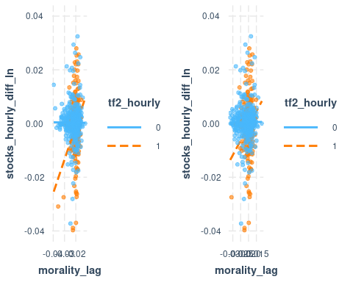

plot1 <- interact_plot(stocks60.model.lme, pred = morality_lag, modx = tf2_hourly, plot.points = TRUE, linearity.check = FALSE) + ylim(-0.04,0.04)  
plot2 <- interact_plot(stocks60.model.lme.outrm, pred = morality_lag, modx = tf2_hourly, plot.points = TRUE, linearity.check = FALSE) + ylim(-0.04,0.04)  
gridExtra::grid.arrange(plot1, plot2, ncol=2)

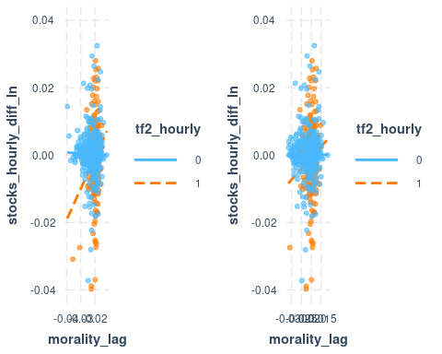

plot1 <- interact_plot(stocks60.model.lm.foundations, pred = care_lag, modx = tf2_hourly, plot.points = TRUE, linearity.check = FALSE) + ylim(-0.04,0.04)  
plot2 <- interact_plot(stocks60.model.lm.foundations.outrm, pred = care_lag, modx = tf2_hourly, plot.points = TRUE, linearity.check = FALSE) + ylim(-0.04,0.04)  
gridExtra::grid.arrange(plot1, plot2, ncol=2)

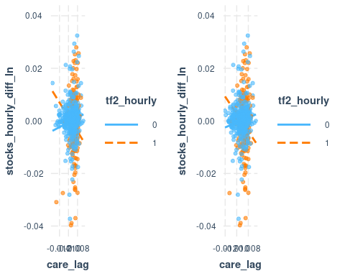

plot1 <- interact_plot(stocks60.model.lm.foundations, pred = fairness_lag, modx = tf2_hourly, plot.points = TRUE, linearity.check = FALSE) + ylim(-0.04,0.04)  
plot2 <- interact_plot(stocks60.model.lm.foundations.outrm, pred = fairness_lag, modx = tf2_hourly, plot.points = TRUE, linearity.check = FALSE) + ylim(-0.04,0.04)  
gridExtra::grid.arrange(plot1, plot2, ncol=2)

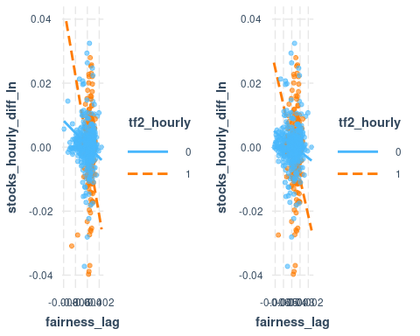

plot1 <- interact_plot(stocks60.model.lm.foundations, pred = loyalty_lag, modx = tf2_hourly, plot.points = TRUE, linearity.check = FALSE) + ylim(-0.04,0.04)  
plot2 <- interact_plot(stocks60.model.lm.foundations.outrm, pred = loyalty_lag, modx = tf2_hourly, plot.points = TRUE, linearity.check = FALSE) + ylim(-0.04,0.04)  
gridExtra::grid.arrange(plot1, plot2, ncol=2)

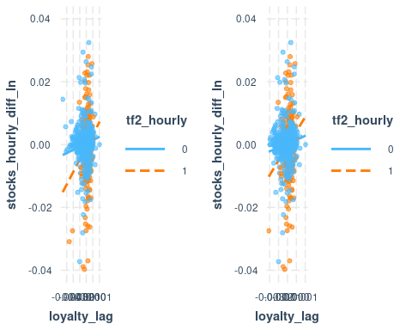

plot1 <- interact_plot(stocks60.model.lm.foundations, pred = authority_lag, modx = tf2_hourly, plot.points = TRUE, linearity.check = FALSE) + ylim(-0.04,0.04)  
plot2 <- interact_plot(stocks60.model.lm.foundations.outrm, pred = authority_lag, modx = tf2_hourly, plot.points = TRUE, linearity.check = FALSE) + ylim(-0.04,0.04)  
gridExtra::grid.arrange(plot1, plot2, ncol=2)

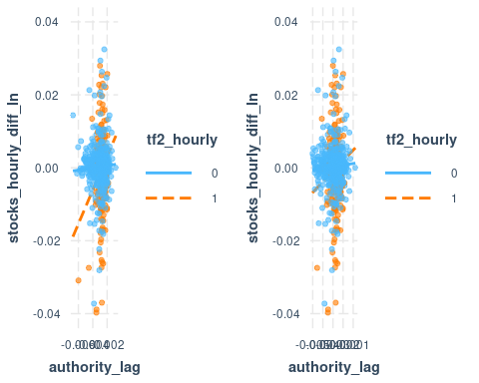

plot1 <- interact_plot(stocks60.model.lm.foundations, pred = sanctity_lag, modx = tf2_hourly, plot.points = TRUE, linearity.check = FALSE) + ylim(-0.04,0.04)  
plot2 <- interact_plot(stocks60.model.lm.foundations.outrm, pred = sanctity_lag, modx = tf2_hourly, plot.points = TRUE, linearity.check = FALSE) + ylim(-0.04,0.04)  
gridExtra::grid.arrange(plot1, plot2, ncol=2)

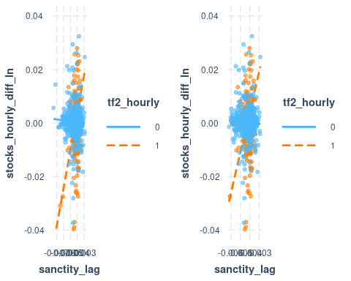

library(sjPlot)

##   
## Attaching package: 'sjPlot'

## The following object is masked _by_ '.GlobalEnv':  
##   
## plot_scatter

tab_model(stocks60.model.lme.null.outrm, stocks60.model.lme.outrm, stocks60.model.lme.foundations.outrm,  
 pred.labels = c("(Intercept)","60min intraday seasonality","Economic period","Morality","(Economic period):(Morality)","Care","Fairness","Loyalty","Authority","Sanctity","(Economic period):(Care)","(Economic period):(Fairness)","(Economic period):(Loyalty)","(Economic period):(Authority)","(Economic period):(Sanctity)"))

## Argument 'df_method' is deprecated. Please use 'ci_method' instead.

## Argument 'df_method' is deprecated. Please use 'ci_method' instead.  
## Argument 'df_method' is deprecated. Please use 'ci_method' instead.

stocks_hourly_diff_ln

stocks_hourly_diff_ln

stocks_hourly_diff_ln

Predictors

Estimates

CI

p

Estimates

CI

p

Estimates

CI

p

(Intercept)

0.00

-0.00 – 0.00

0.974

0.00

-0.00 – 0.00

0.894

0.00

-0.01 – 0.01

0.592

60min intraday seasonality

-0.00

-0.00 – 0.00

0.592

-0.00

-0.00 – 0.00

0.235

Economic period

0.01

0.00 – 0.02

0.015

0.00

-0.03 – 0.03

0.999

Morality

-0.02

-0.18 – 0.15

0.846

(Economic period):(Morality)

0.67

0.19 – 1.15

0.007

Care

1.07

-0.59 – 2.73

0.204

Fairness

-2.08

-4.35 – 0.19

0.073

Loyalty

0.88

-1.62 – 3.38

0.490

Authority

0.24

-1.99 – 2.47

0.830

Sanctity

-0.30

-2.28 – 1.69

0.767

(Economic period):(Care)

-1.82

-6.66 – 3.03

0.463

(Economic period):(Fairness)

-9.92

-16.31 – -3.54

0.002

(Economic period):(Loyalty)

5.44

-0.95 – 11.82

0.095

(Economic period):(Authority)

-2.14

-7.79 – 3.50

0.457

(Economic period):(Sanctity)

12.95

6.49 – 19.40

<0.001

Random Effects

σ2

0.00

0.00

0.00

τ00

0.00 day_count

0.00 day_count

0.00 day_count

τ11

0.00 day_count.season_intraday_hourly

0.00 day_count.season_intraday_hourly

ρ01

-1.00 day_count

-1.00 day_count

ICC

0.03

N

172 day_count

172 day_count

172 day_count

Observations

1020

1020

1020

Marginal R2 / Conditional R2

0.000 / 0.028

0.015 / NA

0.059 / NA