Homework #04

# 1

1a)

Represents the covariance between product 2 price and product 1 price

F=[ -6, 47, -42, -66, 35, 21, 9, 2;

89, -64, 4, 56, 20, 11, -59, -57];

[M, N] = size(F);

disp('Covariance Matrix:')

Covariance Matrix:

C=(1/8).*F * F.'

C = 2×2

103 ×

1.2645 -0.8900

-0.8900 2.8025

[U, lambda]=eig(C);

disp('Principal Components:')

Principal Components:

for i = 1:1:length(U)

disp(U(:, i))

end

-0.9093

-0.4161

-0.4161

0.9093

Represents the projection of F data at time 4 onto the first PC (the amplitude of 1st PC in the data at time=4)

disp('Expansion Matrix:')

Expansion Matrix:

T=U.' * F

T = 2×8

-31.5728 -16.1115 36.5280 36.7173 -40.1480 -23.6727 16.3632 ⋯

83.4276 -77.7523 21.1117 78.3826 3.6249 1.2656 -57.3955

for i = 1:1:length(U)

disp('For PC:')

disp(U(:, i))

disp(['variance explained = ' num2str(100*lambda(i,i)/sum(lambda(:))) '%'])

end

For PC:

-0.9093

-0.4161

variance explained = 21.0793%

For PC:

-0.4161

0.9093

variance explained = 78.9207%

1b) So the PC with the greatest eigenvalue, and therefore greatest variance explained, is:

disp('First PC:')

First PC:

disp(U(:,2))

-0.4161

0.9093

So this PC tells us that the two product price deviations are inversely correlated such that the first product price tends to be half as deviated and in the opposite direction as the second product price deviation.

So likely these are two products who are related in such a way that their prices are inversely correlated with each other.

1c) "Variance explained by each PCA mode" means how much of the variation in the F dataset can be attributed to each of the principal components (modes).

1d) So each row in F is a variable and therefore the variance for each row/variable m of F is:

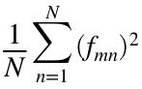

Total variance is the sum of these for every row:

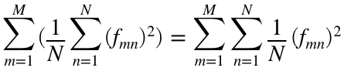

which is the trace/sum of eigenvalues of the covariance matrix:

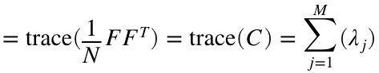

the fraction of explained variance for the ith PC is then:

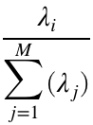

# 2

2a)

% Matlab

%

N=1300; t=1:N;

V1=[1;2;0;-1.1;0];

V2=[0;-1;0;-0.8;0];

V3=[1.5;0;0;-0.6;1.5];

F=3*V1*cos(t/5) ...

+2*V2*cos(t/3)...

+1.5*V3*cos(t/7);

[M, N] = size(F)

M = 5

N = 1300

figure; hold on

for i=1:1:M

plot(t(1, 1:100), F(i, 1:100))

end

hold off

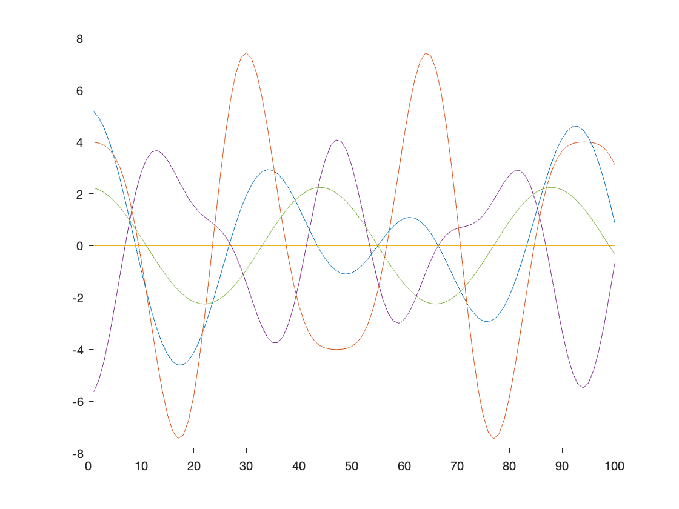

2b)

F_prime = F - mean(F,2);

disp('Covariance Matrix:')

Covariance Matrix:

C=(1/N).*F_prime * F_prime.'

C = 5×5

6.9365 8.8994 0 -5.8796 2.4911

8.8994 19.9962 0 -8.2378 -0.0898

0 0 0 0 0

-5.8796 -8.2378 0 7.0627 -0.9661

2.4911 -0.0898 0 -0.9661 2.5354

Interpretation of covariance matrix: the matrix that contains the covariance of each stock's price with all the other stock prices and itself.

disp('Verifying C is symmetric:')

Verifying C is symmetric:

disp(C*C.')

168.0892 287.8954 0 -158.0275 28.4769

287.8954 546.9162 0 -275.1428 28.1051

0 0 0 0 0

-158.0275 -275.1428 0 153.2455 -23.1802

28.4769 28.1051 0 -23.1802 13.5753

disp(C.'*C)

168.0892 287.8954 0 -158.0275 28.4769

287.8954 546.9162 0 -275.1428 28.1051

0 0 0 0 0

-158.0275 -275.1428 0 153.2455 -23.1802

28.4769 28.1051 0 -23.1802 13.5753

 so C is indeed symmetric.

The diagonal entries contain that specific stock price's own variance across the days, where C(i,i) is the variance for stock price i.

Stock 2 has the highest variance, then stock 4, then stock 1, then stock 5, and stock 3 does not vary/has 0 variance.

The non-diagonal entries above the diagonal contain the covariances between stock prices, so C(i,j) is the covariance between stock i price and stock j price.

Stock 1 is positively correlated with stocks 2 and somewhat with 5, and it is negatively correlated with stock 4.

Stock 2 is also negatively correlated with stock 4 and barely negatively correlated with stock 5.

Stock 4 is slightly negatively correlated with stock 5.

Stock 3 is not correlated with any of them.

2c)

[U, lambda]=eig(C);

disp('Principal Components:')

Principal Components:

for i = 1:1:length(U)

disp(U(:, i))

disp(['with eigenvalue: ' num2str(lambda(i,i))])

end

-0.4353

-0.7969

0

0.4155

-0.0531

with eigenvalue: 29.1461

-0.4977

0.5057

0

0.3721

-0.5984

with eigenvalue: 5.284

-0.7160

0.2121

0

-0.2652

0.6099

with eigenvalue: -5.0555e-15

0.2240

0.2533

0

0.7865

0.5168

with eigenvalue: 2.1008

0

0

1

0

0

with eigenvalue: 0

For each PC, stock prices that are more strongly correlated with each other will be of similar sign and larger in magnitude. And then for each PC, the eigenvalue tells us how well it explains the total data variance.

2d)

T=U.'*F;

figure; hold on

n_N = N;

n=1:1:n_N;

for i = 1:1:M

plot(n, T(i, 1:n_N))

end

hold off

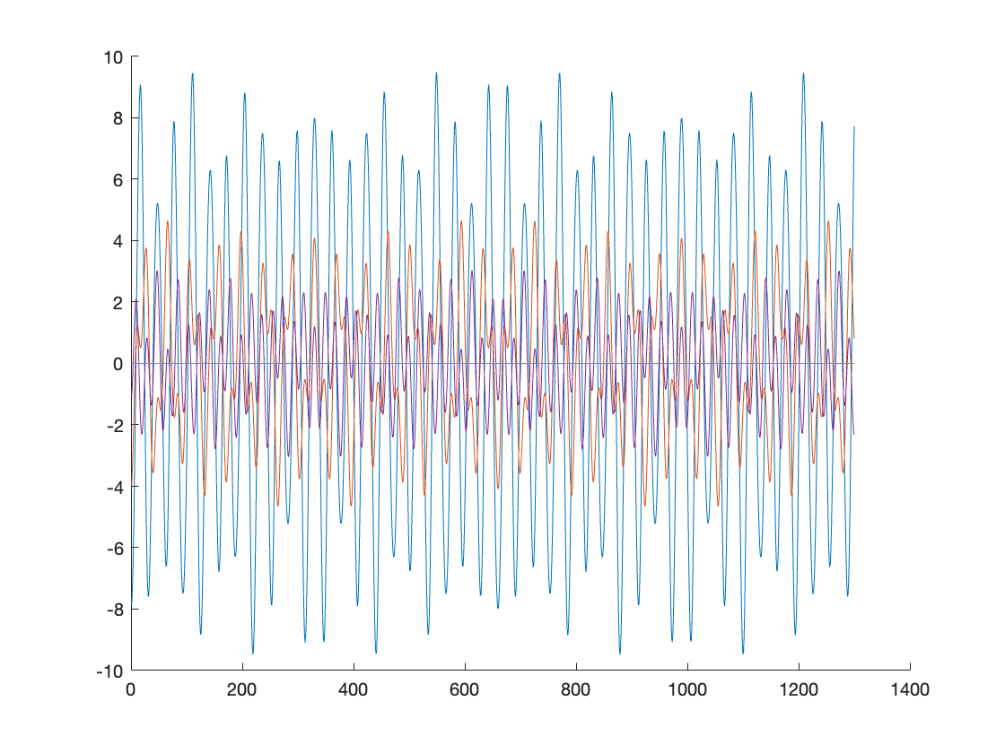

2e) 1st, 2nd, 3rd PC has significantly greater eigenvalue than the last two (which are basically 0). So we can use k=3.

reconst_PCs=[1,2,4];

F_reconst=U(:,reconst_PCs)*T(reconst_PCs, :)

F_reconst = 5×1300

5.1673 4.9220 4.5225 3.9827 3.3209 2.5599 1.7256 ⋯

3.9905 3.9546 3.8714 3.7098 3.4333 3.0064 2.4013

0 0 0 0 0 0 0

-5.6370 -5.1604 -4.4067 -3.4325 -2.3098 -1.1191 0.0580

2.2271 2.1588 2.0465 1.8925 1.7000 1.4729 1.2157

figure; hold on

for i=1:1:M

plot(t(1, 1:100), F_reconst(i, 1:100))

end

hold off



This reconstruction from 3 PC's has similar values and importantly, similar trends to F:

F

F = 5×1300

5.1673 4.9220 4.5225 3.9827 3.3209 2.5599 1.7256 ⋯

3.9905 3.9546 3.8714 3.7098 3.4333 3.0064 2.4013

0 0 0 0 0 0 0

-5.6370 -5.1604 -4.4067 -3.4325 -2.3098 -1.1191 0.0580

2.2271 2.1588 2.0465 1.8925 1.7000 1.4729 1.2157

figure; hold on

for i=1:1:M

plot(t(1, 1:100), F(i, 1:100))

end

hold off



The data were originally constructed using 3 cosine function signals of varying amplitudes, so it makes sense that it is best reconstructed with 3 PCs.

# 3

3a)

A is 2x3 so A*A^T will have the smaller dimension and therefore will be used for this SVD.

A=[-10,-9,8;-0,4,3];

[U,S,V]=svd(A)

U = 2×2

0.9985 -0.0543

-0.0543 -0.9985

S = 2×3

15.6733 0 0

0 4.9343 0

V = 3×3

-0.6371 0.1101 0.7629

-0.5872 -0.7104 -0.3879

0.4993 -0.6951 0.5172

They are the same

# 4

4a)

% Matlab

A=double(rgb2gray(imread('./coronavirus.jpg'))); A=A-mean(A(:));

figure(1); clf; imagesc(A); colormap(gray); colorbar

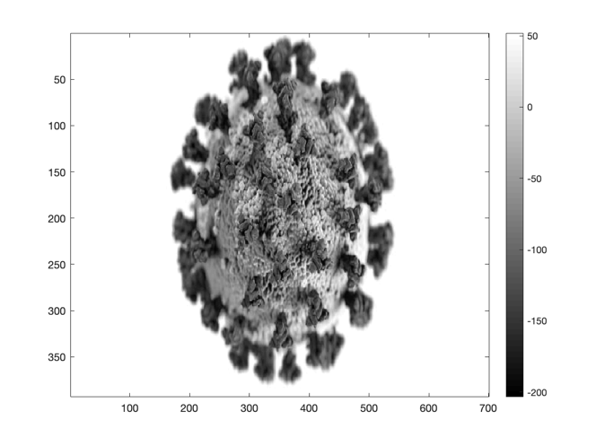

[M, N]=size(A);

[U,S,V]=svd(A)

U = 393×393

-0.0063 -0.0625 0.0099 -0.0796 0.0304 -0.0600 0.0484 ⋯

-0.0062 -0.0627 0.0100 -0.0797 0.0302 -0.0592 0.0485

-0.0060 -0.0630 0.0098 -0.0796 0.0303 -0.0592 0.0489

-0.0056 -0.0637 0.0094 -0.0796 0.0300 -0.0581 0.0497

-0.0046 -0.0650 0.0088 -0.0801 0.0287 -0.0549 0.0510

-0.0036 -0.0664 0.0083 -0.0806 0.0267 -0.0511 0.0525

-0.0021 -0.0679 0.0083 -0.0820 0.0225 -0.0428 0.0536

-0.0003 -0.0694 0.0090 -0.0841 0.0174 -0.0317 0.0540

0.0019 -0.0709 0.0105 -0.0870 0.0114 -0.0176 0.0526

0.0040 -0.0719 0.0130 -0.0906 0.0064 -0.0030 0.0507

⋮

S = 393×700

104 ×

3.0118 0 0 0 0 0 0 ⋯

0 1.4580 0 0 0 0 0

0 0 0.8663 0 0 0 0

0 0 0 0.7432 0 0 0

0 0 0 0 0.6421 0 0

0 0 0 0 0 0.5737 0

0 0 0 0 0 0 0.5461

0 0 0 0 0 0 0

0 0 0 0 0 0 0

0 0 0 0 0 0 0

⋮

V = 700×700

0.0313 -0.0219 0.0072 -0.0202 0.0102 -0.0118 0.0130 ⋯

0.0313 -0.0219 0.0072 -0.0202 0.0102 -0.0118 0.0130

0.0313 -0.0219 0.0072 -0.0202 0.0102 -0.0118 0.0130

0.0313 -0.0219 0.0072 -0.0202 0.0102 -0.0118 0.0130

0.0313 -0.0219 0.0072 -0.0202 0.0102 -0.0118 0.0130

0.0313 -0.0219 0.0072 -0.0202 0.0102 -0.0118 0.0130

0.0313 -0.0219 0.0072 -0.0202 0.0102 -0.0118 0.0130

0.0313 -0.0219 0.0072 -0.0202 0.0102 -0.0118 0.0130

0.0313 -0.0219 0.0072 -0.0202 0.0102 -0.0118 0.0130

0.0313 -0.0219 0.0072 -0.0202 0.0102 -0.0118 0.0130

⋮

m=1:1:M;

s=m;

for i = 1:1:M

s(i) = S(i,i);

end

figure

disp('non-log plot:')

non-log plot:

plot(m,s)

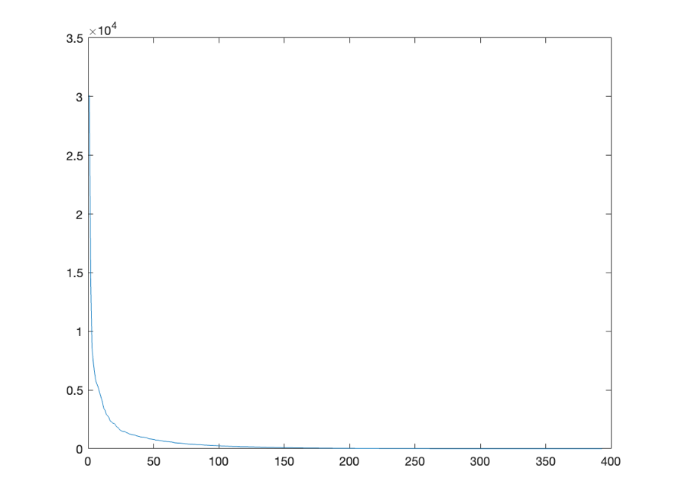

figure

disp('log10 plot:')

log10 plot:

semilogy(m,s)

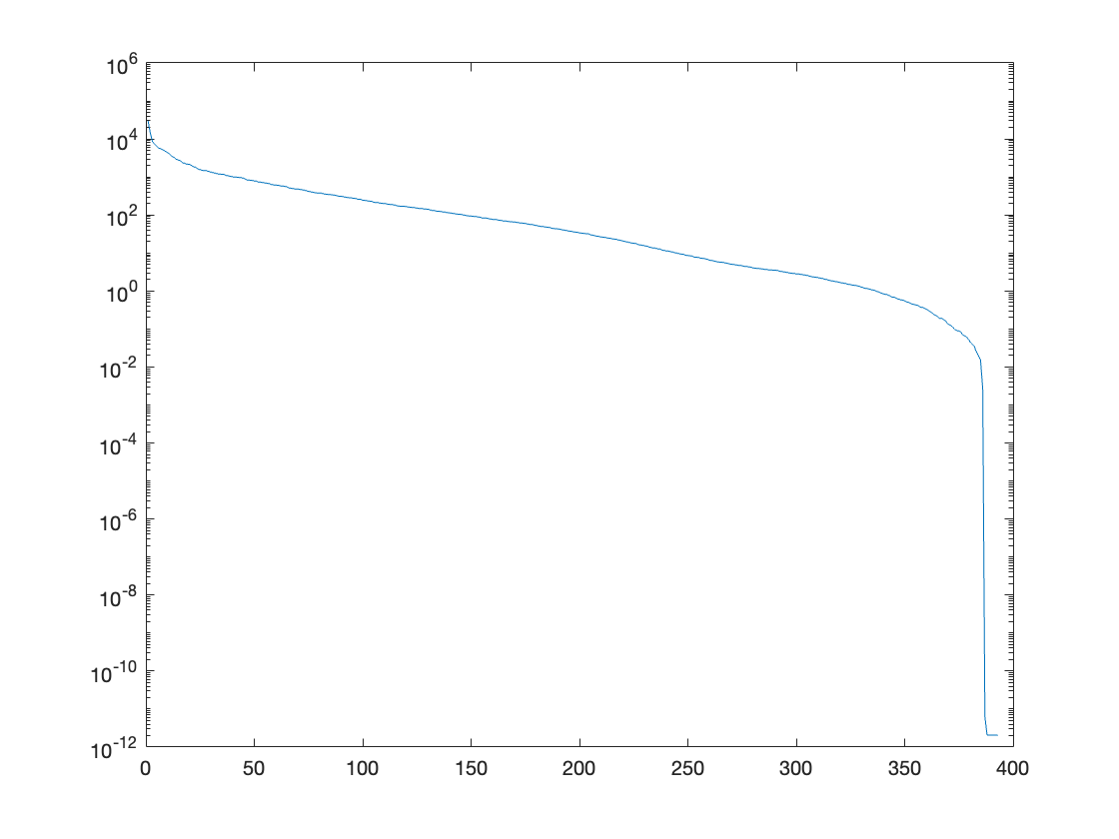

Looks like singular values get close to 0 after around 25. So I predict 25 modes.

4b)

for n_modes = [5, 25, 50, 100]

S_reconst = S;

S_reconst(n_modes+1:end, n_modes+1:end) = 0;

A_reconst = U*S_reconst*V.';

disp(['# of modes: ' num2str(n_modes)])

exp_var = 100.*sum(diag(S(1:n_modes,1:n_modes)).^2)/sum(diag(S(:,:)).^2);

disp(['variance explained: ' num2str(exp_var) '%'])

figure; imagesc(A_reconst); colormap(gray); colorbar

end

# of modes: 5

variance explained: 82.5591%

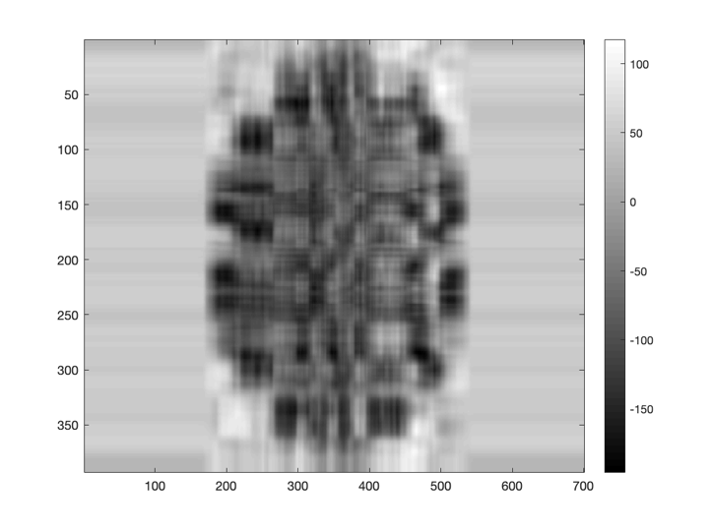

# of modes: 25

variance explained: 97.1502%

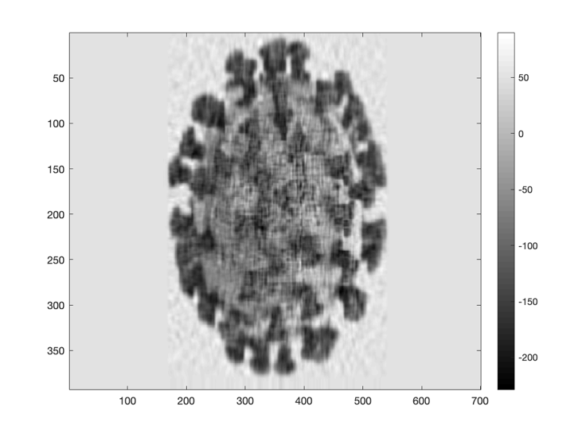

# of modes: 50

variance explained: 99.1807%

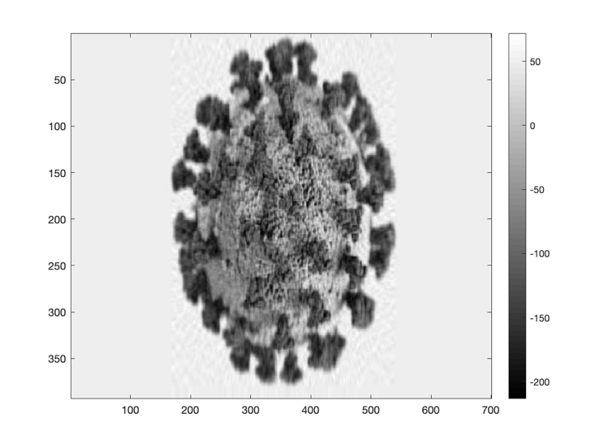

# of modes: 100

variance explained: 99.9035%

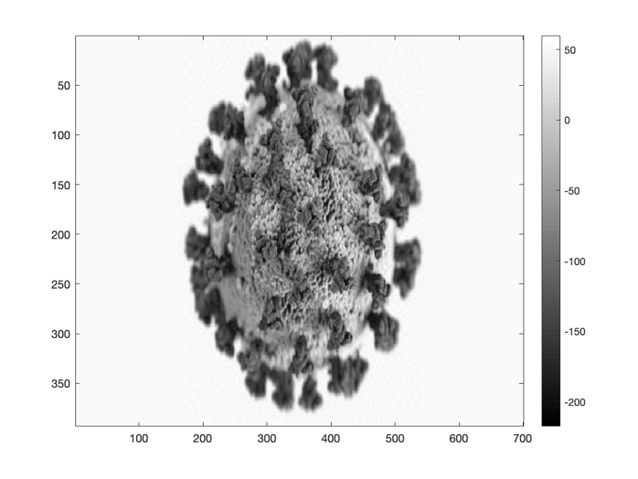

4c) n_modes=25 looks good and its explained variance is pretty close to 100%.

n_modes=25

n_modes = 25

compression_ratio=(n_modes+(n_modes*M)+(n_modes*N))/(M*N);

disp(['storage saved as 1-compression ratio: ' num2str(100- (100*compression_ratio)) '%'])

storage saved as 1-compression ratio: 90.0582%

# 5

5a)

A=[ 1.97, 3.59, -0.177, 0.726;

-4.06, 0.879, -0.513, 3.4;

0.411, 5.16, -0.308, 0.756;

3.34, -2.41, -0.0974, 3.33];

[M, N]=size(A);

disp('From SVD:')

From SVD:

[U,S,V]=svd(A);

svd_norm=S(1,1)

svd_norm = 6.8390

svd_cond=S(1,1)/S(M,M)

svd_cond = 5.1683e+04

disp('From Matlab:')

From Matlab:

norm(A)

ans = 6.8390

cond(A)

ans = 5.1683e+04

Norm and condition from SVD are in fact equal to Matlab's norm() and cond() functions.

5b)

[V,D] = eig(A.'*A)

V = 4×4

-0.0337 0.1127 0.9788 -0.1676

0.0477 -0.0626 0.1768 0.9811

0.9935 -0.0900 0.0342 -0.0602

0.0974 0.9876 -0.0974 0.0759

D = 4×4

0.0000 0 0 0

0 23.7682 0 0

0 0 31.3893 0

0 0 0 46.7723

max eigenvalue is 4th one

x_for_normA=V(:,4)

x_for_normA = 4×1

-0.1676

0.9811

-0.0602

0.0759

5c)

b =[ 0.476; 0.268; 0.741; -0.391];

delta_b=[-0.744; -0.153; 0.626; 0.176];

x=inv(A)*b;

x_error=inv(A)*(b + delta_b)

x_error = 4×1

103 ×

-0.2543

0.3608

7.5063

0.7357

disp('relative solution error:')

relative solution error:

disp(norm(x_error - x)/norm(x))

6.6595e+03

disp('relative error of b:')

relative error of b:

disp(norm(delta_b)/norm(b))

0.9997

5d)

A1=[ 2.98, 0.383, 2.11, -0.942;

0.938, 2.14, 3.81, -1.98;

-0.649, 0.775, 1.16, -0.416;

1.49, 0.118, 3.61, 0.483];

[M, N]=size(A1);

[U,sigma,V]=svd(A1)

U = 4×4

-0.4887 0.5889 0.5416 -0.3479

-0.6816 -0.5802 0.2520 0.3678

-0.1495 -0.4523 -0.1939 -0.8576

-0.5236 0.3347 -0.7782 0.0907

sigma = 4×4

6.7873 0 0 0

0 2.5970 0 0

0 0 1.8682 0

0 0 0 0.0000

V = 4×4

-0.4094 0.7712 0.4372 -0.2155

-0.2687 -0.5110 0.2701 -0.7706

-0.8386 -0.1094 -0.4986 0.1902

0.2386 0.3634 -0.6981 -0.5689

so Vmax is the 1st and Vmin is the 4th

b1=V(:,1)

b1 = 4×1

-0.4094

-0.2687

-0.8386

0.2386

delta_b1=V(:,4)*0.01

delta_b1 = 4×1

-0.0022

-0.0077

0.0019

-0.0057

disp(norm(delta_b1))

0.0100

x1=inv(A1)*b1;

delta_x1=inv(A1)*delta_b1;

disp('max relative solution error:')

max relative solution error:

disp(norm(delta_x1)/norm(x1))

0.0054

# 6

c=10:1:30;

n=1;

for N=10:1:30

dx=(1/N);

gamma=2;

A=zeros([N,N]);

for i=1:1:N

A(i, i)=(-2/(dx^2))-gamma;

if i==1

A(i, N)=1/(dx^2);

else

A(i, i-1)=1/(dx^2);

end

if i==N

A(i, 1)=1/(dx^2);

else

A(i, i+1)=1/(dx^2);

end

end

c(n)=norm(inv(A))*norm(A);

disp(['condition number for N=' num2str(N) ': ' num2str(c(n))])

n=n+1;

end

condition number for N=10: 201

condition number for N=11: 238.0986

condition number for N=12: 289

condition number for N=13: 334.0892

condition number for N=14: 393

condition number for N=15: 446.0832

condition number for N=16: 513

condition number for N=17: 574.0792

condition number for N=18: 649

condition number for N=19: 718.0764

condition number for N=20: 801

condition number for N=21: 878.0744

condition number for N=22: 969

condition number for N=23: 1054.0729

condition number for N=24: 1153

condition number for N=25: 1246.0717

condition number for N=26: 1353

condition number for N=27: 1454.0708

condition number for N=28: 1569

condition number for N=29: 1678.07

condition number for N=30: 1801

plot(10:1:30, c)

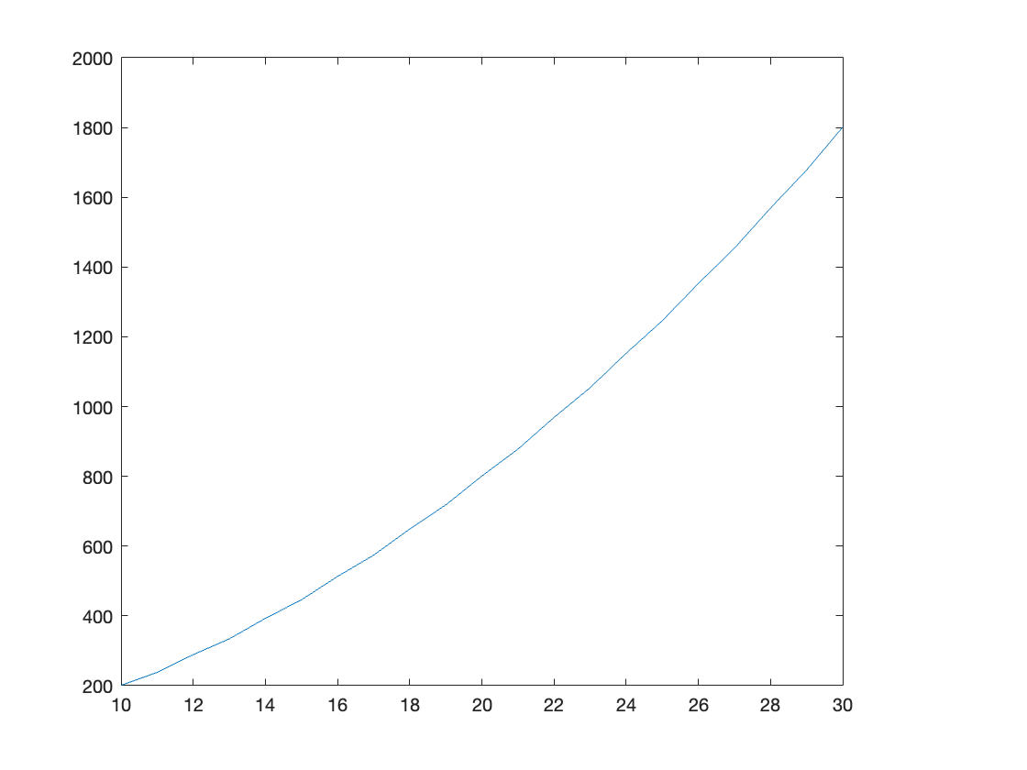

But from OH, TF said to insert gamma within the parentheses:

c=10:1:30;

n=1;

for N=10:1:30

dx=(1/N);

gamma=2;

A=zeros([N,N]);

for i=1:1:N

A(i, i)=((-2-gamma)/(dx^2));

if i==1

A(i, N)=1/(dx^2);

else

A(i, i-1)=1/(dx^2);

end

if i==N

A(i, 1)=1/(dx^2);

else

A(i, i+1)=1/(dx^2);

end

end

c(n)=norm(inv(A))*norm(A);

disp(['condition number for N=' num2str(N) ': ' num2str(c(n))])

n=n+1;

end

condition number for N=10: 3

condition number for N=11: 2.9595

condition number for N=12: 3

condition number for N=13: 2.9709

condition number for N=14: 3

condition number for N=15: 2.9781

condition number for N=16: 3

condition number for N=17: 2.983

condition number for N=18: 3

condition number for N=19: 2.9864

condition number for N=20: 3

condition number for N=21: 2.9888

condition number for N=22: 3

condition number for N=23: 2.9907

condition number for N=24: 3

condition number for N=25: 2.9921

condition number for N=26: 3

condition number for N=27: 2.9932

condition number for N=28: 3

condition number for N=29: 2.9941

condition number for N=30: 3

plot(10:1:30, c)

