Homework #09

# 1

clear all

X=[-3.6, 1.8, -7.2, -9.6, 0.5, -0.9, -2.1, -2.8, -3.2, -2.2, 1.3, -3.6, -6.3, -0.9, -2.4, 5.2;

7.8, -7.5, -0.6, 4.5, 0.9, 0, -7, -6.8, -6.4, -9.3, -5.9, -2.5, -7.9, -6.1, 8.6, 5.4];

y=[ 1, -1, 1, 1, -1, -1, -1, -1, -1, -1, -1, -1, -1, -1, 1, 1];

1a)

[dim, N]=size(X);

% plot training data:

sym(1:N)='o';

sym(y<0)='x';

col(1:N)='r';

col(y<0)='b';

figure;clf;hold on

for i=1:1:N

plot(X(1,i),X(2,i),[col(i) sym(i)],'markersize',14,'linewidth',2);

if N<=30; text(X(1,i)+0.05,X(2,i),num2str(i)); end

end

xlim([-10 10]);ylim([-10 10]);

axis square; hold off

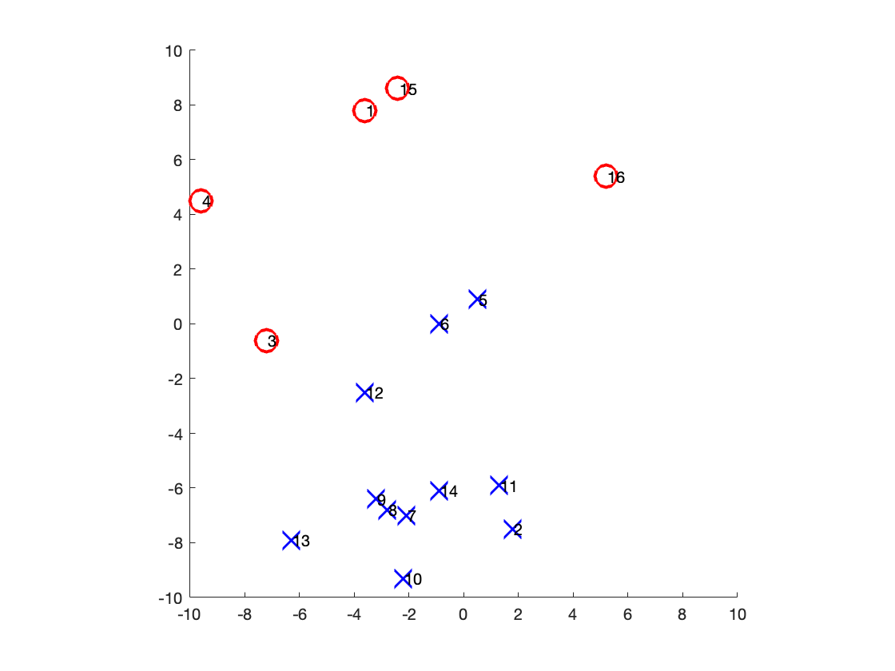

1b)

try slightly below line between 16 and 3:

figure;clf;hold on

for i=1:1:N

plot(X(1,i),X(2,i),[col(i) sym(i)],'markersize',14,'linewidth',2);

if N<=30; text(X(1,i)+0.05,X(2,i),num2str(i)); end

end

xlim([-10 10]);ylim([-10 10]);

axis square;

plot([X(1,16) X(1,3)], [X(2,16)-1 X(2,3)-1], 'g')

hold off

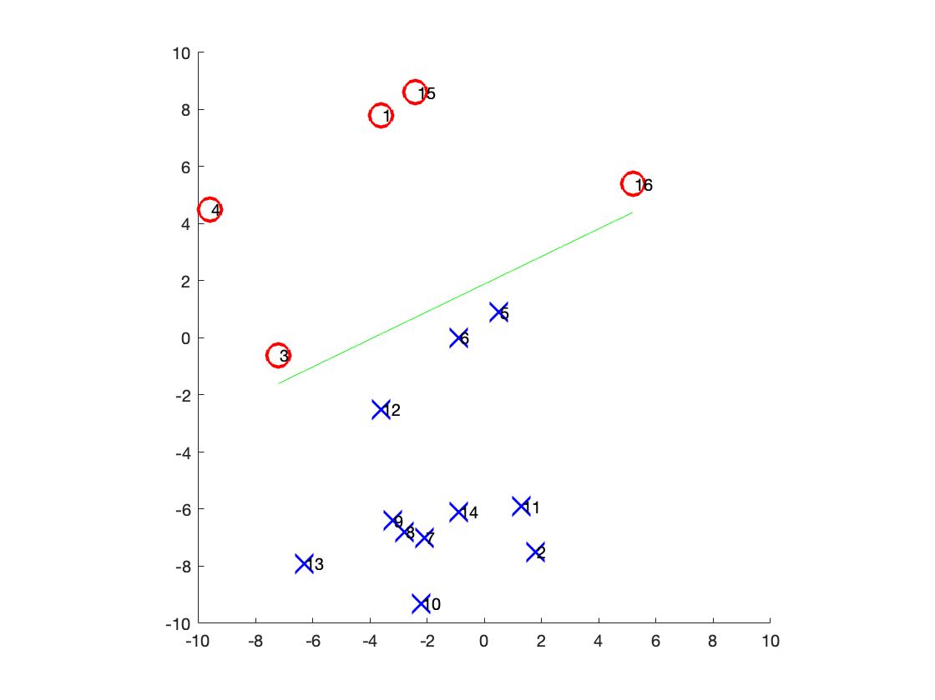

line_fit = polyfit([X(1,16); X(1,3)], [X(2,16)-1; X(2,3)-1], 1)

line_fit = 1×2

0.4839 1.8839

w=[-1*line_fit(1); 1; line_fit(2)]

w = 3×1

-0.4839

1.0000

1.8839

try another one even more slightly below that one:

figure;clf;hold on

for i=1:1:N

plot(X(1,i),X(2,i),[col(i) sym(i)],'markersize',14,'linewidth',2);

if N<=30; text(X(1,i)+0.05,X(2,i),num2str(i)); end

end

xlim([-10 10]);ylim([-10 10]);

axis square;

plot([X(1,16) X(1,3)], [X(2,16)-1.5 X(2,3)-1.5], 'g')

hold off

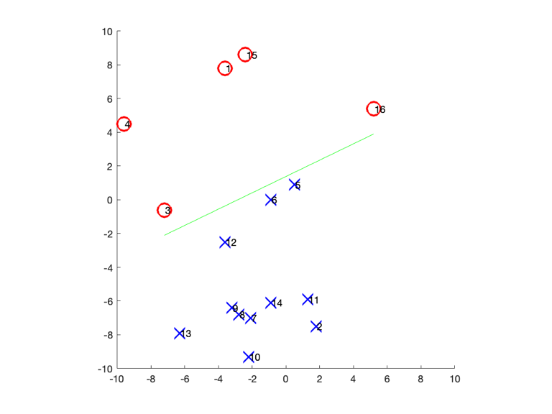

line_fit = polyfit([X(1,16); X(1,3)], [X(2,16)-1.5; X(2,3)-1.5], 1)

line_fit = 1×2

0.4839 1.3839

w=[-1*line_fit(1); 1; line_fit(2)]

w = 3×1

-0.4839

1.0000

1.3839

It looks like you can put a lot of lines between the two groups because they are distinct enough. So there are an infinite number of perceptron lines that will successfully divide these groups.

1c)

small_X = X(:,[6,10,16])

small_X = 2×3

-0.9000 -2.2000 5.2000

0 -9.3000 5.4000

small_y = y([6,10,16])

small_y = 1×3

-1 -1 1

[pic of hand calc]

1d) Adapted from "perceptron_classification_example.m"

Parameters:

eta = 0.1; % learning rate

num_epochs = 4; % number of training loop iterations

Initialize:

% initialize w

w=ones(dim+1,1);

theta=0;

% initialize for plotting purposes:

hl_previous.MarkerSize=0;

harrow_previous=0;

% initial plot line

figure;clf;hold on; title('initial plot and line:')

for i=1:1:N

plot(X(1,i),X(2,i),[col(i) sym(i)],'markersize',14,'linewidth',2);

if N<=30; text(X(1,i)+0.05,X(2,i),num2str(i)); end

end

xlim([-10 10]);ylim([-10 10]);

axis square

% two x values to use only for plotting perceptron line, no need to change:

line_lim=[-10,10];

% plot initial separation line from w:

hl=plot(line_lim,(-line_lim*w(1)+theta)/w(2),'-');

hold off

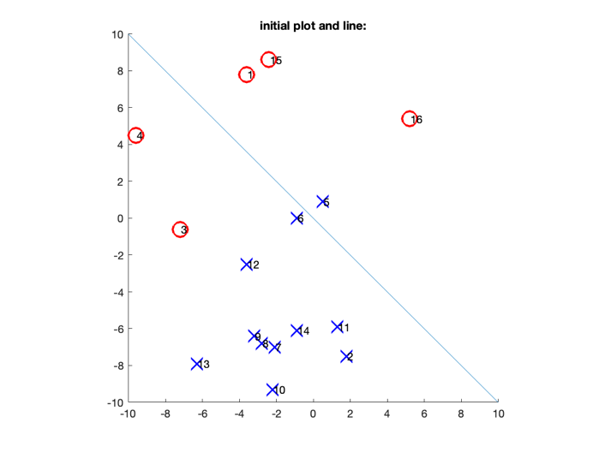

Training loop:

for epoch=1:1:num_epochs

for i=1:1:N

% label the current datapoint

yp=w'*[X(:,i);-1];

if sign(yp) ~= sign(y(i)) || sign(yp)==0

% adjustment step:

w_old=w;

theta_old=theta;

w=w+eta*y(i)*[X(:,i);-1];

% normalize to order 1. is this a good idea? sure

w=w/norm(w);

theta=w(dim+1);

fprintf(1,' testing data X(:,%d)=[%4.2f,%4.2f]; y''=%g; sign(y'')=%d, sign(y(i))=%d\n' ...

,i,X(:,i),yp,sign(yp),sign(y(i)))

fprintf(1,'adjusted from w=[%4.2g,%4.2g]; theta=%4.2f; to w=[%4.2g,%4.2g]; theta=%4.2g\n' ...

,w_old(1:dim),theta_old,w(1:dim),theta);

% replot data for this iteration bc adjusted:

figure;clf;hold on; title(['adjusted on iteration: ' num2str(epoch)])

for j=1:1:N

plot(X(1,j),X(2,j),[col(j) sym(j)],'markersize',14,'linewidth',2);

if N<=30; text(X(1,j)+0.05,X(2,j),num2str(j)); end

end

xlim([-10 10]);ylim([-10 10]);

axis square

% draw currently considered data point in green:

h_red_symbol=plot(X(1,i),X(2,i),['g' sym(i)],'markersize',14,'linewidth',2);

% plot current preceptron-derived separation line

if w(2) ~= 0

hl=plot(line_lim,(theta-line_lim*w(1))/w(2),'g-');

elseif w(1) ~= 0

hl=plot((theta-line_lim*w(2))/w(1),line_lim,'g-');

end

hold off

end

end

end

testing data X(:,3)=[-7.20,-0.60]; y'=-8.8; sign(y')=-1, sign(y(i))=1

adjusted from w=[ 1, 1]; theta=0.00; to w=[0.21,0.71]; theta=0.68

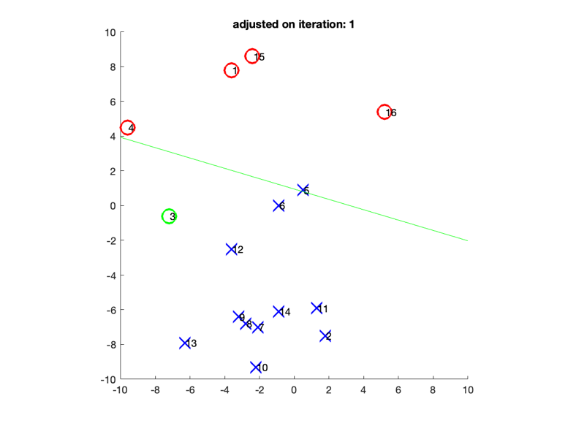

testing data X(:,5)=[0.50,0.90]; y'=0.0646051; sign(y')=1, sign(y(i))=-1

adjusted from w=[0.21,0.71]; theta=0.68; to w=[0.16,0.61]; theta=0.77

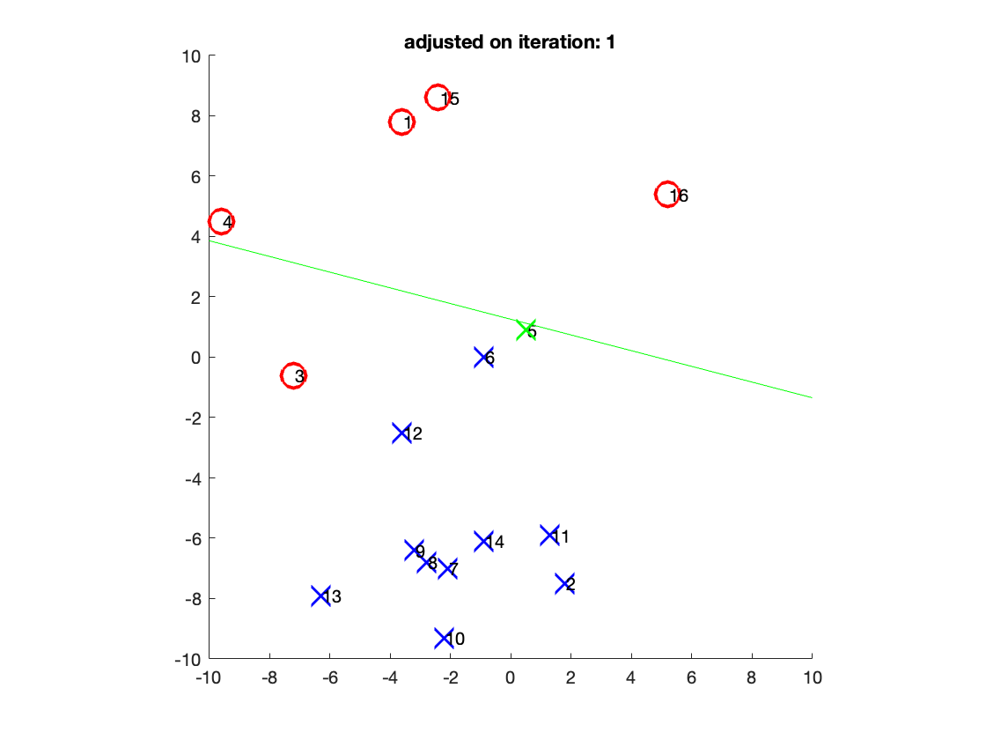

testing data X(:,3)=[-7.20,-0.60]; y'=-2.29147; sign(y')=-1, sign(y(i))=1

adjusted from w=[0.16,0.61]; theta=0.77; to w=[-0.54,0.53]; theta=0.65

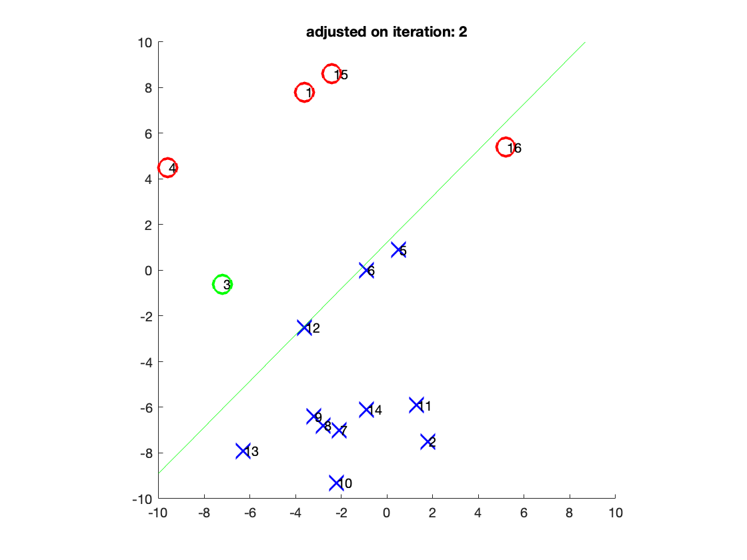

testing data X(:,16)=[5.20,5.40]; y'=-0.575219; sign(y')=-1, sign(y(i))=1

adjusted from w=[-0.54,0.53]; theta=0.65; to w=[-0.017,0.89]; theta=0.46

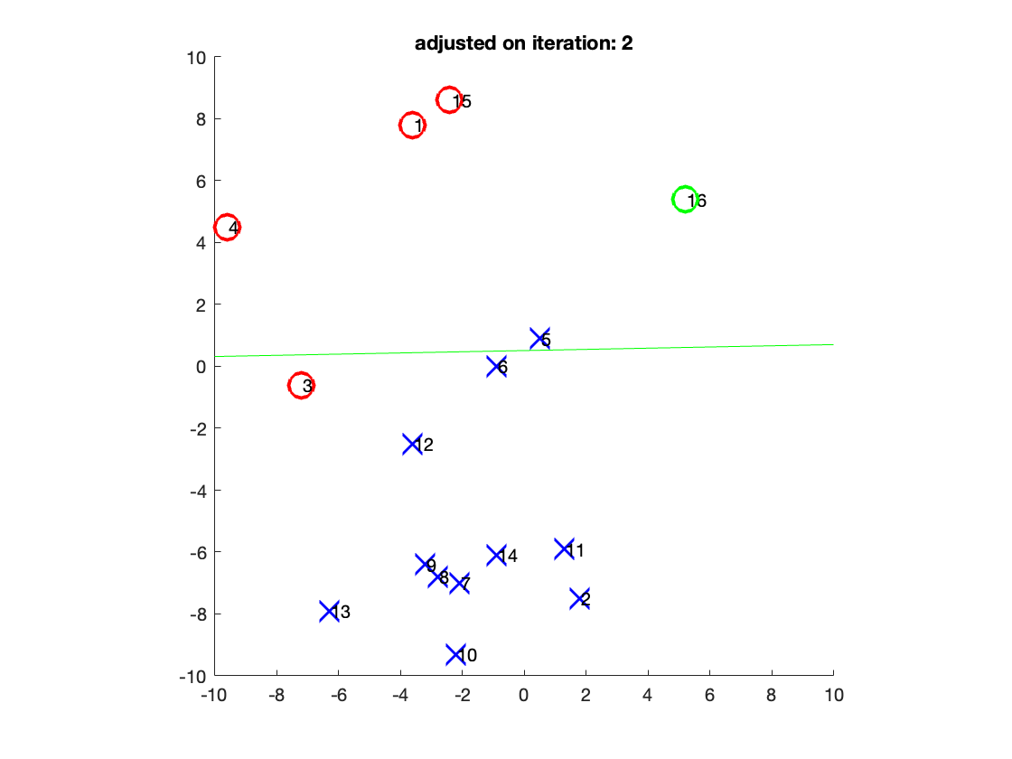

testing data X(:,3)=[-7.20,-0.60]; y'=-0.865972; sign(y')=-1, sign(y(i))=1

adjusted from w=[-0.017,0.89]; theta=0.46; to w=[-0.63,0.71]; theta= 0.3

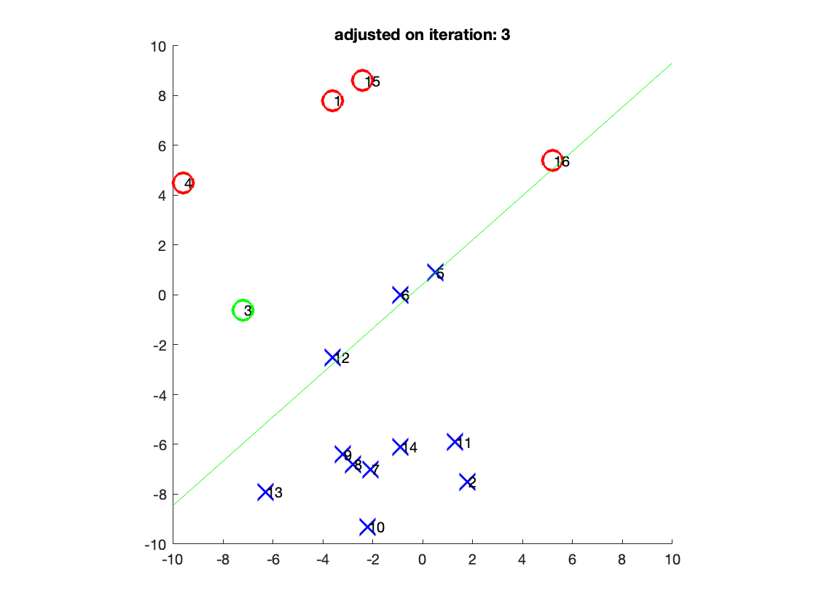

testing data X(:,5)=[0.50,0.90]; y'=0.0199161; sign(y')=1, sign(y(i))=-1

adjusted from w=[-0.63,0.71]; theta=0.30; to w=[-0.68,0.62]; theta= 0.4

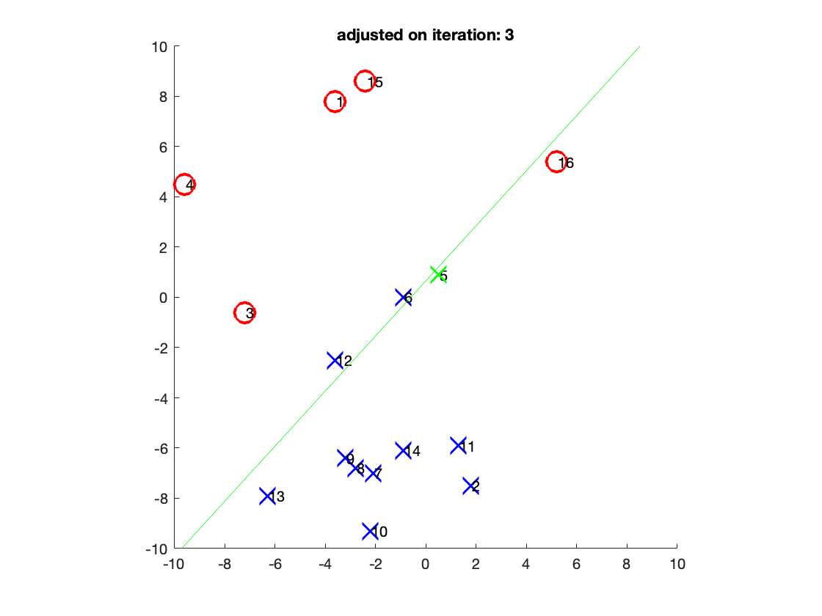

testing data X(:,6)=[-0.90,0.00]; y'=0.207581; sign(y')=1, sign(y(i))=-1

adjusted from w=[-0.68,0.62]; theta=0.40; to w=[-0.59,0.62]; theta=0.51

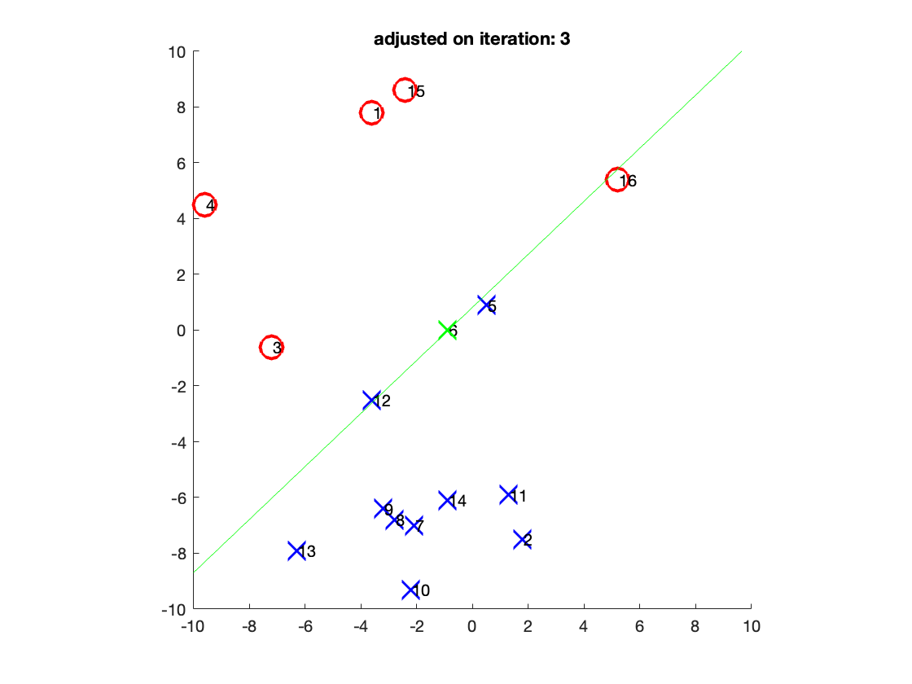

testing data X(:,12)=[-3.60,-2.50]; y'=0.0690554; sign(y')=1, sign(y(i))=-1

adjusted from w=[-0.59,0.62]; theta=0.51; to w=[-0.21, 0.8]; theta=0.56

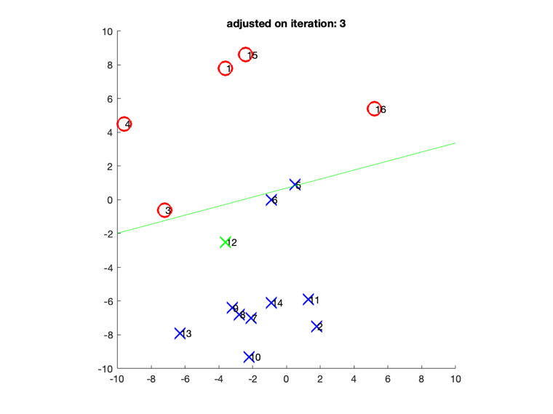

testing data X(:,5)=[0.50,0.90]; y'=0.0574158; sign(y')=1, sign(y(i))=-1

adjusted from w=[-0.21, 0.8]; theta=0.56; to w=[-0.26,0.71]; theta=0.65

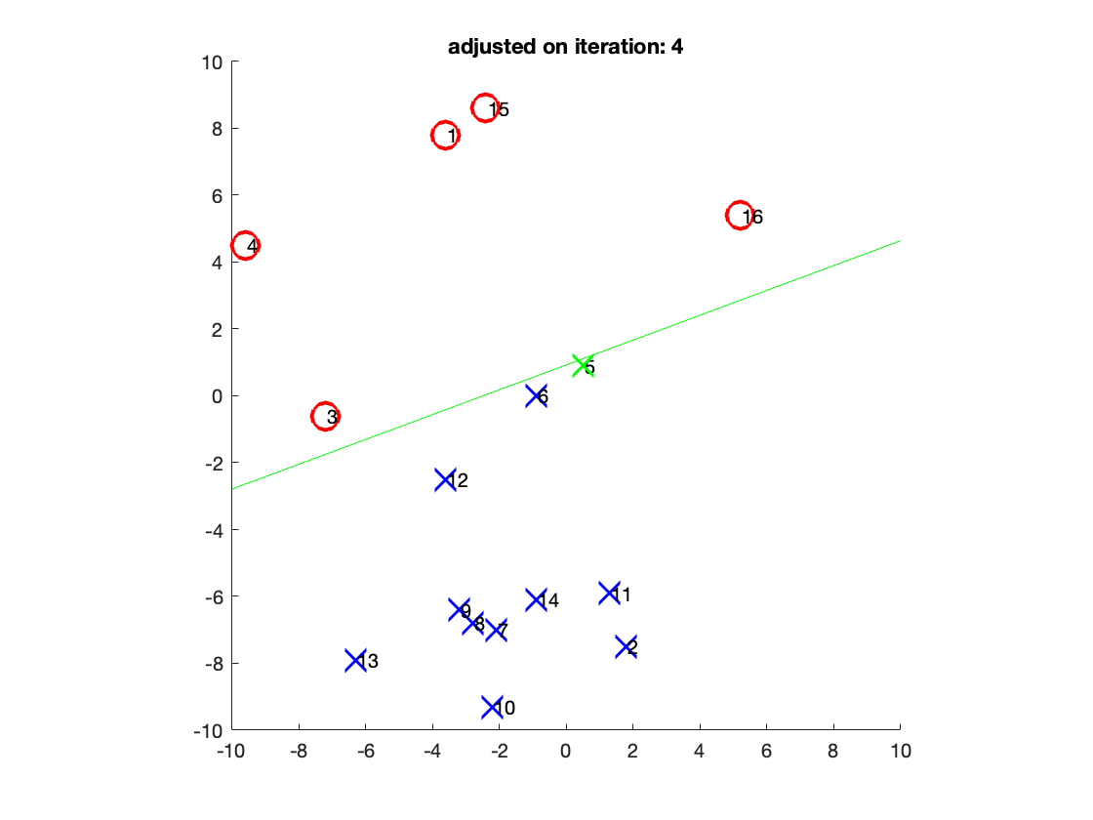

Show final w:

w

w = 3×1

-0.2633

0.7089

0.6543

# 2

clear all

load nonlin-percept-HW.mat

% (data, labels) XX; y and initial guess for w

u=XX(1,:);v=XX(2,:);

Adapted from "perceptron_nonlinear_classification_example.m"

Parameters:

% number of data points

[dim,N]=size(XX);

% number of epochs (passes over all data points)

Nepochs=20;

% base rate of adjustment of perceptron coefficients:

eta=0.01;

% nonlinear equation

eqn_X = [u; v; u.^2; u.*v; ones([1 N])];

Initial plot:

**Note: auxiliary field contour plotting function at the bottom of hw**

% x,y values to use only for plotting perceptron lines, no need to change:

xx=[-1:0.02:1]; yy=[-1:0.02:1];

Nx=length(xx); Ny=length(yy);

% plot training data:

sym(1:N)='o';

sym(y<0)='x';

figure;clf; hold on

for i=1:1:N

plot(XX(1,i),XX(2,i),['b' sym(i)],'markersize',14,'linewidth',2);

if N<=30; text(XX(1,i)+0.05,XX(2,i),num2str(i)); end

end

xlim([-1 1]);ylim([-1 1]);

axis square

% plot initial separation line as the zero contour level:

field=calc_perceptron_contour(w,xx,yy,Nx,Ny);

[hl,hc]=contour(xx,yy,field',[0,1000],'linewidth',2,'color','k');

xlabel('X_1');

ylabel('X_2');

epoch=0;

title(sprintf('Initial perceptron: o=+1; x=-1; epoch=%d',epoch));

hold off

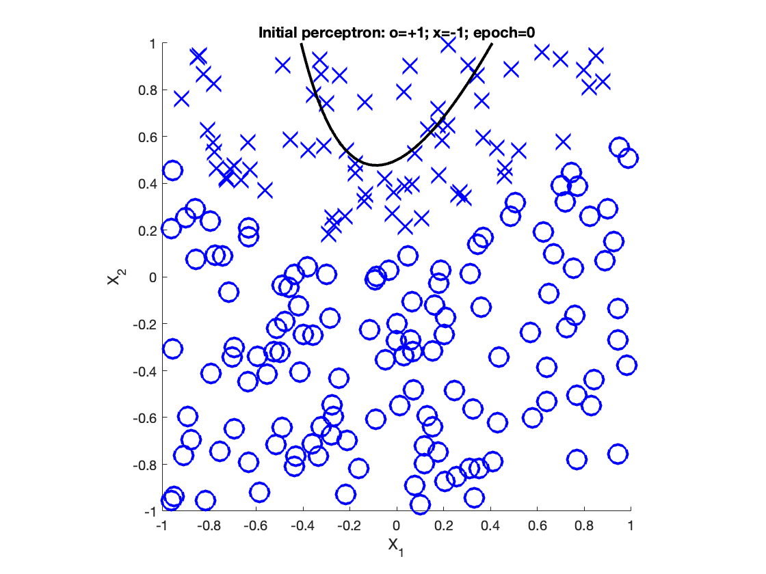

Training/learning loop:

for epoch=1:1:Nepochs

for i=1:1:N

% label the current data point:

yp=w'*eqn_X(:,i);

if sign(yp) ~= sign(y(i)) || sign(yp)==0

% adjustment step:

w_old=w;

w=w+(eta*y(i)*eqn_X(:,i));

% normalize to order 1. is this a good idea? sure

w=w/norm(w);

end

end

% re-plot after every 5 epochs:

if ~mod(epoch,5)

figure; hold on

for j=1:1:N

plot(XX(1,j),XX(2,j),['b' sym(j)],'markersize',14,'linewidth',2);

end

xlim([-1 1]);ylim([-1 1]);

axis square

xlabel('X_1');

ylabel('X_2');

title(['epoch: ' num2str(epoch)]);

% plot new separation line:

field=calc_perceptron_contour(w,xx,yy,Nx,Ny);

[hl,hc]=contour(xx,yy,field',[0,1000],'linewidth',2,'color','k');

hold off

end

end

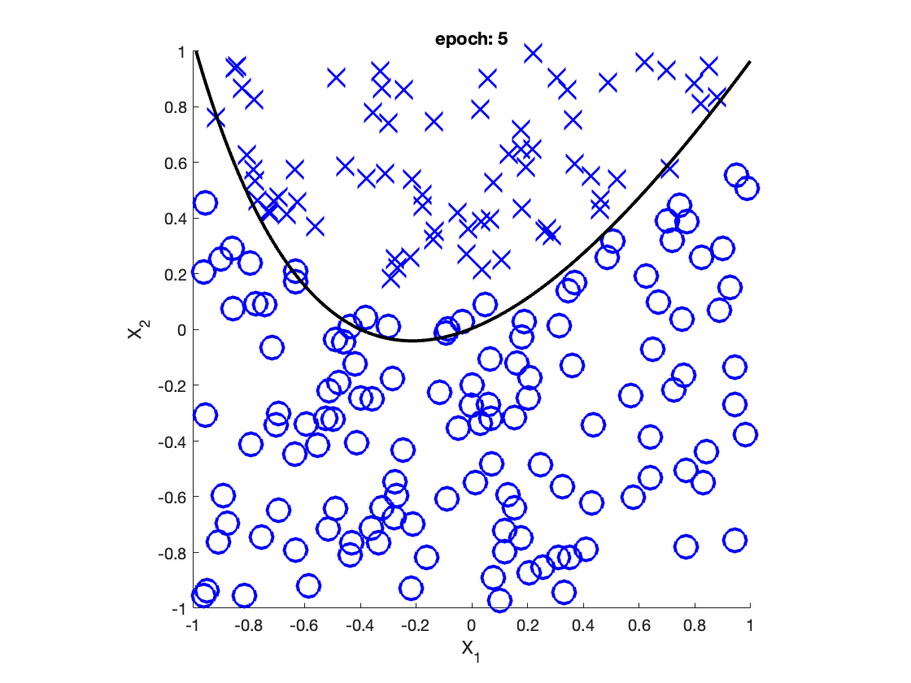

Show final w:

w

w = 5×1

0.2431

-0.7088

0.5923

-0.2914

0.0530

# 3

clear all

w2=[-0.31314, 0.38796;

-0.60718, 0.67412;

2.8908, -1.5217];

b2=[ 0.81989;

0.81574;

3.674];

w3=[ -1.007, -1.7446, 5.1881;

16.877, -7.3917, -4.1027;

50.772, -21.437, -38.171];

b3=[-15.236;

-1.8673;

20.628];

w4=[ 1.812, 44.299, -35.869];

b4=[ 5.2558];

Some activation functions:

sigmoid = @(x) 1.0./(1.0+exp(-x));

linear = @(x) x;

Input space:

x1=1:0.1:2;

x2=1:0.1:2;

3a)

3b)

3c)

Look at sizes needed for input and output layers:

disp('input:')

size(w2)

disp('output:')

size(w4)

So looks like inputs to be column vectors, output will be 1 dim

inputs:

disp('10 inputs:')

X=[1:0.1:1.9;...

1:0.01:1.09]

Neural network:

a2 = sigmoid(w2*X + b2);

a3 = sigmoid(w3*a2 + b3);

a4 = linear(w4*a3 + b4);

disp('10 outputs:')

outputs = a4

**Deduce which simple function of the inputs x1; x2 the network returns.**

Look at 3D surface plot of neural network output:

x1=1:0.1:2;

x2=1:0.1:2;

[X1, X2]=meshgrid(x1, x2);

a2 = sigmoid(w2*[X1(:).'; X2(:).'] + b2);

a3 = sigmoid(w3*a2 + b3);

a4 = linear(w4*a3 + b4);

A = a4;

figure; hold on

surf(X1, X2, reshape(A, size(X1)) )

view(-30,10)

hold off

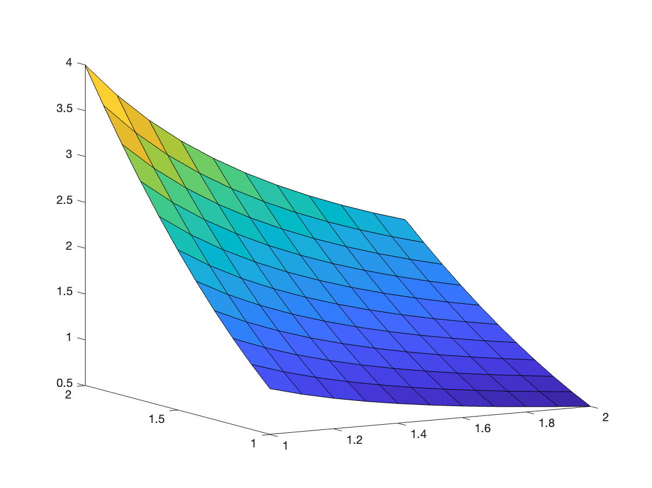

From hovering mouse over various points, it looks like points change 1) directly proportional to 1/x_1 as we keep x_2 constant and 2) x_2^2 when x_1 is constant. So looks like it's approximating: 

**Don't you think it's amazing that this actually works? :-)** Yeah

**Does it also work for the input [-0.5;3.5]?**

test_x = [-0.5;3.5]

a2 = sigmoid(w2*test_x + b2);

a3 = sigmoid(w3*a2 + b3);

a4 = linear(w4*a3 + b4);

nn_output = a4

nn_output = 13.5935

actual_output = test_x(2,1).^2 ./ test_x(1,1)

actual_output = -24.5000

No

**Can you guess why?** Maybe neural network hasn't been trained to distinguish/can not generalize past this asymptote because this is pretty different and hard to predict from just looking at a tiny, non-asymptotic and fairly smooth section of the general function.

Check by extending my output surface plot past x_1=0:

x1=-1:0.1:2;

x2=1:0.1:2;

[X1, X2]=meshgrid(x1, x2);

a2 = sigmoid(w2*[X1(:).'; X2(:).'] + b2);

a3 = sigmoid(w3*a2 + b3);

a4 = linear(w4*a3 + b4);

A = a4;

figure; hold on

surf(X1, X2, reshape(A, size(X1)) )

view([1 60])

hold off

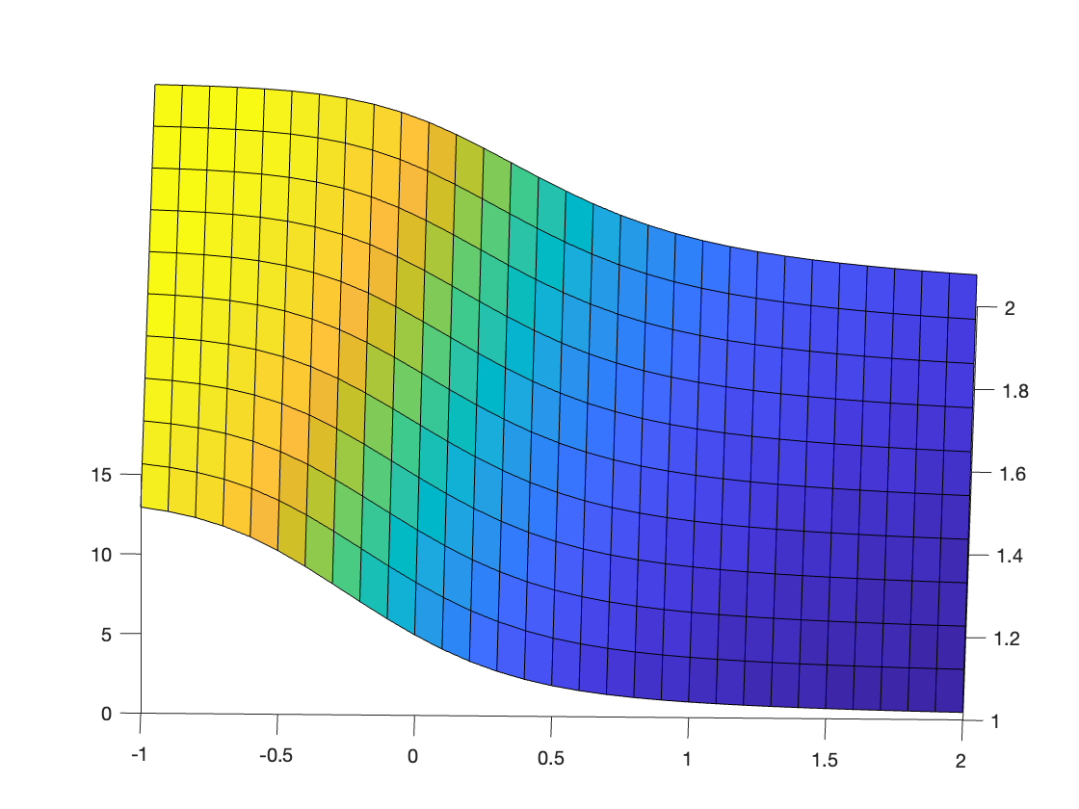

NN is smooth all the way through x_1=0.

Auxillary functions:

function field=calc_perceptron_contour(w,xx,yy,Nx,Ny)

for i=1:Nx; for j=1:Ny

field(i,j)=w(1)*xx(i)+w(2)*yy(j)+w(3)*xx(i)^2+w(4)*xx(i)*yy(j)+w(5);

end; end

end