Homework #10

# 1

Training datapoint:

X=[-1; 2]; y=2;

Initial weights:

w2=[ -0.2, -0.4;

0.4, -0.4;

0.1, 0.1];

b2=[ -0.5;

0.2;

0.1];

w3=[ 0.1, 0.1, 0.1];

b3=[ -0.1];

All nodes are sigmoid. Sigmoid activation function:

sigmoid = @(zl) 1.0 ./ (1.0+exp(-zl));

Cost function:

cost = @(y, al) 0.5* ((y-al).^2);

1a)

z2 = w2*X + b2

z2 = 3×1

-1.1000

-1.0000

0.2000

a2 = sigmoid(z2)

a2 = 3×1

0.2497

0.2689

0.5498

z3 = w3*a2 + b3

z3 = 0.0069

a3 = sigmoid(z3)

a3 = 0.5017

datapoint_cost = cost(y, a3)

datapoint_cost = 1.1224

1b)

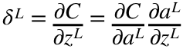

And 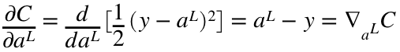

And 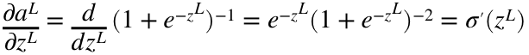

So 

From the last layer's delta, we can find all other subsequent earlier layer delta using:



And then for any layer, we can calculate its gradient and how much to adjust its weights based on its delta using:



1c)

1d)

sigma_prime function:

sigma_prime = @(zl) exp(-zl)./ ((1+exp(-zl)).^2);

delta L calculation function:

calc_delta = @(y, al, zl) (al-y)*sigma_prime(zl);

Calculate gradient with respect to all weights

delta3 = calc_delta(y, a3, z3);

gradient_w3 = delta3*a2.'

gradient_w3 = 1×3

-0.0935 -0.1007 -0.2059

gradient_b3 = delta3

gradient_b3 = -0.3746

delta2 = (w3.' * delta3) .* sigma_prime(z2);

gradient_w2 = delta2*X.'

gradient_w2 = 3×2

0.0070 -0.0140

0.0074 -0.0147

0.0093 -0.0185

gradient_b2 = delta2

gradient_b2 = 3×1

-0.0070

-0.0074

-0.0093

1e) Direct perturbation approach for w2_12

epsilon = 0.002;

epsilon_w2 = w2;

epsilon_w2(1,2) = epsilon_w2(1,2) + epsilon;

epsilon_z2 = epsilon_w2*X + b2;

epsilon_a2 = sigmoid(epsilon_z2);

epsilon_z3 = w3*epsilon_a2 + b3;

epsilon_a3 = sigmoid(epsilon_z3);

epsilon_datapoint_cost = cost(y, epsilon_a3);

disp('direct perturbation approach:')

direct perturbation approach:

epsilon_delta = (epsilon_datapoint_cost - datapoint_cost) ./epsilon

epsilon_delta = -0.0141

which is pretty similar to our gradient calculated value:

disp('gradient calculation approach:')

gradient calculation approach:

disp(gradient_w2(1,2))

-0.0140

1f)

eta = 1;

1 iteration of steepest-descent

new_w2 = w2 - (eta.*gradient_w2);

new_b2 = b2 - (eta.*gradient_b2);

new_w3 = w3 - (eta.*gradient_w3);

new_b3 = b3 - (eta.*gradient_b3);

new_z2 = new_w2*X + new_b2;

new_a2 = sigmoid(new_z2);

new_z3 = new_w3*new_a2 + new_b3;

new_a3 = sigmoid(new_z3)

new_a3 = 0.6347

disp('new datapoint cost:')

new datapoint cost:

new_datapoint_cost = cost(y, new_a3)

new_datapoint_cost = 0.9320

disp('old datapoint cost:')

old datapoint cost:

datapoint_cost

datapoint_cost = 1.1224

Yes.

We moved the weights in the direction opposite of the max gradient of the cost, so now the output will in fact have a lower cost.

# 2

close('all')

X=[3,6,1,0,5,5,4,4,3,4,6,3,2,5,4,8,6,8, 9,8,3,6, 1,4,7,2,9,1,4,2,9,1,5;

9,1,5,7,5,5,2,2,2,0,2,4,1,2,9,8,8,10,1,3,4,6,10,7,2,7,4,9,4,6,8,9,4];

y=[2,3,1,1,3,3,3,3,1,3,3,1,1,3,2,2,2, 2,3,3,1,2, 1,2,3,1,2,1,1,1,2,1,3];

Input space:

x1=[0:0.1:10];

x2=[0:0.1:10];

Plot training data:

figure;clf

set(0,'defaulttextfontsize',16); set(0,'defaultaxesfontsize',16);

xlim([-1 11])

ylim([-1 11])

xlabel('x')

ylabel('y')

box on

for i=1:length(y)

text(X(1,i),X(2,i),num2str(y(i)));

end

title('training data for value as func of (x,y)');

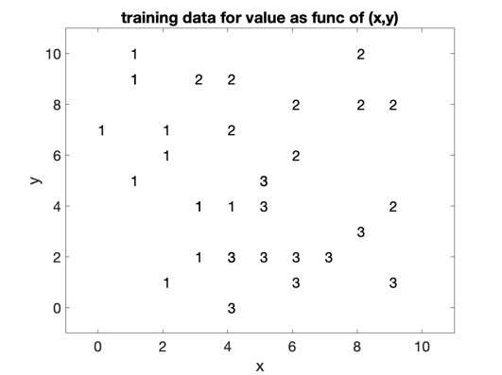

2a) Classification:

adapted from "neural_networks3_simple_2d_classification.m"

% for classification, need to turn labels into matrix format:

T=zeros(max(y),length(y)); for i=1:length(y); T(y(i),i)=1; end

% Create network: specify number of neurons in each layer:

rng(3456);

clear net1

% [e.g., [2 6 2] would create 3 hidden layers with 2,6,2 neurons in each]

net1 = feedforwardnet([3 3]); % 2 hidden layers with 3 neurons each. sure.

disp('net1 = feedforwardnet([3 3]);');

net1 = feedforwardnet([3 3]);

% don't divide data into training, testing, validation.

net1.divideFcn='';

% Train network:

net1 = train(net1,X,T);

disp('net1 = train(net1,X,T);');

net1 = train(net1,X,T);

view(net1);

Contour plot:

[X1, X2]=meshgrid(x1, x2);

Xtest = [X1(:).'; X2(:).'];

ytest=net1(Xtest);

% back into labels 1-3

ytest_labels=zeros(1,length(ytest));

for i=1:1:length(ytest)

[~,label] = max(ytest(:, i));

ytest_labels(1,i)=label;

end

figure; hold on

contourf(x1, x2, reshape(ytest_labels, size(X1)) )

colorbar

hold off

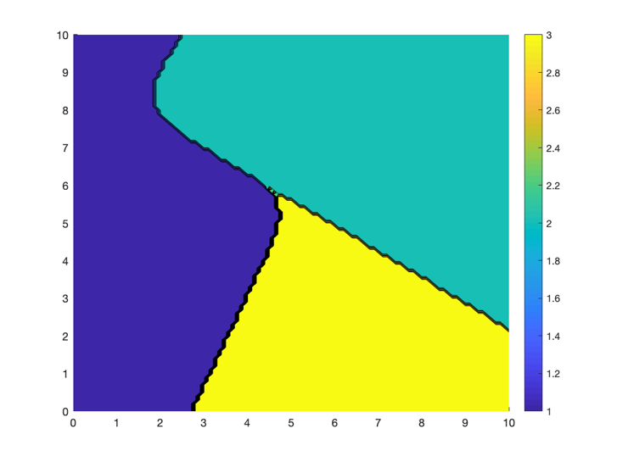

2b) Regression:

% Create network: specify number of neurons in each layer:

rng(3456);

clear net2

From trying increasing number of layers, seems like 7 hidden layers did okay so we'll stick with that

arch = [3 3 3 3 3 3 3];

% [e.g., [2 6 2] would create 3 hidden layers with 2,6,2 neurons in each]

net2 = feedforwardnet(arch); % 2 hidden layers with 5 neurons each. sure.

disp('net2 = feedforwardnet(arch);');

net2 = feedforwardnet(arch);

% don't divide data into training, testing, validation.

net2.divideFcn='';

% Train network:

net2 = train(net2,X,y);

disp('net2 = train(net2,X,y);');

net2 = train(net2,X,y);

view(net2);

Contour plot:

[X1, X2]=meshgrid(x1, x2);

Xtest = [X1(:).'; X2(:).'];

ytest2=net2(Xtest);

figure; hold on

contourf(x1, x2, reshape(ytest2, size(X1)) )

colorbar

hold off

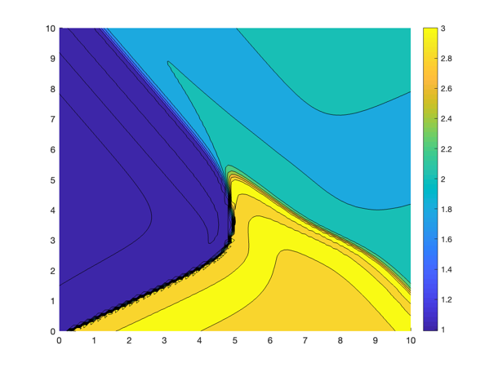

# 3

clear all

load saved-network-HW-10.mat

% w2, b2, w3, b3, w4, b4

Activation functions:

tansig = @(zl) ( 2./(1+exp(-2.*zl)) ) -1;

linear = @(zl) zl;

Input space:

x1=0:0.1:1;

x2=x1;

To make this easier, combine bs into ws and add 1's to input

w2 = horzcat(w2, b2);

w3 = horzcat(w3, b3);

w4 = horzcat(w4, b4);

[X1, X2]=meshgrid(x1, x2);

Xtest = [X1(:).'; X2(:).'];

[~, N] = size(Xtest);

Xtest = vertcat(Xtest, ones([1 N]));

% Running network

z2 = w2*Xtest;

a2 = tansig(z2);

[~, N] = size(a2); a2 = vertcat(a2, ones([1 N]));

z3 = w3*a2;

a3 = tansig(z3);

[~, N] = size(a3); a3 = vertcat(a3, ones([1 N]));

z4 = w4*a3;

a4 = linear(z4);

figure; hold on; title('0:0.1:1')

contourf(x1, x2, reshape(a4, size(X1)) )

colorbar; caxis([-1, 1]);

hold off

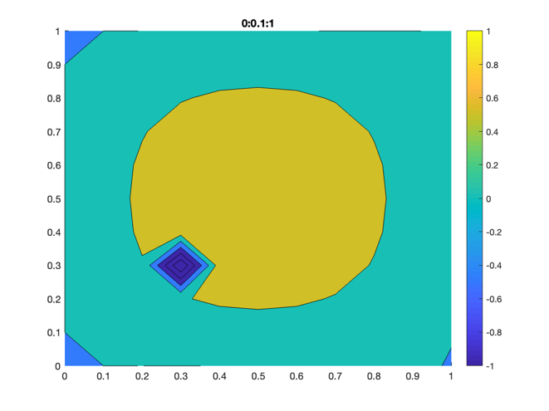

Now with a different input space:

x1=0:0.2:1;

x2=x1;

% add row of 1's instead of dealing with separate b's

[X1, X2]=meshgrid(x1, x2);

Xtest = [X1(:).'; X2(:).'];

[~, N] = size(Xtest);

Xtest = vertcat(Xtest, ones([1 N]));

% Running network

z2 = w2*Xtest;

a2 = tansig(z2);

[~, N] = size(a2); a2 = vertcat(a2, ones([1 N]));

z3 = w3*a2;

a3 = tansig(z3);

[~, N] = size(a3); a3 = vertcat(a3, ones([1 N]));

z4 = w4*a3;

a4 = linear(z4);

figure; hold on; title('0:0.2:1')

contourf(x1, x2, reshape(a4, size(X1)) )

colorbar; caxis([-1, 1]);

hold off

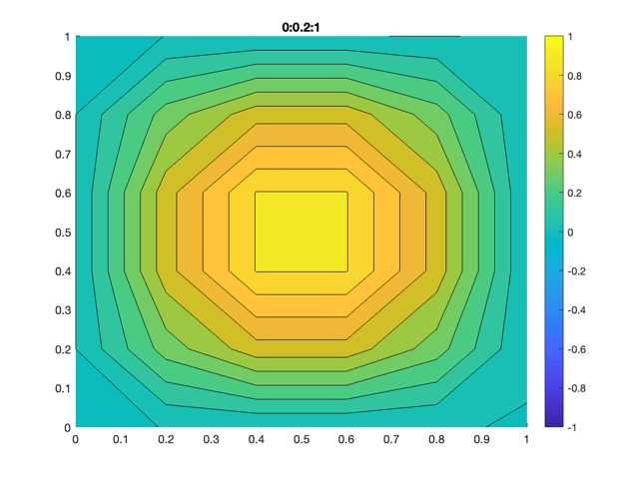

There is a local ~0.1 width spot of lowered output with this network that is missed with just 0.2 input increments. This is likely the result of overfitting due to noise in the training data that has slightly lower values (from noise not true signal) in that region.

The problem may be overcome by training with more training data, more dummy data by adding noise to existing data, possibly using a smaller network, or adding a regularization term to account for rising w and b values in the cost.