Homework #01

# 1

# 

I_s=[1.78504; 0.398297; 0.624653; 0.462755];

mu=1.5;

I_0=8;

% log(x) is ln(x) in matlab

rhs = (-1./mu) .* log(I_s./I_0);

a=[0 0 0 1];

b=[0 1 1 0];

c=[0 1 0 1];

d=[1 1 0 0];

A = [a; b; c; d];

b=rhs;

rho = inv(A)*b

rho = 4×1

1.2000

0.7000

1.3000

1.0000

% the 3rd pixel density is indeed 1.3 :)

# 2

A=[-4, -7, -12.4;...

8, -7, -17.2;...

2, -1, -2.8];

b=[1;-1;0];

2A) Row interpretation: each row is an equation (for a plane)

x=[-0.5,-0.5,0.5,0.5];

y=[0.5,-0.5,-0.5,0.5];

z1 = (b(1,1) - A(1,1).*x - A(1,2).*y)./A(1,3);

z2 = (b(2,1) - A(2,1).*x - A(2,2).*y)./A(2,3);

z3 = (b(3,1) - A(3,1).*x - A(3,2).*y)./A(3,3);

figure

hold on

% plot first plane:

p1=patch(x(:),y(:),z1(:),'red');

set(p1,'facealpha',0.2); set(p1,'edgealpha',0.2)

view(3);

xlabel('x')

ylabel('y')

zlabel('z')

% plot second plane:

p2=patch(x(:),y(:),z2(:),'green');

set(p2,'facealpha',0.2); set(p2,'edgealpha',0.2)

% plot third plane:

p3=patch(x(:),y(:),z3(:),'blue');

set(p3,'facealpha',0.2); set(p3,'edgealpha',0.2)

hold off

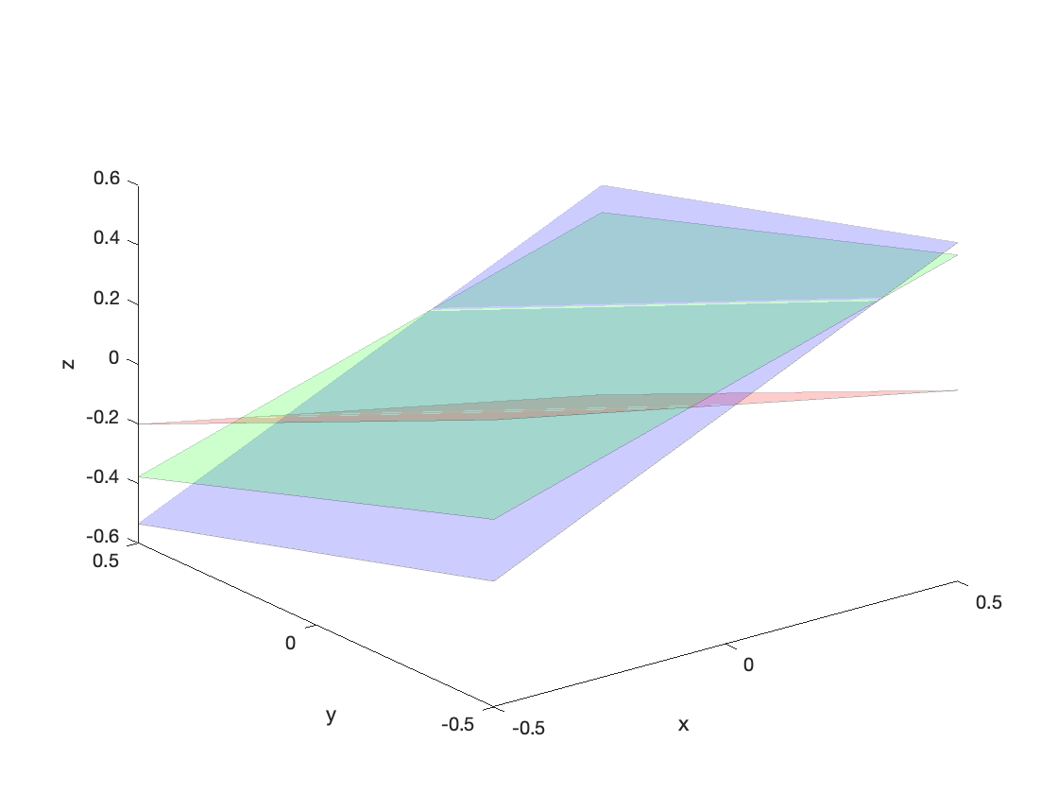

as plotted, there's no point where all three planes intersect at once

2B) Column interpretation: combination of columns as vectors

figure

ax = axes();

xlim(ax, [-20 20]);

ylim(ax, [-20 20]);

zlim(ax, [-20 20]);

view(ax, 3)

hold(ax, 'on')

quiver3(0,0,0, A(1,1),A(2,1),A(3,1), 1, 'Color', 'r','linewidth',5)

quiver3(A(1,1),A(2,1),A(3,1), A(1,2),A(2,2),A(3,2), 1, 'Color', 'r','linewidth',5)

quiver3(A(1,1)+A(1,2),A(2,1)+A(2,2),A(3,1)+A(3,2), A(1,3),A(2,3),A(3,3), 1, 'Color', 'r', 'linewidth',5)

quiver3(0,0,0, b(1,1),b(2,1),b(3,1), 1, 'Color', 'b','linewidth',5)

axis equal

hold off

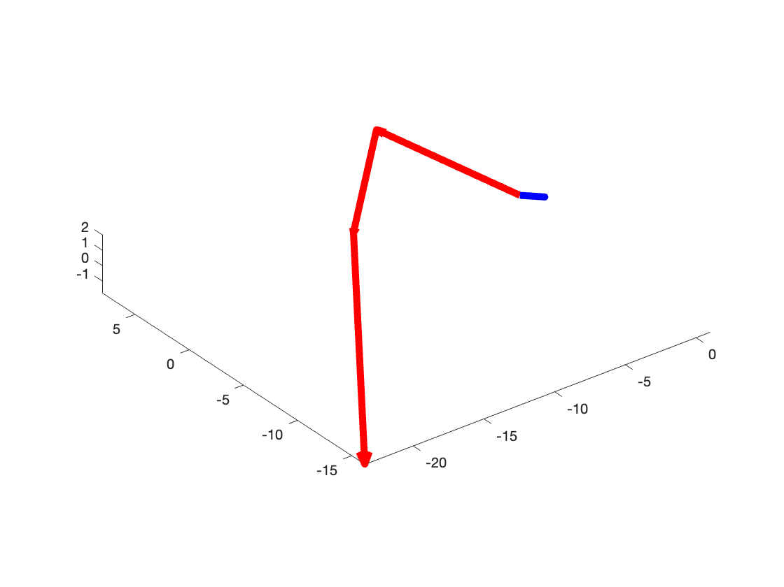

as plotted, no span combination of the A col vectors (in red) would give the b vector (in blue)

# 3

A=[ -2, -1.33333, 0.666667;...

3, -1, 0;...

6, -5, 4];

b=[3;9;6];

3b)

[L,U,P]=lu(A)

L = 3×3

1.0000 0 0

-0.3333 1.0000 0

0.5000 -0.5000 1.0000

U = 3×3

6.0000 -5.0000 4.0000

0 -3.0000 2.0000

0 0 -1.0000

P = 3×3

0 0 1

1 0 0

0 1 0

disp(L*U)

6.0000 -5.0000 4.0000

-2.0000 -1.3333 0.6667

3.0000 -1.0000 0

disp(P*A)

6.0000 -5.0000 4.0000

-2.0000 -1.3333 0.6667

3.0000 -1.0000 0

3c continued)

x=A\b

x = 3×1

0.5555

-7.3334

-8.5000

# 4

% 4a continued

A=[ -9, -5, 1;...

5, -9, -2;...

1, -1, 10];

b=[1;-1;-1];

x_k1=[-0.1396; 0.0444; -0.0816]

x_k1 = 3×1

-0.1396

0.0444

-0.0816

% second set by code

x_ktemp=x_k1;

for i = 1:1:length(b)

x_ktemp=x_ktemp+( 1.*norm(A(i,:)).^-2.*(( b(i,1)-(A(i,:)*x_ktemp) ).*A(i,:)'));

end

x_k2=x_ktemp

x_k2 = 3×1

-0.1466

0.0476

-0.0806

4b)

disp(['Error after 1 set: ' num2str(norm(x_k1 - (inv(A)*b)))])

Error after 1 set: 0.0076993

disp(['Error after 2 sets: ' num2str(norm(x_k2 - (inv(A)*b)))])

Error after 2 sets: 8.6556e-05

4c)

v_1 = A(1,:);

v_2 = A(2,:);

v_3 = A(3,:);

theta1 = rad2deg(atan2(norm(cross(v_1, v_2)), dot(v_1, v_2)))

theta1 = 91.0563

theta2 = rad2deg(atan2(norm(cross(v_1, v_3)), dot(v_1, v_3)))

theta2 = 86.7075

theta3 = rad2deg(atan2(norm(cross(v_2, v_3)), dot(v_2, v_3)))

theta3 = 93.2472

So because all my angles are pretty close to 90 degrees and are therefore close to perpendicular to each other, the Kaczmarz method (which makes lines perpendicular to the planes) will pretty quickly converge to close to the actual intersection.

4d)

x=[-0.2,-0.2,0.2,0.2];

y=[0.2,-0.2,-0.2,0.2];

z1 = (b(1,1) - A(1,1).*x - A(1,2).*y)./A(1,3);

z2 = (b(2,1) - A(2,1).*x - A(2,2).*y)./A(2,3);

z3 = (b(3,1) - A(3,1).*x - A(3,2).*y)./A(3,3);

figure

hold on

% plot first plane:

p1=patch(x(:),y(:),z1(:),'red');

set(p1,'facealpha',0.2); set(p1,'edgealpha',0.2)

view(3);

xlabel('x')

ylabel('y')

zlabel('z')

% plot second plane:

p2=patch(x(:),y(:),z2(:),'green');

set(p2,'facealpha',0.2); set(p2,'edgealpha',0.2)

% plot third plane:

p3=patch(x(:),y(:),z3(:),'blue');

set(p3,'facealpha',0.2); set(p3,'edgealpha',0.2)

x_ktemp = [0;0;0];

for s = 1:1:2 % 2 sets

for i = 1:1:length(b)

jump=( 1.*norm(A(i,:)).^-2.*(( b(i,1)-(A(i,:)*x_ktemp) ).*A(i,:)'));

quiver3(x_ktemp(1,1),x_ktemp(2,1),x_ktemp(3,1), jump(1,1),jump(2,1),jump(3,1), 1, 'linewidth',5)

x_ktemp=x_ktemp + jump;

end

end

hold off

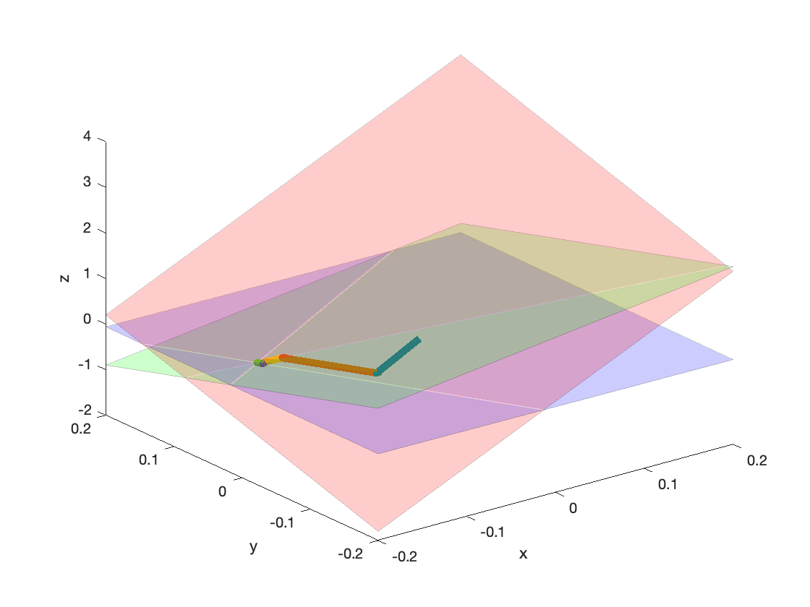

# 5

5a)

i =[30 43 25 13 81 62];

j =[27 84 142 54 9 108];

aij =[0.6 0.9 -0.5 2.8 1.8 -1.8];

A = sparse(i,j,aij,100,200);

disp(['# of nonzero elements: ' num2str(nnz(A))])

# of nonzero elements: 6

5b)

% Matlab

% generate random 2150x2150 matrix A (seeded by 2023)

N=2150; rng(2023); A=rand(N,N);

% make a symmetric matrix across diagonal

% since vals are 0-1, <0.97 leaves only 3% nonzero elements, making a sparse matrix

A=(A'+A)/2; A(abs(A)<0.97)=0;

% shift the mean of nonzero elements to 0; increase range by 1000x

A(A~=0)=(A(A~=0)-mean(A(A~=0)))*1000;

% store A as a sparse matrix and show the count of non-zero elements

Asp=sparse(A); nnz(Asp)

ans = 8596

% select figure 1 and delete all visible children of this figure

figure(1); clf;

% visualize non-zero elements of A

plot(Asp(Asp~=0),'.')

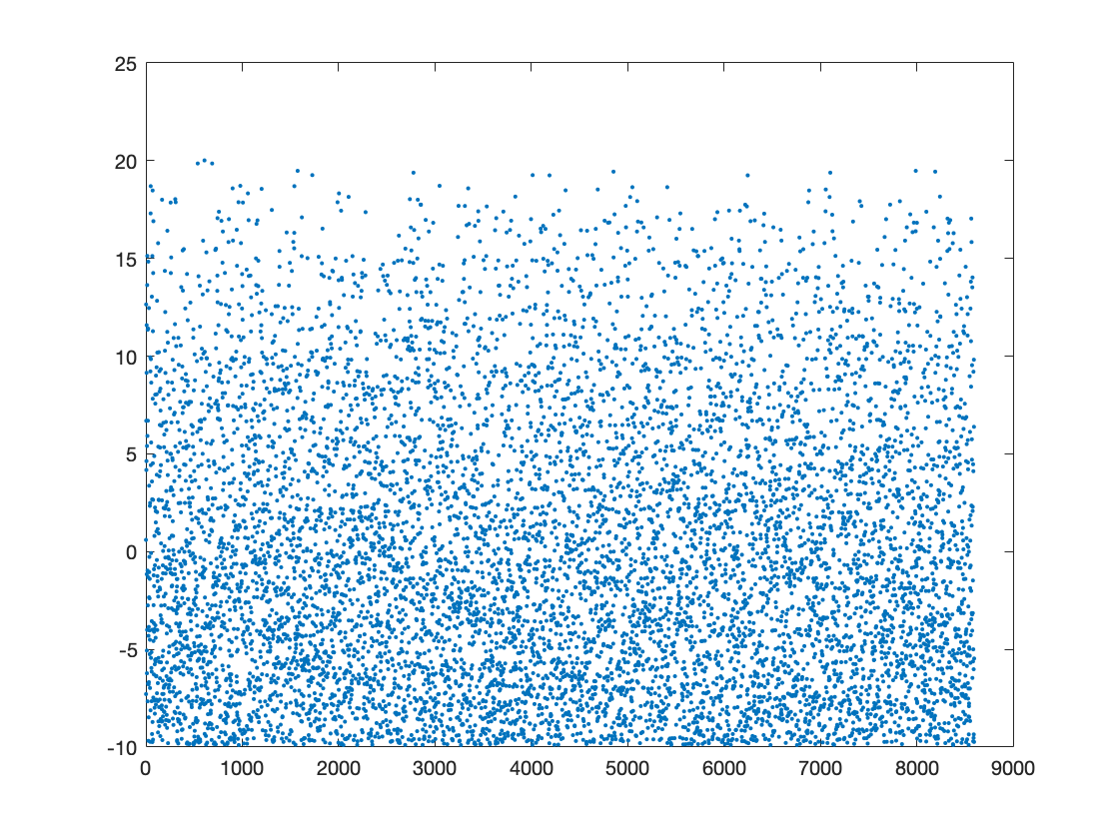

% do a big computation with matrix not specially stored as sparse matrix

% (x5 by itself and add itself) and time this line

tic; X=A*A*A*A*A+A; toc;

Elapsed time is 1.231091 seconds.

% do a big computation with matrix stored as sparse matrix

% and time this line

tic; Xsp=Asp*Asp*Asp*Asp*Asp+Asp; toc;

Elapsed time is 0.074118 seconds.

So doing the computation with the matrix stored as a sparse matrix in Matlab is much faster when timed, so we should store matrices as sparse matrices if they are sparse.

# 6

6a)

A=[ 4.51383, 4.81534, 1.60189;...

2.57472, 3.69404, 1.5812;...

5.28217, -0.091319, -0.476303];

delta_b=[ -0.122189;...

0.155624;...

0.0291701];

b=[ -6.70581;...

-4.52604;...

-3.94298];

without_noise = inv(A)*b

with_noise = inv(A)*(b+delta_b)

without_noise = 3×1

-0.7747

-0.6006

-0.1978

with_noise = 3×1

-0.6940

-1.0047

0.7134

6b) Two of the planes are very close together and almost linearly dependent/on top of each other. Therefore, a small change in one of the planes could drastically change the location of the intersection.

6c)

x=[-5,-5,5,5];

y=[5,-5,-5,5];

z1 = (b(1,1) - A(1,1).*x - A(1,2).*y)./A(1,3);

z2 = (b(2,1) - A(2,1).*x - A(2,2).*y)./A(2,3);

z3 = (b(3,1) - A(3,1).*x - A(3,2).*y)./A(3,3);

figure

hold on

% plot first plane:

p1=patch(x(:),y(:),z1(:),'red');

set(p1,'facealpha',0.2); set(p1,'edgealpha',0.2)

view(3);

xlabel('x')

ylabel('y')

zlabel('z')

% plot second plane:

p2=patch(x(:),y(:),z2(:),'green');

set(p2,'facealpha',0.2); set(p2,'edgealpha',0.2)

% plot third plane:

p3=patch(x(:),y(:),z3(:),'blue');

set(p3,'facealpha',0.2); set(p3,'edgealpha',0.2)

% plot location of solution:

plot3(without_noise(1,1),without_noise(2,1),without_noise(3,1),'x','markersize',14,'linewidth',3)

hold off

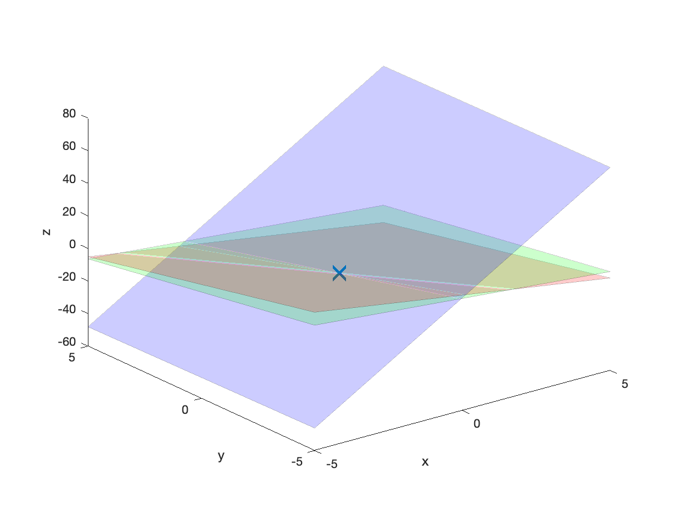

# 7

A=[0.0003 1;...

3 1];

b=[3; 2];

% plotting the two line equations

figure

hold on

x = -5:1:5;

y1 = ( b(1,1)-(A(1,1).*x) ) ./A(1,2);

y2 = ( b(2,1)-(A(2,1).*x) ) ./A(2,2);

plot(x,y1)

plot(x,y2)

hold off

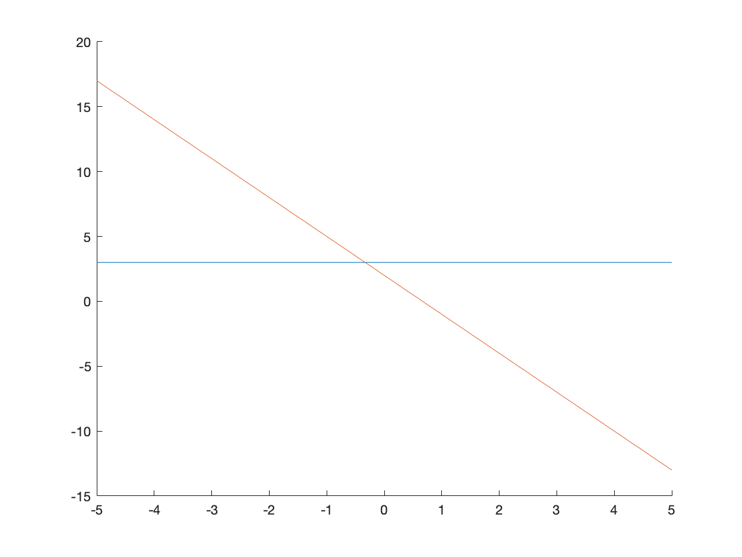

7 continued) No the matrix is not near-singular and the lines are not that close together. The source of sensitivity to noise is that we didn't pivot and with our 3-digit accuracy this led us to get a less accurate answer. If we had pivoted, even with the 3-digit accuracy, we would have gotten a closer answer.

# 8

8a) From a database with a list of all the friends for each user,

In the MAP stage: each user's line of friends is an individual chunk. From each chunk, [key, value] pairs are mapped where each key is a possible pair of friends from the friends list and the value is that particular user. This is done for all chunks/users.

In the SHUFFLE stage: All [key, value] pairs are shuffled and sorted (so all pairs with key=[user_A, user_B] are treated the same as pairs with key=[user_B, user_A]). All occurrences for each key/user pair are then returned.

In the REDUCE stage: All occurrences for each key/user pair are combined into a single list of mutual friends for that user pair.

8b)

%%%%%%%%%%%%%%%%%%%%%%%%%%%%%%%%%%%%%%%%%%%%%%%%%%%%%%%%%%%%%%%%%%%%%%%%

%% find mutual facebook friends using MapReduce algorithm.

%% see

%% help/matlab/import_export/getting-started-with-mapreduce.html#bug4okz

%% Eli, APM120, 201906

%% select data file:

ds = datastore('Data/friends.txt');

% send a single line of the data to the map function each time:

ds.ReadSize=1;

%% display information about entire dataset:

ds

ds =

TabularTextDatastore with properties:

Files: {

'/Users/paulazhu/coding/class-notes/HW_01/Data/friends.txt'

}

FileEncoding: 'UTF-8'

AlternateFileSystemRoots: {}

ReadVariableNames: false

VariableNames: {'Var1', 'Var2', 'Var3' ... and 1 more}

DatetimeLocale: en_US

Text Format Properties:

NumHeaderLines: 0

Delimiter: ' '

RowDelimiter: '\r\n'

TreatAsMissing: ''

MissingValue: NaN

Advanced Text Format Properties:

TextscanFormats: {'%f', '%f', '%f' ... and 1 more}

TextType: 'char'

ExponentCharacters: 'eEdD'

CommentStyle: ''

Whitespace: '\b\t'

MultipleDelimitersAsOne: false

Properties that control the table returned by preview, read, readall:

SelectedVariableNames: {'Var1', 'Var2', 'Var3' ... and 1 more}

SelectedFormats: {'%f', '%f', '%f' ... and 1 more}

ReadSize: 1 rows

fprintf(1,'specified dataset ReadSize=%d\n',ds.ReadSize);

specified dataset ReadSize=1

%% show a few data values:

fprintf(1,'\n\nA preview of some of the flight data values:\n')

A preview of some of the flight data values:

preview(ds)

ans = 5×4 table

|  | **Var1** | **Var2** | **Var3** | **Var4** |
| --- | --- | --- | --- | --- |
| **1** | 1 | 2 | 3 | 4 |
| **2** | 2 | 1 | 3 | 5 |
| **3** | 3 | 1 | 2 | 5 |
| **4** | 4 | 1 | 5 | NaN |
| **5** | 5 | 2 | 3 | 4 |

%% calculate mean daily flight delay using MapReduce:

outds = mapreduce(ds, @mutual_friends_MapFun, @mutual_friends_ReduceFun ...

,'OutputFolder','./Output/friends/');

Parallel mapreduce execution on the parallel pool:

********************************

* MAPREDUCE PROGRESS *

********************************

Map 0% Reduce 0%

--> entering map function: size(data)=1x4

info.Offset=0, info.NumCharactersRead=8

exiting map function Mean_Daily_Delay_MapFun

--> entering map function: size(data)=1x4

info.Offset=8, info.NumCharactersRead=8

exiting map function Mean_Daily_Delay_MapFun

--> entering map function: size(data)=1x4

info.Offset=16, info.NumCharactersRead=8

exiting map function Mean_Daily_Delay_MapFun

--> entering map function: size(data)=1x4

info.Offset=24, info.NumCharactersRead=7

exiting map function Mean_Daily_Delay_MapFun

--> entering map function: size(data)=1x4

info.Offset=31, info.NumCharactersRead=7

exiting map function Mean_Daily_Delay_MapFun

Map 50% Reduce 0%

Map 100% Reduce 0%

--> entering reduce function, intermKey = 2 4:

key=2 4; mutual_friends: 1, 5,

exiting reduce function Mean_Daily_Delay_ReduceFun.

--> entering reduce function, intermKey = 1 2:

key=1 2; mutual_friends: 3,

exiting reduce function Mean_Daily_Delay_ReduceFun.

--> entering reduce function, intermKey = 2 5:

key=2 5; mutual_friends: 3,

exiting reduce function Mean_Daily_Delay_ReduceFun.

--> entering reduce function, intermKey = 3 4:

key=3 4; mutual_friends: 1, 5,

exiting reduce function Mean_Daily_Delay_ReduceFun.

--> entering reduce function, intermKey = 3 5:

key=3 5; mutual_friends: 2,

exiting reduce function Mean_Daily_Delay_ReduceFun.

--> entering reduce function, intermKey = 1 3:

key=1 3; mutual_friends: 2,

exiting reduce function Mean_Daily_Delay_ReduceFun.

--> entering reduce function, intermKey = 1 5:

key=1 5; mutual_friends: 2, 3, 4,

exiting reduce function Mean_Daily_Delay_ReduceFun.

--> entering reduce function, intermKey = 2 3:

key=2 3; mutual_friends: 1, 5,

exiting reduce function Mean_Daily_Delay_ReduceFun.

Map 100% Reduce 100%

%% read and display results:

a=readall(outds);

N=length(a.Key);

disp('users: mutual friends')

users: mutual friends

for i=1:N

fprintf(1,'%s: ',char(a.Key(i)));

fprintf('%d,',cell2mat(a.Value(i)));

fprintf('\n');

end

2 4:

1,5,

1 2:

3,

2 5:

3,

3 4:

1,5,

3 5:

2,

1 3:

2,

1 5:

2,3,4,

2 3:

1,5,

%% EDITS HERE: now display number of mutual friends for each user pair

disp('now display number of mutual friends for each user pair')

now display number of mutual friends for each user pair

disp('users: # of mutual friends')

users: # of mutual friends

for i=1:N

fprintf(1,'%s: ',char(a.Key(i)));

fprintf('# of mutual friends = %d,',length(cell2mat(a.Value(i))));

fprintf('\n');

end

2 4:

# of mutual friends = 2,

1 2:

# of mutual friends = 1,

2 5:

# of mutual friends = 1,

3 4:

# of mutual friends = 2,

3 5:

# of mutual friends = 1,

1 3:

# of mutual friends = 1,

1 5:

# of mutual friends = 3,

2 3:

# of mutual friends = 2,

%%%%%%%%%%%%%%%%%%%%%%%%%%%%%%%%%%%%%%%%%%%%%%%%%%%%%%%%%%%%%%%%%%%%%%%%

function mutual_friends_MapFun(data, info, intermKVStore)

%%%%%%%%%%%%%%%%%%%%%%%%%%%%%%%%%%%%%%%%%%%%%%%%%%%%%%%%%%%%%%%%%%%%%%%%

%% Map function: input is a chunk of the data. Output is the sum

%% over delays and number of delay events per each day, for this

%% chunk only, returned as a (KEY,VALUE) pair.

fprintf(1,['--> entering map function: ' ...

'size(data)=%dx%d\n'] ,size(data));

fprintf(1,'info.Offset=%d, info.NumCharactersRead=%d\n' ...

,info.Offset,info.NumCharactersRead);

%% Initialize variables

%% calculate sum over delays and number of delay events, per each

%% day, only for the current chunk of data:

input_data=table2array(data);

user=input_data(1);

friends=input_data(2:end);

Nfriends=length(friends);

for i=1:Nfriends

for j=1:Nfriends

friend1=friends(i);

friend2=friends(j);

if friend1>friend2

%% returned KEY is pair of friends;

%% returned VALUE is the user on this line

%% add(intermKVStore, KEY, VALUE)

key=sort([friend1,friend2]);

key_character=sprintf('%d %d',key);

add(intermKVStore, key_character, user);

end

end

end

fprintf(1,'exiting map function Mean_Daily_Delay_MapFun\n');

end

%%%%%%%%%%%%%%%%%%%%%%%%%%%%%%%%%%%%%%%%%%%%%%%%%%%%%%%%%%%%%%%%%%%%%%%%

function mutual_friends_ReduceFun(intermKey, intermValIter, outKVStore)

%%%%%%%%%%%%%%%%%%%%%%%%%%%%%%%%%%%%%%%%%%%%%%%%%%%%%%%%%%%%%%%%%%%%%%%%

%% Reduce function. Called once for each value of the key. We

%% have 7 values corresponding to 7 days. Each call to this reduce

%% function therefore deals with flight delay data corresponding to

%% one day.

fprintf(1,'--> entering reduce function, intermKey = %s:\n',intermKey);

%% Loop over all data belonging to the day given by intermKey:

%% This is based on the SHUFFLE STEP, because mapreduce now needs to

%% sort all keys and return here only the ones we are requesting:

num_mutual_friends=0;

while hasnext(intermValIter)

num_mutual_friends=num_mutual_friends+1;

next_value=getnext(intermValIter);

%% calculate the sum over delays and the number of delays:

mutual_friends(num_mutual_friends) = next_value;

end

%% return output of calculation for each day, again as a (KEY,VALUE)

%% pair, where the key is the day and the value is the mean delay:

add(outKVStore, intermKey, mutual_friends);

fprintf(1,' key=%s; mutual_friends: ',intermKey)

fprintf(1,' %d,',mutual_friends)

fprintf(1,' \n')

fprintf(1,'exiting reduce function Mean_Daily_Delay_ReduceFun.\n');

end