Homework #02

# 1a

A=[ -5.868, -7.551, 0.158;

-7.551, 3.83, 0.426;

0.158, 0.426, 6.038];

1a continued)

v1=[-0.8733; -0.217; 0.4361];

v=v1;

for i = 2:1:50

v=A*v;

v=v./norm(v);

if i<6

disp([num2str(i) 'th iteration:'])

disp(v)

end

end

2th iteration:

0.7290

0.6347

0.2564

3th iteration:

-0.9310

-0.3056

0.1994

4th iteration:

0.7919

0.6034

0.0940

5th iteration:

-0.9258

-0.3657

0.0957

e1=v;

disp('50th iteration:')

50th iteration:

disp(e1)

0.8772

0.4796

-0.0214

lambda1 = (A*e1) ./ e1;

lambda1 = mean(lambda1(:));

disp('lambda for 50th iteration:')

lambda for 50th iteration:

disp(lambda1)

-10.0004

# 1b

Hotelling deflation can be used for normal (and symmetric) matrices since they have eigenvectors that are orthogonal and Hotelling deflation needs  = 0. The Wielandt deflation can be used for non-normal matrices/when the eigenvectors are not orthogonal.

# 1c

A=[ -5.868, -7.551, 0.158;

-7.551, 3.83, 0.426;

0.158, 0.426, 6.038];

B=[ 4.828, 2.053, -0.002;

-4.651, 3.21, -7.63;

-1.889, -11.09, -4.038];

disp('checking if A is normal:')

checking if A is normal:

disp(A*A')

91.4760 15.4562 -3.1899

15.4562 71.8680 3.0107

-3.1899 3.0107 36.6639

disp(A'*A)

91.4760 15.4562 -3.1899

15.4562 71.8680 3.0107

-3.1899 3.0107 36.6639

A looks normal (looks symmetric) and we can check this from A*A' and A'*A being equal, so we can use Hotelling deflation

disp('checking if B is normal:')

checking if B is normal:

disp(B*B')

27.5244 -15.8496 -31.8798

-15.8496 90.1528 3.9968

-31.8798 3.9968 142.8619

disp(B'*B)

48.5097 15.9312 43.1053

15.9312 137.5070 20.2850

43.1053 20.2850 74.5223

B is not normal since B*B' isn't equal to B'*B, so we can not use Hotelling deflation.

A_e2=[1.8275 -3.3436, -0.0296;

-3.3436, 6.13, 0.3235;

-0.0296, 0.3235, 6.0426];

e2_v1=[-0.215; 0.430; 0.877];

v=e2_v1;

for i = 2:1:50

v=A_e2*v;

v=v./norm(v);

if i<6

disp([num2str(i) 'th iteration:'])

disp(v)

end

end

2th iteration:

-0.2728

0.5345

0.7999

3th iteration:

-0.3258

0.6273

0.7073

4th iteration:

-0.3688

0.7017

0.6097

5th iteration:

-0.4008

0.7561

0.5174

e2=v;

disp('e2 50th iteration:')

e2 50th iteration:

disp(e2)

-0.4714

0.8689

0.1507

lambda2 = (A_e2*e2) ./ e2;

lambda2 = mean(lambda2(:));

disp('lambda 2 for 50th iteration:')

lambda 2 for 50th iteration:

disp(lambda2)

8.0001

A_e3=[0.0496, -0.0665, 0.5389;

-0.0665, 0.0895, -0.7243;

0.5389, -0.7243, 5.8608];

e3_v1=[0.0901; -0.123; 0.989];

v=e3_v1;

for i = 2:1:50

v=A_e3*v;

v=v./norm(v);

if i<6

disp([num2str(i) 'th iteration:'])

disp(v)

end

end

2th iteration:

0.0909

-0.1221

0.9883

3th iteration:

0.0909

-0.1221

0.9883

4th iteration:

0.0909

-0.1221

0.9883

5th iteration:

0.0909

-0.1221

0.9883

e3=v;

disp('e3 50th iteration:')

e3 50th iteration:

disp(e3)

0.0909

-0.1221

0.9883

lambda3 = (A_e3*e3) ./ e3;

lambda3 = mean(lambda3(:));

disp('lambda 3 for 50th iteration:')

lambda 3 for 50th iteration:

disp(lambda3)

5.9999

# 1d

B=[ 4.828, 2.053, -0.002;

-4.651, 3.21, -7.63;

-1.889, -11.09, -4.038];

Yes since Wielandt deflation can be used for non-normal matrices like B.

% first eigenvector

v=ones(3,1);

for i = 1:1:50

v=B*v;

v=v./norm(v);

end

e1=v;

disp('first eigenvector:')

first eigenvector:

disp(e1)

-0.0665

0.4813

0.8740

lambda1 = (B*e1) ./ e1;

lambda1 = mean(lambda1(:));

disp('first eigenvalue:')

first eigenvalue:

disp(lambda1)

-10.0014

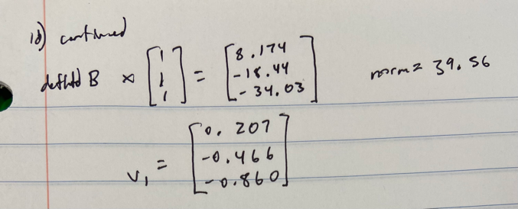

B_e2 = [4.9718, 2.897, 0.3053;

-5.6913, -2.8976, -9.8538;

-3.778, -22.1801, -8.076];

e2_v1=[0.207; -0.466; -0.86];

v=e2_v1;

for i = 2:1:50

v=B_e2*v;

v=v./norm(v);

if i<6

disp([num2str(i) 'th iteration:'])

disp(v)

end

end

2th iteration:

-0.0313

0.4639

0.8853

3th iteration:

0.0729

-0.4945

-0.8661

4th iteration:

-0.0662

0.4741

0.8779

5th iteration:

0.0659

-0.4848

-0.8721

e_defl2=v;

lambda_defl2 = (B_e2*e_defl2) ./ e_defl2;

lambda_defl2 = nanmean(lambda_defl2(:));

[max_val, max_idx] = max(abs(e1));

e_1p=e1(max_idx, 1);

b_p=B(max_idx, :);

e2=e_defl2 + ((b_p*e_defl2 ./ (lambda_defl2 - lambda1))*(e1./e_1p))

e2 = 3×1

-0.1330

0.9626

1.7480

# 1e

disp('For A:')

For A:

[V_A,D_A]=eig(A)

V_A = 3×3

0.8772 -0.0908 0.4714

0.4796 0.1221 -0.8689

-0.0214 -0.9884 -0.1507

D_A = 3×3

-10.0002 0 0

0 5.9999 0

0 0 8.0003

The eigenvectors (V_A) are along the same vectors and the eigenvalues (D_A) are equal from power method as those from the Matlab eig() function. For A, they do in fact converge with the power method and arrive at the correct eigenvalues/vectors. This is possible because each of the eigenvalues here are different in absolute value and each eigenvalue is significantly greater than the next eigenvalue in absolute value.

# 2

Q=[ 0 0 0 1/3 0 1/3 0 1/3;

0 0 1/2 0 0 0 1/2 0;

0 0 0 0 1 0 0 0;

0 0 0 0 1/2 0 1/2 0;

0 0 0 0 0 0 0 0;

0 0 0 1/3 1/3 0 0 1/3;

0 0 1 0 0 0 0 0;

0 0 0 0 1 0 0 0];

[n, ~]=size(Q);

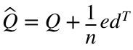

e_vec = sum(Q,2)==0;

d_vec = ones(n, 1);

Q_hat=Q + ((1/n).* e_vec * d_vec.');

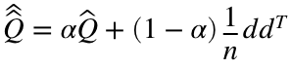

tel=0.85;

Q_hathat=(tel*Q_hat) + ((1-tel).*(1/n).*d_vec*d_vec.');

% finding largest eigenvector of Q_hathat.' with power method

x = ones(n, 1);

for i=1:1:50

x=Q_hathat.'*x;

x=x./norm(x);

end

disp(x)

0.1264

0.1264

0.4084

0.2082

0.7849

0.1622

0.2686

0.2082

So from largest to smallest importance: 5, 3, 7, 4 and 8, 6, 1 and 2 which looks like it seems to make sense

# 3

3a)

disp('Adjacent:')

Adjacent:

Adj=[0 0 1 1 1 0 0;

0 0 0 0 0 1 1;

1 0 0 1 1 1 0;

1 0 1 0 1 0 0;

1 0 1 1 0 0 1;

0 1 1 0 0 0 1;

0 1 0 0 1 1 0]

Adj = 7×7

0 0 1 1 1 0 0

0 0 0 0 0 1 1

1 0 0 1 1 1 0

1 0 1 0 1 0 0

1 0 1 1 0 0 1

0 1 1 0 0 0 1

0 1 0 0 1 1 0

disp('Degree:')

Degree:

Deg=diag(sum(Adj,2))

Deg = 7×7

3 0 0 0 0 0 0

0 2 0 0 0 0 0

0 0 4 0 0 0 0

0 0 0 3 0 0 0

0 0 0 0 4 0 0

0 0 0 0 0 3 0

0 0 0 0 0 0 3

disp('Laplacian:')

Laplacian:

Lap=Deg - Adj

Lap = 7×7

3 0 -1 -1 -1 0 0

0 2 0 0 0 -1 -1

-1 0 4 -1 -1 -1 0

-1 0 -1 3 -1 0 0

-1 0 -1 -1 4 0 -1

0 -1 -1 0 0 3 -1

0 -1 0 0 -1 -1 3

[n, ~]=size(Lap);

3b)

% calculate multiple (p) eigenvectors with block inverse method

% (since already know Laplacian is symmetric/normal)

p=3;

U = rand(n, p);

for i = 1:1:50

warning('off', 'MATLAB:nearlySingularMatrix')

% doesn't like dividing by Laplacian, so just hide the warning for now

U=Lap \ U;

% gram schmidt

for ii = 1:1:p

U(:,ii) = U(:,ii) / norm(U(:,ii));

for jj = ii+1:1:p

% projection for each

u = U(:,ii);

v = U(:,jj);

proj = (dot(v,u) / dot(u,u)) * u;

U(:,jj) = U(:,jj) - proj;

end

end

end

disp('eigenvectors:')

eigenvectors:

disp(U)

0.3780 -0.4036 -0.1954

0.3780 0.5944 -0.6816

0.3780 -0.2250 0.1949

0.3780 -0.4036 -0.2606

0.3780 -0.2250 0.0852

0.3780 0.3314 0.5196

0.3780 0.3314 0.3378

disp('eigenvalues:')

eigenvalues:

lambda = Lap*U(:, :)./U(:, :);

disp(lambda(1,:))

0.0000 0.8851 3.0997

3c)

figure

hold on

title('second smallest eigenvector')

scatter([1 2 3 4 5 6 7], U(:, 2))

plot([0 0 0 0 0 0 0])

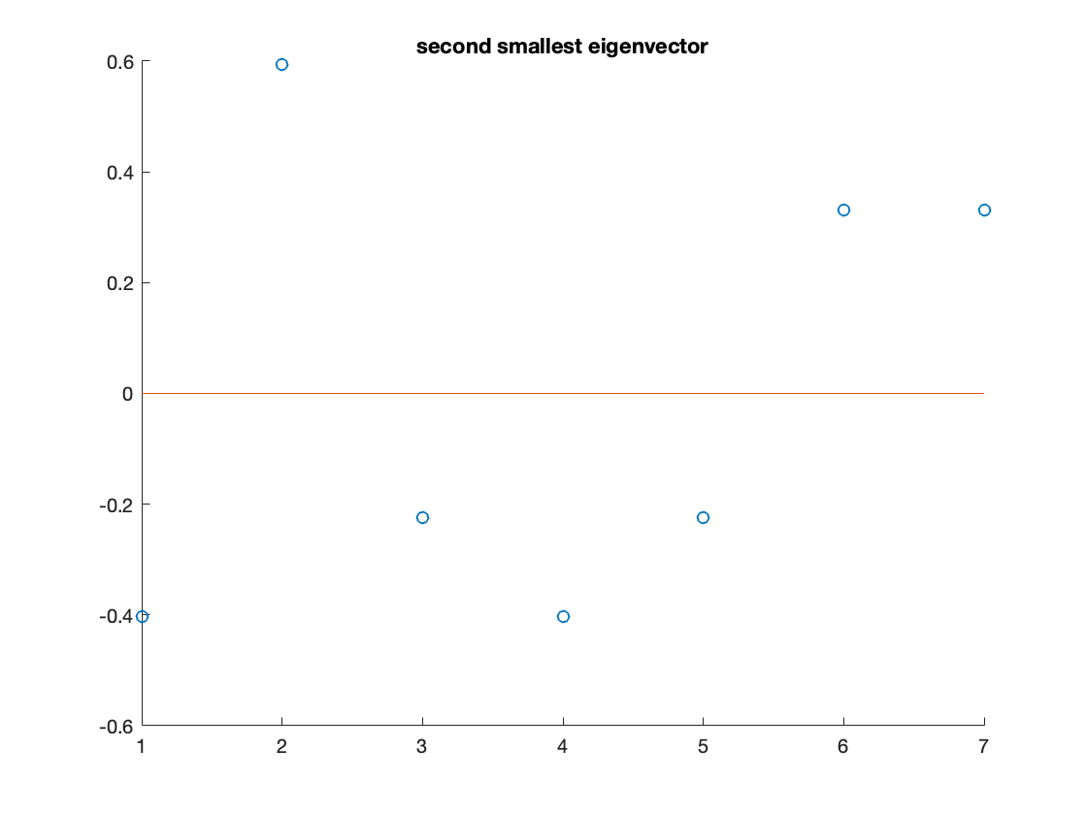

so positive entries can be one partition (1, 3, 4, 5), negative can be another partition (2, 6, 7)

3d)  is equal to the sum of distances that we are trying to minimize. Then using the eigenvectors and eigenvalues of L, , so to minimize, we want the smallest possible eigenvalue which we can find with the inverse power method. And then since the absolute smallest will just be 0 with an eigenvector of 1s and won't actually partition our network, we'll find the 2nd smallest eigenvalue to actually start to partition the network.

# 4

% for any specified alpha

alpha = rand(1);

A=[-2.03,-4.73,-6.71;

-4.73,0.767,-0.901;

-6.71,-0.901,7.27];

[n, ~] = size(A);

% using shifted inverse power method

shifted_A = A-(alpha.*eye(n));

v=ones(n, 1);

for i=1:1:50

v=shifted_A^(-1)*v;

v=v./norm(v);

end

disp('closest eigenvalue:')

closest eigenvalue:

lambda = A*v./v;

disp(lambda(1,1))

3.0016

With , its eigenvectors will have eigenvalues of . So . Therefore,  will be the smallest eigenvector when . We can use the inverse power method to find the eigenvector for when is smallest and find .

% for alpha = -7 and 10 iterations

alpha = -7;

A=[-2.03,-4.73,-6.71;

-4.73,0.767,-0.901;

-6.71,-0.901,7.27];

[n, ~] = size(A);

% using shifted inverse power method

shifted_A = A-(alpha.*eye(n));

v=ones(n, 1);

v=shifted_A^(-10)*v;

disp('closest eigenvalue:')

closest eigenvalue:

lambda = A*v./v;

disp(lambda(1,1))

-7.9961

disp('corresponding eigenvector:')

corresponding eigenvector:

disp(v./norm(v))

0.7978

0.4695

0.3784

% comparing with Matlab calculated eigenvalues

[V, D]=eig(A)

V = 3×3

-0.7978 0.3430 0.4959

-0.4695 -0.8694 -0.1540

-0.3784 0.3557 -0.8546

D =

-7.9961 0 0

0 3.0016 0

0 0 11.0015

-7.9961 is in fact an eigenvalue of A and it's corresponding eigenvector is along the same vector as found with Matlab's eig() function.