Homework #03

# 1

1a)

1b)

A=[-0.7108,-2.995;1.336,-0.7892];

x0 = [-5; 2];

% finding eigenvalues

a=A(1,1);

b=A(1,2);

c=A(2,1);

d=A(2,2);

disp('eigenvalues:')

eigenvalues:

lambda = [(a+d)/2+( ((a+d)/2).^2 - ((a.*d) - (b.*c)) )^(1/2), 0; ...

0, (a+d)/2-( ((a+d)/2).^2 - ((a.*d) - (b.*c)) )^(1/2)];

lambda_vec = [lambda(1,1) lambda(2,2)]

lambda_vec = 1×2 complex

-0.7500 + 1.9999i -0.7500 - 1.9999i

% finding eigenvectors

e_vecs = zeros(length(lambda_vec), 2);

for i=1:1:length(lambda_vec)

e_space = A-lambda_vec(1,i)*eye(2);

e_vecs(:, i) = null(e_space);

end

disp('eigenvectors:')

eigenvectors:

disp(e_vecs)

0.8316 + 0.0000i 0.8316 + 0.0000i

0.0109 - 0.5553i 0.0109 + 0.5553i

% finding the a constant based on x0

disp('the a constant:')

the a constant:

a_const = e_vecs^(-1)*x0;

a_const=a_const.'

a_const = 1×2 complex

-3.0063 + 1.8598i -3.0063 - 1.8598i

1c)

t=2.0;

% diag turns elements of vector into diagonal elements

expm_A2=e_vecs*diag(exp(lambda_vec*t))*e_vecs^(-1)

expm_A2 = 2×2 complex

-0.1492 + 0.0000i 0.2529 + 0.0000i

-0.1128 - 0.0000i -0.1426 + 0.0000i

disp('from Matlab expm() function:')

from Matlab expm() function:

disp(expm(A*t))

-0.1492 0.2529

-0.1128 -0.1426

The calculated sum is indeed equal to Matlab's expm output

disp('solution at t=2:')

solution at t=2:

disp(expm_A2*x0)

1.2516 - 0.0000i

0.2789 + 0.0000i

1d)

t=0:0.1:5;

x_traj=zeros(2,15);

for i=1:1:length(t)

x_traj(:,i)=e_vecs*diag(exp(lambda_vec*t(1,i)))*e_vecs^(-1)*x0;

end

figure

hold on

[X,Y] = meshgrid(-10:1:10,-10:1:10);

X=X(:).';

Y=Y(:).';

gradient = A*[X;Y];

U = gradient(1,:);

V = gradient(2,:);

q = quiver(X,Y,U,V);

plot(x_traj(1,:), x_traj(2,:), 'm')

Warning: Imaginary parts of complex X and/or Y arguments ignored

hold off

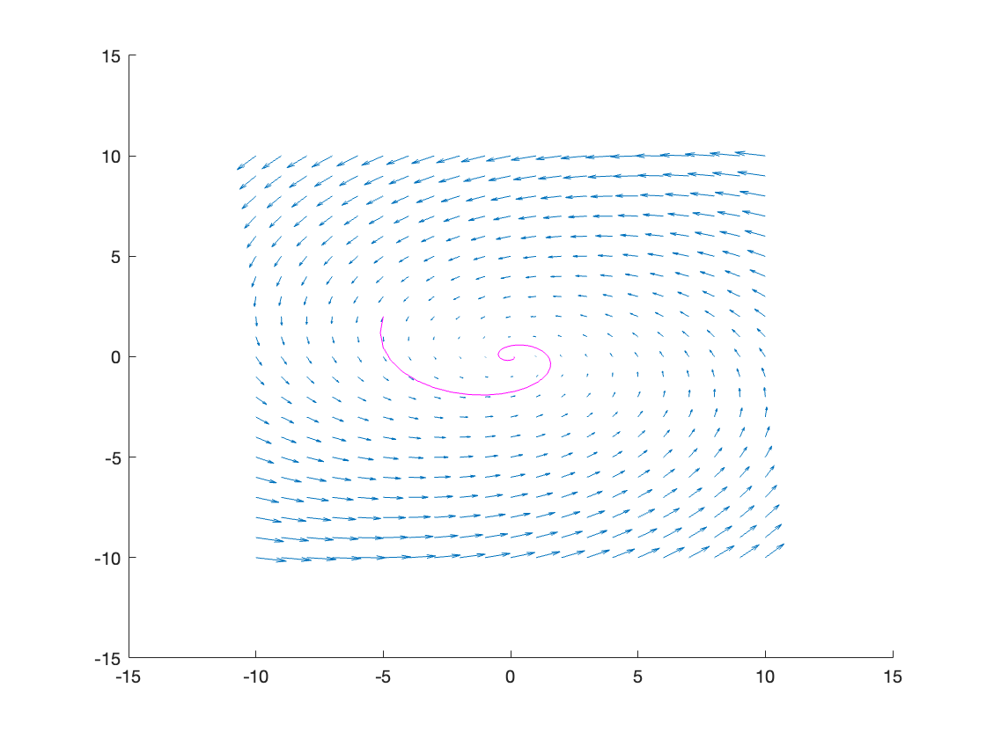

1e) So 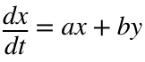

then 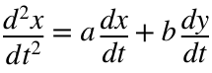

and if 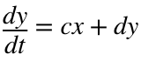

then 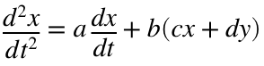



disp(['x''''=' num2str((a*a) + (b*c)) 'x+' num2str((a*b)+(b*d)) 'y'])

x''=-3.4961x+4.4925y

1fi)

t=2.0;

x2_sad=[-2; -2];

disp('initial conditions based on x2=[-2;-2]:')

initial conditions based on x2=[-2;-2]:

x0_sad=expm_A2^(-1)*x2_sad

x0_sad = 2×1 complex

15.8843 - 0.0000i

1.4615 - 0.0000i

1fii)

For t=2, it is possible to optimize a starting condition point out on the trajectory that would lead to both positive values specifically at t=2.

However, long-term no, the eigenvalues have negative real parts:

disp(lambda_vec)

-0.7500 + 1.9999i -0.7500 - 1.9999i

So they will always eventually end up at 0, 0

1gi)

t=0:0.1:15;

x_sad=zeros(2,15);

for i=1:1:length(t)

x_sad(:,i)=e_vecs*diag(exp(lambda_vec*t(1,i)))*e_vecs^(-1)*x0_sad;

end

figure

hold on

plot(t, x_sad(1,:), 'r')

Warning: Imaginary parts of complex X and/or Y arguments ignored

plot(t, x_sad(2,:), 'b')

Warning: Imaginary parts of complex X and/or Y arguments ignored

plot(t, sqrt(x_sad(1,:).^2+x_sad(2,:).^2), 'g')

Warning: Imaginary parts of complex X and/or Y arguments ignored

hold off

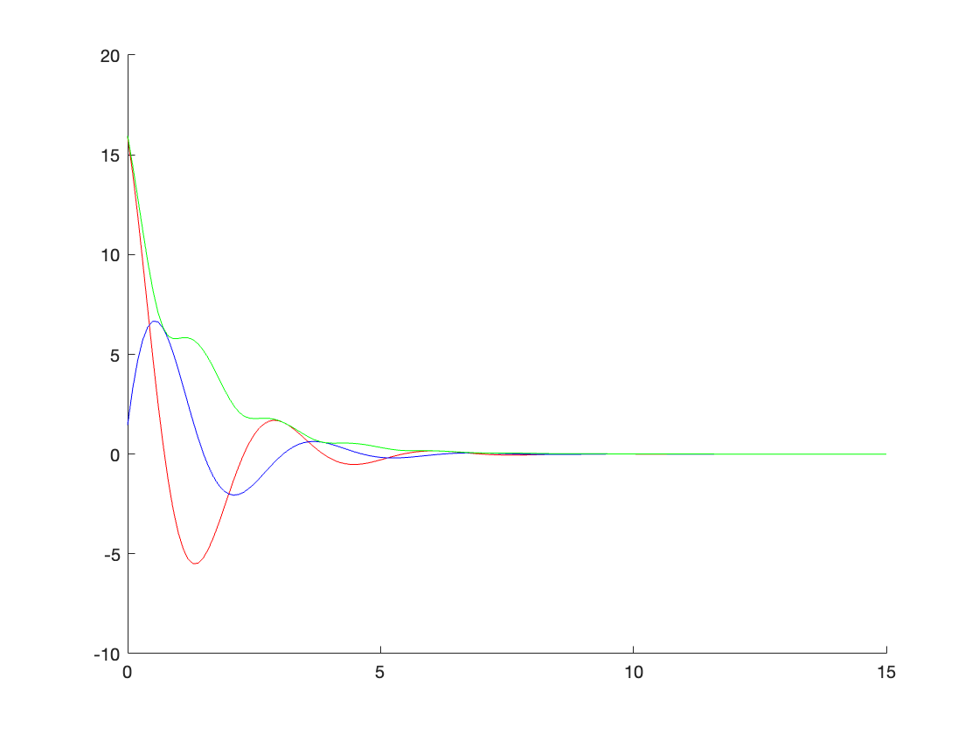

1gii)

figure

hold on

plot(x_sad(1,:), x_sad(2,:), 'm')

Warning: Imaginary parts of complex X and/or Y arguments ignored

1giii)

[X,Y] = meshgrid(-10:1:20,-5:1:10);

X=X(:).';

Y=Y(:).';

gradient = A*[X;Y];

U = gradient(1,:);

V = gradient(2,:);

q = quiver(X,Y,U,V);

hold off

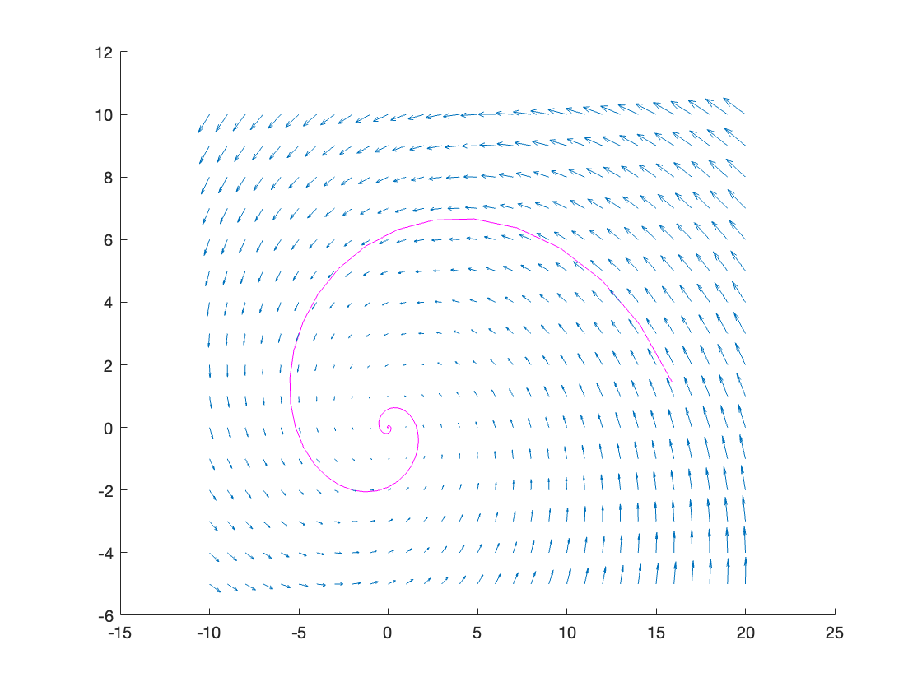

# 2

2a)

A=[ -64.0859, -22.6535;

177.346, 62.6859];

TF during OH said I can use the eig() function directly here

[e_vecs, D]=eig(A);

disp('eigenvalues:')

eigenvalues:

lambda_vec = [D(1,1) D(2,2)]

lambda_vec = 1×2

-1.2145 -0.1855

disp('eigenvectors:')

eigenvectors:

disp(e_vecs)

-0.3390 0.3341

0.9408 -0.9425

Since  and the eigenvalues are negative,  and  overall will go towards 0. However, although they are both negative, one is much greater than the other.

Moreover, the two eigenvectors are also very close to each other and are therefore clearly linearly dependent on each other. Thus, there will also be some oscillation before it goes towards 0.

2b)

t=1.5;

% diag turns elements of vector into diagonal elements

B=e_vecs*diag(exp(lambda_vec*t))*e_vecs^(-1);

BT_B=B.'*B;

% eigenvector with max eigenvalue

v=BT_B^(50)*[1;1];

disp('initial condition for max amplitude:')

initial condition for max amplitude:

x0=v/norm(v)

x0 = 2×1

0.9403

0.3403

disp('corresponding eigenvalue from B^T*B:')

corresponding eigenvalue from B^T*B:

amp_lambda = mean(BT_B*x0./x0)

amp_lambda = 1.3391e+04

Amplitude eigenvalue for maximizing sqrt(eigenvalue) is positive

2c)

% finding the a constant based on x0

disp('the a constant:')

the a constant:

a_const = inv(e_vecs)*x0;

a_const=a_const.'

a_const = 1×2

-194.3623 -194.3663

so writing it out explicitly:

2d)

xsols=zeros(2, 15);

xsols_norm=zeros(1, 15);

coeff1=zeros(1, 15);

coeff2=zeros(1, 15);

for i=1:1:15

coeffs=exp(lambda_vec*i).*a_const;

coeff1(1,i)=coeffs(1,1);

coeff2(1,i)=coeffs(1,2);

% sum(,2) sums each of the rows

xsols(:, i) = sum([coeffs;coeffs].*e_vecs, 2).';

% typo in pset according to OH since norm is sqrt

xsols_norm(1, i)=sqrt(xsols(1, i).^2 + (xsols(2, i).^2));

end

figure

hold on

t=1:1:15;

plot(t, xsols_norm, 'g')

plot(t, coeff1, 'r')

plot(t, coeff2, 'b')

hold off

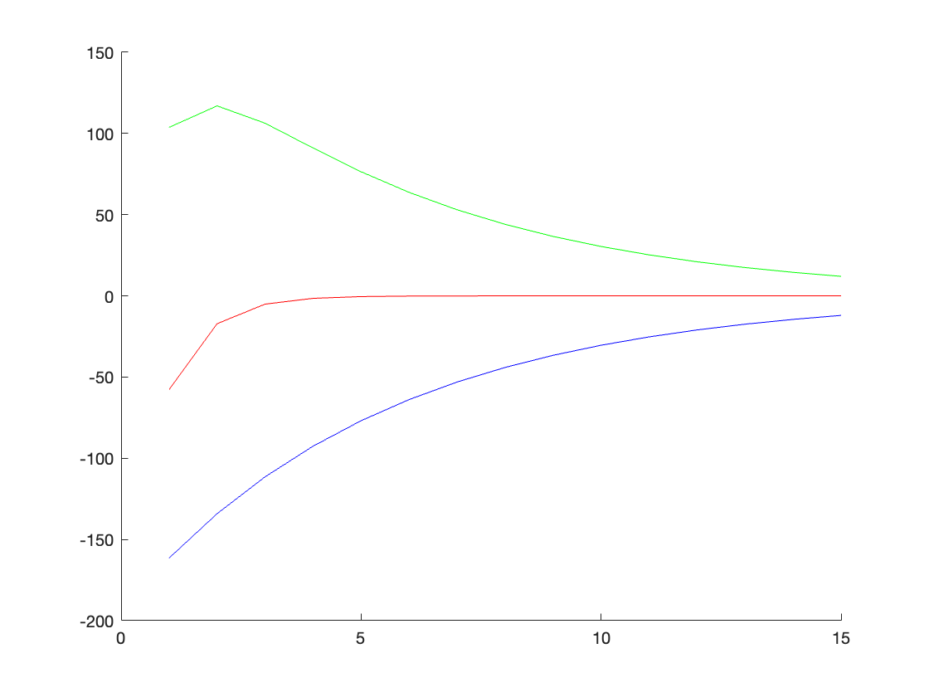

Because the eigenvectors are close to parallel, there is some initial oscillation and the green goes up for a bit, but eventually goes towards 0 since the eigenvalues are still negative.

# 3

3a)

A=[5, -1, -1;

-10, 5, 3;

16, -2, -1];

TF during OH said I can use the eig() function directly here too

[V, D] = eig(A)

V = 3×3 complex

-0.1374 - 0.0000i -0.1374 + 0.0000i -0.1374 + 0.0000i

0.5494 + 0.0000i 0.5494 - 0.0000i 0.5494 + 0.0000i

-0.8242 + 0.0000i -0.8242 + 0.0000i -0.8242 + 0.0000i

D = 3×3 complex

3.0000 + 0.0000i 0.0000 + 0.0000i 0.0000 + 0.0000i

0.0000 + 0.0000i 3.0000 - 0.0000i 0.0000 + 0.0000i

0.0000 + 0.0000i 0.0000 + 0.0000i 3.0000 + 0.0000i

disp('det(V):')

det(V):

disp(det(V))

-9.5745e-23 - 1.1290e-16i

No, we can't directly diagonalize A. Literally all of our eigenvalues are 3/our eigenvectors are the same, so we don't have enough distinct eigenvectors for a basis. This is reflected by the determinant which is zero here so V isn't invertible.

disp('M and J from A:')

M and J from A:

[M,J]=jordan(A)

M = 3×3

-2 2 1

8 -10 0

-12 16 0

J = 3×3

3 1 0

0 3 1

0 0 3

3b)

A1=A+[0 0 0.0000001; 0 0 0; 0 0 0];

disp('M and J from A1:')

M and J from A1:

[V, D] = eig(A1)

V = 3×3 complex

0.1369 + 0.0000i -0.1376 - 0.0004i -0.1376 + 0.0004i

-0.5491 + 0.0000i 0.5496 + 0.0004i 0.5496 - 0.0004i

0.8244 + 0.0000i -0.8240 + 0.0000i -0.8240 + 0.0000i

D = 3×3 complex

2.9893 + 0.0000i 0.0000 + 0.0000i 0.0000 + 0.0000i

0.0000 + 0.0000i 3.0053 + 0.0092i 0.0000 + 0.0000i

0.0000 + 0.0000i 0.0000 + 0.0000i 3.0053 - 0.0092i

The Jordan form is very sensitive to noise. As we can see, when adding noise, the new eigenvectors and values will change and can quickly start to differ from each other, allowing a matrix to become diagonalizable.

3c)

So we start with eigenvalue 3

lambda=3;

I = eye(3);

B = A - (lambda*I);

B(abs(B)<1.e-13)=0;

B3 = B^3;

B3(abs(B3)<1.e-13)=0;

B3null=null(B3)

B3null = 3×3

1 0 0

0 1 0

0 0 1

v3=B3null(:, 1);

v2=B*v3

v2 = 3×1

2

-10

16

v1=B*v2

v1 = 3×1

-2

8

-12

disp('M matrix found using generalized eigenvectors:')

M matrix found using generalized eigenvectors:

M=[v1 v2 v3]

M = 3×3

-2 2 1

8 -10 0

-12 16 0

3d)

disp('J matrix:')

J matrix:

J=inv(M)*A*M

J = 3×3

3.0000 1.0000 0

0.0000 3.0000 1.0000

0.0000 -0.0000 3.0000

disp('Matlab calculated M and J from jordan():')

Matlab calculated M and J from jordan():

[M,J]=jordan(A)

M = 3×3

-2 2 1

8 -10 0

-12 16 0

J = 3×3

3 1 0

0 3 1

0 0 3

The M and J matrices found using generalized eigenvectors are indeed equal to the ones calculated from Matlab's jordan() function.