Homework #05

# 1

1a)

So for our least sqs solution, we want to minimize the distance between Ax and b,, which is = 

So we have an optimization problem and want to look for where the derivative = 0:

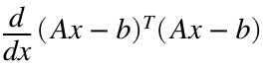

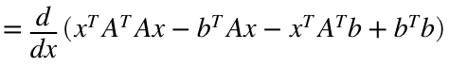



Therefore,  and 

1b)

A=[ 4, 1, 3; -4, -2, -5; 3, -1, -4; 0, 4, -1];

b=[ 0; 5; -1; -2];

x=inv(A.'*A)*(A.'*b)

x = 3×1

-0.4023

-0.5666

-0.0704

1c)

residual=(A*x)-b

residual = 4×1

-2.3868

-1.9059

0.6412

-0.1959

Because although this least sqs solution minimizes the distance between Ax and b, it can not get it to 0 since there is no exact solution/intersection since there are more equations than actual unknowns.

1d)

disp('norm of residual:')

norm of residual:

disp(norm(residual))

3.1271

disp('norm of b:')

norm of b:

disp(norm(b))

5.4772

I would consider the residual large since we can compare the residual as a proportion of the right hand side, b, and it seems to be about 60% (a significant proportion) of the magnitude of b.

1e)

x=A\b

x = 3×1

-0.4023

-0.5666

-0.0704

Matlab's function gives the same result

# 2

2a)

A=[-0.4, 0.2, -0.7;

0.8, -0.7, -0.1];

b=[-1;

0.5];

[U, sigma, V]=svd(A)

U = 2×2

-0.5001 -0.8659

0.8659 -0.5001

sigma = 2×3

1.1684 0 0

0 0.6817 0

V = 3×3

0.7641 -0.0788 -0.6403

-0.6044 0.2595 -0.7532

0.2255 0.9625 0.1506

2b)

A_pseudo=[-0.2270 0.6241;

-0.0709 -0.6383;

-1.3191 -0.5390]

A_pseudo = 3×2

-0.2270 0.6241

-0.0709 -0.6383

-1.3191 -0.5390

x=A_pseudo*b

x = 3×1

0.5391

-0.2482

1.0496

2c)

disp('using pinv():')

using pinv():

x2=pinv(A)*b

x2 = 3×1

0.5390

-0.2482

1.0496

disp('using A\b:')

using A\b:

x3=A\b

x3 = 3×1

0.7500

0

1.0000

We get the same result if Matlab's pseudoinverse function, pinv() is used, but since there are technically infinite solutions to this sytem, Matlab's A\b will just give a solution that might not be the same as the one gotten using A's pseudoinverse.

However, their norms similar:

disp('norm of x from calculated pseudoinverse:')

norm of x from calculated pseudoinverse:

disp(norm(x))

1.2058

disp('norm of x from Matlab pinv():')

norm of x from Matlab pinv():

disp(norm(x))

1.2058

disp('norm of x from Matlab A\b:')

norm of x from Matlab A\b:

disp(norm(x3))

1.2500

# 3

3a)

A=[-1.3, -0.3; 0.75, -0.52];

[U, sigma, V]=svd(A)

U = 2×2

-0.8662 0.4997

0.4997 0.8662

sigma = 2×2

1.5008 0

0 0.6003

V = 2×2

1 0

0 -1





3b)

Corners=[1, 7, 3, 4,-1, 2;

-5, 2, 1, 4, 0, 0];

% draw lines, made of sets of points, between each two consecutive corners:

R=[0:0.01:1;0:0.01:1];

NR=length(R);

Ncorners=length(Corners(1,:));

start=1;

X=zeros(2, NR);

for j=1:Ncorners

jm1=j-1;

% the first line is between the last and first corners:

if j==1

jm1=Ncorners;

end

X(:,start:start+NR-1)=Corners(:,jm1)+R.*(Corners(:,j)-Corners(:,jm1));

start=start+length(R(1,:));

end

NX=length(X(1,:));

% rotate and stretch matrices

A_rotate = U*V.';

A_stretch = V*sigma*V.';

figure

subplot(2,2,1)

hold on; xlim([-10 10]); ylim([-10 10]);

title('original')

plot(X(1,:),X(2,:),'.')

subplot(2,2,2)

hold on; xlim([-10 10]); ylim([-10 10]);

title('just stretch')

for i=1:NX

X_stretch(:,i)=A_stretch*X(:,i);

end

plot(X_stretch(1,:),X_stretch(2,:),'.')

subplot(2,2,3)

hold on; xlim([-10 10]); ylim([-10 10]);

title('just rotate')

for i=1:NX

X_rotate(:,i)=A_rotate*X(:,i);

end

plot(X_rotate(1,:),X_rotate(2,:),'.')

subplot(2,2,4)

hold on; xlim([-10 10]); ylim([-10 10]);

title('all together')

for i=1:NX

X_all(:,i)=A_rotate*A_stretch*X(:,i);

end

plot(X_all(1,:),X_all(2,:),'.')

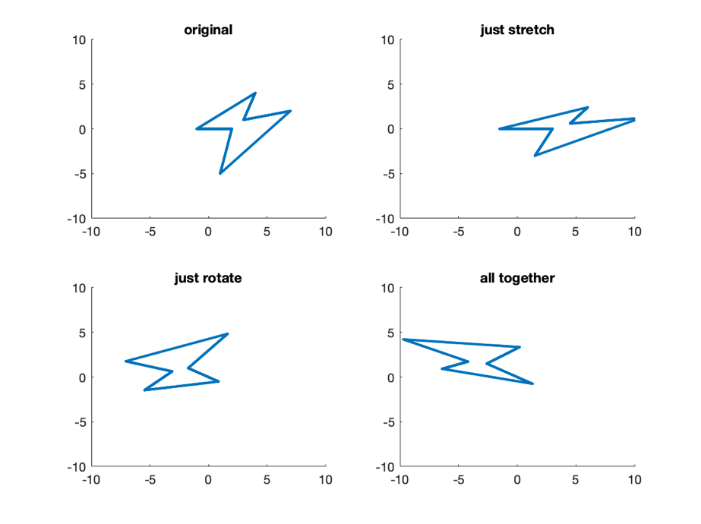

3d)

Using direct scaling of M:

T=[1, 0, 5;

0, 1, -0.5;

0, 0, 1]

T = 3×3

1.0000 0 5.0000

0 1.0000 -0.5000

0 0 1.0000

M=T*[A_rotate [0;0]; [0 0 0]]*[A_stretch [0;0]; [0 0 0]];

M=M(1:2,1:2);

I=eye(2,2);

figure; title('Direct scaling of M')

hold on;xlim([-10 10]); ylim([-10 10]);

color={[1 0 0] [1 0.5 0] [1 1 0] [0.5 1 0] [0 1 0] [0 1 0.5] [0 1 1] [0 0.5 1] [0 0 1] [0.5 0 1]};

for tn=0:1:9

t=tn/10;

for i=1:NX

X_M1(:, i)=(t.*M + (1-t).*I)*X(:,i);

end

plot(X_M1(1,:),X_M1(2,:),'.', 'Color', color{tn+1})

end

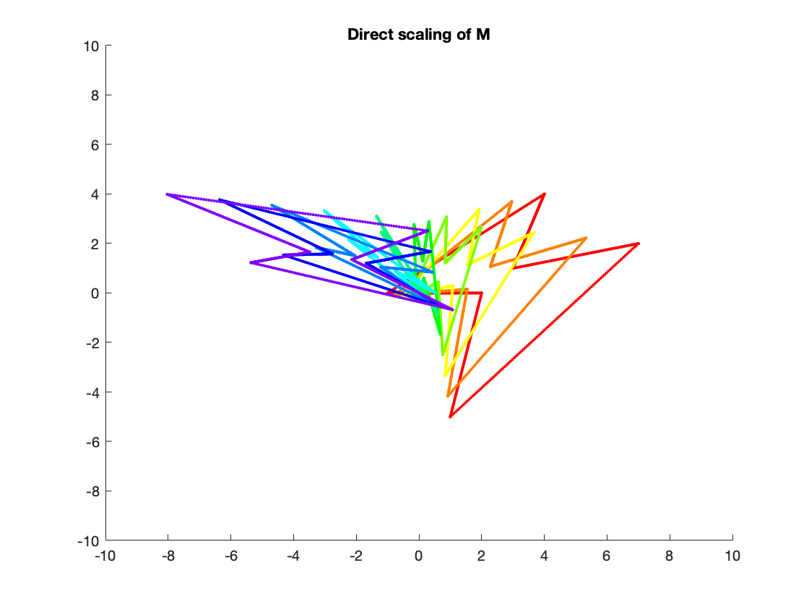

Using polar decomposition:

theta=acos(A_rotate(1,1));

disp(theta)

2.6183

theta_degree=theta*180/pi

theta_degree = 150.0184

S=[A_stretch [0;0]; [0 0 0]];

I=eye(3,3);

figure; title('Using polar decomposition')

hold on;xlim([-10 10]); ylim([-10 10]);

color={[1 0 0] [1 0.5 0] [1 1 0] [0.5 1 0] [0 1 0] [0 1 0.5] [0 1 1] [0 0.5 1] [0 0 1] [0.5 0 1]};

for tn=0:1:9

t=tn/10;

for i=1:NX

R_t_theta=[cos(theta*t), -sin(theta*t), 0;

sin(theta*t), cos(theta*t), 0;

0, 0, 0];

M2=(t.*T + ((1-t).*I))...

*R_t_theta...

*(t.*S + ((1-t).*I));

X_M2(:,i)=M2(1:2, 1:2)*X(:,i);

end

plot(X_M2(1,:),X_M2(2,:),'.', 'Color', color{tn+1})

end

