Homework #07

# 1

s1='takeasadsong'; s2='makeitbetter';

x=[6,-4,-2]; y=[53,-42,-13];

1a)

1b)

1c) A set of points where the distance from origin (radius) is the same.

# 2

2a)

% parameters:

N=1000; % number of vectors, make it even

% font size:

set(0,'defaulttextfontsize',16); set(0,'defaultaxesfontsize',16);

% loop over dimension:

for d=[3,2]

% setup a set of row vectors of uniformly distributed random

% numbers between -1 and 1 - each row of X is a vector:

X=2*(rand(N,d)-0.5);

Xnorm=zeros(N,1);

for i=1:N

Xnorm(i)=sqrt(sum(X(i,:).*X(i,:)));

end

i=0;

distances=NaN(N*(N-1)/2,1);

angles=NaN(N*(N-1)/2,1);

for n=1:N

for m=2:(n-1)

i=i+1;

diff=X(n,:)-X(m,:); distances(i)=sqrt(sum(diff.*diff));

angles(i)=acos(sum(X(n,:).*X(m,:))/(Xnorm(n)*Xnorm(m)));

end

end

dist_mean=mean(distances(1:i));

distances=distances(1:i)/dist_mean;

angle_mean=mean(angles(1:i))*180/pi;

angles=angles(1:i)*180/pi;

figure; clf

% plot distribution of distances:

[counts,centers]=hist(distances,100);

counts=counts/sum(counts);

bar(centers,counts,'edgecolor','none');

xlim([0,2]);

title(sprintf('distance distribution, dim=%d, $\\langle{}dist\\rangle$=%.2g',d,dist_mean) ...

,'interpreter','LaTeX');

xlabel('distance/mean');

ylabel('freq');

end

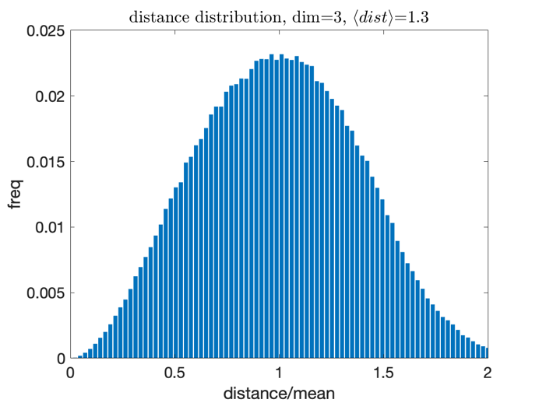

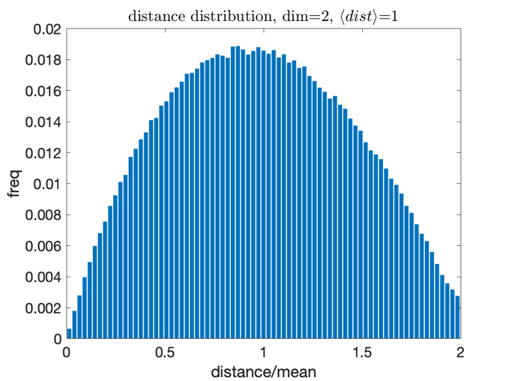

L3 distances are increasingly centered around the average of random squared distances (for all the dims), which is 1 in these random vectors, compared to L2 because as the dim increases, these random value differences will go towards this average, so the distribution will close in on this average.

2b) Because with L1, each dimension will add distance to the total distance, so with increasing n dims, there will be increasing n terms for the total L1 distance.

2c) So since the formula for the angle (cosine dist) is the arccos of the correlation between points, as dim increases, then the points will become less and less correlated and it will go towards the arccos of 0, or center around 90 degrees.

# 3

X=[ 5, 4.5, 6, 9, 9.5, 4, 2, 2.5, 5;...

9.5, 5, 9, 6, 4.5, 4, 5, 3, 8];

3a) **smallest increase in cluster variance:**

figure;clf; scatter(X(1,:),X(2,:));

box on; hold on;xlabel('x');ylabel('y');

for ii=1:length(X(1,:))

text(X(1,ii)+0.07,X(2,ii),num2str(ii)...

,'FontSize',20);end

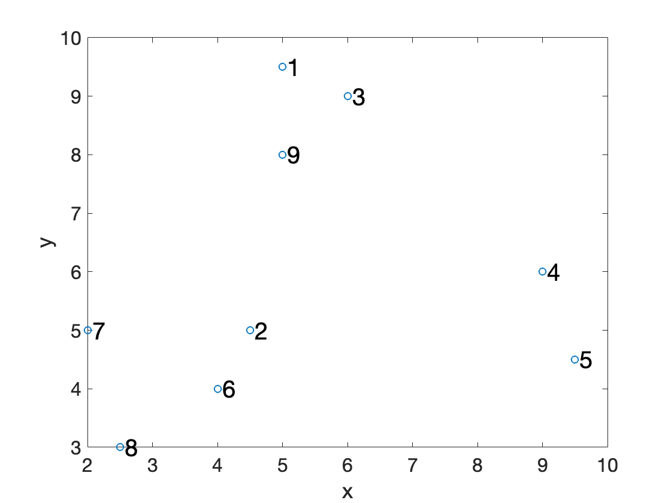

TF said only need to hand draw dendrogram for the first two mergings.

Rest of the clusters and dendrogram:

Xnew = horzcat(X, [4.25; 4.5], [5.5; 9.25]);

X_num = horzcat(ones(1, 9), 2, 2);

[M,N] = size(Xnew);

var_delta=[];

for a=1:1:N

for b=1:1:N

Na=X_num(:,a);

Nb=X_num(:,b);

xa=Xnew(:, a);

xb=Xnew(:,b);

var_delta(a, b) = (Na*Nb/(Na+Nb)) * (((xb-xa)'*(xb-xa)));

end

end

var_delta

var_delta = 11×11

0 10.2500 0.6250 14.1250 22.6250 15.6250 14.6250 ⋯

10.2500 0 9.1250 10.6250 12.6250 0.6250 3.1250

0.6250 9.1250 0 9.0000 16.2500 14.5000 16.0000

14.1250 10.6250 9.0000 0 1.2500 14.5000 25.0000

22.6250 12.6250 16.2500 1.2500 0 15.2500 28.2500

15.6250 0.6250 14.5000 14.5000 15.2500 0 2.5000

14.6250 3.1250 16.0000 25.0000 28.2500 2.5000 0

24.2500 4.0000 24.1250 25.6250 25.6250 1.6250 2.1250

1.1250 4.6250 1.0000 10.0000 16.2500 8.5000 9.0000

17.0417 0.2083 15.5417 16.5417 18.3750 0.2083 3.5417

⋮

Second smallest variance increase is between 9 and centroid of (1,3)

xc=(1/3)*sum(Xnew(:,9)+Xnew(:,1)+Xnew(:,3),2)

xc = 2×1

5.3333

8.8333

Xnew = horzcat(Xnew, xc);

X_num = horzcat(X_num, 3);

[M,N] = size(Xnew);

var_delta=[];

for a=1:1:N

for b=1:1:N

Na=X_num(:,a);

Nb=X_num(:,b);

xa=Xnew(:, a);

xb=Xnew(:,b);

var_delta(a, b) = (Na*Nb/(Na+Nb)) * (((xb-xa)'*(xb-xa)));

end

end

var_delta

var_delta = 12×12

0 10.2500 0.6250 14.1250 22.6250 15.6250 14.6250 ⋯

10.2500 0 9.1250 10.6250 12.6250 0.6250 3.1250

0.6250 9.1250 0 9.0000 16.2500 14.5000 16.0000

14.1250 10.6250 9.0000 0 1.2500 14.5000 25.0000

22.6250 12.6250 16.2500 1.2500 0 15.2500 28.2500

15.6250 0.6250 14.5000 14.5000 15.2500 0 2.5000

14.6250 3.1250 16.0000 25.0000 28.2500 2.5000 0

24.2500 4.0000 24.1250 25.6250 25.6250 1.6250 2.1250

1.1250 4.6250 1.0000 10.0000 16.2500 8.5000 9.0000

17.0417 0.2083 15.5417 16.5417 18.3750 0.2083 3.5417

⋮

Next smallest is 4 and 5

xc=(1/2)*sum(Xnew(:,4)+Xnew(:,5),2)

xc = 2×1

9.2500

5.2500

Xnew = horzcat(Xnew, xc);

X_num = horzcat(X_num, 2);

[M,N] = size(Xnew);

var_delta=[];

for a=1:1:N

for b=1:1:N

Na=X_num(:,a);

Nb=X_num(:,b);

xa=Xnew(:, a);

xb=Xnew(:,b);

var_delta(a, b) = (Na*Nb/(Na+Nb)) * (((xb-xa)'*(xb-xa)));

end

end

var_delta

var_delta = 13×13

0 10.2500 0.6250 14.1250 22.6250 15.6250 14.6250 ⋯

10.2500 0 9.1250 10.6250 12.6250 0.6250 3.1250

0.6250 9.1250 0 9.0000 16.2500 14.5000 16.0000

14.1250 10.6250 9.0000 0 1.2500 14.5000 25.0000

22.6250 12.6250 16.2500 1.2500 0 15.2500 28.2500

15.6250 0.6250 14.5000 14.5000 15.2500 0 2.5000

14.6250 3.1250 16.0000 25.0000 28.2500 2.5000 0

24.2500 4.0000 24.1250 25.6250 25.6250 1.6250 2.1250

1.1250 4.6250 1.0000 10.0000 16.2500 8.5000 9.0000

17.0417 0.2083 15.5417 16.5417 18.3750 0.2083 3.5417

⋮

Next smallest is 7 and 8

xc=(1/2)*sum(Xnew(:,7)+Xnew(:,8),2)

xc = 2×1

2.2500

4.0000

Xnew = horzcat(Xnew, xc);

X_num = horzcat(X_num, 2);

[M,N] = size(Xnew);

var_delta=[];

for a=1:1:N

for b=1:1:N

Na=X_num(:,a);

Nb=X_num(:,b);

xa=Xnew(:, a);

xb=Xnew(:,b);

var_delta(a, b) = (Na*Nb/(Na+Nb)) * (((xb-xa)'*(xb-xa)));

end

end

var_delta

var_delta = 14×14

0 10.2500 0.6250 14.1250 22.6250 15.6250 14.6250 ⋯

10.2500 0 9.1250 10.6250 12.6250 0.6250 3.1250

0.6250 9.1250 0 9.0000 16.2500 14.5000 16.0000

14.1250 10.6250 9.0000 0 1.2500 14.5000 25.0000

22.6250 12.6250 16.2500 1.2500 0 15.2500 28.2500

15.6250 0.6250 14.5000 14.5000 15.2500 0 2.5000

14.6250 3.1250 16.0000 25.0000 28.2500 2.5000 0

24.2500 4.0000 24.1250 25.6250 25.6250 1.6250 2.1250

1.1250 4.6250 1.0000 10.0000 16.2500 8.5000 9.0000

17.0417 0.2083 15.5417 16.5417 18.3750 0.2083 3.5417

⋮

Next smallest is between (2,6) (10 in my continuously updated Xnew matrix) and (7,8) (14 in Xnew)

xc=(1/4)*sum(Xnew(:,2)+Xnew(:,6)+Xnew(:,7)+Xnew(:,8),2)

xc = 2×1

3.2500

4.2500

Xnew = horzcat(Xnew, xc);

X_num = horzcat(X_num, 4);

[M,N] = size(Xnew);

var_delta=[];

for a=1:1:N

for b=1:1:N

Na=X_num(:,a);

Nb=X_num(:,b);

xa=Xnew(:, a);

xb=Xnew(:,b);

var_delta(a, b) = (Na*Nb/(Na+Nb)) * (((xb-xa)'*(xb-xa)));

end

end

var_delta

var_delta = 15×15

0 10.2500 0.6250 14.1250 22.6250 15.6250 14.6250 ⋯

10.2500 0 9.1250 10.6250 12.6250 0.6250 3.1250

0.6250 9.1250 0 9.0000 16.2500 14.5000 16.0000

14.1250 10.6250 9.0000 0 1.2500 14.5000 25.0000

22.6250 12.6250 16.2500 1.2500 0 15.2500 28.2500

15.6250 0.6250 14.5000 14.5000 15.2500 0 2.5000

14.6250 3.1250 16.0000 25.0000 28.2500 2.5000 0

24.2500 4.0000 24.1250 25.6250 25.6250 1.6250 2.1250

1.1250 4.6250 1.0000 10.0000 16.2500 8.5000 9.0000

17.0417 0.2083 15.5417 16.5417 18.3750 0.2083 3.5417

⋮

Finally, (1, 3, 9) (12 in Xnew) and (4,5) (13 in Xnew).

xc=(1/5)*sum(Xnew(:,1)+Xnew(:,3)+Xnew(:,9)+Xnew(:,4)+Xnew(:,5),2)

xc = 2×1

6.9000

7.4000

Xnew = horzcat(Xnew, xc);

X_num = horzcat(X_num, 5);

[M,N] = size(Xnew);

var_delta=[];

for a=1:1:N

for b=1:1:N

Na=X_num(:,a);

Nb=X_num(:,b);

xa=Xnew(:, a);

xb=Xnew(:,b);

var_delta(a, b) = (Na*Nb/(Na+Nb)) * (((xb-xa)'*(xb-xa)));

end

end

var_delta

var_delta = 16×16

0 10.2500 0.6250 14.1250 22.6250 15.6250 14.6250 ⋯

10.2500 0 9.1250 10.6250 12.6250 0.6250 3.1250

0.6250 9.1250 0 9.0000 16.2500 14.5000 16.0000

14.1250 10.6250 9.0000 0 1.2500 14.5000 25.0000

22.6250 12.6250 16.2500 1.2500 0 15.2500 28.2500

15.6250 0.6250 14.5000 14.5000 15.2500 0 2.5000

14.6250 3.1250 16.0000 25.0000 28.2500 2.5000 0

24.2500 4.0000 24.1250 25.6250 25.6250 1.6250 2.1250

1.1250 4.6250 1.0000 10.0000 16.2500 8.5000 9.0000

17.0417 0.2083 15.5417 16.5417 18.3750 0.2083 3.5417

⋮

In summary,

preZ=[2 6;

1 3;

9 11;

4 5;

7 8;

10 14;

12 13;

15 16]

preZ = 8×2

2 6

1 3

9 11

4 5

7 8

10 14

12 13

15 16

Finding the dendrogram y-axis,

% matlab version bc looks better on dendrogram

Z_vars = [ sqrt(2*var_delta(2,6));

sqrt(2*var_delta(1,3));

sqrt(2*var_delta(11,9));

sqrt(2*var_delta(4,5));

sqrt(2*var_delta(7,8));

sqrt(2*var_delta(10,14));

sqrt(2*var_delta(12,13));

sqrt(2*var_delta(15,16));

]

Z_vars = 8×1

1.1180

1.1180

1.5546

1.5811

2.0616

2.9155

8.2239

10.1642

dendro=horzcat(preZ, Z_vars);

dendrogram(dendro);

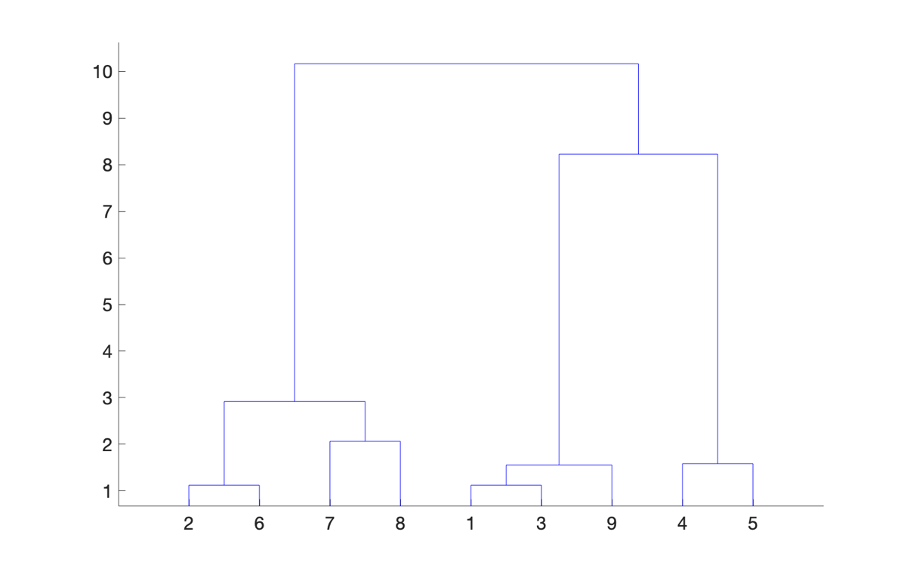

The vertical distances in the dendrogram represents how far along and the variance at merging for each instance of two cluster merging.

plot(1:1:8, flip(Z_vars'), '-o');

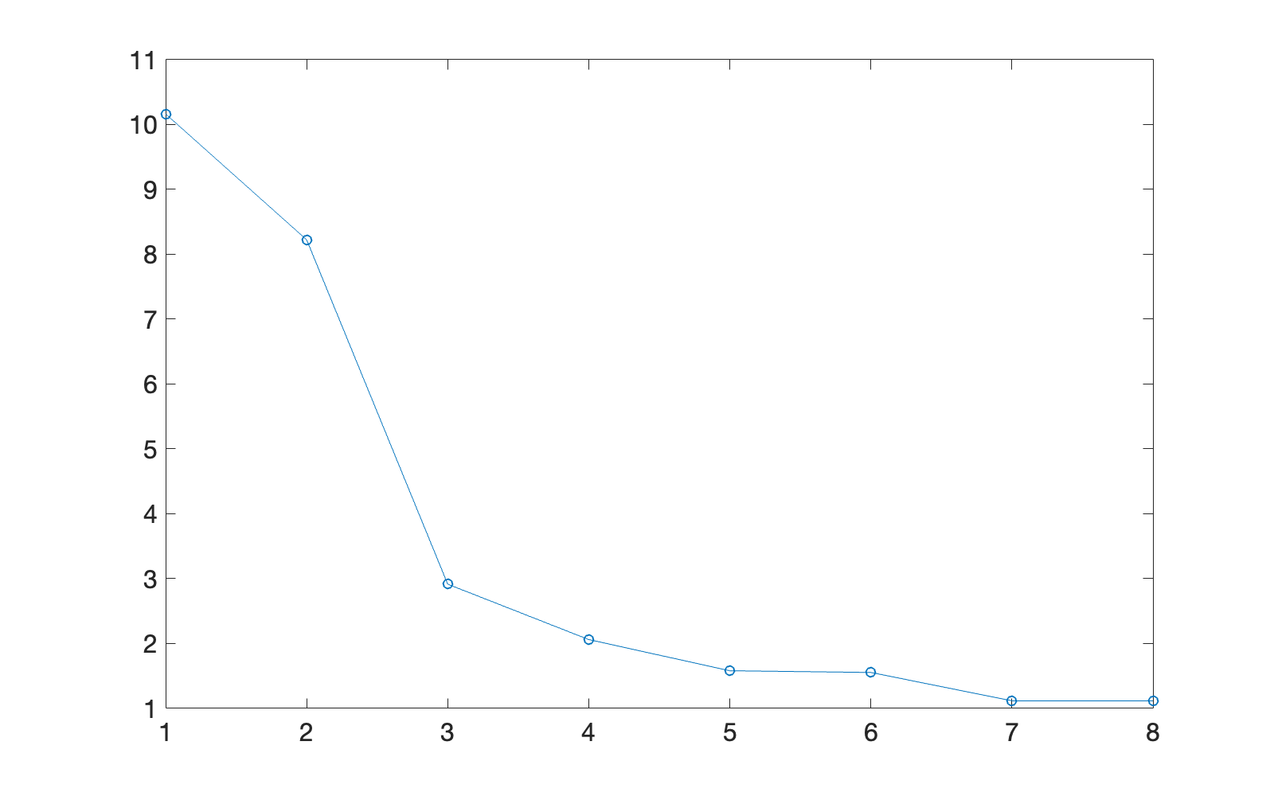

Ideally we want to find where the changes in variances start to increase way more as the clustering continues. From the elbow plot that looks like at around 3 clusters.

3b)

% Y is the Euclid distances of X

Y=pdist(X');

% convert to set of pairwise distance vectors

% so distances(i, j) is the dist between points i and j

distances=squareform(Y)

distances = 9×9

0 4.5277 1.1180 5.3151 6.7268 5.5902 5.4083 ⋯

4.5277 0 4.2720 4.6098 5.0249 1.1180 2.5000

1.1180 4.2720 0 4.2426 5.7009 5.3852 5.6569

5.3151 4.6098 4.2426 0 1.5811 5.3852 7.0711

6.7268 5.0249 5.7009 1.5811 0 5.5227 7.5166

5.5902 1.1180 5.3852 5.3852 5.5227 0 2.2361

5.4083 2.5000 5.6569 7.0711 7.5166 2.2361 0

6.9642 2.8284 6.9462 7.1589 7.1589 1.8028 2.0616

1.5000 3.0414 1.4142 4.4721 5.7009 4.1231 4.2426

% cluster by the cluster variance method ("Ward method")

Z=linkage(Y,'ward');

% plot dendrogram from Z

dendrogram(Z);

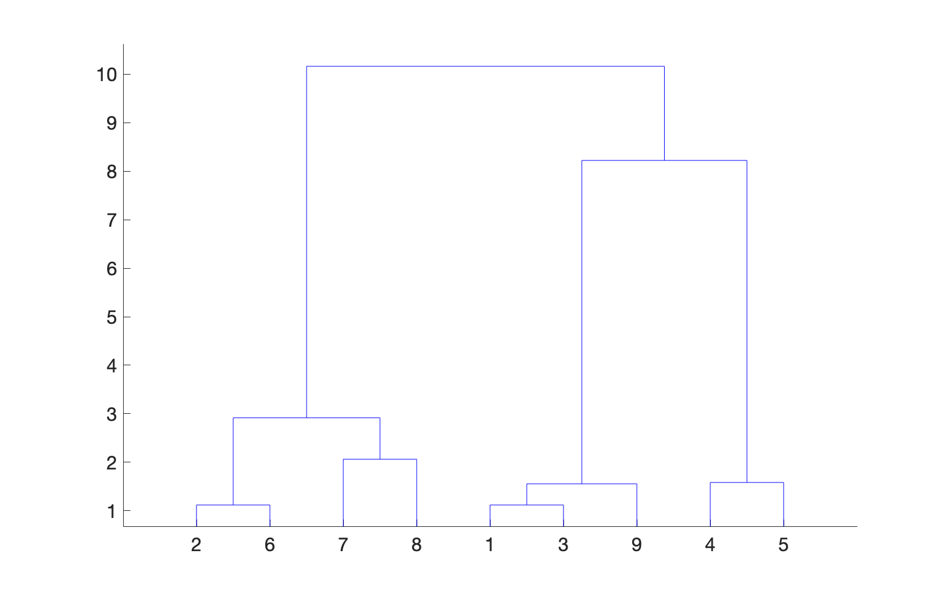

% set k to 3

k=3;

% idx is the cluster assignment for each point

% using 3 clusters

idx=cluster(Z,'maxclust',k)'

idx = 1×9

1 3 1 2 2 3 3 3 1

3c)

distances

distances = 9×9

0 4.5277 1.1180 5.3151 6.7268 5.5902 5.4083 ⋯

4.5277 0 4.2720 4.6098 5.0249 1.1180 2.5000

1.1180 4.2720 0 4.2426 5.7009 5.3852 5.6569

5.3151 4.6098 4.2426 0 1.5811 5.3852 7.0711

6.7268 5.0249 5.7009 1.5811 0 5.5227 7.5166

5.5902 1.1180 5.3852 5.3852 5.5227 0 2.2361

5.4083 2.5000 5.6569 7.0711 7.5166 2.2361 0

6.9642 2.8284 6.9462 7.1589 7.1589 1.8028 2.0616

1.5000 3.0414 1.4142 4.4721 5.7009 4.1231 4.2426

distances is a matrix of pairwise distance vectors between every point and every other point. So distances(i, j) is the dist between points i and j and the diagonal, distances between the same point and itself, is always 0.

Z

Z = 8×3

2.0000 6.0000 1.1180

1.0000 3.0000 1.1180

9.0000 11.0000 1.5546

4.0000 5.0000 1.5811

7.0000 8.0000 2.0616

10.0000 14.0000 2.9155

12.0000 13.0000 8.2239

15.0000 16.0000 10.1642

Z is the output matrix from the clustering method where each row is a newly formed cluster going down. The two clusters that were merged to create each newly formed cluster are the indices in the first two columns and the third column is the y axes for how far along before this cluster was formed. Each newly formed cluster then also gets a new index past the original number of datapoints (so past 9).

idx

idx = 1×9

1 3 1 2 2 3 3 3 1

This is the final cluster assignments for all the points. Each column has that respective datapoint's cluster assignment based on using k input number of clusters.

dendrogram(Z)



This function plots the dendrogram based on the cluster formation information from Z.

The results from Matlab's clustering analysis are the same as mine.

# 4

4a) TF said only need to find the initial clusteroids for each k

X=[ 5, 4.5, 6, 9, 9.5, 4, 2, 2.5, 5;

9.5, 5, 9, 6, 4.5, 4, 5, 3, 8];

ks=[2 3 4];

Y=pdist(X');

distances=squareform(Y)

distances = 9×9

0 4.5277 1.1180 5.3151 6.7268 5.5902 5.4083 ⋯

4.5277 0 4.2720 4.6098 5.0249 1.1180 2.5000

1.1180 4.2720 0 4.2426 5.7009 5.3852 5.6569

5.3151 4.6098 4.2426 0 1.5811 5.3852 7.0711

6.7268 5.0249 5.7009 1.5811 0 5.5227 7.5166

5.5902 1.1180 5.3852 5.3852 5.5227 0 2.2361

5.4083 2.5000 5.6569 7.0711 7.5166 2.2361 0

6.9642 2.8284 6.9462 7.1589 7.1589 1.8028 2.0616

1.5000 3.0414 1.4142 4.4721 5.7009 4.1231 4.2426

k=2: So the farthest pt from 4 is 8, so that's the second initial clusteroid pt. Then points that are closer to 4 will go to that clusteroid so (1, 3, 5, 9) and points closer to 8 will go to that clusteroid so (2, 6, 7).

idx = [1 2 1 1 1 2 2 2 1]

k=3: The pt with the greatest smallest dist out of distances to 4 and 8 is 1. So (5) is closest to and joins clusteroid 4, (2, 6, 7) for clusteroid 8, and (3, 9) for clusteroid 1.

idx = [1 3 1 2 2 3 3 3 1]

k=4: The pt with the greatest smallest dist out of distances to 4, 8, and 1 is 2. (5) for clusteroid 4, (7) for clusteroid 8, (3, 9) for clusteroid 1, (6) for clusteroid 2.

idx = [1 2 1 3 3 2 4 4 1]

4b)

4c)

ks=[2 3 4 5];

for i = 1:1:length(ks)

k = ks(1,i);

opts = statset('Display','final');

[idx,C] = kmeans(X',k, ...

'Distance','sqeuclidean' ...

,'Replicates',5,'Options',opts);

disp(['idx for k=' num2str(k) ' :']);disp(idx)

end

Replicate 1, 1 iterations, total sum of distances = 43.9.

Replicate 2, 1 iterations, total sum of distances = 53.5357.

Replicate 3, 2 iterations, total sum of distances = 43.9.

Replicate 4, 2 iterations, total sum of distances = 53.5357.

Replicate 5, 1 iterations, total sum of distances = 43.9.

Best total sum of distances = 43.9

idx for k=2 :

1

2

1

1

1

2

2

2

1

Replicate 1, 1 iterations, total sum of distances = 10.0833.

Replicate 2, 1 iterations, total sum of distances = 10.0833.

Replicate 3, 2 iterations, total sum of distances = 10.0833.

Replicate 4, 2 iterations, total sum of distances = 10.0833.

Replicate 5, 3 iterations, total sum of distances = 10.0833.

Best total sum of distances = 10.0833

idx for k=3 :

1

3

1

2

2

3

3

3

1

Replicate 1, 1 iterations, total sum of distances = 8.83333.

Replicate 2, 1 iterations, total sum of distances = 5.83333.

Replicate 3, 1 iterations, total sum of distances = 8.875.

Replicate 4, 1 iterations, total sum of distances = 5.83333.

Replicate 5, 1 iterations, total sum of distances = 5.83333.

Best total sum of distances = 5.83333

idx for k=4 :

1

4

1

3

3

4

2

2

1

Replicate 1, 1 iterations, total sum of distances = 4.625.

Replicate 2, 1 iterations, total sum of distances = 4.625.

Replicate 3, 1 iterations, total sum of distances = 3.70833.

Replicate 4, 1 iterations, total sum of distances = 7.625.

Replicate 5, 1 iterations, total sum of distances = 3.70833.

Best total sum of distances = 3.70833

idx for k=5 :

3

1

3

2

2

1

4

5

3

4d)

for i = 1:1:length(ks)

k = ks(1,i);

opts = statset('Display','final');

[idx,C] = kmeans(X',k, ...

'Distance','sqeuclidean' ...

,'Replicates',5,'Options',opts);

for j=1:1:k

pts = find(idx==j);

xc = (1/length(pts)) * sum(X(:,pts),2);

radius(i,j) = max(sum((X(:,pts) - xc).^2));

% also go ahead and find diameters

if length(pts) < 2

diameter(i,j) = 0;

else

diameter_mat = pdist(X(:, pts)');

diameter(i,j) = max(diameter_mat(:));

end

disp(['diameter for k=' num2str(k) ' cluster ' num2str(j) ':'])

disp(diameter(i,j))

end

end

Replicate 1, 1 iterations, total sum of distances = 43.9.

Replicate 2, 2 iterations, total sum of distances = 53.5357.

Replicate 3, 1 iterations, total sum of distances = 43.9.

Replicate 4, 1 iterations, total sum of distances = 43.9.

Replicate 5, 1 iterations, total sum of distances = 43.9.

Best total sum of distances = 43.9

diameter for k=2 cluster 1:

6.7268

diameter for k=2 cluster 2:

2.8284

Replicate 1, 1 iterations, total sum of distances = 10.0833.

Replicate 2, 1 iterations, total sum of distances = 10.0833.

Replicate 3, 1 iterations, total sum of distances = 10.0833.

Replicate 4, 4 iterations, total sum of distances = 10.0833.

Replicate 5, 1 iterations, total sum of distances = 10.0833.

Best total sum of distances = 10.0833

diameter for k=3 cluster 1:

1.5000

diameter for k=3 cluster 2:

2.8284

diameter for k=3 cluster 3:

1.5811

Replicate 1, 1 iterations, total sum of distances = 5.83333.

Replicate 2, 1 iterations, total sum of distances = 5.83333.

Replicate 3, 1 iterations, total sum of distances = 8.875.

Replicate 4, 1 iterations, total sum of distances = 5.83333.

Replicate 5, 1 iterations, total sum of distances = 7.83333.

Best total sum of distances = 5.83333

diameter for k=4 cluster 1:

1.1180

diameter for k=4 cluster 2:

2.0616

diameter for k=4 cluster 3:

1.5000

diameter for k=4 cluster 4:

1.5811

Replicate 1, 1 iterations, total sum of distances = 4.58333.

Replicate 2, 1 iterations, total sum of distances = 7.

Replicate 3, 1 iterations, total sum of distances = 6.04167.

Replicate 4, 1 iterations, total sum of distances = 3.70833.

Replicate 5, 1 iterations, total sum of distances = 4.625.

Best total sum of distances = 3.70833

diameter for k=5 cluster 1:

1.5000

diameter for k=5 cluster 2:

1.5811

diameter for k=5 cluster 3:

0

diameter for k=5 cluster 4:

1.1180

diameter for k=5 cluster 5:

0

So we want to minimize the max cluster radius,

plot(ks,max(radius, [], 2)', '-o')

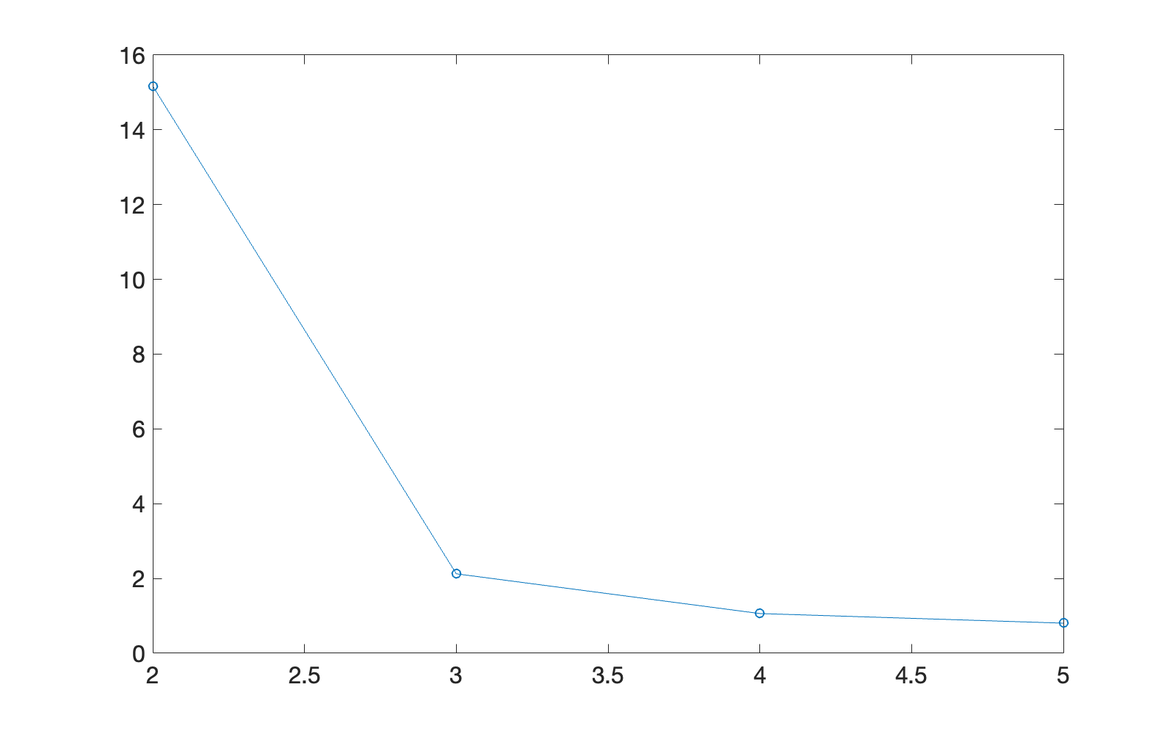

Ideally we want to find where the changes in max radius start to increase way more as k clustering continues. From the elbow plot that looks like at around 3 clusters.

4e)

In this case, they both gave the same clusters with the same datapoints. Our data does not spatially have any clusters that are more densely clustered than others or can equally give a minimum radius by splitting a cluster or something like that, so hierarchal clustering and making clusters one by one via variance increases and k-means clustering by slowly finding 3 spatially distant centroids and clusters of small-ish radius will give a similar result.