# Java terminology whack a mole

Find the Java that the terminology refers to!

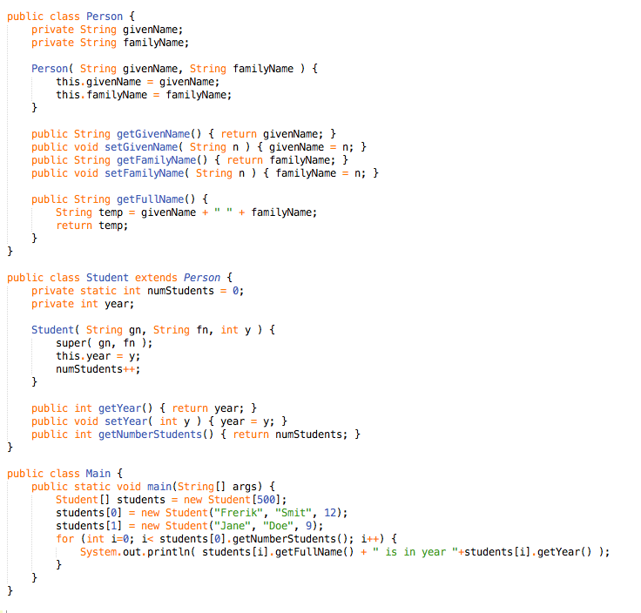

CAN YOU FIND THEM ALL?

class identifier primitive abstract instance variable

local variable method mutator accessor constructor

private public inheritance polymorphism access modifier

encapsulation static extends parameter variable return value

function array string integer assignment

comparison concatenation