Link Git: [paulbboone/HW-LAB2 (github.com)](https://github.com/paulbboone/HW-LAB2)

HW1:

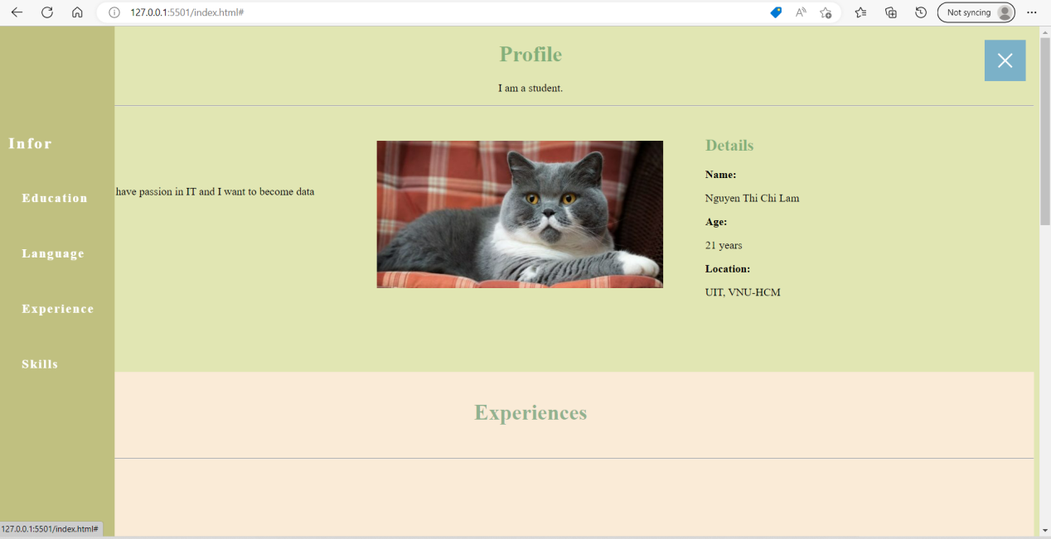

HW2:

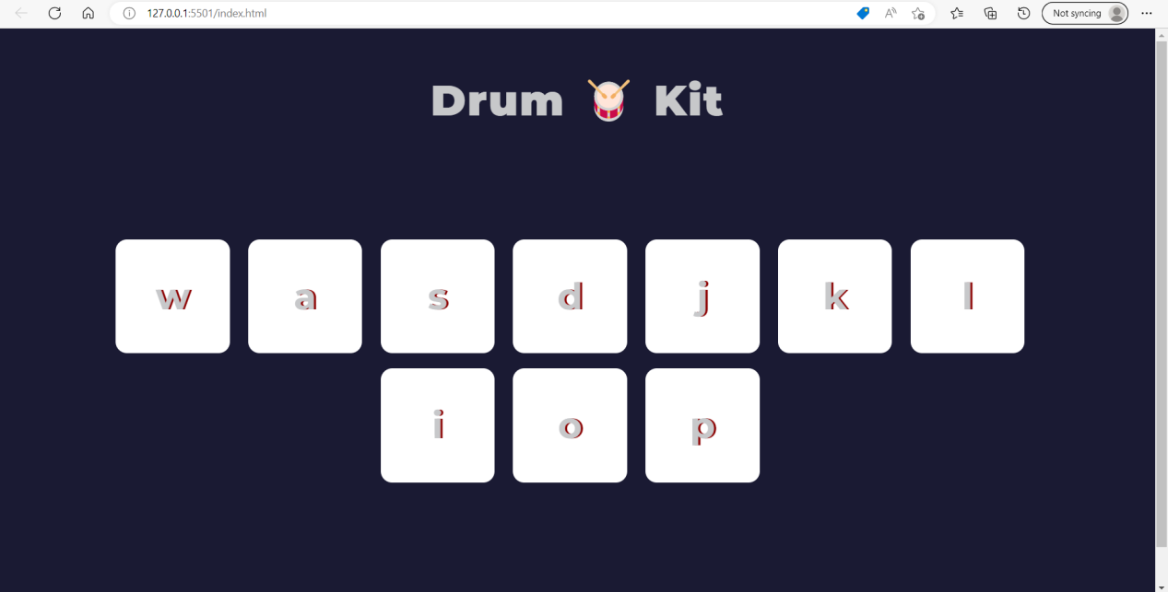

HW3:

