1. In vacancy posting, under experience can you please change the word ‘Fresher’ to ‘Fresh Graduate”

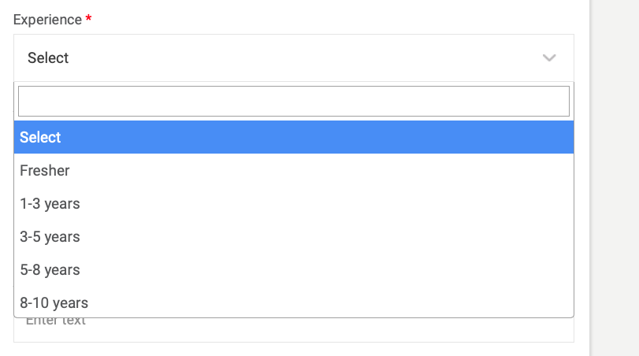

1. In vacancy posting under Education can you please set these in this particular order;
2. Secondary School Certificate
3. Diploma Certification
4. Bachelor’s Degree
5. Master’s Degree
6. Doctorate/PH.D

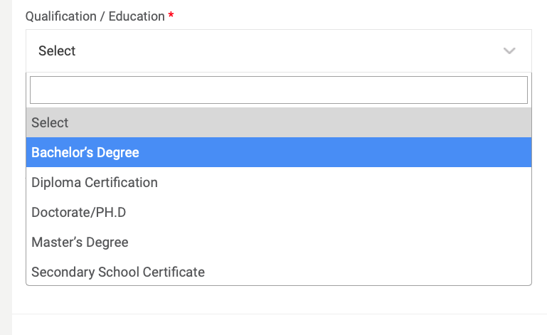

1. In vacancy posting under Contract type can you please do the following;

Change ‘Contract Type’ to “Employment Type”

Full Time

Part Time

Temporary/Contract

Internship

1. In candidate search- Advanced search, under ‘Notice Period’ can you please amend the fields to read:

* Immediately Available
* 1 month or less
* 2 months
* 3 months
* 6 months

1. Under employment status – Can you make it read:

* Employed
* Self-employed
* Unemployed

1. In the employer registration under ‘Position in Company” can it please read as follows:

* Officer
* Supervisor/Assistant Manager
* Manager/Senior Manager
* Head of Department
* General Manager
* Director/Executive Director
* Chief Financial Officer
* Chief Operating Officer
* Chief Executive Officer