**REGISTRATION MODIFICATION – JOBS4BAHRAINIS**

**First Page:**

* First Name
* Last Name
* Nationality
* Contact Number
* Email
* Confirm Email
* Password
* Confirm Password

**2nd Page: (Profile Summary)**

* Date of Birth
* Gender
* Marital Status
* Current Location
* Highest Level of Education
* Name of Educational Institution
* Industry/Sector
* Function
* Job Title/Designation
* Total number of years’ experience
* Profile description
* Add Profile Photo
* Add CV
* Add Identification

**3rd Page (Work History)**

**As is:**

**\*Once the job seeker completes these 3 information sections/pages (3 minutes) they will be successfully registered and will gain access to the J4B platform.**

**A message will pop up on the screen:**

**‘Congratulations you have successfully registered on the Jobs4Bahrainis career platform- Please check your email to activate your account. Your basic jobseeker profile is now complete however in order to stay ahead of the competition the J4B team recommend you complete the remaining information fields through your dashboard.**

Once the candidate activates their account through their email, they will be able to log in which will take them to their Jobseeker profile homepage. (As below)

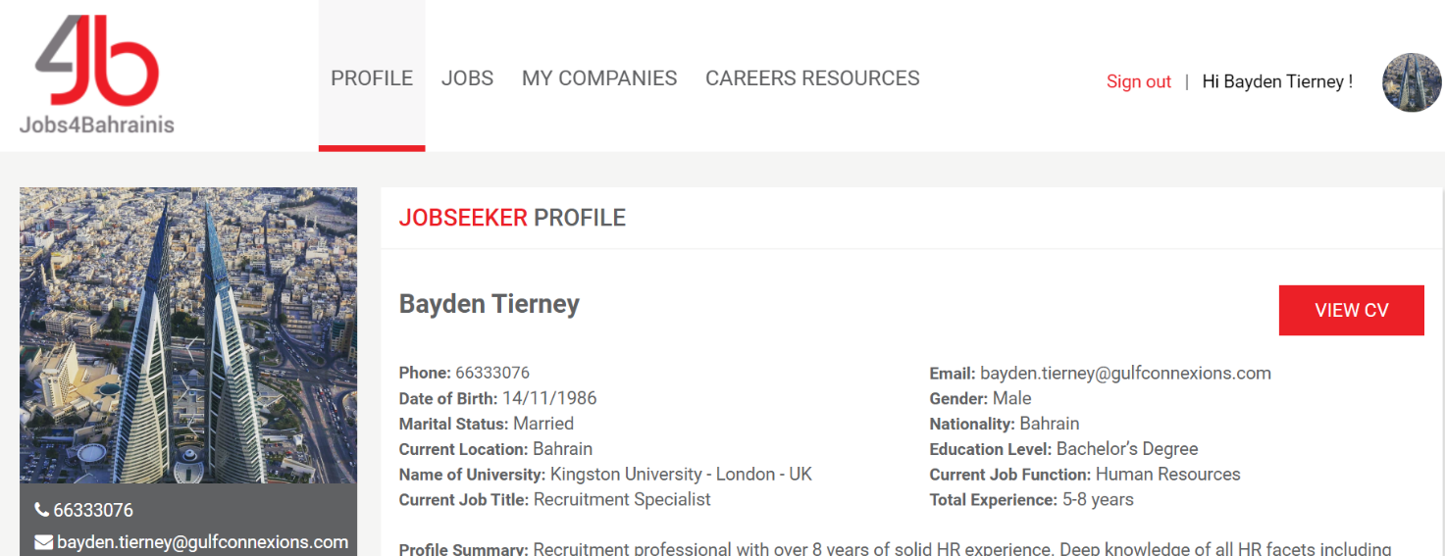

From here they can complete the remaining sectors/fields by using the side bar as is.

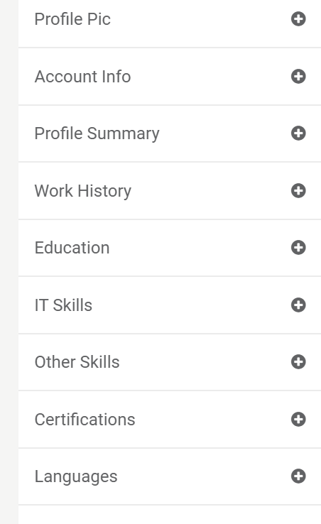

On this side bar we can have add a green tick and a red cross signifying that each section has been successfully completed or if it requires further attention and needs to be completed.

Eg:

* Languages: Completed

**×** IT Skills: Add/Finish

Somewhere on the Jobseeker’s home page we can have a profile completeness bar/graph to keep the candidate informed of the quality of their profile- Maybe if they complete their profile to 100%, they get a ‘5-star profile’ or something to that affect- This will incentivize them!

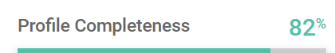

Tabs for the candidate to complete at a later date include:

* **Education:**
* **Skills**
* **Accomplishments**
* **Ideal Career Move.**

In an ideal world what I would like to happen is that a jobseeker can have access to the site, browse all of the available opportunities