Code-Switching and Sentiment in English-Tamil Bilingual Text
Paul Bontempo
2025-11-30

INTRODUCTION
This project investigates the relationship between sentiment and language choice in code-switched English-Tamil text from YouTube comments. We hypothesize that sentiment predicts both the proportion of English used and the frequency of language switches within utterances.
Research Questions: 1. Does sentiment category predict the proportion of English vs. Tamil in code-switched utterances? 2. Does sentiment category predict the frequency of language switches within utterances?
Proportion hypotheses H0: Utterance sentiment has no effect on proportion of embedded language to matrix language H1: Utterance sentiment predicts the proportion of embedded language to matrix language Frequency hypotheses H0: Utterance sentiment has no effect on the frequency of language switches H1: Utterance sentiment predicts the frequency of language switches

DATA IMPORT AND PREPARATION
library(tidyverse)
library(broom)
library(car)
# Import data
cs_data <- read.csv("entacs_data_complete.csv", stringsAsFactors = FALSE)
# Convert sentiment to factor with Positive as reference level
cs_data$sentiment <- factor(cs_data$sentiment,
levels = c("Positive", "Mixed_feelings", "Negative", "unknown"))
# Check structure
summary(cs_data)
## sentence_id sentiment en_proportion ta_proportion
## Length:35649 Positive :19871 Min. :0.0000 Min. :0.0000
## Class :character Mixed_feelings: 3855 1st Qu.:0.1250 1st Qu.:0.4286
## Mode :character Negative : 4479 Median :0.2857 Median :0.6667
## unknown : 7444 Mean :0.3307 Mean :0.6231
## 3rd Qu.:0.5000 3rd Qu.:0.8462
## Max. :1.0000 Max. :1.0000
## na_proportion num_switches sentence_length sentence
## Min. :0.00000 Min. : 0.000 Min. : 1.000 Length:35649
## 1st Qu.:0.00000 1st Qu.: 1.000 1st Qu.: 6.000 Class :character
## Median :0.00000 Median : 2.000 Median : 8.000 Mode :character
## Mean :0.04618 Mean : 2.283 Mean : 9.369
## 3rd Qu.:0.00000 3rd Qu.: 3.000 3rd Qu.:11.000
## Max. :1.00000 Max. :32.000 Max. :81.000

Data Overview
# Sentiment distribution
table(cs_data$sentiment)
##
## Positive Mixed_feelings Negative unknown
## 19871 3855 4479 7444
# Overall proportions
cat("Overall NA proportion:", mean(cs_data$na_proportion), "\n")
## Overall NA proportion: 0.04618302
cat("Overall English proportion:", mean(cs_data$en_proportion), "\n")
## Overall English proportion: 0.3307124
cat("Overall Tamil proportion:", mean(cs_data$ta_proportion), "\n")
## Overall Tamil proportion: 0.6231057
cat("Overall switches per sentence:", mean(cs_data$num_switches), "\n")
## Overall switches per sentence: 2.283234

Filter to Main Sentiment Categories
Focus on the three clear sentiment categories for primary analysis:
# Create filtered dataset for main analysis
cs_main <- cs_data %>%
filter(sentiment %in% c("Positive", "Mixed_feelings", "Negative"))
# Re-level factor to drop unused level
cs_main$sentiment <- droplevels(cs_main$sentiment)
# Summary of filtered data
cat("Sentences in main analysis:", nrow(cs_main), "\n")
## Sentences in main analysis: 28205
table(cs_main$sentiment)
##
## Positive Mixed_feelings Negative
## 19871 3855 4479

Distribution of English Proportion
ggplot(cs_main, aes(x = en_proportion)) +
geom_histogram(binwidth = 0.05, fill = "steelblue", color = "black") +
facet_wrap(~sentiment) +
labs(title = "Distribution of English Proportion by Sentiment",
x = "English Proportion", y = "Count") +
theme_minimal()
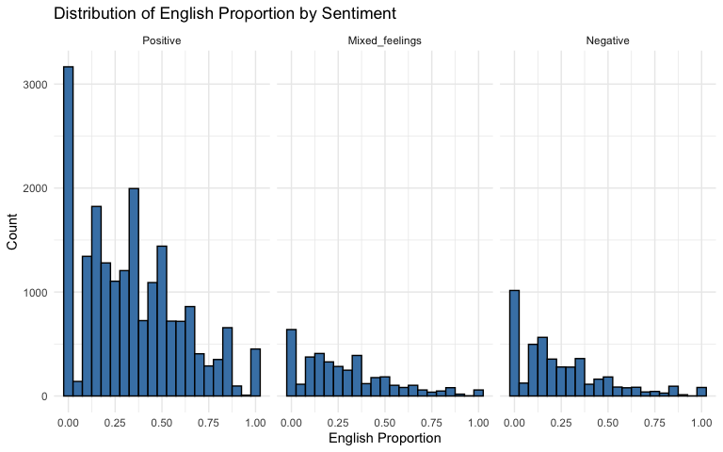

Boxplot: English Proportion by Sentiment
ggplot(cs_main, aes(x = sentiment, y = en_proportion, fill = sentiment)) +
geom_boxplot(outlier.shape = 1) +
stat_summary(fun = mean, geom = "point", shape = 23, size = 3, fill = "white") +
ylim(0, 1) + # Show full scale from 0 to 1
labs(title = "English Proportion by Sentiment",
x = "Sentiment", y = "English Proportion") +
theme_minimal() +
theme(legend.position = "none")
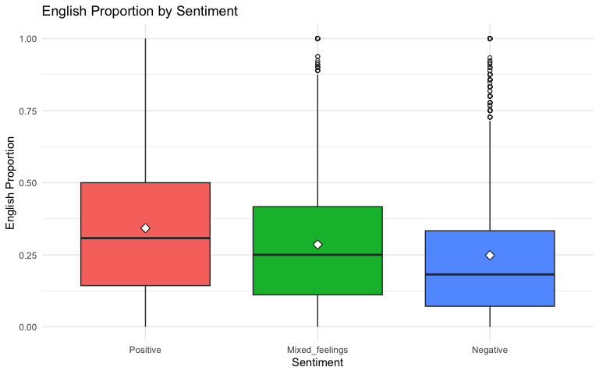
# Summary statistics
cs_main %>%
group_by(sentiment) %>%
summarise(
n = n(),
mean_en = mean(en_proportion),
sd_en = sd(en_proportion),
median_en = median(en_proportion)
)
## # A tibble: 3 × 5
## sentiment n mean_en sd_en median_en
## <fct> <int> <dbl> <dbl> <dbl>
## 1 Positive 19871 0.343 0.261 0.308
## 2 Mixed_feelings 3855 0.285 0.239 0.25
## 3 Negative 4479 0.248 0.238 0.182

Boxplot: Number of Switches by Sentiment
ggplot(cs_main, aes(x = sentiment, y = num_switches, fill = sentiment)) +
geom_boxplot(outlier.shape = 1) +
stat_summary(fun = mean, geom = "point", shape = 23, size = 3, fill = "white") +
coord_cartesian(ylim = c(0, max(cs_main$num_switches))) + # Show all data including outliers
labs(title = "Language Switches per Utterance by Sentiment",
x = "Sentiment", y = "Number of Switches") +
theme_minimal() +
theme(legend.position = "none")
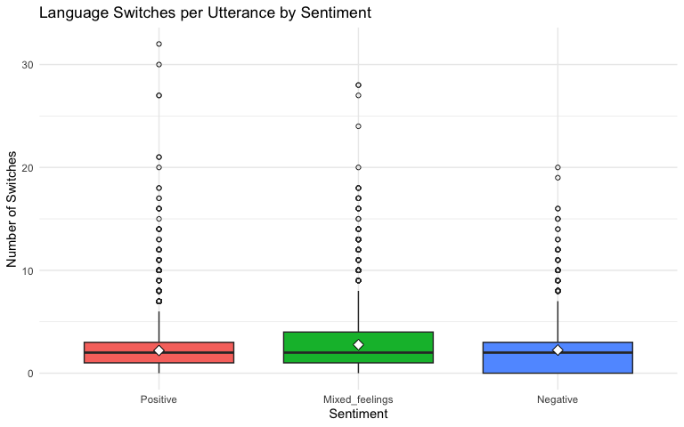
# Summary statistics
cs_main %>%
group_by(sentiment) %>%
summarise(
n = n(),
mean_switches = mean(num_switches),
sd_switches = sd(num_switches),
median_switches = median(num_switches)
)
## # A tibble: 3 × 5
## sentiment n mean_switches sd_switches median_switches
## <fct> <int> <dbl> <dbl> <int>
## 1 Positive 19871 2.20 1.95 2
## 2 Mixed_feelings 3855 2.77 2.74 2
## 3 Negative 4479 2.25 2.20 2

EXPERIMENT 1: LANGUAGE AS A FUNCTION OF SENTIMENT

1a: Simple Linear Model
# Model 1a: English proportion predicted by sentiment
model1a <- lm(en_proportion ~ sentiment, data = cs_main)
summary(model1a)
##
## Call:
## lm(formula = en_proportion ~ sentiment, data = cs_main)
##
## Residuals:
## Min 1Q Median 3Q Max
## -0.34252 -0.19962 -0.04252 0.15748 0.75188
##
## Coefficients:
## Estimate Std. Error t value Pr(>|t|)
## (Intercept) 0.342524 0.001804 189.83 <2e-16 ***
## sentimentMixed_feelings -0.057095 0.004476 -12.76 <2e-16 ***
## sentimentNegative -0.094407 0.004207 -22.44 <2e-16 ***
## ---
## Signif. codes: 0 '***' 0.001 '**' 0.01 '*' 0.05 '.' 0.1 ' ' 1
##
## Residual standard error: 0.2544 on 28202 degrees of freedom
## Multiple R-squared: 0.02031, Adjusted R-squared: 0.02024
## F-statistic: 292.4 on 2 and 28202 DF, p-value: < 2.2e-16

Q-Q Plot (Simple Model)
# Q-Q plot to check normality of residuals
qqnorm(resid(model1a), main = "Q-Q Plot Residuals (Model 1a)")
qqline(resid(model1a), col = "red")
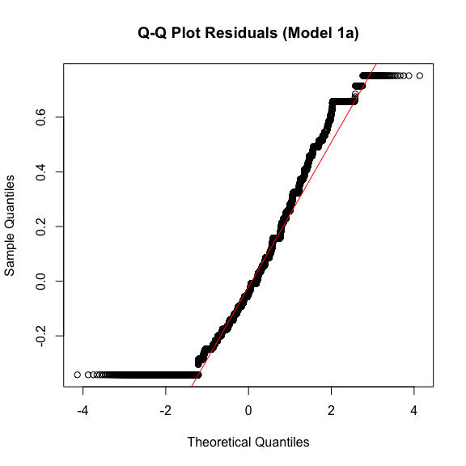

Coefficient Plot w/ Confidence Intervals (Simple Model)
# Extract coefficients
model1a_coefs <- tidy(model1a, conf.int = TRUE) %>%
filter(term != "(Intercept)") %>%
arrange(estimate) %>%
mutate(term = factor(term, levels = term))
# Dot-and-whiskers plot
ggplot(model1a_coefs, aes(x = term, y = estimate)) +
geom_point(size = 3) +
geom_errorbar(aes(ymin = conf.low, ymax = conf.high), width = 0.2) +
geom_hline(yintercept = 0, linetype = "dashed", color = "red") +
coord_flip() +
labs(title = "Effect of Sentiment on English Proportion",
subtitle = "(Model 1a; Reference Level: Positive)",
x = "Predictor", y = "Coefficient Estimate (95% CI)") +
theme_minimal()
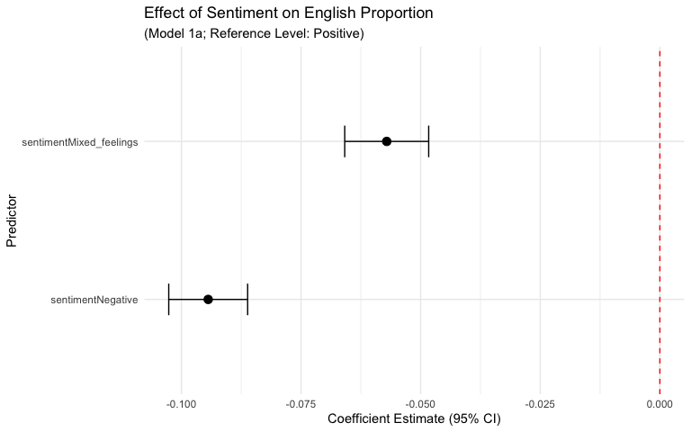

Model Fit (Simple Model)
# Model fit
cat("R-squared:", summary(model1a)$r.squared, "\n")
## R-squared: 0.02031247
cat("Adjusted R-squared:", summary(model1a)$adj.r.squared, "\n\n")
## Adjusted R-squared: 0.02024299

1b: Interaction Model Proportion ~ Sentiment * Sentence Length
# Model 1b: English proportion predicted by sentiment, sentence length, and their interaction
model1b <- lm(en_proportion ~ sentiment * sentence_length, data = cs_main)
summary(model1b)
##
## Call:
## lm(formula = en_proportion ~ sentiment * sentence_length, data = cs_main)
##
## Residuals:
## Min 1Q Median 3Q Max
## -0.3906 -0.1924 -0.0272 0.1533 0.7601
##
## Coefficients:
## Estimate Std. Error t value Pr(>|t|)
## (Intercept) 0.3969553 0.0042497 93.408 < 2e-16
## sentimentMixed_feelings -0.0511138 0.0078558 -6.507 7.82e-11
## sentimentNegative -0.0895277 0.0090329 -9.911 < 2e-16
## sentence_length -0.0063149 0.0004471 -14.125 < 2e-16
## sentimentMixed_feelings:sentence_length 0.0012696 0.0006236 2.036 0.0418
## sentimentNegative:sentence_length 0.0004572 0.0008250 0.554 0.5795
##
## (Intercept) ***
## sentimentMixed_feelings ***
## sentimentNegative ***
## sentence_length ***
## sentimentMixed_feelings:sentence_length *
## sentimentNegative:sentence_length
## ---
## Signif. codes: 0 '***' 0.001 '**' 0.01 '*' 0.05 '.' 0.1 ' ' 1
##
## Residual standard error: 0.2526 on 28199 degrees of freedom
## Multiple R-squared: 0.0342, Adjusted R-squared: 0.03403
## F-statistic: 199.7 on 5 and 28199 DF, p-value: < 2.2e-16

Q-Q Plot (Interaction Model)
# Q-Q plot for model with interaction
qqnorm(resid(model1b), main = "Q-Q Plot Residuals (Model 1b with Interaction)")
qqline(resid(model1b), col = "red")
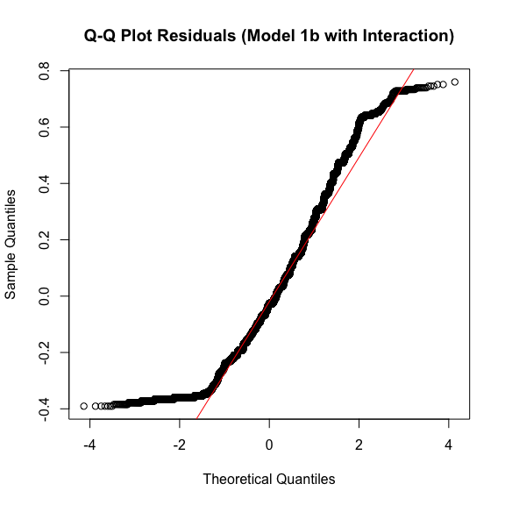

Coefficient Plot w/ Confidence Intervals (Interaction Model)
# Extract coefficients from interaction model
model1b_coefs <- tidy(model1b, conf.int = TRUE) %>%
filter(term != "(Intercept)") %>%
arrange(estimate) %>%
mutate(term = factor(term, levels = term))
# Dot-and-whiskers plot
ggplot(model1b_coefs, aes(x = term, y = estimate)) +
geom_point(size = 3) +
geom_errorbar(aes(ymin = conf.low, ymax = conf.high), width = 0.2) +
geom_hline(yintercept = 0, linetype = "dashed", color = "red") +
coord_flip() +
labs(title = "Effect of Sentiment and Length on English Proportion",
subtitle = "(Model 1b; Reference Level: Positive)",
x = "Predictor", y = "Coefficient Estimate (95% CI)") +
theme_minimal()
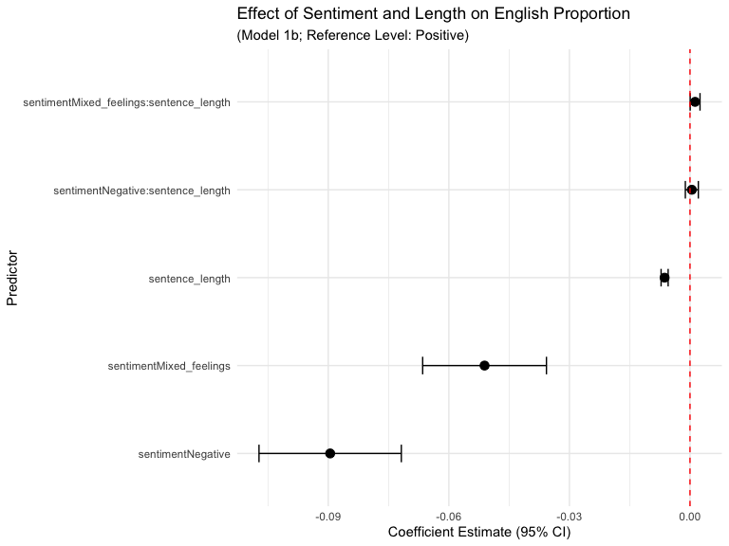

1c: Model Comparison
# Compare models with ANOVA
anova(model1a, model1b)
## Analysis of Variance Table
##
## Model 1: en_proportion ~ sentiment
## Model 2: en_proportion ~ sentiment * sentence_length
## Res.Df RSS Df Sum of Sq F Pr(>F)
## 1 28202 1824.6
## 2 28199 1798.7 3 25.866 135.17 < 2.2e-16 ***
## ---
## Signif. codes: 0 '***' 0.001 '**' 0.01 '*' 0.05 '.' 0.1 ' ' 1
# Compare R-squared values
cat("Model 1a R-squared:", summary(model1a)$r.squared, "\n")
## Model 1a R-squared: 0.02031247
cat("Model 1b (with interaction) R-squared:", summary(model1b)$r.squared, "\n")
## Model 1b (with interaction) R-squared: 0.03420127

Interaction Visualization
# Plot actual data points with fitted regression lines
ggplot(cs_main, aes(x = sentence_length, y = en_proportion, color = sentiment)) +
geom_point(alpha = 0.3, size = 0.8) + # Actual data points
geom_smooth(method = "lm", se = TRUE, linewidth = 1.2) + # Fitted lines with confidence bands
ylim(0, 1) +
labs(title = "English Proportion by Sentiment and Sentence Length",
subtitle = "Points show actual data; lines show linear model fits",
x = "Sentence Length (tokens)",
y = "English Proportion",
color = "Sentiment") +
theme_minimal()
## `geom_smooth()` using formula = 'y ~ x'
## Warning: Removed 40 rows containing missing values or values outside the scale range
## (`geom_smooth()`).
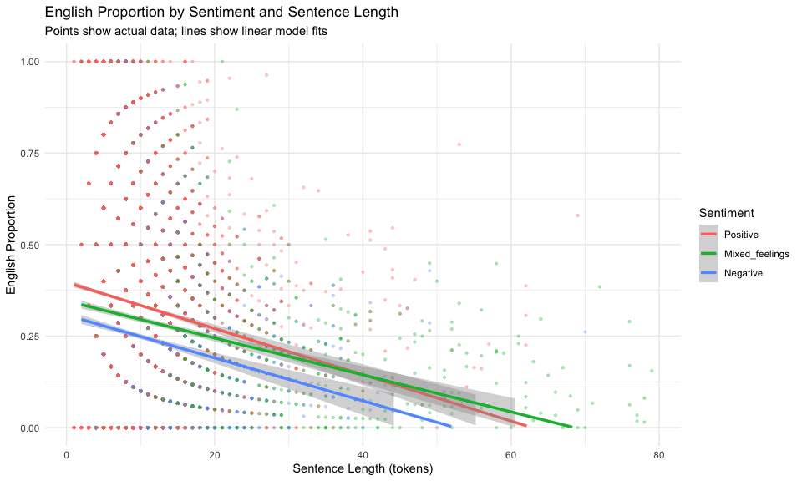

EXPERIMENT 2: SWITCHES AS FUNCTION OF SENTIMENT

2a: Simple Linear Model
# Model 2a: Number of language switches per utterance predicted by sentiment
model2a <- lm(num_switches ~ sentiment, data = cs_main)
summary(model2a)
##
## Call:
## lm(formula = num_switches ~ sentiment, data = cs_main)
##
## Residuals:
## Min 1Q Median 3Q Max
## -2.7715 -1.2460 -0.2048 0.7952 29.7952
##
## Coefficients:
## Estimate Std. Error t value Pr(>|t|)
## (Intercept) 2.20482 0.01499 147.098 <2e-16 ***
## sentimentMixed_feelings 0.56664 0.03719 15.239 <2e-16 ***
## sentimentNegative 0.04122 0.03495 1.179 0.238
## ---
## Signif. codes: 0 '***' 0.001 '**' 0.01 '*' 0.05 '.' 0.1 ' ' 1
##
## Residual standard error: 2.113 on 28202 degrees of freedom
## Multiple R-squared: 0.008243, Adjusted R-squared: 0.008172
## F-statistic: 117.2 on 2 and 28202 DF, p-value: < 2.2e-16

Q-Q Plot (Simple Model)
# Q-Q plot to check normality of residuals
qqnorm(resid(model2a), main = "Q-Q Plot Residuals (Model 2a)")
qqline(resid(model2a), col = "red")
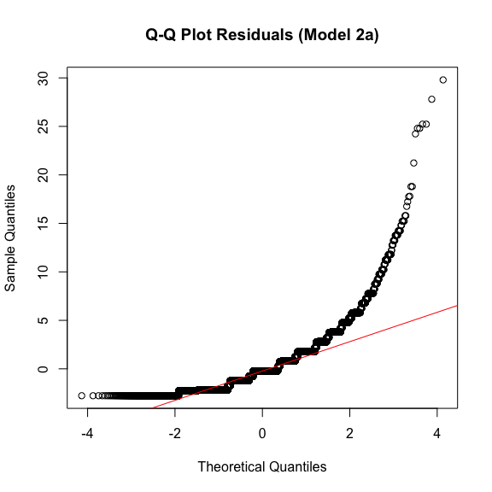

Coefficient Plot (Simple Model)
# Extract coefficients
model2a_coefs <- tidy(model2a, conf.int = TRUE) %>%
filter(term != "(Intercept)") %>%
arrange(estimate) %>%
mutate(term = factor(term, levels = term))
# Dot-and-whiskers plot
ggplot(model2a_coefs, aes(x = term, y = estimate)) +
geom_point(size = 3) +
geom_errorbar(aes(ymin = conf.low, ymax = conf.high), width = 0.2) +
geom_hline(yintercept = 0, linetype = "dashed", color = "red") +
coord_flip() +
labs(title = "Effect of Sentiment on Language Switches",
subtitle = "(Model 2a; Reference: Positive sentiment)",
x = "Predictor", y = "Coefficient Estimate (95% CI)") +
theme_minimal()
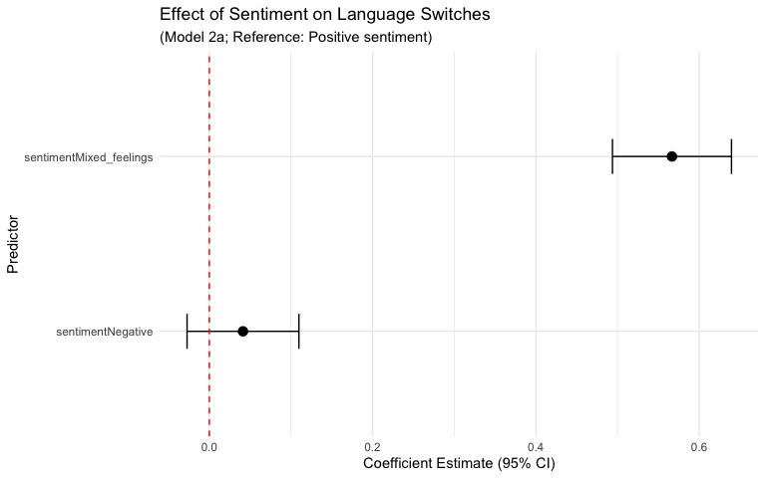

Model Fit (Simple Model)
# Model fit
cat("R-squared:", summary(model2a)$r.squared, "\n")
## R-squared: 0.008242772
cat("Adjusted R-squared:", summary(model2a)$adj.r.squared, "\n\n")
## Adjusted R-squared: 0.00817244

2b: Interaction Model Language Switches ~ Sentiment * Sentence Length
# Model 2b: Switches predicted by sentiment, sentence length, and their interaction
model2b <- lm(num_switches ~ sentiment * sentence_length, data = cs_main)
summary(model2b)
##
## Call:
## lm(formula = num_switches ~ sentiment * sentence_length, data = cs_main)
##
## Residuals:
## Min 1Q Median 3Q Max
## -13.2989 -1.2344 -0.0387 1.0072 18.4323
##
## Coefficients:
## Estimate Std. Error t value Pr(>|t|)
## (Intercept) -0.106071 0.029721 -3.569 0.000359
## sentimentMixed_feelings 1.003063 0.054941 18.257 < 2e-16
## sentimentNegative 0.073590 0.063174 1.165 0.244077
## sentence_length 0.268099 0.003127 85.745 < 2e-16
## sentimentMixed_feelings:sentence_length -0.111554 0.004362 -25.577 < 2e-16
## sentimentNegative:sentence_length -0.043066 0.005770 -7.464 8.66e-14
##
## (Intercept) ***
## sentimentMixed_feelings ***
## sentimentNegative
## sentence_length ***
## sentimentMixed_feelings:sentence_length ***
## sentimentNegative:sentence_length ***
## ---
## Signif. codes: 0 '***' 0.001 '**' 0.01 '*' 0.05 '.' 0.1 ' ' 1
##
## Residual standard error: 1.766 on 28199 degrees of freedom
## Multiple R-squared: 0.307, Adjusted R-squared: 0.3069
## F-statistic: 2498 on 5 and 28199 DF, p-value: < 2.2e-16

Q-Q Plot (Interaction Model)
# Q-Q plot for model with interaction term
qqnorm(resid(model2b), main = "Q-Q Plot Residuals (Model 2b with Interaction)")
qqline(resid(model2b), col = "red")
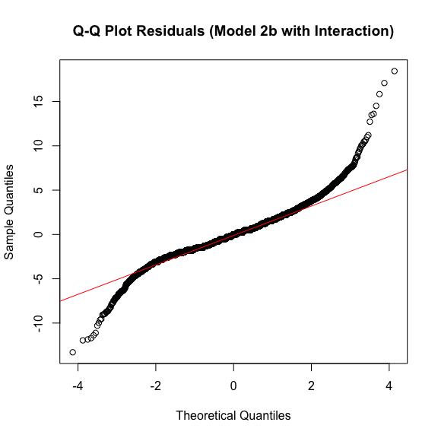

Coefficient Plot (Interaction Model)
# Extract coefficients
model2b_coefs <- tidy(model2b, conf.int = TRUE) %>%
filter(term != "(Intercept)") %>%
arrange(estimate) %>%
mutate(term = factor(term, levels = term))
# Dot-and-whiskers plot
ggplot(model2b_coefs, aes(x = term, y = estimate)) +
geom_point(size = 3) +
geom_errorbar(aes(ymin = conf.low, ymax = conf.high), width = 0.2) +
geom_hline(yintercept = 0, linetype = "dashed", color = "red") +
coord_flip() +
labs(title = "Effect of Sentiment and Length on Language Switches",
subtitle = "(Model 2b; Reference Level: Positive)",
x = "Predictor", y = "Coefficient Estimate (95% CI)") +
theme_minimal()
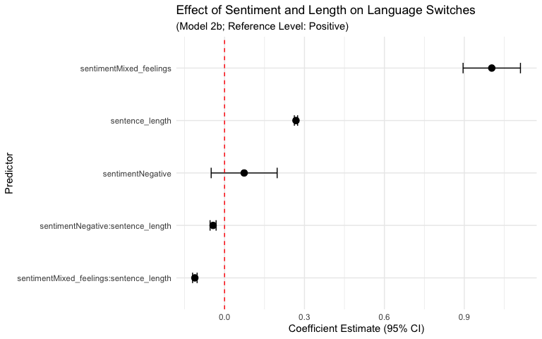

2c: Model Comparison
# Compare models with ANOVA
anova(model2a, model2b)
## Analysis of Variance Table
##
## Model 1: num_switches ~ sentiment
## Model 2: num_switches ~ sentiment * sentence_length
## Res.Df RSS Df Sum of Sq F Pr(>F)
## 1 28202 125903
## 2 28199 87978 3 37925 4051.9 < 2.2e-16 ***
## ---
## Signif. codes: 0 '***' 0.001 '**' 0.01 '*' 0.05 '.' 0.1 ' ' 1
# Compare R-squared values
cat("Model 2a R-squared:", summary(model2a)$r.squared, "\n")
## Model 2a R-squared: 0.008242772
cat("Model 2b (with interaction) R-squared:", summary(model2b)$r.squared, "\n")
## Model 2b (with interaction) R-squared: 0.306981

Visualization of Interaction
# Plot actual data points with fitted regression lines
ggplot(cs_main, aes(x = sentence_length, y = num_switches, color = sentiment)) +
geom_point(alpha = 0.3, size = 0.8) + # Actual data points
geom_smooth(method = "lm", se = TRUE, linewidth = 1.2) + # Fitted lines with confidence bands
labs(title = "Language Switches by Sentiment and Sentence Length",
subtitle = "Points show actual data; lines show linear model fits",
x = "Sentence Length (tokens)",
y = "Number of Language Switches",
color = "Sentiment") +
theme_minimal()
## `geom_smooth()` using formula = 'y ~ x'
