August 11, 2014  
Paul C. Cross  
2327 University Way, Suite 2  
Bozeman MT 59715  
Phone: 406/994-6908; Fax: 406/994-6556  
Email: pcross@usgs.gov

RH: Cross et al. Cause-specific hazards

**Estimating the phenology of elk brucellosis transmission with hierarchical models of cause-specific and baseline hazards**

PAUL C. CROSS, *U.S. Geological Survey, Northern Rocky Mountain Science Center, Bozeman MT, 59715 USA* ERIC J. MAICHAK, *Wyoming Game and Fish Department, Pinedale WY, 82941 USA*  
JARED D. ROGERSON, *Wyoming Game and Fish Department, Pinedale WY, 82941 USA*  
KATHRYN M. IRVINE, *U.S. Geological Survey, Northern Rocky Mountain Science Center, Bozeman MT, 59715 USA*  
JENNIFER JONES, *U.S. Geological Survey, Northern Rocky Mountain Science Center, Bozeman MT, 59715 USA*  
DENNIS M. HEISEY, *U.S. Geological Survey, National Wildlife Health Center, Madison WI, 53711 USA*  
WILLIAM H. EDWARDS, *Wyoming Game and Fish Department, Laramie WY, 82070 USA*  
BRANDON. M. SCURLOCK, *Wyoming Game and Fish Department, Pinedale WY, 82941 USA*

*Peer Review disclaimer*: This draft manuscript is distributed solely for purposes of scientific peer review. Its content is deliberative and predecisional, so it must not be disclosed or released by reviewers. Because the manuscript has not yet been approved for publication by the U.S. Geological Survey (USGS), it does not represent any official USGS finding or policy.

**ABSTRACT** Understanding the seasonal timing of disease transmission can lead to more effective control strategies, but the seasonality of transmission is often unknown for directly-transmitted pathogens. We inserted vaginal implant transmitters (VITs) in 580 elk (*Cervus canadensis*) from 2006 to 2014 to assess when reproductive failures (*i.e.*, abortions or still births) occur, which is the primary transmission route of *Brucella abortus*, the causative agent of brucellosis in the Greater Yellowstone Ecosystem. Using a survival analysis framework, we developed a Bayesian hierarchical model that simultaneously estimated the total baseline hazard of a reproductive event as well as its two, mutually-exclusive, parts (abortions or live births). Approximately 16% (95% CI = [0.10, 0.23]) of the pregnant seropositive elk had reproductive failures, while 2% (95% CI = [0.01, 0.04]) of the seronegative elk aborted. The timing of events was only known to an interval, but reproductive failures could have occurred as early as January 22nd and as late as July 10th, peaking from March through May. Model results suggest that less than 5% of abortions are likely to occur after June 5th each year and abortions are five to six times more likely in March, April or May compared to February or June. In this region, supplemental feeding of elk begins in December and ends during the peak of elk abortions and brucellosis transmission (*i.e.* March and April). Years with more snow may enhance elk-to-elk transmission on supplemental feeding areas because elk are artificially aggregated for a larger portion of the transmission season. Elk-to-cattle transmission rate will depend on the transmission period defined here, as well as elk seroprevalence, population size, and the amount of commingling during the transmission season. Our statistical approach improved our ability to define the transmission season of brucellosis compared to a simpler model where birth events were censored. Our model structure has general application to survival analyses that need to simultaneously estimate the fluctuating baseline hazard in addition to the cause-specific parts.

**KEY WORDS** *Brucella abortus*, Greater Yellowstone Ecosystem, survival analysis, time to event, wildlife disease, vaginal implant transmitter

Seasonal peaks in disease transmission are typical of many vector-borne and environmentally transmitted infections (Altizer et al. 2006). In the absence of a temperature or moisture-dependent vector, however, it is difficult to know when disease transmission occurs, particularly for chronic infections without obvious signs. Understanding the seasonal timing of transmission can allow for more targeted control strategies (*e.g.* vector control or maintaining spatial separation between host species) during the key time periods (Altizer et al. 2006, Kilpatrick et al. 2009).

Brucellosis, caused by the bacterium *Brucella abortus*, is a major management issue around the Greater Yellowstone Ecosystem (GYE) due to the potential for transmission from elk (*Cervus canadensis*) or bison (*Bison bison*) to cattle. The cattle populations of most states in the USA are brucellosis-free (Ragan 2002), with the exception of Idaho, Montana and Wyoming where there have been an increasing number of infections despite high vaccination coverage in cattle (Rhyan et al. 2013). Meanwhile, *B. abortus* appears to be expanding into new elk populations (Cross et al. 2010).

*B. abortus* typically causes a pregnant animal to abort, and physical contact with the aborted fetus is the primary route of transmission (Cheville et al. 1998). Therefore, preventing spatial overlap of elk with livestock during the abortion period is often considered the most effective management strategy to reduce cattle exposure. In captive studies of elk, *Brucella*-induced abortions occurred during the third trimester of pregnancy (Thorne et al. 1978, Roffe et al. 2004). As a result, elk and bison are hazed off of cattle properties in late winter and early spring in some regions of the GYE to minimize possible cross-species transmission (Jones et al. 2010). In addition, adjusting the date that cattle are moved to federal grazing allotments in summer can also affect the amount of elk-cattle comingling. However, the relative transmission risk of commingling during June compared to March, for example, is unknown, in part because abortions are rare and difficult to observe in field settings.

State and Federal managers provide supplemental hay during the winter to around 24,000 elk at 23 sites in western Wyoming. The increased aggregation caused by the feeding program promotes elk contact and disease transmission (Maichak et al. 2009, Creech et al. 2012), but reduces co-mingling between cattle and elk during the feeding season. Thus, understanding how changes to the feeding program may affect elk-to-elk and elk-to-cattle transmission depends upon the seasonal timing of elk abortions. In this study, we compared data on when fetuses were opportunistically recovered from feedgrounds from 1969 to 2014 with an analysis of over 500 pregnant elk that were fitted with vaginal implant transmitters (VITs) to determine when abortions occurred.

Disease, survival, and pregnancy data have similar characteristics when the outcome of interest is frequency or timing of the event. We can equate time until death in a survival context with time until infection or birth in a disease or pregnancy context, respectively. These data can be statistically challenging due to left-truncation, interval and right-censoring. Here we borrow from the survival analysis literature to estimate the timing and frequency of reproductive events during a season. We then partition the event type using a cause-specific hazard framework. In this case, our two competing risks are abortion and live birth, rather than hunting or natural mortality, for example, in a survival analysis. This combined model allows us to estimate the timing of the transmission season for *B. abortus* in this region.

Cox proportional hazards (CoxPH) models are commonly used to estimate the relative risk of death by comparing the covariates associated with the individuals that die to the other subjects that were at-risk (Cox 1972, Fieberg and DelGiudice 2009). The underlying baseline hazard of mortality is removed from the model by focusing on the relative risk (via a partial likelihood). Here the baseline hazard refers to the instantaneous rate of an event occurring. Removing the baseline is useful in some applications (e.g. medical treatment trials) because the time-varying baseline hazard may be difficult to model parametrically and is more of a nuisance to control for rather than the primary interest. In this study, however, the baseline hazard of when reproductive events occur is of direct interest, and is required to estimate the density of events over time rather than just the instantaneous hazard. As Fieberg and DelGiudice (2009) note, one can use different timescales (e.g., age, calendar time, and day of year) to establish Cox PH risk sets, and hence, redefine the baseline hazard. However, one cannot investigate multiple time scales simultaneously. Further, covariate effects that vary over time are problematic due to the proportionality assumption (Zucker and Karr 1990, Grambsch and Therneau 1994).

In addition to estimating the baseline hazard, we also have a problem of competing risks whereby females can end their pregnancy in one of two ways (abortion or live birth). These mutually exclusive reproductive event types are similar to cause-specific mortality analyses in which individuals can die from different causes (e.g., natural versus hunting mortality, Lebreton 2005). A common approach is to censor the records of events due to causes other than the one of interest (Kalbfleisch and Prentice 1980), which assumes that failures due to those other causes are not informative. In our case, however, a live birth is informative that an abortion did not occur because they are mutually-exclusive. As an alternative, Lunn and McNeil (1995) proposed an augmented data approach whereby the failure type is included as a covariate in a CoxPH model. However, with the CoxPH model we have lost the ability to look at the baseline hazard, and we must assume that the relative risks are proportional to one another over time.

Here, we describe the timing of Brucella-induced abortions from the use of VITs and recovery of aborted fetuses from feedgrounds. Then, based on those empirical data, we illustrate how to estimate both the total hazard of an event and partition that hazard into its cause-specific components using a hierarchical Bayesian approach. In our example, we equate pregnancy with survival. All individuals enter the study as pregnant (*i.e.* alive) and exit the analysis (*i.e.* die) when a birth or abortion event occurs. Our approach is generalizable to survival analyses so we use this equivalence in our initial mathematical formulation. We contrast our approach with a more typical approach of censoring all the events that are not of interest, and discuss how this methodology may be applicable to building better survival analyses. We end with a discussion of how these results relate to intra- and interspecific brucellosis transmission risk associated with elk in western Wyoming.

**STUDY AREA**  
We monitored elk across the western Wyoming area of the Greater Yellowstone Ecosystem where the elevations ranged from around 1000 to 4200 m and landownership was a mixture of private, State, Bureau of Land Management, US Forest Service, and US National Park property (Figure 1). Vegetation at lower elevations was typified by sagebrush (*Artemisia spp.*) communities, transitioning to lodgepole pine (*Pinus contorta*), Douglas fir (*Pseudotsuga menziesii*), and aspen (*Populus tremuloides*) at mid-elevations, and spruce (*Picea engelmannii*) and subalpine fir (*Abies lasiocarpa*) at upper elevations. Around the supplemental feeding grounds the vegetation was dominated by a few grass (*Bromus inermis*, *Agropyron christatum*) and forb (*Descurania pinnata*, *Polygonum douglasii*) species.

**MATERIALS AND METHODS**

**General Survival Case**

The conditional survival function from day *r* to *s* can be estimated as

where is the instantaneous mortality hazard and is the log cumulative hazard on day *k* assuming a piecewise constant hazard (Heisey et al. 2010). Few datasets will support the independent estimation of daily hazards. To resolve this issue we 'borrow strength' from neighboring days on the assumption that the underlying biological hazard is not too different from one day to the next. We used two approaches for smoothing the daily hazards. First we used a first-order conditional autoregressive approach whereby and . We also used a penalized spline approach of Crainiceau *et al* (2005) which had better mixing properties on MCMC chains.

Let be the cause-specific hazard of cause *c* and

and , where *C* is the total number of possible causes of death. Note that although overall survival , itself does not have a meaningful biological interpretation and the cumulative cause-specific mortality does not equal (Heisey and Patterson 2006). Instead

which accounts for the censoring due to other causes of mortality. With a hierarchical modeling approach, we can partition into its constituent parts. For the case with two mortality types (e.g., natural and anthropogenic), we could use logistic regression to estimate the covariates associated with mortality being more likely to be of one cause than another or how partitioning of the hazard changes through time. Multinomial regressions may be appropriate for scenarios with three or more mortality types. We develop this approach below using data on elk reproductive events that are due to two different causes. We then illustrate how this combined data likelihood, which accounts for the mutually exclusive nature of event types, can change our conclusions compared to an approach where one of the event types is censored.

**Elk Pregnancy Data**

During January through March of 2006-2014 we captured 580 adult (>1 year old), female elk from feedgrounds and adjacent native winter ranges in the Lincoln, Sublette, Sweetwater and Teton counties of Wyoming, using corral traps, ground darting, and net guns (Fig. 1, Table S1). We used a portable ultrasound (E.I. Medical Imaging, Loveland, CO) to determine pregnancy and implanted VITs in pregnant elk. Misclassified non-pregnant elk, as determined by blood tests (Noyes et al. 1997), were removed from the analyses. We used 43-g VITs and followed the method of Johnson *et al*. (2006) for implantation. Births or reproductive failures result in VIT expulsion and the temperature change initiates a change in the VIT signal from 40 to 80 beats-per-minute (Barbknecht et al. 2009). To supplement our VIT analyses, we collected records of dates fetuses were observed on the supplemental elk feedgrounds from 1968 to 2014. Although this is an opportunistic sample of reproductive failures, feeders are on-site daily during the supplemental feeding season.

We monitored VITs from the ground while elk remained near, and as they dispersed from, feedgrounds. From mid-March through July we conducted periodic telemetry flights until all VITs were expelled. We classified events as regular births when we observed a location exhibiting with typical birth site characteristics (e.g. matted and/or eaten vegetation, moist soil, fresh feces, elk odor, ants and/or flies, lack of fetus or fetal remains; Barbknecht et al. 2009) during the typical birth season (mid-May through late June; Barbknecht et al. 2011). We classified an event as a reproductive failure when we found a fetus or partial remains; we isolated *Brucella* by culturing or PCR; and/or we recovered the VIT outside of the typical birthing season (Barbknecht et al. 2009). We address the possibility of misclassification, and how it would affect our conclusions, in the discussion. The date of a reproductive event was determined by a precise event timing (PET) device which activated once a VIT switched to 80 bpm and indicates the time of expulsion within 30 minutes (Barbknecht et al. 2009). Events that occurred later in the year during warmer ambient temperatures and/or VITs that were exposed to direct sunlight for prolonged periods of time did occasionally switch back to 40 bpm, giving the impression that the VIT was still inside the elk and rendering the PET code unreliable. In addition, the PET code has a maximum coded time signal of 5.3 days. In these cases, we used an event interval starting with the last date the VIT was heard active to the first date it was heard at 80bpm. For elk with GPS collars we compared the GPS locations with the location of the recovered VIT to ascertain an exact date or a shorter time interval for the reproductive event.

We restricted most of our statistical analyses to brucellosis seropositive elk because the cumulative abortion hazard will likely increase with seroprevalence. As a first approximation, our abortion hazards can be extrapolated to other areas by multiplying by the seroprevalence of those regions. This assumes that the disease is at equilibrium and abortion rates are constant over time given the seroprevalence. When the disease is increasing over time, a higher fraction of individuals will be newly infected and thus more likely to have an abortion (Thorne et al. 1978, Cheville et al. 1998). To assess whether the inclusion of seronegative elk affected our analyses we also conducted some analyses with all individuals. About 10% of individuals were monitored in more than one year, but we assumed their reproductive events were independent samples from one year to the next.

We assessed *Brucella* status using the card test, plate agglutination, rivanol precipitation-plate agglutination, and complement fixation serological assays (Scurlock and Edwards 2010). We used a competitive ELISA to discriminate field and vaccine strain titers (Van Houten et al. 2003). Reactors were those animals with positive card tests, rivanol incomplete at 1:25 or higher, CF of 2+ at 1:20 or higher, and SPT positive at 1:25 or higher. Serological profiles were categorized using the United States Department of Agriculture's brucellosis eradication uniform methods and rules for cervids (APHIS 91-45-013).

**Statistical Analysis**

Let represent the data on reproductive events (still pregnant = 1 and no longer pregnant = 0) of individual *i* for data record *j* (Fig. 2). Time intervals start at and end at . Individuals have only one record if they were censored due to death, collar failure, the reproductive event had occurred between the capture date and the first recorded follow-up, or due to equipment malfunctions (as happened in 2007).

We can then model each reproductive event as a conditionally independent Bernoulli trial such that

,where is the log of the cumulative hazard of any reproductive event for time period *k*. Let represent the data on the type of reproductive event (*i.e.* the two competing risks; 0 = live birth, 1 = abortion). We estimated the probability that an event was an abortion using a generalized logistic function that allowed for a lower asymptote: , and

where is the probability of an abortion for individual *i* given the event occurred by day of year *s*. The lower asymptote, , allowed for there to be a small chance of an abortion event even late in the year after many births have occurred. Elk are seasonal breeders so reproductive failures are likely to occur earlier in the year than live births; and determine how quickly reproductive events transition from reproductive failures to births (for model code see Appendix S1). We also explored models without a lower asymptote that were simple logistic regressions of the probability of abortion (data not shown).

The joint data likelihood was . We estimated the posterior distribution of model parameters using Bayesian estimation via Markov chain Monte Carlo (MCMC) and Just Another Gibbs Sampler (JAGS, Plummer 2003) launched from R version 3.1 (R Development Core Team 2014). We used the following prior distributions: , , , , which assumes that reproductive failures tend to occur before births with respect to day of year, but are otherwise relatively non-informative. For the CAR smoothing we assumed , , , which are also relatively uninformative.

We used the approach of Crainiceau *et al.* (2005) for the penalized splines, where , is a vector of random coefficients for the *n* knots (10 or 40) with prior distributions of and and represents a design matrix (Appendix S1). Once we have estimated these parameters we can then derive . Assuming that is a good approximation of we can estimate the cause-specific hazard of a reproductive failure (*c*=1) as and the hazard of a normal birth as . For comparison, we also estimate using a dataset where all live births are censored, in which case because there is only one type of reproductive event in the dataset. For each model, we ran three chains of 500,000 iterations and a burn-in period of 250,000 iterations. We checked convergence visually by assessing sample trace plots and by calculating the potential scale reduction factor to compare within- and among-chain variance, where values of 1 to 1.1 typically indicate convergence (Gelman and Hill 2007).

Our statistical approach estimates the hazard, but managers are more interested in when reproductive failures occur, also known as the probability density function or event density . Constructing the event density using the raw data on timing of reproductive failures is problematic because the sampling intensity changes over time and the exact timing of some events is only known to a broad interval (Fig. 2). The event density equals the survival function times the hazard function . To estimate the abortion event density we use Estimating and its precision is relatively straightforward here, but is difficult in other survival analyses because one simultaneously needs , , and their associated errors, which may be correlated with one another. For this reason, we present only the estimated hazard for approach where births are censored rather than the event density.

**RESULTS**

Among 580 female elk captured, 168 were seropositive and we documented 30 reproductive failures that occurred from January 22nd at the earliest to July 10th at the latest (Fig. S1). Of those individuals that did not die and were pregnant, seropositive individuals were more likely to have a reproductive failure (proportion aborting = 0.16, than seronegative individuals (proportion aborting = 0.02, 95% CI = [0.01, 0.04]). For the seropositive elk dataset, we had 141 reproductive events and 126 unique individuals (Fig. 2A). WGFD records noted 79 fetuses that were observed from February 2nd to May 10th during 1968-2014 (Fig. 2B). There was one outlier abortion that occurred after July 1st that was included in all the analyses.

All the smoothing models had similar predictive power based upon deviance information criterion (DIC, Table 1), and hazard estimates were similar (Fig. S2), so we present only the 40-knot spline model in the main text. Abortion hazards were relatively similar between the models where births were censored compared to the full models with births and abortions included (Fig. 3). However, the models that partition the hazard, rather than censoring the live births, allowed us to estimate how the probability of an abortion changed through time (Fig. 4) as well as the abortion and birth densities (Fig. 5). The probability a reproductive event was an abortion declines rapidly from 98% on May 1st to less than a 5% chance of it being an abortion after May 23rd (Fig. 4). The lower asymptote, , for the probability a reproductive event was an abortion event was 0.02 (95% CI = [0, 0.06]) for all models.

The event density and the hazards of an event given that it has not yet occurred can be very different (Fig. 5). For example, the hazard of having a live birth remains high through July (Fig. 5C) even though most births occur around the 1st of June (Fig. 5D). For models that partitioned the hazard, 95% of reproductive failures for seropositive females are likely to occur prior to the 3rd of June, and 75% probably occur before 9th of May (Table 1). There was a bimodal pattern of abortion densities in March and May (Fig. 5A, B and Fig. S2). We calculated the expected number of abortions from 100 seropositive elk by summing the area under the curve of the abortion density and multiplying by 100 (Table 2). Abortions were roughly five to six times more common during March, April or May compared to either February or June (Table 2). By limiting most of our analyses to brucellosis seropositive elk we removed eight of the 30 total abortions in the VIT dataset. When these are included 75% and 95% of reproductive failures are likely to have occurred before the 15th of May and the 5th of June, respectively (Table S2, Fig. S3).

**DISCUSSION**

Using a hierarchical Bayesian approach we simultaneously estimated total and cause-specific hazards over time while accounting for interval-censoring, left truncation and right-censoring. Elk abortions, the primary transmission route of *Brucella abortus*, were concentrated between March and May. As more births occur in June our sample of monitored elk declines dramatically, which results in high uncertainty when births are treated as censored. However, births are informative that an abortion did not occur. By estimating the total hazard, and then partitioning it between its cause-specific parts, we were able to estimate the density of abortion events over time, which we believe is a useful proxy for the timing of brucellosis transmission. 95% of elk abortions probably occur prior to the 5th of June in this region, and abortions are about five to six times more common in March, April and May compared to February or June.

The bimodal pattern of abortion hazards and densities (Fig. 5, Fig. S3) is one of the reasons why Cox PH models are used. When thebaseline hazards are not of direct interest it is easier to remove them and focus on covariate effects. In our case, however, the temporal fluctuations were our primary interest. The May peak in abortions a model artifact whereby the total reproductive event hazard increased in mid May due to live birth events and is only later counteracted by the decreasing probability that then event is an abortion (Fig. 4, 5). Alternatively, the two peaks in the abortion density may have a biological explaination. Some elk may becoming infected early in the winter and then aborting later that same year in May; while others that were infected in April and May may have an abortion early the following year in March. Our model estimates and the fetuses recovered from feedground generally agree that abortions begin in February and continue through early May. The opportunistic data on abortions in late spring are probably biased, however, because elk feeders do not make daily visits to feedgrounds once the elk disperse. Live births of elk were concentrated around June 1st, consistent with previous findings (Barbknecht et al. 2011).

In our assessment of brucellosis transmission, we did not address the persistence of *B. abortus* in the environment or shedding of the bacteria post-abortion. *B. abortus* can persist in the environment for several weeks (Cook 1999, Aune et al. 2012), and vaginal exudates of infected cow elk were shown to contain *B. abortus* following abortion for up to 17 days (Thorne et al. 1978). Environmental persistence of *B. abortus* is likely to be driven by the scavenging rate of fetuses and abiotic conditions at the time of abortion. In areas distant from feedgrounds, Aune *et al* (2012) found that fetuses disappeared on average within 18 days, but on the feedgrounds fetuses tend to be removed by scavengers within two days (Cook et al. 2004, Maichak et al. 2009). By adding the median environmental bacterial lifespan in May (13 days, Aune et al. 2012), or the 17 days of potential post-abortion shedding, to the 95th percentile of the cumulative abortion density we can approximate that less than 2.5% of all potential elk brucellosis transmission is likely to occur after the 22nd of June. Even though our results suggest that cattle risk may be very low after May, our empirical data show that reproductive failures do occur as late as July 9th. Only a single contact with a contaminated fetus is sufficient to expose a cattle herd. We suggest that land and livestock managers in the GYE review site-specific information of elk space-use during the transmission risk period, which we helped to define here, to identify and avoid areas of high risk.

In this analysis, we assumed that normal births were not infectious and that they were not misclassified. Misclassification may occur because we were aware of the date as we investigated the VIT expulsion sites and this may have biased our assessment towards classifying events later in the year as normal births. We believe that live births or late-season abortions are less likely to result in B. abortus transmission. Of the 116 live births that we have culture results for, only one was positive for *B. abortus*. Abiotic factors during the calving season are not as favorable for environmental persistence of *B. abortus* (Aune et al. 2012), and elk having live births tend to seclude themselves as predator avoidance strategy (Geist 2002, Barbknecht et al. 2011), thus minimizing contact. In addition, proximity collar data from elk show low elk-to-elk contact rates in June (Cross et al. 2013). Based on observations of elk feeders, WGFD personnel, and proximity collar data from elk on feedgrounds (Cross et al. 2013), elk do not appear to exhibit this behavior when experiencing an abortion event on a feedground.

The hierarchical approach that we develop here has potential applicability to other wildlife survival studies. In particular, it could be extended to include covariates at different levels of the model hierarchy. For example, individual (e.g. sex and age) or environmental (e.g. region, habitat) covariates may be predictive of a specific cause of mortality, but only weakly associated with overall mortality, particularly if that cause-specific mortality hazard is lower than others. Also, covariates may have varying impacts upon different cause-specific mortalities, which may cancel each other out in a total mortality analysis. Our approach could be expanded to time-varying covariate effects as well, something that is problematic in a Cox PH model (Grambsch and Therneau 1994). This model also may be relevant to work on compensatory versus additive mortality induced by hunting. This can be statistically assessed through the correlation of the cause-specific hazards (Schaub and Lebreton 2004, Servanty et al. 2010). Ideally one might estimate the cumulative hazards over some period of time and then assess the correlation between the cumulative hazards. However, it is not obvious what the appropriate time periods are and what the time lag might be for one cause-specific hazard to respond to another.

**MANAGEMENT IMPLICATIONS**

Our estimates on the seasonal timing of abortions, combined with information about where elk are at these times, will allow managers to assess the risk of different locations for elk-to-elk or elk-to-cattle brucellosis transmission. In this region, snowpack drives the length of the supplemental feeding season (Cross et al. 2007). In years with more snow, such as 2011, the average end of the feeding season was the 17th of April. In years with less snow, like 2010 and 2012, the average end of the feeding season was March 30th, at which point only about 40% of the abortions for that year have occurred. Thus, years and sites with more snow are likely to have more elk-to-elk transmission due to longer duration of high elk aggregation throughout the transmission season. In years with less snow and shorter feeding seasons the the risk of brucellosis transmission to cattle will depend upon the extent of elk and cattle co-mingling during the time period after elk disperse from feedgrounds.

**ACKNOWLEDGEMENTS**

We thank P.J. White, S. Cubaynes, and XXX reviewers for their comments on earlier versions of this paper, J. Jennings-Gaines and H. Killion for serologic testing, D. Stinson and T. Schell for aerial flights. J. Henningsen, A. Barbknecht, L. Linn-Meadows, W.S. Fairbanks, K. Belinda, C. Hansen, D. Damm, J. Brown, C. Brown, E. Tooker, B. Wise, K. Campbell, D. Clark, B. Lozier, T. Peden, B. Klareen, T. Haverberger, J. Schmidt, M. Shaffer, B. King, and many others assisted with VIT monitoring and retrievals. Animals were under the Montana State Univ. animal use and care protocol (#2010-02). This work was supported by the Wyoming Wildlife-Livestock Disease Partnership, Morris Animal Foundation, Rocky Mountain Elk Foundation, The American Museum of Natural History's Theodore Roosevelt Memorial Fund, Iowa State University, National Science Foundation and National Institutes of Health Ecology of Infectious Disease Grant DEB-1067129, Wyoming Game and Fish Department, and U.S. Geological Survey. Any use of trade, product, or firm names is for descriptive purposes only and does not imply endorsement by the U.S. Government.

**LITERATURE CITED**

Altizer, S. M., A. P. Dobson, P. Hosseini, P. J. Hudson, M. Pascual, and P. Rohani. 2006. Seasonality and the dynamics of infectious diseases. Ecology Letters 9:467–484.

Aune, K. E., J. C. Rhyan, R. Russell, T. J. Roffe, and B. Corso. 2012. Environmental persistence of Brucella abortus in the Greater Yellowstone Area. The Journal of Wildlife Management 76:253–261.

Barbknecht, A. E., W. S. Fairbanks, J. D. Rogerson, E. J. Maichak, B. M. Scurlock, and L. L. Meadows. 2011. Elk parturition site selection at local and landscape scales. The Journal of Wildlife Management 75:646–654.

Barbknecht, A. E., W. S. Fairbanks, J. D. Rogerson, E. J. Maichak, and L. L. Meadows. 2009. Effectiveness of vaginal-implant transmitters for locating elk parturition sites. Journal of Wildlife Management 73:144–148.

Cheville, N. F., D. R. McCullough, and L. R. Paulson. 1998. Brucellosis in the Greater Yellowstone Area. National Academy Press, Washington, D.C.

Cook, W. E. 1999. Brucellosis in elk: Studies of epizootiology and control. PhD thesis, University of Wyoming.

Cook, W. E., E. S. Williams, and S. A. Dubay. 2004. Disappearance of bovine fetuses in northwestern Wyoming. Wildlife Society Bulletin 32:254–259.

Cox, D. 1972. Regression models and life-tables (with discussion). Journal of the Royal Statistical Society, Series B 34:187–220.

Crainiceanu, C. M., D. Ruppert, and M. P. Wand. 2005. Bayesian analysis for penalized spline regression using WinBUGS. Journal of Statistical Software 14.

Creech, T. G., P. C. Cross, B. M. Scurlock, E. J. Maichak, J. D. Rogerson, J. C. Henningsen, and S. Creel. 2012. Effects of low-density feeding on elk-fetus contact rates on Wyoming feedgrounds. Journal of Wildlife Management 67:877–886.

Cross, P. C., T. G. Creech, M. R. Ebinger, K. Manlove, K. Irvine, J. Henningsen, J. Rogerson, B. M. Scurlock, and S. Creel. 2013. Female elk contacts are neither frequency nor density dependent. Ecology 94:2076–2086.

Cross, P. C., W. H. Edwards, B. M. Scurlock, E. J. Maichak, and J. D. Rogerson. 2007. Effects of management and climate on elk brucellosis in the Greater Yellowstone Ecosystem. Ecological Applications 17:957–64.

Cross, P. C., D. M. Heisey, B. M. Scurlock, W. H. Edwards, M. R. Ebinger, and A. Brennan. 2010. Mapping brucellosis increases relative to elk density using hierarchical Bayesian models. PLoS ONE 5:e10322.

Fieberg, J., and G. D. DelGiudice. 2009. What time is it? Choice of time origin and scale in extended proportional hazards models. Ecology 90:1687–1697.

Geist, V. 2002. Adaptive behavioral strategies. Pages 389–433 *in* D. Toweill and Thomas JW, editors. North american elk: Ecology and management. Smithsonian Institution Press, Washington DC.

Gelman, A., and J. Hill. 2007. Data Analysis Using Regression and Multilevel/Hierarchical Models. Cambridge University Press, Cambridge, New York.

Grambsch, P. M., and T. M. Therneau. 1994. Proportional hazards tests and diagnostics based on weighted residuals. Biometrika 81:515–526.

Heisey, D. M., and B. R. Patterson. 2006. A review of methods to estimate cause-specific mortality in presence of competing risks. Journal of Wildlife Management 70:1544–1555.

Heisey, D. M., E. E. Osnas, P. C. Cross, D. O. Joly, J. A. Langenberg, and M. W. Miller. 2010. Linking process to pattern: Estimating spatiotemporal dynamics of a wildlife epidemic from cross-sectional data. Ecological Monographs 80:221–240.

Johnson, B. K., T. McCoy, C. O. Kochanny, and R. C. Cook. 2006. Evaluation of vaginal implant transmitters in elk (Cervus elaphus nelsoni). Journal of Zoo and Wildlife Medicine 37:301–305.

Jones, J. D., J. J. Treanor, R. L. Wallen, and P. J. White. 2010. Timing of parturition events in Yellowstone bison Bison bison: implications for bison conservation and brucellosis transmission risk to cattle. Wildlife Biology 16:333–339.

Kalbfleisch, J. D., and R. L. Prentice. 1980. The Statistical Analysis of Failure Time Data. JOHN WILEY & SONS LTD, New York.

Kilpatrick, A. M., C. M. Gillin, and P. Daszak. 2009. Wildlife-livestock conflict: the risk of pathogen transmission from bison to cattle outside Yellowstone National Park. Journal of Applied Ecology 46:476–485.

Lebreton, J.-d. 2005. Dynamical and statistical models for exploited populations. Australian & New Zealand Journal of Statistics 47:49–63.

Lunn, M., and D. McNeil. 1995. Applying Cox regression to competing risks. Biometrics 51:524–32.

Maichak, E. J., B. M. Scurlock, J. D. Rogerson, L. L. Meadows, A. E. Barbknecht, W. H. Edwards, and P. C. Cross. 2009. Effects of management, behavior, and scavenging on risk of brucellosis transmission in elk of western Wyoming. Journal of Wildlife Diseases 45:398–410.

Noyes, J. H., R. G. Sasser, B. K. Johnson, L. D. Bryant, and B. Alexander. 1997. Accuracy of pregnancy detection by serum protein (PSPB) in elk. Wildlife Society Bulletin 25:695–698.

Plummer, M. 2003. A program for analysis of Bayesian graphical models using Gibbs sampling JAGS: Just another Gibbs sampler.

R Development Core Team. 2014. R: A Language and Environment for Statistical Computing. R Foundation for Statistical Computing, Vienna, Austria. <<http://www.r-project.org>>.

Ragan, V. E. 2002. The Animal and Plant Health Inspection Service (APHIS) brucellosis eradication program in the United States. Veterinary Microbiology 90:11–18.

Rhyan, J. C., P. Nol, C. Quance, A. Gertonson, J. Belfrage, L. Harris, K. Straka, and S. Robbe-Austerman. 2013. Transmission of brucellosis from elk to cattle and bison, Greater Yellowstone area, U.S.A., 2002-2012. Emerging infectious diseases 19:1992–5.

Roffe, T. J., L. C. Jones, K. Coffin, M. L. Drew, S. J. Sweeney, S. D. Hagius, P. H. Elzer, and D. Davis. 2004. Efficacy of single calfhood vaccination of elk with Brucella abortus strain 19. Journal of Wildlife Management 68:830–836.

Schaub, M., and J.-D. Lebreton. 2004. Testing the additive versus the compensatory hypothesis of mortality from ring recovery data using a random effects model. Animal Biodiversity and Conservation 27:73–85.

Scurlock, B. M., and W. H. Edwards. 2010. Status of brucellosis in free ranging elk and bison in Wyoming. Journal of Wildlife Diseases 46:442–449.

Servanty, S., R. Choquet, É. Baubet, S. Brandt, J.-m. Gaillard, M. Schaub, C. Toïgo, J.-d. Lebreton, M. Buoro, O. Gimenez, and E. Baubet. 2010. Assessing whether mortality is additive using marked animals: a Bayesian state-space modeling approach. Ecology 91:1916–23.

Thorne, E. T., J. K. Morton, F. M. Blunt, and H. A. Dawson. 1978. Brucellosis in elk II. Clinical effects and means of transmission as determined through artificial infections. Journal of Wildlife Diseases 14:280–291.

Van Houten, C. K., E. L. Belden, T. J. Kreeger, E. S. Williams, W. H. Edwards, E. T. Thorne, W. E. Cook, K. W. Mills, and E. Lee Belden. 2003. Validation of a Brucella abortus competitive enzyme-linked immunosorbent assay for use in Rocky Mountain elk (Cervus elaphus nelsoni). Journal of Wildlife Diseases 39:316–322.

Zucker, D. M., and A. F. Karr. 1990. Nonparametric survival analysis with time-dependent covariate effects: A partial likelihood approach. The Annals of Statistics 18:329–353.

**Table 1**. Comparison of elk abortion timing across models with different smoothing functions for the total hazard of a reproductive event. In all cases, the sub-model of the probability of an abortion relative to a live birth was a logistic regression.

|  |  |  |  |  |  |  |
| --- | --- | --- | --- | --- | --- | --- |
| Model | DIC | pD | 5% | 25% | 75% | 95% |
|  |  |  |  |  |  |  |
| 10 knots | 1027.1 | 12.2 | 25-Feb | 20-Mar | 9-May | 3-Jun |
|  |  |  |  |  |  |  |
| 40 knots | 1025.7 | 16.3 | 25-Feb | 20-Mar | 8-May | 3-Jun |
|  |  |  |  |  |  |  |
| CAR model | 1026.9 | 22.6 | 25-Jan | 15-Mar | 6-May | 2-Jun |

DIC: Deviance information criteria  
 pD: Estimate of model complexity  
 5-95%: Estimated day of the year when % of the abortions have occurred.

**Table 2**. Expected number of abortions per month for 100 seropositive elk using different model structures. Numbers inside the parentheses are the 95% credible intervals.

|  |  |  |  |  |  |  |
| --- | --- | --- | --- | --- | --- | --- |
| Model | February | March | April | May | June | July |
|  |  |  |  |  |  |  |
| 10 knots | 1.0 (0.1, 3.4) | 5.8 (2.3, 11) | 4.6 (1.9, 9) | 5.9 (1.9, 12) | 1.0 (0.2, 2.5) | 0.1 (0, 0.2) |
|  |  |  |  |  |  |  |
| 40 knots | 1.0 (0.1, 3.5) | 5.8 (2.2, 12) | 4.7 (1.8, 9) | 5.7 (1.9, 12) | 1.0 (0.2, 2.5) | 0.1 (0, 0.3) |
|  |  |  |  |  |  |  |
| CAR model | 1.5 (0.1, 4.8) | 5.4 (1.5, 13) | 5 (1.4, 12) | 5.7 (1.5, 14) | 1.0 (0.2, 2.6) | 0.1 (0, 0.3) |

# Figure Legends

**Figure 1.** Female elk captures and reproductive event locations from the study area in the southern region of the Greater Yellowstone Ecosystem.

**Figure 2**. Timelines of brucellosis seropositive elk reproductive events from the vaginal implant transmitters (VITs, A) and a histogram of fetuses opportunistically recovered from feedgrounds during 1968 to 2014 (B). In A, grey lines extend from the capture date to the time interval of the reproductive event. Red and blue lines indicate time intervals when VITs were expelled due to abortions or normal birth events, respectively.

**Figure 3**. Daily hazard of an abortion for female elk exposed to *Brucella abortus* given she is still pregnant using the 40-knot spline model. Live births were either censored (A) or included in the full model where the total hazard was partitioned between two cause-specific event types (B, abortions and live births). Grey and black solid lines are the posterior mean and medians, respectively. Dotted lines are the posterior 95% credible intervals.

**Figure 4**. The probability that a reproductive event was an abortion using the full 40-knot spline model. Grey and black solid lines are the posterior mean and medians, respectively. Dotted lines are the posterior 95% credible intervals.

**Figure 5**. Seasonal elk reproductive event hazards (A and C) and event densities (B and D) estimated from the full 40-knot spline model. Hazards are conditional on the elk still being pregnant. Grey and black solid lines are the posterior mean and medians, respectively. Dotted lines are the posterior 95% credible intervals.

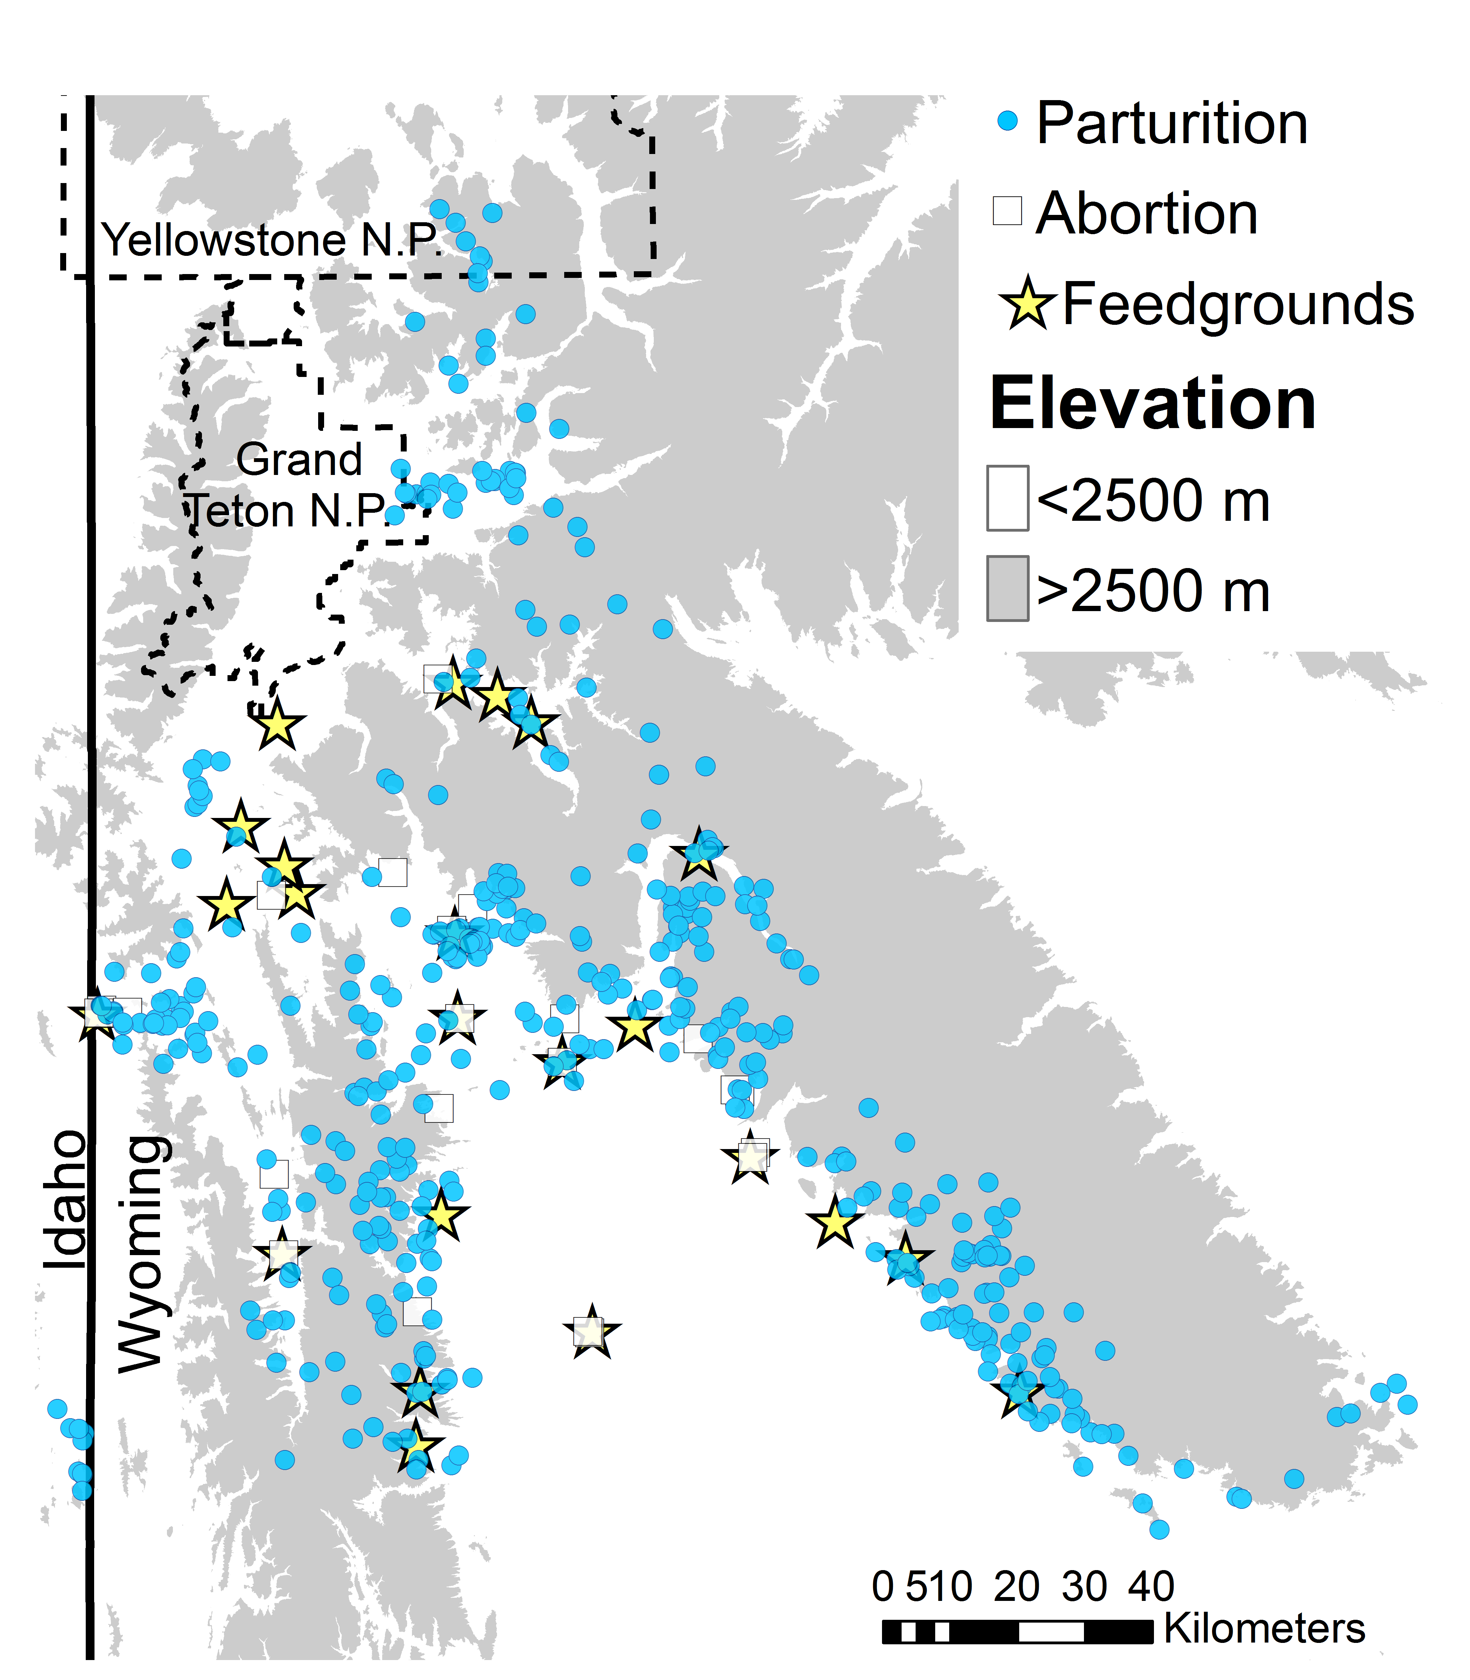

**Figure 1.**

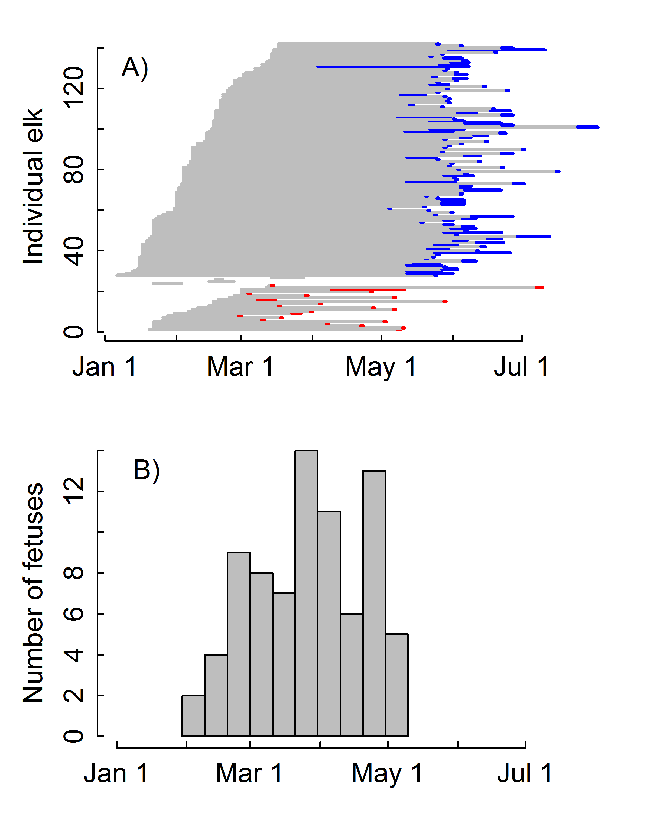

**Figure 2**.

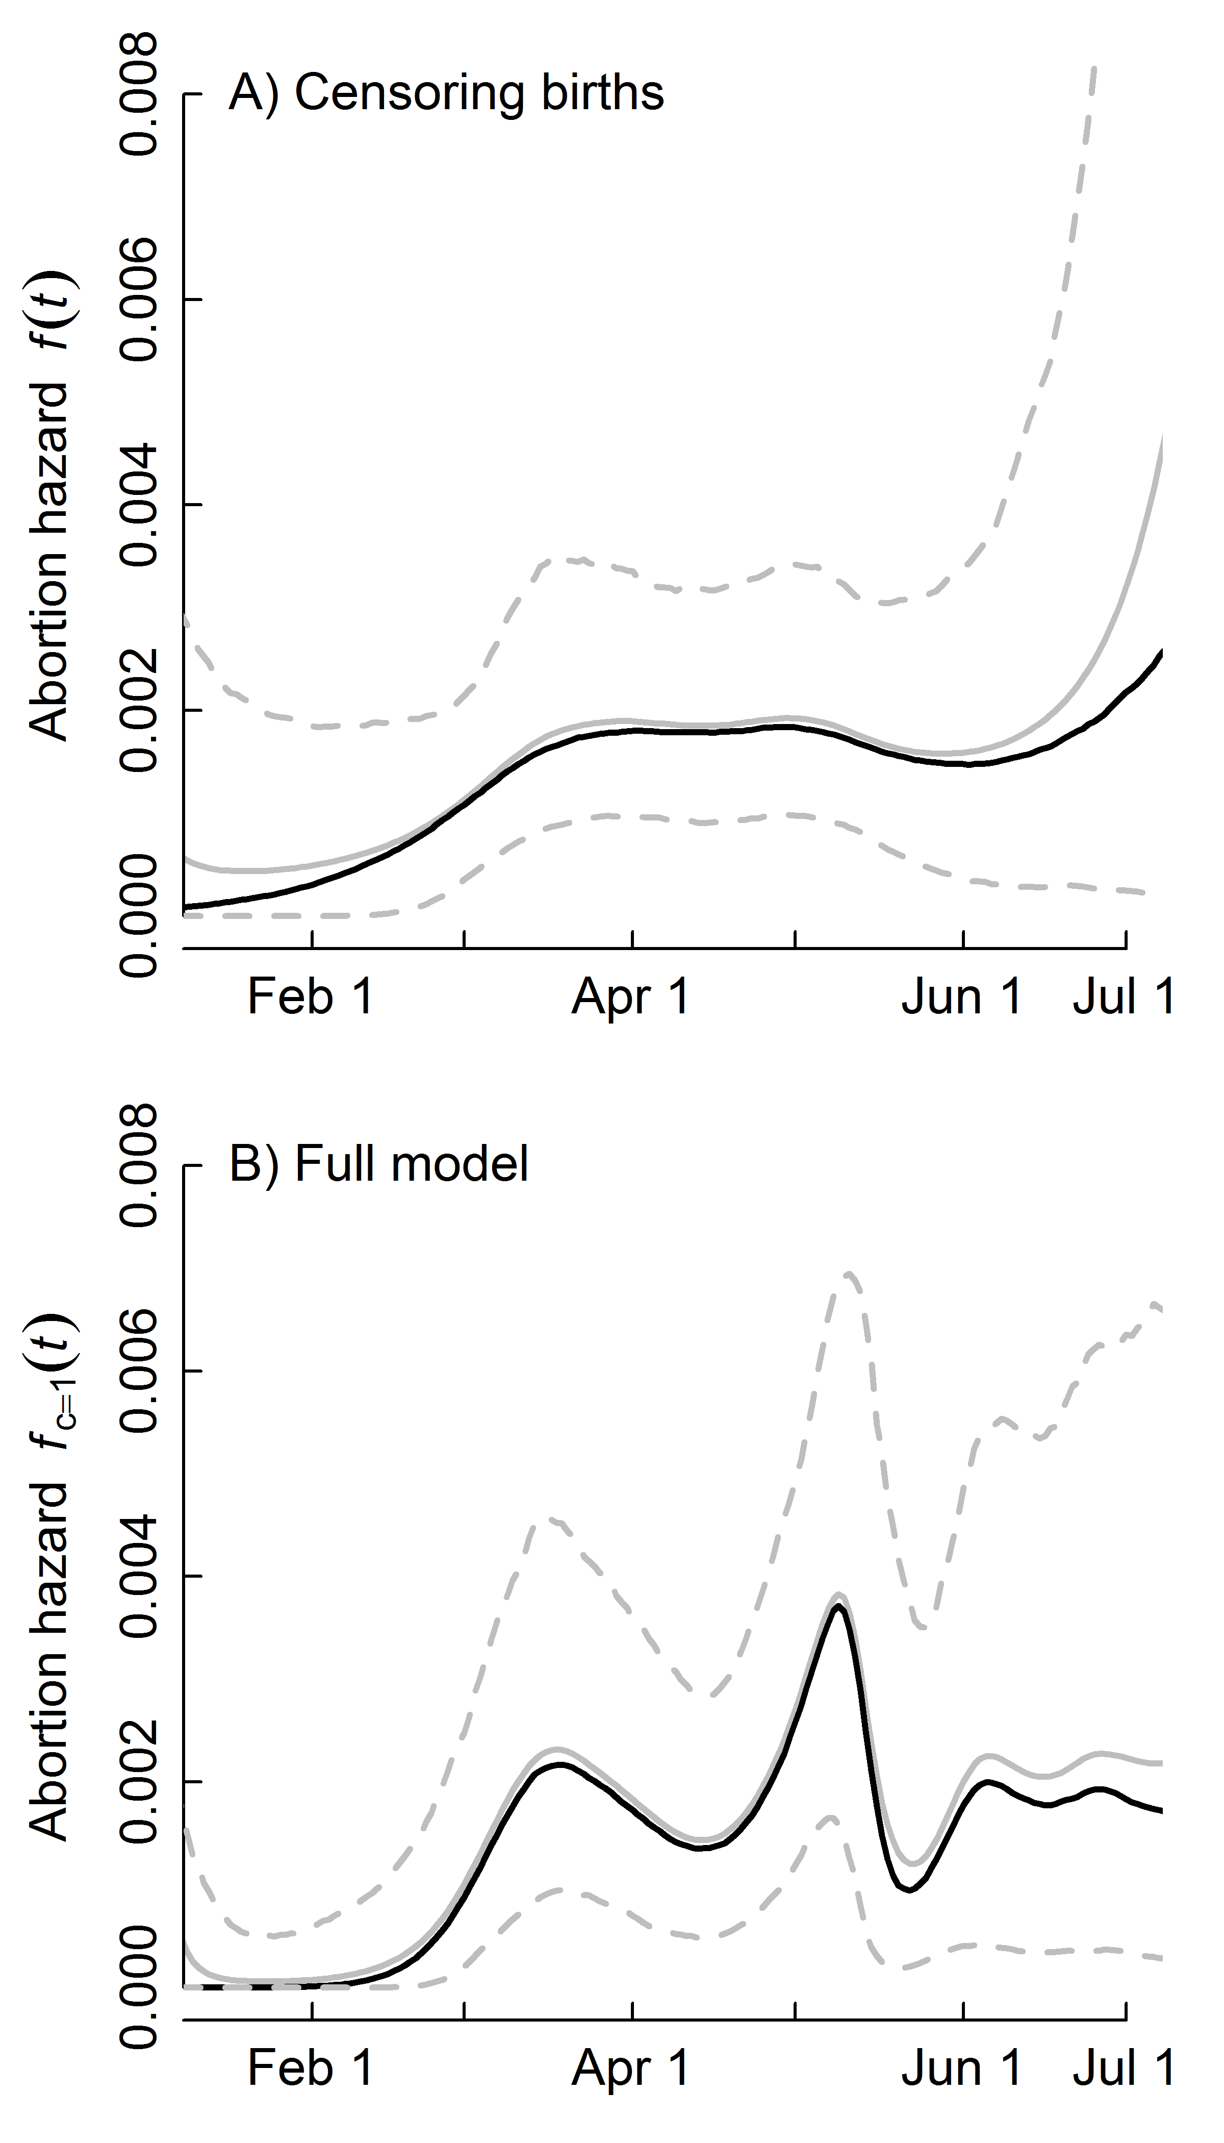

**Figure 3**.

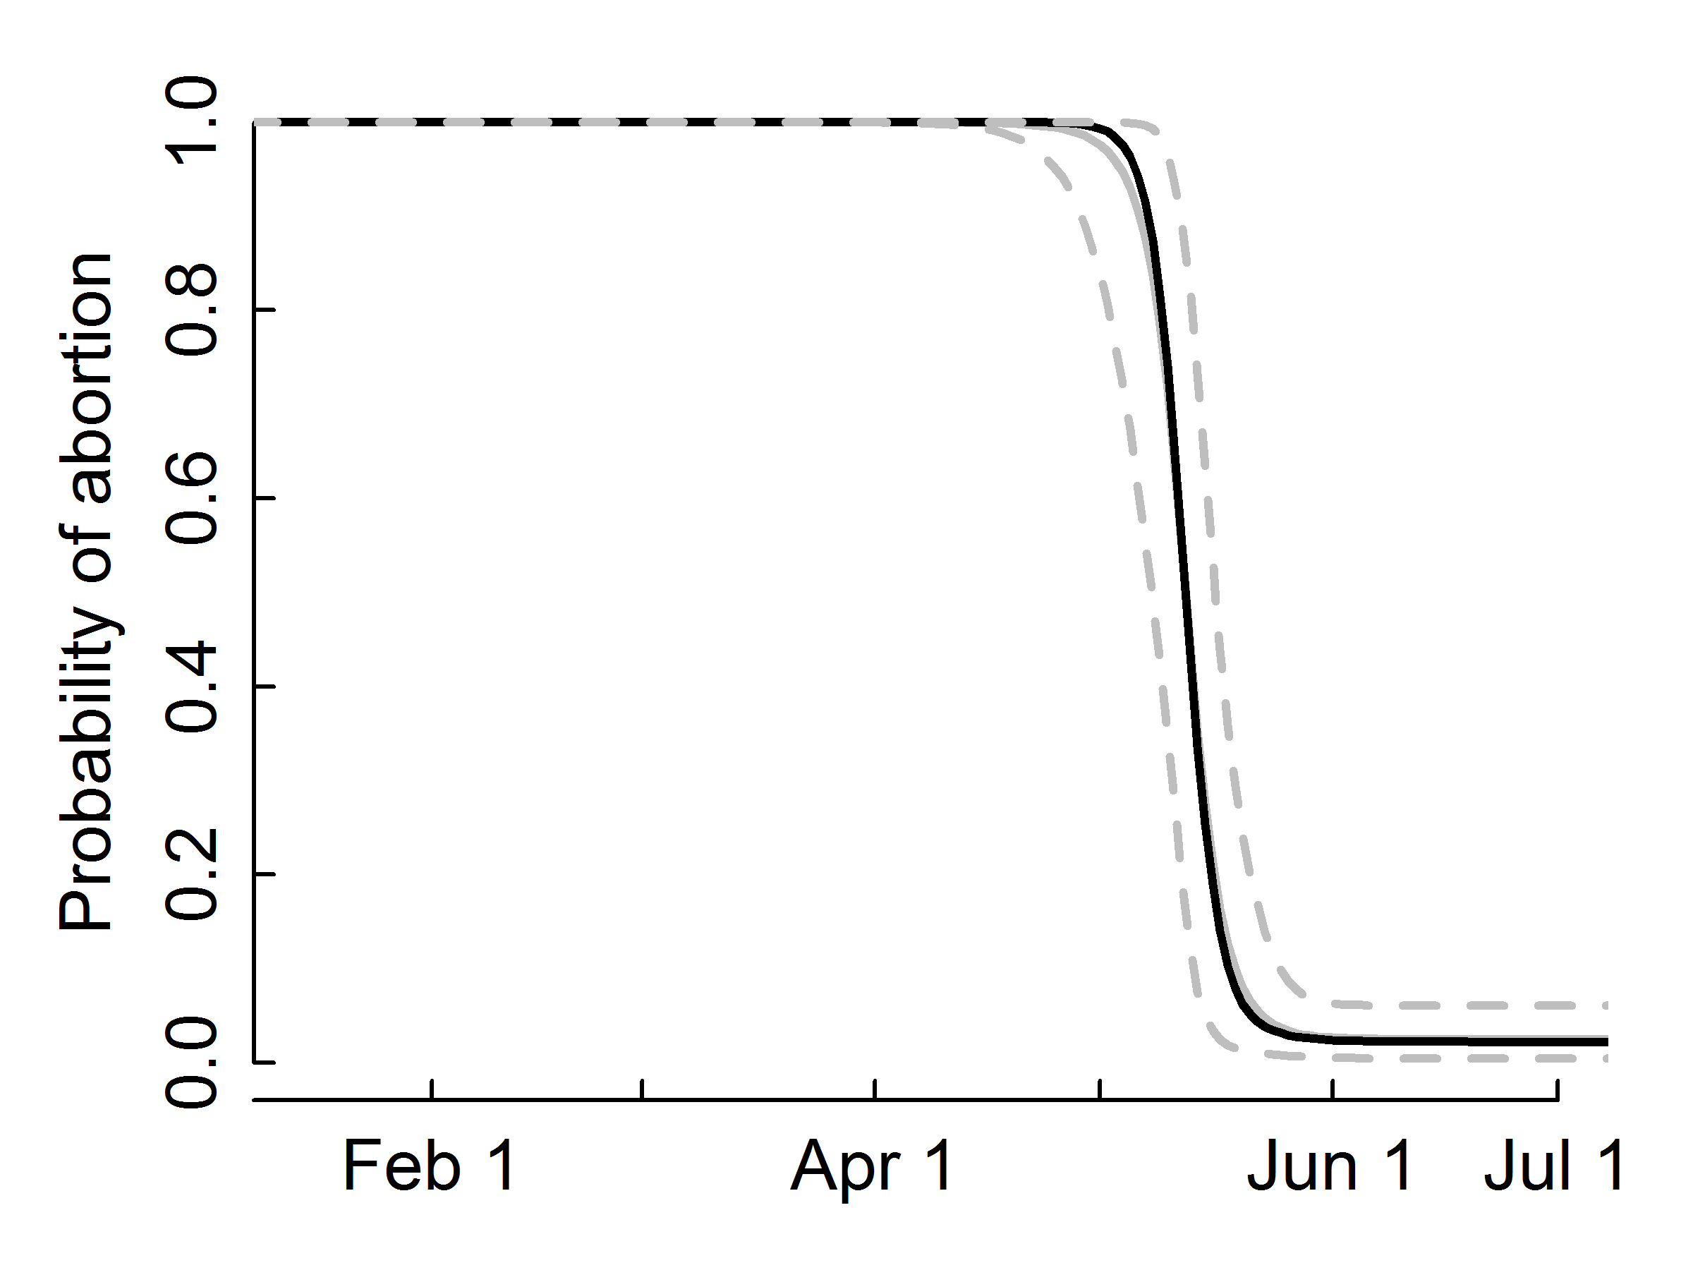

**Figure 4**.

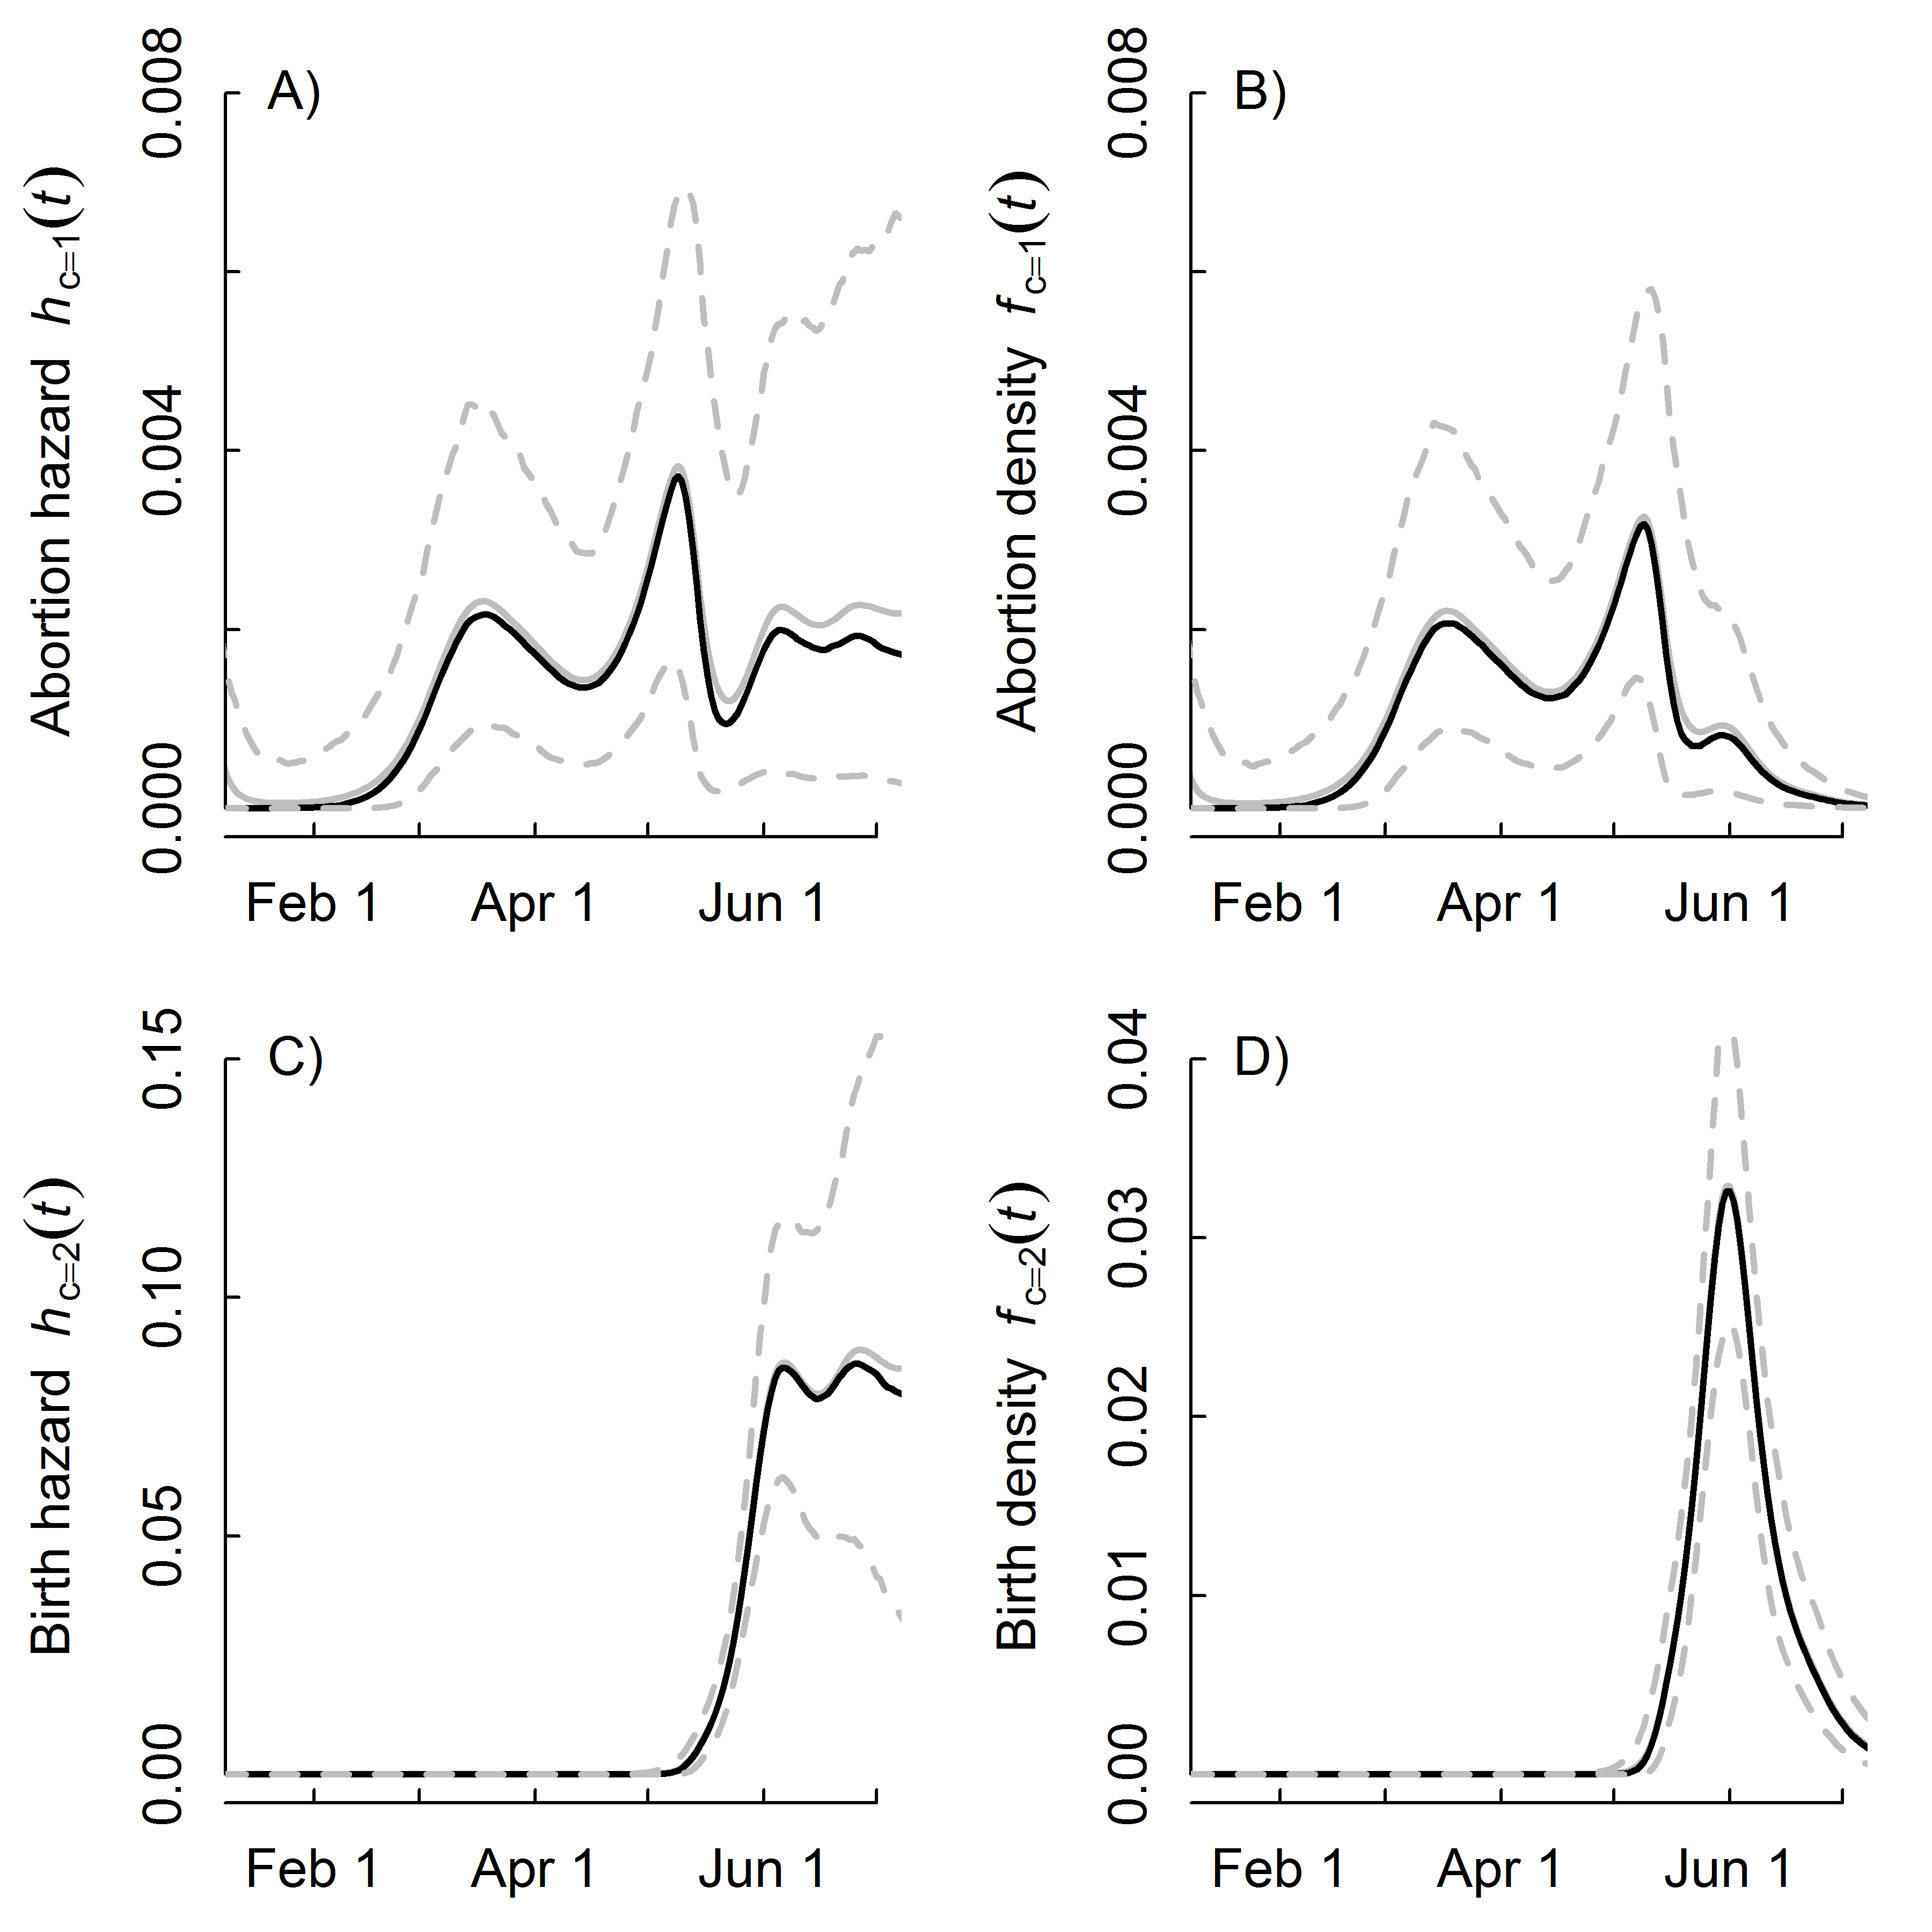

**Figure 5**.

# Supplementary Information:

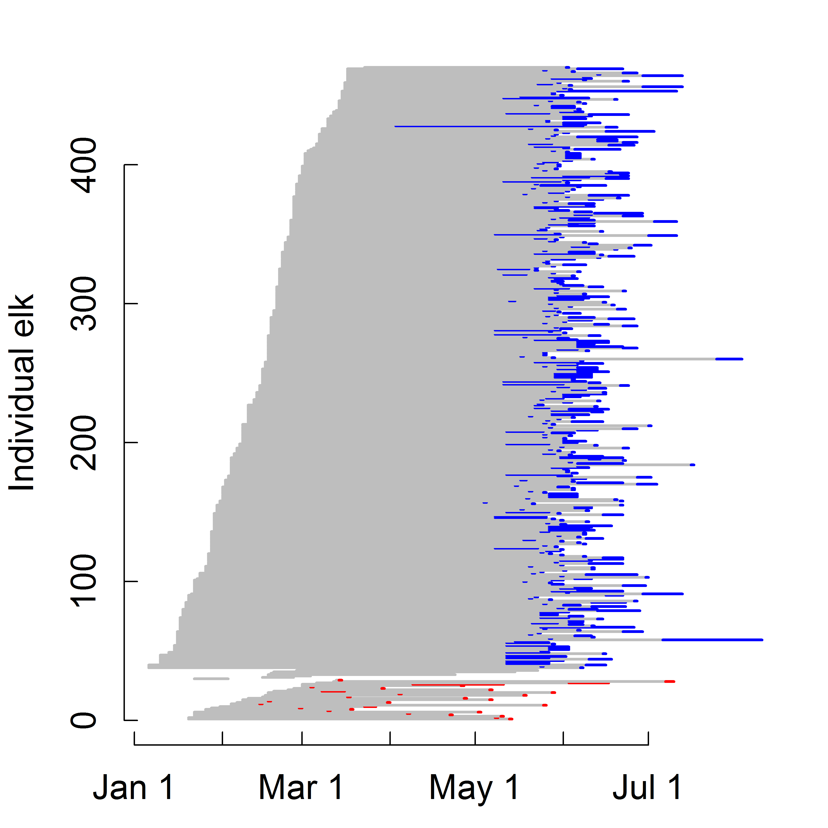

**Figure S1**. Raw data on the reproductive events of all pregnant elk in the study. Grey lines extend from the capture date to the time interval when the reproductive event occurred. Red and blue lines indicate time intervals when VITs were expelled due to abortions or normal birth events, respectively.

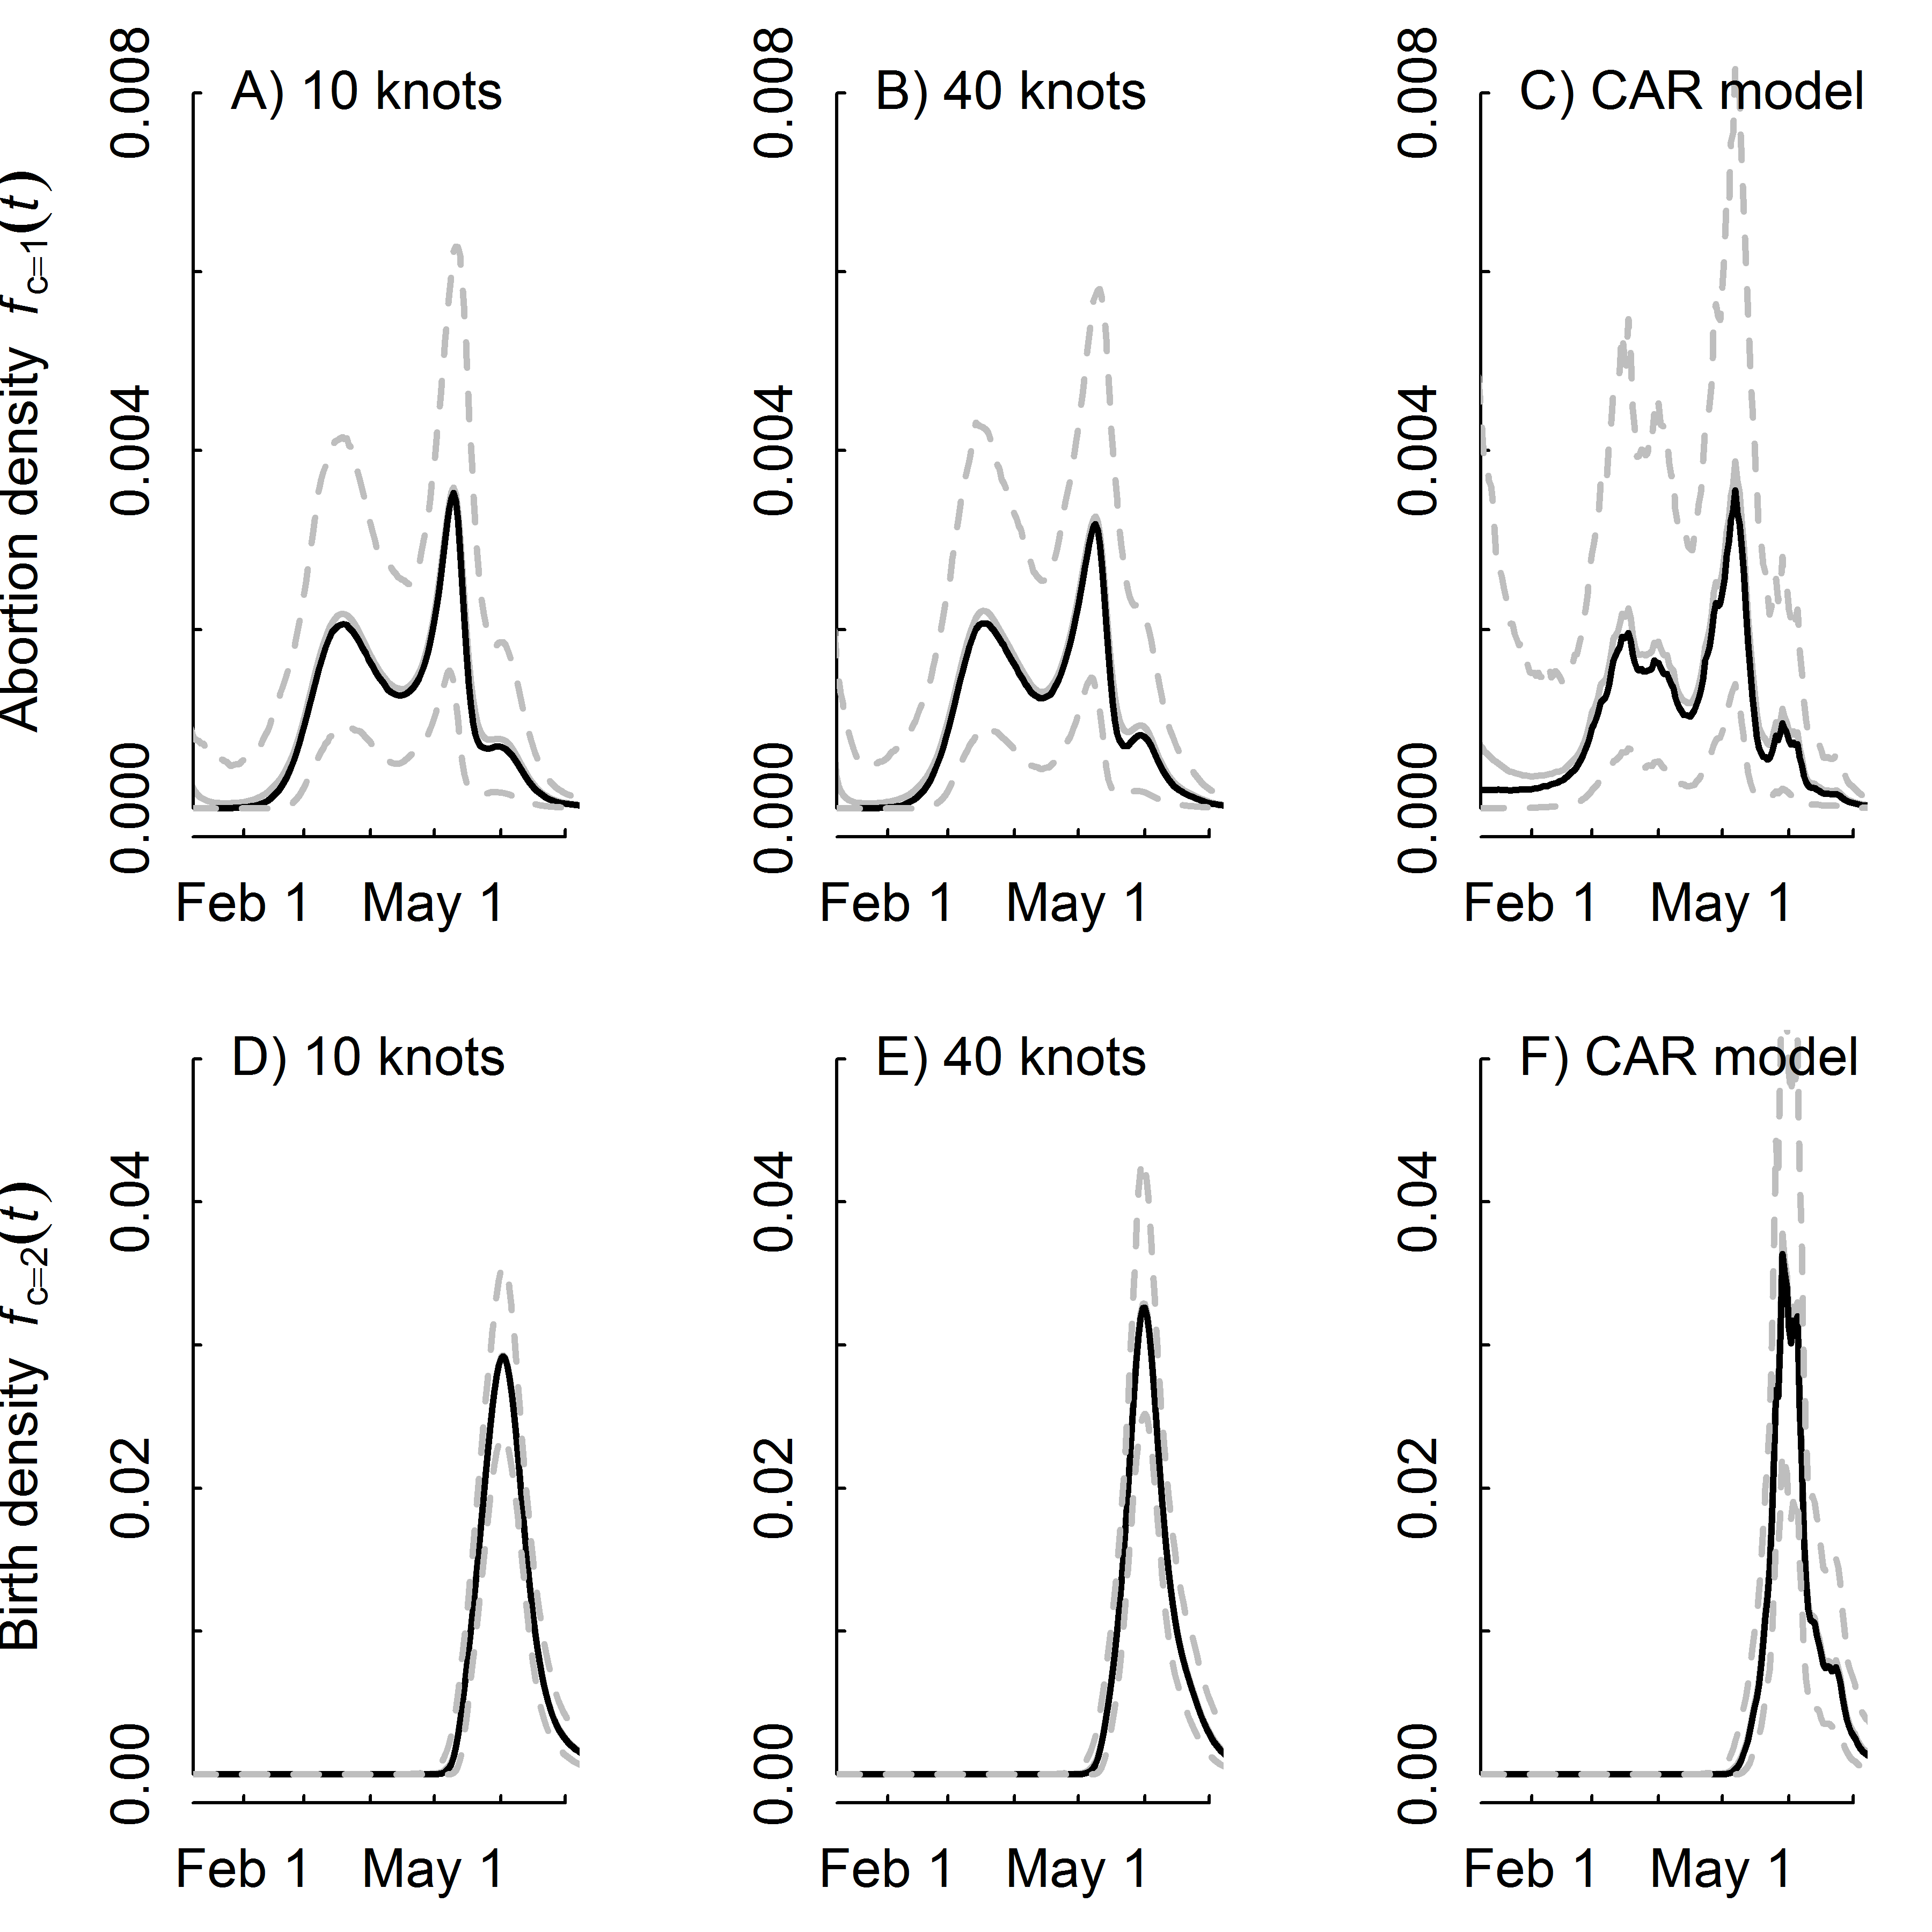

**Figure S2**. Comparison of reproductive event densities using different smoothing functions and only seropositive elk. Grey and black solid lines are the predicted posterior mean and medians. Dotted lines are the predicted posterior 95% credible intervals.

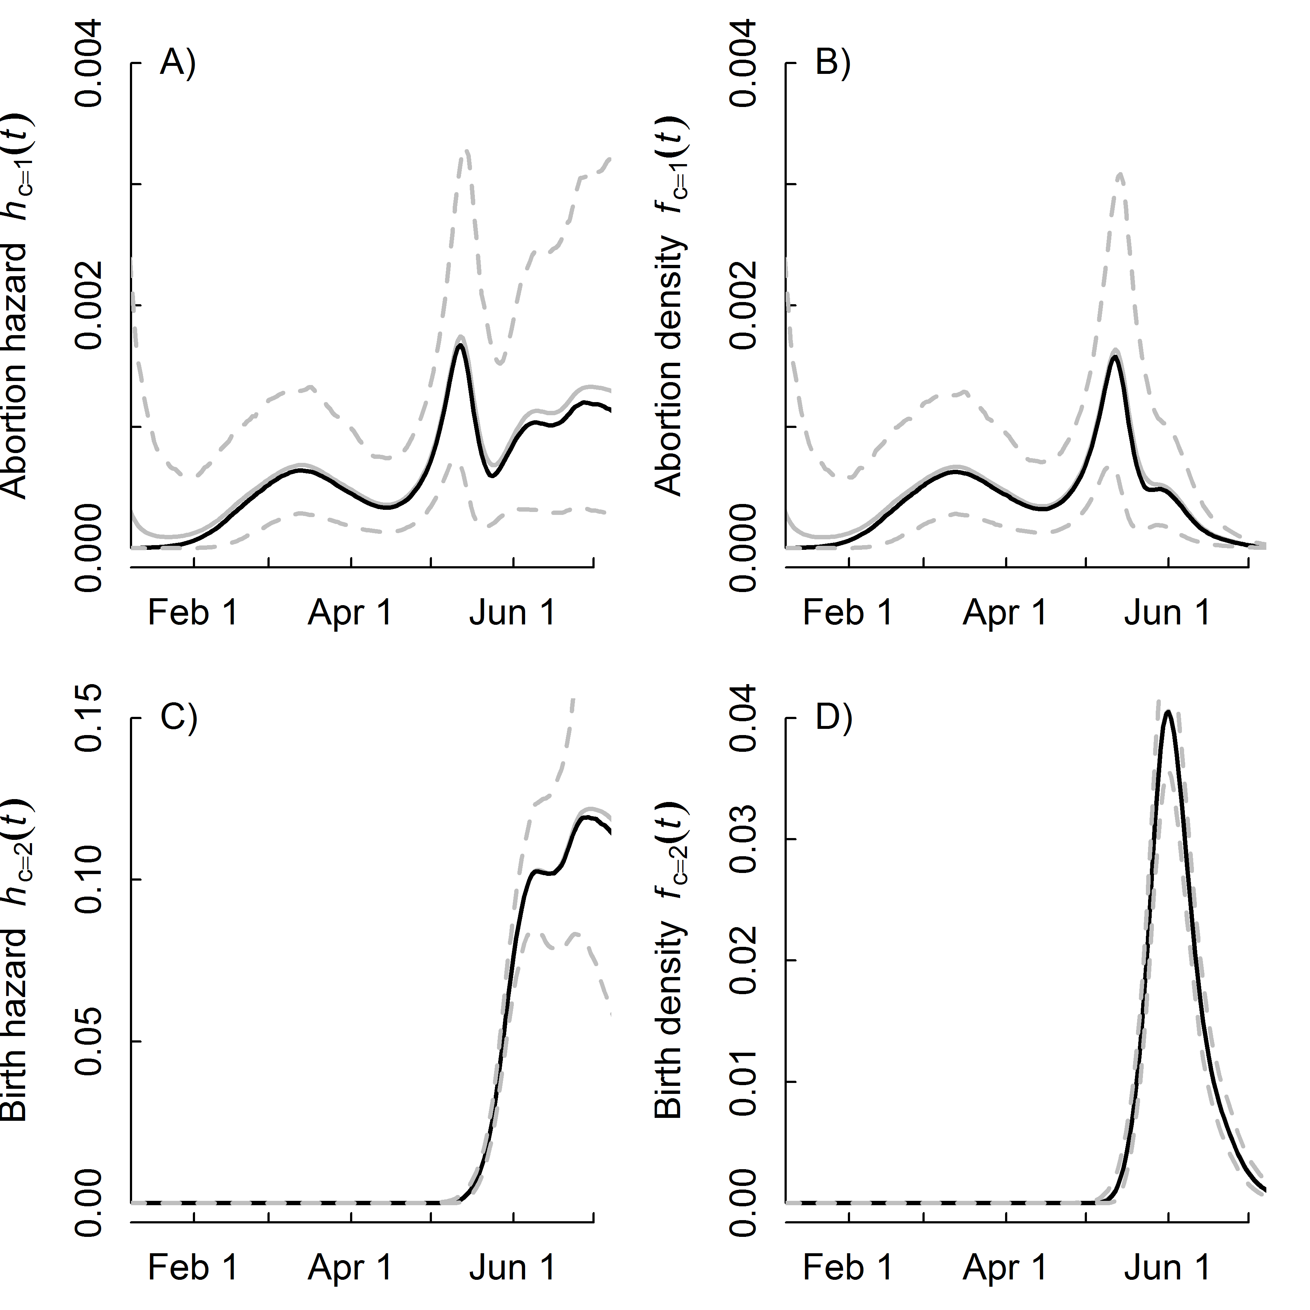

**Figure S3**. Results using seropositive and seronegative elk and the 40 knot spline model. Grey and black solid lines are the predicted posterior mean and medians. Dotted lines are the predicted posterior 95% credible intervals.

**Table S2**. Comparison of elk abortion timing across models when using all pregnant elk (n = 429). Models had different smoothing functions for the total hazard of a reproductive event, but the sub-model of the probability of an abortion relative to a live birth was a logistic regression in all cases.

|  |  |  |  |  |  |  |
| --- | --- | --- | --- | --- | --- | --- |
| Model | DIC | pD | 5% | 25% | 75% | 95% |
|  |  |  |  |  |  |  |
| 10 knots | 2823.5 | 12.6 | 19-Feb | 16-Mar | 15-May | 5-Jun |
|  |  |  |  |  |  |  |
| 40 knots | 2821.1 | 14.1 | 18-Feb | 17-Mar | 13-May | 5-Jun |
|  |  |  |  |  |  |  |
| CAR model | 2829.7 | 33.2 | 31-Jan | 13-Mar | 12-May | 4-Jun |
|  |  |  |  |  |  |  |

DIC: Deviance information criteria  
pD: Estimate of model complexity  
5-95%: Estimated day of the year when *X*% of the abortions have occurred.

**Appendix S1:** Model code.  
**Hazard spline model that is not partitioned by event type (10knots)**

# Priors  
 gamma0 ~ dnorm(0, 1.0E-6)  
 sigmab ~ dunif(0,3)  
 taub <- pow(sigmab, -2)  
 for (l in 1:num.knots){b[l] ~ dnorm(0,taub)}  
   
 # Likelihood for the total hazard  
 for (j in 1:records) {  
 for (k in left[j]:(right[j]-1)) {  
 # unit cumulative hazard  
 UCH[j,k] <- exp(gamma0 + mre110[k])  
 }   
   
 SLR[j] <- exp(-sum(UCH[j,left[j]:(right[j]-1)])) # total prob of not having an event   
   
 # Bernoulli draw for "surviving"  
 noevent[j] ~ dbern(SLR[j])   
 }  
  
# Calculate the baseline hazard  
 for (i in 1:D) {  
 Haz_b[i] <- exp(gamma0 + mre110[i]) # baseline hazard  
 # Spline part  
 mre110[i] <- b[1]*Z[i,1]+b[2]*Z[i,2]+b[3]*Z[i,3]+b[4]*Z[i,4]+b[5]*Z[i,5]+  
 b[6]*Z[i,6]+b[7]*Z[i,7]+b[8]*Z[i,8]+b[9]*Z[i,9]+b[10]*Z[i,10]  
 }

## **Hazard spline model that is partitioned by event type (10knots)**

# Priors  
sigmab ~ dunif(0,3)  
taub <- pow(sigmab, -2)  
gamma0 ~ dnorm(0, 1.0E-6)  
beta ~ dunif(0,2) # slope for the probability of an abortion  
alpha ~ dunif(50, 200) # offset for the transition from abortion to birth  
K ~ dunif(0,0.5) # lower asymptote for the prob. of an abortion  
for (l in 1:num.knots){b[l] ~ dnorm(0,taub)}  
  
#Derived parameters  
for (i in 1:D) {  
 Haz_b[i] <- exp(gamma0 + mre110[i]) # baseline hazard  
  
 mre110[i] <- b[1]*Z[i,1]+b[2]*Z[i,2]+b[3]*Z[i,3]+b[4]*Z[i,4]+b[5]*Z[i,5]+  
 b[6]*Z[i,6]+b[7]*Z[i,7]+b[8]*Z[i,8]+b[9]*Z[i,9]+b[10]*Z[i,10]  
  
 prob.ab[i] <- 1 + (K - 1) / (1 + exp(-beta*(i - alpha))) # probability of abortion   
 Haz_a[i] <- prob.ab[i] * Haz_b[i] # abortion hazard  
 Haz_l[i] <- (1-prob.ab[i]) * Haz_b[i] # live birth hazard  
}   
  
# Likelihood for the total hazard  
for (j in 1:records) {  
 for (k in left[j]:(right[j]-1)) {UCH[j,k] <- exp(gamma0 + mre110[k])}   
 SLR[j] <- exp(-sum(UCH[j,left[j]:(right[j]-1)])) # total prob of not having an event   
 noevent[j] ~ dbern(SLR[j])   
}  
  
# Likelihood on partitioning the event types  
for (m in 1:n.events) {  
 b.type[m] ~ dbern(p.a[m])  
 p.a[m] <- 1 + (K - 1) / (1 + exp(-beta*(event.day[m] - alpha)))  
}

**Estimating the design matrix *Z* for the splines was done in R as follows:**

Z_K<-(abs(outer(covariate,knots,"-")))^3   
OMEGA_all<-(abs(outer(knots,knots,"-")))^3   
svd.OMEGA_all<-svd(OMEGA_all)   
sqrt.OMEGA_all<-t(svd.OMEGA_all$v %*%   
(t(svd.OMEGA_all$u)*sqrt(svd.OMEGA_all$d)))   
Z<-t(solve(sqrt.OMEGA_all,t(Z_K)))

## **Conditional autoregressive model with event-type partitioning**

# Priors  
 gamma0 ~ dnorm(0, 1.0E-6)  
 beta ~ dunif(0,2) # slope for the probability of an abortion  
 alpha ~ dunif(50, 200) # offset for the transition from abortion to birth  
 K ~ dunif(0,0.5) # lower asymptote for the prob. of an abortion  
 sd.rho ~ dunif(0,10) # hyperprior  
 tau.rho <- pow(sd.rho, -2)   
 rho[1] ~ dnorm(0, 1.0E-6)  
 for (i in 2:D) {rho[i]~dnorm(rho[i-1],tau.rho)}  
   
 #Derived quantities  
 for (i in 1:D) {  
 Haz_b[i] <- exp(gamma0 + rho[i]) # overall baseline  
 prob.ab[i] <- 1 + (K - 1) / (1 + exp(-beta*(i - alpha))) # probability of abortion   
 Haz_a[i] <- prob.ab[i] * Haz_b[i] # abortion hazard  
 Haz_l[i] <- (1-prob.ab[i]) * Haz_b[i] # live birth hazard  
 }   
  
 # Likelihood  
 for (j in 1:records) {  
 for (k in left[j]:(right[j]-1)) {  
 UCH[j,k] <- exp(gamma0 + rho[k]) # unit hazard over the interval  
 }   
 SLR[j] <- exp(-sum(UCH[j,left[j]:(right[j]-1)]))# total prob of not having an event   
 noevent[j] ~ dbern(SLR[j])   
 }  
   
 # Likelihood on partitioning the event types  
 for (m in 1:n.events) {  
 b.type[m] ~ dbern(p.a[m])  
 p.a[m] <- 1 + (K - 1) / (1 + exp(-beta*(event.day[m] - alpha)))  
 }