# Supplementary Information:

**Table S1**. Raw data on the presumed pregnant elk captured from 2006 through 2013. Start and stop dates refer to the dates when the reproductive events occurred. Brucella status was determined from serological tests interpreted according the USDA methods and rules for cervids.

|  |  |  |  |  |  |  |
| --- | --- | --- | --- | --- | --- | --- |
| ElkID | Feedground | Capture | Event.Start | Event.End | Status | Brucella |
| 1 | Dell | 2008-01-18 | 2008-05-28 | 2008-05-30 | Birth | NEG |
| 2 | Dell | 2008-01-18 | 2008-06-09 | 2008-06-21 | Birth | POS |
| 3 | Dell | 2008-01-18 | 2008-05-30 | 2008-06-05 | Birth | POS |
| 5 | Dell | 2008-01-18 | 2008-05-23 | 2008-05-24 | Birth | NEG |
| 6 | Dell | 2008-01-18 | 2008-06-09 | 2008-06-21 | Birth | NEG |
| 7 | Dell | 2008-01-25 | 2008-05-22 | 2008-05-23 | Birth | POS |
| 8 | Dell | 2008-01-25 | 2008-03-08 | 2008-03-09 | Abortion | POS |
| 10 | Dell | 2008-01-25 | 2008-03-16 | 2008-03-17 | Abortion | POS |
| 17 | Bench | 2008-02-18 | 2008-05-24 | 2008-05-25 | Birth | NEG |
| 18 | Bench | 2008-02-18 | 2008-05-27 | 2008-05-28 | Birth | NEG |
| 19 | Bench | 2008-02-18 | 2008-05-30 | 2008-06-05 | Birth | NEG |
| 19 | Bench | 2006-02-07 | 2006-05-31 | 2006-06-05 | Birth | NEG |
| 20 | Bench | 2008-02-18 | 2008-05-28 | 2008-05-29 | Birth | NEG |
| 21 | Greys | 2008-02-19 | 2008-06-18 | 2008-06-21 | Birth | NEG |
| 22 | Greys | 2009-02-16 | 2009-06-06 | 2009-06-07 | Birth | NEG |
| 22 | Greys | 2008-02-19 | 2008-05-27 | 2008-05-28 | Birth | NEG |
| 24 | Greys | 2008-02-19 | 2008-06-01 | 2008-06-02 | Birth | NEG |
| 25 | Greys | 2008-02-19 | 2008-06-16 | 2008-06-17 | Birth | POS |
| 26 | Greys | 2010-01-21 | 2010-06-01 | 2010-06-02 | Birth | POS |
| 26 | Greys | 2008-02-19 | 2008-05-25 | 2008-05-26 | Birth | POS |
| 27 | Greys | 2008-02-19 | 2008-06-13 | 2008-06-14 | Birth | NEG |
| 28 | Greys | 2008-02-19 | 2008-05-11 | 2008-05-13 | Birth | POS |
| 29 | Soda | 2008-02-20 | 2008-05-30 | 2008-06-06 | Birth | NEG |
| 29 | Soda | 2006-02-28 | 2006-06-20 | 2006-06-21 | Birth | NEG |
| 29 | Soda | 2011-03-13 | 2011-06-05 | 2011-06-06 | Birth | NEG |
| 29 | Soda | 2007-03-05 | * | * | * | NEG |
| 30 | Soda | 2008-02-20 | 2008-05-29 | 2008-05-30 | Birth | NEG |
| 31 | Soda | 2007-01-19 | 2007-06-25 | 2007-06-26 | Birth | NEG |
| 31 | Soda | 2008-02-20 | * | * | NotPregnant | NEG |
| 31 | Soda | 2006-02-28 | 2006-06-15 | 2006-06-23 | Birth | NEG |
| 32 | Soda | 2008-02-20 | 2008-05-28 | 2008-05-29 | Birth | POS |
| 32 | Soda | 2006-03-09 | 2006-06-15 | 2006-06-19 | Birth | NEG |
| 33 | Soda | 2007-01-19 | 2007-05-12 | 2007-05-13 | Abortion | NEG |
| 33 | Soda | 2006-02-21 | 2006-05-21 | 2006-05-22 | Birth | NEG |
| 41 | Scab | 2006-02-12 | 2006-05-25 | 2006-05-31 | Birth | NEG |
| 41 | Scab | 2008-02-23 | 2008-05-25 | 2008-05-27 | Birth | NEG |
| 41 | Scab | 2007-03-01 | 2007-05-29 | 2007-05-30 | Birth | NEG |
| 42 | Greys | 2008-02-25 | * | * | * | POS |
| 43 | Greys | 2009-02-16 | 2009-07-24 | 2009-08-02 | Birth | POS |
| 43 | Greys | 2008-02-25 | 2008-03-27 | 2008-03-28 | Abortion | POS |
| 44 | Greys | 2008-02-25 | 2008-05-26 | 2008-05-27 | Birth | NEG |
| 50 | Soda | 2007-01-19 | 2007-05-26 | 2007-05-27 | Birth | NEG |
| 50 | Soda | 2006-02-28 | 2006-06-16 | 2006-06-17 | Birth | NEG |
| 51 | Soda | 2007-01-19 | 2007-05-19 | 2007-05-20 | Birth | NEG |
| 51 | Soda | 2006-02-21 | 2006-05-27 | 2006-05-28 | Birth | NEG |
| 52 | Soda | 2007-01-15 | 2007-05-27 | 2007-05-28 | Birth | POS |
| 52 | Soda | 2006-03-09 | 2006-04-02 | 2006-06-07 | Birth | POS |
| 53 | Bench | 2007-02-18 | * | * | * | NEG |
| 54 | Bench | 2007-02-18 | 2007-03-07 | 2007-03-15 | Abortion | POS |
| 57 | Scab | 2007-02-14 | * | * | * | NEG |
| 59 | Soda | 2007-02-19 | * | * | * | POS |
| 60 | Soda | 2007-02-19 | * | * | * | NEG |
| 60 | Soda | 2006-03-09 | 2006-05-31 | 6006-06-08 | Birth | NEG |
| 61 | Bench | 2006-02-14 | 2006-05-10 | 2006-05-31 | Birth | POS |
| 61 | Bench | 2007-03-07 | 2007-05-31 | 2007-06-02 | Birth | * |
| 68 | Soda | 2011-03-13 | 2011-05-27 | 2011-06-04 | Birth | NEG |
| 75 | Soda | 2011-01-22 | 2011-06-04 | 2011-06-10 | Birth | POS |
| 75 | Soda | 2007-02-11 | * | * | * | POS |
| 75 | Soda | 2006-02-28 | 2006-03-03 | 2006-03-04 | Abortion | POS |
| 85 | Soda | 2009-01-15 | 2009-05-11 | 2009-05-26 | Birth | POS |
| 85 | Soda | 2011-03-13 | 2011-05-27 | 2011-06-04 | Birth | POS |
| 85 | Soda | 2006-03-09 | 2006-05-31 | 2006-06-13 | Birth | NEG |
| 88 | Soda | 2009-01-12 | * | * | NotPregnant | NEG |
| 88 | Soda | 2006-03-09 | * | * | NotPregnant | NEG |
| 89 | Soda | 2009-01-12 | 2009-06-14 | 2009-06-15 | Birth | NEG |
| 89 | Soda | 2006-02-21 | 2006-05-31 | 2006-06-08 | Birth | NEG |
| 90 | Soda | 2009-01-12 | 2009-05-11 | 2009-05-26 | Birth | POS |
| 90 | Soda | 2011-01-20 | 2011-06-28 | 2011-07-12 | Birth | POS |
| 91 | Dell | 2011-01-21 | 2011-05-27 | 2011-06-21 | Birth | POS |
| 91 | Dell | 2009-01-22 | * | * | * | POS |
| 92 | Dell | 2009-01-14 | 2009-05-23 | 2009-05-24 | Birth | NEG |
| 93 | Dell | 2009-01-14 | 2009-05-26 | 2009-06-02 | Birth | POS |
| 93 | Dell | 2011-01-15 | 2011-05-14 | 2011-05-15 | Birth | POS |
| 93 | Dell | 2010-02-23 | 2010-05-28 | 2010-05-29 | Birth | POS |
| 94 | Dell | 2009-01-14 | 2009-05-26 | 2009-06-02 | Birth | NEG |
| 96 | Dell | 2009-01-14 | 2009-05-26 | 2009-06-02 | Birth | NEG |
| 96 | Dell | 2012-02-07 | * | * | NotPregnant | POS |
| 97 | Dell | 2009-01-14 | 2009-05-11 | 2009-05-26 | Birth | NEG |
| 98 | Finnegan | 2009-01-09 | 2009-05-11 | 2009-05-26 | Birth | NEG |
| 99 | Finnegan | 2009-01-09 | 2009-05-11 | 2009-05-26 | Birth | NEG |
| 100 | Finnegan | 2009-01-09 | 2009-05-11 | 2009-05-31 | Birth | POS |
| 101 | Finnegan | 2009-01-09 | 2009-06-09 | 2009-06-17 | Birth | NEG |
| 102 | Finnegan | 2009-01-09 | 2009-05-11 | 2009-05-26 | Birth | NEG |
| 103 | Finnegan | 2009-01-09 | 2009-05-11 | 2009-06-01 | Birth | NEG |
| 106 | Finnegan | 2009-01-09 | 2009-05-11 | 2009-05-26 | Birth | NEG |
| 107 | Dog | 2010-02-04 | 2010-05-30 | 2010-06-14 | Birth | NEG |
| 112 | Greys | 2010-01-21 | 2010-06-05 | 2010-06-06 | Birth | POS |
| 112 | Greys | 2009-02-06 | 2009-05-30 | 2009-05-31 | Birth | POS |
| 119 | Greys | 2009-02-06 | 2009-06-11 | 2009-06-12 | Birth | POS |
| 119 | Greys | 2009-02-06 | 2009-06-11 | 2009-06-12 | Birth | POS |
| 121 | Greys | 2009-02-06 | 2009-05-11 | 2009-05-26 | Birth | NEG |
| 128 | Greys | 2010-01-21 | 2010-02-02 | * | Death | POS |
| 129 | Greys | 2010-01-21 | 2010-05-09 | 2010-05-10 | Abortion | POS |
| 133 | Greys | 2010-02-25 | 2010-05-30 | 2010-06-09 | Birth | NEG |
| 136 | Fall | 2009-01-28 | 2009-05-26 | 2009-06-11 | Birth | NEG |
| 137 | Fall | 2009-01-28 | 2009-05-26 | 2009-06-09 | Birth | NEG |
| 138 | Fall | 2009-01-28 | 2009-05-26 | 2009-06-10 | Birth | NEG |
| 139 | Fall | 2009-01-28 | 2009-05-26 | 2009-06-17 | Birth | NEG |
| 141 | Muddy | 2009-01-29 | 2009-05-11 | 2009-05-26 | Birth | NEG |
| 142 | Muddy | 2009-01-29 | 2009-06-08 | 2009-06-09 | Birth | NEG |
| 143 | Muddy | 2009-01-29 | 2009-05-16 | 2009-05-17 | Birth | NEG |
| 144 | South | 2009-02-03 | 2009-05-11 | 2009-06-01 | Birth | POS |
| 145 | South | 2010-02-17 | 2010-05-07 | 2010-05-30 | Birth | NEG |
| 145 | South | 2009-02-03 | 2009-06-03 | 2009-06-05 | Birth | NEG |
| 146 | South | 2009-02-03 | 2009-06-01 | 2009-06-02 | Birth | NEG |
| 147 | South | 2009-02-03 | 2009-06-01 | 2009-06-02 | Birth | POS |
| 148 | UG | 2009-02-19 | 2009-05-26 | 2009-06-07 | Birth | NEG |
| 149 | UG | 2009-02-19 | 2009-05-26 | 2009-06-09 | Birth | NEG |
| 150 | UG | 2009-02-19 | 2009-05-26 | 2009-06-16 | Birth | NEG |
| 151 | UG | 2009-02-19 | 2009-05-29 | 2009-05-30 | Birth | POS |
| 152 | Franz | 2009-03-11 | 2009-06-09 | 2009-06-23 | Birth | NEG |
| 153 | Franz | 2009-03-11 | 2009-07-06 | 2009-07-09 | Abortion | POS |
| 154 | Franz | 2009-03-11 | 2009-05-11 | 2009-05-26 | Birth | NEG |
| 155 | Soda | 2006-02-21 | 2006-05-25 | 2006-05-26 | Birth | NEG |
| 156 | Soda | 2006-02-21 | 2006-05-24 | 2006-05-25 | Birth | NEG |
| 157 | Soda | 2006-02-21 | 2006-05-25 | 2006-05-26 | Birth | NEG |
| 158 | Soda | 2006-02-28 | 2006-05-24 | 2006-05-25 | Birth | NEG |
| 159 | Soda | 2006-02-28 | 2006-05-28 | 2006-05-29 | Birth | NEG |
| 160 | Soda | 2006-02-28 | 2006-05-21 | 2006-05-22 | Birth | NEG |
| 161 | Soda | 2006-02-28 | 2006-05-29 | 2006-05-30 | Birth | NEG |
| 162 | Bench | 2007-03-04 | 2007-05-31 | 2007-06-02 | Birth | NEG |
| 163 | Soda | 2006-03-09 | 2006-05-25 | 2006-05-26 | Birth | NEG |
| 164 | Soda | 2006-03-09 | 2006-05-25 | 2006-05-26 | Birth | POS |
| 165 | Soda | 2007-02-22 | * | * | * | NEG |
| 165 | Soda | 2006-03-09 | 2006-05-31 | 2006-06-08 | Birth | NEG |
| 166 | Soda | 2006-03-10 | 2006-05-31 | 2006-06-07 | Birth | NEG |
| 167 | Soda | 2006-03-10 | 2006-05-31 | 2006-06-10 | Birth | NEG |
| 168 | Greys | 2010-01-21 | 2010-05-30 | 2010-06-10 | Birth | POS |
| 169 | Greys | 2010-01-21 | 2010-06-04 | 2010-06-09 | Birth | POS |
| 170 | Greys | 2010-01-21 | 2010-06-21 | 2010-06-29 | Birth | NEG |
| 171 | Muddy | 2010-01-25 | 2010-05-31 | 2010-06-01 | Birth | NEG |
| 172 | Muddy | 2010-01-25 | 2010-06-10 | 2010-06-11 | Birth | NEG |
| 173 | Muddy | 2010-01-25 | 2010-06-10 | 2010-06-11 | Birth | NEG |
| 174 | Muddy | 2010-01-25 | 2010-05-19 | 2010-05-20 | Birth | NEG |
| 174 | Muddy | 2011-02-21 | 2011-05-27 | 2011-06-04 | Birth | NEG |
| 176 | Dell | 2010-02-16 | * | * | NotPregnant | NEG |
| 177 | Dell | 2010-02-16 | 2010-05-27 | 2010-05-28 | Birth | NEG |
| 178 | Dell | 2010-02-16 | * | * | NotPregnant | POS |
| 179 | Dell | 2010-02-16 | 2010-04-03 | 2010-04-04 | Abortion | POS |
| 180 | Dell | 2010-02-16 | 2010-05-16 | 2010-05-17 | Birth | NEG |
| 181 | Dell | 2010-02-16 | 2010-05-24 | 2010-05-25 | Birth | NEG |
| 182 | Dell | 2011-01-21 | 2011-05-27 | 2011-05-31 | Birth | POS |
| 182 | Dell | 2010-02-16 | * | * | NotPregnant | POS |
| 183 | Jewett | 2010-02-09 | 2010-05-24 | 2010-05-25 | Birth | NEG |
| 184 | Jewett | 2010-02-09 | 2010-06-03 | 2010-06-14 | Birth | NEG |
| 186 | Jewett | 2010-02-09 | 2010-05-25 | 2010-05-26 | Birth | NEG |
| 188 | Franz | 2010-02-09 | 2010-05-29 | 2010-05-30 | Birth | POS |
| 189 | Franz | 2010-02-09 | 2010-06-03 | 2010-06-04 | Birth | POS |
| 190 | Franz | 2010-02-09 | 2010-05-19 | 2010-05-20 | Birth | NEG |
| 191 | South | 2010-02-17 | 2010-05-31 | 2010-06-01 | Birth | POS |
| 192 | South | 2010-02-17 | 2010-05-26 | 2010-05-27 | Birth | NEG |
| 193 | South | 2010-02-17 | 2010-05-07 | 2010-05-30 | Birth | POS |
| 194 | South | 2010-02-17 | 2010-05-30 | 2010-06-03 | Birth | NEG |
| 195 | HA99 | 2010-01-27 | 2010-05-23 | 2010-05-24 | Birth | NEG |
| 195 | HA99 | 2011-03-15 | 2011-06-02 | 2011-06-03 | Birth | NEG |
| 197 | Spring | 2010-01-28 | 2010-05-30 | 2010-06-01 | Birth | NEG |
| 198 | HA99 | 2010-01-27 | 2010-05-25 | 2010-05-30 | Birth | NEG |
| 199 | UGNWR | 2010-01-26 | * | * | * | NEG |
| 200 | UGNWR | 2010-01-26 | 2010-05-30 | 2010-05-31 | Birth | NEG |
| 201 | UGNWR | 2010-01-26 | 2010-06-09 | 2010-06-21 | Birth | NEG |
| 202 | HA99 | 2010-01-27 | 2010-05-30 | 2010-05-31 | Birth | POS |
| 203 | Spring | 2010-01-28 | 2010-05-25 | 2010-05-26 | Birth | NEG |
| 204 | Spring | 2010-01-28 | 2010-06-08 | 2010-06-09 | Birth | NEG |
| 205 | Spring | 2010-01-28 | 2010-05-30 | 2010-05-31 | Birth | NEG |
| 206 | UGNWR | 2010-01-26 | 2010-05-28 | 2010-05-29 | Birth | NEG |
| 206 | UG | 2011-02-25 | 2011-06-21 | 2011-06-28 | Birth | NEG |
| 207 | UGNWR | 2010-01-26 | 2010-05-30 | 2010-06-10 | Birth | NEG |
| 208 | UGNWR | 2010-01-26 | 2010-06-09 | 2010-06-21 | Birth | NEG |
| 209 | Spring | 2010-01-28 | 2010-05-27 | 2010-05-28 | Birth | NEG |
| 212 | HA99 | 2010-01-27 | 2010-05-07 | 2010-05-22 | Birth | NEG |
| 213 | HA99 | 2010-01-27 | 2010-05-28 | 2010-05-29 | Birth | NEG |
| 213 | HA99 | 2011-03-15 | 2011-05-31 | 2011-06-01 | Birth | NEG |
| 214 | HA99 | 2010-01-27 | 2010-05-24 | 2010-05-25 | Birth | NEG |
| 215 | HA99 | 2010-01-26 | 2010-06-14 | 2010-06-21 | Birth | NEG |
| 216 | Spring | 2010-01-28 | 2010-05-07 | 2010-05-25 | Birth | NEG |
| 217 | HA99 | 2011-03-15 | * | * | * | NEG |
| 218 | HA99 | 2010-01-26 | * | * | * | NEG |
| 218 | HA99 | 2011-03-16 | 2011-06-21 | 2011-06-23 | Birth | NEG |
| 219 | Spring | 2010-01-28 | 2010-05-07 | 2010-05-25 | Birth | NEG |
| 220 | HA99 | 2010-01-27 | 2010-01-27 | 2010-05-23 | Birth | NEG |
| 220 | HA99 | 2011-03-15 | 2011-06-28 | 2011-07-12 | Birth | NEG |
| 221 | UGNWR | 2010-01-26 | 2010-06-07 | 2010-06-08 | Birth | NEG |
| 222 | HA99 | 2010-01-27 | 2010-06-07 | 2010-06-08 | Birth | NEG |
| 222 | HA99 | 2011-03-15 | * | * | NotPregnant | NEG |
| 223 | Spring | 2010-01-28 | 2010-06-14 | 2010-06-21 | Birth | NEG |
| 224 | HA99 | 2010-01-26 | 2010-05-30 | 2010-05-31 | Birth | NEG |
| 224 | HA99 | 2011-03-16 | 2011-06-07 | 2011-06-08 | Birth | NEG |
| 225 | HA99 | 2010-01-27 | 2010-06-05 | 2010-06-06 | Birth | NEG |
| 226 | HA99 | 2010-01-27 | 2010-05-30 | 2010-05-31 | Birth | NEG |
| 226 | HA99 | 2011-03-15 | 2011-06-02 | 2011-06-03 | Birth | NEG |
| 227 | UGNWR | 2010-01-26 | 2010-05-26 | 2010-05-27 | Birth | NEG |
| 228 | Spring | 2010-01-28 | 2010-05-29 | 2010-05-30 | Birth | NEG |
| 229 | HA99 | 2010-01-27 | 2010-05-17 | 2010-05-21 | Birth | NEG |
| 245 | Alkali | 2012-02-14 | 2012-06-08 | 2012-06-12 | Birth | NEG |
| 245 | Alkali | 2010-02-24 | 2010-06-30 | 2010-07-10 | Birth | NEG |
| 246 | Alkali | 2010-02-24 | 2010-05-07 | 2010-05-30 | Birth | NEG |
| 248 | Alkali | 2010-02-24 | 2010-05-28 | 2010-05-29 | Birth | NEG |
| 249 | Alkali | 2010-02-24 | 2010-06-13 | 2010-06-14 | Birth | POS |
| 250 | Alkali | 2010-02-24 | 2010-05-22 | 2010-05-25 | Birth | NEG |
| 251 | Dog | 2010-03-01 | 2010-05-22 | 2010-05-24 | Birth | POS |
| 254 | Franz | 2010-03-02 | 2010-06-01 | 2010-06-02 | Birth | POS |
| 255 | Franz | 2010-03-02 | 2010-05-27 | 2010-05-28 | Birth | NEG |
| 256 | Finnegan | 2010-03-22 | 2010-06-01 | 2010-06-02 | Birth | NEG |
| 257 | Dell | 2011-01-21 | 2011-05-26 | 2011-05-27 | Birth | NEG |
| 257 | Dell | 2010-02-23 | 2010-05-21 | 2010-05-25 | Birth | NEG |
| 258 | Dell | 2010-02-23 | 2010-02-23 | 2010-05-30 | Birth | POS |
| 259 | Dell | 2010-02-23 | 2010-05-05 | 2010-05-06 | Abortion | POS |
| 281 | Bench | 2006-02-07 | 2006-05-31 | 2006-06-08 | Birth | NEG |
| 282 | Scab | 2007-01-16 | 2007-06-05 | 2007-06-06 | Birth | NEG |
| 283 | Bench | 2006-02-20 | 2006-05-27 | 2006-05-31 | Birth | NEG |
| 284 | Bench | 2006-02-20 | 2006-05-27 | 2006-05-28 | Birth | POS |
| 285 | Bench | 2006-02-26 | * | * | NotPregnant | NEG |
| 286 | Bench | 2006-02-20 | 2006-05-28 | 2006-06-05 | Birth | NEG |
| 287 | Bench | 2006-02-26 | 2006-06-09 | 2006-06-23 | Birth | NEG |
| 288 | Bench | 2006-03-14 | 2006-06-18 | 2006-06-19 | Birth | POS |
| 289 | Bench | 2006-02-07 | 2006-05-31 | 2006-06-01 | Birth | NEG |
| 290 | Bench | 2006-02-14 | 2006-05-10 | 2006-06-08 | Birth | NEG |
| 291 | Bench | 2006-02-14 | * | * | * | NEG |
| 292 | Bench | 2006-02-26 | * | * | * | NEG |
| 293 | Bench | 2006-02-20 | 2006-05-26 | 2006-05-31 | Birth | NEG |
| 294 | Bench | 2006-03-14 | 2006-05-10 | 2006-06-09 | Birth | NEG |
| 295 | Bench | 2006-02-20 | 2006-06-03 | 2006-06-04 | Birth | NEG |
| 296 | Bench | 2006-03-14 | 2006-05-16 | 2006-05-17 | Birth | NEG |
| 297 | Bench | 2006-02-07 | 2006-05-31 | 2006-06-01 | Birth | NEG |
| 298 | Bench | 2006-02-20 | 2006-05-10 | 2006-05-18 | Birth | NEG |
| 299 | Bench | 2006-02-24 | 2006-05-23 | 2006-05-24 | Birth | NEG |
| 300 | Bench | 2006-03-14 | 2006-05-30 | 2006-05-31 | Birth | NEG |
| 301 | Bench | 2006-03-14 | 2006-05-27 | 2006-05-28 | Birth | NEG |
| 302 | Bench | 2006-03-14 | 2006-05-27 | 2006-05-28 | Birth | NEG |
| 303 | Bench | 2006-02-07 | 2006-02-16 | 2006-02-17 | Abortion | NEG |
| 304 | Bench | 2006-02-26 | 2006-05-17 | 2006-05-18 | Birth | NEG |
| 305 | Bench | 2006-02-26 | 2006-05-26 | 2006-05-31 | Birth | NEG |
| 306 | Bench | 2006-02-26 | 2006-06-01 | 2006-06-02 | Birth | NEG |
| 307 | Bench | 2006-02-26 | 2006-06-03 | 2006-06-04 | Birth | NEG |
| 308 | Bench | 2006-02-26 | 2006-05-20 | 2006-05-21 | Birth | NEG |
| 309 | Scab | 2006-02-12 | 2006-05-31 | 2006-06-06 | Birth | NEG |
| 310 | Scab | 2006-02-27 | 2006-06-01 | 2006-06-02 | Birth | NEG |
| 311 | Scab | 2006-02-27 | 2006-05-10 | 2006-05-30 | Birth | NEG |
| 312 | Scab | 2006-02-12 | 2006-02-12 | 2006-04-21 | * | NEG |
| 313 | Scab | 2006-02-27 | 2006-05-31 | 2006-06-06 | Birth | POS |
| 314 | Scab | 2006-02-27 | 2006-06-15 | 2006-06-23 | Birth | NEG |
| 315 | Scab | 2006-02-12 | 2006-02-12 | 2006-04-21 | * | NEG |
| 315 | Scab | 2007-03-01 | 2007-05-24 | 2007-05-29 | Birth | NEG |
| 316 | Scab | 2006-02-27 | 2006-05-20 | 2006-06-09 | Birth | NEG |
| 317 | Scab | 2006-02-12 | 2006-05-31 | 2006-06-09 | Birth | NEG |
| 318 | Scab | 2006-02-12 | 2006-05-31 | 2006-06-15 | Birth | NEG |
| 319 | Scab | 2006-02-27 | 2006-05-31 | 2006-06-23 | Birth | NEG |
| 320 | Soda | 2006-02-28 | 2006-04-25 | 2006-04-26 | Abortion | POS |
| 321 | Soda | 2006-02-21 | * | * | * | NEG |
| 322 | Soda | 2006-02-28 | * | * | * | NEG |
| 323 | Soda | 2007-02-22 | * | * | * | POS |
| 323 | Soda | 2006-02-28 | 2006-04-08 | 2006-05-10 | Abortion | POS |
| 323 | Soda | 2011-03-13 | 2011-05-21 | 2011-05-22 | Birth | POS |
| 324 | Soda | 2006-03-09 | * | * | NotPregnant | NEG |
| 325 | Scab | 2007-01-05 | * | * | * | NEG |
| 326 | Scab | 2007-01-05 | * | * | * | NEG |
| 327 | Scab | 2007-01-05 | 2007-06-06 | 2007-06-07 | Birth | NEG |
| 328 | Scab | 2007-01-05 | 2007-05-23 | 2007-05-24 | Birth | POS |
| 329 | Scab | 2007-01-05 | 2007-06-08 | 2007-06-15 | Birth | NEG |
| 330 | Scab | 2007-01-05 | * | * | * | NEG |
| 331 | Scab | 2007-01-16 | 2007-05-24 | 2007-05-25 | Birth | POS |
| 332 | Scab | 2007-01-16 | 2007-05-23 | 2007-06-25 | Birth | POS |
| 333 | Scab | 2007-01-16 | 2007-06-10 | 2007-06-11 | Birth | POS |
| 334 | Scab | 2007-01-23 | 2007-06-29 | 2007-06-30 | Birth | NEG |
| 335 | Scab | 2007-01-23 | * | * | * | NEG |
| 336 | Scab | 2007-01-23 | 2007-05-30 | 2007-05-31 | Birth | NEG |
| 337 | Scab | 2007-01-23 | 2007-06-08 | 2007-06-26 | Birth | POS |
| 338 | Scab | 2007-01-23 | 2007-05-20 | 2007-05-21 | Birth | NEG |
| 339 | Scab | 2007-02-14 | 2007-06-03 | 2007-06-04 | Birth | NEG |
| 340 | Scab | 2007-02-14 | 2007-06-03 | 2007-06-04 | Birth | NEG |
| 341 | Scab | 2007-02-20 | 2007-05-27 | 2007-05-28 | Birth | NEG |
| 342 | Scab | 2007-02-20 | 2007-06-05 | 2007-06-06 | Birth | NEG |
| 343 | Scab | 2007-02-23 | 2007-05-30 | 2007-05-31 | Birth | NEG |
| 344 | Scab | 2007-02-23 | * | * | * | NEG |
| 345 | Scab | 2007-02-26 | 2007-06-05 | 2007-06-06 | Birth | NEG |
| 346 | Scab | 2007-02-26 | 2007-05-23 | 2007-06-15 | Birth | NEG |
| 347 | Scab | 2007-02-26 | 2007-05-21 | 2007-05-22 | Birth | NEG |
| 348 | Scab | 2007-02-26 | 2007-05-22 | * | Death | NEG |
| 349 | Scab | 2007-03-01 | 2007-05-31 | 2007-06-03 | Birth | NEG |
| 351 | Scab | 2007-03-01 | 2007-06-10 | 2007-06-11 | Birth | NEG |
| 352 | Scab | 2007-03-07 | 2007-06-15 | 2007-07-02 | Birth | NEG |
| 353 | Scab | 2007-03-07 | 2007-05-28 | 2007-05-29 | Birth | NEG |
| 354 | Scab | 2007-03-07 | 2007-05-19 | 2007-05-20 | Birth | NEG |
| 355 | Soda | 2007-01-27 | 2007-06-08 | 2007-06-14 | Birth | NEG |
| 356 | Soda | 2007-01-27 | 2007-06-05 | 2007-06-06 | Birth | NEG |
| 357 | Soda | 2007-01-27 | 2007-05-29 | 2007-05-30 | Birth | NEG |
| 358 | Soda | 2007-01-27 | 2007-02-27 | 2007-02-28 | Abortion | POS |
| 359 | Soda | 2007-01-27 | * | * | NotPregnant | NEG |
| 360 | Soda | 2007-01-27 | * | * | NotPregnant | NEG |
| 361 | Soda | 2007-01-27 | * | * | NotPregnant | POS |
| 362 | Soda | 2007-01-27 | 2007-06-07 | 2007-06-08 | Birth | NEG |
| 363 | Soda | 2007-01-27 | 2007-06-07 | 2007-06-08 | Birth | NEG |
| 364 | Soda | 2007-01-15 | 2007-07-05 | 2007-08-09 | Birth | NEG |
| 365 | Soda | 2007-01-27 | 2007-05-23 | 2007-05-26 | Birth | NEG |
| 366 | Soda | 2007-01-15 | 2007-05-26 | 2007-05-27 | Birth | NEG |
| 367 | Soda | 2007-01-19 | 2007-05-21 | 2007-05-22 | Birth | NEG |
| 368 | Soda | 2007-01-19 | 2007-06-15 | 2007-06-21 | Birth | POS |
| 368 | Soda | 2011-03-13 | 2011-06-07 | 2011-06-08 | Birth | NEG |
| 369 | Soda | 2007-01-19 | 2007-05-07 | 2007-05-08 | Abortion | POS |
| 370 | Soda | 2007-02-11 | * | * | * | NEG |
| 371 | Soda | 2007-02-11 | 2007-05-22 | 2007-05-23 | Birth | NEG |
| 372 | Soda | 2007-02-11 | 2007-05-31 | 2007-06-03 | Birth | NEG |
| 373 | Soda | 2007-02-22 | * | * | * | NEG |
| 374 | Soda | 2007-02-11 | * | * | * | NEG |
| 375 | Soda | 2007-02-04 | * | * | * | NEG |
| 376 | Bench | 2007-02-05 | * | * | * | NEG |
| 377 | Bench | 2007-02-05 | * | * | * | NEG |
| 378 | Bench | 2007-02-05 | * | * | * | NEG |
| 379 | Bench | 2007-02-09 | 2007-04-26 | 2007-04-27 | Abortion | POS |
| 380 | Bench | 2007-02-09 | * | * | * | NEG |
| 381 | Franz | 2009-03-11 | 2009-05-30 | 2009-06-07 | Birth | POS |
| 382 | Dell | 2011-01-15 | 2011-06-10 | 2011-06-11 | Birth | NEG |
| 383 | Dell | 2011-01-15 | 2011-06-04 | 2011-06-10 | Birth | POS |
| 384 | Dell | 2011-01-15 | 2011-05-19 | 2011-05-20 | Birth | POS |
| 385 | Dell | 2011-01-15 | 2011-05-22 | 2011-05-23 | Birth | POS |
| 386 | Dell | 2011-01-15 | 2011-06-21 | 2011-06-28 | Birth | NEG |
| 387 | Dell | 2011-01-21 | 2011-05-17 | 2011-05-18 | Birth | POS |
| 388 | Dell | 2011-01-21 | 2011-04-21 | 2011-04-22 | Abortion | POS |
| 389 | Dell | 2011-01-21 | 2011-05-27 | 2011-05-31 | Birth | POS |
| 390 | Dell | 2011-01-21 | 2011-04-06 | 2011-04-07 | Abortion | POS |
| 390 | Dell | 2012-02-07 | 2012-05-04 | 2012-05-05 | Abortion | POS |
| 391 | Dell | 2011-01-21 | 2011-01-21 | 2011-04-18 | Abortion | NEG |
| 392 | Dell | 2011-01-21 | 2011-05-01 | 2011-05-02 | Abortion | POS |
| 393 | McNeel | 2011-01-30 | 2011-03-22 | 2011-03-26 | Abortion | POS |
| 394 | McNeel | 2011-01-30 | 2011-05-20 | 2011-05-21 | Birth | POS |
| 395 | McNeel | 2011-01-30 | 2011-05-03 | 2011-05-04 | Birth | POS |
| 396 | McNeel | 2011-01-30 | 2011-06-20 | 2011-06-21 | Birth | NEG |
| 397 | Greys | 2011-02-03 | 2011-05-31 | 2011-06-01 | Birth | POS |
| 398 | Greys | 2011-02-03 | 2011-05-24 | 2011-05-25 | Abortion | NEG |
| 399 | Greys | 2011-02-03 | 2011-05-27 | 2011-06-09 | Birth | POS |
| 400 | Greys | 2011-02-03 | 2011-06-05 | 2011-06-06 | Birth | POS |
| 401 | Greys | 2011-02-03 | 2011-07-15 | 2011-07-16 | Birth | POS |
| 402 | Forest | 2011-02-05 | 2011-06-03 | 2011-06-04 | Birth | NEG |
| 403 | Forest | 2011-02-05 | 2011-05-29 | 2011-05-30 | Birth | POS |
| 404 | Forest | 2011-02-05 | 2011-05-26 | 2011-05-27 | Birth | NEG |
| 405 | Forest | 2011-02-05 | 2011-06-21 | 2011-06-23 | Birth | NEG |
| 406 | Forest | 2011-02-05 | 2011-03-30 | 2011-03-31 | Abortion | POS |
| 407 | Muddy | 2011-02-07 | 2011-05-24 | 2011-05-25 | Birth | POS |
| 408 | Muddy | 2011-02-07 | 2011-06-02 | 2011-06-03 | Birth | NEG |
| 409 | Muddy | 2011-02-07 | 2011-05-24 | 2011-05-25 | Birth | NEG |
| 410 | Muddy | 2011-02-07 | 2011-05-27 | 2011-06-04 | Birth | NEG |
| 461 | HA99 | 2011-01-29 | 2011-06-04 | 2011-06-10 | Birth | NEG |
| 463 | HA99 | 2011-01-29 | 2011-06-04 | 2011-06-10 | Birth | NEG |
| 480 | HA99 | 2011-01-29 | 2011-06-20 | 2011-06-21 | Birth | NEG |
| 486 | Fall | 2011-02-09 | 2011-05-27 | 2011-06-09 | Birth | NEG |
| 492 | Fall | 2011-02-09 | 2011-05-27 | 2011-06-07 | Birth | NEG |
| 493 | Fall | 2011-02-09 | 2011-06-10 | 2011-06-14 | Birth | NEG |
| 506 | Fall | 2011-02-09 | 2011-05-27 | 2011-06-10 | Birth | NEG |
| 512 | Patrol | 2011-02-14 | 2011-05-28 | 2011-06-10 | Birth | NEG |
| 512 | Alkali | 2012-02-14 | 2012-02-25 | * | Death | POS |
| 513 | Patrol | 2011-02-14 | 2011-05-28 | 2011-06-10 | Birth | NEG |
| 514 | Patrol | 2011-02-14 | 2011-05-28 | 2011-06-10 | Birth | NEG |
| 515 | Patrol | 2011-02-14 | 2011-05-28 | 2011-06-10 | Birth | NEG |
| 516 | Horse | 2011-02-16 | * | * | NotPregnant | POS |
| 517 | Horse | 2011-02-16 | 2011-05-27 | 2011-05-28 | Abortion | POS |
| 518 | Horse | 2011-02-16 | * | * | * | POS |
| 519 | Horse | 2011-02-16 | 2011-05-24 | 2011-05-25 | Birth | NEG |
| 520 | Fall | 2011-02-19 | 2011-06-07 | 2011-06-08 | Birth | NEG |
| 521 | Jewett | 2011-02-24 | 2011-05-25 | 2011-05-26 | Birth | NEG |
| 522 | UG | 2011-02-25 | 2011-06-04 | 2011-06-10 | Birth | NEG |
| 523 | UG | 2011-02-25 | 2011-06-11 | 2011-06-28 | Birth | NEG |
| 524 | UG | 2011-02-25 | 2011-06-04 | 2011-06-10 | Birth | NEG |
| 525 | Jewett | 2011-03-03 | 2011-06-04 | 2011-06-20 | Birth | NEG |
| 526 | Franz | 2011-03-12 | 2011-06-04 | 2011-06-06 | Birth | POS |
| 527 | Franz | 2011-03-12 | 2011-03-13 | 2011-03-14 | Abortion | POS |
| 530 | McNeel | 2011-03-13 | 2011-03-27 | * | Death | POS |
| 531 | McNeel | 2011-03-13 | 2011-06-05 | 2011-06-06 | Birth | NEG |
| 532 | McNeel | 2011-03-13 | 2011-05-26 | 2011-05-27 | Birth | POS |
| 534 | HA99 | 2011-03-15 | 2011-05-22 | 2011-05-27 | Birth | NEG |
| 535 | HA99 | 2011-03-16 | 2011-05-27 | 2011-06-10 | Birth | NEG |
| 536 | HA99 | 2011-03-16 | 2011-06-07 | 2011-06-08 | Birth | NEG |
| 537 | HA99 | 2011-03-16 | 2011-06-28 | 2011-07-12 | Birth | NEG |
| 538 | HA99 | 2011-03-16 | 2011-06-12 | 2011-06-13 | Birth | NEG |
| 539 | Soda | 2007-03-05 | * | * | * | POS |
| 540 | Forest | 2012-02-01 | 2012-05-13 | 2012-05-14 | Birth | NEG |
| 540 | Forest | 2012-02-01 | 2012-05-13 | 2012-05-14 | Birth | NEG |
| 541 | Forest | 2012-02-01 | 2012-06-25 | 2012-07-02 | Birth | NEG |
| 542 | Forest | 2012-02-01 | * | * | * | NEG |
| 543 | Forest | 2012-02-01 | 2012-06-04 | 2012-06-20 | Birth | POS |
| 544 | Forest | 2012-02-01 | 2012-06-02 | 2012-06-03 | Birth | POS |
| 544 | Forest | 2012-02-01 | 2012-06-02 | 2012-06-03 | Birth | POS |
| 545 | Buffalo | 2006-03-01 | 2006-03-01 | 2006-05-23 | Birth | NEG |
| 546 | Buffalo | 2006-03-01 | 2006-03-01 | 2006-06-01 | Birth | NEG |
| 547 | Buffalo | 2006-03-01 | 2006-06-01 | 2006-06-11 | * | NEG |
| 548 | Buffalo | 2006-03-01 | * | * | * | NEG |
| 549 | Buffalo | 2006-03-01 | 2006-06-01 | 2006-06-06 | Birth | NEG |
| 550 | Buffalo | 2006-03-01 | 2006-03-01 | 2006-05-27 | Birth | NEG |
| 551 | Buffalo | 2006-03-01 | 2006-03-01 | 2006-05-24 | Birth | NEG |
| 552 | Buffalo | 2006-03-01 | 2006-03-01 | 2006-05-22 | Birth | POS |
| 553 | Buffalo | 2006-03-01 | 2006-06-01 | 2006-06-06 | Birth | NEG |
| 554 | Buffalo | 2006-03-01 | 2006-03-01 | 2006-06-05 | Birth | NEG |
| 555 | Buffalo | 2006-03-01 | 2006-06-01 | 2006-06-06 | Birth | NEG |
| 556 | Buffalo | 2006-03-01 | 2006-03-01 | 2006-06-04 | Birth | NEG |
| 558 | Buffalo | 2006-03-01 | 2006-03-01 | 2006-05-26 | Birth | NEG |
| 559 | Buffalo | 2006-03-01 | 2006-03-01 | 2006-05-30 | * | NEG |
| 560 | Buffalo | 2006-03-01 | 2006-03-01 | 2006-05-17 | Birth | NEG |
| 562 | Buffalo | 2006-03-01 | 2006-03-01 | 2006-05-22 | Birth | NEG |
| 563 | Buffalo | 2006-03-01 | 2006-03-01 | 2006-05-22 | Birth | POS |
| 564 | Buffalo | 2006-03-01 | 2006-03-01 | 2006-05-23 | Birth | NEG |
| 566 | Buffalo | 2006-03-01 | * | * | * | NEG |
| 567 | Buffalo | 2006-03-01 | * | * | * | NEG |
| 568 | Buffalo | 2006-03-01 | 2006-03-01 | 2006-06-07 | Birth | POS |
| 569 | Buffalo | 2006-03-01 | 2006-03-01 | 2006-06-03 | Birth | NEG |
| 570 | Buffalo | 2006-03-01 | 2006-03-01 | 2006-05-19 | Birth | NEG |
| 571 | Buffalo | 2006-03-01 | 2006-03-01 | 2006-06-01 | Birth | NEG |
| 572 | Buffalo | 2006-03-01 | 2006-06-01 | 2006-06-06 | Birth | POS |
| 573 | Buffalo | 2006-03-01 | 2006-03-01 | 2006-05-17 | Birth | POS |
| 574 | Buffalo | 2007-01-17 | * | * | * | NEG |
| 575 | Buffalo | 2007-01-17 | 2007-01-17 | 2007-05-21 | Birth | NEG |
| 576 | Buffalo | 2007-01-16 | 2007-06-02 | 2007-06-07 | Birth | NEG |
| 577 | Buffalo | 2007-01-16 | 2007-01-16 | 2007-05-22 | Birth | NEG |
| 578 | Buffalo | 2007-01-17 | 2007-01-17 | 2007-05-23 | Birth | NEG |
| 579 | Buffalo | 2007-01-16 | * | * | * | NEG |
| 580 | Buffalo | 2007-01-17 | 2007-01-17 | 2007-05-24 | Birth | NEG |
| 581 | Buffalo | 2007-01-17 | 2007-06-02 | 2007-06-07 | Birth | NEG |
| 582 | Buffalo | 2007-01-16 | 2007-01-16 | 2007-05-22 | Birth | NEG |
| 583 | Buffalo | 2007-01-17 | * | * | * | NEG |
| 584 | Buffalo | 2007-01-17 | 2007-05-23 | 2007-05-29 | Birth | NEG |
| 585 | Buffalo | 2007-01-17 | 2007-05-23 | 2007-05-29 | Birth | NEG |
| 586 | Buffalo | 2007-01-16 | 2007-05-20 | 2007-05-29 | Birth | POS |
| 587 | Buffalo | 2007-01-16 | 2007-01-16 | 2007-05-27 | Birth | NEG |
| 588 | Buffalo | 2007-01-17 | 2007-01-17 | 2007-05-22 | Birth | NEG |
| 589 | Buffalo | 2007-01-16 | 2007-06-02 | 2007-06-07 | Birth | NEG |
| 590 | Buffalo | 2007-01-16 | 2007-03-01 | 2007-05-27 | * | NEG |
| 591 | Buffalo | 2007-01-17 | * | * | * | NEG |
| 592 | Buffalo | 2007-01-16 | 2007-06-02 | 2007-06-07 | Birth | NEG |
| 593 | Buffalo | 2007-01-17 | 2007-01-17 | 2007-05-22 | Birth | NEG |
| 594 | Buffalo | 2007-01-16 | 2007-06-12 | 2007-06-14 | Birth | POS |
| 595 | Buffalo | 2007-01-16 | 2007-05-23 | 2007-06-02 | Birth | POS |
| 596 | Buffalo | 2007-01-17 | 2007-05-23 | 2007-06-02 | Birth | NEG |
| 597 | Buffalo | 2007-01-16 | 2007-01-16 | 2007-05-30 | Birth | NEG |
| 598 | Buffalo | 2007-01-17 | 2007-06-12 | 2007-06-27 | Birth | NEG |
| 599 | Buffalo | 2007-01-17 | 2007-06-02 | 2007-06-12 | Birth | NEG |
| 600 | Buffalo | 2007-01-17 | 2007-01-17 | 2007-06-01 | Birth | NEG |
| 603 | Greys | 2012-02-03 | 2012-06-04 | 2012-06-20 | Birth | NEG |
| 604 | Greys | 2012-02-03 | 2012-02-13 | 2012-02-14 | Abortion | NEG |
| 605 | Greys | 2012-02-03 | 2012-06-01 | 2012-06-02 | Birth | POS |
| 605 | Greys | 2012-02-03 | 2012-06-01 | 2012-06-02 | Birth | POS |
| 606 | Greys | 2012-02-03 | 2012-06-20 | 2012-06-21 | Birth | POS |
| 607 | Greys | 2012-02-03 | 2012-06-08 | 2012-06-12 | Birth | NEG |
| 608 | Greys | 2012-02-03 | 2012-05-29 | 2012-06-20 | Birth | NEG |
| 646 | Dell | 2012-02-07 | 2012-05-10 | 2012-05-23 | Birth | POS |
| 647 | Dell | 2012-02-07 | 2012-06-04 | 2012-06-11 | Birth | POS |
| 648 | Dell | 2012-02-07 | 2012-06-20 | 2012-06-25 | Birth | POS |
| 649 | McNeel | 2012-02-17 | * | * | NotPregnant | POS |
| 650 | Dell | 2012-02-07 | 2012-05-25 | 2012-05-26 | Birth | POS |
| 651 | Dell | 2012-02-07 | 2012-06-29 | 2012-06-30 | Birth | POS |
| 652 | McNeel | 2012-02-17 | 2012-02-20 | * | Death | POS |
| 653 | Dell | 2012-02-07 | 2012-05-26 | 2012-05-27 | Birth | POS |
| 654 | Black | 2012-02-16 | 2012-05-23 | 2012-05-24 | Birth | NEG |
| 657 | Black | 2012-02-16 | 2012-06-07 | 2012-06-08 | Birth | NEG |
| 658 | Black | 2012-02-16 | 2012-05-29 | 2012-06-04 | Birth | NEG |
| 658 | Black | 2012-02-16 | 2012-05-28 | 2012-06-04 | Birth | NEG |
| 659 | McNeel | 2012-02-17 | 2012-05-27 | 2012-05-28 | Birth | NEG |
| 660 | McNeel | 2012-02-17 | 2012-06-20 | 2012-06-25 | Birth | POS |
| 661 | Alkali | 2012-02-14 | 2012-06-04 | 2012-06-15 | Birth | NEG |
| 662 | Alkali | 2012-02-14 | 2012-03-15 | 2012-03-16 | Abortion | POS |
| 663 | Alkali | 2012-02-14 | 2012-06-04 | 2012-06-11 | Birth | NEG |
| 664 | Alkali | 2012-02-14 | 2012-05-28 | 2012-06-11 | Birth | NEG |
| 666 | Alkali | 2012-02-15 | 2012-06-04 | 2012-06-11 | Birth | NEG |
| 667 | Alkali | 2012-02-15 | 2012-05-23 | 2012-05-24 | Birth | NEG |
| 668 | Alkali | 2012-02-15 | 2012-05-28 | 2012-06-04 | Birth | NEG |
| 669 | Horse | 2012-02-16 | 2012-06-20 | 2012-06-25 | Birth | POS |
| 670 | Horse | 2012-02-16 | 2012-06-04 | 2012-06-20 | Birth | POS |
| 671 | Horse | 2012-02-16 | 2012-03-02 | * | Death | NEG |
| 672 | Horse | 2012-02-16 | * | * | Death | NEG |
| 673 | Horse | 2012-02-16 | 2012-06-04 | 2012-06-08 | Birth | NEG |
| 674 | McNeel | 2012-02-22 | * | * | NotPregnant | NEG |
| 675 | McNeel | 2012-02-22 | 2012-05-23 | 2012-05-24 | Birth | POS |
| 676 | McNeel | 2012-02-22 | 2012-06-17 | 2012-06-18 | Birth | NEG |
| 677 | Jewett | 2012-03-05 | 2012-06-20 | 2012-06-25 | Birth | NEG |
| 678 | Jewett | 2012-03-05 | 2012-06-11 | 2012-06-18 | Birth | NEG |
| 679 | Jewett | 2012-03-05 | 2012-06-11 | 2012-06-18 | Birth | NEG |
| 680 | Jewett | 2012-03-05 | 2012-05-24 | 2012-05-25 | Birth | NEG |
| 681 | Jewett | 2012-03-05 | 2012-06-04 | 2012-06-25 | Birth | NEG |
| 682 | Jewett | 2012-03-05 | 2012-05-26 | 2012-05-27 | Birth | POS |
| 683 | Jewett | 2012-03-05 | 2012-05-27 | 2012-05-28 | Birth | POS |
| 687 | Patrol | 2012-03-13 | 2012-05-28 | 2012-07-09 | Birth | POS |
| 688 | Jewett | 2012-03-14 | 2012-05-28 | 2012-05-29 | Birth | NEG |
| 689 | McNeel | 2012-03-15 | 2012-06-20 | 2012-06-25 | Birth | POS |
| 690 | McNeel | 2012-03-15 | 2012-06-02 | 2012-06-03 | Birth | POS |
| 691 | McNeel | 2012-03-15 | 2012-05-23 | 2012-05-24 | Birth | POS |
| 692 | McNeel | 2012-03-15 | 2012-06-04 | 2012-06-20 | Birth | NEG |
| 694 | Forest | 2013-02-09 | 2013-06-02 | 2013-06-16 | Birth | NEG |
| 695 | Forest | 2013-02-09 | 2013-05-21 | 2013-05-26 | Birth | NEG |
| 698 | Forest | 2013-02-15 | 2013-05-17 | 2013-05-18 | Abortion | NEG |
| 699 | Forest | 2013-02-15 | * | * | NotPregnant | NEG |
| 700 | Forest | 2013-02-15 | 2013-06-05 | 2013-06-14 | Birth | NEG |
| 701 | Forest | 2013-02-15 | 2013-05-21 | 2013-06-05 | Birth | POS |
| 702 | Black | 2013-02-17 | * | * | * | NEG |
| 703 | Black | 2013-02-17 | * | * | * | NEG |
| 704 | Black | 2013-02-17 | 2013-06-11 | 2013-06-16 | Birth | NEG |
| 705 | Black | 2013-02-17 | 2013-05-24 | 2013-05-25 | Birth | NEG |
| 707 | McNeel | 2013-02-17 | 2013-05-31 | 2013-06-01 | Birth | NEG |
| 708 | McNeel | 2013-02-17 | 2013-06-02 | 2013-06-10 | Birth | POS |
| 709 | McNeel | 2013-02-17 | 2013-06-16 | 2013-06-25 | Birth | POS |
| 710 | McNeel | 2013-02-17 | 2013-06-02 | 2013-06-11 | Birth | NEG |
| 713 | Jewett | 2013-02-19 | * | * | * | NEG |
| 715 | Jewett | 2013-02-19 | 2013-05-28 | 2013-05-29 | Birth | NEG |
| 716 | Jewett | 2013-02-19 | 2013-06-21 | 2013-06-22 | Birth | NEG |
| 718 | Jewett | 2013-02-19 | * | * | * | POS |
| 719 | Jewett | 2013-02-19 | 2013-05-28 | 2013-05-29 | Birth | POS |
| 722 | Jewett | 2013-02-19 | 2013-05-21 | 2013-06-02 | Birth | NEG |
| 723 | Muddy | 2013-02-21 | 2013-06-12 | 2013-06-13 | Birth | NEG |
| 725 | Muddy | 2013-02-21 | 2013-06-16 | 2013-06-25 | Birth | NEG |
| 726 | Muddy | 2013-02-21 | 2013-06-13 | 2013-06-14 | Birth | NEG |
| 729 | Muddy | 2013-02-21 | 2013-05-21 | 2013-06-11 | Birth | NEG |
| 730 | Muddy | 2013-02-21 | 2013-06-02 | 2013-06-11 | Birth | NEG |
| 731 | Fall | 2013-02-24 | 2013-06-02 | 2013-06-11 | Birth | NEG |
| 732 | Fall | 2013-02-24 | 2013-05-26 | 2013-06-05 | Birth | NEG |
| 734 | Fall | 2013-02-24 | 2013-06-02 | 2013-06-11 | Birth | NEG |
| 737 | Fall | 2013-02-24 | 2013-07-02 | 2013-07-10 | Birth | NEG |
| 740 | Fall | 2013-02-24 | 2013-06-02 | 2013-06-11 | Birth | NEG |
| 741 | Patrol | 2013-02-25 | 2013-05-26 | 2013-06-02 | Birth | NEG |
| 742 | Patrol | 2013-02-25 | * | * | NotPregnant | POS |
| 743 | Patrol | 2013-02-25 | 2013-05-28 | 2013-05-29 | Birth | NEG |
| 747 | Patrol | 2013-02-25 | 2013-05-21 | 2013-05-29 | Birth | POS |
| 749 | Patrol | 2013-02-25 | 2013-05-21 | 2013-06-11 | Birth | NEG |
| 750 | Patrol | 2013-02-25 | 2013-06-08 | 2013-06-09 | Birth | NEG |
| 751 | Patrol | 2013-02-25 | 2013-06-02 | 2013-06-11 | Birth | NEG |
| 752 | Patrol | 2013-02-25 | 2013-05-24 | 2013-05-25 | Birth | POS |
| 755 | Camp | 2013-03-05 | 2013-06-02 | 2013-06-16 | Abortion | NEG |
| 756 | Camp | 2013-03-05 | 2013-05-21 | 2013-06-02 | Birth | NEG |
| 757 | Camp | 2013-03-05 | 2013-06-16 | 2013-06-25 | Birth | NEG |
| 758 | Dell | 2013-01-31 | 2013-05-18 | 2013-05-19 | Birth | POS |
| 759 | Dell | 2013-01-31 | 2013-05-26 | 2013-06-05 | Birth | POS |
| 760 | Dell | 2013-01-31 | 2013-05-26 | 2013-06-05 | Birth | POS |
| 761 | Dell | 2013-01-31 | 2013-05-26 | 2013-06-05 | Birth | POS |
| 762 | Dell | 2013-01-31 | 2013-05-24 | 2013-05-25 | Birth | POS |
| 763 | Dell | 2013-01-31 | 2013-05-19 | 2013-05-20 | Birth | POS |
| 764 | Dell | 2013-01-31 | 2013-06-03 | 2013-06-04 | Birth | POS |
| 765 | Dell | 2013-01-31 | 2013-06-03 | 2013-06-04 | Birth | POS |
| 766 | Greys | 2013-02-16 | 2013-06-05 | 2013-06-11 | Birth | NEG |
| 767 | Greys | 2013-02-16 | 2013-06-05 | 2013-06-16 | Birth | NEG |
| 768 | Greys | 2013-02-16 | 2013-06-05 | 2013-06-16 | Birth | NEG |
| 769 | Greys | 2013-02-16 | 2013-05-21 | 2013-06-05 | Birth | POS |

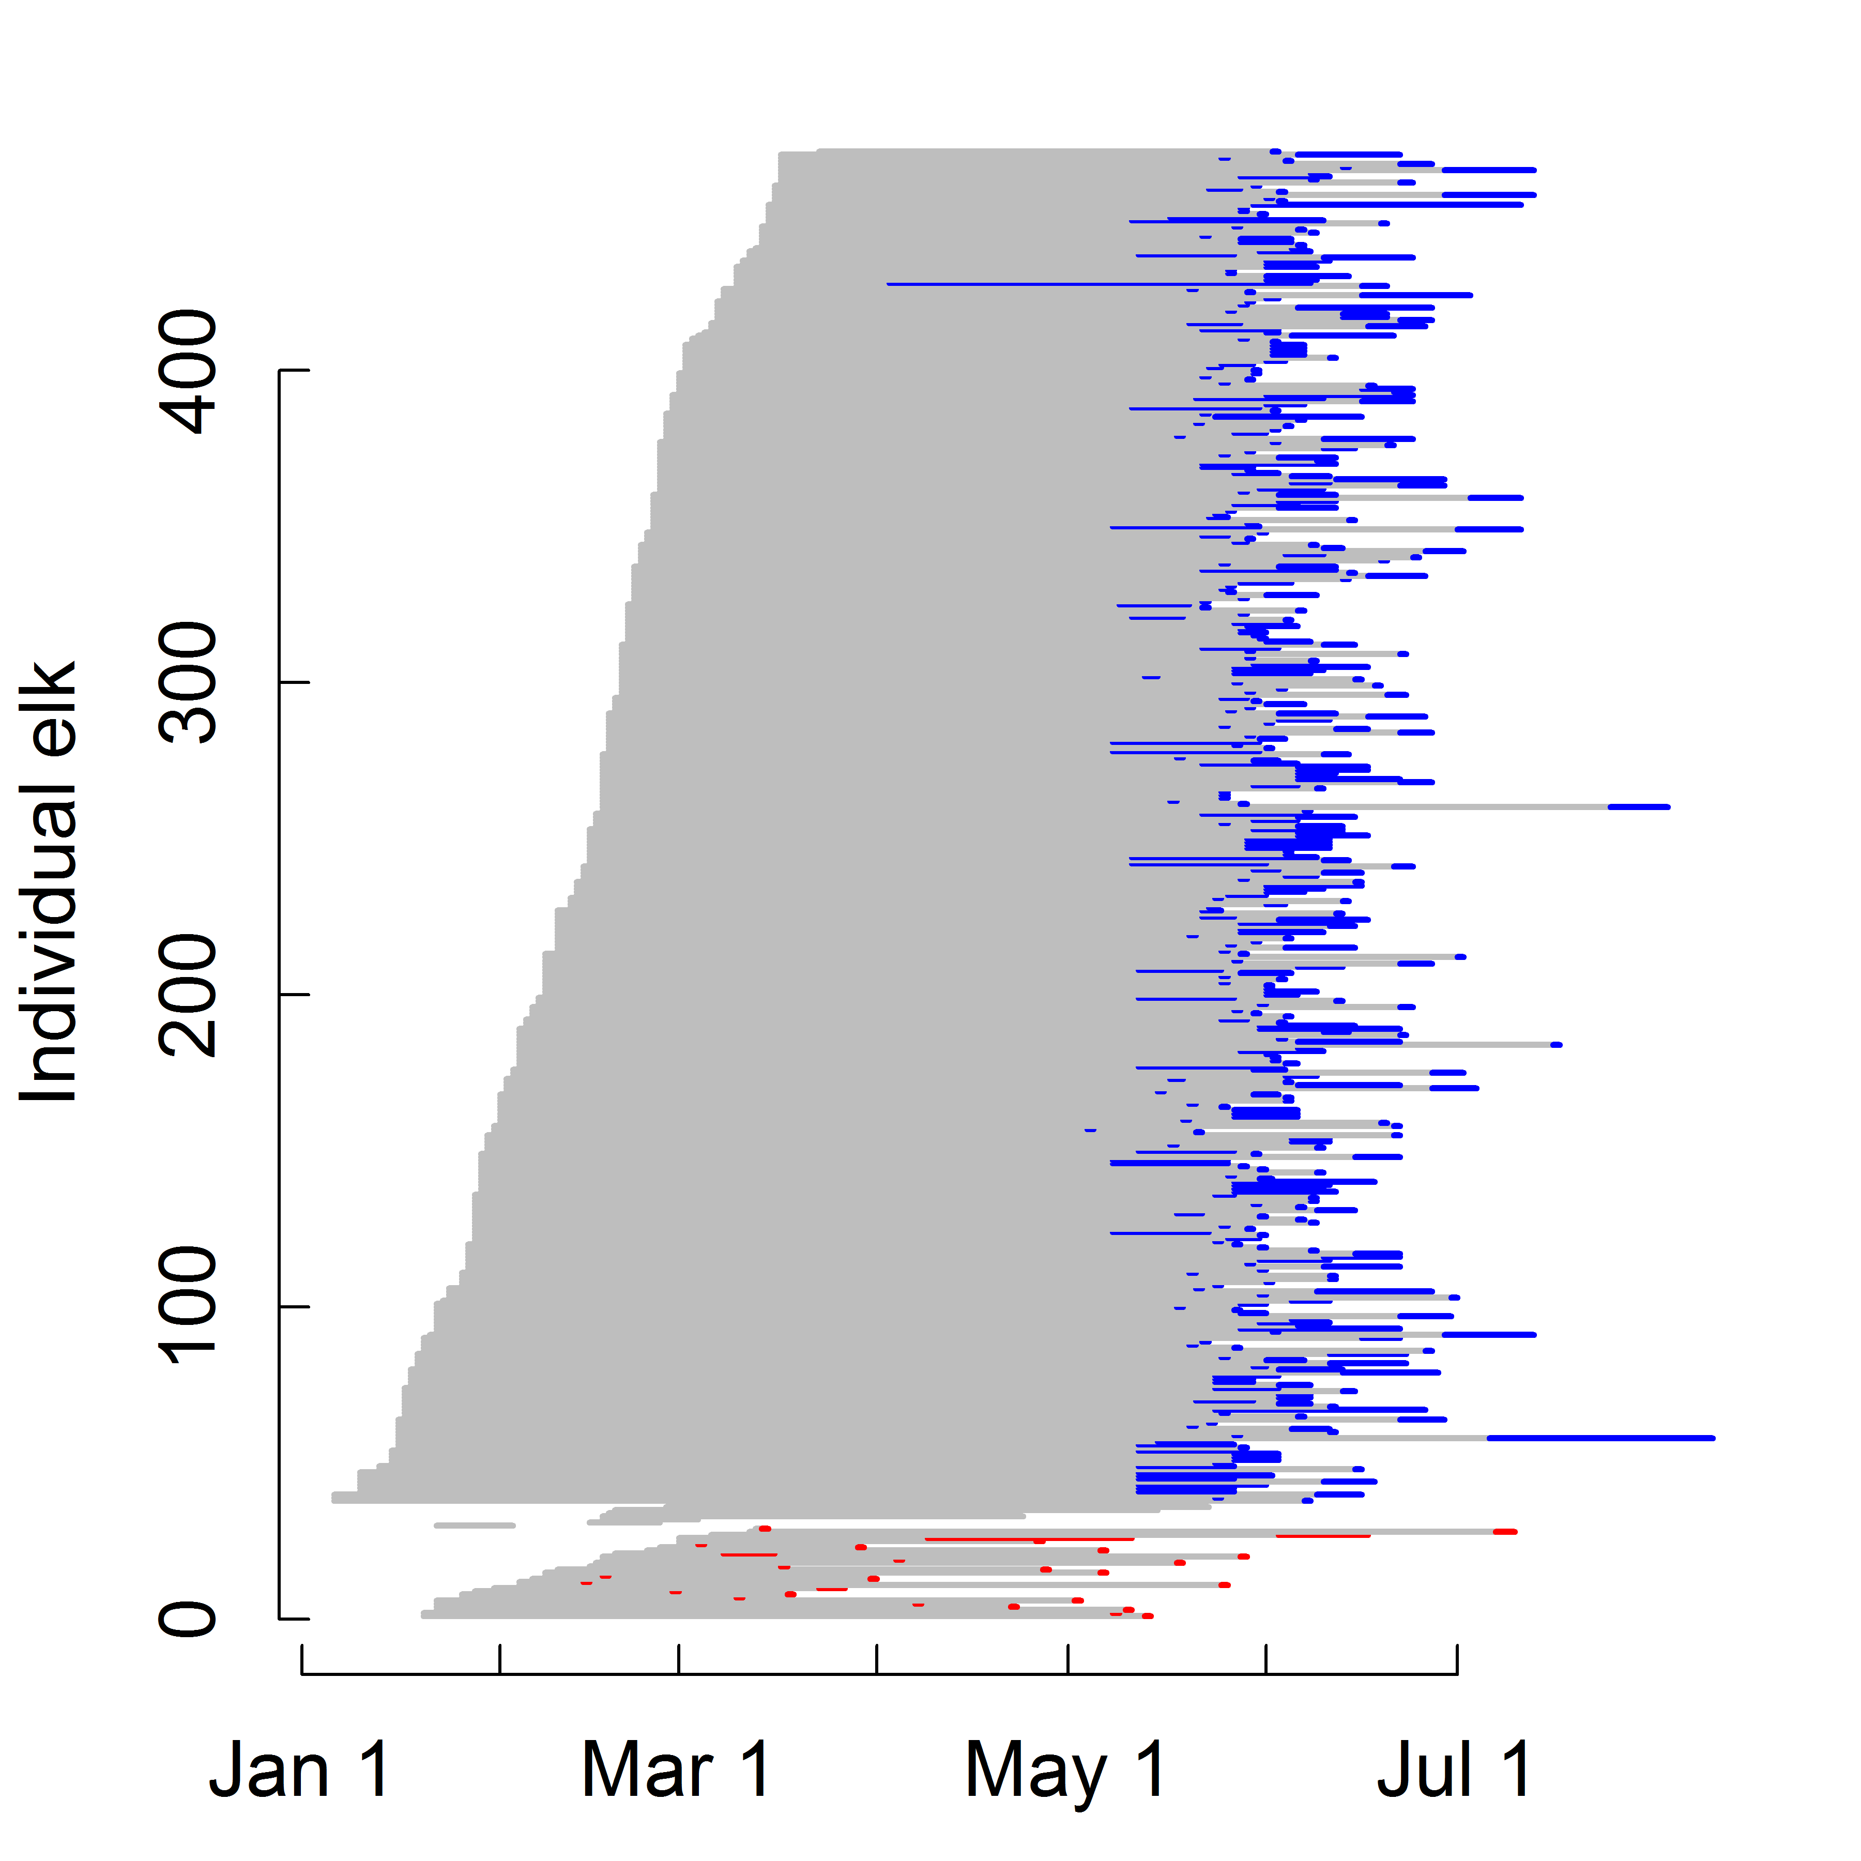

**Figure S1**. Raw data on the reproductive events of all pregnant elk in the study. Grey lines extend from the capture date to the time interval when the reproductive event occurred. Red and blue lines indicate time intervals when VITs were expelled due to abortions or normal birth events, respectively.

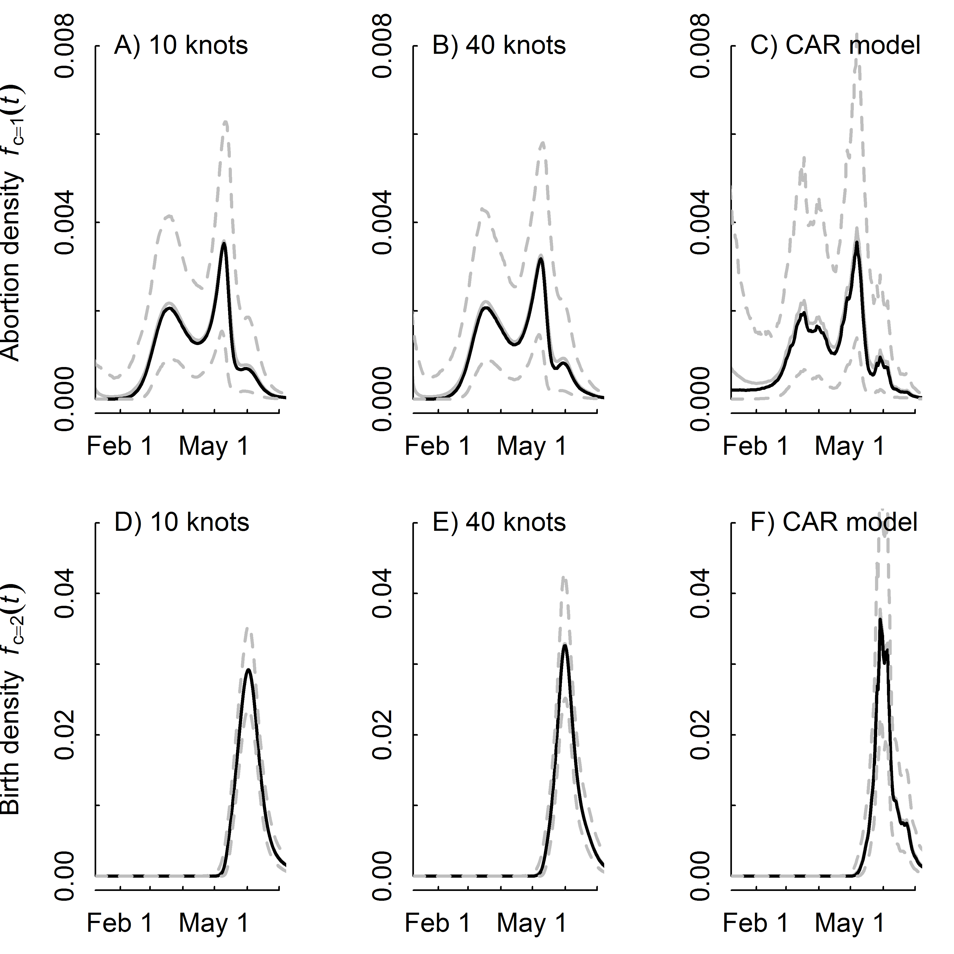

**Figure S2**. Comparison of reproductive event densities using different smoothing functions and only seropositive elk. Grey and black solid lines are the predicted posterior mean and medians. Dotted lines are the predicted posterior 95% credible intervals.

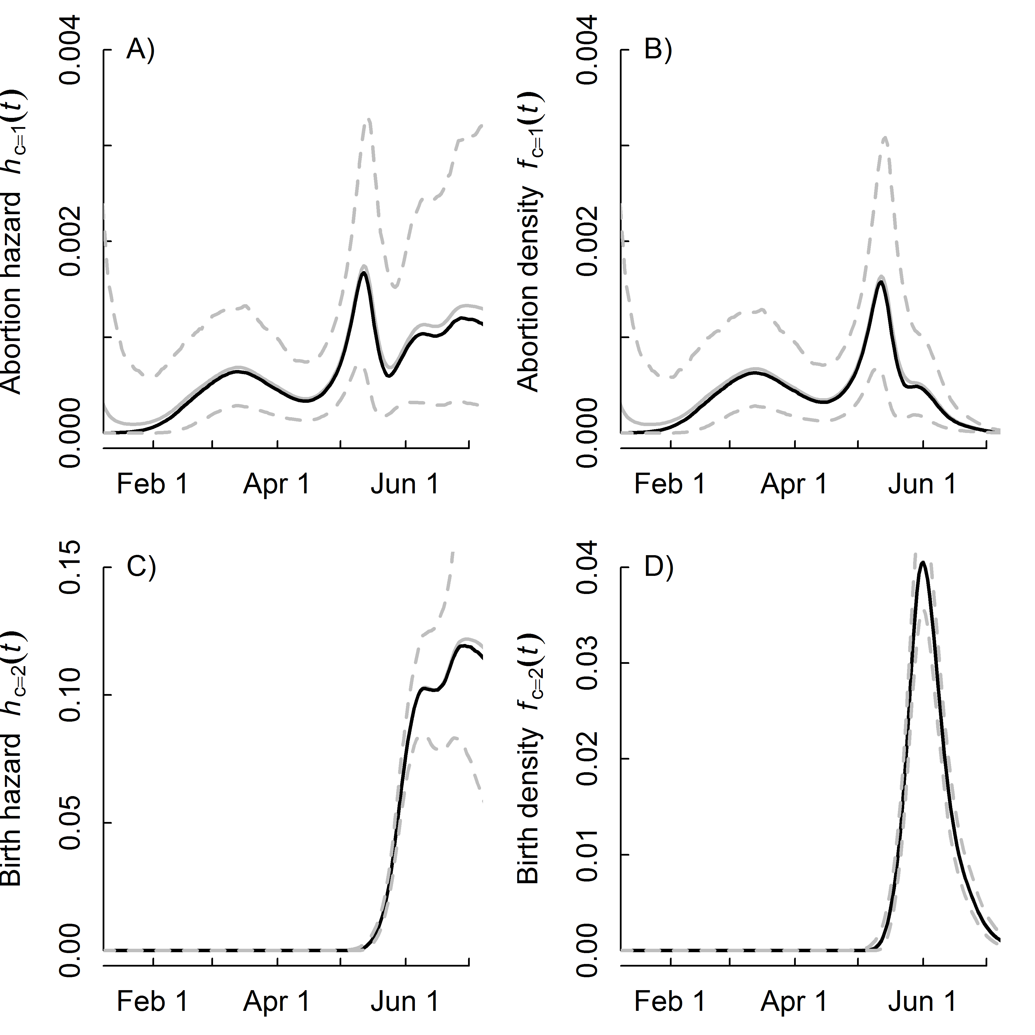

**Figure S3**. Results using seropositive and seronegative elk and the 40 knot spline model. Grey and black solid lines are the predicted posterior mean and medians. Dotted lines are the predicted posterior 95% credible intervals.

**Table S2**. Comparison of elk abortion timing across models when using all pregnant elk (n = 397). Models had different smoothing functions for the total hazard of a reproductive event, but the sub-model of the probability of an abortion relative to a live birth was a logistic regression in all cases.

|  |  |  |  |  |  |  |
| --- | --- | --- | --- | --- | --- | --- |
| Model | DIC | pD | 5% | 25% | 75% | 95% |
| 10 knots | 2606.6 | 12.7 | 18-Feb | 15-Mar | 15-May | 5-Jun |
| 40 knots | 2603.3 | 14.4 | 18-Feb | 17-Mar | 14-May | 5-Jun |
| CAR model | 2613.5 | 36.3 | 2-Feb | 14-Mar | 12-May | 4-Jun |

DIC: Deviance information criteria  
pD: Estimate of model complexity  
5-95%: Estimated day of the year when *X*% of the abortions have occurred.

**Appendix S1:** Model code.  
Hazard spline model that is not partitioned by event type (10knots) -----------------------------------------------------

# Priors  
 gamma0 ~ dnorm(0, 1.0E-6)  
 sigmab ~ dunif(0,3)  
 taub <- pow(sigmab, -2)  
 for (l in 1:num.knots){b[l] ~ dnorm(0,taub)}  
   
 # Likelihood for the total hazard  
 for (j in 1:records) {  
 for (k in left[j]:(right[j]-1)) {  
 # unit cumulative hazard  
 UCH[j,k] <- exp(gamma0 + mre110[k])  
 }   
   
 SLR[j] <- exp(-sum(UCH[j,left[j]:(right[j]-1)])) # total prob of not having an event   
   
 # Bernoulli draw for "surviving"  
 noevent[j] ~ dbern(SLR[j])   
 }  
  
# Calculate the baseline hazard  
 for (i in 1:D) {  
 Haz_b[i] <- exp(gamma0 + mre110[i]) # baseline hazard  
 # Spline part  
 mre110[i] <- b[1]*Z[i,1]+b[2]*Z[i,2]+b[3]*Z[i,3]+b[4]*Z[i,4]+b[5]*Z[i,5]+  
 b[6]*Z[i,6]+b[7]*Z[i,7]+b[8]*Z[i,8]+b[9]*Z[i,9]+b[10]*Z[i,10]  
 }

## Hazard spline model that is partitioned by event type (10knots)

# Priors  
sigmab ~ dunif(0,3)  
taub <- pow(sigmab, -2)  
gamma0 ~ dnorm(0, 1.0E-6)  
beta ~ dunif(0,2) # slope for the probability of an abortion  
alpha ~ dunif(50, 200) # offset for the transition from abortion to birth  
K ~ dunif(0,0.5) # lower asymptote for the prob. of an abortion  
for (l in 1:num.knots){b[l] ~ dnorm(0,taub)}  
  
#Derived parameters  
for (i in 1:D) {  
 Haz_b[i] <- exp(gamma0 + mre110[i]) # baseline hazard  
  
 mre110[i] <- b[1]*Z[i,1]+b[2]*Z[i,2]+b[3]*Z[i,3]+b[4]*Z[i,4]+b[5]*Z[i,5]+  
 b[6]*Z[i,6]+b[7]*Z[i,7]+b[8]*Z[i,8]+b[9]*Z[i,9]+b[10]*Z[i,10]  
  
 prob.ab[i] <- 1 + (K - 1) / (1 + exp(-beta*(i - alpha))) # probability of abortion   
 Haz_a[i] <- prob.ab[i] * Haz_b[i] # abortion hazard  
 Haz_l[i] <- (1-prob.ab[i]) * Haz_b[i] # live birth hazard  
}   
  
# Likelihood for the total hazard  
for (j in 1:records) {  
 for (k in left[j]:(right[j]-1)) {UCH[j,k] <- exp(gamma0 + mre110[k])}   
 SLR[j] <- exp(-sum(UCH[j,left[j]:(right[j]-1)])) # total prob of not having an event   
 noevent[j] ~ dbern(SLR[j])   
}  
  
# Likelihood on partitioning the event types  
for (m in 1:n.events) {  
 b.type[m] ~ dbern(p.a[m])  
 p.a[m] <- 1 + (K - 1) / (1 + exp(-beta*(event.day[m] - alpha)))  
}

Estimating the design matrix *Z* for the splines was done in R as follows:

Z_K<-(abs(outer(covariate,knots,"-")))^3   
OMEGA_all<-(abs(outer(knots,knots,"-")))^3   
svd.OMEGA_all<-svd(OMEGA_all)   
sqrt.OMEGA_all<-t(svd.OMEGA_all$v %*%   
(t(svd.OMEGA_all$u)*sqrt(svd.OMEGA_all$d)))   
Z<-t(solve(sqrt.OMEGA_all,t(Z_K)))

## Conditional autoregressive model with event-type partitioning

# Priors  
 gamma0 ~ dnorm(0, 1.0E-6)  
 beta ~ dunif(0,2) # slope for the probability of an abortion  
 alpha ~ dunif(50, 200) # offset for the transition from abortion to birth  
 K ~ dunif(0,0.5) # lower asymptote for the prob. of an abortion  
 sd.rho ~ dunif(0,10) # hyperprior  
 tau.rho <- pow(sd.rho, -2)   
 rho[1] ~ dnorm(0, 1.0E-6)  
 for (i in 2:D) {rho[i]~dnorm(rho[i-1],tau.rho)}  
   
 #Derived quantities  
 for (i in 1:D) {  
 Haz_b[i] <- exp(gamma0 + rho[i]) # overall baseline  
 prob.ab[i] <- 1 + (K - 1) / (1 + exp(-beta*(i - alpha))) # probability of abortion   
 Haz_a[i] <- prob.ab[i] * Haz_b[i] # abortion hazard  
 Haz_l[i] <- (1-prob.ab[i]) * Haz_b[i] # live birth hazard  
 }   
  
 # Likelihood  
 for (j in 1:records) {  
 for (k in left[j]:(right[j]-1)) {  
 UCH[j,k] <- exp(gamma0 + rho[k]) # unit hazard over the interval  
 }   
 SLR[j] <- exp(-sum(UCH[j,left[j]:(right[j]-1)]))# total prob of not having an event   
 noevent[j] ~ dbern(SLR[j])   
 }  
   
 # Likelihood on partitioning the event types  
 for (m in 1:n.events) {  
 b.type[m] ~ dbern(p.a[m])  
 p.a[m] <- 1 + (K - 1) / (1 + exp(-beta*(event.day[m] - alpha)))  
 }