% DSP_Project_1

%

% Design of Case 1 Linear-Phase FIR Digital Filter(odd,symmetric)

%

clear all; % clear workspace

clc; % clear command window

N = 31;

wp = 0.4*pi;

ws = 0.5*pi;

% Wp = Ws = 1;

%

NH = (N-1)/2;

%

%

P = zeros(NH+1,1);

Qp = zeros(NH+1,NH+1);

Qs = zeros(NH+1,NH+1);

for i=0:NH % 0:1:NH

if i==0

P(i+1) = -2*wp;

else

P(i+1) = -2*sin(i*wp)/i;

end

for j=0:NH

if i==0 && j==0

Qp(i+1,j+1) = wp;

Qs(i+1,j+1) = pi - ws;

elseif i==j

Qp(i+1,j+1) = 0.5*wp + 0.5*sin((i+j)*wp)/(i+j);

Qs(i+1,j+1) = 0.5*(pi - ws) - 0.5*sin((i+j)*ws)/(i+j);

else

Qp(i+1,j+1) = 0.5*sin((i-j)*wp)/(i-j) + 0.5*sin((i+j)*wp)/(i+j);

Qs(i+1,j+1) = -0.5*sin((i-j)*ws)/(i-j) - 0.5*sin((i+j)*ws)/(i+j);

end

end

end

Q = Qp + Qs;

A = -0.5*inv(Q)*P;

%

%

h = zeros(N,1);

h(NH+1) = A(1);

h(1:NH) = 0.5*A(NH+1:-1:2);

h(NH+2:N) = 0.5*A(2:NH+1);

%

% need to show several plots simultaneously

subplot(2,2,1);

stem(0:N-1,h);

xlabel('n');

ylabel('Impulse Response');

%

% Amplitude Response

subplot(2,2,2);

AR = abs(freqz(h,1,0:pi/200:pi));

plot(0:1/200:1,AR);

axis([0,1,0,1.1]);

xlabel('Normalized Frequency (\omega/\pi)');

ylabel('Amplitude Response');

%

% Amplitude Response in dB

subplot(2,2,4);

plot(0:1/200:1,20*log10(AR));

axis([0,1,-60,10]);

xlabel('Normalized Frequency (\omega/\pi)');

ylabel('Amplitude Response in dB');

pause;

close all; % close formal plots

%

% signal simulation

%

% low frequency input 1

NT = (0:200)';

xL = sin(0.2*pi*NT);

subplot(2,3,1);

plot(NT,xL);

axis([0,200,-3,3]);

%

% low frequency output 2

yL = filter(h,1,xL);

subplot(2,3,4);

plot(NT,yL); % plot shows input delay

axis([0,200,-3,3]);

%

% high frequency input 3

xH = 1.5*cos(0.7*pi*NT);

subplot(2,3,2);

plot(NT,xH);

axis([0,200,-3,3]);

%

% high frequency output 4

yH = filter(h,1,xH);

subplot(2,3,5);

plot(NT,yH); % plot shows transition time

axis([0,200,-3,3]);

%

% high and low combined input 5

subplot(2,3,3);

plot(NT,xL + xH);

axis([0,200,-3,3]);

%

% high and low combined output 6

y = filter(h,1,xL + xH);

subplot(2,3,6);

plot(NT,y); % plot 6 is pretty the same with 2

axis([0,200,-3,3]);

%

%

%

% Case 1 Linear-Phase FIR Digital Filter

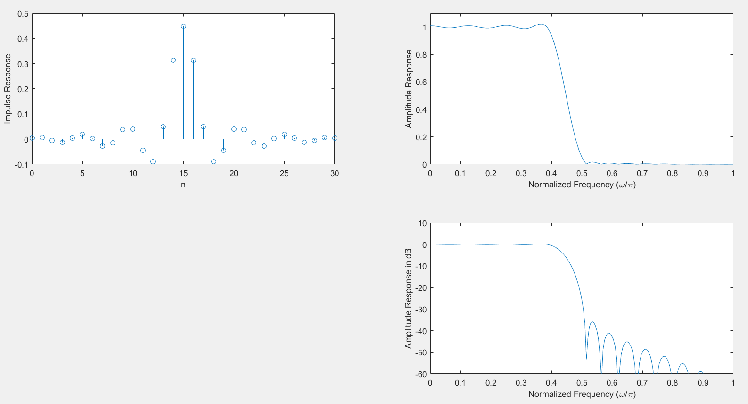

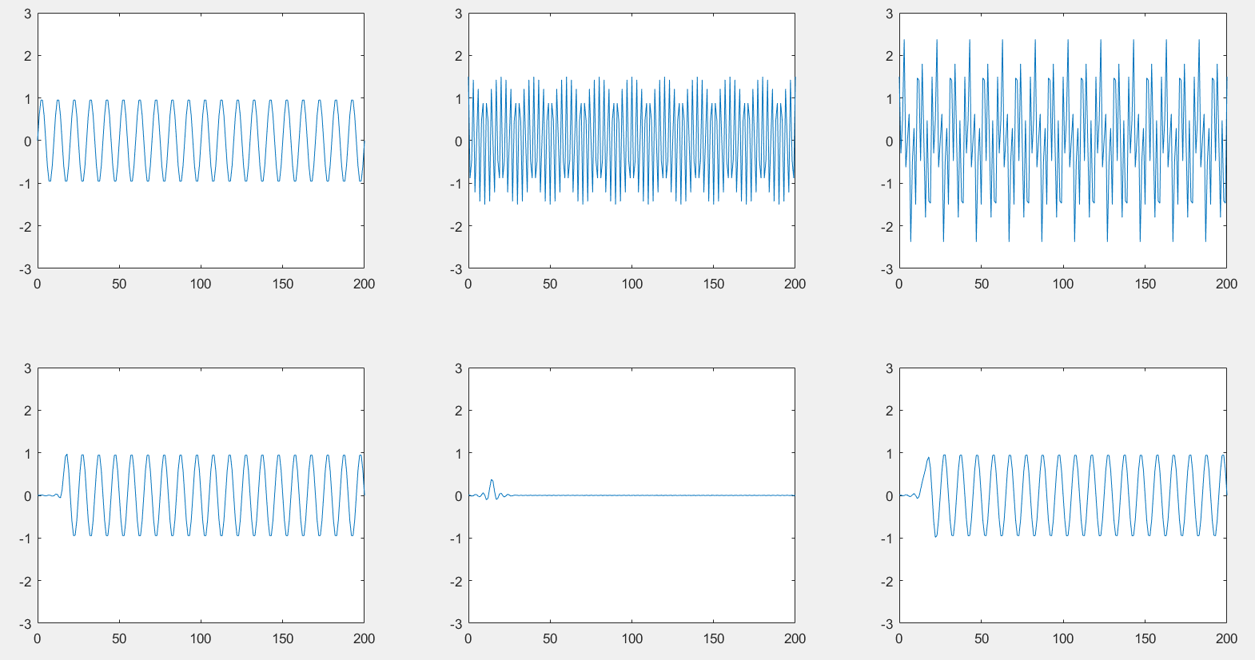

%

% Design of Case 3 Differentiator

%

clear all; % clear workspace

clc; % clear command window

N = 41;

wp = 0.9*pi; % wp = wp1

% no need wp2

%

%

NH = (N-1)/2;

%

%

P = zeros(NH,1);

Q = zeros(NH,NH);

for i=1:NH % 0:1:NH

P(i) = 2*wp*cos(i*wp)/i - 2*sin(i*wp)/i^2;

for j=1:NH

if i==j

Q(i,j) = 0.5*wp - 0.5*sin((i+j)*wp)/(i+j);

else

Q(i,j) = 0.5*sin((i-j)*wp)/(i-j) - 0.5*sin((i+j)*wp)/(i+j);

end

end

end

A = -0.5*inv(Q)*P;

%

%

h = zeros(N,1);

h(1:NH) = 0.5*A(NH:-1:1);

h(NH+2:N) = -0.5*A;

%

% subplot - need to show several plots simultaneously

% 從圖可知是 high-pass filter

subplot(1,2,1);

stem(0:N-1,h);

xlabel('n');

ylabel('Impulse Response');

%

% Amplitude Response

subplot(1,2,2);

AR = abs(freqz(h,1,0:pi/200:pi));

plot(0:1/200:1,AR);

axis([0,1,0,3]);

xlabel('Normalized Frequency (\omega/\pi)');

ylabel('Amplitude Response');

%

% Case 3 don't need dB plots

%

% Case 3 Differentiator

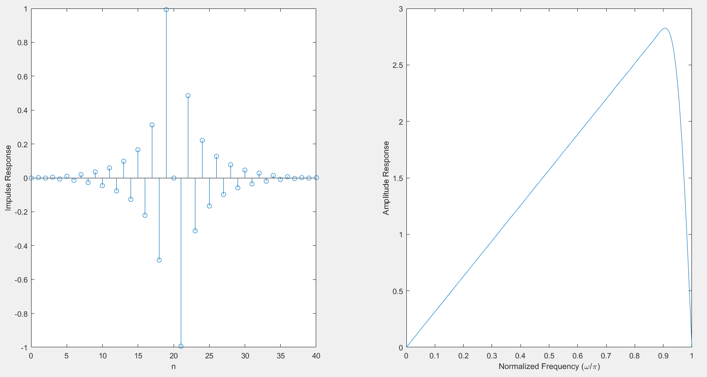

%

% Design of case 3 Hilbert Transformers

%

clear all; % clear workspace

clc; % clear command window

N = 31;

wp1 = 0.05*pi;

wp2 = 0.95*pi;

%

%

NH = (N-1)/2;

%

%

P = zeros(NH,1);

Q = zeros(NH,NH);

for i=1:NH % 0:1:NH

P(i) = -2*(cos(i*wp2) - cos(i*wp1))/i;

for j=1:NH

if i==j

Q(i,j) = 0.5*(wp2-wp1) - 0.5*sin((i+j)*wp2)/(i+j) + 0.5*sin((i+j)*wp1)/(i+j);

else

Q(i,j) = 0.5*sin((i-j)*wp2)/(i-j) - 0.5*sin((i-j)*wp1)/(i-j) ....

- 0.5*sin((i+j)*wp2)/(i+j) + 0.5*sin((i+j)*wp1)/(i+j);

end

end

end

A = -0.5*inv(Q)*P;

%

%

h = zeros(N,1);

h(1:NH) = 0.5*A(NH:-1:1);

h(NH+2:N) = -0.5*A;

%

% subplot - need to show several plots simultaneously

subplot(1,2,1);

stem(0:N-1,h);

xlabel('n');

ylabel('Impulse Response');

%

% Amplitude Response

subplot(1,2,2);

AR = abs(freqz(h,1,0:pi/200:pi));

plot(0:1/200:1,AR);

axis([0,1,0,1.1]);

xlabel('Normalized Frequency (\omega/\pi)');

ylabel('Amplitude Response');

%

% case 3 don't need dB plots

%

% Case 3 Hilbert Transformers

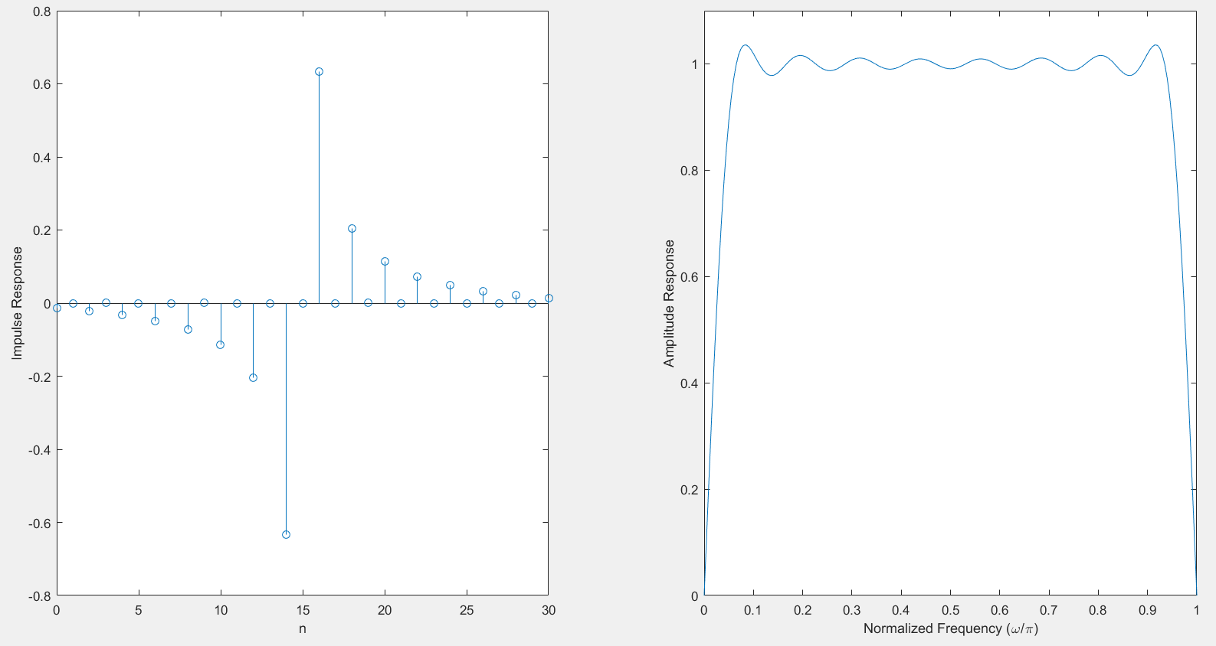

%

% Design of Case 4 Differentiator

%

clear all; % clear workspace

clc; % clear command window

N = 30; % filter length

% wp1 = 0; 因為下限從0開始，所以不再需要wp1

% wp2 = pi; 因為上限可以到pi，所以不再需要wp2

%

NH = N/2;

%

%

P = zeros(NH,1); % declaration 宣告

for i=1:NH % 0:1:NH

P(i) = -2*sin((i-0.5)*pi)/(i-0.5)^2;

end

Q = 0.5*pi*eye(NH);

A = -0.5*inv(Q)*P;

%

%

h = zeros(N,1); % 怎麼求得h ?

h(1:NH) = 0.5*A(NH:-1:1);

h(NH+1:N) = -0.5*A;

%

% subplot - need to show several plots simulteneously

subplot(1,2,1);

stem(0:N-1,h);

xlabel('n');

ylabel('Impulse Response');

%

% Amplitude Response

subplot(1,2,2);

AR = abs(freqz(h,1,0:pi/200:pi));

plot(0:1/200:1,AR);

axis([0,1,0,3.5]);

xlabel('Normalized Frequency (\omega/\pi)');

ylabel('Amplitude Response');

%

% signal simulation

%

NT = (0:200)';

x = zeros(1,201);

for in=0:200

x(in+1) = cos(in*(in/400)*pi);

end

subplot(2,1,1);

plot(NT,x);

axis([0,200,-3,3]);

%

%

y = filter(h,1,x);

subplot(2,1,2);

plot(NT,y); % plot shows input delay

axis([0,200,-3,3]);

%

%

% Case 4 Differentiator

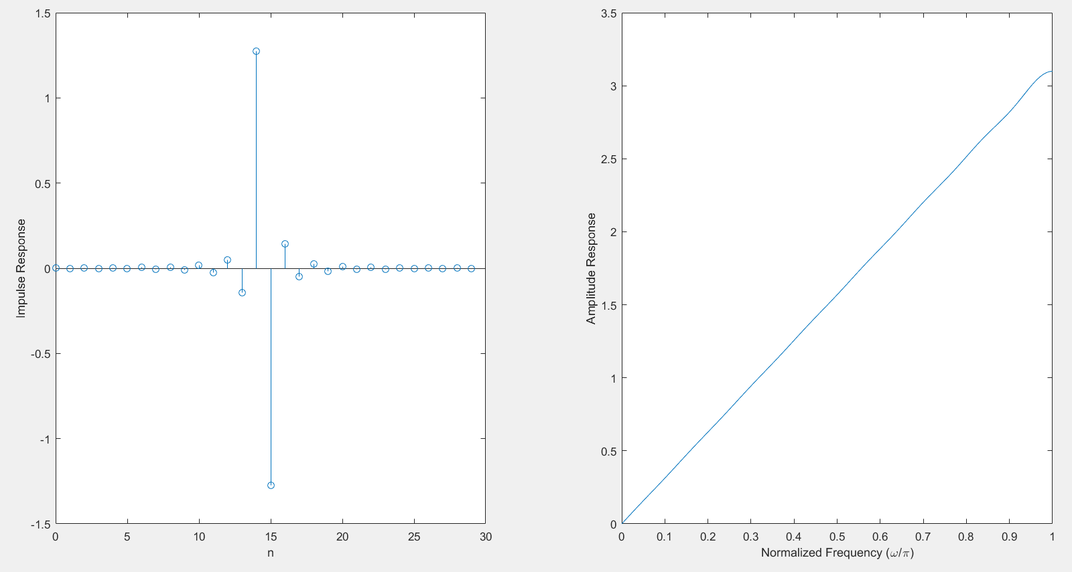

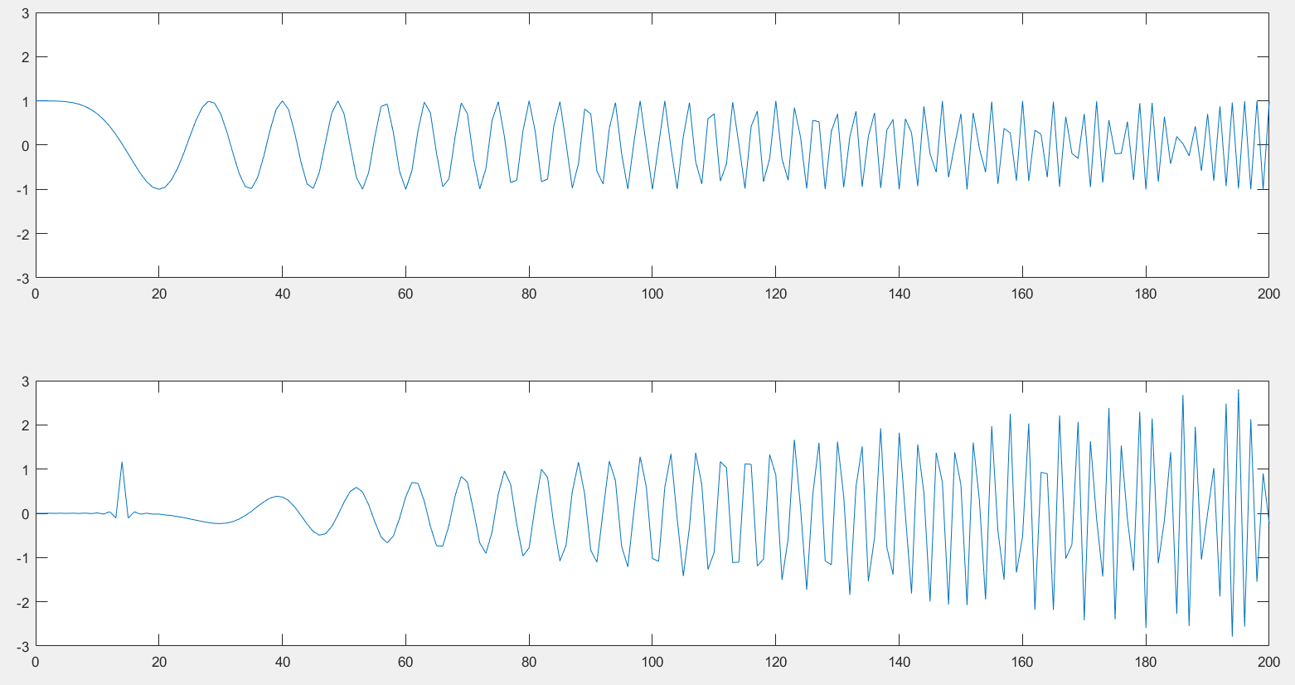

%

% Design of case 4 Hilbert Transformers

%

clear all; % clear workspace

clc; % clear command window

N = 30;

wp1 = 0.05*pi;

% wp2 = pi; 因為上限可到pi，所以不再需要wp2

%

%

NH = N/2;

%

%

P = zeros(NH,1);

Q = zeros(NH,NH);

for i=1:NH % 0:1:NH

P(i) = 2*cos((i-0.5)*wp1/(i-0.5));

for j=1:NH

if i==j

Q(i,j) = 0.5*(pi-wp1) + 0.5*sin((i+j-1)*wp1)/(i+j-1);

else

Q(i,j) = -0.5*sin((i-j)*wp1)/(i-j) + 0.5*sin((i+j-1)*wp1)/(i+j-1);

end

end

end

A = -0.5*inv(Q)*P;

%

%

h = zeros(N,1);

h(1:NH) = 0.5*A(NH:-1:1);

h(NH+1:N) = -0.5*A;

%

% subplot - need to show several plots simulteneously

subplot(1,2,1);

stem(0:N-1,h);

xlabel('n');

ylabel('Impulse Response');

%

% Amplitude Response

subplot(1,2,2);

AR = abs(freqz(h,1,0:pi/200:pi));

plot(0:1/200:1,AR);

axis([0,1,0,1.1]);

xlabel('Normalized Frequency (\omega/\pi)');

ylabel('Amplitude Response');

%

%

% case 4 Hilbert Transformers

