**Homework #1 Solution**

**Due 23:59, Oct. 27, 2022**

**(5% + 5%)**

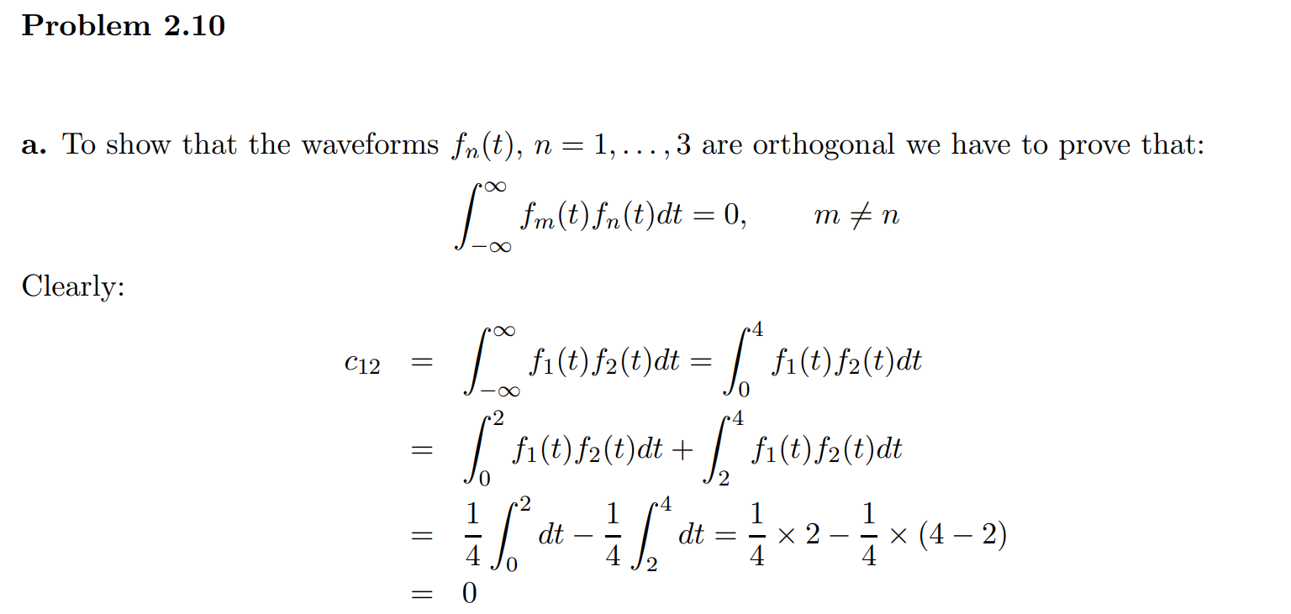

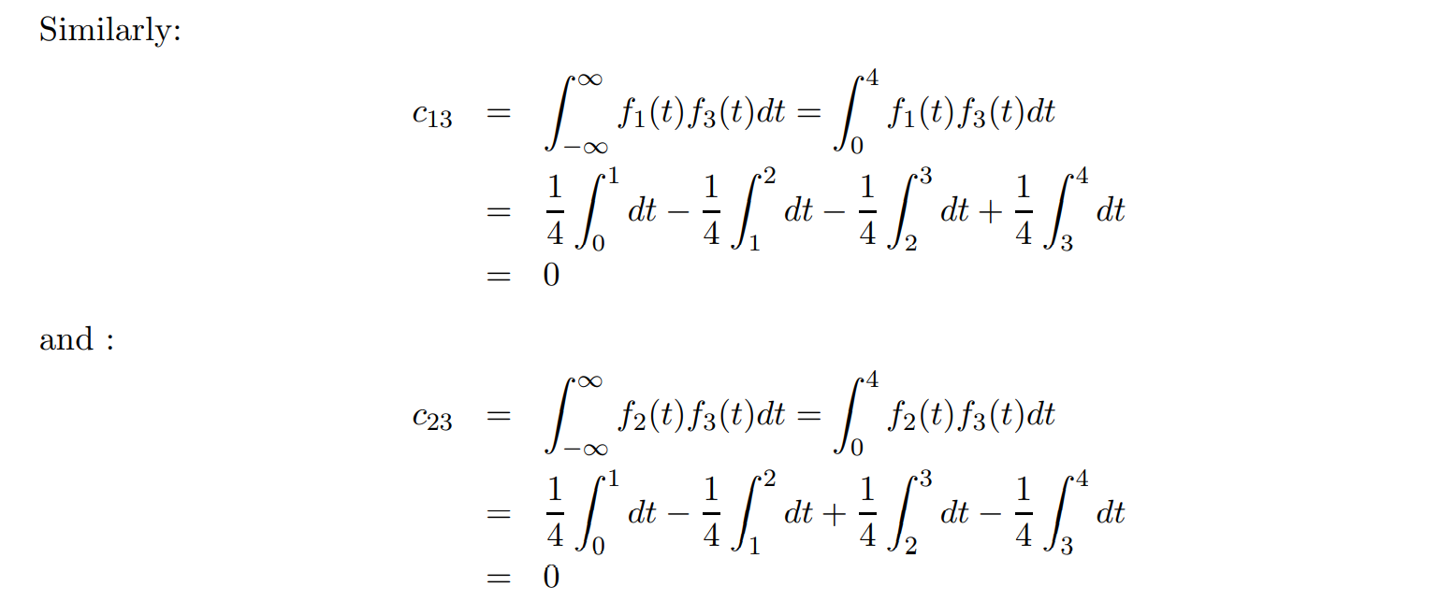

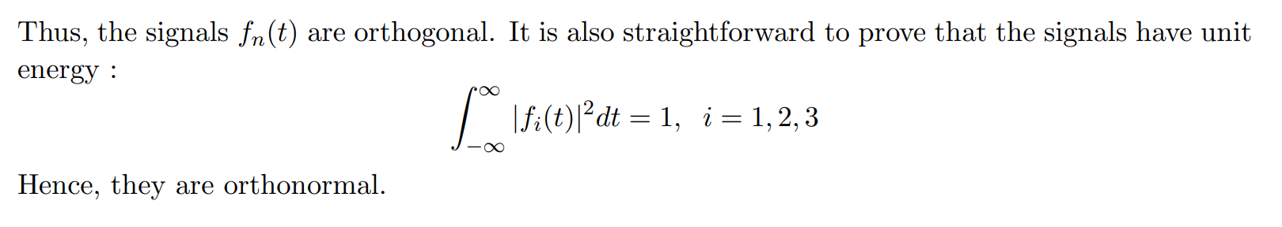

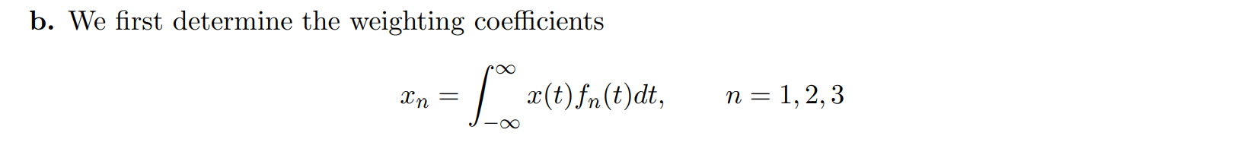

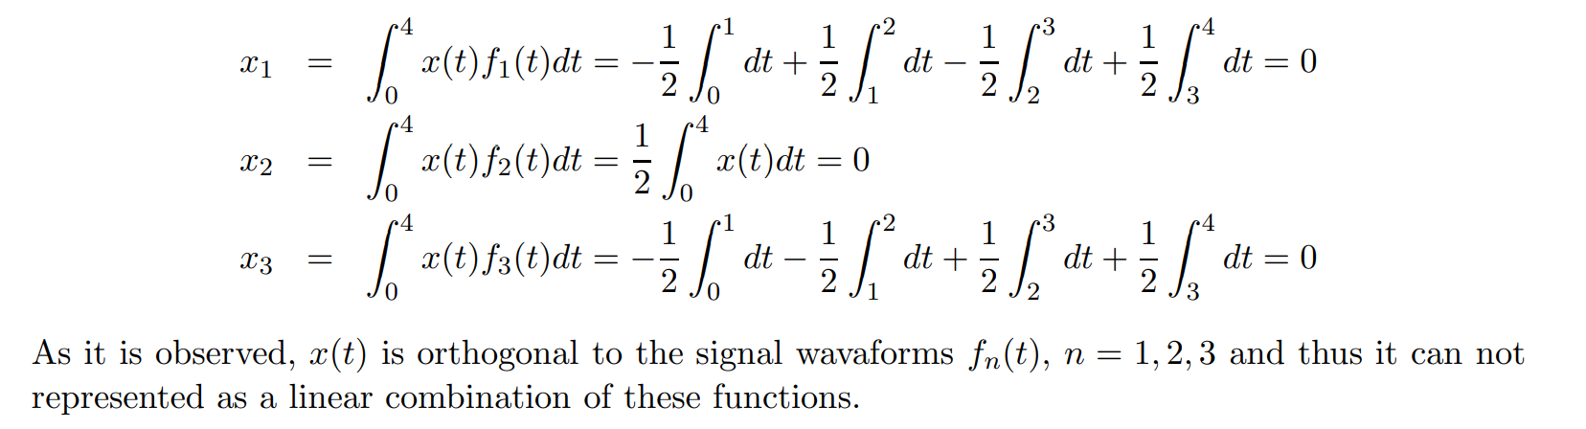

**(10%)**

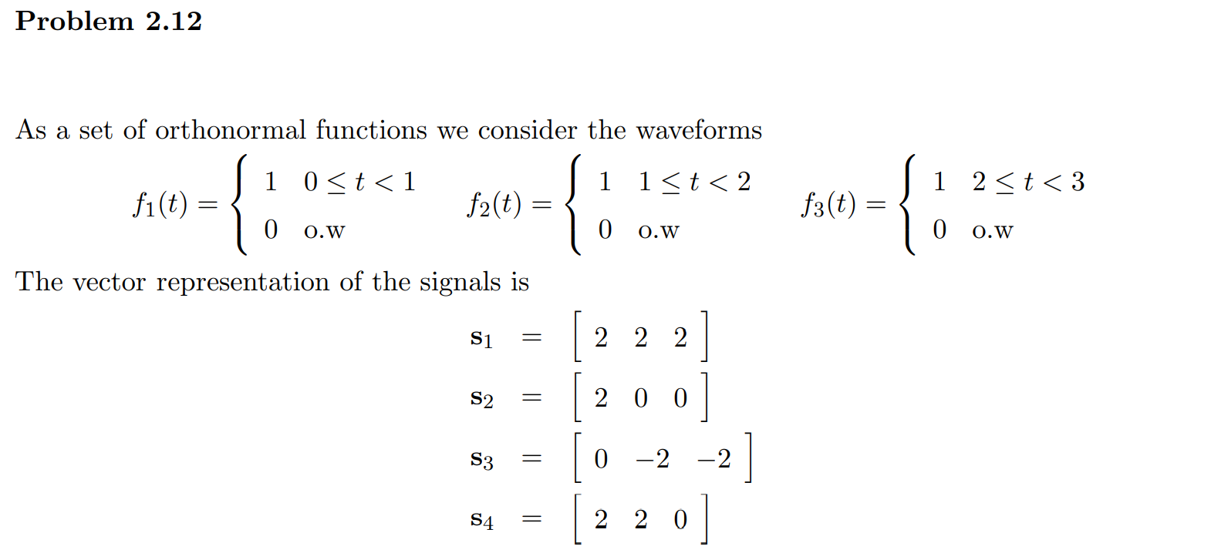



**(10%)**

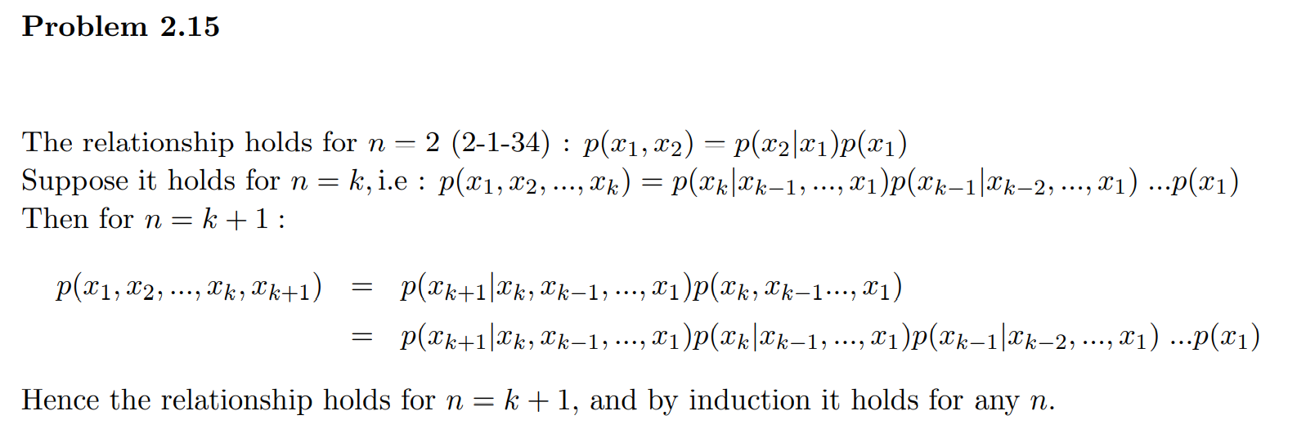

**(10%)**

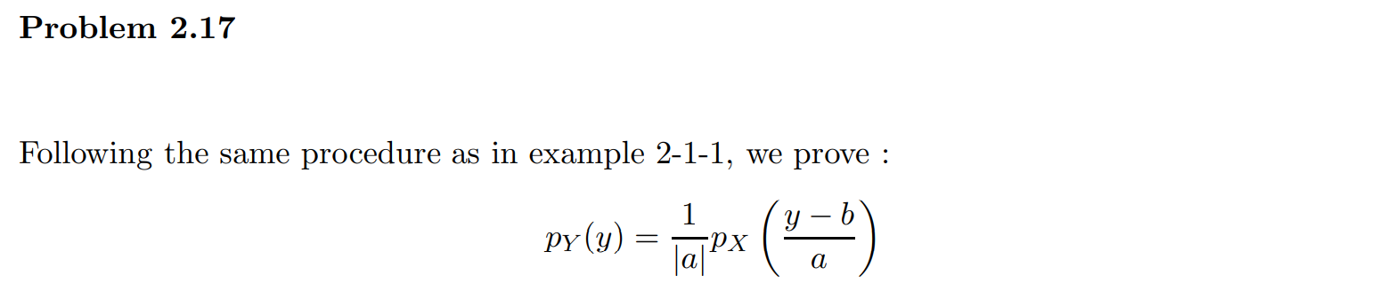

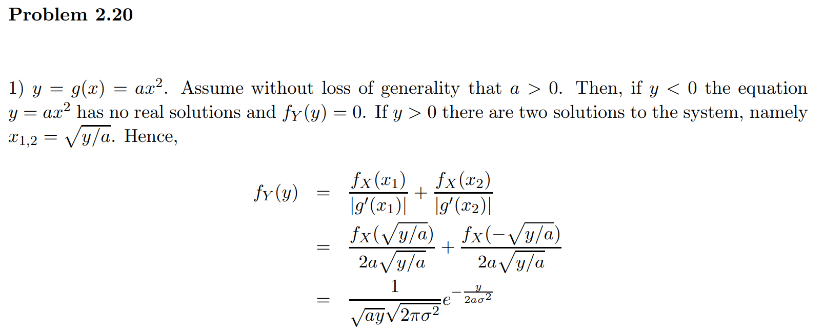

**(5% + 5% + 5% + 5%)**

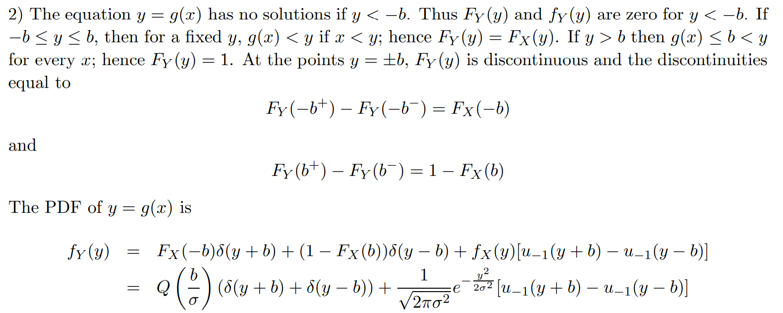

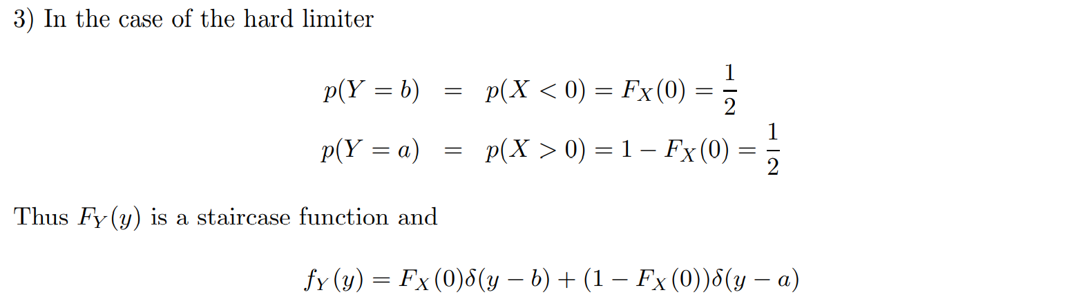

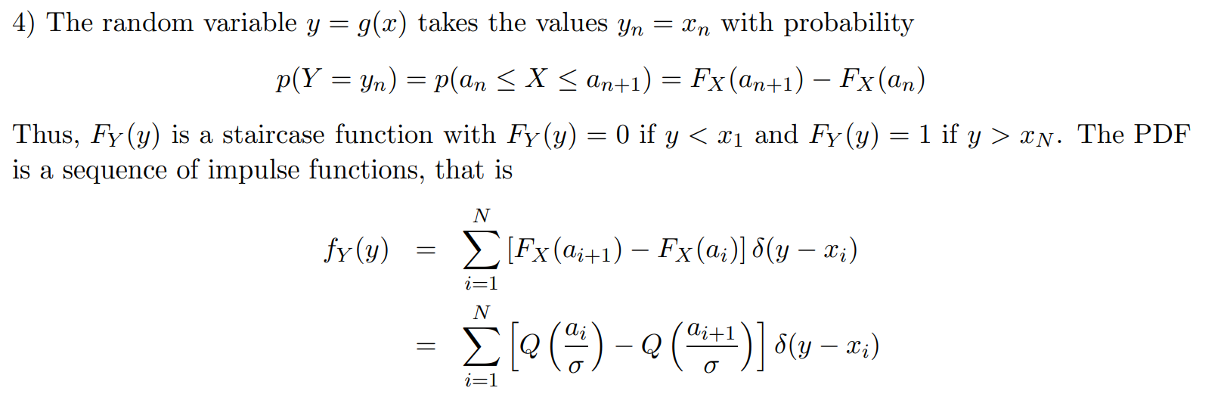

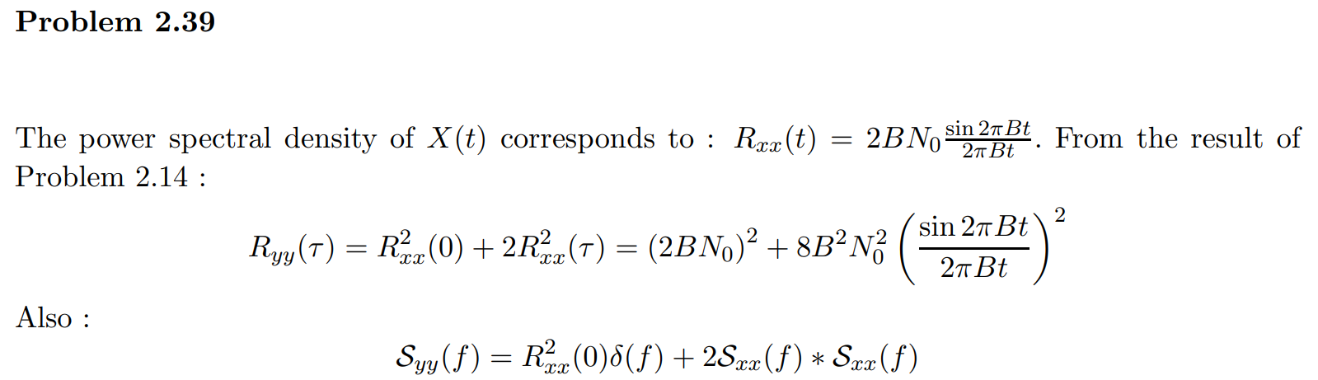

**(10%)**

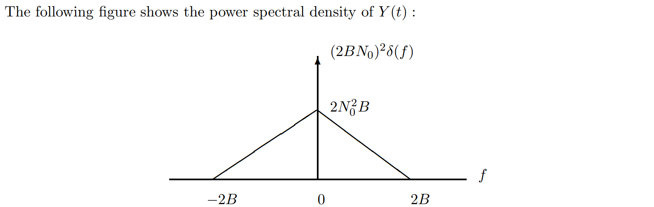

**4 N_0^2 B**

**(10%)**

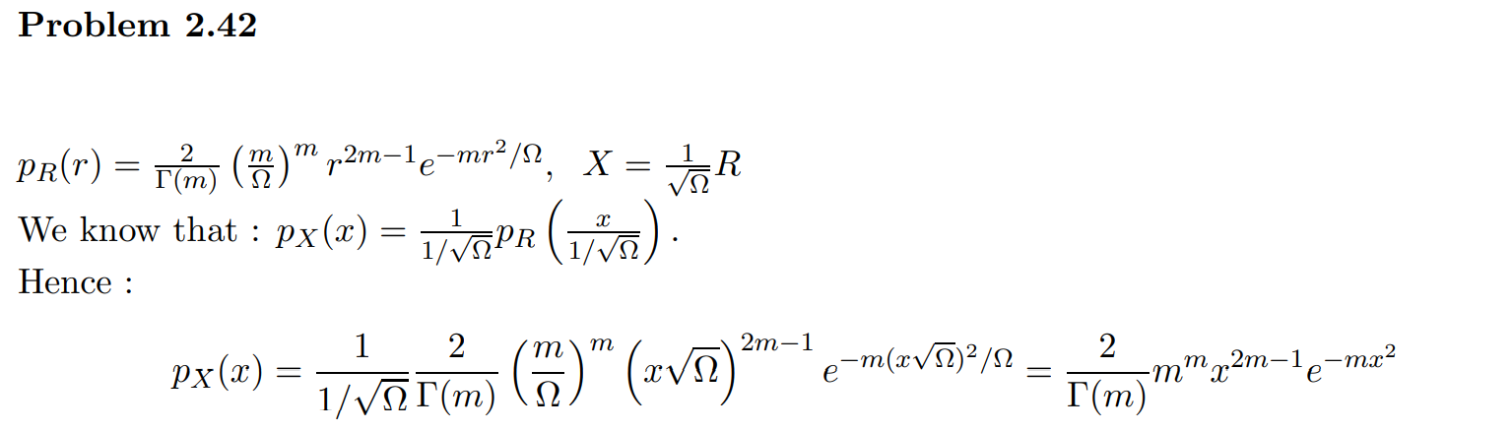

**(10%)**

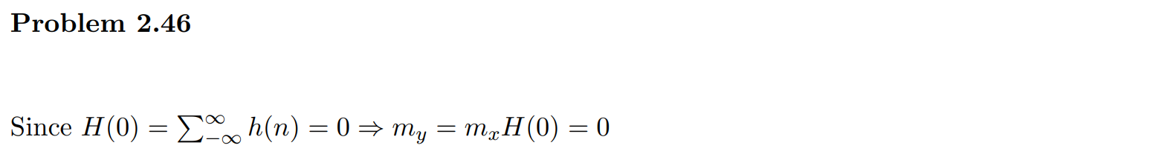









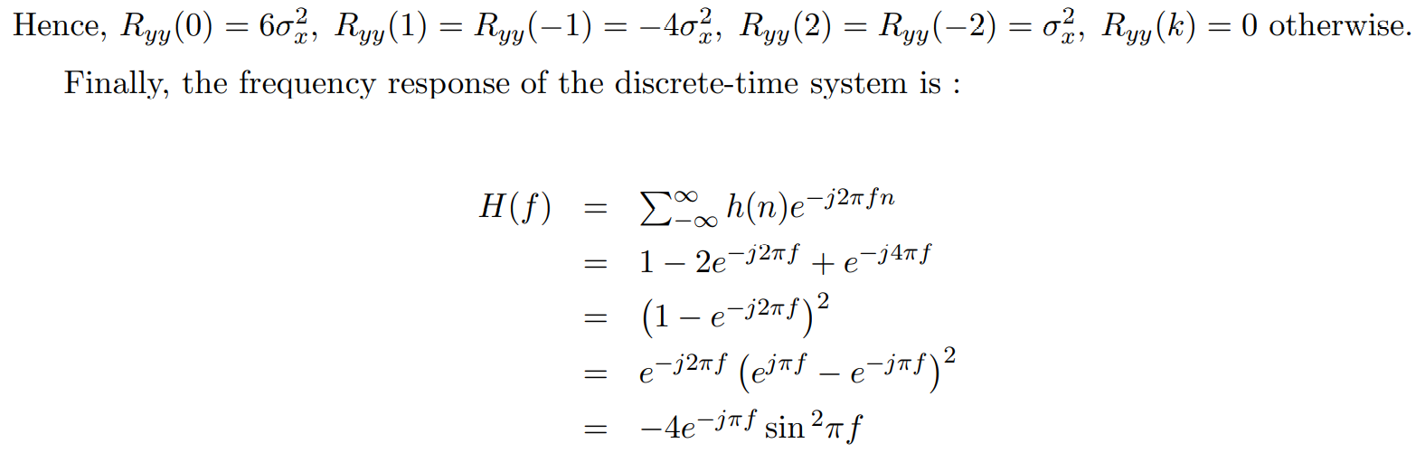

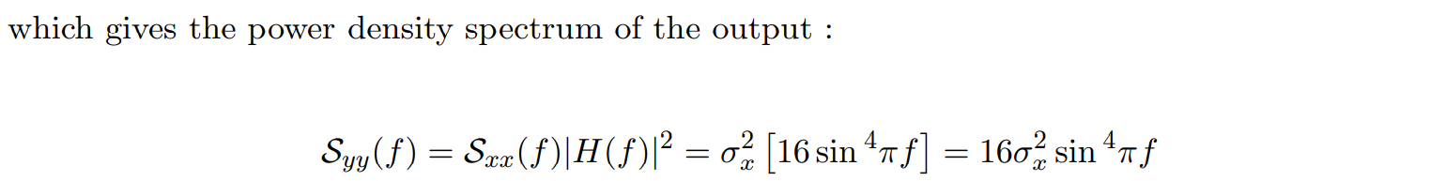

**(10%)**

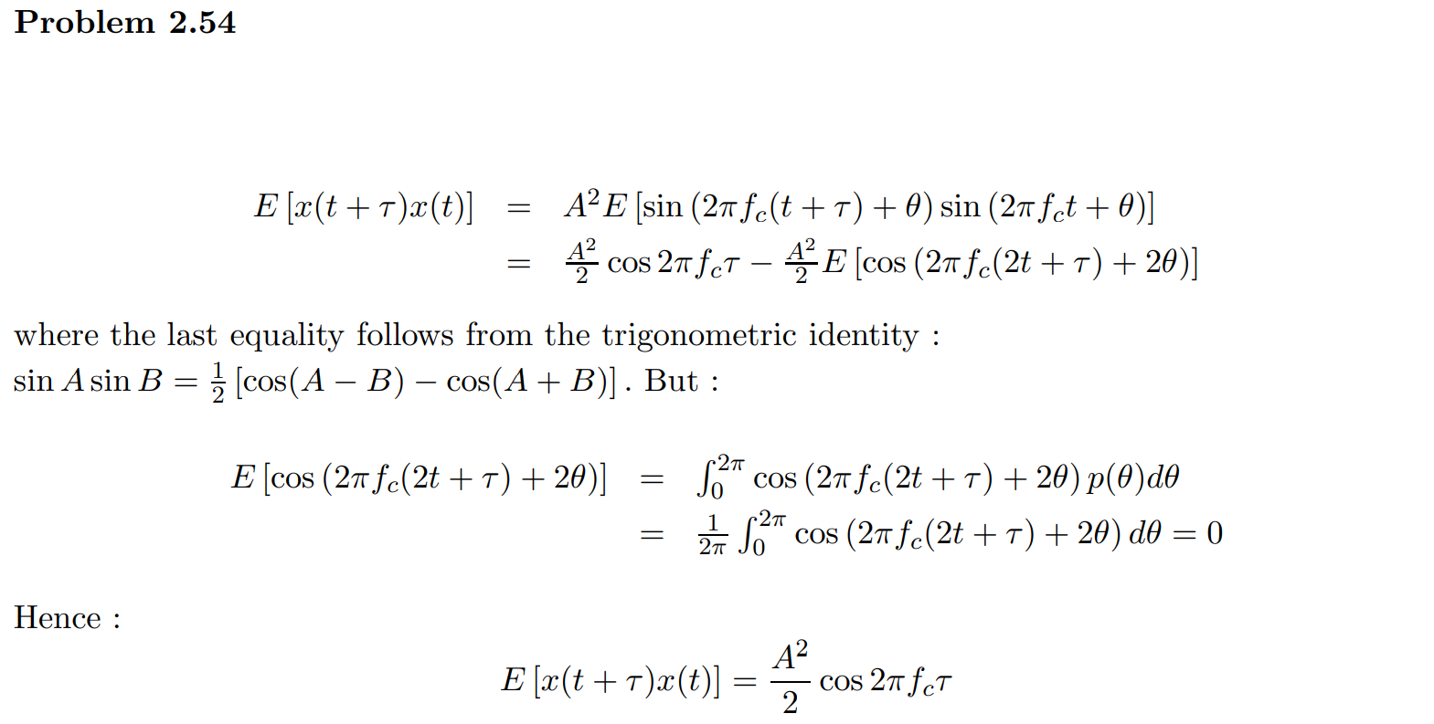

**Appendix**

**Problem 2.39** is actually a follow-up question of **Problem 2.27** and **Problem 2.41**, so we also provide the solution of these two questions for you reference.

