1. Show the Bias-Variance Decomposition, and introduce Bias-Variance Tradeoff

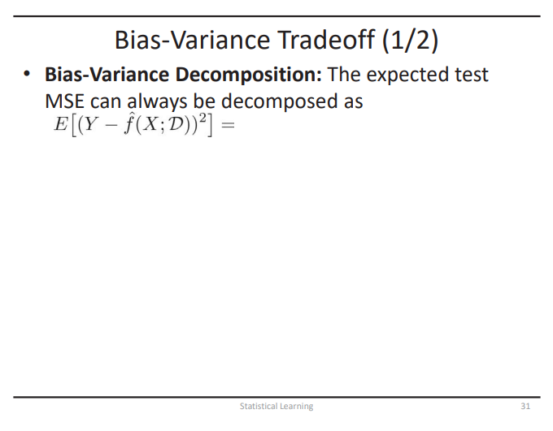

2. 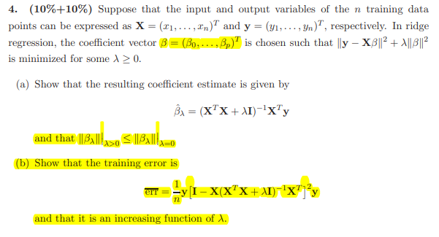

and find the standard errors of the coefficient SE().

3. Suppose that the available data set is D = {(x1, y1),(x2, y2),(x3, y3)} = {(1, 2),(3, 7),(5, 8)}. Find the overall MSE of 3-fold CV

4. Find the classification rule using QDA

5.

(a) Compare the Validation Set Approach and Cross-Validation

(b) 為什麼要有logistic regression

(c) explain the meaning of t-statistic.