1.

(a)

|  |  |  |  |  |
| --- | --- | --- | --- | --- |
|  | Coefficient | Std.Error | t-statistic | p-value |
| (intercept) | -4945.59 | 6211.16 | -0.79624 | 0.426353 |
| X1 | -0.268917 | 0.038996 | -6.89607 | 2.04E-11 |
| X2 | -0.0042591 | 0.000723 | -5.88814 | 8.17E-09 |
| X3 | 1.16302 | 0.190221 | 6.11406 | 2.27E-09 |
| X4 | 237.767 | 44.948 | 5.28983 | 2.00E-07 |
| X5 | -7.80546 | 49.1489 | -0.15881 | 0.873895 |

(b)

|  |  |  |  |  |
| --- | --- | --- | --- | --- |
|  | Coefficient | Std.Error | t-statistic | p-value |
| (intercept) | 39.1229 | 1.29951 | 30.106 | 0 |
| X2 | -0.005578 | 0.000473 | -11.7989 | 0 |
| X3 | 1.1976 | 0.202566 | 5.91213 | 7.11E-09 |

|  |  |  |
| --- | --- | --- |
|  |  | RSE |
| (a) | 0.57116171 | 8.964741 |
| (b) | 0.49656835 | 9.677661 |

(c)

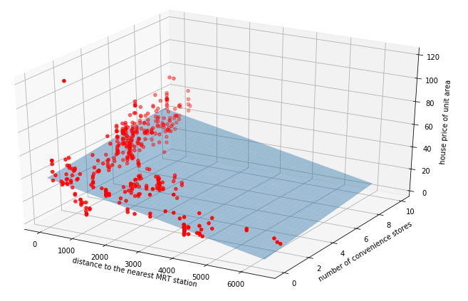

(d)

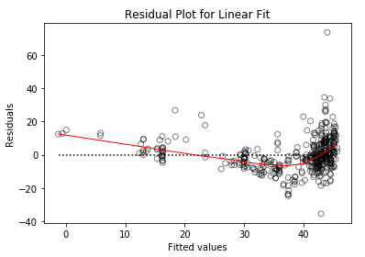

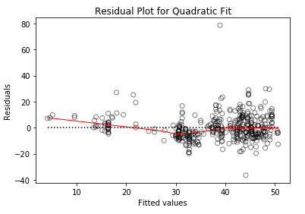

2.

(a) Confusion Matrix:

橫軸為真實的 ,縱軸為估計的

|  |  |  |
| --- | --- | --- |
|  | 1 | 2 |
| 1 | 107 | 3 |
| 2 | 13 | 117 |

(b) Confusion Matrix:

橫軸為真實的 ,縱軸為估計的

|  |  |  |  |
| --- | --- | --- | --- |
|  | 1 | 2 | 3 |
| 1 | 100 | 11 | 7 |
| 2 | 10 | 81 | 38 |
| 3 | 10 | 28 | 75 |