Csc 226 Assignment 1

Paul Cheng

V00838497

1. Comparison sorting like insertion sort has a running time O (n) when on an already-sorted list. But in this case, it’s not. Also Bubble sort and selection sort will have Ω (n^2) running time. Merge sort has to compare every x1, x2; x3, x4 and so on. So it has Ω (nlogn). Quicksort has Ω (nlogn) running time. So comparison sorting algorithm still can’t be faster than Ω (nlogn) because there are n! possible input permutations, so the best case we get log(n!) , which is Ω (nlogn)(Stirling’s approximation).
2. If we divide elements into groups of 3 then we will have

T (n) = O (n) + T (n/3) + T (2n/3)

The height of tree is log32n and each level has n elements so

T (n) = O(nlogn)

3.

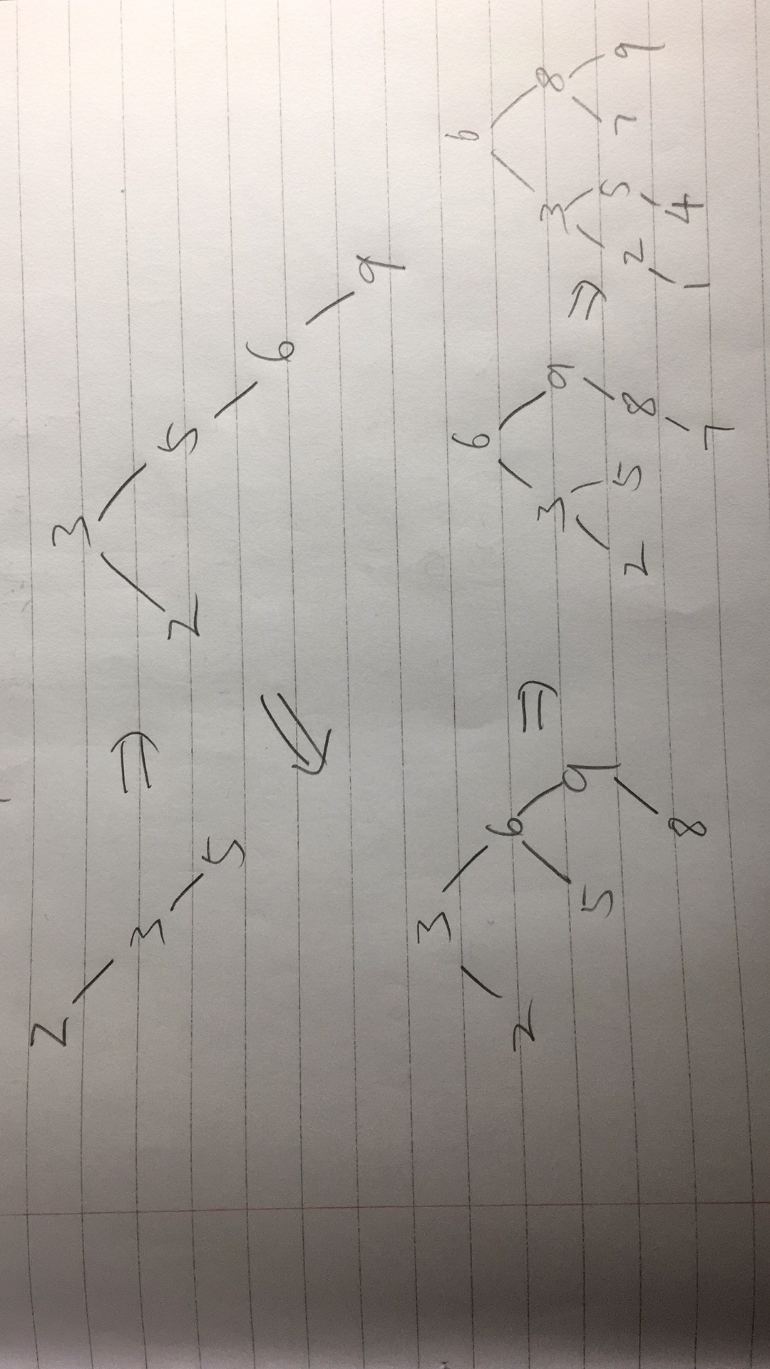

4.

Consider all nodes at levels 1,2,3…,k-2 have 2 children. (Otherwise, it’s not balanced tree) So the tree has at least 2^(k-1)nodes. In an AVL tree of height h, the leaf closest to the root is at level (h+1)/2. On the first (h-1)/2 levels, the AVL tree is a complete binary tree thins out after (h-1)/2 level

Then 2(h-1)/2≤ number of nodes ≤2h.

Substitute h = 2k-1. Then the height is at most 2k-1.