Assignment4 Paul(Pengshengnan) Cheng V00838497

1.a)-1 -3 -2 -1/4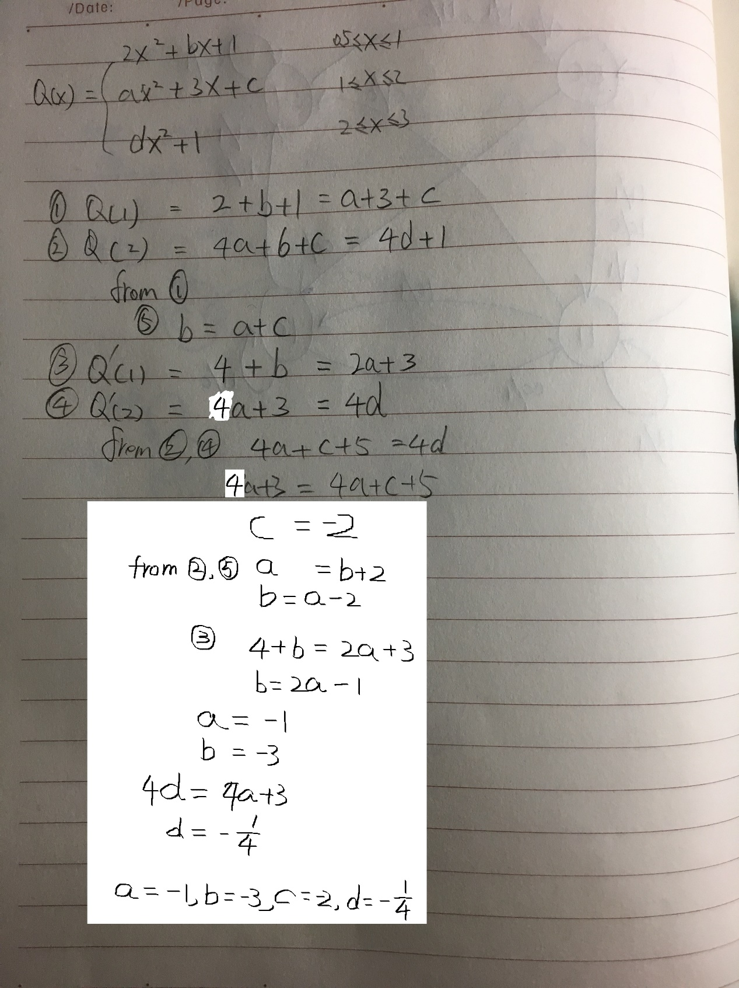

b)

>> x=0.5:0.1:3;

>> plot(x,2\*x.^2-3\*x+1,x,(-1)\*x.^2+3\*x-2,'g--',x,(-1/4)\*x.^2+1,'black.');

>> legend('2x^2+bx+1','ax^2+3x+c','dx^2+1')

2.

f(x)=1; $\int_{-1}^{1}{1}dx$ = 2 = a+b;

f(x)=x; $\int_{-1}^{1}{x}dx$ = 0 = -a+b+c+d;

f(x)=x^2 $\int_{-1}^{1}{x^2}dx$ = 2/3 = a+b-2c+2d;

f(x)=x^3; $\int_{-1}^{1}{x^3}dx$ = 0 = -a+b+3c+3d;

a = 1, b = 1, c = 1/3, d = -1/3.

$\int_{-1}^{1}{f(x)}dx$ = f(-1)+f(1)+1/3f’(-1)-1/3f’(1)

3.(a)

function trap(a, b,f, maxiter, tol)

m = 1;

x = linspace(a, b, m+1);

y = f(x);

approx = trapz(x, y);

disp('m integral approximation');

fprintf(' %5.0f %16.10f \n ', m, approx);

for i = 1 : maxiter

m = 2\*m ;

oldapprox = approx ;

x = linspace ( a , b , m+1 ) ;

y = f(x);

approx = trapz(x, y);

fprintf(' %5.0f %16.10f \n ', m, approx);

if abs( (approx-oldapprox)/oldapprox ) < tol

return

end

end

fprintf('Did not converge in %g iterations', maxiter)

end

(b)

function y=f(x)

y=(x.\*cos(1./(x)));

return ;

>> trap(0.1,3,@f,20,10^(-5))

m integral approximation

1 3.9888973448

2 3.7902074408

4 3.5976493493

8 3.4808457876

16 3.4678411685

32 3.4856113710

64 3.4877924488

128 3.4870325249

256 3.4867926880

512 3.4867333190

1024 3.4867185769

function y=f1(x)

y=exp(3.\*x).\*sin((x+1).^(1/2)+1);

end

>> trap(-1,1,@f1,20,10^(-7))

m integral approximation

1 13.3970553517

2 7.6078251027

4 5.6929741681

8 5.1698664471

16 5.0360666322

32 5.0024583324

64 4.9940594943

128 4.9919647293

256 4.9914430366

512 4.9913133379

1024 4.9912811709

2048 4.9912732205

4096 4.9912712651

8192 4.9912707877

>>