Final Diagram – Deployed and working
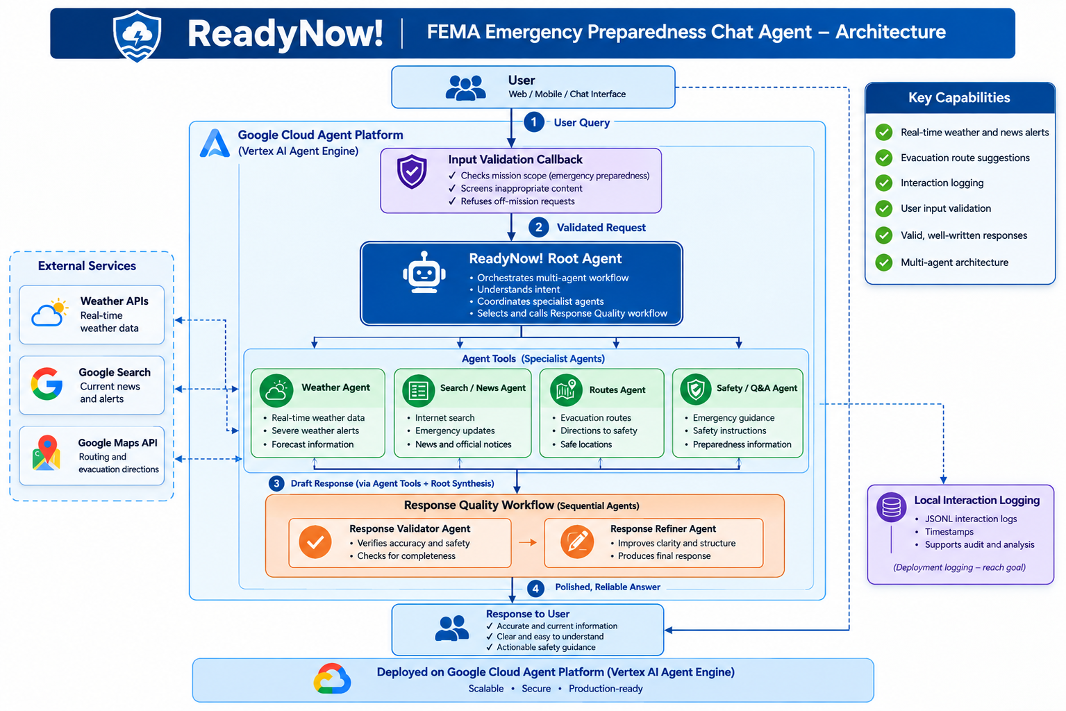

Original Diagram – Could not get it to work deployed
